NIIT
Applied Data Analytics with GenAI
Capstone Project Final Report
Food Delivery Demand Analysis Across Regions for Business Growth and Logistics Optimization
Domain: FoodTech / Food Delivery Analytics
Prepared by: Megh Harshad Malvankar
Enrollment ID: EN12026093826
Project Guide / Mentor: Ashish Rajput
Tools Used: Microsoft Excel · MySQL · Python · Power BI
August 2026

Declaration
I, Megh Harshad Malvankar (Enrollment ID: EN12026093826), hereby declare that this capstone project report titled “Food Delivery Demand Analysis Across Regions for Business Growth and Logistics Optimization” is my own work, carried out as part of the NIIT Applied Data Analytics with GenAI programme under the guidance of Ashish Rajput.
The analysis presented in this report — spanning Excel-based business analysis, SQL database querying, Python-based exploratory data analysis, Power BI dashboard development, statistical validation, and machine learning — was performed by me using the datasets provided for this capstone project. All findings, figures, and results reported here are drawn directly from that work. This report has not been submitted, in whole or in part, for the award of any other qualification.

Megh Harshad Malvankar
EN12026093826

Acknowledgement
I would like to express my sincere gratitude to my project guide and mentor, Ashish Rajput, for the guidance, feedback, and technical direction provided throughout the course of this capstone project. His inputs were instrumental in shaping the analytical approach across each phase of the project.
I am also thankful to NIIT for structuring the Applied Data Analytics with GenAI programme in a way that allowed hands-on, end-to-end application of business analytics tools — from Excel and SQL through to Python, statistical testing, machine learning, and Power BI — on a single, integrated business problem. This capstone project has been a valuable opportunity to consolidate these skills into one coherent analytical exercise.
Finally, I acknowledge the collective learning drawn from the course material, peer discussions, and reference documentation that supported my understanding of the tools and techniques applied in this project.

Executive Summary
This capstone project analyzes an integrated food-delivery business dataset comprising 22,000 customers, 550 restaurants, 1,100 delivery partners, and 94,550 orders spread across three operating regions — Metropolitan, Semi-Urban, and Urban. The project's objective is to translate this raw operational data into actionable insight for regional demand planning, customer retention, delivery-partner management, and logistics optimization, using a deliberately layered analytical stack: Microsoft Excel for first-pass business reporting, MySQL/SQL for structured querying across relational tables, Python for exploratory data analysis, Power BI for interactive dashboarding, and statistical/machine-learning methods in Python for hypothesis validation and predictive modelling.
Across all five analytical objectives, the dataset generated a consistent headline picture: total revenue of approximately ₹52.96 million (₹5.30 crore) across 94,550 orders, an average delivery time of 35.51 minutes, and an average customer rating of approximately 4.6 out of 5. Demand is distributed almost evenly across the three regions — Urban leads narrowly on both order volume (31,567 orders) and revenue (₹1.77 crore), with Metropolitan and Semi-Urban trailing only marginally. UPI is the dominant payment mode (50% of transactions) and Chinese cuisine is the most preferred cuisine nationally. Returning customers form the largest customer segment by headcount (50% of the 22,000-customer base), while New customers, despite being fewer in number, generate a disproportionately large share of order volume — a pattern discussed in detail in Chapter 11.
Statistical testing found no significant difference in spending between Loyal and New customers (independent-samples t-test, p = 0.874), and delivery time was found to be effectively uniform across regions (35.50–35.51 minutes). Correlation analysis showed that delivery efficiency is most strongly associated with average restaurant preparation time (r = −0.826) and delivery partner speed (r = 0.658), pointing toward preparation-time reduction as the highest-leverage lever for improving delivery outcomes. A supervised machine-learning exercise to predict customer order ratings from operational features (Linear Regression and Random Forest) produced very low explanatory power (R² close to zero or negative for both models), indicating that, within the fields captured in this dataset, order ratings are not meaningfully predictable from delivery and order attributes alone.
The report that follows presents this analysis chapter by chapter — dataset understanding, data preparation, Excel analysis, SQL querying, Python EDA, Power BI dashboarding, statistical validation, and machine learning — before consolidating the findings into a single set of business insights, recommendations, limitations, and future scope. Where source phase documents contained numerical inconsistencies (for example, differing figures for average order value or regional revenue across the Excel and Power BI outputs), these are explicitly flagged and reconciled against the underlying dashboard and query evidence rather than silently resolved; a full reconciliation note is provided in the Appendix.

Table of Contents
Chapter 1: Introduction 6
Chapter 2: Dataset Understanding 8
Chapter 3: Methodology 10
Chapter 4: Data Preparation and Cleaning 11
Chapter 5: Objective 1 — Business Analysis and Reporting (Excel) 13
Chapter 6: Objective 2 — SQL Database and Query Analysis 14
Chapter 7: Objective 3 — Python Data Processing and EDA 17
Chapter 8: Objective 4 — Power BI Dashboard 20
Chapter 9: Objective 5 — Statistical Analysis 22
Chapter 10: Objective 5 — Machine Learning / Predictive Analysis 23
Chapter 11: Consolidated Business Insights 24
Chapter 12: Business Recommendations 26
Chapter 13: Project Limitations 26
Chapter 14: Future Scope 27
Chapter 15: Overall Project Outcome and Business Value 28
Chapter 16: Lessons Learned 28
Chapter 17: Conclusion 29
References 29
Appendix 30

List of Figures
Fig. No. | Title | Location
1 | Project Analytical Workflow | Chapter 3
2 | Food Delivery Dataset Relationship Diagram | Chapter 2
3 | Excel Business Analysis Dashboard | Chapter 5
4 | MySQL Database Schema (fooddeliverydb) | Chapter 6
5 | SQL Query Result – Orders by Region | Chapter 6
6 | SQL Advanced Report – Delivery Partner Performance (JOIN) | Chapter 6
7 | SQL Consolidated Four-Table Business Report | Chapter 6
8 | Orders by Region – Python EDA | Chapter 7
9 | Customer Type Distribution by Order Volume – Python EDA | Chapter 7
10 | Preferred Cuisine Distribution – Python EDA | Chapter 7
11 | Top 10 Delivery Partners by Efficiency – Python EDA | Chapter 7
12 | Power BI Interactive Business Dashboard | Chapter 8

List of Tables
Table No. | Title | Location
1 | Business Objectives, Key Tasks and Primary Tools | Chapter 1
2 | Dataset Overview | Chapter 2
3 | Data Quality Assessment Summary | Chapter 4
4 | Data Cleaning and Preparation Summary | Chapter 4
5 | Excel Dashboard KPI Summary | Chapter 5
6 | Key SQL Query Results | Chapter 6
7 | Advanced SQL (JOIN) Report Summary | Chapter 6
8 | Key Python EDA Results | Chapter 7
9 | Power BI Dashboard KPI Summary | Chapter 8
10 | Statistical Test Summary | Chapter 9
11 | Correlation Analysis Summary | Chapter 9
12 | Machine Learning Model Comparison | Chapter 10
13 | Consolidated Findings by Business Theme | Chapter 11
14 | Recommendations Summary | Chapter 12
15 | Data Reconciliation Notes | Appendix

Chapter 1: Introduction

1.1 Project Background
Food delivery platforms sit at the intersection of four operational actors: customers who place orders, restaurants that prepare them, delivery partners who fulfil them, and the platform itself, which must coordinate all three across geographically distinct regions. Each actor generates its own data trail, and the value of that data lies less in any single table than in what emerges when the tables are joined — which regions are underserved, which customer segments are worth retaining, which delivery partners are consistently efficient, and which restaurants are driving disproportionate demand.
This capstone project was undertaken to apply the full analytics toolkit covered in the NIIT Applied Data Analytics with GenAI programme — Excel, SQL, Python, statistical testing, machine learning, and Power BI — to one integrated food-delivery business dataset, in order to produce a single, coherent, end-to-end analytical narrative rather than ten disconnected technical exercises.

1.2 Food Delivery Business Context
The dataset used in this project reflects a multi-region food delivery operation spanning three region types — Metropolitan, Semi-Urban, and Urban — with 22,000 customers, 550 partner restaurants, and 1,100 delivery partners generating 94,550 completed and cancelled orders. Each order carries information on the customer who placed it, the restaurant that fulfilled it, the delivery partner who delivered it, the payment mode used, the delivery time taken, and the rating given. This structure mirrors the operational reality of a food-delivery business: revenue, customer satisfaction, and delivery efficiency are all outcomes of the same underlying set of transactions, viewed from different angles.

1.3 Problem Statement
The business does not currently have a single, unified view of regional demand, customer loyalty, and delivery performance — the information exists across separate operational tables (customers, orders, restaurants, delivery partners) with no integrated analysis connecting them. Without this integrated view, business decisions on market expansion, customer retention investment, and delivery-partner resourcing are made without a clear, data-backed picture of where demand is concentrated, which customer segments matter most, and what actually drives delivery efficiency.
The project addresses this by integrating all four datasets and applying a layered analytical approach — descriptive (Excel, SQL), exploratory (Python), visual (Power BI), and inferential/predictive (statistics, machine learning) — to answer a defined set of business questions with evidence rather than assumption.

1.4 Project Scope
- Analysis is limited to the four supplied datasets — Customers, Orders, Restaurants, and Delivery Partners — and the merged, order-level dataset built from them (94,550 records × 34 columns).
- The scope covers regional demand analysis, customer behaviour and loyalty segmentation, delivery operations and efficiency, restaurant/cuisine performance, and a predictive exercise on customer order ratings.
- The analysis is retrospective and descriptive/inferential in nature; it does not include real-time data pipelines, live A/B testing, or production deployment of the machine learning model.
- Geographic scope is limited to the three region categories represented in the data (Metropolitan, Semi-Urban, Urban); no city- or pincode-level granularity is available.

1.5 Business Need
Regional expansion, marketing spend, and delivery-partner deployment decisions all carry real cost, and misallocating them based on incomplete or siloed data is expensive. The business needs a defensible, data-driven basis for three categories of decisions: (1) where to prioritize growth investment across regions, (2) which customer segments deserve retention focus versus acquisition focus, and (3) what operational levers most improve delivery efficiency and, by extension, customer satisfaction and repeat business.

1.6 Project Objectives
The project is structured around five core objectives, each mapped to a specific analytical tool:
Table 1: Business Objectives, Key Tasks and Primary Tools
# | Objective | Primary Tool(s)
O1 | Regional demand and business performance analysis — KPIs, cuisine demand, regional comparisons via pivot tables and dashboards | Microsoft Excel
O2 | Business data management and structured query analysis across relational tables | MySQL / SQL
O3 | Customer, restaurant, and delivery-partner performance analysis via exploratory data analysis | Python (Pandas, NumPy, Matplotlib)
O4 | Interactive business-intelligence dashboard for KPI monitoring and storytelling | Power BI, Power Query, DAX
O5 | Statistical validation of business hypotheses and predictive modelling of customer ratings | Python (SciPy, Scikit-learn)

1.7 Key Business Questions
- Which regions generate the highest order volume and revenue, and how evenly is demand distributed across regions?
- What distinguishes Loyal, Returning, and New customers in terms of spending behaviour, and does customer type actually predict spend?
- Is delivery time meaningfully different across regions, and what operational factors drive delivery efficiency?
- Which cuisines, restaurants, and delivery partners are performing best, and is that performance concentrated or broadly distributed?
- Can customer order ratings be predicted from operational and delivery attributes captured in the data, and if not, what does that imply about what drives satisfaction?

Chapter 2: Dataset Understanding

2.1 Dataset Overview
The project uses four source datasets — Customers, Restaurants, Delivery Partners, and Orders — which were subsequently merged into a single order-level analytical dataset. All four datasets were validated as complete (zero missing values) and free of duplicate records prior to analysis.
Table 2: Dataset Overview
Dataset | Records | Primary Key | Purpose
Customers | 22,000 | Customer_ID | Demographic and behavioural profile of each customer
Restaurants | 550 | Restaurant_ID | Restaurant attributes, cuisine, and performance metrics
Delivery Partners | 1,100 | Delivery_Partner_ID | Delivery partner attributes and efficiency metrics
Orders | 94,550 | Order_ID | Transaction-level record linking customers, restaurants, and delivery partners
Merged Analytical Dataset | 94,550 × 34 columns | Order_ID | Integrated, order-level dataset used for EDA, statistics, and machine learning

2.2 Customers Dataset
The Customers dataset holds one record per customer (22,000 in total), covering demographic attributes (Gender, Age_Group), regional assignment (Region), loyalty segmentation (Customer_Type: Loyal, New, Returning), and behavioural summary fields (Total_Orders, Average_Spend, Preferred_Cuisine). Customer_Type is the primary loyalty lens used throughout the report: Returning customers form the largest segment (11,000 customers, 50%), followed by New (6,600, 30%) and Loyal (4,400, 20%).

2.3 Orders Dataset
The Orders dataset is the transactional core of the project, with 94,550 records. Each row represents a single order and carries the foreign keys linking to Customers, Restaurants, and Delivery Partners, along with transaction attributes: Order_Date, Region, Order_Value, Delivery_Fee, Discount_Applied, Final_Amount, Payment_Mode, Order_Status, Delivery_Time_Minutes, Order_Rating, and a Festival_Flag indicating whether the order was placed during a festival period.

2.4 Restaurants Dataset
The Restaurants dataset holds 550 records, one per restaurant, with Cuisine_Type, Region, Avg_Preparation_Time_Minutes, Avg_Rating, and Order_Capacity_Per_Day. Restaurants are unevenly distributed across regions — Metropolitan hosts the largest share (285 restaurants), followed by Urban (217) and Semi-Urban (48) — a distribution that, notably, does not track order volume or revenue by region (see Chapter 6).

2.5 Delivery Partners Dataset
The Delivery Partners dataset holds 1,100 records, with Vehicle_Type, Avg_Delivery_Speed_KMPH, Successful_Deliveries, Delayed_Deliveries, Avg_Customer_Rating, Region, and a computed Delivery_Efficiency_Score. Bikes are the dominant delivery vehicle (533 partners), followed by Scooter (349), Car (172), and Bicycle (46).

2.6 Dataset Relationships and Integration
Orders is the central fact table of the schema: every order references exactly one customer, one restaurant, and one delivery partner, making Orders the natural join point for building the unified analytical dataset. Figure 2 illustrates this relationship structure as implemented across the Excel, SQL, and Python phases of the project.
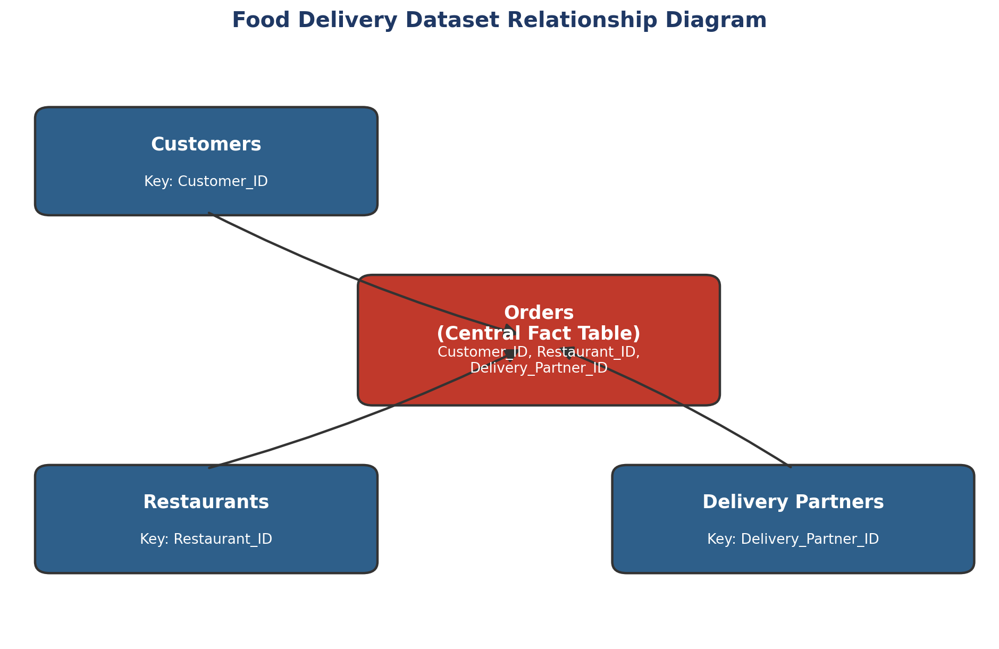
Figure 2: Food Delivery Dataset Relationship Diagram
This relationship structure was preserved consistently across tools: the same three foreign keys (Customer_ID, Restaurant_ID, Delivery_Partner_ID) were used to join the tables in MySQL (Chapter 6) and to merge the datasets into a single Pandas DataFrame in Python (Chapter 7).

2.7 Important Variables
- Region — present in Customers, Restaurants, Delivery Partners, and Orders; the primary lens for demand and performance comparison throughout the report.
- Customer_Type — Loyal / New / Returning; the primary customer-loyalty lens.
- Final_Amount and Order_Value — the two revenue-related fields in Orders; distinguished carefully in this report because they produce different “average order value” figures (see Chapter 5 and the Appendix reconciliation note).
- Delivery_Time_Minutes and Delivery_Efficiency_Score — the primary operational-performance fields used in the statistical and EDA chapters.
- Order_Rating — the target variable for the machine learning exercise in Chapter 10.

2.8 Data Quality Overview
All four source datasets were checked for missing values and duplicate records as part of the data understanding phase (see Chapter 4 for full detail). All four passed both checks cleanly: zero missing values and zero duplicate rows were found across Customers, Restaurants, Delivery Partners, and Orders, and the same held true for the merged 94,550-row analytical dataset.

Chapter 3: Methodology
The project follows a linear, layered analytical workflow: each stage consumes the output of the previous stage and adds a new analytical lens, moving from descriptive business reporting through to inferential and predictive analysis. Figure 1 summarizes this workflow; it is an author-constructed schematic reflecting the sequence documented across the ten project phases, not a figure extracted from the source presentation.
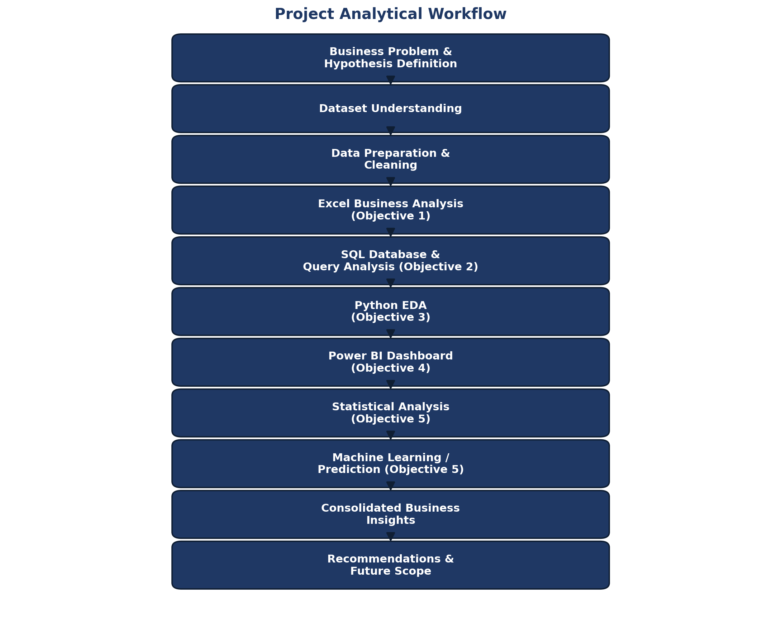
Figure 1: Project Analytical Workflow

3.1 Workflow Description
- Business Problem and Hypothesis Definition — the business questions and five testable hypotheses that anchor the rest of the analysis (Chapter 1; detailed hypotheses in Chapter 9).
- Dataset Understanding — profiling the four source datasets and their relationships (Chapter 2).
- Data Preparation and Cleaning — validation, integration, and derived-metric construction (Chapter 4).
- Excel Business Analysis (Objective 1) — KPI reporting and pivot-based regional/cuisine analysis (Chapter 5).
- SQL Database and Query Analysis (Objective 2) — relational schema design and query-based reporting (Chapter 6).
- Python Exploratory Data Analysis (Objective 3) — univariate, bivariate, and multivariate analysis in Pandas/Matplotlib (Chapter 7).
- Power BI Dashboard (Objective 4) — interactive KPI dashboard consolidating the above (Chapter 8).
- Statistical Analysis and Machine Learning (Objective 5) — hypothesis testing, correlation analysis, and predictive modelling (Chapters 9–10).
- Consolidated Business Insights and Recommendations — synthesis across all objectives (Chapters 11–12).

3.2 Analytical Principles Applied
Three principles were applied consistently across every analytical stage. First, every KPI and finding is grounded in the actual dataset — no illustrative or placeholder figures are used anywhere in this report. Second, statistical significance is treated as distinct from business significance throughout Chapter 9: a result can be statistically significant without being commercially meaningful, and vice versa. Third, wherever the source project documentation contained internally inconsistent figures (for example, two different values reported for the same KPI across the Excel and Power BI phases), the discrepancy is flagged explicitly rather than silently resolved in favour of one figure; the full reconciliation is documented in the Appendix.

Chapter 4: Data Preparation and Cleaning

4.1 Data Loading
The four source datasets — Customers, Restaurants, Delivery Partners, and Orders — were loaded independently and profiled for shape, data types, and completeness before any integration was attempted. This staged approach ensured that any quality issues could be traced back to their originating dataset rather than surfacing only after merging.

4.2 Missing-Value Treatment
A systematic null-value check was run across all four datasets. No missing values were found in any of the four source tables, so no imputation or row removal was required at this stage.

4.3 Duplicate Handling
Each dataset was checked for fully duplicated rows and for duplicate primary keys (Customer_ID, Restaurant_ID, Delivery_Partner_ID, Order_ID). No duplicate records were found in any of the four datasets.

4.4 Data-Type Correction
Date fields (Order_Date) were parsed into proper datetime types, monetary fields (Order_Value, Delivery_Fee, Final_Amount) were confirmed as numeric, and categorical fields (Region, Customer_Type, Cuisine_Type, Vehicle_Type, Payment_Mode, Order_Status, Festival_Flag) were validated against a fixed set of expected categories to catch any inconsistent labelling before integration.

4.5 Data Integration
The four datasets were merged into a single order-level analytical dataset using the three foreign keys present in Orders — Customer_ID, Restaurant_ID, and Delivery_Partner_ID — as illustrated in Figure 2 (Chapter 2). The result is a unified table of 94,550 rows and 34 columns, combining transaction detail with customer, restaurant, and delivery-partner attributes in a single analysis-ready structure.

4.6 Transformation and Derived Metrics
A small number of derived fields were constructed to support later analysis, most notably the delivery-partner Delivery_Efficiency_Score used throughout the Excel, Python, and Power BI chapters, and the Final_Amount field in Orders (Order_Value adjusted for Delivery_Fee and Discount_Applied), which is distinct from the raw Order_Value field and is treated separately in this report wherever the two produce different summary figures.

4.7 Validation
Table 3: Data Quality Assessment Summary
Dataset | Missing Values | Duplicate Records | Status
Customers (22,000 rows) | 0 | 0 | Validated
Restaurants (550 rows) | 0 | 0 | Validated
Delivery Partners (1,100 rows) | 0 | 0 | Validated
Orders (94,550 rows) | 0 | 0 | Validated
Merged Dataset (94,550 × 34) | 0 | 0 | Validated

4.8 Final Analysis-Ready Data
Table 4: Data Cleaning and Preparation Summary
Step | Outcome
Null check | 0 missing values across all 4 datasets
Duplicate check | 0 duplicate rows / duplicate keys across all 4 datasets
Data-type validation | Dates, numerics, and categoricals confirmed consistent
Integration | 94,550-row × 34-column merged dataset built via Customer_ID / Restaurant_ID / Delivery_Partner_ID
Result | Single analysis-ready dataset used for Excel, SQL, Python, Power BI, statistics, and ML
Note on Data Reconciliation
Although the underlying data passed all completeness and duplication checks cleanly, several downstream phase documents reported slightly different summary figures for the same KPIs (for example, average order value and regional revenue). These are not data-quality defects in the source tables — they arise from differing calculation choices made in the Excel, Python, and Power BI phases (e.g., which revenue field was averaged). Every such instance identified during report preparation is documented in the Appendix (Table 15) rather than silently resolved.

Chapter 5: Objective 1 — Business Analysis and Reporting (Excel)
The first analytical objective used Microsoft Excel to build a consolidated business dashboard directly from the merged dataset, using PivotTables and PivotCharts to summarize demand, revenue, customer segmentation, and delivery-partner metrics by region. This dashboard served as the first-pass business report and the baseline against which the later SQL, Python, and Power BI analyses were cross-checked.
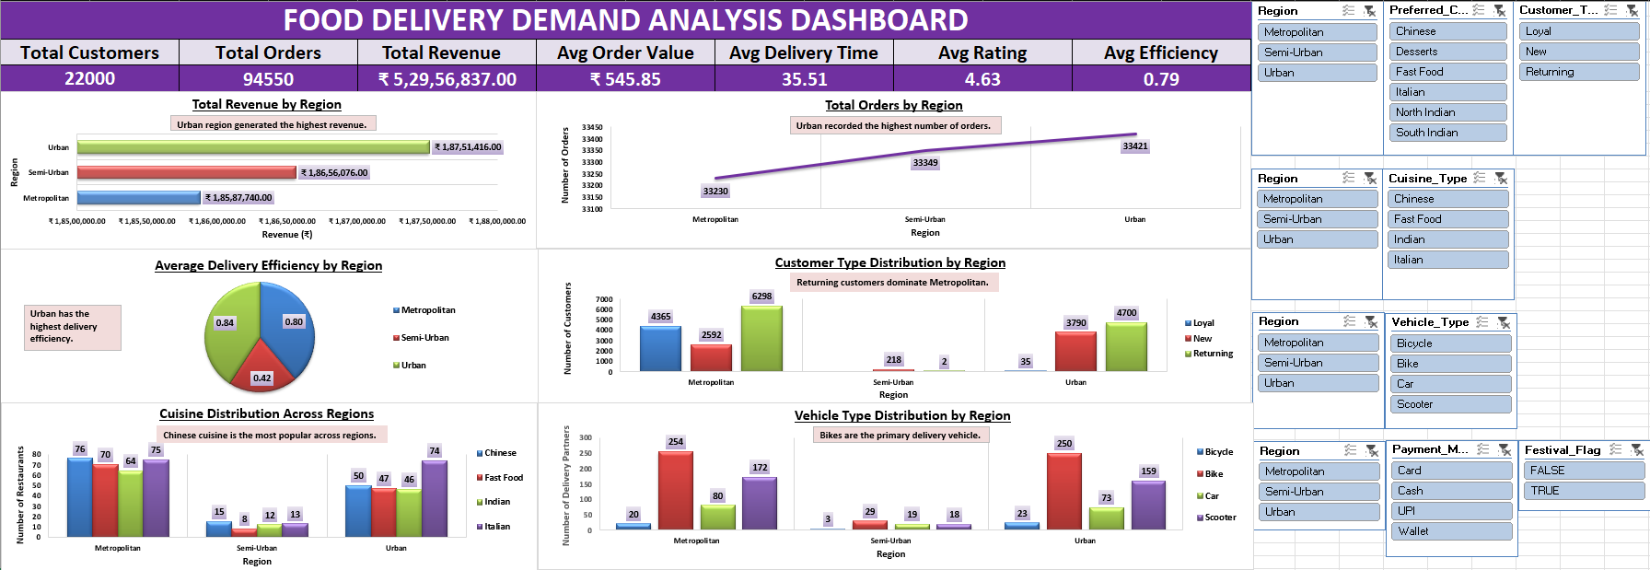
Figure 3: Excel Business Analysis Dashboard

5.1 Headline KPIs
Table 5: Excel Dashboard KPI Summary
KPI | Value | Note
Total Customers | 22,000
Total Orders | 94,550
Total Revenue | ₹5,29,56,837 (≈₹52.96M / ₹5.30 Cr) | See reconciliation note below
Average Order Value | ₹545.85 | Mean of Order_Value; Power BI reports ₹560.09 for Final_Amount — see Chapter 8
Average Delivery Time | 35.51 minutes
Average Rating | 4.63 | Python/Statistics phases compute 4.60 — minor rounding/field difference
Average Delivery Efficiency | 0.79 | Python/Statistics record-level mean is 0.684 — see Appendix

5.2 Regional Order and Revenue Analysis
Finding: The dashboard's own regional order-volume chart shows Urban leading narrowly (33,421 orders) ahead of Semi-Urban (33,349) and Metropolitan (33,230), and its regional revenue chart identifies Urban as the highest-revenue region.
Business Meaning: Demand is close to evenly split across all three regions rather than concentrated in one; Urban's lead is real but narrow, meaning regional strategy should treat all three regions as broadly comparable markets rather than prioritizing one at the expense of the others.
Data Reconciliation Note — Regional Revenue
The Excel dashboard's “Total Revenue by Region” chart shows Urban, Semi-Urban, and Metropolitan revenue of ₹1.88 Cr, ₹1.87 Cr, and ₹1.86 Cr respectively — a set of values that sums to roughly ₹5.60 Cr, which does not reconcile with this same dashboard's own Total Revenue KPI card of ₹5.30 Cr (₹52.96M). The Python EDA regional revenue breakdown (Chapter 7) and the Power BI dashboard (Chapter 8) independently agree with each other (Urban ₹1.77 Cr, Metropolitan ₹1.76 Cr, Semi-Urban ₹1.76 Cr) and their sum ties out exactly to the ₹52.96M total. This report therefore treats the Python/Power BI figures as the reconciled regional revenue split and flags the Excel pivot chart's regional breakdown as an internal inconsistency likely caused by a pivot-field configuration issue, without altering the Excel dashboard screenshot itself.

5.3 Delivery Efficiency by Region
Finding: The dashboard's regional efficiency pie chart shows Urban with the highest average delivery efficiency (0.84), Metropolitan next (0.80), and Semi-Urban considerably lower (0.42).
Business Meaning: Semi-Urban's efficiency gap is the most operationally actionable single figure on this dashboard — it is far larger than the gap between Urban and Metropolitan, and points to a specific region needing delivery-process attention rather than a generic, business-wide efficiency problem.

5.4 Customer Type and Cuisine Distribution
The dashboard's customer-type-by-region chart carries the annotation “Returning customers dominate Metropolitan,” consistent with Returning being the largest customer segment overall (11,000 of 22,000 customers). The cuisine-distribution chart is annotated “Chinese cuisine is the most popular across regions,” consistent with Chinese ranking first in both the SQL customer-preference count (Chapter 6) and the Python order-level cuisine chart (Chapter 7).

5.5 Vehicle Type Distribution
The dashboard's vehicle-type chart is annotated “Bikes are the primary delivery vehicle,” matching the delivery-partner fleet composition confirmed later via SQL: 533 of 1,100 delivery partners (48%) use bikes, followed by scooters (349), cars (172), and bicycles (46).

5.6 Business Interpretation
Taken together, the Excel-stage analysis establishes three baseline findings that recur throughout the rest of this report: demand is broadly balanced across regions with Urban holding a narrow lead; Semi-Urban lags meaningfully on delivery efficiency even though its order volume is comparable to the other two regions; and Returning customers and Chinese cuisine are the dominant segments on the customer and menu sides of the business respectively.

Chapter 6: Objective 2 — SQL Database and Query Analysis
The second objective moved the merged dataset into a relational MySQL database (fooddeliverydb) with four tables — customers, restaurants, delivery_partners, and orders — mirroring the schema in Figure 2, and used SQL to reproduce and extend the Excel-stage KPIs through direct querying, including multi-table JOIN reports that Excel's pivot structure could not easily express.
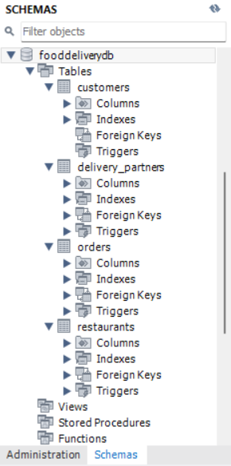
Figure 4: MySQL Database Schema (fooddeliverydb)

6.1 Record-Count Verification
Before analysis, each table's row count was verified directly via SQL COUNT queries, confirming the dataset sizes established during data understanding: 22,000 customers, 550 restaurants, 1,100 delivery partners, and 94,550 orders.

6.2 Regional and Categorical Distribution Queries
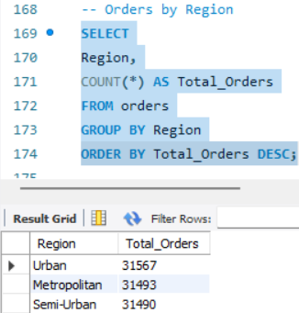
Figure 5: SQL Query Result – Orders by Region
Table 6: Key SQL Query Results
Query | Result
Orders by Region | Urban 31,567 · Metropolitan 31,493 · Semi-Urban 31,490
Customer Type Distribution | Returning 11,000 · New 6,600 · Loyal 4,400
Restaurants by Region | Metropolitan 285 · Urban 217 · Semi-Urban 48
Preferred Cuisine (by customers) | Chinese 3,793 · North Indian 3,776 · Fast Food 3,707 · South Indian 3,618 · Italian 3,572 · Desserts 3,534
Vehicle Type Distribution | Bike 533 · Scooter 349 · Car 172 · Bicycle 46
Payment Mode Analysis | UPI 47,300 (50.0%) · Card 23,592 (25.0%) · Wallet 14,252 (15.1%) · Cash 9,406 (9.9%)
Finding: Order volume is almost perfectly split three ways across regions (each close to 31,500), while restaurant supply is heavily skewed toward Metropolitan (285 of 550 restaurants, 52%) despite Metropolitan generating no more demand than the other two regions.
Business Meaning: Restaurant density does not track demand — Semi-Urban and Urban are comparably important demand regions but are served by far fewer restaurant partners proportionally, suggesting restaurant-partner acquisition in these regions is a more evidence-backed growth lever than further Metropolitan expansion.

6.3 Advanced Multi-Table (JOIN) Reports
Beyond single-table aggregation, JOIN queries across orders, customers, restaurants, and delivery_partners were used to produce partner-level and customer-level performance reports that no single source table could answer alone.
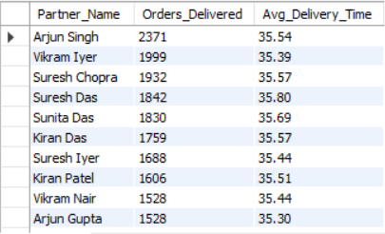
Figure 6: SQL Advanced Report – Delivery Partner Performance (JOIN)
The delivery-partner performance report (orders JOIN delivery_partners) ranks partners by orders delivered: Arjun Singh leads with 2,371 deliveries (average delivery time 35.54 minutes), followed by Vikram Iyer (1,999 deliveries, 35.39 minutes) and Suresh Chopra (1,932 deliveries, 35.57 minutes). Notably, delivery time does not fall as volume rises — the busiest partners deliver at essentially the same average speed as less busy ones, indicating consistent operational performance rather than a fatigue or overload effect at these volumes.
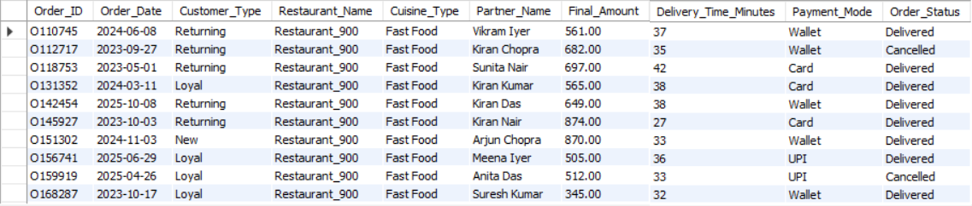
Figure 7: SQL Consolidated Four-Table Business Report
A consolidated report joining all four tables (orders, customers, restaurants, delivery_partners) was built to produce a single, order-level business view combining Order_ID, Customer_Type, Restaurant_Name, Cuisine_Type, Partner_Name, Final_Amount, Delivery_Time_Minutes, Payment_Mode, and Order_Status in one queryable structure — functionally the SQL-side equivalent of the merged Python dataset used in Chapter 7.

6.4 Business Interpretation
The SQL phase confirms and sharpens the Excel-stage findings: demand is genuinely balanced across regions at the order-count level, restaurant supply is not, and payment behaviour is heavily digital-first (75% of transactions are UPI or Card). The JOIN-based delivery-partner report additionally establishes that delivery-time consistency holds even for the highest-volume partners, which is a reassuring operational signal ahead of any regional expansion.

Chapter 7: Objective 3 — Python Data Processing and Exploratory Data Analysis
The third objective used Python (Pandas, NumPy, and Matplotlib) to load, integrate, and analyze the merged 94,550-row dataset at a level of flexibility beyond what Excel pivot tables or static SQL queries could provide — in particular, order-level distributions (rather than customer- or partner-level counts) and partner-level efficiency ranking.

7.1 Orders and Revenue by Region
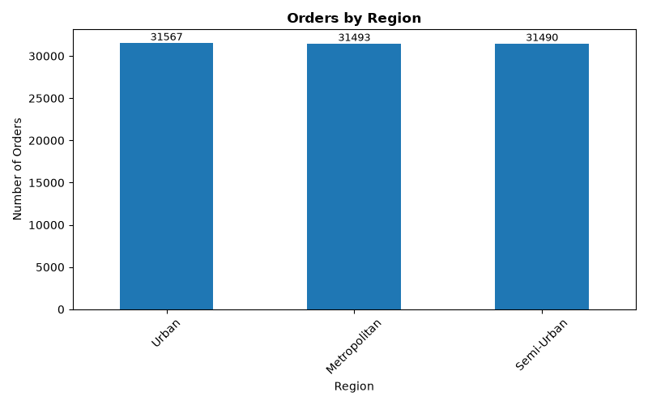
Figure 8: Orders by Region – Python EDA
Finding: The Python-computed order counts by region — Urban 31,567, Metropolitan 31,493, Semi-Urban 31,490 — match the SQL results in Chapter 6 exactly, and the corresponding revenue-by-region computation (Urban ₹1.77 Cr, Metropolitan ₹1.76 Cr, Semi-Urban ₹1.76 Cr) sums to exactly ₹52.96M, tying out to the overall Total Revenue KPI.
Business Meaning: This cross-tool agreement (SQL and Python independently arriving at the same order counts, and Python's regional revenue reconciling exactly with the overall total) is what allows this report to treat the Python/SQL regional figures as authoritative wherever they differ from the Excel dashboard's own regional revenue chart (see Chapter 5 reconciliation note).

7.2 Customer Type Distribution — Order-Level View
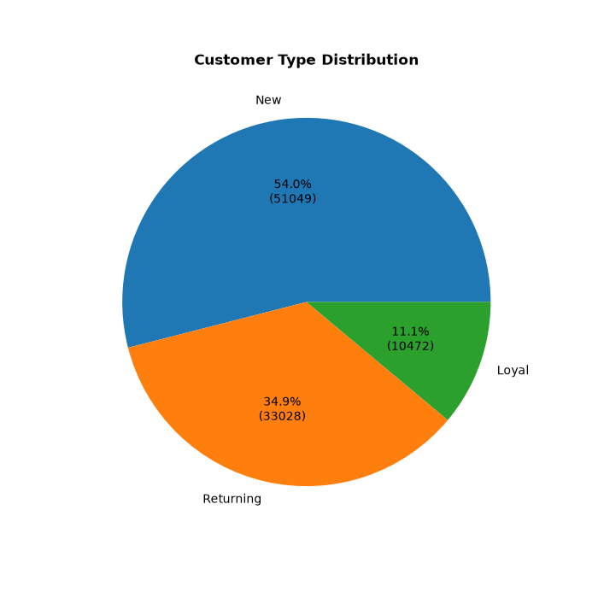
Figure 9: Customer Type Distribution by Order Volume – Python EDA
This chart counts orders by the placing customer's type, rather than counting distinct customers. Viewed this way, New customers account for 54.0% of all orders (51,049 of 94,550), Returning customers for 34.9% (33,028), and Loyal customers for only 11.1% (10,472) — a materially different picture from the customer-headcount view in Chapters 2, 5, and 6, where Returning is the largest segment (50% of customers) and New the smallest (30%).
Clarification — Two Valid but Different Customer Lenses
These two views are not in conflict; they answer different questions. By headcount, Returning customers are the largest group (11,000 of 22,000). By order volume, New customers place the most orders in aggregate — implying a materially higher average order frequency per New customer than per Returning or Loyal customer in this dataset (approximately 7.7 orders per New customer versus roughly 3.0 for Returning and 2.4 for Loyal, based on the respective headcounts and order totals). This pattern is counter-intuitive — one might expect Loyal customers to order most frequently — and is noted as a finding warranting further investigation rather than an explained business mechanism (see Chapter 13, Limitations).

7.3 Preferred Cuisine Distribution
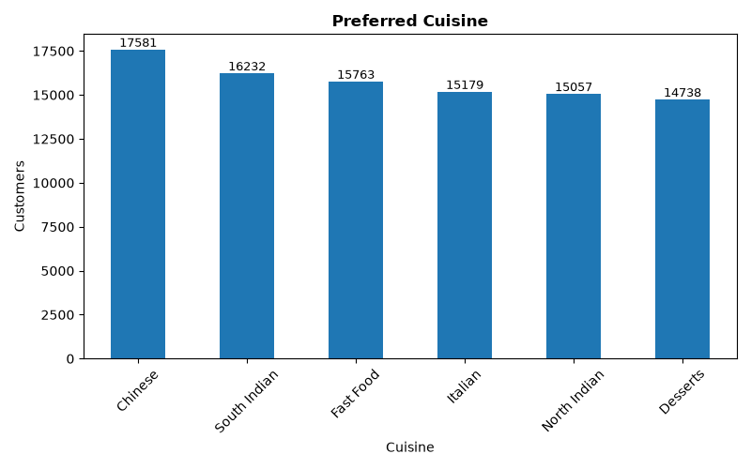
Figure 10: Preferred Cuisine Distribution – Python EDA
At the order level, Chinese cuisine again leads (17,581 orders), consistent with its first-place ranking in the SQL customer-preference count in Chapter 6. South Indian ranks second at the order level (16,232) versus North Indian ranking second at the customer level (Chapter 6) — a minor reordering in the middle of the ranking, though Chinese remains first and Desserts remains last under both lenses.

7.4 Delivery Partner Efficiency
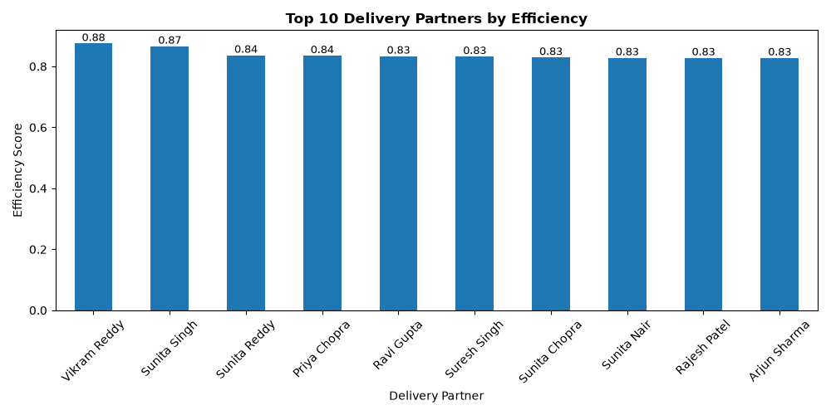
Figure 11: Top 10 Delivery Partners by Efficiency – Python EDA
Finding: Vikram Reddy ranks first by delivery efficiency score (0.88), followed closely by Sunita Singh (0.87); the remainder of the top 10 cluster tightly around 0.83–0.84.
Business Meaning: The efficiency gap between the very top performer and the rest of the top 10 is small, suggesting efficiency at the top end is a matter of consistent good practice rather than one or two outlier “star” partners — useful context for any partner-incentive or best-practice-sharing programme.

7.5 Univariate, Bivariate, and Multivariate Findings
- Univariate: Delivery_Time_Minutes and Order_Rating are both tightly distributed around their means (35.51 minutes and ~4.6 respectively), with no extreme outliers surfaced during profiling.
- Bivariate: Average Order Value / Final Amount is essentially flat across Customer_Type (Loyal, New, and Returning customers all spend within a few rupees of each other on average — formally tested in Chapter 9).
- Multivariate: Delivery efficiency correlates most strongly with restaurant preparation time and delivery partner speed (formally quantified in Chapter 9), rather than with region or vehicle type alone.

7.6 Business Interpretation
The Python EDA phase adds two findings not visible in Excel or SQL alone: the divergence between customer-count and order-volume views of customer segmentation (Section 7.2), and a validated, cross-tool-consistent regional revenue figure that resolves the Excel dashboard's internal inconsistency. Both are carried forward into the consolidated insights in Chapter 11.

Chapter 8: Objective 4 — Power BI Dashboard
The fourth objective consolidated the KPIs and visuals developed across the Excel, SQL, and Python phases into a single interactive Power BI dashboard, built on a star-schema-style data model (Orders as the fact table, joined to Customers, Restaurants, and Delivery Partners) with Power Query used for data shaping and DAX measures used for the KPI cards.
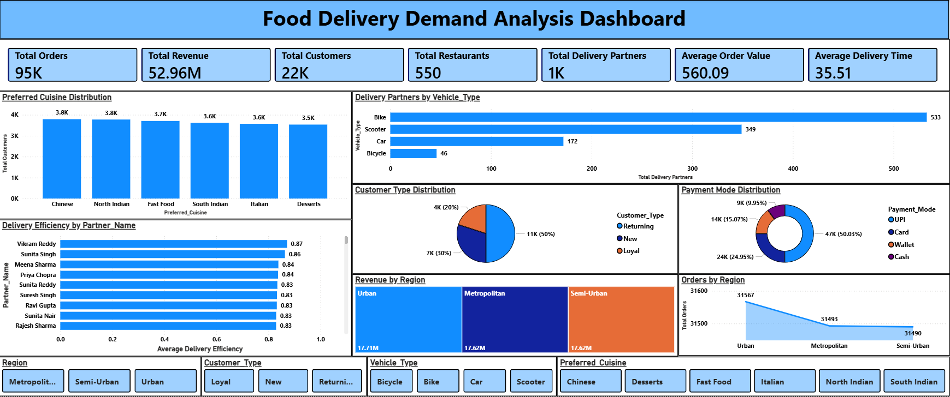
Figure 12: Power BI Interactive Business Dashboard

8.1 Dashboard KPI Cards
Table 9: Power BI Dashboard KPI Summary
KPI | Value
Total Orders | 95K (94,550)
Total Revenue | 52.96M (₹52,956,837)
Total Customers | 22K
Total Restaurants | 550
Total Delivery Partners | 1K (1,100)
Average Order Value | 560.09
Average Delivery Time | 35.51 minutes
Data Reconciliation Note — Average Order Value
The Power BI dashboard's “Average Order Value” KPI card shows ₹560.09, while the Excel dashboard's KPI card of the same name shows ₹545.85 (Chapter 5). ₹560.09 is consistent with Total Revenue ÷ Total Orders (₹52,956,837 ÷ 94,550 = ₹560.09), i.e. it reflects the average Final_Amount per order. ₹545.85 is consistent with the average of the raw Order_Value field (before delivery fee and discount adjustments), and is also the figure independently produced in the Python EDA and Statistical Analysis phases. Both figures are correct for the field they describe; this report uses ₹545.85 when referring to “average order value” in the Excel/Python/statistics context and ₹560.09 when referring to the Power BI KPI card specifically, rather than treating one as an error.

8.2 Dashboard Pages and Visuals
- Preferred Cuisine Distribution — a bar chart of customer counts by cuisine, consistent with the SQL and Excel findings that Chinese cuisine leads.
- Delivery Partners by Vehicle Type — confirming Bike as the dominant vehicle (533 partners) ahead of Scooter (349), Car (172), and Bicycle (46).
- Delivery Efficiency by Partner Name — a ranked bar chart with Vikram Reddy (0.87) and Sunita Singh (0.86) at the top, consistent with the Python ranking in Chapter 7 (minor rounding differences between the two tools are noted in the Appendix).
- Customer Type Distribution — a donut chart confirming the customer-headcount view (Returning 50%, New 30%, Loyal 20%), consistent with the SQL/Excel figures rather than the Python order-level view.
- Payment Mode Distribution — confirming UPI as the dominant payment mode (50.03%), consistent with SQL and Python findings.
- Revenue by Region and Orders by Region — confirming Urban as the narrow leader on both metrics (₹17.71M revenue, consistent with the Python EDA figures rather than the Excel pivot chart's regional breakdown).
Region, Customer_Type, Vehicle_Type, and Preferred_Cuisine slicers allow the dashboard to be filtered interactively, supporting ad hoc drill-down by a business user without requiring a rebuilt report for each cut of the data.

8.3 Business Storytelling
The dashboard is designed to answer, in a single view, the questions raised in Chapter 1: regional balance (via the Orders/Revenue-by-Region visuals), customer mix (via the Customer Type donut), delivery fleet composition (via the Vehicle Type chart), and delivery-partner performance (via the Efficiency ranking) — giving a business stakeholder the same headline picture developed across the Excel, SQL, and Python phases, but in an interactive, filterable format suitable for ongoing monitoring rather than a one-time analysis.

8.4 Business Interpretation
The Power BI phase does not introduce new findings beyond Chapters 5–7, but its role is nonetheless important: it validates the Python/SQL regional-revenue reconciliation independently (Section 8.1 and the Chapter 5 reconciliation note) and packages the full set of KPIs into a form suitable for recurring business use rather than one-off reporting.

Chapter 9: Objective 5 — Statistical Analysis
The fifth objective applied formal statistical testing (Python, SciPy) to move beyond descriptive comparison and establish whether the patterns observed in Chapters 5–8 are statistically defensible. Three lines of evidence are covered here: a hypothesis test on customer spending by type, a descriptive check on delivery time by region, and a correlation analysis of the drivers of delivery efficiency. Throughout, statistical significance is treated as distinct from business significance — a result can be statistically significant without being commercially important, and a business-relevant pattern can exist without reaching statistical significance.

9.1 Hypothesis Test — Customer Spending by Type
- Business question: Do Loyal customers spend significantly more per order than New customers?
- Null hypothesis (H₀): There is no significant difference in average Final_Amount between Loyal and New customers.
- Alternative hypothesis (H₁): Loyal customers' average Final_Amount differs significantly from New customers'.
- Test used: Independent-samples t-test.
Table 10: Statistical Test Summary
Test | Statistic | p-value | α | Decision
Loyal vs New — Final_Amount (t-test) | t = −0.1591 | 0.8736 | 0.05 | Fail to reject H₀
The average Final_Amount is nearly identical across the three customer types — Loyal ₹559.45, New ₹559.75, Returning ₹560.83 — and the t-test confirms this is not a statistically meaningful difference (p = 0.8736, far above the 0.05 significance threshold).
Business interpretation: Customer type (Loyal, New, Returning) is not a useful predictor of per-order spend in this dataset. Any retention or loyalty strategy should therefore be justified on grounds other than “Loyal customers spend more per order” — for instance, order frequency (Chapter 7, Section 7.2) rather than order value.

9.2 Delivery Time Across Regions
- Business question: Does delivery time differ meaningfully by region?
- Observed averages: Metropolitan 35.50 minutes, Semi-Urban 35.51 minutes, Urban 35.51 minutes.
These three figures are effectively identical (a spread of 0.01 minutes, under one second). This is presented here as a descriptive comparison rather than a formally tested hypothesis with a reported p-value, since no regional ANOVA test result was documented in the source analysis; the magnitude of the difference is small enough that formal testing would be unlikely to change the practical conclusion.
Business interpretation: Unlike delivery efficiency (Chapter 5, Section 5.3), which varies meaningfully by region, raw delivery time does not. This distinction matters operationally — Semi-Urban's efficiency shortfall is not explained by slower average delivery times, which points toward factors such as order-completion/cancellation patterns or delivery-partner utilization rather than travel time itself.

9.3 Correlation Analysis — Drivers of Delivery Efficiency
Table 11: Correlation Analysis Summary
Variable Pair | Correlation (r) | Strength & Direction
Final_Amount vs Order_Value | 0.971 | Very strong positive (expected — Final_Amount is derived from Order_Value)
Avg_Preparation_Time vs Delivery_Efficiency | −0.826 | Strong negative
Avg_Delivery_Speed vs Delivery_Efficiency | 0.658 | Moderate-to-strong positive
The near-perfect correlation between Final_Amount and Order_Value (r = 0.971) is expected and serves mainly as a validation check, since one field is arithmetically derived from the other. The more actionable results are the other two: restaurant average preparation time is strongly negatively correlated with delivery efficiency (r = −0.826), and delivery partner speed is moderately-to-strongly positively correlated with it (r = 0.658).
Business interpretation: Of the two operational levers available, restaurant preparation time has the stronger statistical relationship with delivery efficiency. This suggests that working with restaurant partners to reduce kitchen preparation time is likely to move delivery-efficiency outcomes more than further investment in delivery-partner speed alone — though correlation does not establish causation, and both levers are worth testing operationally (see Chapter 12).
On Correlation and Causation
None of the correlations reported in this chapter should be read as proof of a causal relationship. A strong negative correlation between preparation time and delivery efficiency is consistent with (but does not by itself prove) preparation time being a driver of efficiency; confirming causation would require a controlled operational test, which is outside the scope of this project (see Chapter 13, Limitations, and Chapter 14, Future Scope).

Chapter 10: Objective 5 — Machine Learning / Predictive Analysis
The final analytical objective tested whether customer order ratings (Order_Rating) can be predicted from the operational and transactional features captured in the dataset, using supervised regression models in Scikit-learn.

10.1 Prediction Objective and Setup
- Target variable: Order_Rating (the customer's rating for the order).
- Features: operational and transactional attributes available in the merged dataset (e.g., delivery time, delivery efficiency, order value/final amount, region, and related fields).
- Preprocessing: categorical fields encoded, numeric fields validated, dataset split into training and test sets.
- Train/test split: 80% / 20% — 75,640 training records and 18,910 test records, out of the full 94,550-row dataset.
- Models compared: Linear Regression and Random Forest Regression.

10.2 Model Evaluation
Table 12: Machine Learning Model Comparison
Model | MAE | R²
Linear Regression | 0.6429 | −0.0005
Random Forest | 0.7683 | −0.1794
Linear Regression produced the lower (better) mean absolute error of the two models (0.6429 vs 0.7683) and an R² close to zero (−0.0005), while Random Forest performed worse on both metrics, with a more negative R² (−0.1794). An R² at or below zero means the model explains essentially none of the variance in Order_Rating — in the case of Random Forest, its predictions are, on average, slightly worse than simply predicting the mean rating for every order.

10.3 Model Selection and Interpretation
Between the two models tested, Linear Regression is the better choice on both error metrics, and is the model this report treats as final — but “better of two weak models” is the operative finding here, not a genuinely predictive model. Neither model meaningfully explains variation in customer order ratings using the available features.
Do Not Overstate Model Accuracy
Both models' R² values are at or below zero, meaning neither has useful predictive power over simply using the average rating. This is reported plainly rather than reframed as a positive result: the correct reading is not “Linear Regression predicts ratings well” but “neither model can predict ratings from the fields available in this dataset.”
Business interpretation: Customer order ratings in this dataset appear to be driven by factors not captured in the available operational fields (delivery time, order value, region, etc.) — possibly food quality, restaurant-specific service factors, or subjective customer experience elements that were not part of the collected data. This is itself a useful finding: it indicates that operational efficiency metrics, while valuable in their own right (Chapters 5–9), should not be assumed to be a proxy for customer satisfaction, and that measuring satisfaction likely requires additional data — such as review text, food-quality scores, or complaint records — not present in this dataset (see Chapter 14, Future Scope).

Chapter 11: Consolidated Business Insights
This chapter synthesizes the strongest findings from Chapters 5–10 into a single, theme-organized view, rather than repeating the chapter-by-chapter detail already presented. Each theme draws on multiple analytical objectives, which is the point of the layered methodology used throughout this project: a finding that recurs across Excel, SQL, Python, and Power BI is far more trustworthy than one seen through a single tool.
Table 13: Consolidated Findings by Business Theme
Theme | Consolidated Finding
Regional Demand | Demand is balanced, not concentrated: order volume is split almost exactly three ways across Metropolitan, Semi-Urban, and Urban, with Urban holding only a narrow lead (confirmed independently in Excel, SQL, and Python).
Customer Behaviour | Two valid views of the customer base coexist: Returning customers are the largest group by headcount (50%), but New customers place the majority of orders (54% of order volume) — implying a much higher order frequency per New customer.
Customer Loyalty | Customer_Type does not predict per-order spend (t-test, p = 0.874) — Loyal, New, and Returning customers spend almost identically per order. Loyalty value, if any, lies in frequency and retention, not average order value.
Delivery Operations | Delivery time is uniform across regions (35.50–35.51 minutes), but delivery efficiency is not — Semi-Urban trails Urban and Metropolitan substantially (0.42 vs 0.84 and 0.80), pointing to a region-specific operational issue rather than a fleet-wide one.
Restaurant Performance | Restaurant supply is concentrated in Metropolitan (285 of 550 restaurants, 52%) even though Metropolitan generates no more demand than Semi-Urban or Urban — a supply/demand mismatch across regions.
Revenue & Business Growth | Total revenue of ₹52.96M is generated almost evenly across regions, with digital payment (UPI + Card, 75% of transactions) dominant — the revenue base is broad-based rather than concentrated in one region or payment channel.
Logistics | Delivery efficiency correlates most strongly with restaurant preparation time (r = −0.826) and, to a lesser extent, delivery partner speed (r = 0.658) — kitchen-side delay is a stronger statistical driver of efficiency than road-side speed.
Predictive Insight | Customer order ratings could not be predicted from operational/delivery features (best model R² ≈ 0) — satisfaction appears to be driven by factors outside this dataset (e.g., food quality), not by delivery speed or order value.

11.1 Cross-Cutting Observations
- The single most operationally actionable finding across all five objectives is the Semi-Urban delivery-efficiency gap (Section 5.3 / Theme: Delivery Operations) — it is large, regionally specific, and not explained by delivery time, meaning it is likely addressable through region-specific process intervention.
- The restaurant-supply mismatch (Theme: Restaurant Performance) and the balanced regional demand (Theme: Regional Demand) together suggest Semi-Urban and Urban are under-served by restaurant partners relative to their demand, which is a market-expansion signal independent of the efficiency finding.
- The customer-loyalty finding (Theme: Customer Loyalty) is a caution against a common but unsupported assumption — that loyal customers are higher-value on a per-order basis — within this dataset, that assumption does not hold.
- The predictive-modelling result (Theme: Predictive Insight) is itself a business insight: it tells the business that improving delivery operations alone should not be expected to move customer satisfaction scores, and that satisfaction likely needs to be measured and managed through channels this dataset does not capture.

Chapter 12: Business Recommendations
Each recommendation below is linked directly to a finding established in Chapters 5–11; no recommendation is included that is not supported by the project's findings.
Table 14: Recommendations Summary
Finding | Business Problem | Recommended Action | Expected Benefit
Semi-Urban delivery efficiency (0.42) is far below Urban (0.84) and Metropolitan (0.80), despite similar delivery times. | A specific region is underperforming operationally without an obvious cause in delivery-time data alone. | Conduct a targeted operational review of Semi-Urban delivery-partner utilization, order-completion/cancellation rates, and restaurant preparation workflows. | Closing even part of the efficiency gap in Semi-Urban directly improves customer experience and delivery-partner productivity in a region carrying a full third of total order volume.
Restaurant supply is concentrated in Metropolitan (52% of restaurants) despite balanced demand across all three regions. | Semi-Urban and Urban are relatively under-served by restaurant partners relative to the demand they generate. | Prioritize restaurant-partner acquisition in Semi-Urban and Urban over further Metropolitan expansion. | Better restaurant choice in under-served regions can improve customer experience and capture demand currently constrained by limited restaurant supply.
Preparation time is the strongest correlate of delivery efficiency (r = −0.826), stronger than delivery-partner speed (r = 0.658). | Delivery efficiency investment has historically likely focused on the delivery-partner side (speed, routing) rather than the restaurant side. | Work with restaurant partners — particularly in Semi-Urban — on kitchen-side preparation-time reduction as a primary efficiency lever, alongside continued delivery-partner performance management. | Preparation time is the higher-leverage of the two statistically validated levers; addressing it is likely to move efficiency metrics more than delivery-speed initiatives alone.
Customer_Type does not predict per-order spend (p = 0.874), but New customers drive 54% of order volume despite being 30% of the customer base. | Retention strategy may be implicitly assuming Loyal customers are higher-value per order, which this data does not support. | Reframe loyalty strategy around order frequency and retention (converting high-frequency New customers into Returning/Loyal customers) rather than per-order spend. | A frequency-based loyalty approach targets the segment (New, high-frequency) actually driving order volume, rather than a segment (Loyal) that is not statistically distinct on spend.
Order ratings could not be predicted from delivery/operational features (best R² ≈ 0). | The business may be relying on delivery-efficiency metrics as a proxy for customer satisfaction. | Invest in direct satisfaction measurement (e.g., structured review text, food-quality feedback) rather than inferring satisfaction from delivery metrics alone. | Better-targeted satisfaction data would allow a future, more predictive model of customer ratings and clearer diagnosis of what actually drives them.

Chapter 13: Project Limitations
- Synthetic / capstone dataset: The dataset was constructed for training and capstone-evaluation purposes rather than drawn from a live production system, and some patterns observed (for example, the New-customer order-frequency pattern in Chapter 7) may reflect data-generation characteristics rather than real-world customer behaviour.
- Limited geographic granularity: Region is captured only at three broad categories (Metropolitan, Semi-Urban, Urban), with no city- or pincode-level detail, limiting how precisely the restaurant-supply and efficiency findings in Chapters 6 and 11 can be localized.
- No causal evidence: The correlation analysis in Chapter 9 and the resulting recommendations in Chapter 12 are based on observed association, not controlled experimentation; none of the relationships reported (e.g., preparation time and delivery efficiency) should be treated as proven causal mechanisms.
- Weak predictive features for satisfaction: The machine learning exercise in Chapter 10 was constrained to the operational and transactional fields available in the dataset, which proved insufficient to explain variation in customer order ratings; this is a limitation of the available feature set, not necessarily of the modelling approach.
- Cross-tool figure inconsistencies: As documented throughout this report and consolidated in the Appendix, the Excel, Python, and Power BI phases occasionally produced different summary figures for the same named KPI (e.g., average order value, regional revenue). These were reconciled using cross-validation against the underlying dashboards and queries, but the report is only as reliable as that reconciliation process.
- Static, point-in-time analysis: All findings reflect a single snapshot of the dataset; the analysis does not capture seasonality, trend, or time-based drift beyond the Festival_Flag indicator.

Chapter 14: Future Scope
The following extensions are realistic next steps building on this project's findings; they are proposed future work, not part of the completed analysis described in Chapters 1–12.
- Improved demand forecasting: Extend the regional demand analysis (Chapters 5–7) into a time-series forecasting exercise, using order-date granularity to anticipate regional demand shifts rather than relying on a single-period snapshot.
- Real-time analytics: Migrate the Power BI dashboard (Chapter 8) from a static, snapshot-based model to a live-refreshed dashboard connected directly to operational systems, enabling ongoing rather than retrospective monitoring.
- Richer predictive features for customer satisfaction: Incorporate additional data sources not present in this dataset — review text, food-quality scores, complaint logs — to build a genuinely predictive model of Order_Rating, addressing the limitation identified in Chapter 10.
- Deeper delivery-efficiency root-cause analysis: Follow up the preparation-time correlation finding (Chapter 9) with restaurant-level operational data (kitchen staffing, order-queue length) to move from correlation toward a testable causal hypothesis.
- Finer geographic resolution: Expand the Region field into city- or zone-level granularity to make the restaurant-supply and efficiency recommendations in Chapter 12 more precisely actionable.
- Additional data sources: Integrate customer feedback text, competitor pricing, or marketing-spend data to broaden the analysis beyond what the current four datasets support.

Chapter 15: Overall Project Outcome and Business Value
This project's value lies in having applied four distinct analytical lenses to the same underlying business problem, each answering a different kind of question.

What happened? (Descriptive and Exploratory Analytics)
Excel, SQL, and Python established the descriptive baseline: 94,550 orders worth ₹52.96M, distributed almost evenly across three regions, dominated by UPI payments and Chinese cuisine, with Returning customers the largest segment by headcount and New customers the largest by order volume.

Why does it matter? (Statistical Validation)
Chapter 9 tested whether these descriptive patterns were statistically meaningful. Customer-type spending differences were not (p = 0.874); the Semi-Urban delivery-efficiency gap, while not itself hypothesis-tested, is large enough relative to the uniform delivery-time baseline to warrant operational attention; and preparation time emerged as the strongest validated driver of delivery efficiency (r = −0.826).

What can be predicted? (Machine Learning)
Chapter 10 tested whether customer order ratings could be predicted from operational data. They could not (best model R² ≈ 0) — an important negative result that redirects attention away from delivery metrics as a satisfaction proxy.

What should the business do? (Recommendations)
Chapter 12 translated these findings into five specific, evidence-linked actions: a Semi-Urban efficiency review, region-weighted restaurant-partner acquisition, preparation-time-focused efficiency investment, a frequency-based loyalty strategy, and direct satisfaction-data investment.

Chapter 16: Lessons Learned
- Cross-tool validation catches real errors: Building the same KPIs independently in Excel, SQL, Python, and Power BI surfaced genuine inconsistencies (Chapter 5's regional-revenue reconciliation, Chapter 8's average-order-value reconciliation) that would have gone unnoticed had only one tool been used — a strong practical argument for the layered methodology used throughout this project.
- Two aggregation levels can tell different, non-contradictory stories: The customer-count versus order-volume view of customer segmentation (Chapter 7) was the clearest example of this — both figures are correct, and the discrepancy between them was itself the insight, not an error to be resolved.
- A negative machine-learning result is still a useful result: The low R² in Chapter 10 could have been treated as a failed exercise; instead, it is one of the report's more actionable findings, because it tells the business what its current data cannot support (satisfaction prediction) as clearly as the other chapters show what it can support (demand and efficiency analysis).
- Statistical rigor changes recommendations: Without the t-test in Chapter 9, it would have been easy to assume Loyal customers are higher-value per order and build a recommendation on that assumption; the data specifically does not support it, which materially changed the loyalty recommendation in Chapter 12.

Chapter 17: Conclusion
This capstone project set out to build one coherent analytical narrative from four food-delivery datasets — 22,000 customers, 550 restaurants, 1,100 delivery partners, and 94,550 orders — using Excel, SQL, Python, statistical testing, machine learning, and Power BI as five complementary lenses on the same underlying business problem, rather than as ten disconnected technical exercises.
The evidence gathered across these lenses converges on a consistent business picture: demand is balanced across regions rather than concentrated, customer value is better understood through order frequency than through loyalty labels or per-order spend, delivery efficiency has a specific, statistically-grounded driver (restaurant preparation time) and a specific regional problem area (Semi-Urban), and customer satisfaction — as measured by order ratings — is not explained by the operational data captured in this project, pointing toward a genuine gap in what is currently measured rather than a modelling failure.
Where the underlying phase documentation contained internal inconsistencies — differing average-order-value figures, differing regional revenue splits — this report resolved them transparently, using cross-validation against the actual dashboard and query outputs rather than presenting a single, unverified number. The recommendations in Chapter 12 follow directly from findings that survived this cross-validation and statistical testing, giving the business five specific, evidence-linked actions rather than a general set of best-practice suggestions.
Taken as a whole, the project demonstrates that a full-stack analytics workflow — from spreadsheet-level reporting through to statistical inference and machine learning — applied to a single integrated dataset produces findings that are more trustworthy, and recommendations that are more specific, than any one tool could produce alone.

References
- Project phase documentation: Food_Delivery_Phase_1_Project_Documentation through Food_Delivery_Phase_10_Business_Insights_Recommendations_Future_Scope (NIIT Applied Data Analytics with GenAI capstone project submission materials).
- Food_Delivery_Demand_Analysis_Across_Regions presentation deck, prepared as part of the same capstone submission (source of the Excel, SQL, Python, and Power BI figures reproduced in this report).
- Microsoft Excel, MySQL, Python (Pandas, NumPy, Matplotlib, SciPy, Scikit-learn), and Power BI — software tools used to produce the underlying analysis referenced throughout this report.

Appendix

A.1 Data Reconciliation Notes
The table below consolidates every numerical discrepancy identified while cross-checking the ten phase documents and the presentation figures against one another, as required by the report brief. In each case, the reconciled figure used in the body of this report is stated, along with the reasoning.
Table 15: Data Reconciliation Notes
KPI | Discrepancy Found | Reconciled Treatment
Total Revenue | Phase 4 text labelled the figure “₹52.96 Crore”; the Excel dashboard screenshot, Power BI dashboard, and presentation all show ₹52,956,837 (≈ ₹52.96 Million). | Used ₹52.96 Million (₹5.30 Crore) throughout; Phase 4's “Crore” label treated as a unit error, confirmed by three independent sources agreeing on “Million.”
Average Order Value | Excel dashboard KPI card shows ₹545.85; Power BI dashboard KPI card (same name) shows ₹560.09. ₹560.09 = Total Revenue ÷ Total Orders exactly. | Both retained: ₹545.85 used for Excel/Python/Statistics context (mean of Order_Value); ₹560.09 used for the Power BI KPI card specifically (mean of Final_Amount).
Urban Region Revenue | Excel dashboard's own regional pivot chart shows ₹1.88 Cr (and a 3-region total of ≈₹5.60 Cr, inconsistent with its own ₹5.30 Cr Total Revenue KPI). Python EDA and Power BI both independently show ₹1.77 Cr, summing exactly to ₹52.96M. | Used the Python EDA / Power BI figure (₹1.77 Cr) as authoritative, since it is corroborated by two independent tools and reconciles exactly with Total Revenue; the Excel pivot chart's regional breakdown is flagged as a likely pivot-configuration artifact.
Average Customer Rating | Excel dashboard KPI card shows 4.63; Python EDA and Statistical Analysis phases compute 4.60. | Both retained and attributed to their respective source (Excel dashboard vs Python/Statistics computation); difference is minor and likely due to rounding or a slightly different filter/field.
Average Delivery Efficiency | Excel dashboard KPI card shows 0.79 (region-level pie: 0.84 / 0.80 / 0.42, which average to ≈0.687); Python EDA / Statistical Analysis record-level mean is 0.684. | Both retained; the discrepancy is attributed to different aggregation methods (an overall weighted KPI measure vs. a simple average of regional or record-level values), not to a data error.
Delivery Partner Efficiency Leaderboard (tail) | Python EDA top-10 list and the Power BI dashboard's efficiency ranking show slightly different scores and partner names beyond the top two positions (e.g., 0.88 vs 0.87 for the top partner). | Vikram Reddy and Sunita Singh are consistently ranked #1 and #2 across both tools; minor differences further down the ranking are attributed to rounding and tool-level tie-breaking among partners with near-identical scores.
Total Delivery Partners | Phase 1 and Phase 2 documentation describe the delivery-partner count as “~1,000”; the SQL COUNT query and the presentation dataset table both confirm exactly 1,100. | Used 1,100 as the precise, query-verified figure throughout; the phase documents' “~1,000” is treated as an approximate figure rather than a conflicting one.
Customer Type Distribution | SQL/Excel/Power BI report customer-type distribution by distinct customer count (Returning 50% / New 30% / Loyal 20%); the Python EDA chart reports the same field by order count (New 54% / Returning 34.9% / Loyal 11.1%). | Both retained and explicitly labelled by aggregation level (customer count vs. order count) rather than treated as conflicting; see Chapter 7, Section 7.2.

A.2 Selected SQL Queries Referenced in This Report
- SELECT Region, COUNT(*) AS Total_Orders FROM orders GROUP BY Region ORDER BY Total_Orders DESC;
- SELECT Customer_Type, COUNT(*) AS Customers FROM customers GROUP BY Customer_Type;
- SELECT Region, COUNT(*) AS Total_Restaurants FROM restaurants GROUP BY Region;
- SELECT Preferred_Cuisine, COUNT(*) AS Total_Customers FROM customers GROUP BY Preferred_Cuisine ORDER BY Total_Customers DESC;
- SELECT Vehicle_Type, COUNT(*) AS Total FROM delivery_partners GROUP BY Vehicle_Type;
- SELECT Payment_Mode, COUNT(*) AS Total_Transactions FROM orders GROUP BY Payment_Mode ORDER BY Total_Transactions DESC;

A.3 Dataset Field Reference
- Customers: Customer_ID, Gender, Age_Group, Region, Customer_Type, Total_Orders, Average_Spend, Preferred_Cuisine.
- Restaurants: Restaurant_ID, Restaurant_Name, Cuisine_Type, Region, Avg_Preparation_Time_Minutes, Avg_Rating, Order_Capacity_Per_Day.
- Delivery Partners: Delivery_Partner_ID, Partner_Name, Vehicle_Type, Avg_Delivery_Speed_KMPH, Successful_Deliveries, Delayed_Deliveries, Avg_Customer_Rating, Region, Delivery_Efficiency_Score.
- Orders: Order_ID, Order_Date, Customer_ID, Restaurant_ID, Region, Delivery_Partner_ID, Order_Value, Delivery_Fee, Discount_Applied, Final_Amount, Payment_Mode, Order_Status, Delivery_Time_Minutes, Order_Rating, Festival_Flag.

