1. Servers 139.162.195.28 and 139.162.198.10 are offline:

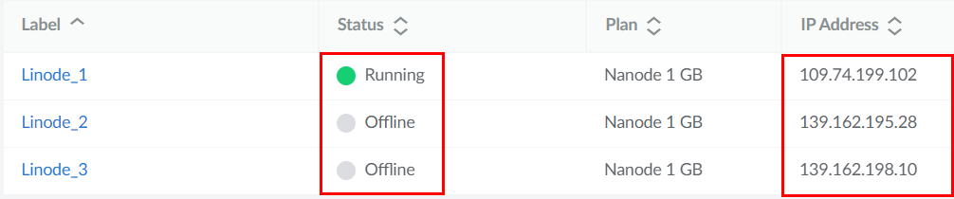

Since two of the servers are Offline, the script will generate a log file with the ping results in the specified folder if it doesn’t already exist and append the ping results to the log file if it already exists.

1. Scheduled the script to run every 5 minutes, everyday, indefinitely:

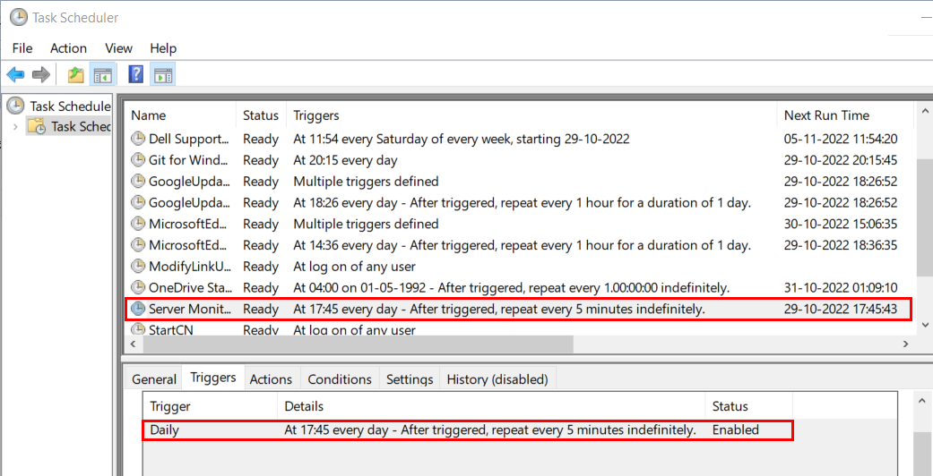

1. Script was run and log file was created:



1. An email alert was sent with the log file as an attachment:

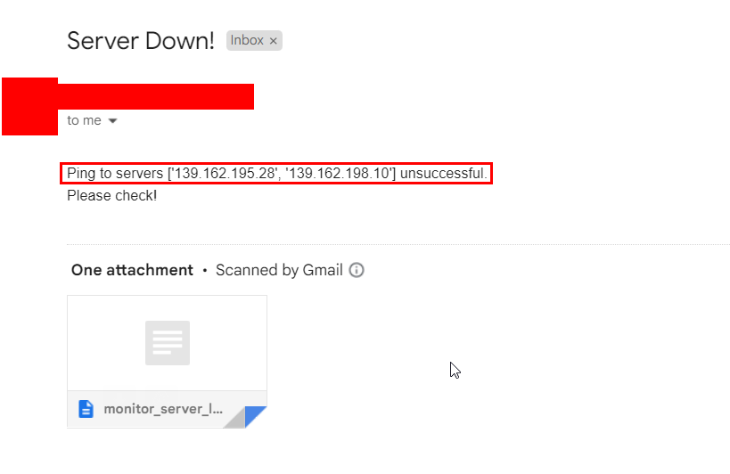

1. Attachment content:

