**Q1. How do you find the middle element of a singly linked list in one pass?**

**A1..** 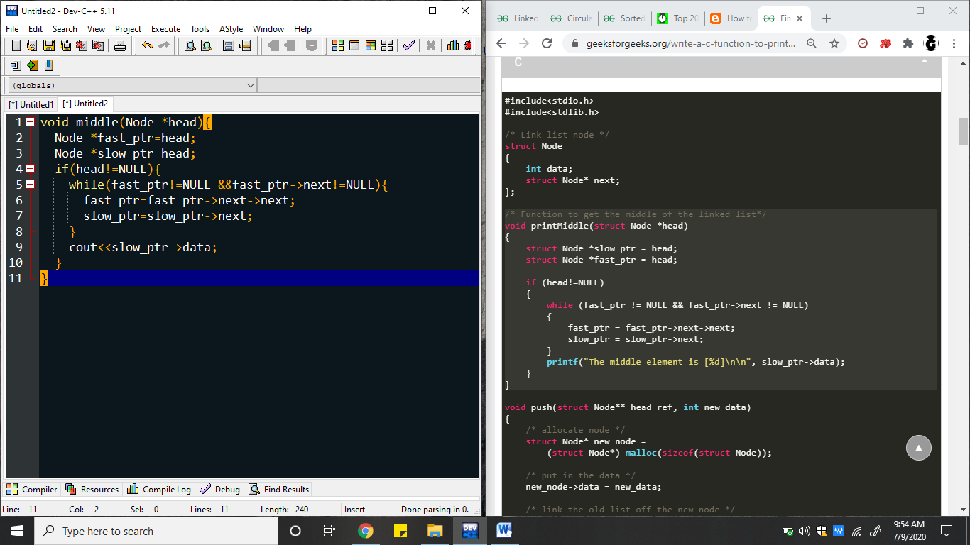

**Q2**. **How do you check if a given linked list contains a cycle? How do you find the starting node of the cycle?**

**A2.**

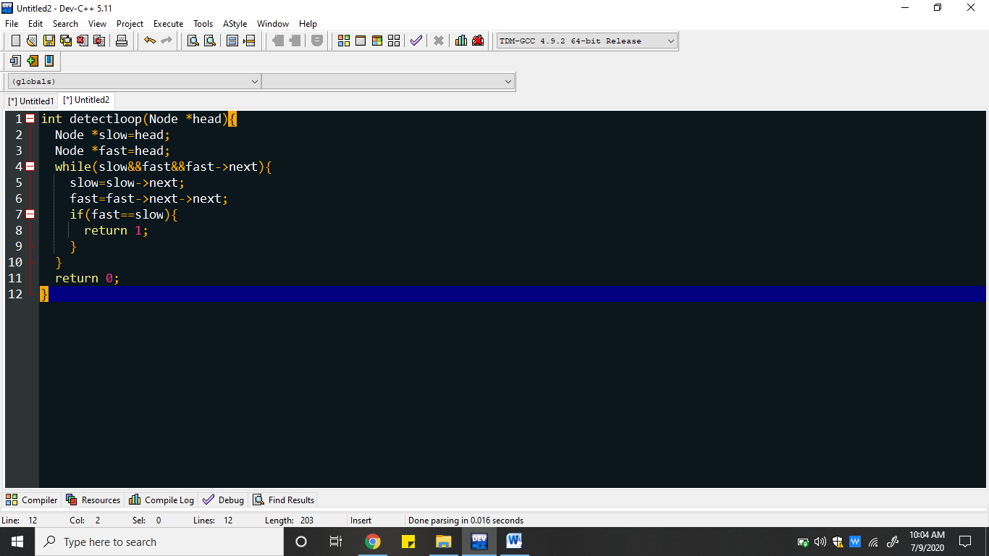

**The point at which fast and slow pointer meets is the first node of the loop.**

**Q3.** **How do you reverse a linked list?**

**A3.**

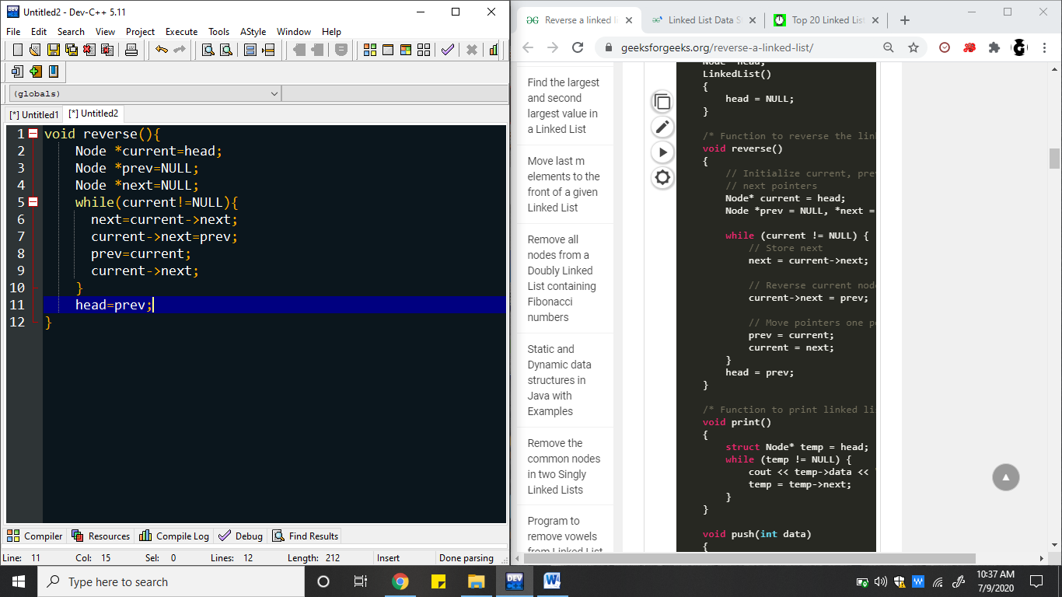

**Q4. Sorted insert for circular linked list**

**A4.**

