Q1. Write a program to search a node in a given tree.

A1. 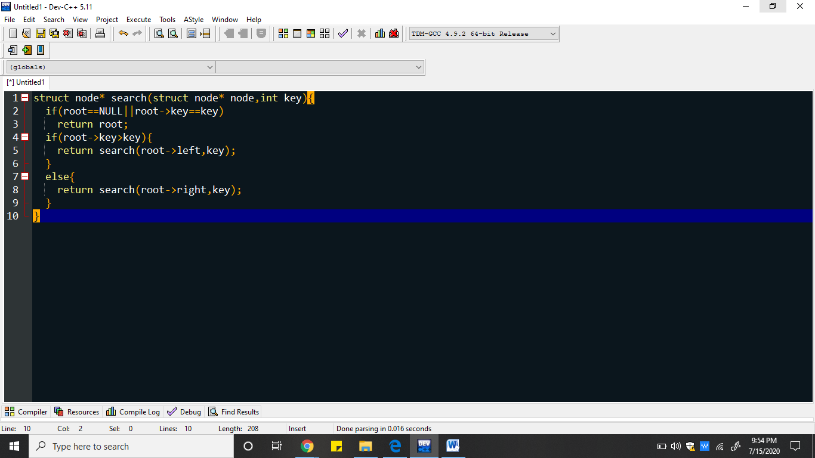

# Q2. Find the node with minimum value in a Binary Search Tree.

# A2.

Q3. Given a binary tree, find its maximum depth.

A3. 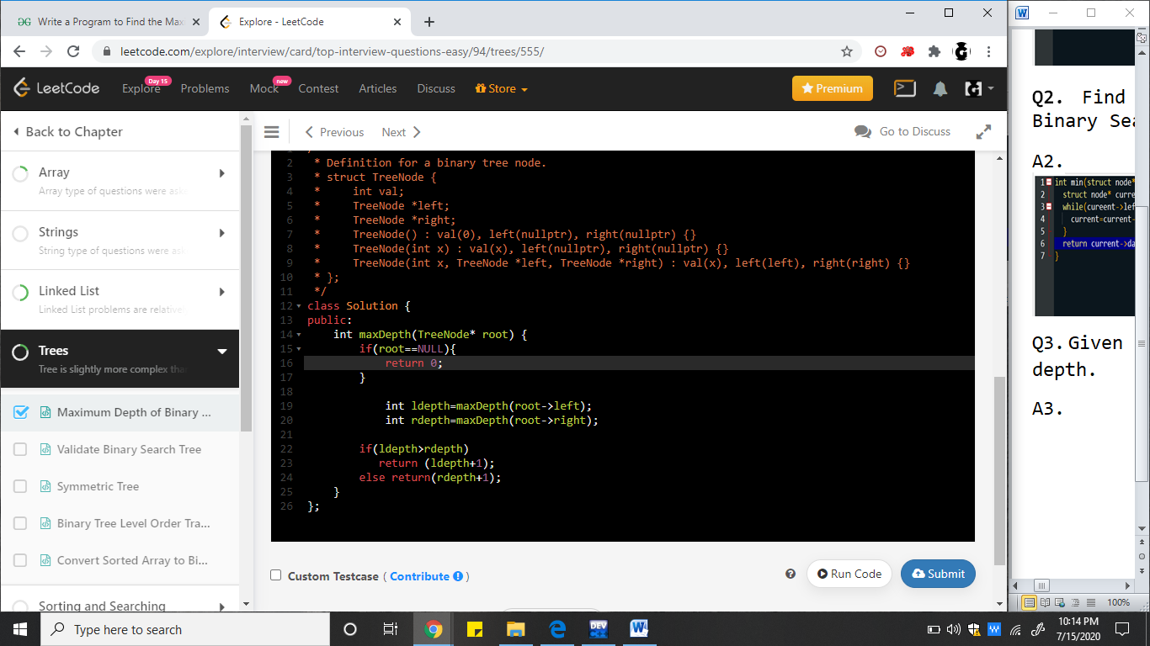

Q4. Given a binary tree, check whether it is a mirror of itself (ie, symmetric around its center).

A4.

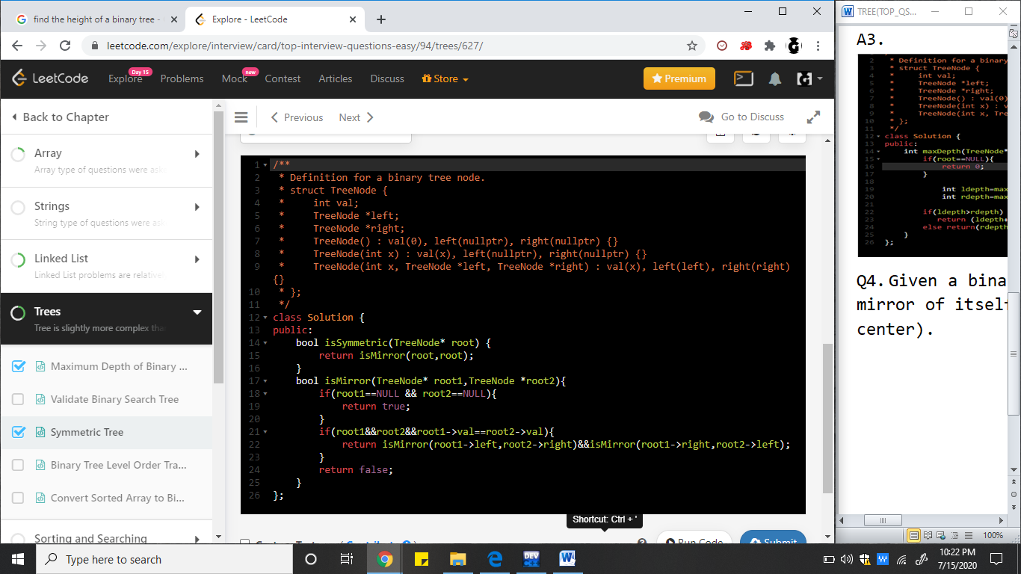

Q5.Given tree is validate BST or not

A5.

