https://www.analyticsvidhya.com/blog/2021/06/python-lambda-functions/ -Good website needs id to use
Database source: https://justclickhere.co.uk/resources/sample-pivot-table-data-downloadable-datasets/
https://www.youtube.com/@SwatiChawlaofficial
https://studyglance.in/python/module.php

https://openclassrooms.com/en/courses/2304731-learn-python-basics-for-data-analysis/7979957-familiarize-yourself-with-python-modules-and-libraries
https://www.igmguru.com/blog/python-modules

https://herovired.com/learning-hub/topics/modules-in-python

Lambda function:
Lambda functions are small anonymous functions, meaning they do not have a defined name. These are small, short-lived functions used to pass simple logic to another function.
- Contain only one expression.
- Result of that expression is returned automatically (no return keyword needed).
In this example, a lambda function is defined to convert a string to its upper case using upper().
a = 'Hello'
upper = lambda x: x.upper()
print(upper(a))

Explaination:
- 'a' store the string 'GeeksforGeeks'.
- upper is a lambda function that takes an argument x and returns x.upper().
- upper(a) applies the lambda to a, converting it to uppercase.

Syntax:
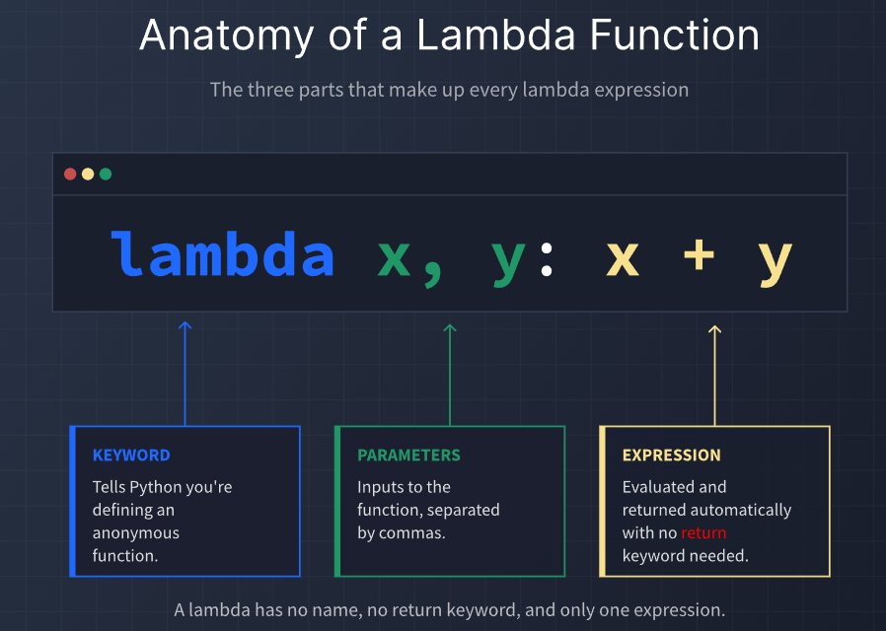

OR
Syntax:
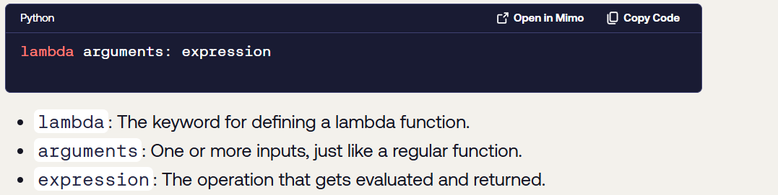

Let's see an example,
greet = lambda : print('Hello World')
Here, we have defined a lambda function and assigned it to the variable named greet.
To execute this lambda function, we need to call it. Here's how we can call the lambda function

# call the lambda
greet()

When to Use a Lambda Function
Use lambda when:
- The function is small and simple.
- It contains only one expression.
- It is used only once.
- You are passing it to functions like map(), filter(), sorted(), etc.
Don't use lambda when:
- The logic is complex.
- The function needs multiple statements.
- The function will be reused in many places
Quick Rule
- Simple + One-time use → lambda
Complex or Reusable → def function
Lambda Functions vs. Regular Functions
Before going further, let's compare a lambda function to a regular function defined with def. This table covers the differences you'll encounter most often:
Feature | Lambda Function | Regular Function (def)
Naming | Anonymous (no function name) | Always has a function name
Syntax | lambda x: x + 1 | def func(x): return x + 1
Return | Implicit (expression result) | Usually explicit via return
Body | Single expression only | Multiple statements allowed
Docstrings | Not supported | Supported
Best for | Short, one-time operations | Reusable or complex logic

Facts About Lambda Functions
Fact | Description
Anonymous | Usually has no function name
One-line | Written in a single line
Single expression | Only one expression allowed
Returns automatically | No return keyword needed
Can take arguments | 0, 1, or many arguments
Can be assigned to variables | Yes
Can be passed as arguments | Very common
Often used with map, filter, sorted, reduce | Yes
Can access outer variables | Yes
Supports conditional expressions | Yes
Good for small tasks | Yes
Not ideal for complex logic | Correct

map() is a built-in Python function used to apply the same operation to every item in an iterable (such as a list, tuple, or string).
Basic idea: Instead of writing a loop, you can use map() to transform data more concisely.
Syntax:
map(function, iterable)
Parameters:
- function → the function to apply to each item.
- iterable → the collection of items to process.
Returns:
- A map object (an iterator), not a list.
Example:
numbers = [1, 2, 3, 4]
result = map(lambda x: x * 2, numbers)
print(list(result))
Output:[2, 4, 6, 8]
map() can work with multiple iterables at the same time.
When multiple iterables are provided, map() stops when the shortest iterable is exhausted.

Since map() returns an iterator:
- It generates values only when needed.
- It is memory-efficient for large datasets.
To see all results at once, you often convert it using:
list(map(...))
You can also convert the result to other types:
tuple(map(...))
set(map(...))
map() is often used with:
- lambda functions for short operations.
- Named functions for reusable logic.
Common use cases:
- Converting strings to integers.
- Modifying every element in a list.
- Combining elements from multiple lists.
- Data preprocessing.
In modern Python, many developers prefer list comprehensions for simple transformations because they are often easier to read.
• map() is especially useful when:
- You already have a function defined.
- You want lazy evaluation (iterator behavior).
- You are processing large datasets efficiently.
Key takeaway:
map() takes a function and applies it to every item in one or more iterables, returning an iterator containing the transformed results.

* Using map() with lambda
A lambda is a small anonymous function. Combining map() and lambda is common when you need a simple transformation that you won't reuse elsewhere.
Syntax:
map(lambda parameters: expression, iterable)
Example 1: Double every number
numbers = [1, 2, 3, 4]
result = map(lambda x: x * 2, numbers)
print(list(result))

Output: [2, 4, 6, 8]

When should you use map()?
- Applying a simple transformation to every item.
- Converting data types.
- Working with existing functions.
- Processing large iterables lazily

reduce() function (from the functools module) applies a function cumulatively to the elements of an iterable and returns a single final value. It processes elements step-by-step, combining two elements at a time until only one result remains.
reduce() is a function that takes a collection of items and reduces it to a single value by repeatedly applying a function.
Think of it like combining items one by one until only one result remains.

Here are some common reduction operations in Python as well as some tools included in Python that are often more efficient and more readable than an equivalent reduce call:
Operation | With functools.reduce | Without reduce
Sum all | reduce(lambda x, y: x+y, nums) | sum(nums)
Multiply all | reduce(lambda x, y: x*y, nums) | math.prod(nums)
Join strings | reduce(lambda s, t: s+t, strs) | "".join(strs)
Merge dictionaries | reduce(lambda g, h: g|h, cfgs) | ChainMap(*reversed(cfgs))
Set union | reduce(lambda s, t: s|t, sets) | set.union(*sets)
Set intersection | reduce(lambda s, t: s&t, sets) | set.intersect(*sets)

How to Use reduce() in Python
To use reduce(), you import it from the functools module. Here's the syntax:
from functools import reduce
reduce(function, iterable[, initializer])

- function: A function that takes two arguments. It’s applied cumulatively to the items of the iterable.
- iterable: A sequence like a list, tuple, or set.
- initializer (optional): A value that is placed before the items in the sequence, acting as a starting point.

You should use reduce() when:
- You want to compute a single value from a list or sequence.
- Each step depends on the result of the previous one.
- You're chaining operations such as summing, multiplying, or merging values.
- You want a concise, functional alternative to traditional loops.
reduce() vs sum() vs join()
- Use sum() for adding numbers: sum([1, 2, 3]) is clearer than using reduce().
- Use ' '.join() for combining strings: reduce() is flexible but verbose for this case.
- Use reduce() when you're applying a custom operation like multiplication, merging dictionaries, or accumulating nested values.
Good for operations that combine many values into one:
- Sum of numbers
- Product of numbers
- Finding maximum/minimum
- Combining strings
- Building a single result from a sequence
reduce() and lambda are often used together, but they do different jobs:
- lambda creates a small anonymous function.
- reduce() repeatedly applies a function to items in a sequence to produce one final value.
Example;
from functools import reduce
numbers = [1, 2, 3, 4]
result = reduce(lambda a, b: a + b, numbers)
print(result)
reduce(lambda a, b: operation, items)
- a = accumulated result so far
- b = current item from the list
- operation = how you want to combine them

Example: reduce(lambda a, b: a + b, [1, 2, 3, 4])

Example:
from functools import reduce

nums = [1, 2, 3, 4]

result = reduce(lambda a, b: a + b, nums)

print(result)

filter() is a built-in Python function that selects elements from an iterable based on a condition.
filter(function, iterable)
filter() function is used to extract elements from an iterable (like a list, tuple or set) that satisfy a given condition. It works by applying a function to each element and keeping only those for which function returns True.
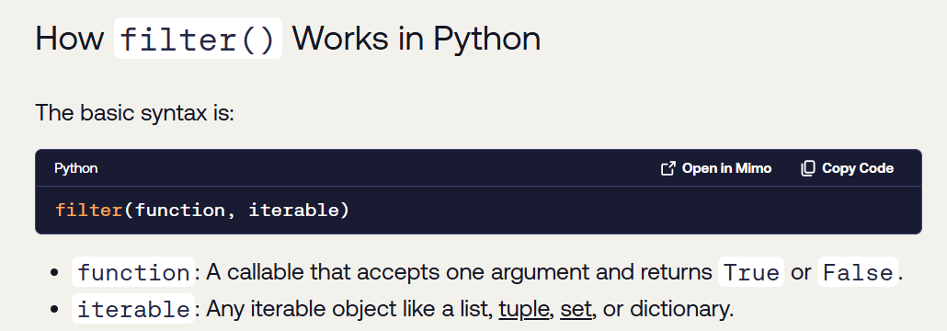
Parameters
- function: Returns True or False.
- iterable: List, tuple, string, etc.
Working
- If the function returns True, the element is included.
- If the function returns False, the element is excluded.
Example
numbers = [1, 2, 3, 4, 5, 6]
result = filter(lambda x: x % 2 == 0, numbers)
print(list(result))
Output:
[2, 4, 6]
Equivalent Loop
result = []
for x in numbers:
if x % 2 == 0:
result.append(x)
Return Value
Returns a filter object (iterator) containing filtered elements.
Uses
- Selecting even/odd numbers
- Filtering strings
- Removing unwanted data
- Data processing

Function | Purpose | Output
filter() | Select elements | Filtered iterable
map() | Transform elements | Modified iterable
reduce() | Combine elements | Single value
lambda | Create small anonymous functions | Function object

Memory Trick
filter → Choose
map → Change
reduce → Combine
lambda → Short function

Why Use filter() in Python
You should reach for filter() when you want to streamline conditional selection. It's especially useful for:
- Keeping only valid data entries from a list or array
- Applying business rules to datasets
- Filtering user input or API responses
- Simplifying logic in functional pipelines

Key Takeaways for Python filter()
- It Returns an Iterator: filter() does not return a list directly. It returns an iterator object, which is memory-efficient. You must use list(), tuple(), or another constructor to see the results.
- It Needs a Function: The first argument to filter() must be a function (or a lambda) that takes one item as an input and returns True or False.
- Keeps Items that are True: The new collection will only contain items for which the function returned True.
- Does Not Change the Original: filter() is a non-destructive operation; the original iterable you passed to it remains unchanged.
- Use None for Truthiness: Passing None as the function (filter(None, my_list)) is a shortcut to remove all "falsy" values from an iterable (e.g., 0, "", False, None).

MCQs

- Which function fills missing values?
✅ fillna()
- Which function is used to create a DataFrame?
✅ pd.DataFrame()
- What is the use of groupby()?
✅ Grouping data for aggregation
- • Which method is used for filtering rows?
✅ Boolean indexing
- • What does df['Age'] > 30 return?
✅ Boolean Series
- • How do you select a column named "Age"?
✅ df['Age']
• What does merge() do?
✅ Combines DataFrames based on keys
• Which function combines DataFrames vertically?
✅ concat()
• What is the use of df.info()?
✅ Data structure info
• What does df.sort_values('Age') do?
✅ Sorts by Age column
• Which function writes a DataFrame to CSV?
✅ to_csv()
- • What is the primary data structure in Pandas?
✅ Series and DataFrame

• What is the difference between apply() and map()?
✅ apply() works on DataFrame, map() on Series
• What is the use of replace()?
✅ Replace specific values
• What does map() do in Pandas?
✅ Works on Series only
• What is hierarchical indexing?
✅ Multiple-level index
• What does df['col'].str.upper() do?
✅ Uppercase conversion
• What does value_counts() return?
✅ Frequency of unique values

• Which function is used to rename columns?
✅ rename()
• What does qcut() do?
✅ Equal frequency bins
• How do you remove duplicate rows?
✅ drop_duplicates()
• What is the purpose of apply() function?
✅ Apply function along axis
• What does df.duplicated() return?
✅ Boolean Series marking duplicates
• What does reset_index() do?
✅ Resets index to default integer index
• Which function is used to handle string operations?
✅ .str accessor
• Which function is used to stack data?
✅ stack()
• What is the purpose of astype()?
✅ Change datatype

• Which parameter in pivot_table() specifies the aggregation function?
✅ aggfunc
• What does cut() function do?
✅ Splits data into bins
• What is the purpose of pivot_table() in Pandas?
✅ Reshape and summarize data
• What does set_index() do?
✅ Sets a column as index
• What does unstack() do?
✅ Converts rows into columns

• What does plt.savefig() do?
✅ Saves plot to file
• Which function creates a pie chart?
✅ plt.pie()
• What is the purpose of plt.grid()?
✅ Add grid lines
• What does plt.legend() do?
✅ Displays legend
• What does plt.subplot() do?
✅ Creates multiple plots in one figure
• What does plt.title() do?
✅ Adds title
• Which function creates a bar chart?
✅ plt.bar()
• What is the purpose of plt.plot()?
✅ Create line graph
• Which function displays the plot?
✅ plt.show()

• Which module is commonly imported for plotting?
✅ matplotlib.pyplot
• What is Matplotlib mainly used for?
✅ Data visualization
• Which parameter changes line color?
✅ Both B and C (color and c)
• Which function labels the x-axis?
✅ xlabel()
• Which function creates a histogram?
✅ plt.hist()
• What does the marker parameter do?
✅ Marks data points

• Why is input validation important before API calls?
✅ Prevent invalid or costly requests
• Where should API keys be stored securely?
✅ In .env file
• What is an API?
✅ A set of rules for communication between software
• What is chain-of-thought prompting?
✅ Step-by-step reasoning
• What is few-shot prompting?
✅ Giving examples before task
• What is the role of the 'system' message in OpenAI API?
✅ Defines AI behavior
• What does json.loads() do?
✅ Parses JSON string into Python object
• What is the purpose of specifying output format in prompts?
✅ Get structured responses
• What does generate_content() do?
✅ Sends request to Gemini model

• What does an API key represent?
✅ A secret credential for authentication
• What is the benefit of using smaller models like GPT-4o Mini?
✅ Faster and cheaper responses
• What is a token in AI APIs?
✅ Unit of text processed by model
• How is authentication done in Gemini API?
✅ genai.configure()
• What is exponential backoff?
✅ Increasing wait time between retries
• What is the purpose of the max_tokens parameter?
✅ Limit response length
• What does chat.completions.create() do?
✅ Sends request to AI model

- What is a "round trip" in JSON processing?
✅ Python → JSON → Python
- What is JSON primarily used for?
✅ Data storage and transfer
- What does json.dump() do?
✅ Writes JSON to file
- What happens when a tuple is converted to JSON?
✅ Becomes array
- Which function reads JSON data from a file?
✅ json.load()
- What does ensure_ascii=False do?
✅ Allows Unicode characters
- What is deserialization in JSON?
✅ JSON → Python
- What is the output type of json.loads()?
✅ Python object
- What is the JSON equivalent of Python None?
✅ null
- What does the 's' in json.loads() represent?
✅ String
- Which function converts JSON string into Python object?
✅ json.loads()
- Which parameter sorts dictionary keys in JSON output?
✅ sort_keys
- What is the Python equivalent of JSON object?
✅ Dictionary

• Which method avoids KeyError when accessing missing keys?
✅ get()
• How are strings represented in JSON?
✅ Double quotes
• What does JSON stand for?
✅ JavaScript Object Notation
• Which data type is NOT supported in JSON?
✅ Tuple
• Which parameter is used for readable JSON formatting?
✅ indent

SQL
• Which clause filters records?
✅ WHERE
• What does commit() do?
✅ Saves changes permanently
• Which method is safest for inserting user data?
✅ Parameterized queries
• What does DELETE without WHERE do?
✅ Deletes all rows
• What does SQL stand for?
✅ Structured Query Language
• Which component executes SQL queries in Python?
✅ Cursor
• What does rollback() do?
✅ Undoes changes
• Which SQL command is used to create a table?
✅ CREATE TABLE
• What does NOT NULL constraint ensure?
✅ Value cannot be empty
• Which method inserts multiple records efficiently?
✅ executemany()
• How can you skip the header row in a CSV file?
✅ next(reader)
• What best describes a CSV file?
✅ A plain text file storing tabular data
• What happens when you open a file in 'w' mode?
✅ Overwrites existing content
• What must match in DictWriter to avoid errors?
✅ Fieldnames and dictionary keys
• What is a dataset in the context of CSV files?
✅ A collection of structured data
• What does csv.reader() return for each row?
✅ List
• What is the main advantage of csv.DictReader?
✅ Access data using column names
• Which of the following is the default delimiter in a CSV file?
✅ Comma (,)
• What does the open() function return when reading a file?
✅ A file object
• What is the data type of values read using csv.reader?
✅ String
• What is the drawback of using file.read() on a CSV file?
✅ It returns data as raw text
• Which delimiter is commonly used in European CSV files?
✅ Semicolon
• What is the purpose of newline="" in file writing?
✅ Removes blank lines issue
• Why are CSV files widely used?
✅ They are lightweight and universally compatible
• What operation selects rows based on conditions?
✅ Filtering
• Why is the with statement preferred when working with files?
✅ It automatically closes the file
• What does csv.writer() do?
✅ Writes formatted CSV data

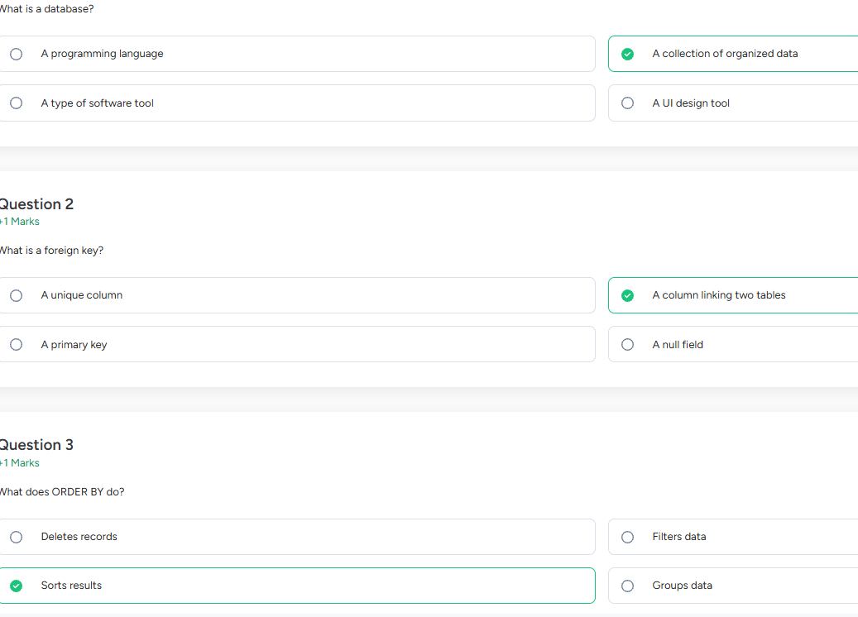
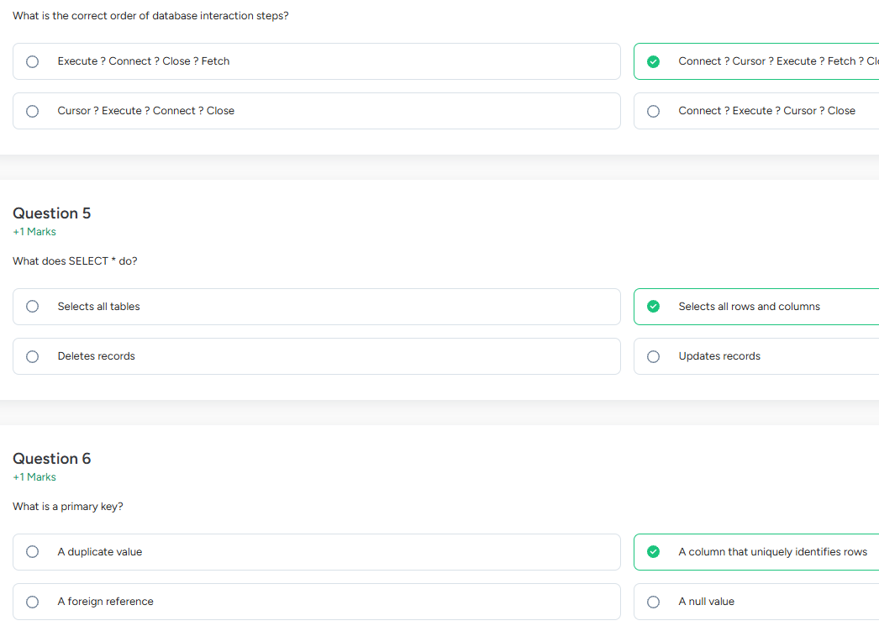
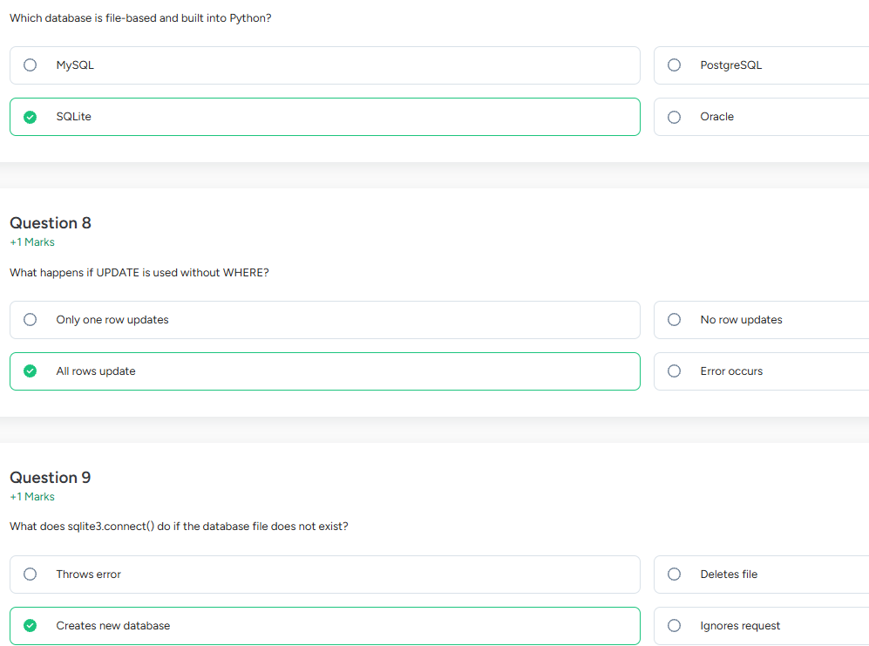
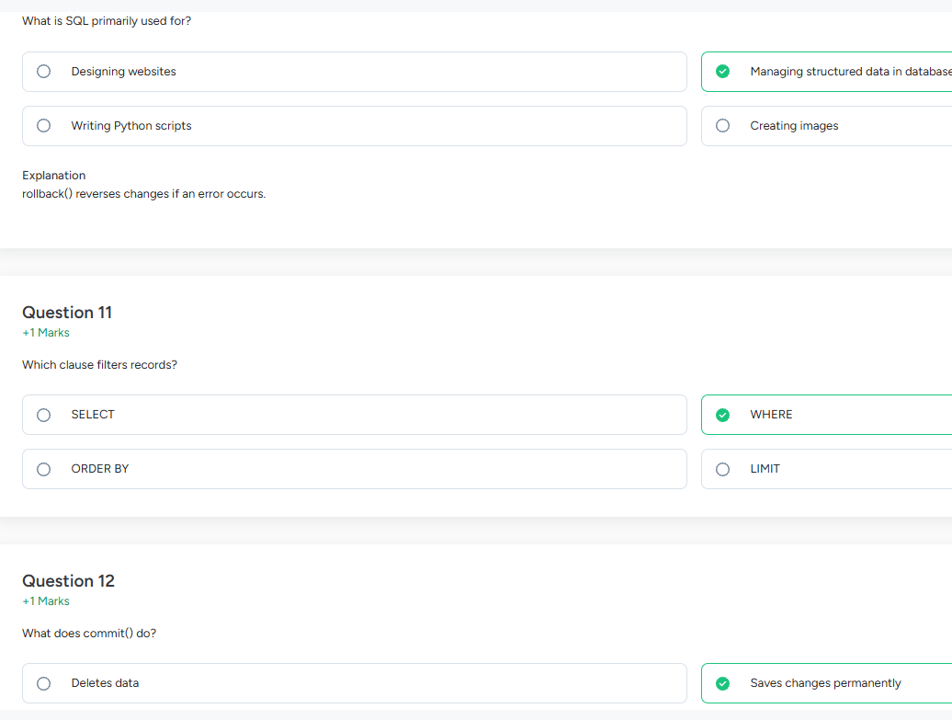

String Function
Topics:
String function with help(), Important string functions, string capitalize method, string center method, string count method, string endswith method, string find method, string format method, string format map method, string index method, string isalnum method, string join method, string lower method, string Istrip method, string replace method, string strip method, string upper method. string split method

Summary
Here's a quick summary of everything covered in the notes above — tap each tab to explore:
help() — Python's built-in documentation tool. Call help(str) to list all string methods, or help(str.method) for details on a specific one. Your in-Python cheat sheet!
String Basics — Strings are immutable sequences of characters. Methods always return a new string and never change the original. Syntax is always string.method().
capitalize() — Makes only the first character uppercase and forces all others to lowercase. Different from title(), which capitalizes every word.
center(width, fillchar) — Centers the string in a field of given width, padded with a character (default: space). If padding is uneven, the extra goes on the right.
count(sub, start, end) — Counts non-overlapping occurrences of a substring. Returns 0 if not found. Search is case-sensitive.
endswith(suffix, start, end) — Returns True or False. Accepts a tuple of suffixes to check multiple endings at once (great for file extension checks).
find(sub, start, end) — Returns the index of the first match, or -1 if not found. Safer than index() which raises a ValueError on failure.
format() — Replaces {} placeholders with values. Supports positional {0}, named {name}, and formatting specs like {:.2f} for decimals or {:>10} for alignment.
Method | Meaning
capitalize() | First letter uppercase, rest lowercase.
center() | Centers the string with padding.
count() | Counts how many times a value appears.
endswith() | Checks whether string ends with a value.
find() | Finds first position of a value.
format() | Inserts values into {} placeholders.
format_map() | Inserts values from a mapping/dictionary.
- index() returns the position of a substring, but gives an error if not found.
- isalnum() checks whether the string contains only letters and digits.
- join() joins items of a list or tuple into one string.
- lower() changes uppercase letters to lowercase.
- lstrip() removes characters from the left side only.
- replace() substitutes one text with another.
- strip() removes characters from both sides.
- upper() changes lowercase letters to uppercase.
- split() converts a string into a list.
One-line examples
- index() → finds position.
- isalnum() → checks alphanumeric characters.
- join() → combines strings.
- lower() → makes text small letters.
- lstrip() → removes left spaces.
- replace() → changes text.
- strip() → removes both-side spaces.
- upper() → makes text capital letters.
- split() → breaks string into parts.
Perplexity answer:
String functions with help()
help() is a built-in Python function used to get information about any function, method, class, or module. For strings, it helps you see the purpose, syntax, and parameters of a string method. It is very useful for learning and revision.
Syntax help(object)
Example help(str.center)
This shows details of the center() method.eng.libretexts
Important string functions
Python strings are objects, and string methods are written with dot notation like text.upper(). These methods usually return a new string and do not change the original string.w3schools+1
Common important string methods include:
- capitalize()
- center()
- count()
- endswith()
- find()
- format()
- format_map()
- upper()
- lower()
- strip()
- replace()
- startswith()w3schools
capitalize() method
capitalize() makes the first character uppercase and all other characters lowercase. It returns a new string.eng.libretexts+1
Syntax string.capitalize()
Example
text = "python is FUN"
print(text.capitalize())
Output:
Python is fun
center() method
center() returns a string centered in a field of a given width. It fills extra space with spaces by default, or with a specified character.dev+1
Syntax

string.center(width, fillchar)
Example

text = "Python"
print(text.center(10, "*"))
Output:
**Python**
count() method
count() returns how many times a substring appears in a string. You can also give optional start and end positions.docs.python+2
Syntax
string.count(value, start, end)
Example
text = "banana"
print(text.count("a"))
Output:3
endswith() method
endswith() checks whether a string ends with a specified value. It returns True or False. Optional start and end arguments can be used.docs.python+2
Syntax
string.endswith(suffix, start, end)
Example
text = "hello.py"
print(text.endswith(".py"))
Output:
True
find() method
find() searches for a substring and returns the index of its first occurrence. If the substring is not found, it returns -1.dev+2
Syntax
string.find(value, start, end)
Example
text = "hello world"
print(text.find("world"))
Output:
6
format() method
format() inserts values into placeholders {} inside a string. It is used for string formatting.dev+1
Syntax
string.format(values)
Example
name = "Asha"
age = 20
print("My name is {} and I am {} years old".format(name, age))
Output:
My name is Asha and I am 20 years old
format_map() method
format_map() works like format(), but it takes a dictionary or mapping object and fills placeholders using keys.w3schools+1
Syntax
string.format_map(mapping)
Example
data = {"name": "Asha", "age": 20}
print("My name is {name} and I am {age} years old".format_map(data))
Output:
My name is Asha and I am 20 years old
Quick exam points
- String methods are built-in functions of string objects.eng.libretexts
- They are called using dot notation, for example text.upper().eng.libretexts
- Most string methods return a new string and do not modify the original string.w3schools
- find() returns -1 if the substring is not found.dev
- count() gives the number of matches.dev+1
- endswith() returns a Boolean value.w3schools+1
- format() uses {} placeholders.dev+1
- format_map() uses a mapping like a dictionary

index() method
index() searches for a substring and returns its first position in the string. It is similar to find(), but if the value is not found, it gives an error instead of -1.
Syntax
string.index(value, start, end)
Example
text = "hello world"
print(text.index("world"))
Output: 6
isalnum() method
isalnum() checks whether all characters in a string are letters or numbers. It returns True if the string has only alphabets and digits, otherwise False.
Syntax
string.isalnum()
Example
text = "Python123"
print(text.isalnum())
Output:
True
join() method
join() combines elements of a sequence into one string using a separator string. The separator is written before .join().
Syntax separator.join(iterable)
Example
words = ["Python", "is", "easy"]
print(" ".join(words))
Output:
Python is easy
lower() method
lower() converts all uppercase letters in a string to lowercase.
Syntax
string.lower()
Example
text = "PyThOn"
print(text.lower())
Output:
python
lstrip() method
lstrip() removes spaces or specified characters from the left side of a string. Your message wrote Istrip, but the correct method is lstrip().
Syntax
string.lstrip(chars)
Example
text = " hello"
print(text.lstrip())
Output:
hello
replace() method
replace() replaces one substring with another substring in a string. It returns a new string.
Syntax
string.replace(old, new, count)
Example
text = "I like Java"
print(text.replace("Java", "Python"))
Output:
I like Python
strip() method
strip() removes spaces or specified characters from both the left and right sides of a string.
Syntax
string.strip(chars)
Example
text = " hello "
print(text.strip())
Output:
hello
upper() method
upper() converts all lowercase letters in a string to uppercase.
Syntax
string.upper()
Example
text = "Python"
print(text.upper())
Output:
PYTHON
split() method
split() breaks a string into a list of words or parts. By default, it splits at spaces, but you can give a separator.
Syntax
string.split(separator, maxsplit)
Example
text = "Python is easy"
print(text.split())
Output:
['Python', 'is', 'easy']

Decorators
A decorator in Python is a function that allows programmers to modify the behaviors of functions as input and return a new function with the modified behavior.
Decorator = Wrap + Add + Return
- Wrap the original function.
- Add extra functionality (before/after).
- Return the new wrapped function.
- Decorators modify a function without changing its source code.
- A decorator is itself a function.
- It takes another function as an argument.
- It returns a new function (usually the wrapper).
- The @ syntax is syntactic sugar (a shortcut).
- The inner function is commonly called wrapper.
- Use *args and **kwargs to make decorators work with any function signature.
- Decorators rely on Python's first-class functions and closures.
- Multiple decorators are applied from the bottom up (the decorator closest to the function runs first).

Common Built-in Decorators
Decorator | Purpose
@staticmethod | Creates a static method
@classmethod | Uses class (cls) instead of instance (self)
@property | Accesses a method like an attribute
@abstractmethod | Declares abstract methods in abstract base classes

Advantages of Decorators
- Code reuse
- Cleaner code
- Easy maintenance
- Separates extra functionality from business logic
- Makes programs modular
- Improves readability
- Avoids duplicate code

Disadvantages
- Harder to understand for beginners
- Can make debugging difficult
- Many nested decorators reduce readability
- Incorrect implementation can hide function details

Applications of Decorators
Decorators are commonly used for:
- Logging
- Authentication
- Authorization
- Caching
- Timing execution
- Error handling
- Input validation
- Flask route decorators
- Django login decorators

Basic structure:
def decorator(function):
def wrapper():
print("Before function")
function()
print("After function")
return wrapper

without decorator:
def message():
print("Welcome")
message()

with decorator:
def decorator(func):

def wrapper():
print("Before")
func()
print("After")

return wrapper
@decorator
def message():
print("Welcome")
message()

Output:
Before
Welcome
After

Print() details
print() function prints the specified message to the screen, or other standard output device. The message can be a string, or any other object.

Quick Syntax Comparison
Method / Style | Syntax Example | Best Used For
Basic print() | print("Hello", "World", sep="-") | Quick debugging and basic output
F-Strings | print(f"Value: {val}") | Modern string formatting with variables
pprint | pprint.pprint(large_dict) | Cleaning up large nested data types
File Writing | print("text", file=open('log.txt', 'w')) | Quick logging into text files

Common Ways to Format Text Inside print()
- F-Strings (Formatted String Literals)-The cleanest and most modern approach for embedding variables directly inside text.
name = "Alice"
print(f"Hello, {name}!")
# Output: Hello, Alice!

- The .format() Method-An older but highly versatile string method used for structured positioning.
print("Hello, {}!".format("Bob"))
# Output: Hello, Bob!

- String Concatenation & Comma Separation- Using + merges strings together manually, while commas automatically add spaces.

print("Hello " + "World") # Output: Hello World
print("Age:", 25) # Output: Age: 25

- Old School % Operator Formatting- A traditional placeholder method similar to C's printf.

print("Hello, %s!" % "Charlie")
# Output: Hello, Charlie!

Claude result:

String

Slicing
Slicing is used to extract a part (subset) of a string or list.

sequence[start : stop : step]

- start → Starting index (included)
- stop → Ending index (not included)
- step → Number of positions to move
If step value is positive, move in forward direction. If step value is negative, move in backward direction.

Facts
- Slicing works with strings, lists, tuples, and other sequence types.
- Start index is included.
- Stop index is excluded.
- Default start = 0.
- Default stop = length of sequence.
- Default step = 1.
- Negative indices count from the end.
- A negative step reverses the sequence.
- Start is included, stop is excluded.
- Step controls the interval between elements.
- Negative indexing accesses elements from the end.
- [::-1] reverses a string or list.
- [:] creates a complete copy of the sequence.
- Slicing returns a new sequence and does not modify the original one.
- Slicing does not change the original string or list; it returns a new sequence.
- If start or stop is outside the valid range, Python adjusts it automatically without giving an error.
- If start > stop with a positive step, the result is an empty sequence ('' for strings or [] for lists).
Example 1: String Slicing

text = "Python"

Index | 0 | 1 | 2 | 3 | 4 | 5
Character | P | y | t | h | o | n
Negative Index | -6 | -5 | -4 | -3 | -2 | -1

String Slicing Conditions

Expression | Output | Explanation
text[:] | "Python" | Copy the entire string
text[0:6] | "Python" | Whole string
text[1:4] | "yth" | From index 1 to 3
text[:4] | "Pyth" | Beginning to index 3
text[2:] | "thon" | Index 2 to end
text[3:3] | "" | Start and stop are the same
text[4:2] | "" | Start > stop (positive step)
text[-4:-1] | "tho" | Negative indexing
text[-3:] | "hon" | Last 3 characters
text[:-2] | "Pyth" | From beginning except last 2
text[::2] | "Pto" | Every 2nd character
text[1::2] | "yhn" | Every 2nd character starting at index 1
text[::-1] | "nohtyP" | Reverse string
text[::-2] | "nhy" | Reverse with step 2
text[:100] | "Python" | Stop index greater than length
text[100:] | "" | Start index greater than length
text[-100:3] | "Pyt" | Start less than minimum index

Example 2: List Slicing

numbers = [10, 20, 30, 40, 50, 60]

Index | 0 | 1 | 2 | 3 | 4 | 5
Value | 10 | 20 | 30 | 40 | 50 | 60
Negative Index | -6 | -5 | -4 | -3 | -2 | -1

List Slicing Conditions

Expression | Output | Explanation
numbers[:] | [10,20,30,40,50,60] | Copy the entire list
numbers[1:4] | [20,30,40] | Index 1 to 3
numbers[:3] | [10,20,30] | Beginning to index 2
numbers[2:] | [30,40,50,60] | Index 2 to end
numbers[3:3] | [] | Start and stop are the same
numbers[5:2] | [] | Start > stop (positive step)
numbers[-4:-1] | [30,40,50] | Negative indexing
numbers[-3:] | [40,50,60] | Last 3 elements
numbers[:-2] | [10,20,30,40] | Excluding last 2 elements
numbers[::2] | [10,30,50] | Every 2nd element
numbers[1::2] | [20,40,60] | Every 2nd element from index 1
numbers[::-1] | [60,50,40,30,20,10] | Reverse list
numbers[::-2] | [60,40,20] | Reverse with step 2
numbers[:100] | [10,20,30,40,50,60] | Stop index greater than length
numbers[100:] | [] | Start index greater than length
numbers[-100:3] | [10,20,30] | Start less than minimum index

Special Cases of Slicing

Condition | Example | Output
Default start | text[:4] | "Pyth"
Default stop | text[2:] | "thon"
Default step | text[1:5] | "ytho"
Negative start | text[-4:] | "thon"
Negative stop | text[:-2] | "Pyth"
Negative step | text[::-1] | "nohtyP"
Empty slice | text[4:2] | ""
Empty list slice | numbers[5:2] | []
Full copy | text[:] | "Python"
Full list copy | numbers[:] | [10,20,30,40,50,60]

Important Facts
Fact | Description
Syntax | sequence[start : stop : step]
Start index | Included
Stop index | Excluded
Default start | 0
Default stop | Length of the sequence
Default step | 1
Negative index | Counts from the end
Negative step | Traverses the sequence in reverse
[:] | Returns a copy of the entire sequence
[::-1] | Reverses the sequence
start == stop | Returns an empty sequence
start > stop with positive step | Returns an empty sequence
Out-of-range indices | Python adjusts them automatically; no error is raised
Original sequence | Slicing returns a new sequence and does not modify the original

String Functions

help() with strings
Built-in function
The help() function displays documentation (docstring) for any Python object, method, or module — including string methods. It is used in the interactive Python shell to learn about methods instantly.
Key facts
→Works in the Python REPL (interactive shell)
→Shows syntax, description, and parameters of a method
→help(str) shows all string methods at once
→help(str.method) shows help for a specific method
→Press q to quit the help viewer in the terminal
Syntax
help(str) # all string methods
help(str.upper) # help for upper() method
help("hello".upper) # also works on an instance
Example output
# Running: help(str.upper)
# Output:
# upper(self, /)
# Return a copy of the string converted to uppercase.

capitalize()
String method
Converts the first character of the string to uppercase and all remaining characters to lowercase. Returns a new string.
Key facts
→Only the very first character is uppercased
→All other characters are forced to lowercase (even if they were uppercase)
→Does not modify the original string (strings are immutable)
→Takes no arguments
→If first character is not a letter (e.g., digit), it stays unchanged
Syntax
string.capitalize()
Example
s = "hELLO wORLD"
print(s.capitalize()) # Output: Hello world

s2 = "123abc"
print(s2.capitalize()) # Output: 123abc (digit unchanged)

center()
String method
Centers the string within a field of a given width, padding it on both sides with a specified fill character (default is space).
Key facts
→First argument: total width of the resulting string
→Second argument (optional): fill character — default is space ' '
→If width is less than or equal to the string length, the original string is returned unchanged
→If total padding is odd, the extra character goes to the right side
→Fill character must be exactly one character long
Syntax
string.center(width, fillchar)
Example
s = "Python"
print(s.center(12)) # Output: ' Python '
print(s.center(12, '*')) # Output: '***Python***'
print(s.center(3)) # Output: 'Python' (width too small)

count()
String method
Counts how many times a substring appears in the string. Optionally, you can specify a start and end index to search within a portion of the string.
Key facts
→Returns an integer (the count)
→Case-sensitive: 'a' and 'A' are counted separately
→Non-overlapping occurrences are counted only (e.g., 'aa' in 'aaa' = 1)
→Returns 0 if substring is not found (never raises an error)
→start and end are optional slice indices
Syntax
string.count(substring, start, end)
Example
s = "banana"
print(s.count('a')) # Output: 3
print(s.count('an')) # Output: 2
print(s.count('a', 2, 5)) # Output: 2 (searches index 2 to 4)

endswith()
String method
Returns True if the string ends with the specified suffix, otherwise returns False. Commonly used to check file extensions or sentence endings.
Key facts
→Returns a boolean: True or False
→Case-sensitive
→Can accept a tuple of suffixes — returns True if string ends with any of them
→Optional start and end parameters to check a slice
→Empty string '' always returns True
Syntax
string.endswith(suffix, start, end)
Example
s = "hello.py"
print(s.endswith('.py')) # True
print(s.endswith('.txt')) # False
print(s.endswith(('.py', '.js'))) # True (tuple check)

find()
String method
Searches for a substring and returns the index of the first occurrence. If not found, it returns -1 (does NOT raise an error).
Key facts
→Returns the lowest index where substring is found
→Returns -1 if not found — safe to use without try-except
→Case-sensitive
→Optional start and end arguments for range search
→Use rfind() to find the last occurrence instead of first
Syntax
string.find(substring, start, end)
Example
s = "welcome to Python"
print(s.find('Python')) # Output: 11
print(s.find('java')) # Output: -1 (not found)
print(s.find('o', 5)) # Output: 9 (search from index 5)

format()
String method
Formats a string by replacing placeholder {} or {name} fields with the given values. This is one of the most important and commonly used string methods.
Key facts
→Placeholders use curly braces {}
→Positional: {0}, {1} — maps to argument order
→Keyword: {name} — maps to named arguments
→Supports number formatting: {:.2f} = 2 decimal places
→Modern alternative: f-strings f"Hello {name}" (Python 3.6+)
→Can reuse arguments: {0} and {0} uses first arg twice
Syntax
string.format(*args, **kwargs)
Example
# Positional
print("Hello, {}! You are {} years old.".format("Alice", 25))
# Output: Hello, Alice! You are 25 years old.

# Keyword
print("Name: {name}, Age: {age}".format(name="Bob", age=30))
# Output: Name: Bob, Age: 30

# Number formatting
print("Price: {:.2f}".format(9.5))
# Output: Price: 9.50
format_map()
String method
Similar to format(), but instead of keyword arguments, it takes a single mapping object (like a dictionary) to fill in placeholders.
Key facts
→Takes a single mapping (e.g., dict) as argument
→More efficient than format(**dict) when dict is large
→Allows custom mapping classes (e.g., to handle missing keys gracefully)
→Raises KeyError if a key in the string is missing from the mapping
→Added in Python 3.2
Syntax
string.format_map(mapping)
Example
data = {'name': 'Alice', 'age': 25}
s = "My name is {name} and I am {age} years old."
print(s.format_map(data))
# Output: My name is Alice and I am 25 years old.

index()
String method
Like find(), but raises a ValueError exception if the substring is not found — instead of returning -1.
Key facts
→Returns the index of the first occurrence of substring
→Raises ValueError if not found — must use try-except for safety
→Case-sensitive
→Optional start and end arguments
→Use find() if you don't want an exception on failure; use index() when absence is an error
Syntax
string.index(substring, start, end)
Example
s = "hello world"
print(s.index('world')) # Output: 6

try:
print(s.index('java'))
except ValueError:
print("Not found!") # Output: Not found!

isalnum()
String method
Returns True if all characters in the string are alphanumeric (letters or digits) and the string is not empty. Otherwise returns False.
Key facts
→Returns boolean: True or False
→Spaces, punctuation, and special chars cause it to return False
→Empty string returns False
→Works with Unicode characters too (not just ASCII)
→Related: isalpha() = letters only, isdigit() = digits only
Syntax
string.isalnum()
Example
print("Hello123".isalnum()) # True
print("Hello 123".isalnum()) # False (space present)
print("abc!".isalnum()) # False (! is not alphanumeric)
print("".isalnum()) # False (empty string)

join()
String method
Joins elements of an iterable (like a list or tuple) into a single string, with the calling string used as a separator between each element.
Key facts
→The calling string is the separator (can be empty '' for no separator)
→All elements in the iterable must be strings — otherwise raises TypeError
→Very efficient for joining many strings (faster than + concatenation in loops)
→Opposite of split()
→Works with any iterable: list, tuple, set, generator
Syntax
separator.join(iterable)
Example
words = ["Python", "is", "fun"]
print(" ".join(words)) # Output: Python is fun
print("-".join(words)) # Output: Python-is-fun
print("".join(words)) # Output: Pythonisfun

lower()
String method
Converts all characters in the string to lowercase. Digits, spaces, and special characters are unaffected.
Key facts
→Returns a new lowercase string
→Non-letter characters remain unchanged
→Commonly used for case-insensitive comparisons
→Takes no arguments
→Opposite of upper()
Syntax
string.lower()
Example
s = "HELLO World 123!"
print(s.lower()) # Output: hello world 123!

# Common use: case-insensitive comparison
user_input = "YES"
if user_input.lower() == "yes":
print("Confirmed") # Output: Confirmed

lstrip()
String method
Removes leading characters (from the left side only) from the string. By default removes whitespace. You can specify which characters to remove.
Key facts
→Only removes from the left (beginning) of the string
→Default (no argument): removes whitespace (spaces, tabs, newlines)
→If a characters string is given, removes any combination of those characters from the left
→NOT removing a specific substring — it removes individual characters from the set
→Related: rstrip() = right side, strip() = both sides

Syntax
string.lstrip(chars)

Example
s = " hello world "
print(s.lstrip()) # Output: 'hello world '

s2 = "###Python###"
print(s2.lstrip('#')) # Output: 'Python###'

replace()
String method
Returns a new string with all occurrences of a specified substring replaced by another substring. Optionally limits how many replacements are made.
Key facts
→First argument: old substring to find
→Second argument: new substring to replace with
→Third argument (optional): max number of replacements to make
→If old string is not found, returns the original string unchanged
→Case-sensitive
→To delete a substring, replace it with ''

Syntax
string.replace(old, new, count)

Example
s = "I like cats and cats like me"
print(s.replace('cats', 'dogs')) # I like dogs and dogs like me
print(s.replace('cats', 'dogs', 1)) # I like dogs and cats like me
print(s.replace('cats', '')) # I like and like me (deletion)

strip()
String method
Removes leading and trailing characters from both sides of the string. Default removes whitespace from both ends.
Key facts
→Removes from BOTH left and right sides
→Default: removes whitespace (spaces, \t, \n, \r)
→Optional chars argument: removes any characters from that set at both ends
→Very commonly used for cleaning user input
→Does not remove characters from the middle of the string

Syntax
string.strip(chars)

Example
s = " hello world "
print(s.strip()) # Output: 'hello world'

s2 = "***Python***"
print(s2.strip('*')) # Output: 'Python'

s3 = "\n\tdata\t\n"
print(s3.strip()) # Output: 'data'

upper()
String method
Converts all characters in the string to uppercase. Digits and non-letter characters remain unchanged.
Key facts
→Returns a new string — original is not changed
→Non-letter characters are unaffected
→Takes no arguments
→Opposite of lower()
→Commonly used for displaying headings or constant-like values

Syntax
string.upper()

Example
s = "hello world 123!"
print(s.upper()) # Output: HELLO WORLD 123!

name = "alice"
print("Welcome, " + name.upper())
# Output: Welcome, ALICE

split()
String method
Splits the string into a list of substrings based on a delimiter. Default delimiter is any whitespace. This is the opposite of join().
Key facts
→Returns a list of strings
→Default separator: any whitespace (multiple spaces = treated as one)
→First argument (optional): separator string to split on
→Second argument (optional): maxsplit — maximum number of splits to do
→The separator itself is not included in the resulting list
→Use rsplit() to split from the right
→Use splitlines() to split on line breaks

Syntax
string.split(separator, maxsplit)

Example
s = "Python is easy to learn"
print(s.split()) # ['Python', 'is', 'easy', 'to', 'learn']
print(s.split(' ', 2)) # ['Python', 'is', 'easy to learn']

csv = "a,b,c,d"
print(csv.split(',')) # ['a', 'b', 'c', 'd']

Here's a summary of the most important exam points to remember:
Golden rules for every string method:
- Strings are immutable — every method returns a new string, never modifying the original.
- All methods are called using dot notation: string.method().
find() vs index() — the most common exam trap:
- find() returns -1 if not found (safe, no crash).
- index() raises ValueError if not found (must wrap in try-except).
lstrip() vs strip() vs rstrip():
- lstrip() = left only, rstrip() = right only, strip() = both sides.
join() vs split():
- They are opposites. split() breaks a string into a list; join() assembles a list back into a string.
help() tip for exams: In Python's interactive shell, help(str.methodname) instantly shows the official documentation for any method.
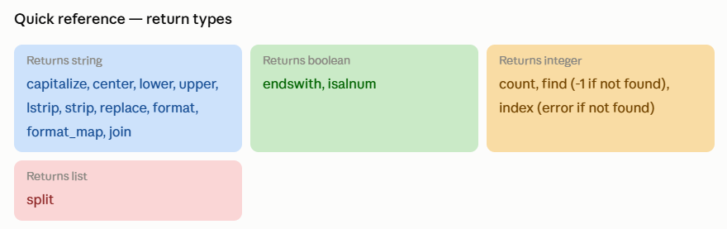

List & Tuple
A list is Python's most used data structure. It stores an ordered collection of items that can be changed after creation. Lists are defined using square brackets [], with items separated by commas.

Key facts about lists
→Ordered — items have a fixed position (index starting from 0)
→Mutable — you can add, remove, or change elements after creation
→Allows duplicate values
→Can hold mixed data types: integers, strings, floats, even other lists
→Negative indexing: -1 is the last element, -2 is second last, etc.
→Use len(list) to find the number of elements
Syntax
mylist = [1, 2, 3]
mixed = [10, "hello", 3.14, True]
empty = []
print(mylist[0]) # Output: 1 (first element)
print(mylist[-1]) # Output: 3 (last element)
print(len(mylist)) # Output: 3

Adding and appending elements to a list
Python provides three main ways to add elements to a list: append() adds one item to the end, insert() adds an item at a specific position, and extend() adds multiple items from another iterable.
The three adding methods at a glance
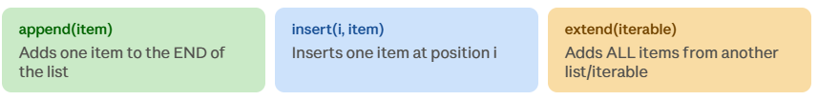
append()
Adds to end
Adds a single element to the end of the list. The list grows by exactly one item.
Key facts
→Modifies the list in-place (returns None)
→Always adds to the END — you cannot specify position
→If you append a list, it adds the list as a SINGLE nested element (use extend() to merge)
→Takes exactly one argument
→Very fast — O(1) time complexity

Syntax
list.append(element)

Example
fruits = ["apple", "banana"]
fruits.append("mango")
print(fruits) # ['apple', 'banana', 'mango']

fruits.append(["kiwi", "grape"])
print(fruits) # ['apple', 'banana', 'mango', ['kiwi', 'grape']]
# Note: the list is nested as ONE element!

insert()
Adds at position
Inserts a single element at a specified index position. All elements at that index and after are shifted one position to the right.
Key facts
→Takes TWO arguments: index position and element to insert
→Modifies the list in-place (returns None)
→If index is 0, inserts at the beginning
→If index is larger than list length, it simply adds to the end (no error)
→Negative indices are allowed: -1 inserts before the last element

Syntax
list.insert(index, element)

Example
nums = [10, 20, 30, 40]
nums.insert(2, 99)
print(nums) # [10, 20, 99, 30, 40] ← 99 inserted at index 2

nums.insert(0, 5)
print(nums) # [5, 10, 20, 99, 30, 40] ← 5 inserted at beginning

extend()
Merges iterables
Adds all elements from another iterable (list, tuple, string, etc.) to the end of the list. Each element is added individually, not as a nested structure.
Key facts
→Modifies the list in-place (returns None)
→Adds each element individually — NOT as a nested list (unlike append)
→Works with any iterable: list, tuple, string, range, set
→Equivalent to using += operator on a list
→If you extend with a string, each character is added separately

Syntax
list.extend(iterable)

Example
a = [1, 2, 3]
b = [4, 5, 6]
a.extend(b)
print(a) # [1, 2, 3, 4, 5, 6] ← merged flat

a.extend("hi")
print(a) # [1, 2, 3, 4, 5, 6, 'h', 'i'] ← string chars added

Deleting elements from a list
Python provides four ways to delete elements from a list. The method you choose depends on whether you know the value or the index, and whether you need the removed item back.
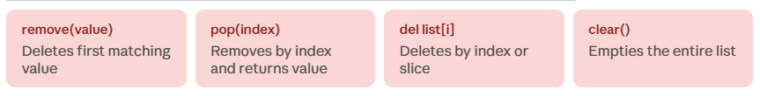
remove()
Delete by value
Removes the first occurrence of the specified value from the list.
Key facts
→Removes by VALUE, not by index
→Only removes the FIRST occurrence if there are duplicates
→Raises ValueError if the element is not found
→Modifies the list in-place (returns None)
→Does not return the removed element

Syntax
list.remove(value)

Example
nums = [10, 20, 30, 20, 40]
nums.remove(20)
print(nums) # [10, 30, 20, 40] ← only FIRST 20 removed

try:
nums.remove(99)
except ValueError:
print("99 not in list") # 99 not in list

pop()
Delete by index + return
Removes and RETURNS the element at the given index. If no index is provided, removes and returns the last element.
Key facts
→Default (no argument): removes and returns the LAST element
→Returns the removed element — unique among deletion methods
→Raises IndexError if index is out of range or list is empty
→Modifies the list in-place
→Commonly used with stacks (LIFO) — append() to push, pop() to pull
Syntax
list.pop(index) # index is optional
Example
fruits = ["apple", "banana", "mango", "kiwi"]
removed = fruits.pop()
print(removed) # kiwi ← last element returned
print(fruits) # ['apple', 'banana', 'mango']

removed2 = fruits.pop(1)
print(removed2) # banana ← index 1 returned
print(fruits) # ['apple', 'mango']

del statement
Delete by index/slice
del is a Python statement (not a method) that deletes an element by index, a slice of elements, or even the entire list variable.
Key facts
→Uses index or slice notation, not a value
→Can delete a range of elements using slicing: del list[1:4]
→Can delete the entire list variable: del mylist — variable no longer exists
→Does NOT return the deleted element
→Raises IndexError if index is out of range

Syntax
del list[index]
del list[start:end]
del list

Example
nums = [10, 20, 30, 40, 50]
del nums[2]
print(nums) # [10, 20, 40, 50]

del nums[1:3]
print(nums) # [10, 50]

del nums
# print(nums) ← NameError: nums no longer exists

clear()
Empty the list
Removes ALL elements from the list, leaving an empty list. The list variable still exists, just with no contents.
Key facts
→The list variable still exists after clear() — it is not deleted
→Returns None
→Takes no arguments
→Different from del list — del removes the variable, clear() keeps it

Syntax
list.clear()

Example
items = [1, 2, 3, 4]
items.clear()
print(items) # [] ← empty list, variable still exists

List methods — all methods with examples

sort()
List method
Sorts the list in ascending order by default. Can sort in descending order or with a custom key function.
Key facts
→Sorts IN-PLACE — modifies the original list (returns None)
→Default: ascending order (A→Z, 0→9)
→reverse=True for descending order
→key= accepts a function to sort by (e.g., key=str.lower for case-insensitive)
→Raises TypeError if list has mixed types (e.g., int and string)
→Use sorted(list) instead if you want to keep the original unchanged

Syntax
list.sort(reverse=False, key=None)

Example
nums = [3, 1, 4, 1, 5, 9]
nums.sort()
print(nums) # [1, 1, 3, 4, 5, 9]

nums.sort(reverse=True)
print(nums) # [9, 5, 4, 3, 1, 1]

words = ["Banana", "apple", "Cherry"]
words.sort(key=str.lower)
print(words) # ['apple', 'Banana', 'Cherry']

reverse()
List method
Reverses the order of all elements in the list in-place. It does NOT sort — it simply flips the current order.
Key facts
→Reverses in-place (returns None)
→Does NOT sort — just flips the existing order
→Takes no arguments
→To reverse without modifying original: use list[::-1] or reversed(list)

Syntax
list.reverse()

Example
items = [1, 2, 3, 4, 5]
items.reverse()
print(items) # [5, 4, 3, 2, 1]

words = ["apple", "banana", "cherry"]
words.reverse()
print(words) # ['cherry', 'banana', 'apple']

index()
Returns integer
Returns the index of the first occurrence of the specified element. Raises ValueError if not found.
Key facts
→Returns the FIRST occurrence's index only
→Raises ValueError if the element is not in the list
→Optional start and end arguments to search within a slice

Syntax
list.index(element, start, end)

Example
fruits = ["apple", "banana", "apple", "mango"]
print(fruits.index("apple")) # 0 ← first occurrence
print(fruits.index("mango")) # 3
print(fruits.index("apple", 1)) # 2 ← search from index 1

count()
Returns integer
Returns the number of times the specified element appears in the list.
Key facts
→Returns 0 if element not found (no error)
→Case-sensitive for strings
→Takes exactly one argument

Syntax
list.count(element)

Example
nums = [1, 2, 2, 3, 2, 4]
print(nums.count(2)) # 3
print(nums.count(99)) # 0 (not found, no error)

copy()
Returns new list
Returns a shallow copy of the list. Changing the copy does NOT affect the original list.
Key facts
→Returns a NEW list — does not modify original
→Shallow copy: nested objects inside still reference the same memory
→Equivalent to list[:] or list(original)
→Assigning b = a does NOT copy — both point to the same list; use copy() instead
Syntax
new_list = list.copy()

Example
original = [1, 2, 3]
copied = original.copy()
copied.append(99)
print(original) # [1, 2, 3] ← unchanged
print(copied) # [1, 2, 3, 99]

Tuple methods
A tuple is like a list but IMMUTABLE — once created, its elements cannot be changed, added, or removed. Because of this, tuples have only TWO built-in methods. Tuples are written with parentheses ().

Key facts about tuples
→Immutable — cannot add, remove, or change elements after creation
→Ordered — maintains insertion order
→Allows duplicates
→Faster than lists because of immutability
→Single-element tuple needs a trailing comma: (5,) — without it, (5) is just an integer
→Used for fixed data: coordinates, RGB colors, database records
→Can be used as dictionary keys (lists cannot, since they are mutable)
Creating a tuple
t = (1, 2, 3)
single = (5,) # single element — trailing comma required!
empty = ()
t2 = 1, 2, 3 # parentheses optional (tuple packing)
print(t[0]) # 1 ← indexing same as list

count()
Tuple method

Returns the number of times a specified value appears in the tuple. Works exactly the same as list's count().
Key facts
→Returns an integer
→Returns 0 if value not found (no error)
→Case-sensitive for strings
Syntax
tuple.count(value)
Example
t = (1, 2, 2, 3, 2, 4)
print(t.count(2)) # 3
print(t.count(99)) # 0

index()
Tuple method

Returns the index of the first occurrence of the specified value in the tuple. Raises ValueError if not found.
Key facts
→Returns the index of the FIRST occurrence only
→Raises ValueError if value is not found
→Optional start and end arguments supported
Syntax
tuple.index(value, start, end)
Example
t = ("a", "b", "c", "b")
print(t.index("b")) # 1 ← first occurrence
print(t.index("c")) # 2
print(t.index("b", 2)) # 3 ← search from index 2

Tuple packing and unpacking
Important concept

Packing means assigning multiple values to a tuple. Unpacking means assigning tuple elements to multiple variables at once.
Example
# Packing
point = 10, 20, 30 # same as (10, 20, 30)

# Unpacking
x, y, z = point
print(x, y, z) # 10 20 30

# Swap variables using tuple unpacking
a, b = 5, 10
a, b = b, a
print(a, b) # 10 5

Summary — list vs tuple
List | Tuple
Syntax: [1, 2, 3]  Mutable (can change)  10 built-in methods  Slightly slower  Cannot be dict key  Use for: data that changes | Syntax: (1, 2, 3)  Immutable (cannot change)  Only 2 methods: count, index  Faster and uses less memory  Can be used as dict key  Use for: fixed/constant data

Quick reference — return types of list methods
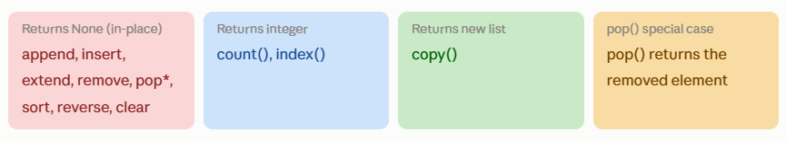
Here are the most critical exam points to remember from this topic:
The biggest list method traps in exams:
append() vs extend() — this is the most tested difference. append([4,5]) adds ONE nested element; extend([4,5]) adds TWO separate elements. Always know which one you mean.
remove() vs pop() vs del — remove works by value; pop works by index AND returns the element; del is a statement (not a method) that can also delete slices or the whole variable.
sort() vs sorted() — sort() modifies the list in-place and returns None; sorted() returns a NEW sorted list and leaves the original intact. A very common exam mistake is assigning mylist = mylist.sort() which gives None.
The biggest tuple trap: A single-element tuple needs a trailing comma — (5,) is a tuple, but (5) is just an integer in parentheses. Always remember the comma.
Why only 2 tuple methods? Since tuples are immutable, any operation that would modify the tuple (add, remove, sort, reverse) is not allowed. Only read-only operations like count() and index() are available.

Set Functions
A set is an unordered, unindexed collection that does not allow duplicate values. Sets are written with curly braces {1, 2, 3}. They are mutable (you can add/remove items), but the elements themselves must be immutable (no lists inside a set). Sets are ideal for membership testing, removing duplicates, and mathematical set operations.
A set is a built-in Python data type used to store multiple items in a single variable. It is the Python implementation of the mathematical concept of a set.
Key facts
→Unordered — elements have no defined position or index
→No duplicates — adding a duplicate value is silently ignored
→Mutable — you can add and remove elements
→Elements must be immutable (hashable) — strings, numbers, tuples are OK; lists and dicts are NOT allowed as elements
→Cannot be indexed or sliced: s[0] raises a TypeError
→Very fast for membership testing: x in s is O(1) — much faster than a list
→Use len(s) to find the number of elements
→To create an empty set, you MUST use set() — using {} creates an empty dictionary, not a set

The set() function

The set() built-in function creates a new set object. It can convert any iterable (list, tuple, string, range) into a set, automatically removing duplicates in the process.

Key facts
→Takes an optional iterable as its argument
→With no argument: creates an empty set
→Automatically removes duplicates from the iterable
→Converting a string creates a set of individual characters
→Commonly used to remove duplicates from a list: list(set(mylist))

Syntax
set(iterable)

Example
set() # set() ← empty set
set([1, 2, 2, 3, 3]) # {1, 2, 3} ← duplicates removed
set((10, 20, 30)) # {10, 20, 30} ← from tuple
set("hello") # {'h', 'e', 'l', 'o'} ← unique chars

# Remove duplicates from a list
nums = [1, 2, 2, 3, 3, 4]
unique = list(set(nums))
print(unique) # [1, 2, 3, 4] (order may vary)
Built-in set methods

add()
Adds element
Adds a single element to the set. If the element is already present, the set remains unchanged (no error, no duplicate).

Key facts
→Adds exactly ONE element
→Does nothing if the element already exists — no error raised
→Modifies the set in-place (returns None)
→Element must be immutable (hashable); adding a list raises TypeError
→To add multiple elements, use update() instead

Syntax
set.add(element)

Example
s = {1, 2, 3}
s.add(4)
print(s) # {1, 2, 3, 4}

s.add(2) # 2 already exists — set unchanged, no error
print(s) # {1, 2, 3, 4}

clear()
Empties set
Removes all elements from the set, leaving an empty set. The set variable still exists.
Key facts
→Set variable still exists after clear() — not deleted
→Returns None
→Takes no arguments

Syntax
set.clear()

Example
s = {1, 2, 3}
s.clear()
print(s) # set() ← empty set (not {})

copy()
Returns new set
Returns a shallow copy of the set. Changes to the copy do not affect the original.

Key facts
→Returns a NEW set object
→Shallow copy — elements themselves are not duplicated in memory
→Assigning b = a does NOT copy — both point to the same set
Syntax
new_set = set.copy()

Example
original = {1, 2, 3}
copied = original.copy()
copied.add(99)
print(original) # {1, 2, 3} ← unchanged
print(copied) # {1, 2, 3, 99}

difference()
Set operation
Returns a NEW set containing elements that are in the calling set but NOT in the other set(s). Think of it as subtracting one set from another.

Key facts
→Returns a new set — does NOT modify the original
→Can accept multiple sets: A.difference(B, C)
→Operator shortcut: A - B
→Order matters: A.difference(B) ≠ B.difference(A)
Syntax
set.difference(other_set)
A - B # operator shortcut

Example
A = {1, 2, 3, 4}
B = {3, 4, 5, 6}
print(A.difference(B)) # {1, 2} ← in A but NOT in B
print(B.difference(A)) # {5, 6} ← in B but NOT in A
print(A - B) # {1, 2} ← same as A.difference(B)

difference_update()
Updates in-place
Like difference() but modifies the set IN-PLACE instead of returning a new set. Removes all elements found in the other set from the calling set.

Key facts
→Modifies the original set in-place (returns None)
→Operator shortcut: A -= B
→Pair rule: methods ending in _update always modify in-place; methods without it return a new set

Syntax
set.difference_update(other_set)
A -= B # operator shortcut

Example
A = {1, 2, 3, 4}
B = {3, 4, 5}
A.difference_update(B)
print(A) # {1, 2} ← A is modified; 3 and 4 removed

discard()
Safe removal
Removes a specific element from the set. If the element does not exist, it does NOTHING — no error raised. This makes it safer than remove().
Key facts
→Does NOT raise an error if element is missing — key difference from remove()
→Modifies the set in-place (returns None)
→Takes exactly one argument (the element to remove)
→Use discard() when you're not sure if element exists; use remove() when absence should be an error

Syntax
set.discard(element)

Example
s = {1, 2, 3}
s.discard(2)
print(s) # {1, 3}

s.discard(99) # 99 not in set — no error, nothing happens
print(s) # {1, 3} ← unchanged

intersection()
Set operation
Returns a NEW set containing only the elements that are common (present) in BOTH sets — the overlap between them.

Key facts
→Returns a new set — does NOT modify originals
→Can compare multiple sets: A.intersection(B, C)
→Operator shortcut: A & B
→Commutative: A.intersection(B) == B.intersection(A)
→Returns empty set if no common elements
Syntax
set.intersection(other_set)
A & B # operator shortcut

Example
A = {1, 2, 3, 4}
B = {3, 4, 5, 6}
print(A.intersection(B)) # {3, 4} ← common elements
print(A & B) # {3, 4} ← same result

C = {10, 20}
print(A.intersection(C)) # set() ← no common elements

intersection_update()
Updates in-place
Like intersection() but modifies the set IN-PLACE, keeping only the elements common to both sets.

Key facts
→Modifies the original set in-place (returns None)
→Removes from the calling set any element NOT in the other set
→Operator shortcut: A &= B

Syntax
set.intersection_update(other_set)

Example
A = {1, 2, 3, 4}
B = {3, 4, 5}
A.intersection_update(B)
print(A) # {3, 4} ← A now contains only common elements

isdisjoint()
Returns boolean
Returns True if the two sets have NO elements in common (they are completely separate). Returns False if they share even one element.

Key facts
→Returns True or False
→"Disjoint" means the intersection is empty
→Commutative: A.isdisjoint(B) == B.isdisjoint(A)
→An empty set is disjoint with every set

Syntax
set.isdisjoint(other_set)
Example
A = {1, 2, 3}
B = {4, 5, 6}
C = {3, 7, 8}
print(A.isdisjoint(B)) # True ← no common elements
print(A.isdisjoint(C)) # False ← 3 is common

issubset()
Returns boolean
Returns True if ALL elements of the calling set are present in the other set. In other words, checks if the calling set is contained inside the other.

Key facts
→Returns True or False
→A.issubset(B) means "is A inside B?"
→Operator shortcut: A <= B
→Every set is a subset of itself
→Empty set is a subset of every set
→Opposite: issuperset() — checks if calling set CONTAINS another set (A >= B)

Syntax
set.issubset(other_set)
A <= B # operator shortcut

Example
A = {1, 2}
B = {1, 2, 3, 4}
print(A.issubset(B)) # True ← all of A is inside B
print(B.issubset(A)) # False ← B has elements not in A
print(A <= B) # True ← same as issubset

pop()
Removes randomly
Removes and returns an ARBITRARY (random) element from the set. Since sets are unordered, you cannot control which element is removed.
Key facts
→Returns the removed element
→The element removed is unpredictable — sets have no order
→Raises KeyError if the set is empty
→Takes no arguments (unlike list's pop which accepts an index)
→Modifies the set in-place
Syntax
removed = set.pop()

Example
s = {10, 20, 30}
item = s.pop()
print(item) # could be 10, 20, or 30 — unpredictable
print(s) # remaining 2 elements (which 2 varies)

empty = set()
try:
empty.pop()
except KeyError:
print("Cannot pop from empty set")

remove()
Remove by value
Removes a specific element from the set by value. Raises a KeyError if the element is not found — use discard() if you want silent failure.
Key facts
→Raises KeyError if element not found — wrap in try-except for safety
→Modifies set in-place (returns None)
→Takes exactly one argument
→Difference from list's remove(): set raises KeyError; list raises ValueError

Syntax
set.remove(element)

Example
s = {1, 2, 3}
s.remove(2)
print(s) # {1, 3}

try:
s.remove(99) # not in set
except KeyError:
print("Not found!") # Not found!

symmetric_difference()
Set operation
Returns a NEW set containing elements that are in EITHER set but NOT in BOTH. It is the opposite of intersection — elements unique to each set.
Key facts
→Returns a new set — does NOT modify originals
→Excludes elements that appear in both sets (the common elements are left out)
→Operator shortcut: A ^ B
→Commutative: A.symmetric_difference(B) == B.symmetric_difference(A)
→Equivalent to: (A | B) - (A & B)

Syntax
set.symmetric_difference(other_set)
A ^ B # operator shortcut

Example
A = {1, 2, 3, 4}
B = {3, 4, 5, 6}
print(A.symmetric_difference(B)) # {1, 2, 5, 6}
print(A ^ B) # {1, 2, 5, 6} ← same
# 3 and 4 are in BOTH so they are EXCLUDED

symmetric_difference_update()
Updates in-place
Like symmetric_difference() but modifies the calling set IN-PLACE instead of returning a new set.
Key facts
→Modifies the original set in-place (returns None)
→Operator shortcut: A ^= B
Syntax
set.symmetric_difference_update(other_set)
Example
A = {1, 2, 3, 4}
B = {3, 4, 5, 6}
A.symmetric_difference_update(B)
print(A) # {1, 2, 5, 6} ← A is modified in-place
union()
Set operation
Returns a NEW set containing ALL elements from BOTH sets combined. Duplicates are automatically removed (as always with sets).

Key facts
→Returns a new set — does NOT modify originals
→Can union multiple sets: A.union(B, C, D)
→Operator shortcut: A | B
→Commutative: A.union(B) == B.union(A)
→Result contains every unique element from all sets combined
Syntax
set.union(other_set)
A | B # operator shortcut
Example
A = {1, 2, 3}
B = {3, 4, 5}
print(A.union(B)) # {1, 2, 3, 4, 5} ← all unique elements
print(A | B) # {1, 2, 3, 4, 5} ← same

C = {6, 7}
print(A.union(B, C)) # {1, 2, 3, 4, 5, 6, 7} ← three sets

update()
Adds multiple elements
Adds all elements from another iterable (set, list, tuple, string) into the calling set. Modifies the set in-place. This is the multi-element version of add().
Key facts
→Modifies the set in-place (returns None)
→Accepts any iterable: set, list, tuple, string, range
→Duplicates are automatically ignored
→Can update with multiple iterables: A.update(B, C)
→Operator shortcut: A |= B
→Like union() but modifies in-place instead of returning a new set
Syntax
set.update(iterable)
Example
s = {1, 2, 3}
s.update([3, 4, 5])
print(s) # {1, 2, 3, 4, 5} ← 3 not duplicated

s.update("hi")
print(s) # {1, 2, 3, 4, 5, 'h', 'i'} ← chars added

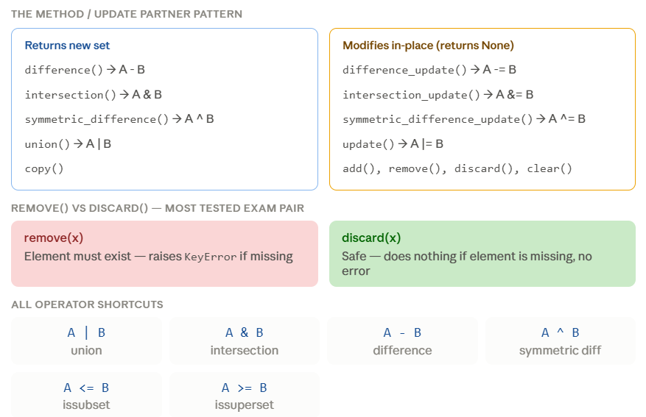
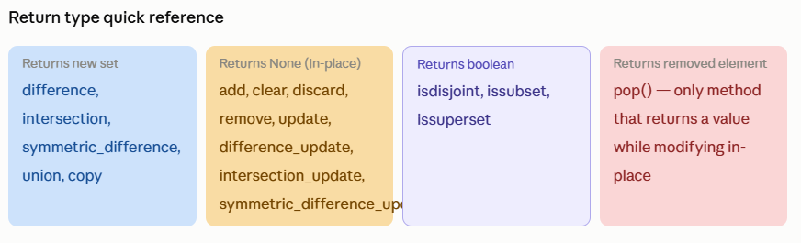
The single biggest trap — creating an empty set: {} creates an empty dictionary, NOT a set. You must write set() for an empty set. This comes up in exams constantly.
The most tested method pair — remove() vs discard(): Both remove an element by value. The difference is that remove() raises a KeyError if the element doesn't exist, while discard() silently does nothing. When in doubt, discard() is the safer choice.
The _update pattern: Every major set operation has two versions — one that returns a new set (e.g., difference()), and one that modifies the set in-place and returns None (e.g., difference_update()). The in-place version always has _update at the end.
pop() on a set is unpredictable: Unlike list's pop() which removes from the end (or a given index), set's pop() removes a random element since sets have no order. It raises KeyError if the set is empty.
The four mathematical operations and their symbols are very commonly tested: union |, intersection &, difference -, symmetric difference ^. Know both the method name and the operator symbol for each.

Dictionary
Python dictionary can store pairs of keys and values. Each key is linked to a specific value. Once stored in a dictionary, you can later obtain the value using just the key.
While keys must be unique and immutable (like strings or numbers), values can be of any data type, whether mutable or immutable.
Key value pair, allows fast data retrieval based on a unique key rather than an index position. Dictionaries are written using curly braces {}. They are mutable (can be changed), ordered (they maintain insertion order as of Python 3.7), and do not allow duplicate keys.
user = { "name": "Alice", "age": 25, "city": "New York" }
Think of it as a real dictionary — you look up a word (key) to find its meaning (value).
Key facts
→Ordered — insertion order is preserved in Python 3.7 and above
→Mutable — keys and values can be added, changed, or removed
→Keys must be unique — duplicate keys are not allowed (later value overwrites earlier)
→Keys must be immutable (strings, numbers, tuples) — lists and dicts cannot be keys
→Values can be any data type and can repeat
→Very fast lookup by key — O(1) average time complexity
→Use len(d) to find number of key-value pairs

Creation of a dictionary

There are multiple ways to create a dictionary in Python. The most common is using curly braces with key-value pairs. You can also use the dict() constructor.

Method 1 — curly braces (most common)
student = {"name": "Ravi", "age": 20, "grade": "A"}

Method 2 — dict() constructor with keyword arguments
student = dict(name="Ravi", age=20, grade="A")
# Note: keys become strings automatically, no quotes needed

Method 3 — dict() with list of tuples
student = dict([("name", "Ravi"), ("age", 20)])
# Each tuple = one key-value pair

Method 4 — empty dictionary then add
d = {} # empty dict (this IS a dict, not a set)
d["name"] = "Ravi" # add key-value pair
d["age"] = 20 # add another pair
print(d) # {'name': 'Ravi', 'age': 20}

Method 5 — dict.fromkeys() to create with default values
keys = ["a", "b", "c"]
d = dict.fromkeys(keys, 0)
print(d) # {'a': 0, 'b': 0, 'c': 0}

Important distinction
{} creates an empty dictionary. To create an empty set, you must use set().
Dictionary objects (properties)
A dictionary is made up of three kinds of objects that you can work with: keys, values, and items (key-value pairs together). Python provides dedicated methods to access each.
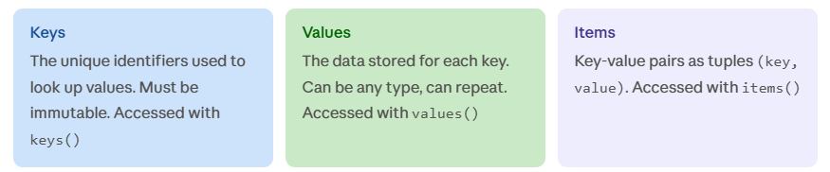
Example showing all three objects
d = {"name": "Alice", "age": 25}

print(d.keys()) # dict_keys(['name', 'age'])
print(d.values()) # dict_values(['Alice', 25])
print(d.items()) # dict_items([('name', 'Alice'), ('age', 25)])

Accessing dictionary elements
Dictionary values are accessed using their keys inside square brackets. There are two ways: direct bracket notation and the get() method. They behave differently when a key is missing.

Method 1 — square bracket notation
d = {"name": "Ravi", "age": 20}
print(d["name"]) # Ravi
print(d["age"]) # 20
# print(d["city"]) ← KeyError: 'city' does not exist!

Modifying and adding values
d["age"] = 21 # update existing key
d["city"] = "Delhi" # add new key-value pair
print(d) # {'name': 'Ravi', 'age': 21, 'city': 'Delhi'}

Checking if a key exists
if "name" in d:
print("Key exists") # Key exists

print("city" not in d) # False (city was just added)

Looping through a dictionary
# Loop through keys (default)
for key in d:
print(key, ":", d[key])

# Loop through key-value pairs (most common)
for key, value in d.items():
print(key, "→", value)

Nested dictionary access
student = {
"name": "Priya",
"marks": {"maths": 90, "science": 85}
}
print(student["marks"]["maths"]) # 90

Built-in dictionary methods

get()
Safe key access
Returns the value for the specified key. If the key does not exist, it returns None by default — or a custom default value you specify. This is the SAFE alternative to bracket notation.
Key facts
→Returns value if key exists
→Returns None if key not found — does NOT raise an error
→Second argument (optional): custom default value to return when key is missing
→Does NOT modify the dictionary
→Always prefer get() over d[key] when key existence is uncertain

Syntax
dict.get(key, default)

Example
d = {"name": "Alice", "age": 25}

print(d.get("name")) # Alice
print(d.get("city")) # None ← key missing, no error
print(d.get("city", "N/A")) # N/A ← custom default returned
print(d.get("age", 0)) # 25 ← key exists, default ignored

items()
Returns view object
Returns a special view object that displays all key-value pairs as a list of tuples. The view is dynamic — it automatically reflects any changes made to the dictionary.
Key facts
→Returns dict_items — a view object, not a plain list
→Each item in the view is a tuple (key, value)
→Dynamic view — updates automatically if the dictionary changes
→Most commonly used in for loops with tuple unpacking
→Convert to list with list(d.items()) if needed

Syntax
dict.items()

Example
d = {"name": "Alice", "age": 25, "city": "Delhi"}

print(d.items())
# dict_items([('name', 'Alice'), ('age', 25), ('city', 'Delhi')])

# Most common use — loop with unpacking
for key, value in d.items():
print(f"{key}: {value}")
# name: Alice
# age: 25
# city: Delhi

# Dynamic view — reflects changes
view = d.items()
d["score"] = 99
print(view) # score:99 is NOW in the view too!

keys()
Returns view object
Returns a view object containing all the keys of the dictionary. Like items(), it is dynamic and reflects live changes to the dictionary.
Key facts
→Returns dict_keys — a dynamic view object
→Contains only the keys (not values)
→Can be iterated, converted to a list, or checked for membership
→Automatically updates if dictionary is modified
→Checking key in d.keys() is the same as key in d
Syntax
dict.keys()
Example
d = {"name": "Alice", "age": 25, "city": "Delhi"}

print(d.keys()) # dict_keys(['name', 'age', 'city'])

# Convert to list
key_list = list(d.keys())
print(key_list) # ['name', 'age', 'city']

# Loop through keys
for k in d.keys():
print(k) # name, age, city

# Membership test
print("age" in d.keys()) # True

values()
Returns view object
Returns a view object containing all the values of the dictionary. Values can repeat (unlike keys which are unique).
Key facts
→Returns dict_values — a dynamic view object
→Values CAN repeat — unlike keys
→Can check if a value exists: value in d.values()
→Does not support key-based lookup — for that, use get() or bracket notation
→Dynamic — reflects changes made to the dictionary

Syntax
dict.values()

Example
d = {"a": 10, "b": 20, "c": 10} # 10 repeated

print(d.values()) # dict_values([10, 20, 10])

# Convert to list
print(list(d.values())) # [10, 20, 10]

# Check if value exists
print(20 in d.values()) # True
print(99 in d.values()) # False

# Sum of all values
print(sum(d.values())) # 40

pop()
Removes and returns
Removes the key-value pair for the specified key and RETURNS the value. Raises KeyError if the key is not found, unless a default is provided.
Key facts
→Takes ONE required argument: the key to remove
→Returns the VALUE of the removed key
→Raises KeyError if key not found and no default is given
→Second argument (optional): default value returned if key not found — prevents KeyError
→Modifies the dictionary in-place
→Unlike set's pop(), dict pop() REQUIRES a key — it does not remove randomly

Syntax
dict.pop(key, default)

Example
d = {"name": "Alice", "age": 25, "city": "Delhi"}

removed = d.pop("age")
print(removed) # 25 ← value returned
print(d) # {'name': 'Alice', 'city': 'Delhi'}

# With default — safe, no KeyError
val = d.pop("score", 0)
print(val) # 0 ← key missing, default returned

# Without default — dangerous
try:
d.pop("country")
except KeyError:
print("Key not found!")

popitem()
Removes last pair
Removes and returns the LAST inserted key-value pair as a tuple (key, value). In Python 3.7+, dictionaries are ordered, so this always removes the most recently added item.
Key facts
→Returns the removed pair as a (key, value) tuple
→Always removes the LAST inserted item (Python 3.7+)
→Takes NO arguments
→Raises KeyError if the dictionary is empty
→Modifies the dictionary in-place
→Useful for processing items one at a time from the end (like a stack)
→In Python 3.6 and below, removed a RANDOM item (older versions were unordered)

Syntax
dict.popitem()

Example
d = {"name": "Alice", "age": 25, "city": "Delhi"}
pair = d.popitem()
print(pair) # ('city', 'Delhi') ← last inserted pair
print(d) # {'name': 'Alice', 'age': 25}

pair2 = d.popitem()
print(pair2) # ('age', 25) ← now this is the last

# Unpack the returned tuple
key, value = d.popitem()
print(key, value) # name Alice

try:
d.popitem() # dict is empty now
except KeyError:
print("Dict is empty!")

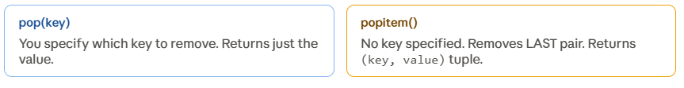
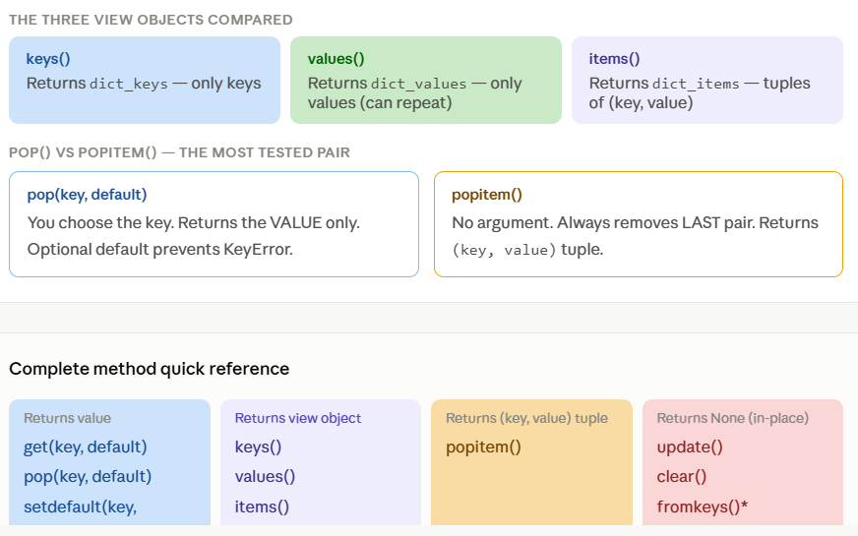
update()
Returns None — modifies in-place

Merges another dictionary (or any iterable of key-value pairs) into the calling dictionary. If a key already exists, its value is overwritten with the new value. If the key is new, it is added.

Key facts
→Modifies the original dictionary in-place — returns None
→Existing keys get their values updated (overwritten)
→New keys are added to the dictionary
→Accepts another dictionary, a list of tuples, or keyword arguments
→Can update with multiple key-value pairs at once
→Does not remove keys from the original that are absent in the argument
Syntax
dict.update(other_dict)
dict.update(key=value, key=value)
dict.update([(key, value), ...])

How it works — step by step
1 Python looks at each key in the argument dictionary one by one
2 If the key already exists in the original → the value is overwritten
3 If the key does not exist in the original → it is added as a new pair
4 Keys in the original that are not in the argument are left untouched

Example — update with another dictionary
student = {"name": "Ravi", "age": 20, "grade": "B"}
updates = {"age": 21, "city": "Mumbai"}

student.update(updates)
print(student)
# {'name': 'Ravi', 'age': 21, 'grade': 'B', 'city': 'Mumbai'}
# ↑ updated ↑ newly added
# 'name' and 'grade' untouched

Example — update with keyword arguments
d = {"x": 1, "y": 2}
d.update(y=99, z=3)
print(d) # {'x': 1, 'y': 99, 'z': 3}

Example — update with list of tuples
d = {"a": 1}
d.update([("b", 2), ("c", 3)])
print(d) # {'a': 1, 'b': 2, 'c': 3}

Real-world use
Merging user settings with default settings, or combining data from two sources into one dictionary without writing a loop.

copy()
Returns new dictionary
Returns a shallow copy of the dictionary. The new dictionary is independent — adding or removing keys in the copy does not affect the original. However, if values are mutable objects (like lists), both the original and copy still share the same inner objects.

Key facts
→Returns a NEW dictionary — does not modify the original
→Takes no arguments
→Shallow copy — top-level keys are independent, but nested objects are shared
→Assigning b = a is NOT a copy — both variables point to the same dictionary
→For fully independent nested objects, use copy.deepcopy() from the copy module

Syntax
new_dict = dict.copy()

Example — basic copy
original = {"name": "Alice", "age": 25}
copied = original.copy()

copied["city"] = "Delhi" # add key to copy only
copied["age"] = 30 # change value in copy

print(original) # {'name': 'Alice', 'age': 25} ← unchanged
print(copied) # {'name': 'Alice', 'age': 30, 'city': 'Delhi'}

Example — assignment vs copy (common mistake)
a = {"x": 10}
b = a # NOT a copy — same object!
b["x"] = 99
print(a) # {'x': 99} ← a also changed!

a = {"x": 10}
c = a.copy() # proper copy
c["x"] = 99
print(a) # {'x': 10} ← a unchanged
b = a (wrong way)

Both variables point to the same dictionary. Any change through b also affects a.
b = a.copy() (right way)
Creates an independent dictionary. Changes to b do not affect a.

clear() method

clear()
Returns None — modifies in-place
Removes ALL key-value pairs from the dictionary, leaving it completely empty. The dictionary variable still exists and can be reused — it is not deleted.

Key facts
→Empties the dictionary — all keys and values are removed
→The variable still exists as an empty dictionary {} — not destroyed
→Returns None
→Takes no arguments
→Different from del d — del deletes the variable entirely; clear() keeps it as {}

Syntax
dict.clear()

Example
cart = {"item1": "pen", "item2": "book", "item3": "bag"}
print(cart) # {'item1': 'pen', 'item2': 'book', 'item3': 'bag'}

cart.clear()
print(cart) # {} ← completely empty, but variable still exists
print(type(cart)) # <class 'dict'> ← still a dictionary
Example — clear vs del
d = {"a": 1}
d.clear()
print(d) # {} ← d still exists

d2 = {"a": 1}
del d2
# print(d2) ← NameError: d2 no longer exists
Exam tip
After clear(), the dictionary is {} — an empty dict. After del d, the variable is completely gone and accessing it raises NameError.

setdefault() method

setdefault()

Returns value — safe insertion
Checks if a key exists in the dictionary. If it does, returns its current value without changing anything. If it does NOT exist, it inserts the key with the given default value and returns that default. It combines a check + insert in one step.
Key facts
→Returns the value for the key if it already exists
→If key is missing — inserts it with the default value AND returns the default
→Default value (second argument) is optional — defaults to None
→Never overwrites an existing key's value — only sets if absent
→More powerful than get() — it actually inserts the key, whereas get() does not

Syntax
dict.setdefault(key, default_value)

How it works — decision logic
1 Check if the key exists in the dictionary
2 If YES → return the existing value. Dictionary is unchanged.
3 If NO → insert key with default value, then return the default value
Example
student = {"name": "Priya", "age": 21}

# Key exists — value returned, nothing changed
result1 = student.setdefault("name", "Unknown")
print(result1) # Priya ← existing value returned
print(student) # {'name': 'Priya', 'age': 21} ← unchanged

# Key missing — inserted with default and returned
result2 = student.setdefault("grade", "A")
print(result2) # A ← default returned
print(student) # {'name': 'Priya', 'age': 21, 'grade': 'A'} ← grade added

# Key missing, no default given — None inserted
student.setdefault("city")
print(student) # {'name': 'Priya', 'age': 21, 'grade': 'A', 'city': None}

get(key, default) | setdefault(key, default)
Returns a value but does NOT insert anything into the dictionary if the key is missing. | Returns a value AND also inserts the key into the dictionary if it was missing.

fromkeys() method

fromkeys()
Class method — returns new dictionary
Creates a brand new dictionary from a sequence of keys, with all keys set to the same given value. It is a class method — called on dict itself, not on an instance.

Key facts
→Called on dict (the class), not on an existing dictionary
→First argument: an iterable of keys (list, tuple, string, set)
→Second argument (optional): the value to assign to all keys — default is None
→Returns a completely NEW dictionary
→All keys share the SAME value — useful for initialising a dictionary with default values
→Warning: if the value is a mutable object (like a list), all keys share the SAME list object — modifying one modifies all
Syntax
dict.fromkeys(keys, value)

Example — basic usage
keys = ["name", "age", "city"]

# With no default — all values become None
d1 = dict.fromkeys(keys)
print(d1) # {'name': None, 'age': None, 'city': None}

# With default value 0
d2 = dict.fromkeys(keys, 0)
print(d2) # {'name': 0, 'age': 0, 'city': 0}

# With string default
d3 = dict.fromkeys(("a", "b", "c"), "unknown")
print(d3) # {'a': 'unknown', 'b': 'unknown', 'c': 'unknown'}

Example — called on an existing dict (result is still a fresh dict)
existing = {"x": 100}
new_d = existing.fromkeys(["p", "q"], 5)
print(new_d) # {'p': 5, 'q': 5} ← existing is ignored entirely
print(existing) # {'x': 100} ← unchanged
Mutable value trap — common exam question
d = dict.fromkeys(["a","b"], []) # ALL keys share ONE list d["a"].append(1) print(d) # {'a': [1], 'b': [1]} ← b also changed!
To avoid this, use a dict comprehension instead: {k: [] for k in keys}

The dict() constructor function

dict()
Built-in constructor
The dict() function is Python's built-in constructor for creating dictionary objects. It can create a dictionary in multiple ways — from keyword arguments, another dictionary, a list of tuples, or with no arguments for an empty dictionary.
Key facts
→Built-in function — no import needed
→With no arguments: creates an empty dictionary {}
→With keyword arguments: keys become strings automatically (no quotes needed for keys)
→Can convert a list of tuples (each tuple = one key-value pair) into a dictionary
→Can take another dictionary and return a copy of it
→When using keyword arguments, keys must be valid Python identifiers (cannot start with a digit, no hyphens)
→dict() and {} both create dictionaries — dict() is more readable for keyword-based creation

Syntax — all forms
dict() # empty dictionary
dict(key=value, key=value) # keyword arguments
dict([(key, value), ...]) # list of tuples
dict(another_dict) # copy of another dictionary
dict(zip(keys_list, values_list)) # from two parallel lists

Example 1 — empty dictionary
d = dict()
print(d) # {}
print(type(d)) # <class 'dict'>

Example 2 — keyword arguments
student = dict(name="Ravi", age=20, grade="A")
print(student)
# {'name': 'Ravi', 'age': 20, 'grade': 'A'}
# Note: no quotes around name, age, grade — they become string keys

Example 3 — list of tuples
pairs = [("name", "Alice"), ("age", 25), ("city", "Delhi")]
d = dict(pairs)
print(d)
# {'name': 'Alice', 'age': 25, 'city': 'Delhi'}

Example 4 — from two parallel lists using zip()
keys = ["name", "age", "city"]
values = ["Bob", 30, "Chennai"]

d = dict(zip(keys, values))
print(d)
# {'name': 'Bob', 'age': 30, 'city': 'Chennai'}

Example 5 — copying another dictionary
original = {"x": 10, "y": 20}
copied = dict(original)
copied["z"] = 30
print(original) # {'x': 10, 'y': 20} ← unchanged
print(copied) # {'x': 10, 'y': 20, 'z': 30}

Here are the three most important things to remember :
update() — two behaviours in one: It both updates existing keys AND adds new ones in a single call. Always remember it modifies the dictionary in-place and returns None.
setdefault() vs get() — the subtle difference: Both return a value safely without a KeyError. But get() only reads — it never touches the dictionary. setdefault() actually writes the key into the dictionary if it was missing. This difference is a very common exam question.
fromkeys() mutable trap: When you use dict.fromkeys(keys, []), all keys point to the exact same list object in memory. Appending to one appends to all. The safe alternative is a dict comprehension: {k: [] for k in keys}.
dict() constructor forms to memorise: Four forms — dict() empty, dict(key=value) keywords, dict([(k,v)]) tuples, and dict(zip(keys, values)) from two lists.
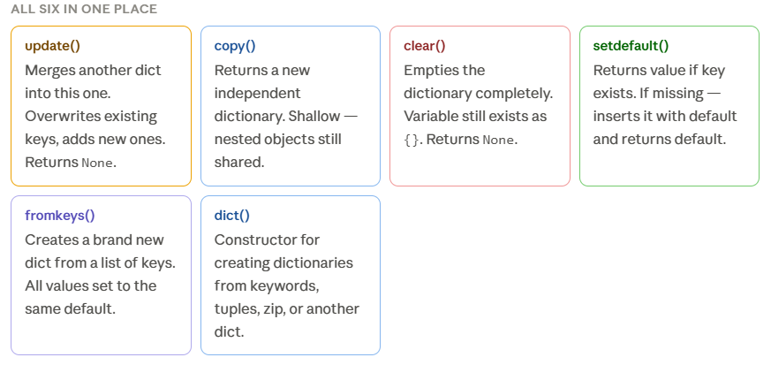
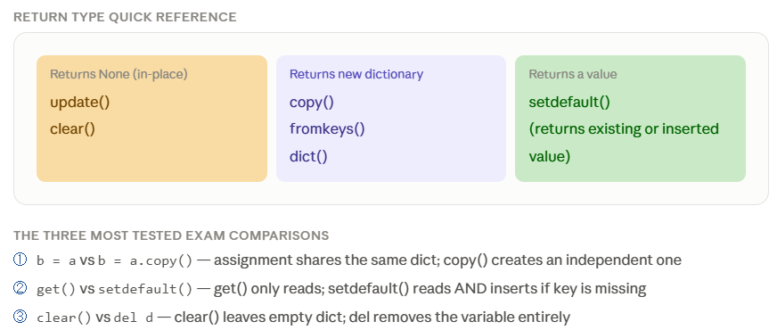

Set functions
What is a Set?
- A set is a collection of unique items.
- It does not allow duplicate values.
- The items are unordered, so they do not have a fixed position.
- Sets are useful when you want to store distinct values and perform mathematical set operation
- fruits = {"apple", "banana", "orange", "apple", "pear"}

The set() function

set()
Built-in constructor
The set() built-in function creates a new set object. It can convert any iterable (list, tuple, string, range) into a set, automatically removing duplicate values.

Key facts
→With no argument: creates an empty set — you MUST use set(), never {} (that makes a dict)
→Accepts any iterable as argument and removes duplicates automatically
→Elements must be immutable (hashable): strings, numbers, tuples are OK; lists and dicts are NOT
→Order of elements is not guaranteed — sets are unordered
→Cannot be indexed: s[0] raises TypeError
→Most common use: remove duplicates from a list

Syntax
set() # empty set
set(iterable) # from any iterable

Example
set() # set() ← empty set
set([1,2,2,3,3]) # {1, 2, 3} ← duplicates removed
set("hello") # {'h','e','l','o'} ← unique chars only
set((10,20,30)) # {10, 20, 30} ← from tuple

# Most common use: remove duplicates from a list
nums = [1,1,2,3,3,4]
unique = list(set(nums))
print(unique) # [1, 2, 3, 4]

empty_set = set() # correct empty set
empty_dict = {} # this is a dict, NOT a set!

Built-in set methods
add()
Adds one element
Adds a single element to the set. If the element already exists, the set stays unchanged — no error, no duplicate is created.
Key facts
→Adds exactly ONE element to the set
→Silently ignored if the element already exists
→Modifies set in-place, returns None
→Element must be immutable — adding a list raises TypeError
→To add multiple elements at once, use update() instead
Syntax
set.add(element)

Example
s = {1, 2, 3}
s.add(4)
print(s) # {1, 2, 3, 4}

s.add(2) # 2 already exists — ignored, no error
print(s) # {1, 2, 3, 4} ← unchanged

clear()
Empties the set
Removes all elements from the set, making it empty. The set variable still exists — it is not deleted.
Key facts
→All elements are removed — set becomes set() (empty)
→The variable still exists after clear() — not destroyed
→Takes no arguments, returns None
→Different from del s — del removes the variable entirely
Syntax
set.clear()

Example
s = {10, 20, 30}
s.clear()
print(s) # set() ← empty, variable still exists
print(type(s)) # <class 'set'>

copy()
Returns new set
Returns a shallow copy of the set. The copy is independent — changes to the copy do not affect the original.
Key facts
→Returns a NEW set object
→Assigning b = a is NOT a copy — both point to the same set
→Takes no arguments
Syntax
new_set = set.copy()
Example
original = {1, 2, 3}
copied = original.copy()
copied.add(99)
print(original) # {1, 2, 3} ← unchanged
print(copied) # {1, 2, 3, 99}

difference()
Set operation — returns new set
Returns a NEW set containing elements that are in the calling set but NOT in the other set. Think of it as subtracting one set from another — what is left only in A?
Key facts
→Returns a new set — originals are NOT modified
→Order matters: A.difference(B) ≠ B.difference(A)
→Operator shortcut: A - B
→Can pass multiple sets: A.difference(B, C)
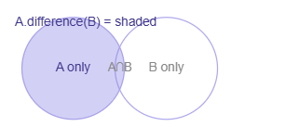
Syntax
A.difference(B) # method
A - B # operator shortcut

Example
A = {1, 2, 3, 4}
B = {3, 4, 5, 6}
print(A.difference(B)) # {1, 2} ← in A but NOT in B
print(B.difference(A)) # {5, 6} ← in B but NOT in A
print(A - B) # {1, 2} ← operator form

difference_update()
Modifies in-place
Like difference() but modifies the calling set IN-PLACE instead of returning a new set. Removes all elements from A that are also in B.
Key facts
→Modifies the original set — returns None
→Operator shortcut: A -= B
→Rule: methods ending in _update always modify in-place and return None

Syntax
A.difference_update(B)
A -= B # operator shortcut
Example
A = {1, 2, 3, 4}
B = {3, 4, 5}
A.difference_update(B)
print(A) # {1, 2} ← 3 and 4 removed from A

discard()
Safe removal
Removes a specified element from the set. If the element does not exist, nothing happens — no error is raised. This is the safe alternative to remove().
Key facts
→Does NOT raise an error if element is missing — key difference from remove()
→Modifies set in-place, returns None
→Takes exactly one argument
→Use discard() when you're unsure if element exists; use remove() when absence is a bug
Syntax
set.discard(element)

Example
s = {1, 2, 3}
s.discard(2)
print(s) # {1, 3}

s.discard(99) # 99 not in set — silent, no crash
print(s) # {1, 3} ← unchanged

intersection()
Set operation — returns new set
Returns a NEW set containing only the elements that are present in BOTH sets — the common elements (the overlap).
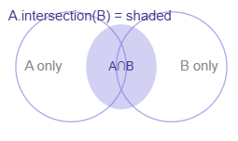
Key facts
→Returns a new set — originals unchanged
→Operator shortcut: A & B
→Commutative: A.intersection(B) == B.intersection(A)
→Can pass multiple sets: A.intersection(B, C)
→Returns empty set if no common elements

Syntax
A.intersection(B)
A & B # operator shortcut

Example
A = {1, 2, 3, 4}
B = {3, 4, 5, 6}
print(A.intersection(B)) # {3, 4} ← only common elements
print(A & B) # {3, 4} ← operator form

C = {10, 20}
print(A.intersection(C)) # set() ← no common elements

intersection_update()
Modifies in-place
Like intersection() but modifies the calling set IN-PLACE, keeping only elements that are common to both sets.
Key facts
→Modifies original set — returns None
→Removes from A any element not found in B
→Operator shortcut: A &= B
Syntax
A.intersection_update(B)
A &= B # operator shortcut
Example
A = {1, 2, 3, 4}
B = {3, 4, 5}
A.intersection_update(B)
print(A) # {3, 4} ← A now has only common elements

isdisjoint()
Returns boolean
Returns True if two sets have NO elements in common (their intersection is empty). Returns False if even one element is shared.
Key facts
→Returns True or False
→Disjoint = completely separate, zero overlap
→Commutative: A.isdisjoint(B) == B.isdisjoint(A)
→An empty set is always disjoint with every set
→No operator shortcut — method only

Syntax
A.isdisjoint(B)

Example
A = {1, 2, 3}
B = {4, 5, 6} # no overlap
C = {3, 7, 8} # 3 is shared

print(A.isdisjoint(B)) # True ← no common elements
print(A.isdisjoint(C)) # False ← 3 is shared
print(A.isdisjoint(set())) # True ← empty set always disjoint

issubset()
Returns boolean
Returns True if ALL elements of the calling set are present in the other set. In other words: is A completely contained inside B?
Key facts
→Returns True or False
→A.issubset(B) means "is every element of A also in B?"
→Operator shortcut: A <= B
→Every set is a subset of itself: A.issubset(A) is True
→Empty set is a subset of every set
→Opposite: issuperset() / A >= B — checks if A CONTAINS all of B

Syntax
A.issubset(B)
A <= B # operator shortcut

Example
A = {1, 2}
B = {1, 2, 3, 4}

print(A.issubset(B)) # True ← all of A is inside B
print(B.issubset(A)) # False ← B has elements not in A
print(A <= B) # True ← operator form
print(A.issubset(A)) # True ← every set is subset of itself

pop()
Removes and returns random element
Removes and returns an arbitrary (random) element from the set. Since sets are unordered, you cannot control which element is removed.
Key facts
→Returns the removed element
→The element chosen is UNPREDICTABLE — sets have no index
→Raises KeyError if the set is empty
→Takes no arguments — unlike list's pop() which accepts an index
→Modifies set in-place

Syntax
removed = set.pop()

Example
s = {10, 20, 30, 40}
item = s.pop()
print(item) # could be any of: 10, 20, 30, 40
print(s) # remaining 3 elements (order unpredictable)

empty = set()
try:
empty.pop()
except KeyError:
print("Cannot pop from empty set")

remove()
Remove by value — raises error if missing
Removes a specific element from the set by value. If the element is not present, it raises a KeyError. Use discard() for safe removal without error.
Key facts
→Raises KeyError if element not found
→Modifies set in-place, returns None
→Takes exactly one argument
→In sets, raises KeyError; in lists, remove() raises ValueError

Syntax
set.remove(element)

Example
s = {1, 2, 3, 4}
s.remove(3)
print(s) # {1, 2, 4}

try:
s.remove(99) # not in set
except KeyError:
print("99 not in set!")

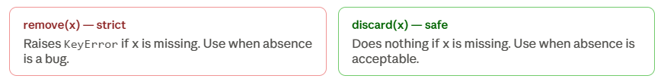

symmetric_difference()
Set operation — returns new set
Returns a NEW set containing elements that are in EITHER set but NOT in BOTH. It is the opposite of intersection — elements unique to each set, with shared ones excluded.
Key facts
→Returns a new set — originals unchanged
→Common elements are EXCLUDED from the result
→Operator shortcut: A ^ B
→Commutative: A.symmetric_difference(B) == B.symmetric_difference(A)
→Equivalent to: (A | B) - (A & B) — union minus intersection
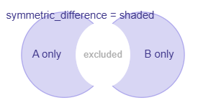
Syntax
A.symmetric_difference(B)
A ^ B # operator shortcut
Example
A = {1, 2, 3, 4}
B = {3, 4, 5, 6}
print(A.symmetric_difference(B)) # {1, 2, 5, 6}
print(A ^ B) # {1, 2, 5, 6} ← same
# 3 and 4 are in BOTH → excluded

symmetric_difference_update()
Modifies in-place
Like symmetric_difference() but modifies the calling set IN-PLACE instead of returning a new set.
Key facts
→Modifies the original set — returns None
→Operator shortcut: A ^= B

Syntax
A.symmetric_difference_update(B)
A ^= B # operator shortcut

Example
A = {1, 2, 3, 4}
B = {3, 4, 5, 6}
A.symmetric_difference_update(B)
print(A) # {1, 2, 5, 6} ← A is modified in-place

union()
Set operation — returns new set
Returns a NEW set containing ALL elements from BOTH sets combined. Duplicates are removed automatically since it is a set.
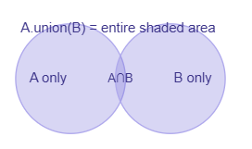
Key facts
→Returns a new set — originals unchanged
→Operator shortcut: A | B
→Commutative: A.union(B) == B.union(A)
→Can pass multiple sets: A.union(B, C, D)
→Result contains every unique element from all sets

Syntax
A.union(B)
A | B # operator shortcut

Example
A = {1, 2, 3}
B = {3, 4, 5}
print(A.union(B)) # {1, 2, 3, 4, 5} ← all unique elements
print(A | B) # {1, 2, 3, 4, 5} ← operator form

C = {6, 7}
print(A.union(B, C)) # {1, 2, 3, 4, 5, 6, 7} ← three sets

update()
Adds multiple elements in-place
Adds all elements from another iterable (set, list, tuple, string, range) into the calling set. This is the in-place version of union() — it modifies the original instead of returning a new set.
Key facts
→Modifies set in-place — returns None
→Accepts any iterable: set, list, tuple, string, range
→Duplicates are silently ignored
→Can update with multiple iterables at once: s.update(A, B, C)
→Operator shortcut: A |= B
→Like add() for multiple elements; like union() but modifies in-place

Syntax
set.update(iterable)
A |= B # operator shortcut

Example
s = {1, 2, 3}
s.update([3, 4, 5])
print(s) # {1, 2, 3, 4, 5} ← 3 not duplicated

s.update("hi")
print(s) # {1, 2, 3, 4, 5, 'h', 'i'}

s2 = {10}
s2.update({20}, [30, 40])
print(s2) # {10, 20, 30, 40}

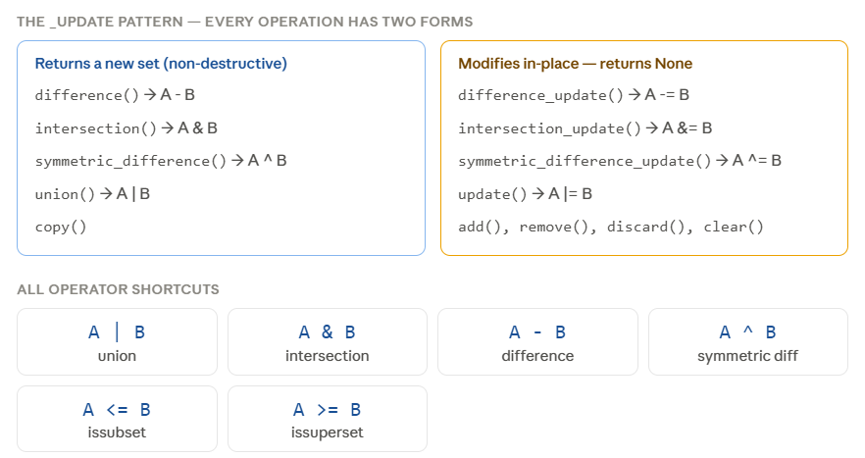
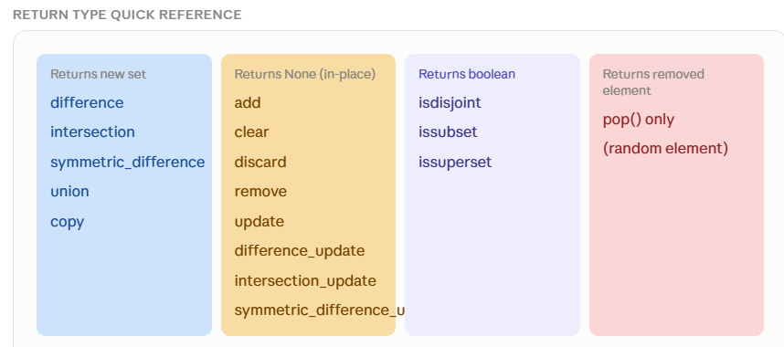
The three most tested exam comparisons
- remove(x) vs discard(x) — remove raises KeyError if missing; discard does nothing
- add(x) vs update(iterable) — add inserts one element; update inserts all elements from an iterable
- union() vs update() — union returns a new set; update modifies in-place and returns None
- {} is an empty DICT, not a set — always use set() for an empty set

Here are the absolute must-know :
The _update pattern is the most important concept: Every major set operation (difference, intersection, symmetric_difference, union) has two versions — one that returns a new set and leaves originals unchanged, and one ending in _update that modifies the set in-place and returns None. If you know this pattern, you know half the methods automatically.
remove() vs discard() — the most tested pair: Both remove one element by value. remove() raises KeyError if the element is not there. discard() silently does nothing. When unsure, discard() is always the safer choice.
pop() on a set is unpredictable: Unlike list's pop() which removes from the end, set's pop() removes a random element because sets have no order. It raises KeyError on an empty set.
set() vs {}: {} always creates an empty dictionary. To make an empty set you must write set(). This is a very common trick question.
The four operator shortcuts to memorise: | union, & intersection, - difference, ^ symmetric difference. The in-place versions are the same with = appended: |=, &=, -=, ^=.

