Name: T.MEGHA HARSHA Reg.No: 192424389
8086 Microprocessor
ADDITION OF 16 BIT NUMBERS WITH CARRY
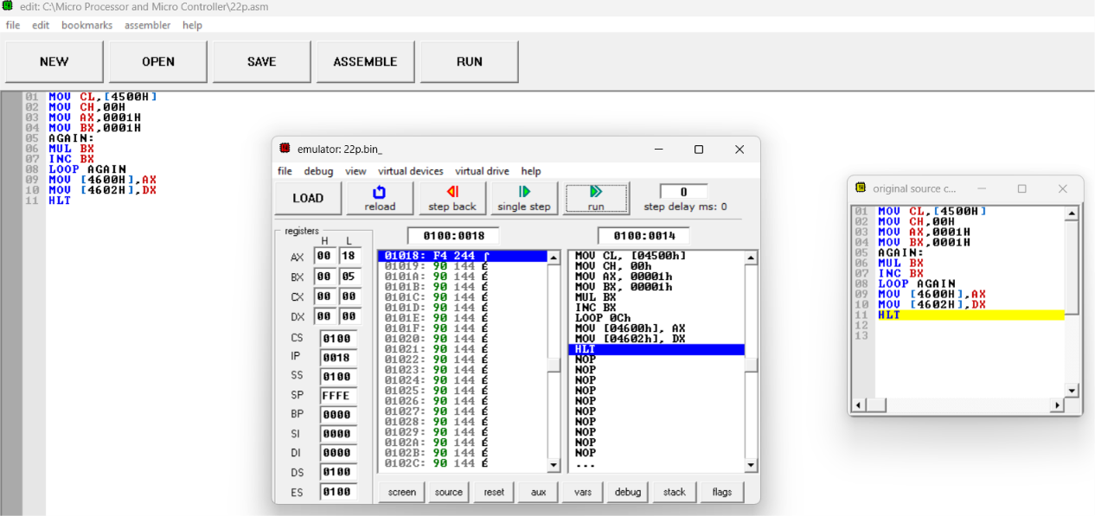
SUBTRACTION OF 16 BIT NUMBERS WITH BORROW
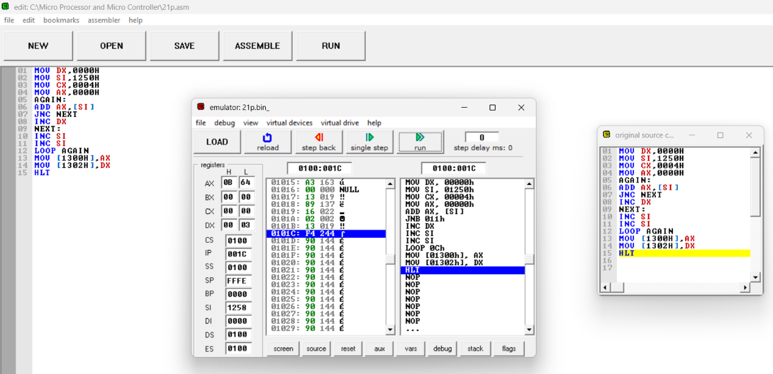

MULTIPLICATION OF 16 BIT NUMBERS
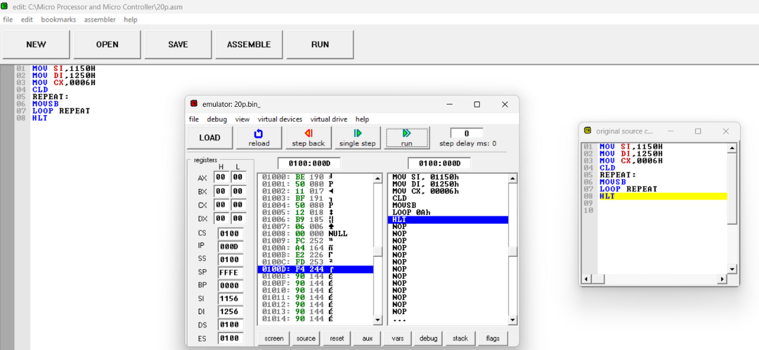
DIVISION OF 16 BIT NUMBERS
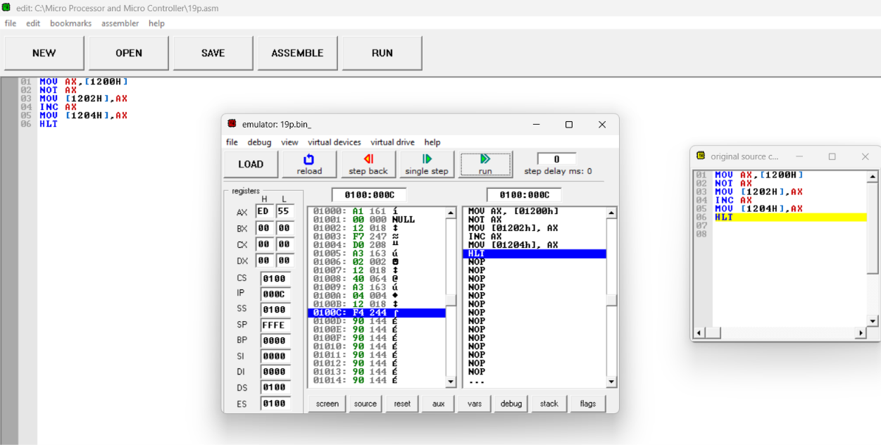

LOGICAL OPERATION: MASKING OF BITS
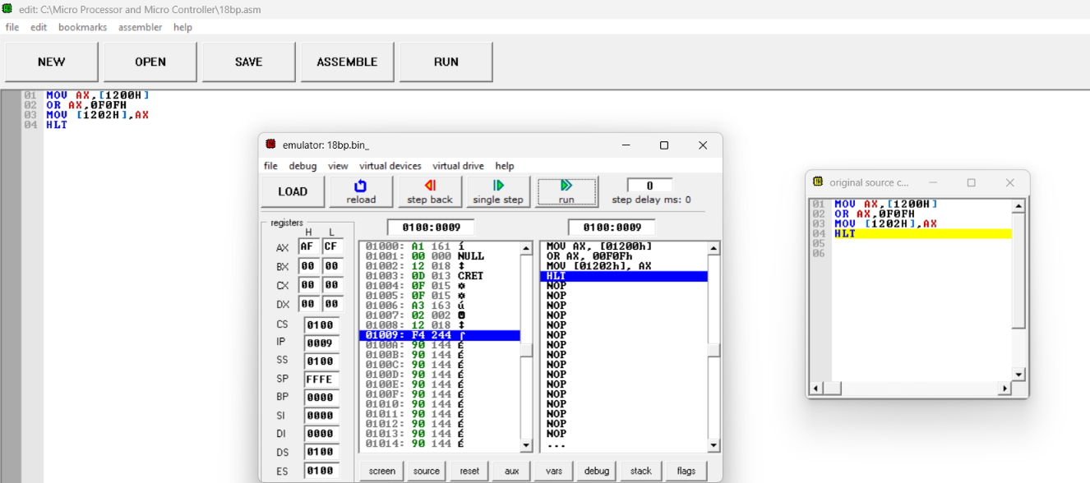
SETTING OF BITS
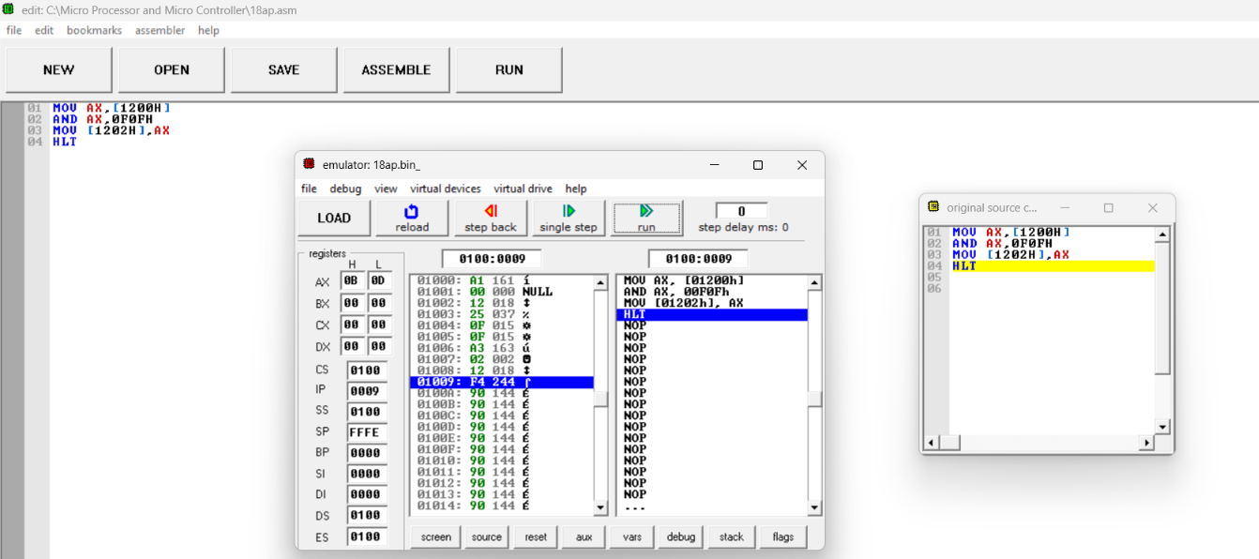

ONE’S AND TWO’S COMPLEMENT
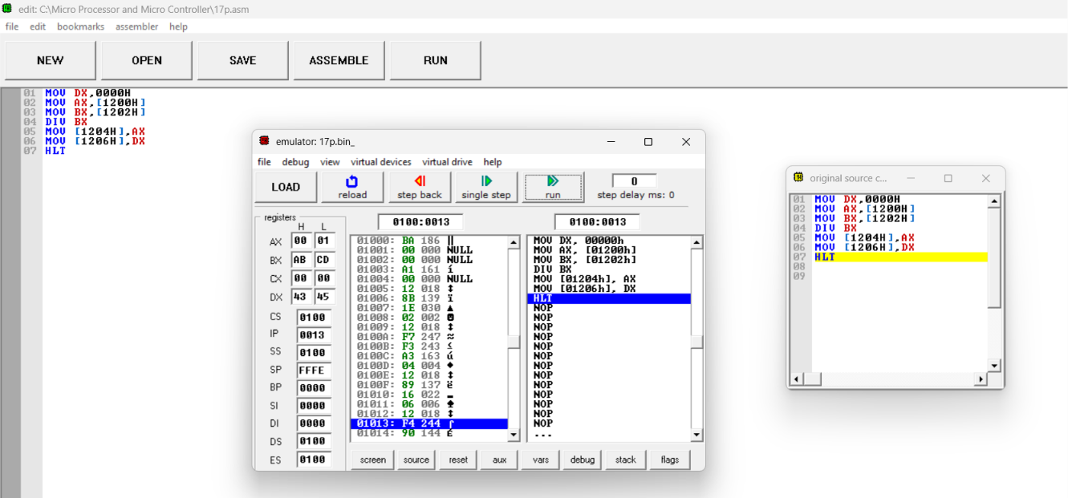
MOVE A DATA BLOCK WITHOUT OVERLAP
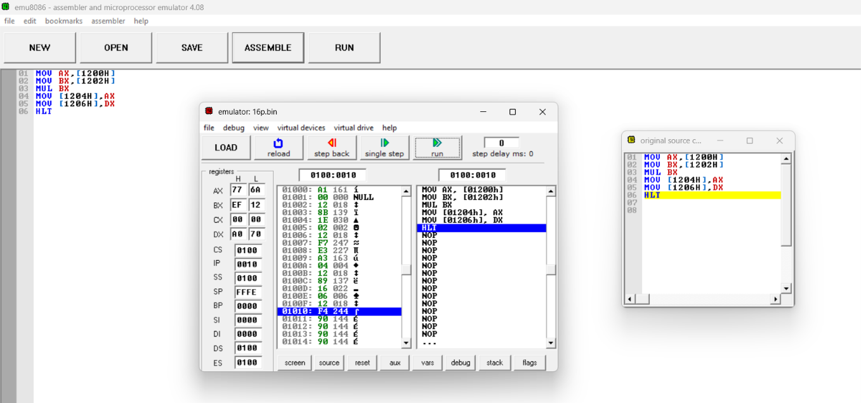

SUM OF N NUMBERS IN A WORD ARRAY
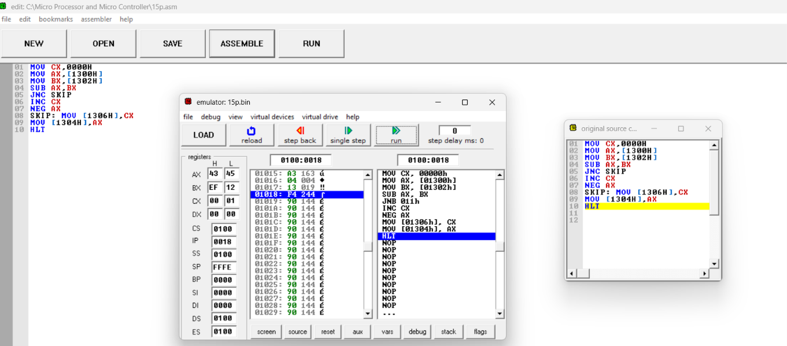
FACTORIAL OF NUMBER USING 8086 MICROPROCESSOR
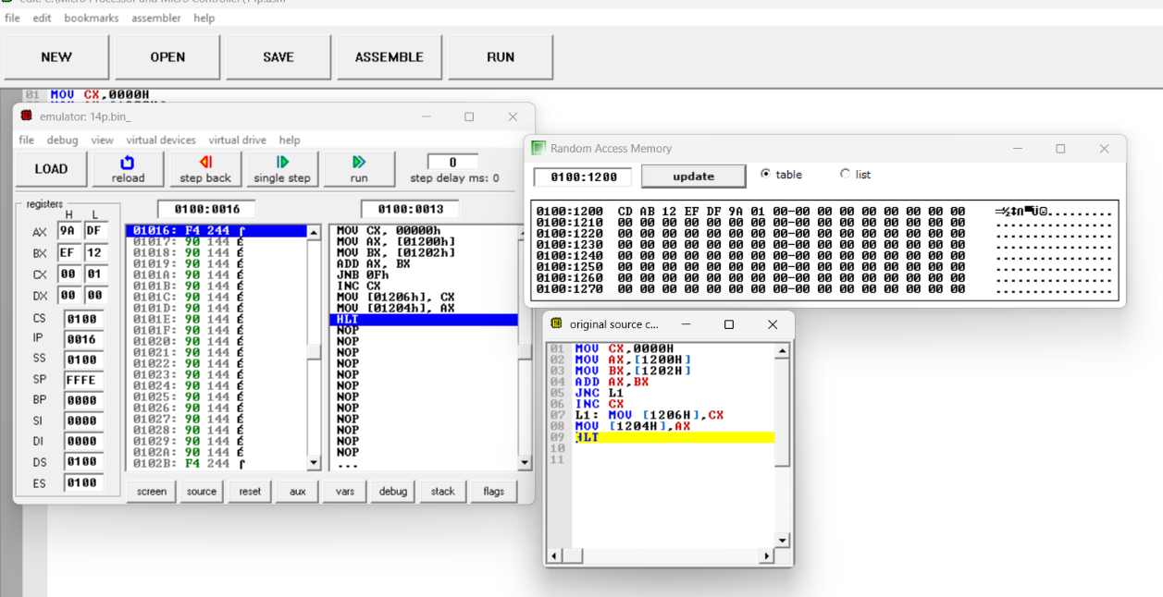

SQUARE OF NUMBER USING 8086 MICROPROCESSOR
