Multithreading – Plural Sight

**Benefits of Multithreading**

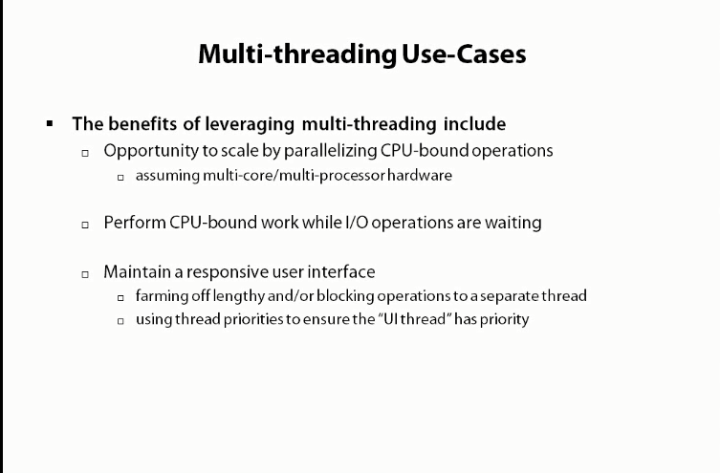

**Price To Pay for Multithreading**

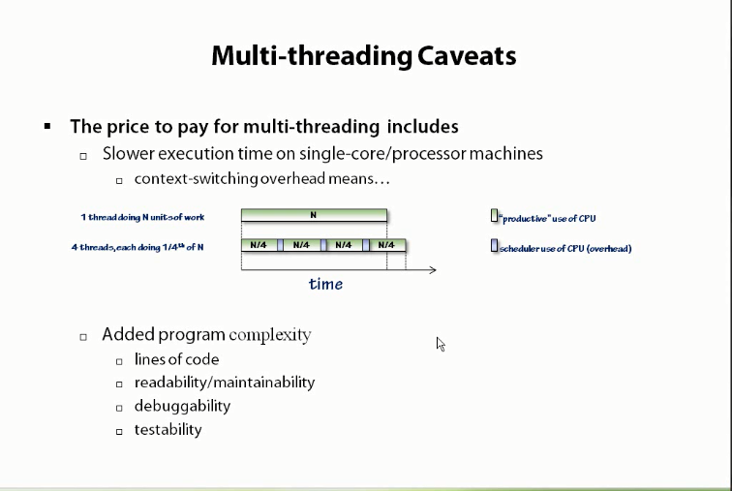

**Starting a Thread**

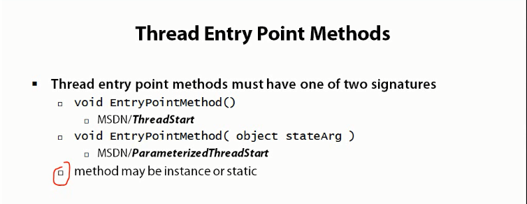

**It can be as following as well**

Thread th = new Thread(Run);

Th.Start();

**Thread Lifespan**

1. When a thread is completely executed, it ends.
2. When an exception is raised by a thread, it ends.

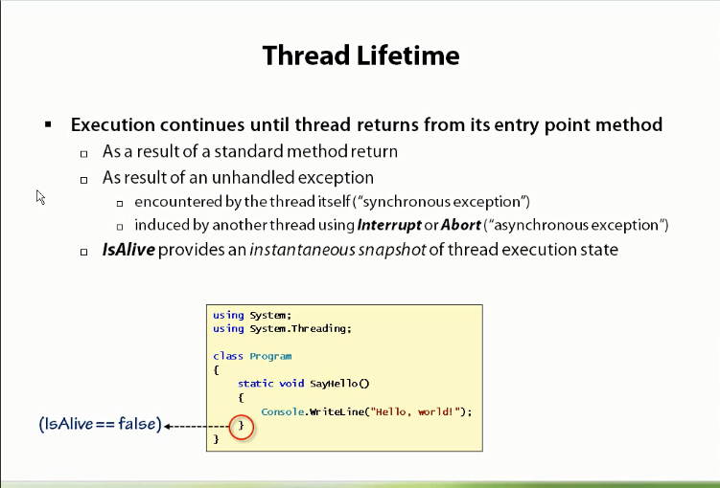

**Coordinating Thread Shutdown**

Something like below slide can also be noticed in the Thread Cancellation Example where as soon as Cancel() on the thread is called, the execution of thread got cancelled.

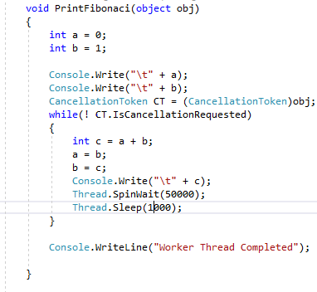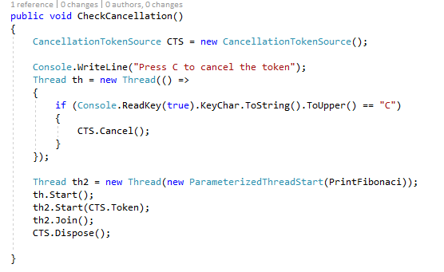

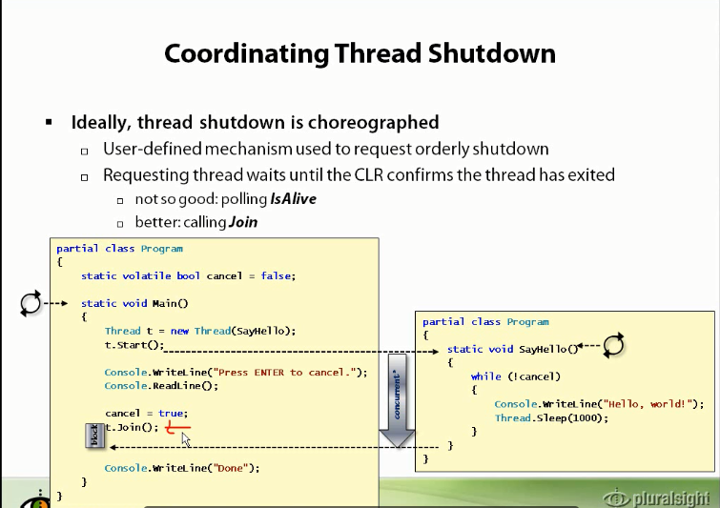

**Volatile :**

When a variable is volatile, it means that it will be updated regularly. It should not be cached by the compiler.

IsBackground:

When the Thread is executing in the background and main program can exit.

When a thread a not a background thread, it will keep the main program paused until the another thread is complete.

**ThreadPool**

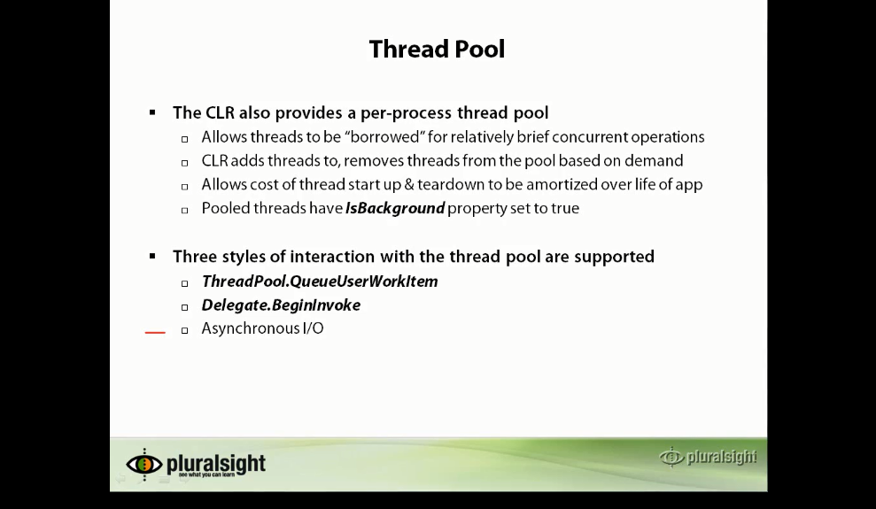

ThreadPool – QueueUserWorkItem

