Industrial Internship Report on
”Python Quiz Game”
Prepared by
Meghashri Lakshmi S

Executive Summary
This report provides details of the Industrial Internship provided by upskill Campus and The IoT Academy in collaboration with Industrial Partner UniConverge Technologies Pvt Ltd (UCT).
This internship was focused on a project/problem statement provided by UCT. We had to finish the project including the report in 6 weeks’ time.
My project was "Python Quiz Game ". The objective of this project was to develop a command-line quiz application using Python.

The application allows users to select categories and difficulty levels, answer multiple-choice questions, and receive scores based on performance. It also includes features like timer-based questions, high score tracking, and replay functionality.
This internship gave me a very good opportunity to get exposure to Industrial problems and design/implement solution for that. It was an overall great experience to have this internship.

TABLE OF CONTENTS
1 Preface 3
2 Introduction 4
2.1 About UniConverge Technologies Pvt Ltd 4
2.2 About upskill Campus 8
2.3 Objective 9
2.4 Reference 9
2.5 Glossary 10
3 Problem Statement 11
4 Existing and Proposed solution 12
5 Proposed Design/ Model 13
5.1 High Level Diagram 13
5.2 Low Level Diagram 13
5.3 Interfaces 13
6 Performance Test 14
6.1 Test Plan/ Test Cases 14
6.2 Test Procedure 14
6.3 Performance Outcome 14
7 My learnings 15
8 Future work scope 16

Preface

This report summarizes the work completed during the 6-week internship program.
The project involved developing a Python-based Quiz Game that runs on the command line. The goal was to apply programming concepts to build a functional application.
The internship provided exposure to real-world problem solving, coding practices, and software development.
I would like to thank upskill Campus and UniConverge Technologies Pvt Ltd for providing this opportunity.
This experience helped me improve my technical skills and confidence in programming.

Introduction

About UniConverge Technologies Pvt Ltd
A company established in 2013 and working in Digital Transformation domain and providing Industrial solutions with prime focus on sustainability and RoI.
For developing its products and solutions it is leveraging various Cutting Edge Technologies e.g. Internet of Things (IoT), Cyber Security, Cloud computing (AWS, Azure), Machine Learning, Communication Technologies (4G/5G/LoRaWAN), Java Full Stack, Python, Front end etc.
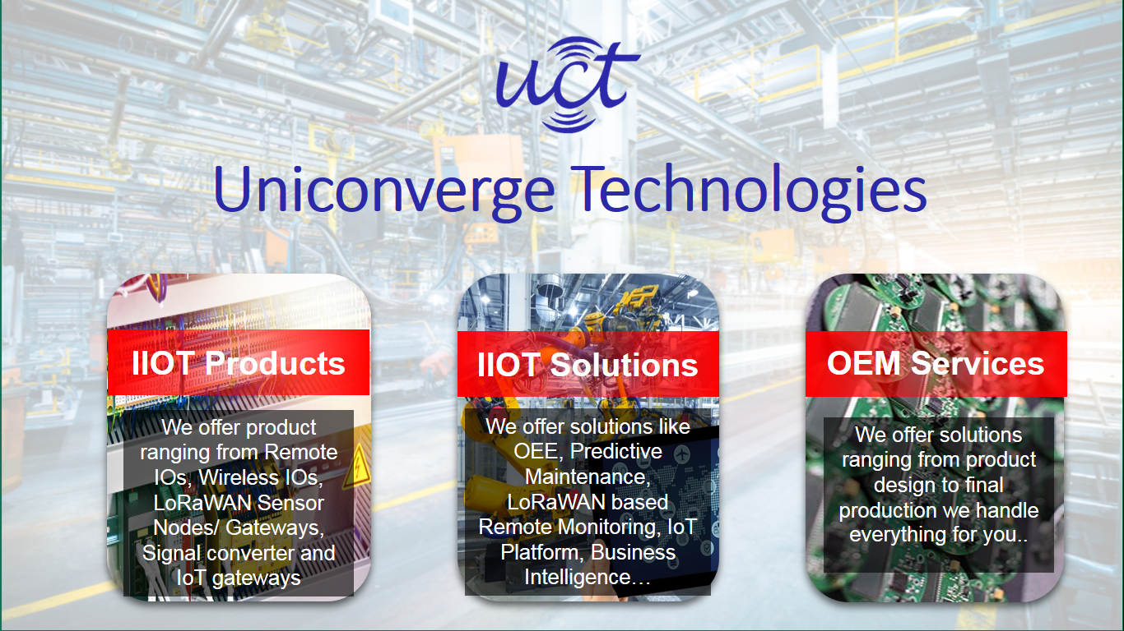
- UCT IoT Platform ()
UCT Insight is an IOT platform designed for quick deployment of IOT applications on the same time providing valuable “insight” for your process/business. It has been built in Java for backend and ReactJS for Front end. It has support for MySQL and various NoSql Databases.
- It enables device connectivity via industry standard IoT protocols - MQTT, CoAP, HTTP, Modbus TCP, OPC UA
- It supports both cloud and on-premises deployments.
It has features to
• Build Your own dashboard
• Analytics and Reporting
• Alert and Notification
• Integration with third party application(Power BI, SAP, ERP)
• Rule Engine

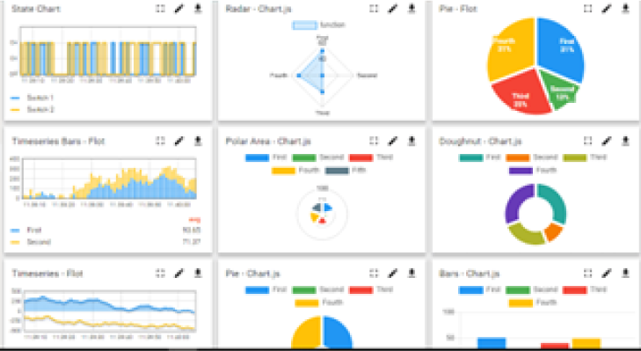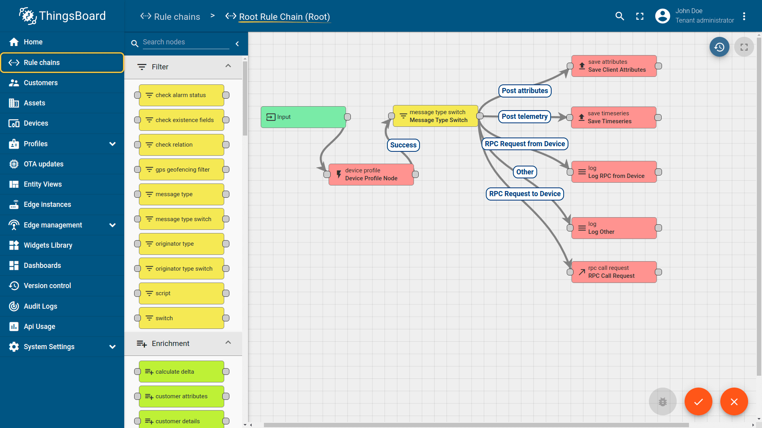

- Smart Factory Platform ()
Factory watch is a platform for smart factory needs.
It provides Users/ Factory
- with a scalable solution for their Production and asset monitoring
- OEE and predictive maintenance solution scaling up to digital twin for your assets.
- to unleased the true potential of the data that their machines are generating and helps to identify the KPIs and also improve them.
- A modular architecture that allows users to choose the service that they what to start and then can scale to more complex solutions as per their demands.
Its unique SaaS model helps users to save time, cost and money.
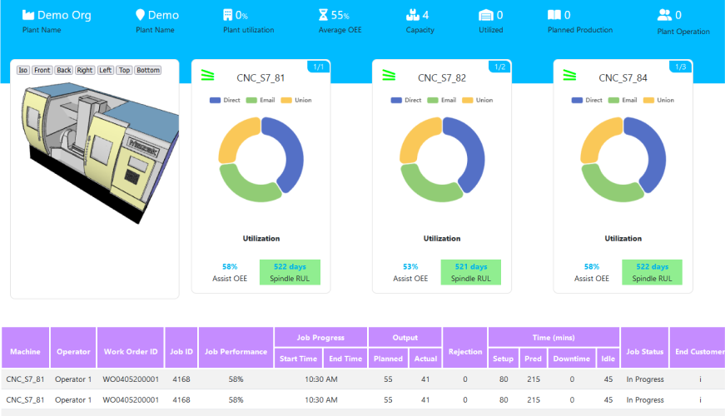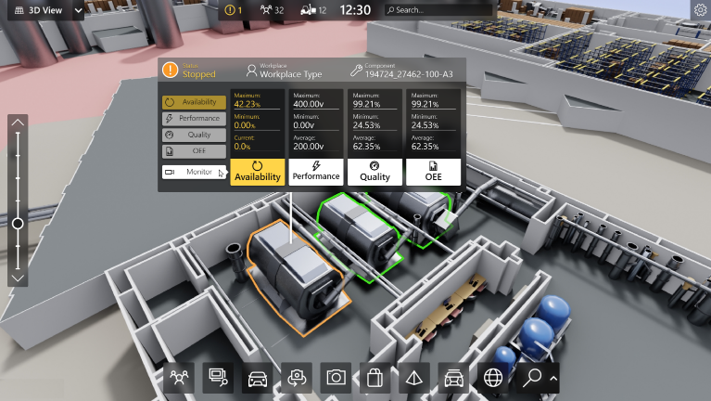

- 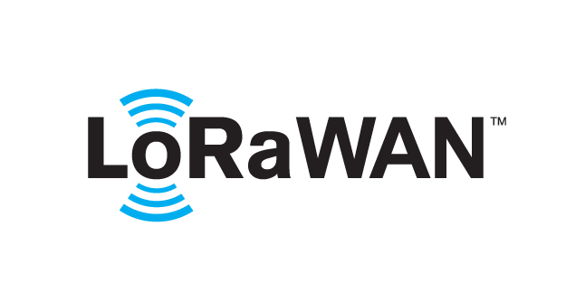 based Solution
UCT is one of the early adopters of LoRAWAN teschnology and providing solution in Agritech, Smart cities, Industrial Monitoring, Smart Street Light, Smart Water/ Gas/ Electricity metering solutions etc.
- Predictive Maintenance
UCT is providing Industrial Machine health monitoring and Predictive maintenance solution leveraging Embedded system, Industrial IoT and Machine Learning Technologies by finding Remaining useful life time of various Machines used in production process.
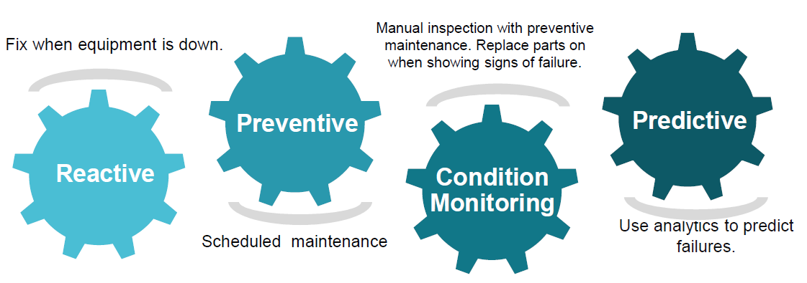

About upskill Campus (USC)
upskill Campus along with The IoT Academy and in association with Uniconverge technologies has facilitated the smooth execution of the complete internship process.
USC is a career development platform that delivers personalized executive coaching in a more affordable, scalable and measurable way.




Seeing need of upskilling in self paced manner along-with additional support services e.g. Internship, projects, interaction with Industry experts, Career growth Services
https://www.upskillcampus.com/
upSkill Campus aiming to upskill 1 million learners in next 5 year

The IoT Academy
The IoT academy is EdTech Division of UCT that is running long executive certification programs in collaboration with EICT Academy, IITK, IITR and IITG in multiple domains.

Objectives of this Internship program
The objective for this internship program was to
☛ get practical experience of working in the industry.
☛ to solve real world problems.
☛ to have improved job prospects.
☛ to have Improved understanding of our field and its applications.
☛ to have Personal growth like better communication and problem solving.

Reference
[1] Python Official Documentation – https://docs.python.org/3/
[2] W3Schools Python Tutorial – https://www.w3schools.com/python/
[3] GeeksforGeeks Python Programming – https://www.geeksforgeeks.org/python-programming-language/
[4] Stack Overflow – https://stackoverflow.com/

Glossary
Terms | Acronym
Command Line | CLI
Object-Oriented Programming | OOP
Integrated Development Environment | IDE
High Score | HS

Problem Statement
The problem statement was to design and develop a quiz application using Python that can:
- Ask multiple-choice questions
- Accept user input
- Validate answers
- Calculate score
Additionally, the system should be user-friendly and efficient.

Existing and Proposed solution

Existing quiz systems are mostly web-based or require complex interfaces.
They may not be suitable for beginners learning programming.
The proposed solution is a CLI-based Quiz Game built using Python.
It includes:
- Category selection
- Difficulty levels
- Timer-based questions
- High score tracking
- Replay functionality
This solution is simple, lightweight, and easy to use.

Code submission (Github link)

Report submission (Github link) : first make placeholder, copy the link.

Proposed Design/ Model

The system follows a simple flow:

1. User selects category

2. User selects difficulty

3. Questions are filtered and displayed

4. Timer is applied for each question

5. Score is calculated

6. High score is stored

7. User can replay

This ensures a structured and interactive experience.

High Level Diagram
The high-level design of the system represents the overall flow of the application.
It starts with user input, followed by category and difficulty selection. The system then filters questions and presents them to the user. Each response is evaluated, and the score is updated accordingly. Finally, the result is displayed and the high score is stored.

Figure 1: HIGH LEVEL DIAGRAM OF THE SYSTEM

Low Level Diagram
The low-level design focuses on internal working of the system.
It includes:
- Question storage using list and dictionary
- Input validation logic
- Timer handling using time module
- File handling for high score storage
- Class-based structure using OOP

Figure 2 : LOW LEVEL DIAGRAM OF THE SYSTEM

Interfaces
The system uses a Command-Line Interface (CLI) to interact with the user.
In this interface, the user provides input using the keyboard and the system displays output on the terminal screen.
There are no external APIs, network protocols, or hardware interfaces involved in this project.
Data Flow:
User Input → Program Processing → Output Display
The program processes user input such as category selection, difficulty level, and answers to questions. Based on the input, the system validates responses, calculates the score, and displays the result.
Flow Representation:
Start → Display Menu → Take Input → Process Input → Display Questions → Validate Answers → Calculate Score → Display Result → End

Performance Test

Performance testing is conducted to evaluate how efficiently the application performs under different conditions.
The following constraints were identified:
- Input validation accuracy
- Execution time (timer-based responses)
- Memory usage (lightweight CLI application)
- Data persistence (high score storage)
The system is designed to handle these constraints effectively using optimized logic and minimal resource usage.

Test Plan/ Test Cases

Test Case 1: Valid Input Handling

Input: A/B/C/D

Expected Output: Correct processing

Test Case 2: Invalid Input Handling

Input: X, 1, empty input

Expected Output: Error message

Test Case 3: Timer Functionality

Delay input beyond time limit

Expected Output: Timeout message

Test Case 4: Score Calculation

Provide correct and incorrect answers

Expected Output: Accurate score display

Test Case 5: High Score Storage

Run program multiple times

Expected Output: High score persists correctly

Test Procedure
The application was executed multiple times using different input scenarios.
Each feature was tested individually:
- Input validation was tested using valid and invalid entries
- Timer functionality was tested by delaying responses
- Score calculation was verified manually
- High score functionality was tested across multiple runs
- All test cases were executed successfully.

6.3 Performance Outcome
The application performed efficiently under all test conditions.
- Input validation works correctly
- Timer logic functions as expected
- Score calculation is accurate
- High score is stored and retrieved properly
The system is lightweight and performs well without any noticeable delay.
Overall, the application meets the expected performance requirements for a CLI-based system.

My learnings

During this internship, I learned:
- Python programming fundamentals
- Object-Oriented Programming (OOP)
- File handling
- Input validation
- CLI application development
This project improved my problem-solving skills and understanding of real-world application development.

Future work scope

Future improvements can include:

- GUI-based version using Tkinter
- Web-based version using Flask
- Database integration
- Multiplayer quiz system

