**SOFTWARE**

**REQUIREMENTS**

**SPECIFICATION**

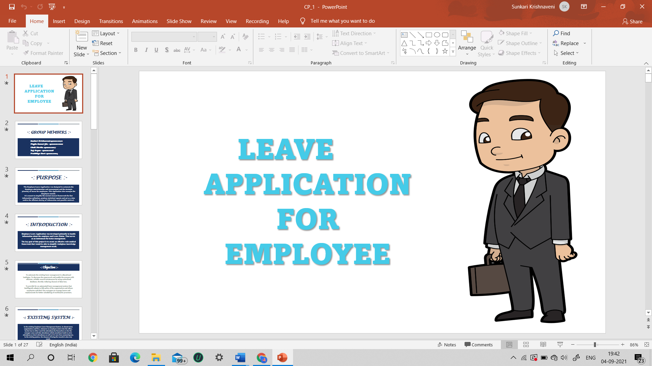

**PROJECT TITLE :**

**EMPLOYEE LEAVE APPLICATION**

**VERSION : 1.0**

**GROUP NO : 3**

**-: GROUP MEMBERS :-**

**190101120014 – Pratikhya Devi**

**190101120027 – Chelli Harika**

**190101120070 – Sunkari Krishnaveni**

**190101120108 – Megha Kumari Jha**

**190101120116 – Raj Aryan**

***CONTENTS***

1. **Introduction**
2. **Purpose**
3. **Scope**
4. **References**
5. **Overview**
6. **Current Product (Existing System)**
7. **Proposed System**
8. **Product Functionality**
9. **Modules of the Project**
10. **Admin module**
11. **Employee module**

**4. Overview of the modules of the Product**

**5. Functional Requirements of the Modules**

**6. Detailed Functional Requirements.**

1. **ADMIN MODULE**
2. **Adding Employee**
3. **Reading Employee data**
4. **Updating Employee**
5. **Deleting Employee**
6. **Accepting or Rejecting Leave**
7. **Monitoring Employee Activities**
8. **Analytical Report of the Leaves**
9. **EMPLOYEE MODULE**
10. **View Profile**
11. **Apply leave**
12. **Cancel leave till Approval of leave by Admin**
13. **View Leave Dashboard**

**7. Operating Environment**

1. **Hardware**
2. **Software**
3. **Network**
4. **Communication**

**-: INTRODUCTION :-**

**An Employee Leave Application is a web-based and android-based that automates every step of the employee leave management process without compromising on functionality. Unlike on-premise leave management tools, an online leave management system gives employees the freedom to apply, approve, reject, and manage leave requests from any place, any time, and from any device.**

**Employee Leave Application was developed primarily to handle information about the employee and Leave Status. That serves as an instrument for better management.**

**The key goal of this project is to create an effective web-enabled framework that would be able to simplify workplace knowledge and management needs.**

**PURPOSE**

**The Employee Leave Application was designed to automate the Employee administration and management and the strategic planning of leaves for employees. This application also manages the Employee records.**

**It is meant to simplify the current manual framework for fast information collection, produce statistical reports and act as a data archive for efficient sharing of information and possible retrieval.**

**SCOPE**

**Scope of this project is limited to any particular organisation rather than used by a single person.**

**REFERENCES**

**-: OVERVIEW :-**

**EXISTING SYSTEM**

**In the existing Employee Leave Management System, in almost every organization and firm, whenever an employee enters into the office, he/she has to either mark the attendance by themselves or else the manager came and take attendance which sometimes leads to extra attendance or short attendance as well as it is very time consuming too. In the existing system, the chances of losing the records is also very much.**

**And whenever an employee wants to apply a leave, he/she has to submit a hard copy of their leave request. They have to wait for their higher officials permission to know whether their leave request has been approved or cancelled. This is a long and time taking process.**

**PROPOSED SYSTEM**

**In the new proposed Employee Leave Application all the data is being maintained into the server as well regular updation will also takes place. In case, if there is some holiday, then the data is being updated automatically under well-defined graphical user interface and thus this software also makes the work load less for the department and management class as well as make easy access to the information for the authorized persons.**

**If an employee wants to apply for an leave, he/she can login into their profile and can apply for an leave by mentioning the purpose anytime rather than submitting a hard copy(paper type) in higher officials cabin. They can also view their leave application status in their “Apply Leave Interface”. This will also reflect in their “Leaves left” data.**

**PRODUCT FUNCTIONALITY**

**Some major product functionalities of the system are as follows:**

* **Information about the employee attendance**
* **Check for Leave Availability**
* **Maintain Employee leave record.**
* **Apply for leave**
* **Approve or reject leave application.**

**-: MODULES OF THE PROJECT :-**

**ADMIN MODULE**

**EMPLOYEE MODULE**

**-: OVERVIEW OF THE MODULES OF THE PROJECT :-**

**-: FUNCTIONAL REQUIREMENTS OF THE MODULES :-**

**-: DETAILED FUNCTIONAL REQUIREMENTS :-**

**-: OPERATING ENVIRONMENT :-**