
Project Report

Programming in Java
CAMPUSPULSE - Campus Operations and Intelligence Platform

Name: Megha Maniska Mohalik
Registration Number: 25BAI10509
Branch: CSE in AI ML
Year: 2026-27
Faculty: Devaraju S
1. INTRODUCTION

CampusPulse is a Java-based campus management application developed to bring several common campus activities into one system. The application allows users to manage campus issues, mess records, library books, and facilities through a simple console-based interface.

The project uses Java for the main application logic and MySQL for storing the data. JDBC is used to connect the Java application with the database. The system also includes an analytics section for viewing useful summaries and a rule-based virtual assistant called Pulse to help users navigate the available modules.

The main idea behind CampusPulse is to keep everyday campus information organized and accessible through one application.

2. PROBLEM STATEMENT

In a college environment, information related to maintenance issues, mess feedback, library records, and campus facilities can be difficult to manage when it is handled separately.

There is a need for a simple system that can store this information, allow basic operations such as adding, viewing, updating, and deleting records, and provide summaries of the stored data.

CampusPulse addresses this problem by combining these activities into a single Java application connected to a MySQL database.

3. OBJECTIVES

The main objectives of CampusPulse are:
1. To develop a practical Java application for managing common campus activities.
2. To provide separate modules for issues, mess, library, and facilities.
3. To store and retrieve application data using MySQL and JDBC.
4. To apply Java concepts such as classes, objects, packages, collections, exception handling, and modular programming.
5. To provide basic analytics from the stored campus data.
6. To provide a simple rule-based assistant that helps users navigate the system.
7. To include input validation and error handling so that incorrect inputs can be handled properly.

4. FUNCTIONAL REQUIREMENTS

The functional requirements of CampusPulse describe the main operations that the system should perform.

1. Issue Management
- Add new campus issues.
- View existing issues.
- Update the status of an issue.
- Delete an issue.
- Store issue category, description, location, status, and priority.

2. Mess Management
- Add meal and menu records.
- View mess records.
- Add or update meal ratings and feedback.
- Delete mess records.
- Calculate basic mess statistics.

3. Library Management
- Issue books to students.
- View library records.
- Return issued books.
- Delete library records.
- Maintain issue and return dates.

4. Facilities Management
- Add campus facility records.
- View available facilities.
- Update facility status.
- Delete facility records.
- Store location and maintenance information.

5. Analytics
- Display summaries of issues, mess records, library records, and facilities.
- Calculate basic statistics such as counts and average ratings.

6. Campus Assistant
- Provide basic responses to common campus-related questions.
- Help users understand the available CampusPulse modules.

5. NON-FUNCTIONAL REQUIREMENTS

The non-functional requirements describe the qualities and characteristics expected from the system.

1. Usability
The application should have a simple menu-based interface so that users can easily navigate between different modules.

2. Reliability
The system should handle incorrect inputs and database errors without abruptly terminating the application.

3. Performance
The application should perform basic database operations and retrieve records without unnecessary processing.

4. Maintainability
The project should be divided into separate classes and packages so that individual modules can be modified or maintained easily.

5. Data Integrity
The system should validate important user inputs before storing information in the database.

6. Security
Database connection details should be kept private and should not expose the user's actual database password in the public project repository.

6. SYSTEM MODULES

CampusPulse is divided into several modules, with each module handling a specific campus-related activity.

6.1 Issue Management

This module is used to record and manage campus complaints or maintenance issues. Users can add an issue with details such as student name, category, description, location, status, and priority. Issues can also be viewed, updated, and deleted.

6.2 Mess Management

The Mess Management module stores information about meals and menu items. Users can add meal records, provide ratings and feedback, view existing records, and update or delete them.

6.3 Library Management

The Library Management module maintains records of books issued to students. It stores details such as book title, author, student name, issue date, return date, and status. Users can issue and return books and manage library records.

6.4 Facilities Management

This module keeps track of campus facilities such as classrooms, laboratories, and other resources. It stores their location, current status, maintenance date, and description.

6.5 Analytics

The Analytics module processes the stored records and displays basic summaries for the different sections of CampusPulse. It provides information such as total records, status counts, category counts, and average mess ratings.

6.6 Pulse Assistant

Pulse is a rule-based virtual assistant included in CampusPulse. It recognizes common keywords and questions related to the application's modules and provides predefined responses to help users navigate the system.

7. TECHNOLOGIES USED

The following technologies and tools were used to develop CampusPulse:
1. Java
Java is used for implementing the main application logic, classes, objects, services, and user interaction.
2. JDK 27
JDK 27 is used to compile and run the Java application.
3. MySQL
MySQL is used as the database for storing campus-related records.
4. JDBC
Java Database Connectivity (JDBC) is used to connect the Java application with the MySQL database and perform database operations.
5. Maven
Maven is used for project management and handling the MySQL Connector/J dependency.
6. Eclipse IDE
Eclipse is used for writing, organizing, compiling, and testing the Java source code.
7. MySQL Workbench
MySQL Workbench is used to create the database, tables, and execute SQL queries.

8. SYSTEM IMPLEMENTATION

CampusPulse is implemented as a console-based Java application connected to a MySQL database.

The application is divided into different packages and classes based on their responsibilities. The model classes represent the data used by the system. Repository classes handle database operations using JDBC. Service classes perform validation and connect the application logic with the repositories. Separate analytics classes process the stored data and display summaries.

The Main class provides the menu through which the user can access the different modules.

The application uses prepared statements for database operations. Input validation is performed before important records are sent to the database. Exception handling is also used to handle database and input-related errors.

The project is organized into the following main packages:
- model
- repository
- service
- analytics
- assistant
- util
The application also contains the CampusAssistant class, which implements the rule-based Pulse assistant.

9. DATABASE DESIGN

CampusPulse uses MySQL to store the information generated by its different modules.

The database is named `campuspulse` and contains four main tables:
1. issues
Stores campus complaints and maintenance issues.
2. mess
Stores meal information, ratings, and feedback.
3. library
Stores book issue and return records.
4. facilities
Stores information about campus facilities and their current status.
Each table has an `id` field as its primary key. The database structure allows the application to store and retrieve records using JDBC. The database is created and initialized using the `database.sql` file included with the project.

10. TESTING AND RESULTS
The CampusPulse application was tested by running the different menu options and checking whether the expected operations were performed correctly.

10.1 Issue Management Testing

The Issue Management module was tested for:
- Adding a new issue.
- Viewing stored issues.
- Updating the status of an issue.
- Deleting an issue.
- Entering an invalid issue ID.
- Checking required input fields.
The module successfully performed the tested operations and displayed appropriate messages for invalid IDs and missing information.

10.2 Mess Management Testing
The Mess Management module was tested for:
- Adding meal records.
- Viewing mess records.
- Updating meal ratings and feedback.
- Deleting records.
- Entering an invalid rating.

The rating validation was tested using a value outside the allowed range. The application rejected the invalid rating and displayed an appropriate message.

10.3 Library Management Testing
The Library Management module was tested for:
- Issuing a book.
- Viewing library records.
- Returning a book.
- Entering an invalid library record ID.

The tested operations worked correctly and the application handled invalid IDs appropriately.

10.4 Facilities Management Testing
The Facilities Management module was tested for:
- Adding a facility.
- Viewing facility records.
- Updating facility status.
- Deleting a facility.
- Entering an invalid facility ID.

The tested operations were completed successfully and invalid IDs were handled correctly.

10.5 Analytics Testing
The Analytics module was tested by viewing:
- Issue analytics.
- Mess analytics.
- Library analytics.
- Facilities analytics.
- Complete analytics.

The application successfully retrieved the stored records and displayed the corresponding summaries.

10.6 Pulse Assistant Testing
The Pulse Assistant was tested with different types of questions and commands, including:
- Greetings.
- Asking about the assistant's identity.
- Asking what the assistant can do.
- Questions about issues.
- Questions about the mess.
- Questions about the library.
- Questions about facilities.
- Questions about analytics.
- Thank-you and goodbye messages.
- Returning to the main menu.

The assistant provided the expected rule-based responses for the tested inputs.

10.7 Database Testing
The database connection and tables were also tested using MySQL Workbench.
The following tables were checked:
- issues
- mess
- library
- facilities

Records could be inserted, retrieved, updated, and deleted through the application, confirming that the Java application was communicating with the MySQL database correctly.
11. SCREENSHOTS
Main Menu
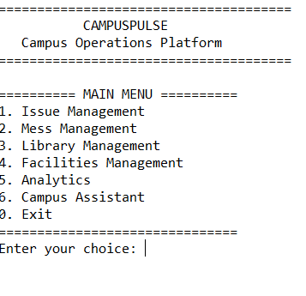

Issue Menu
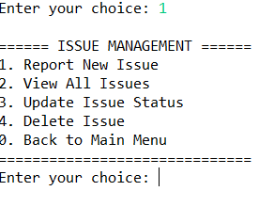

Mess Menu
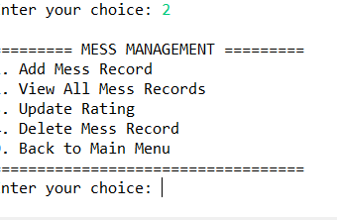

Library Menu
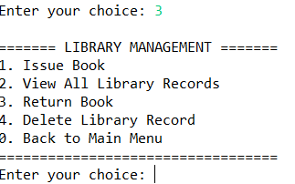

Facilities Menu

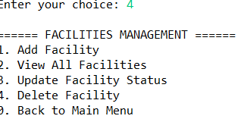

Analytics Menu
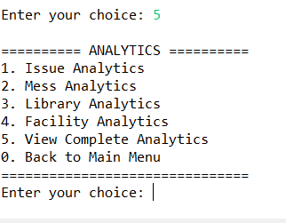

Assistant Pulse
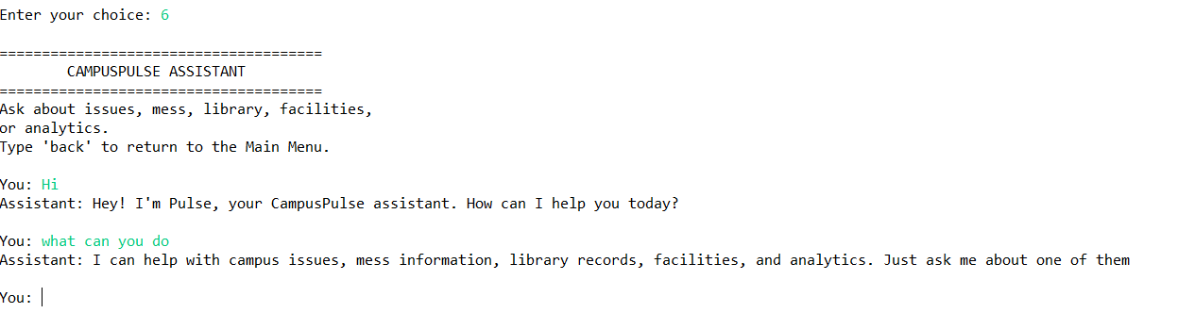

MySQL
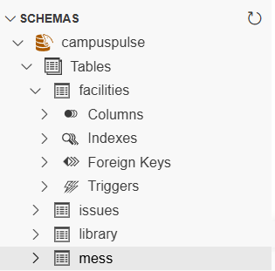

12. CONCLUSION

CampusPulse was developed as a Java-based campus management application that brings different campus operations together in one system. The application provides modules for managing issues, mess records, library books, and campus facilities.

The project demonstrates the use of Java programming concepts along with MySQL database connectivity through JDBC. It also includes validation, exception handling, database operations, analytics, and a rule-based virtual assistant.

Testing of the different modules showed that the main operations such as adding, viewing, updating, and deleting records worked as expected. The project helped in applying Java concepts to a practical problem while maintaining a simple console-based interface.

Overall, CampusPulse provides a functional foundation for managing common campus information through a single application.

13. FUTURE SCOPE
CampusPulse can be further improved by adding more features in future versions. Possible improvements include:
1. Developing a graphical user interface or web-based interface.
2. Adding separate login and authentication for students and administrators.
3. Adding email or notification features for important issue updates.
4. Providing more detailed analytics and graphical reports.
5. Adding search and filtering options for records.
6. Connecting the system with additional campus services.
7. Improving Pulse Assistant so that it can handle a wider range of campus-related queries.
8. Adding role-based access so that different users can have different permissions.

14. REFERENCES
1. Oracle Java Documentation
Java language and standard library concepts.
2. MySQL Documentation
MySQL database and SQL concepts.
3. Oracle JDBC Documentation
Java Database Connectivity concepts and database programming.
4. Apache Maven Documentation
Maven project structure and dependency management.
5. MySQL Connector/J Documentation
JDBC driver used for connecting Java applications with MySQL.

15. PROJECT FILES
The CampusPulse project contains the following major files and folders:
- src/ - Contains the Java source code.
- model/ - Contains classes representing application data.
- repository/ - Contains database-related operations.
- service/ - Contains validation and application logic.
- analytics/ - Contains the analytics modules.
- assistant/ - Contains the Pulse virtual assistant.
- util/ - Contains database connection utilities.
- database.sql - Contains the database and table creation queries.
- pom.xml - Contains Maven project configuration and dependencies.
- README.md - Provides project setup and execution instructions.
- statement.md - Contains the project statement.
- Project_Report.pdf - Contains the detailed project documentation.

