Structural Diagram:
- Object Diagram

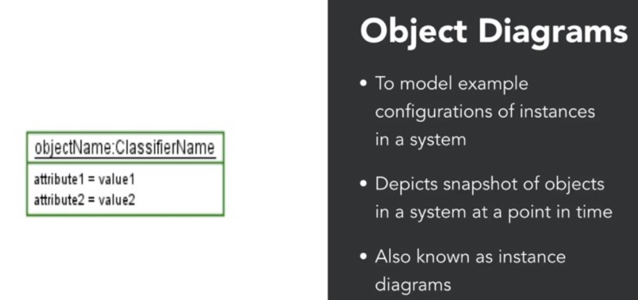

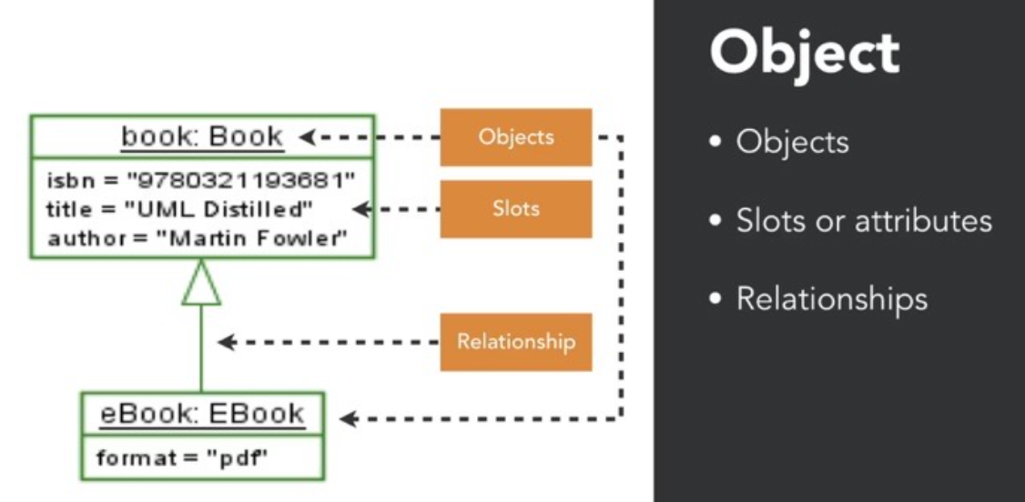

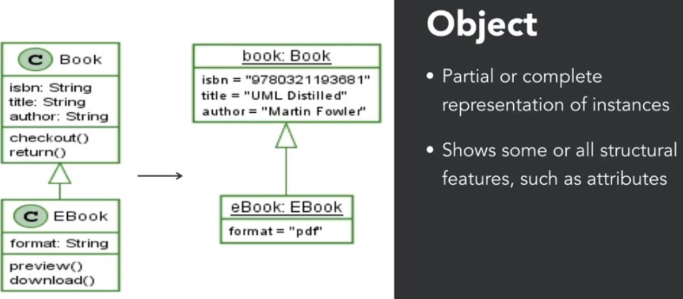

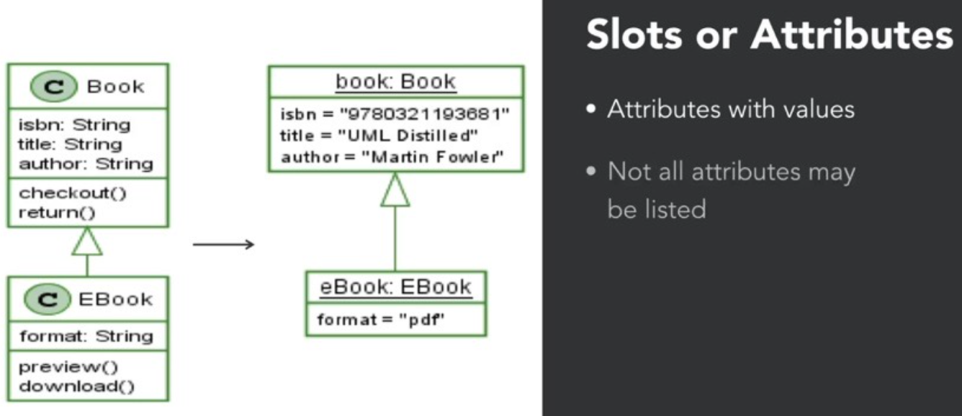
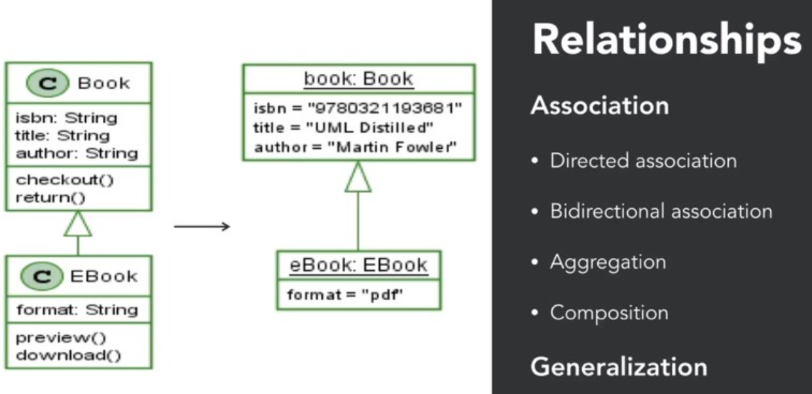

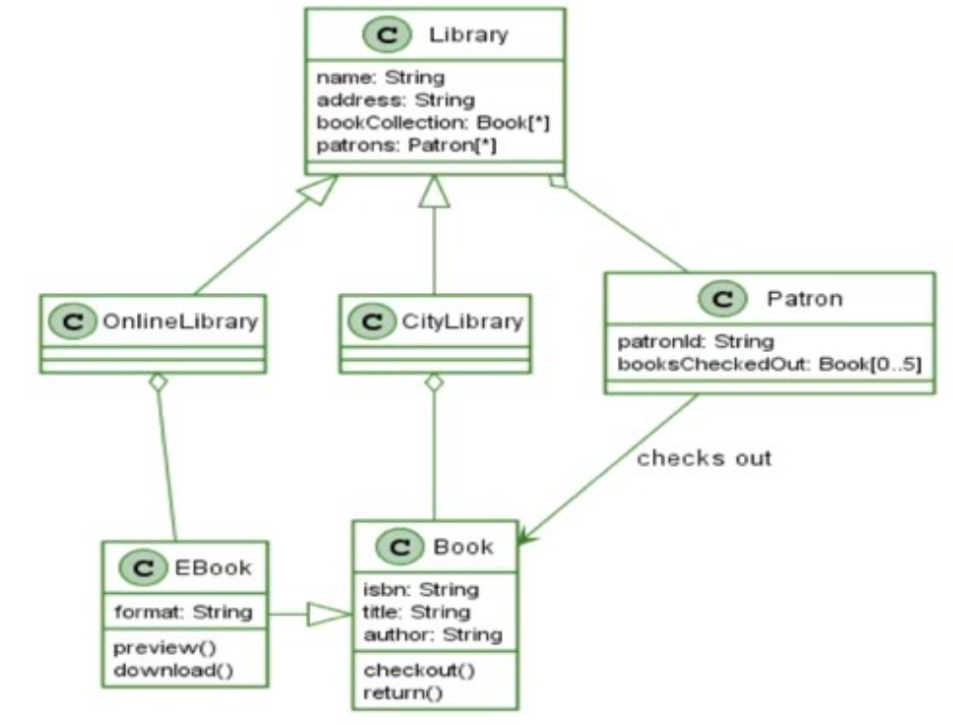

🔹 1. Association
- Symbol: A solid line connecting two classes.
- Direction:
  - Unidirectional: Arrow at one end.
  - Bidirectional: No arrow; both classes know each other.
2. Aggregation
- Symbol: A hollow diamond at the "whole" side.
- Meaning: "Has-a" relationship where the part can exist independently.
🔹 3. Composition
- Symbol: A filled diamond at the "whole" side.
- Meaning: Stronger "has-a" relationship; part cannot exist without the whole.
4. Generalization (Inheritance)
- Symbol: A solid line with a hollow triangle pointing to the superclass.
- Meaning: "Is-a" relationship.

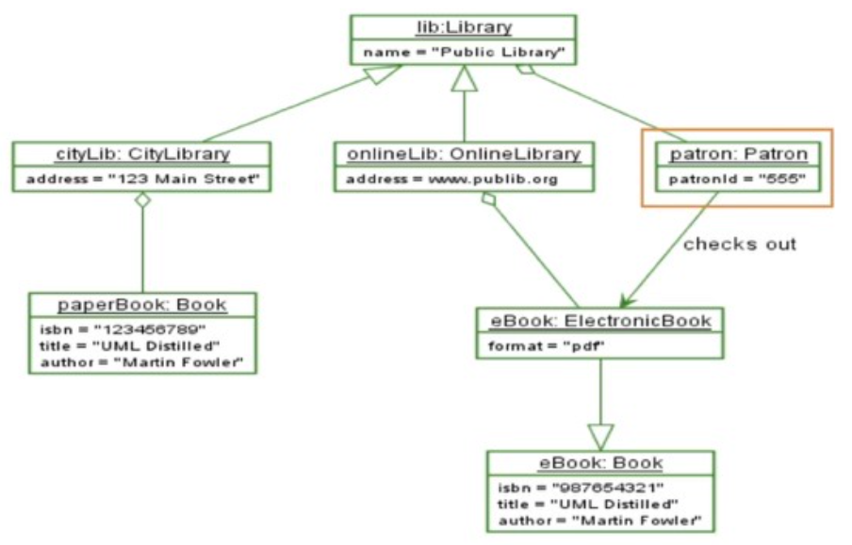

Behavioural Diagram:
- State machine Diagram

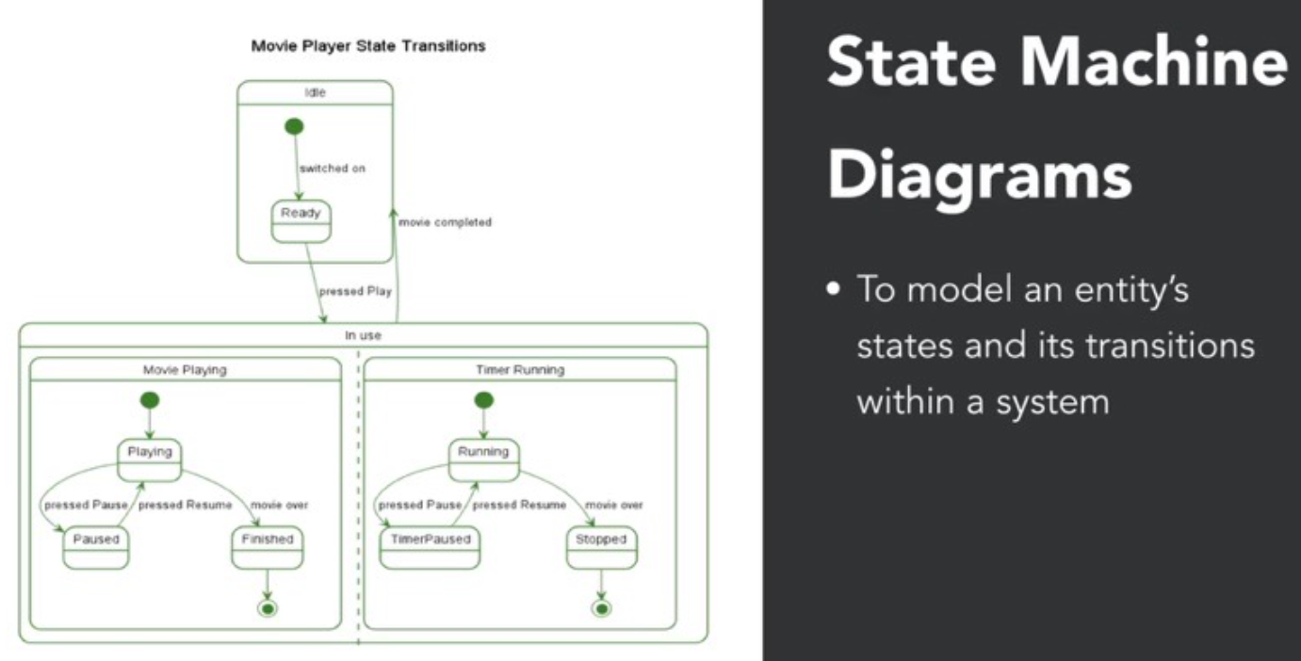

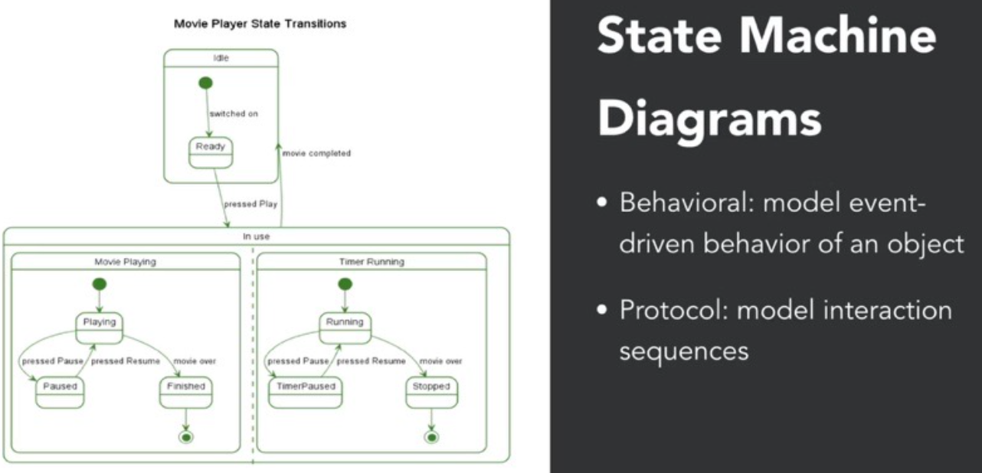
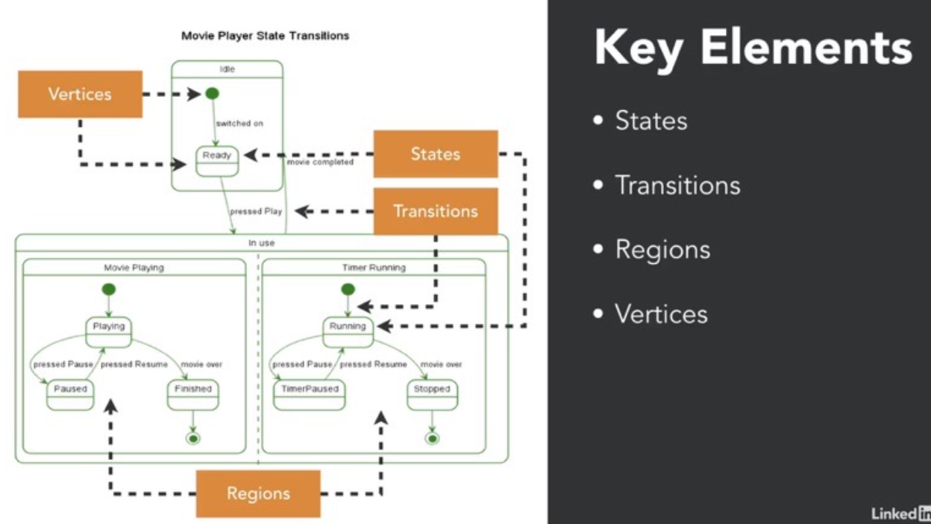
Vertices
- A vertex is a graphical node in the state diagram.
- It can represent:
  - A state
  - A pseudostate (like initial, choice, junction)
  - A final state
- So, every state is a vertex, but not every vertex is a state.

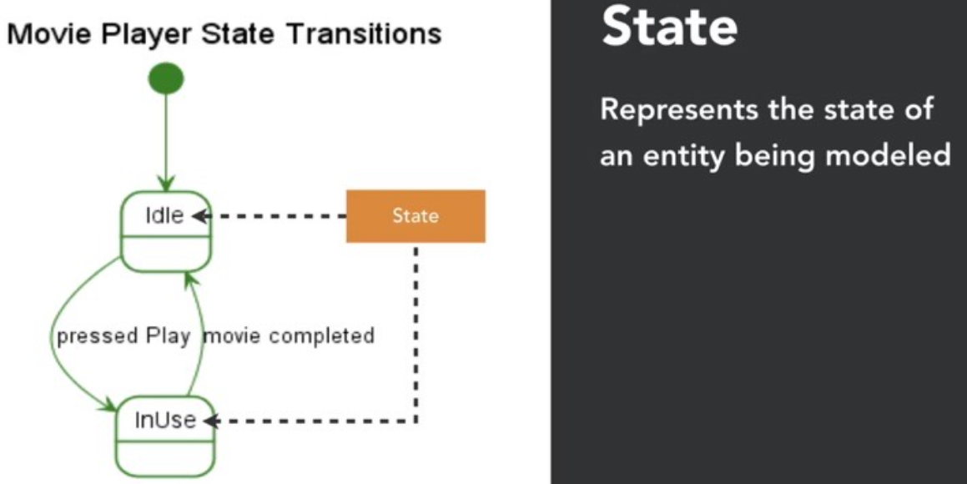

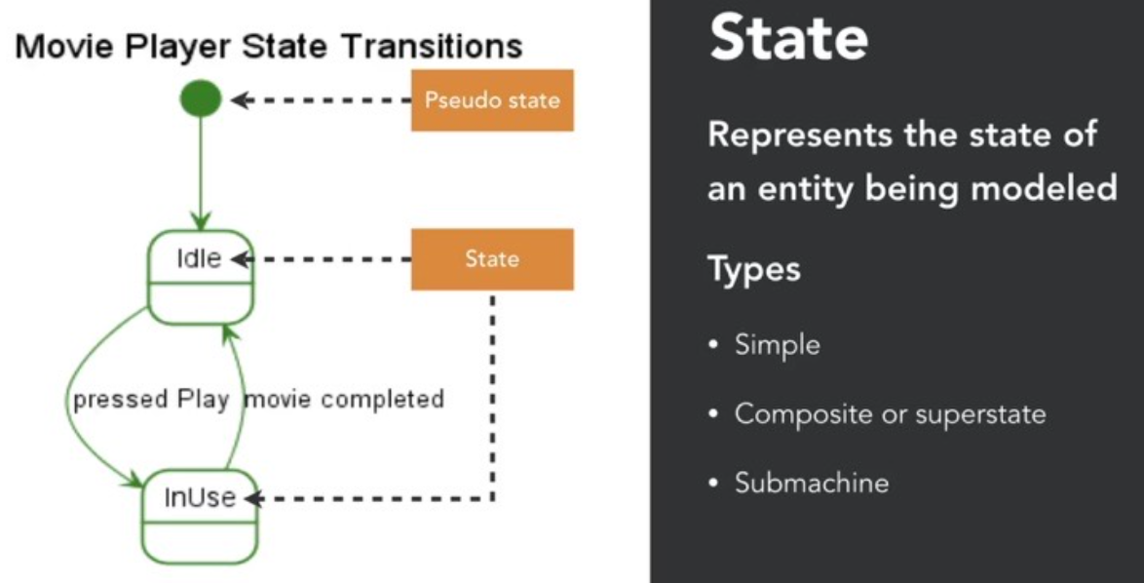
2. Composite State (Superstate)
- A state that contains nested states.
- Used to group related states under a common parent.
- Example (not shown in diagram):
A Playing state might contain sub-states like Buffering, Playing, and Paused.
3. Submachine State
- A state that refers to another state machine diagram.
- Helps modularize complex behavior.
- Example (not shown in diagram):
A TimerRunning state could refer to a separate timer state machine.

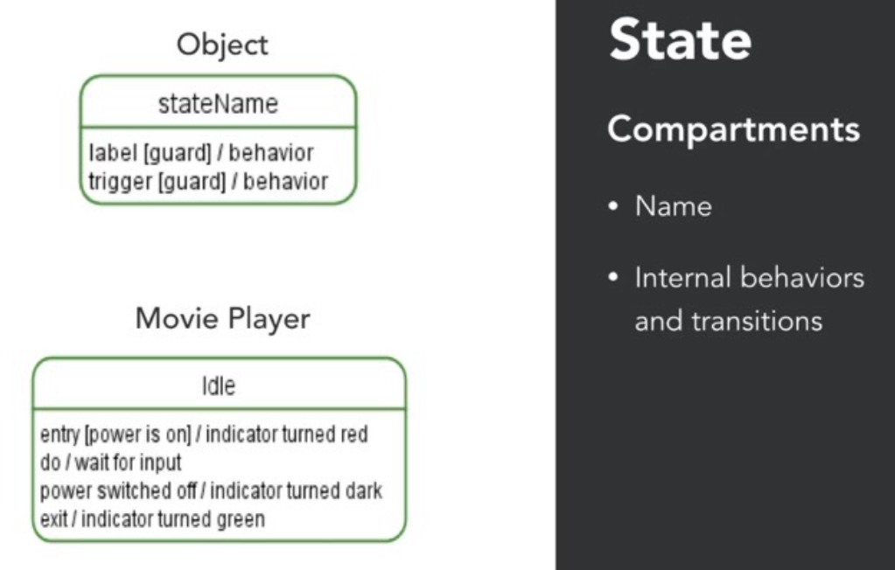
This diagram will become clear in a few slides when we cover transitions.
Internal Behaviors Compartment: This includes entry, do, and exit actions:
- entry / action: Executed when the state is entered.
- do / action: Ongoing activity while in the state.
- exit / action: Executed when the state is exited.

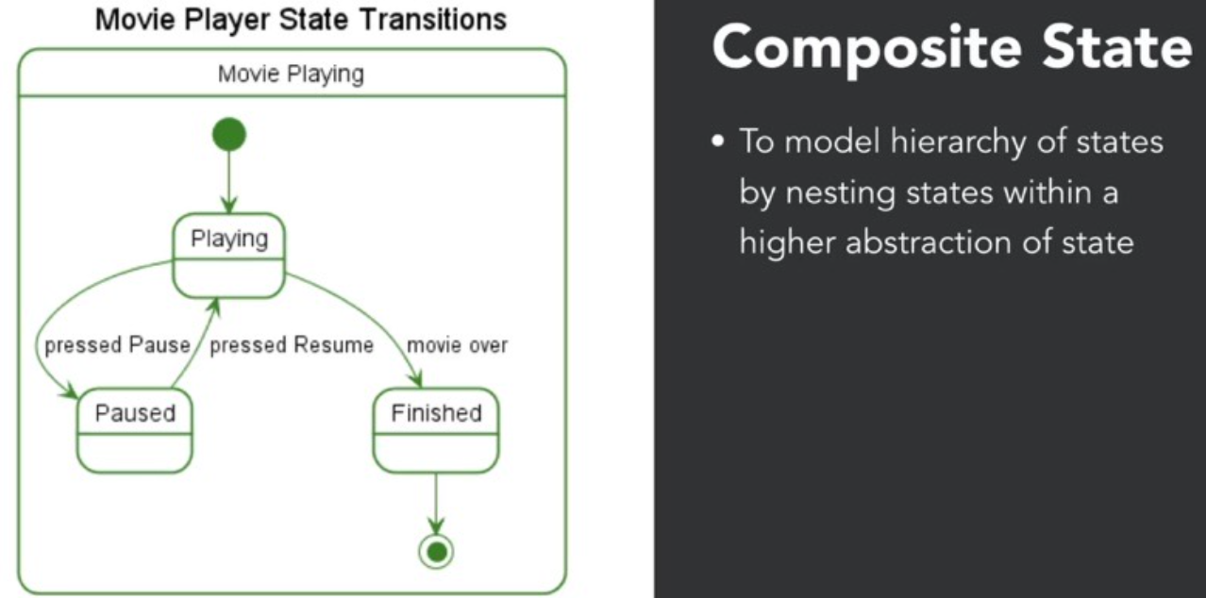
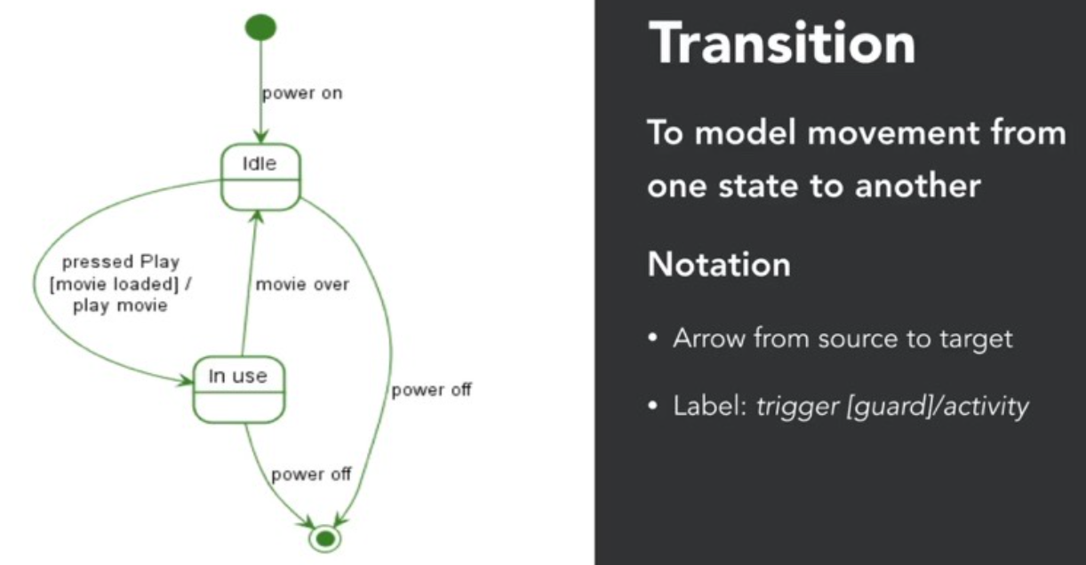
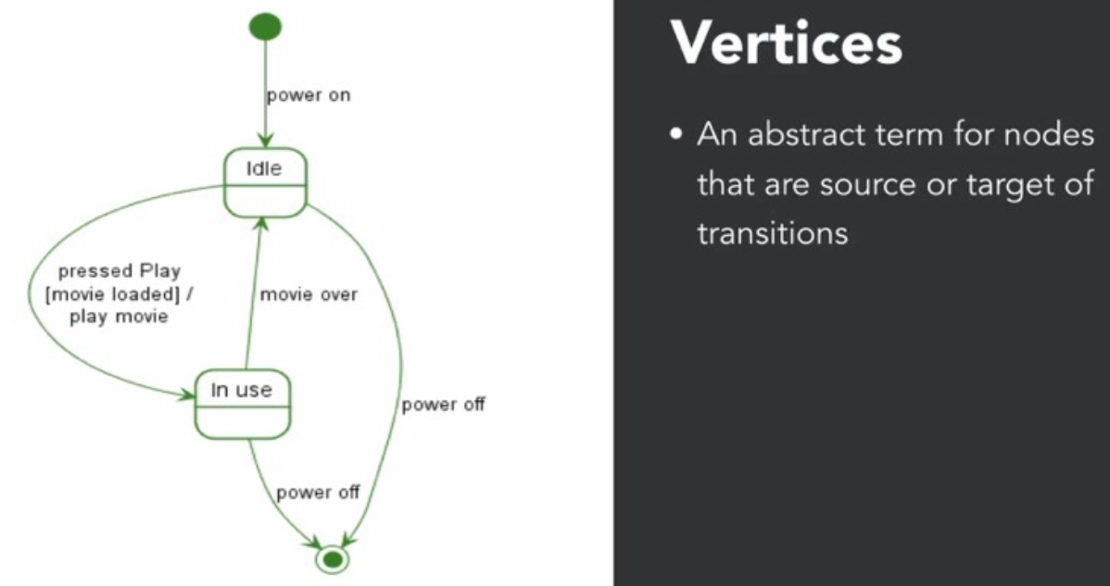

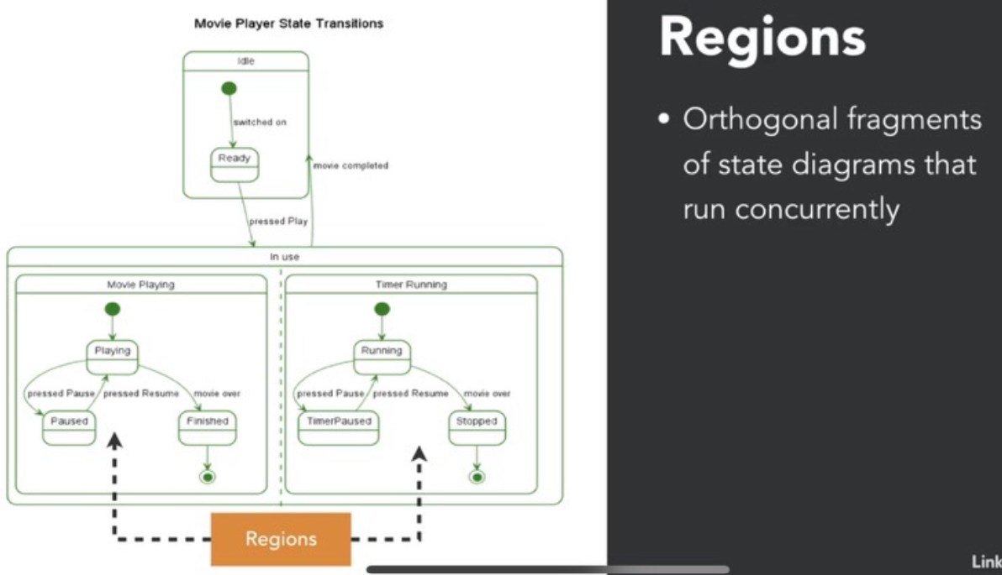

Structural Diagram:
- Component Diagram

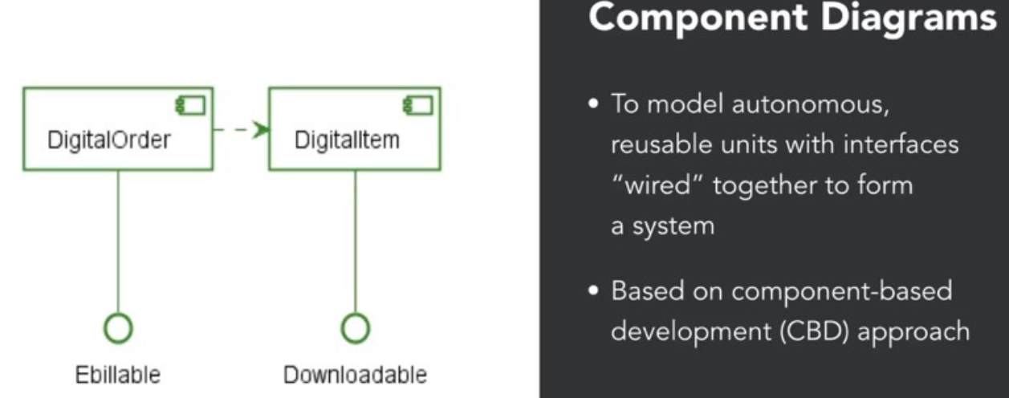

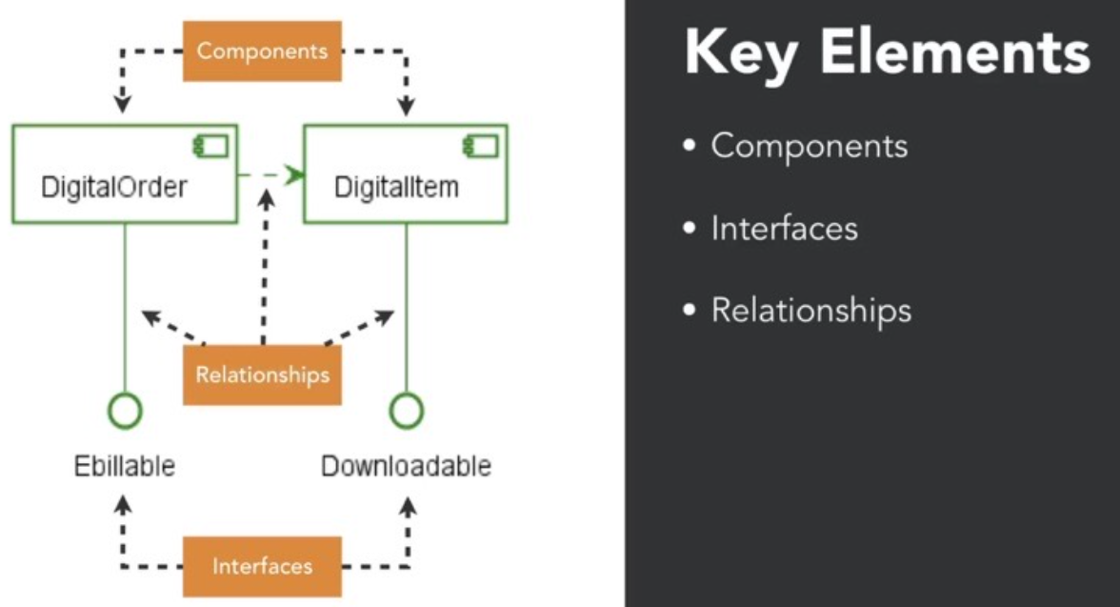

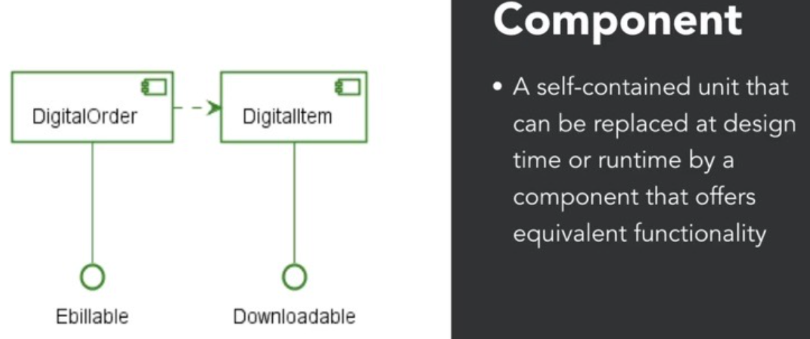

The symbol looks like plug and play component.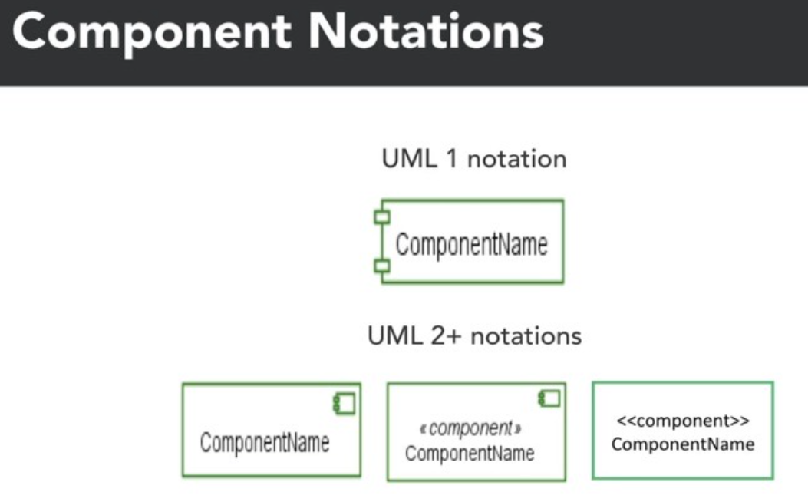
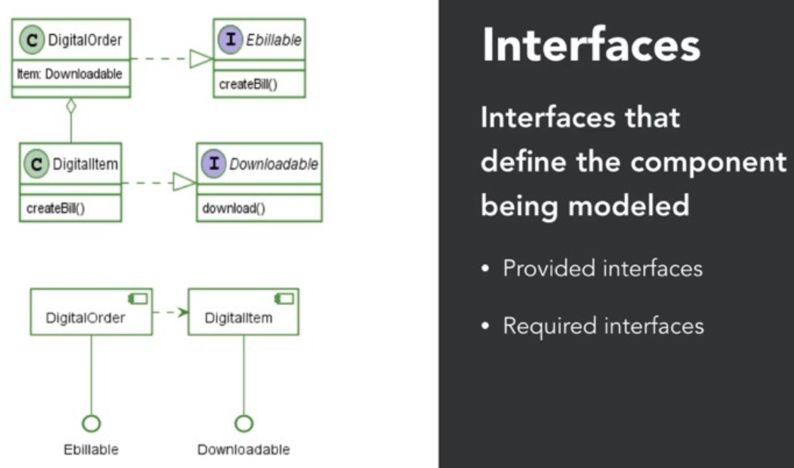
DigitalOrder implements EBillable interface which is provided interface but it also depends on downloadable interface as it has to inculcate DigitalItem component as that in turn depends on Downloadable interface.
Interfaces: Components have provided and required interfaces. Provided interfaces are shown using a lollipop notation, while required interfaces use a socket notation. This helps define what the component can do and what it requires from other components.

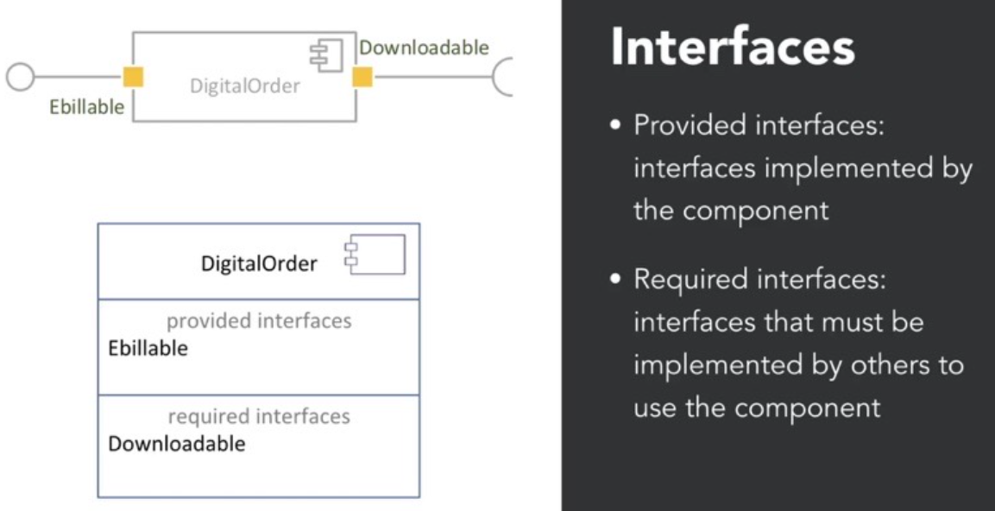
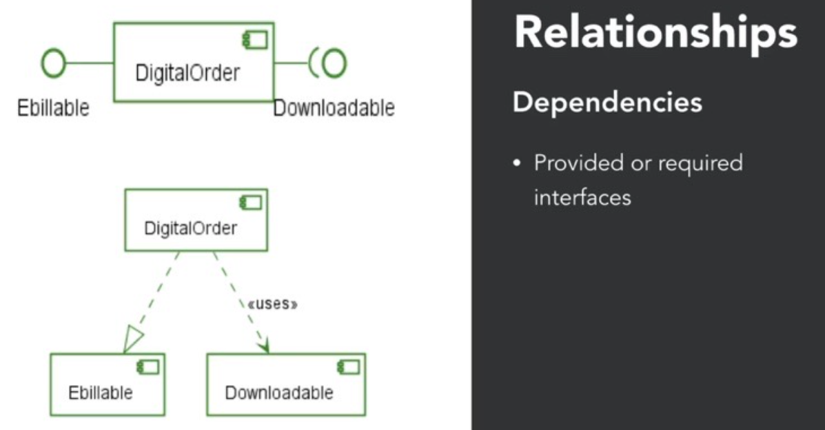

Structural Diagram:
- Package Diagram

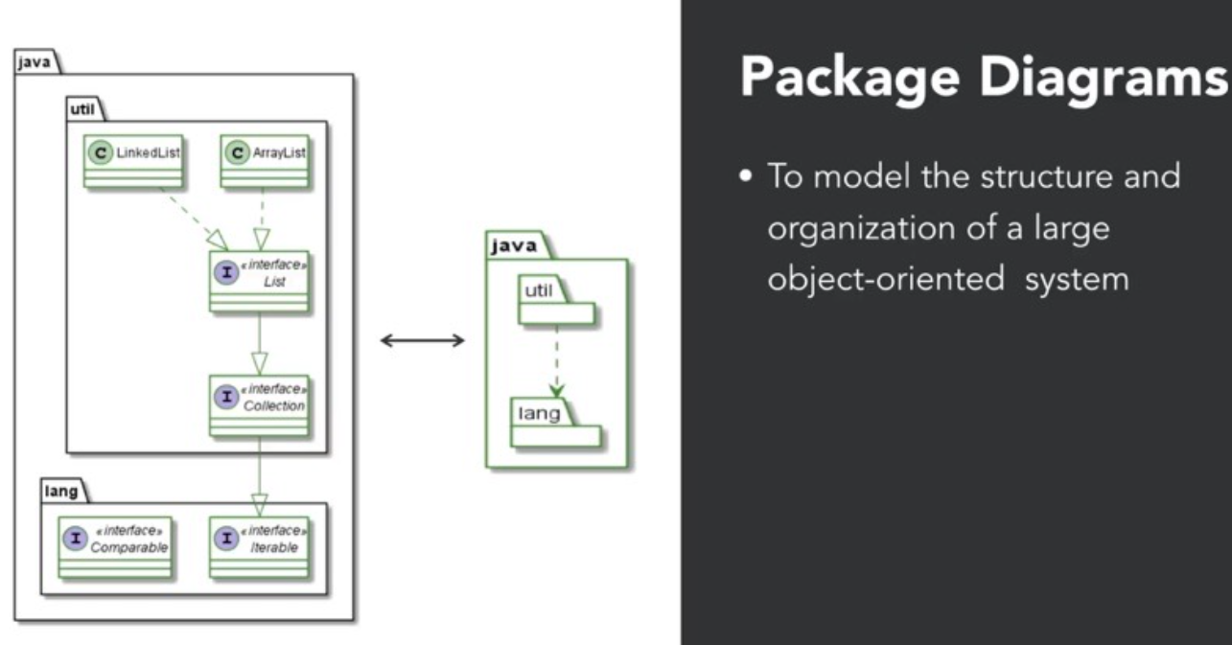
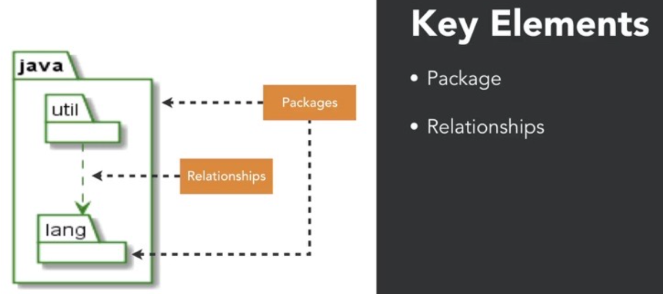

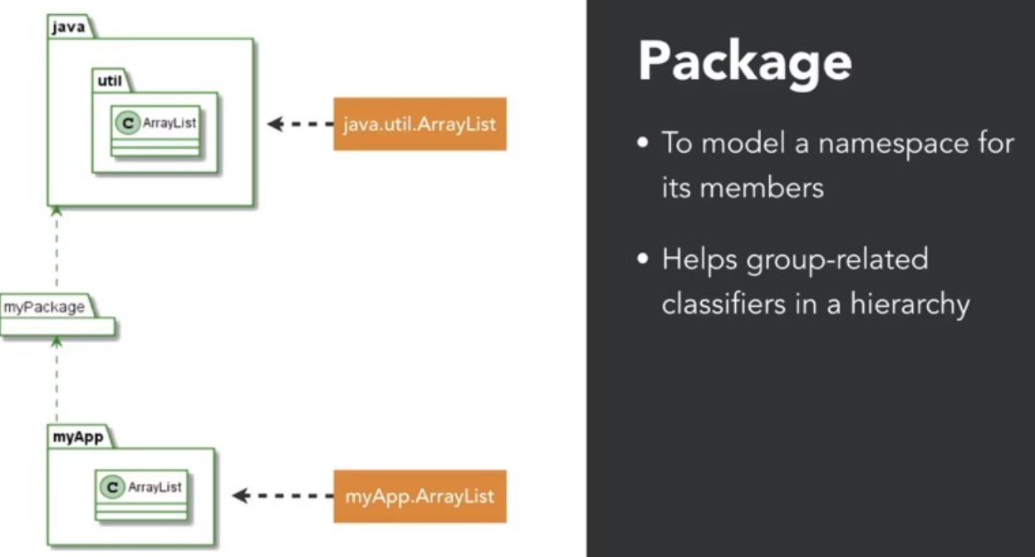
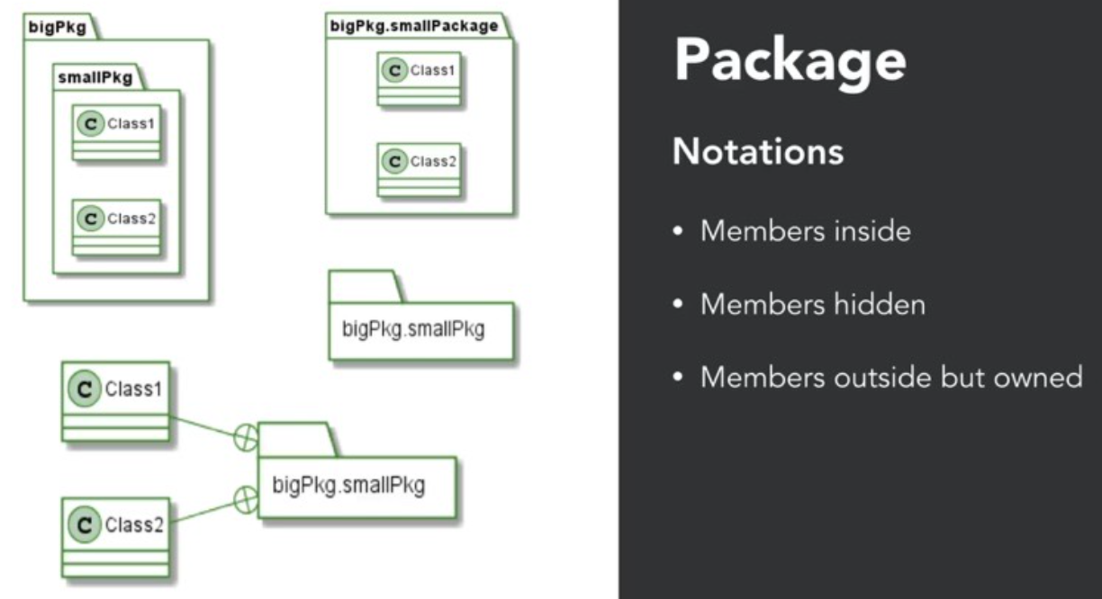

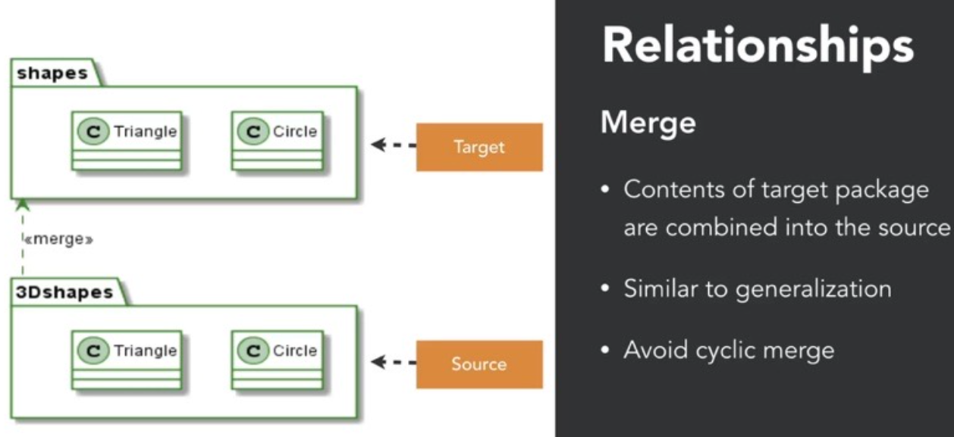

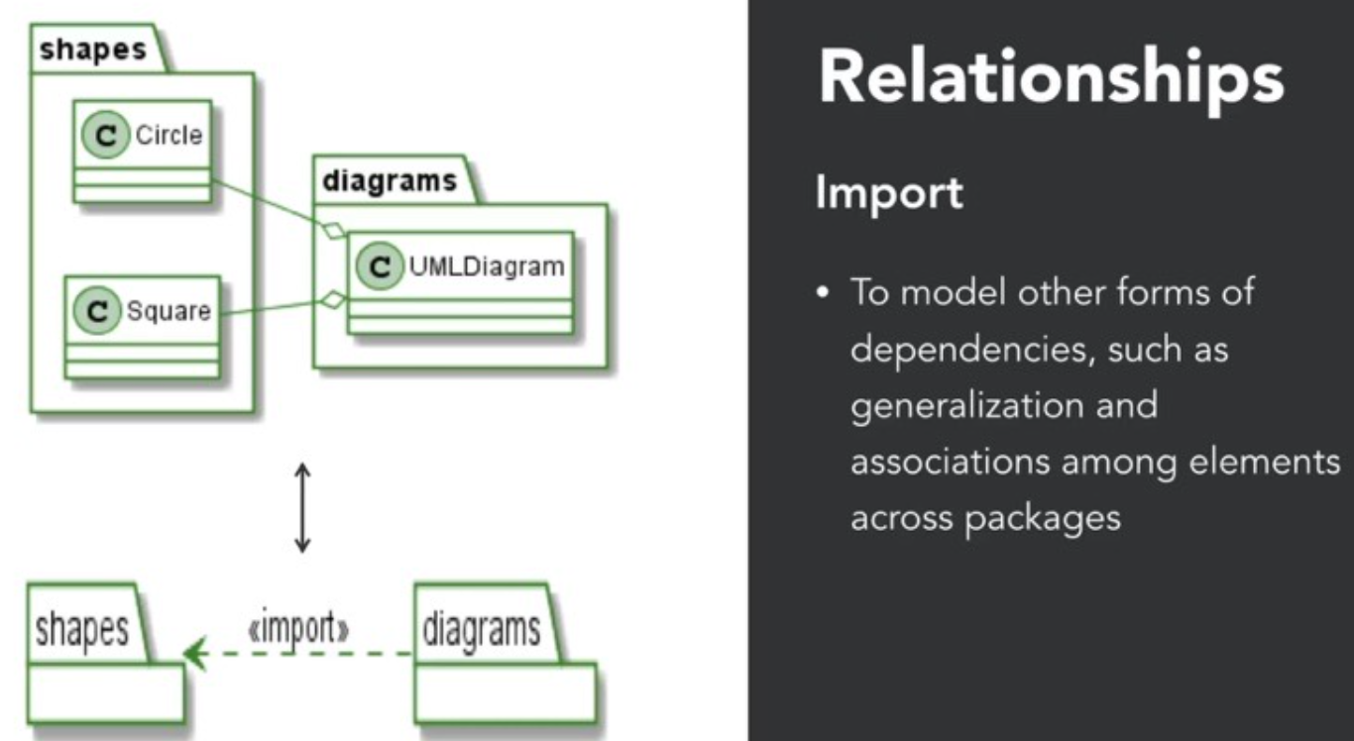

Structural Diagram:
- Deployment Diagram

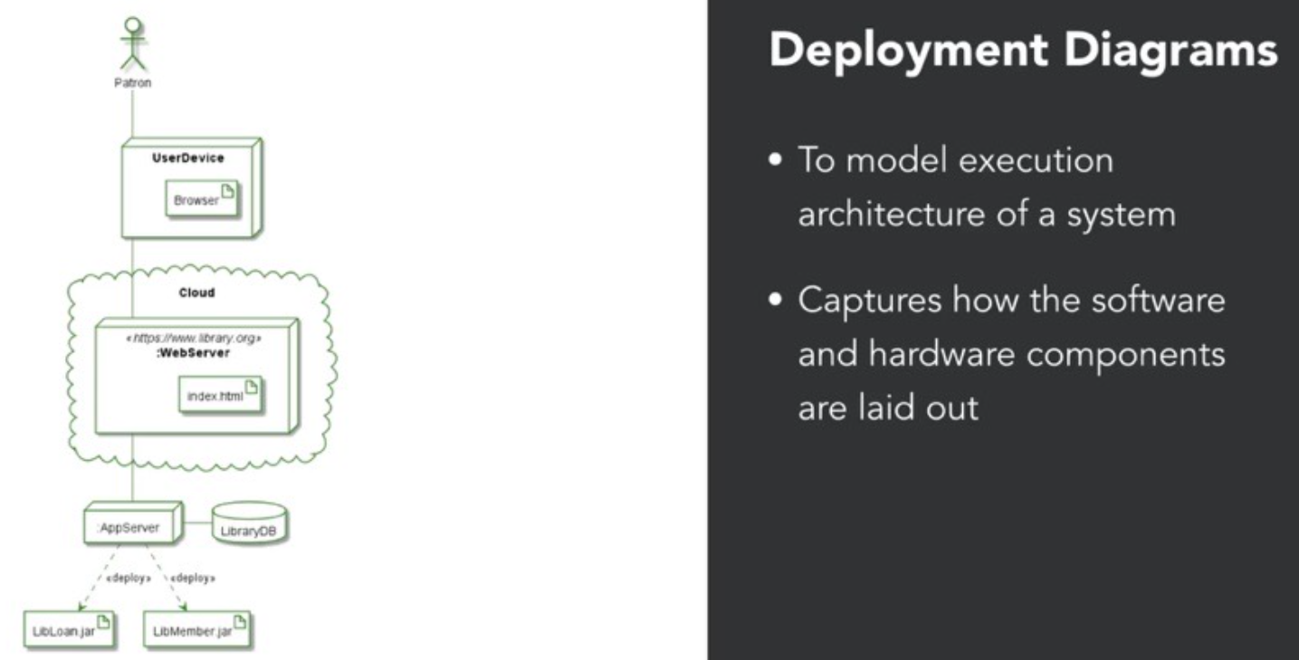
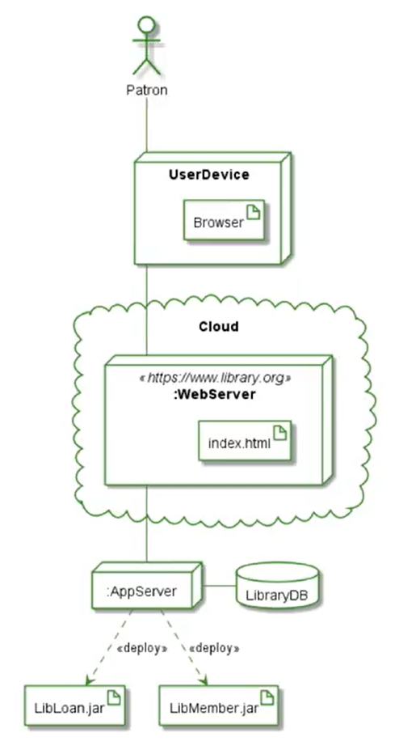
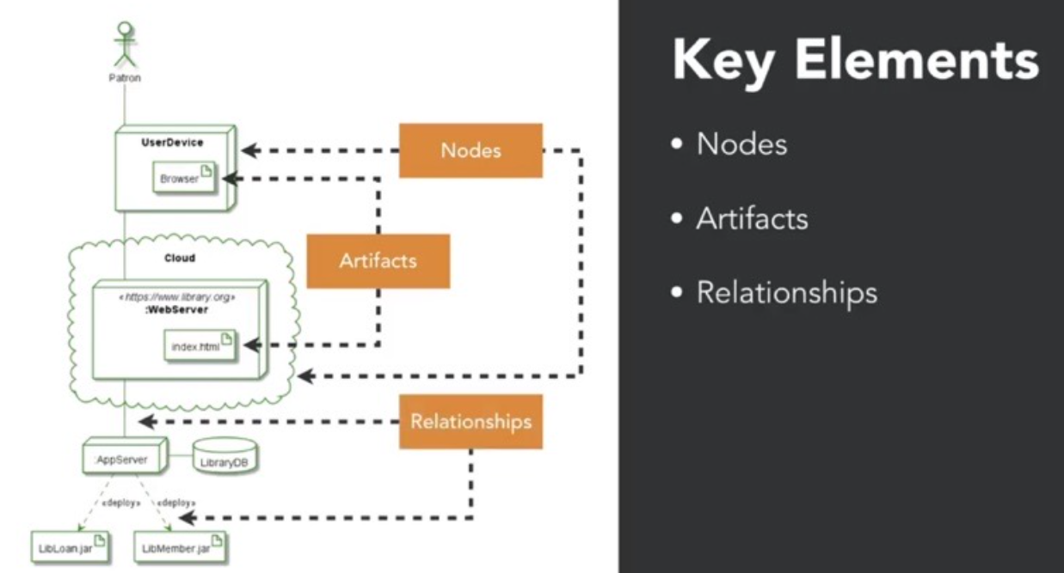

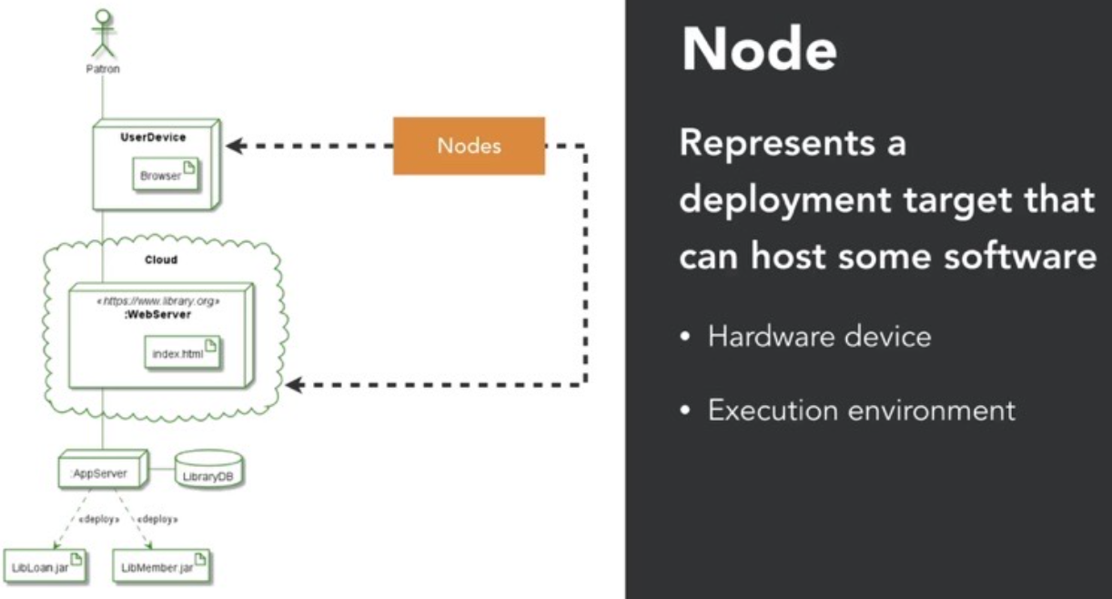

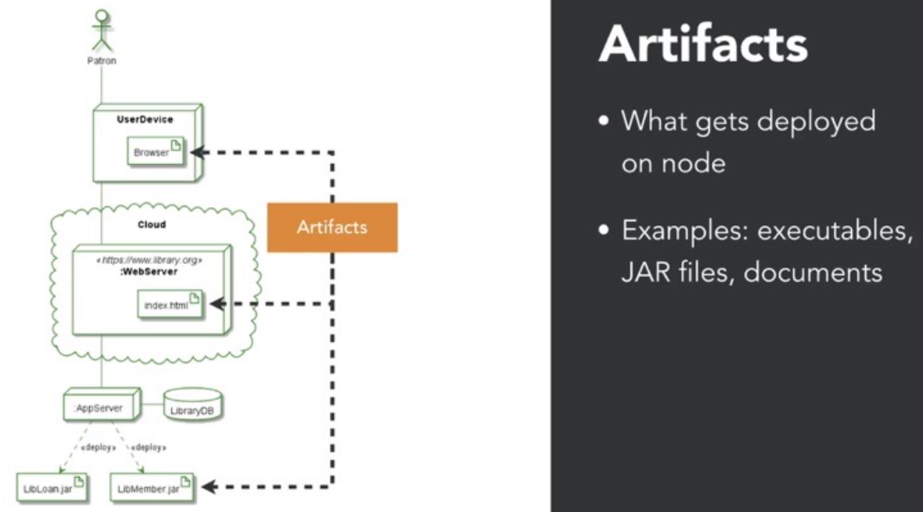

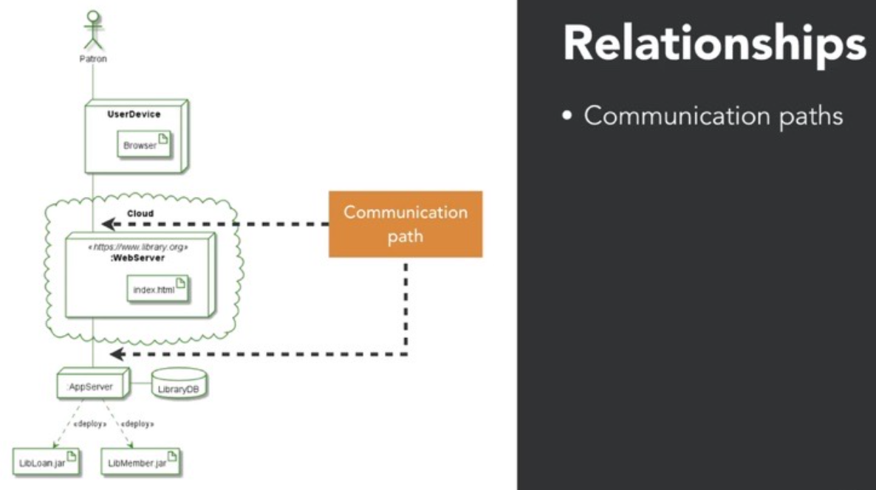
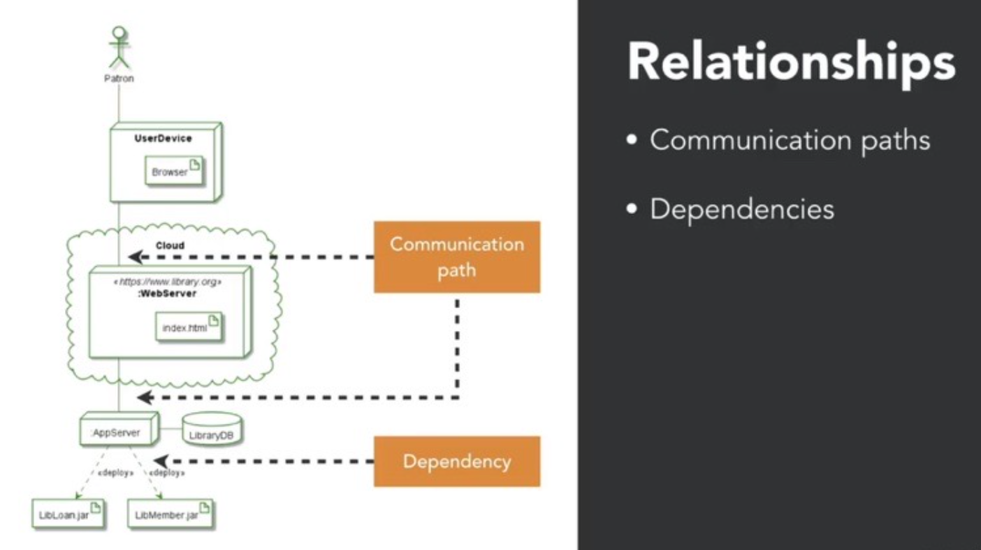

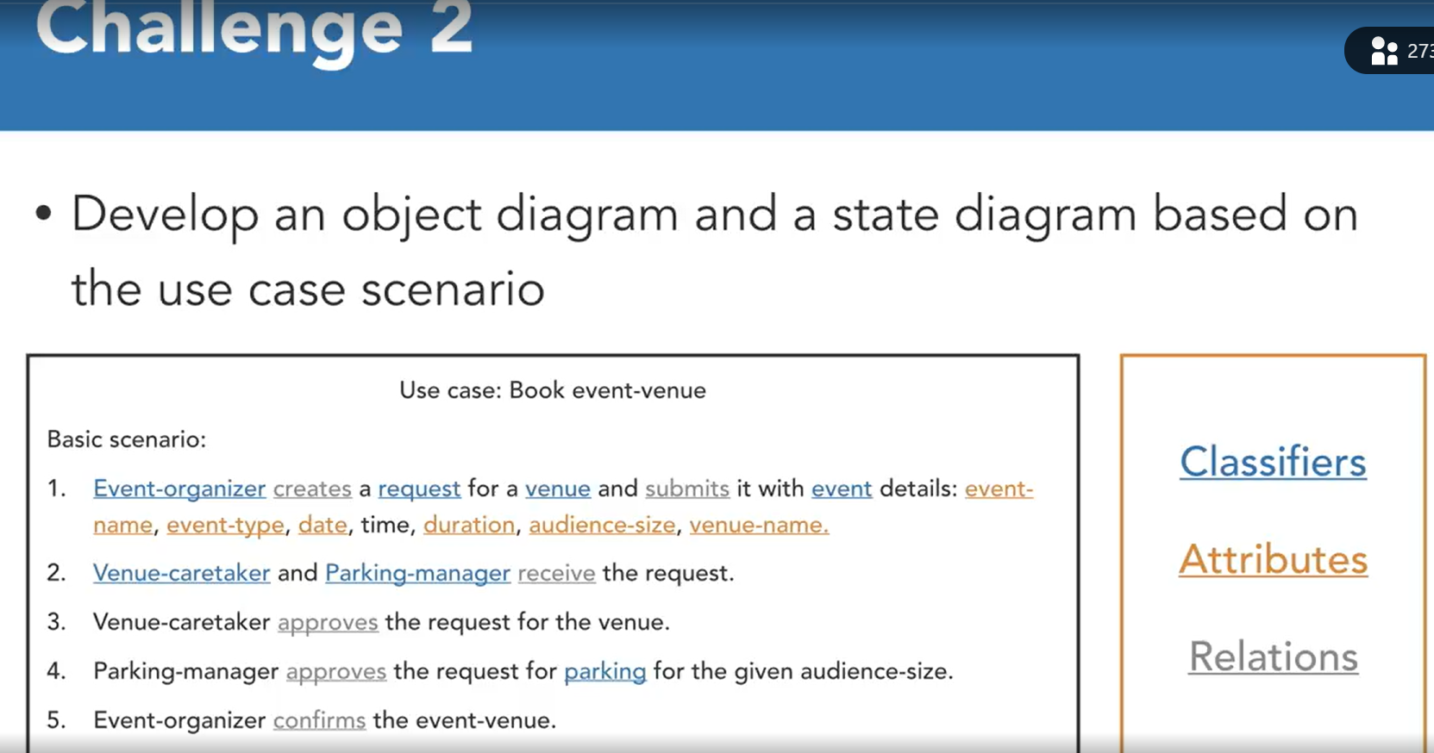
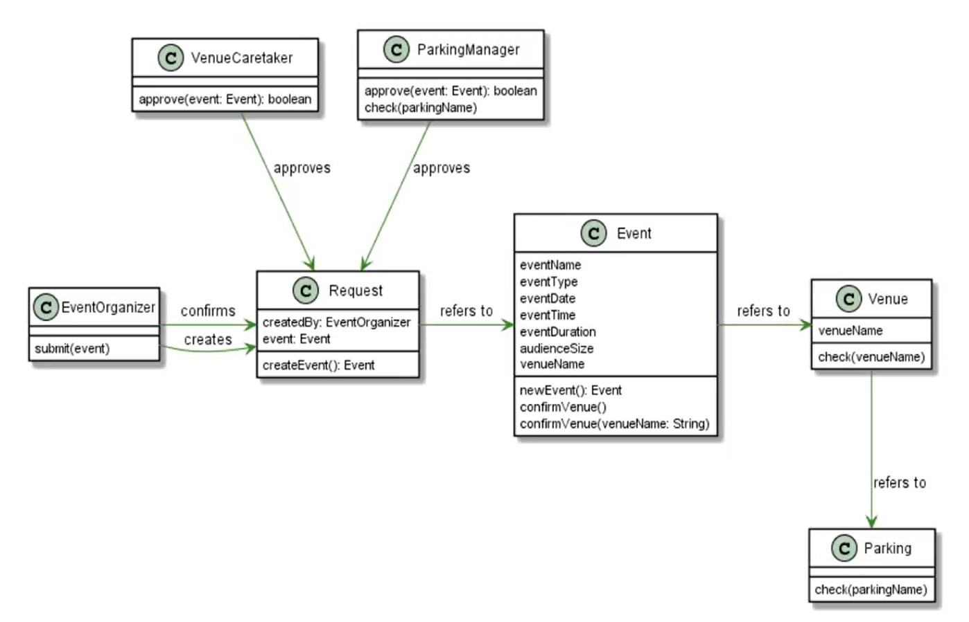
Solution: Object Diagram, Any association requires an ID to establish who created a particular request.
Wrong what I made:
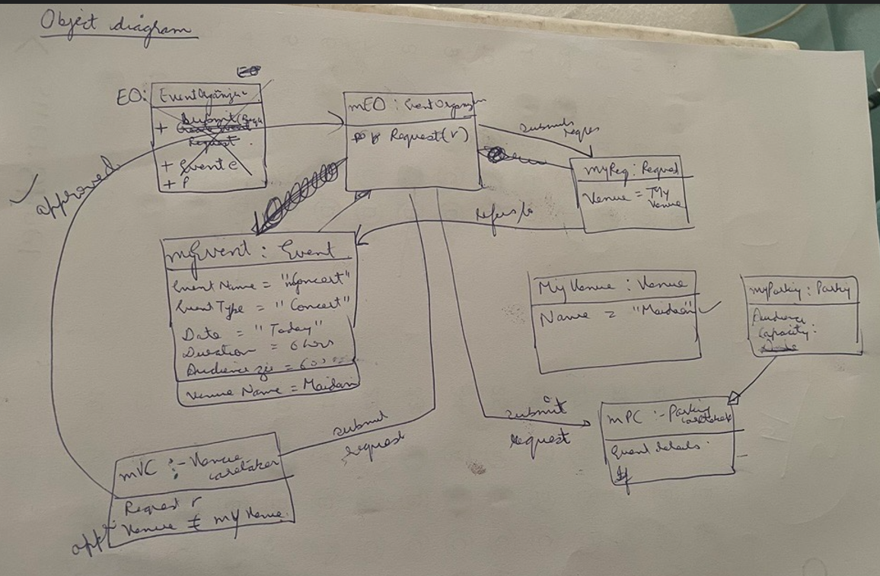
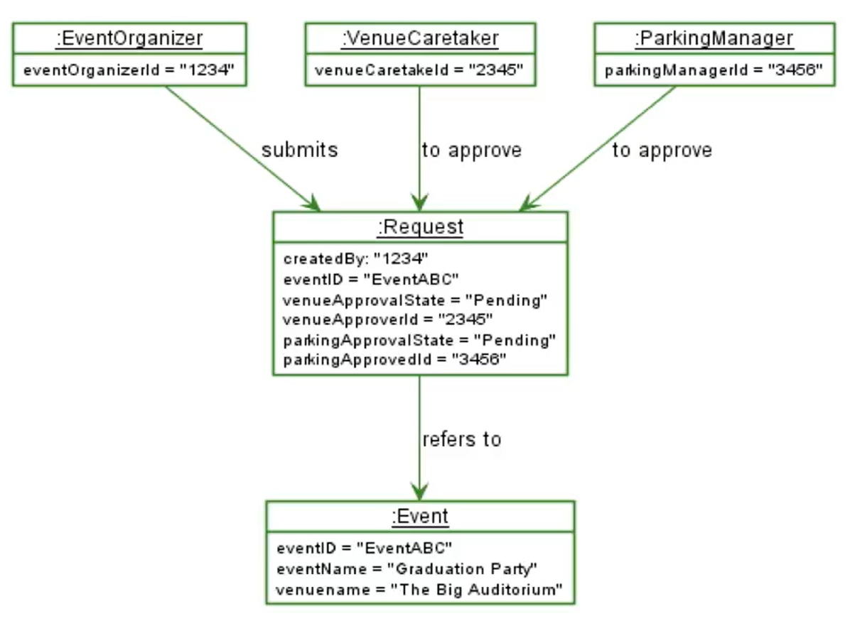

Solution: State Diagram , what I Made: close
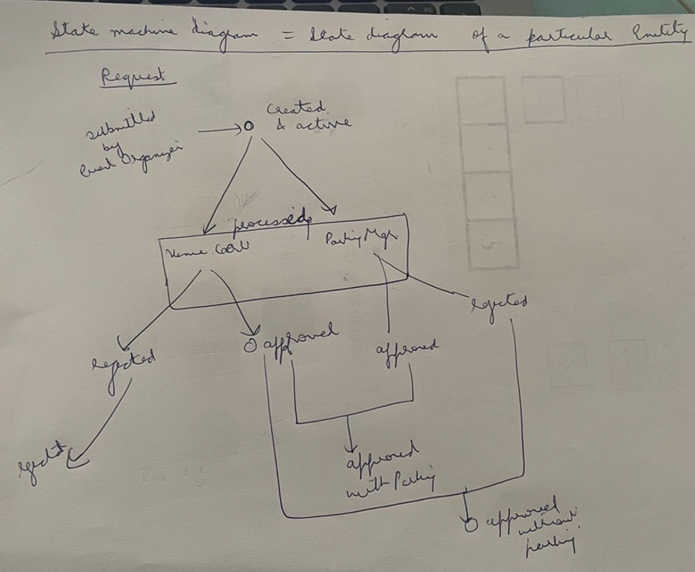
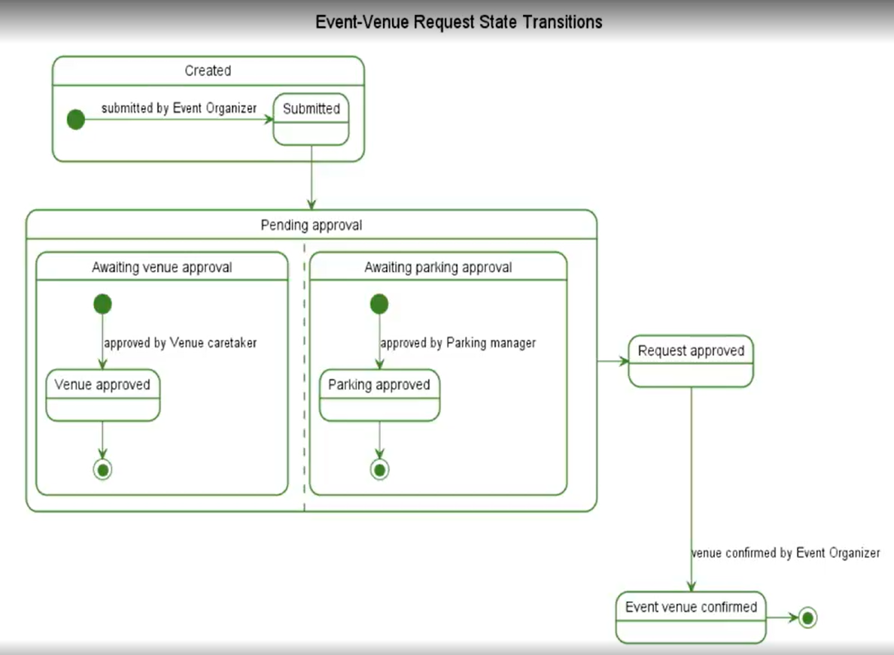

Interaction Diagram:
3.3 Interaction Overview Diagram

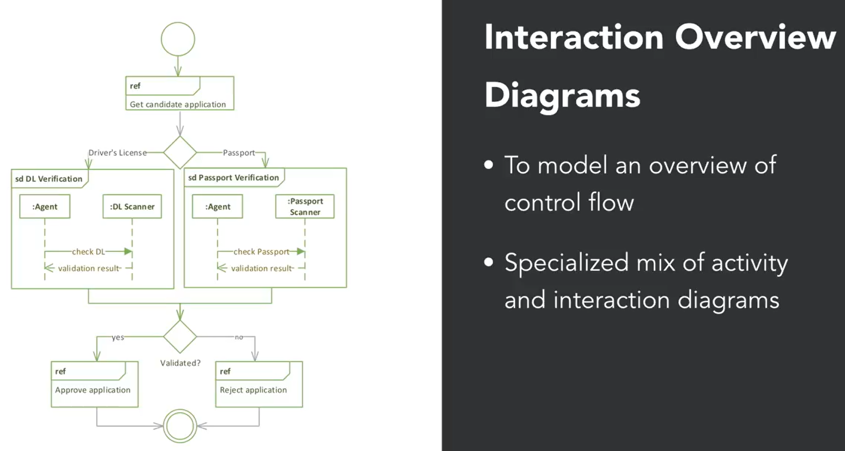

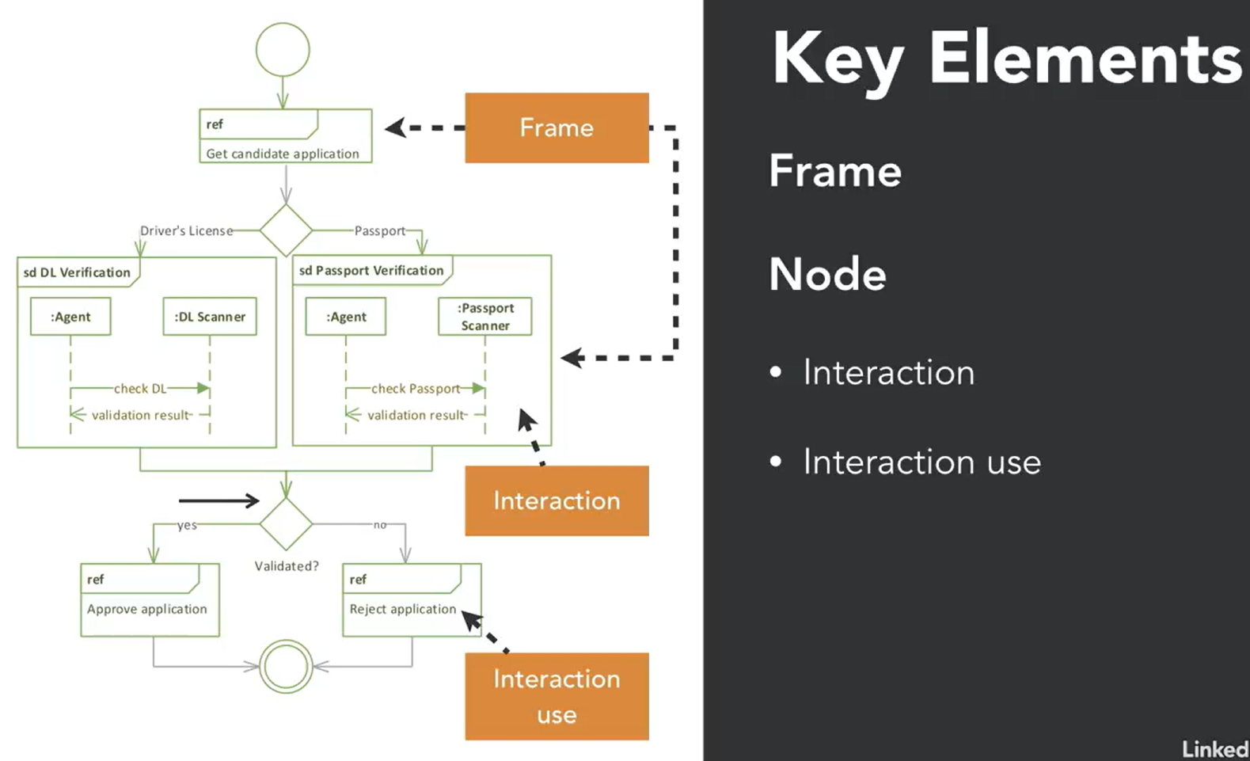

Interaction overview diagram
Learning AI:Here are the key takeaways from the "Interaction overview diagram" video:
- Purpose: Interaction overview diagrams model an overview of control flow, similar to activity diagrams but with interaction nodes.
- Components: They use notations like start and stop, decision and merge, and directional flow of arrows. The key difference is the action node, which is replaced by a combination of frames and interaction nodes.
- Usage: These diagrams are useful for visualizing interactions within a system, such as the example of a candidate applying for a bank account, showing different interactions based on the type of identification document submitted.

Structural Diagram:
- Composite Structure Diagram

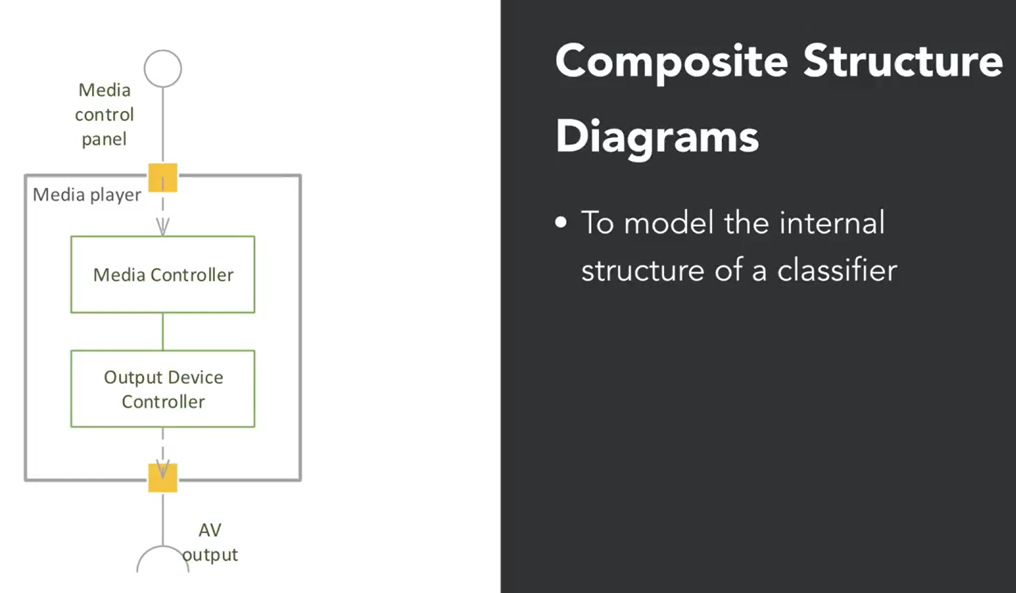

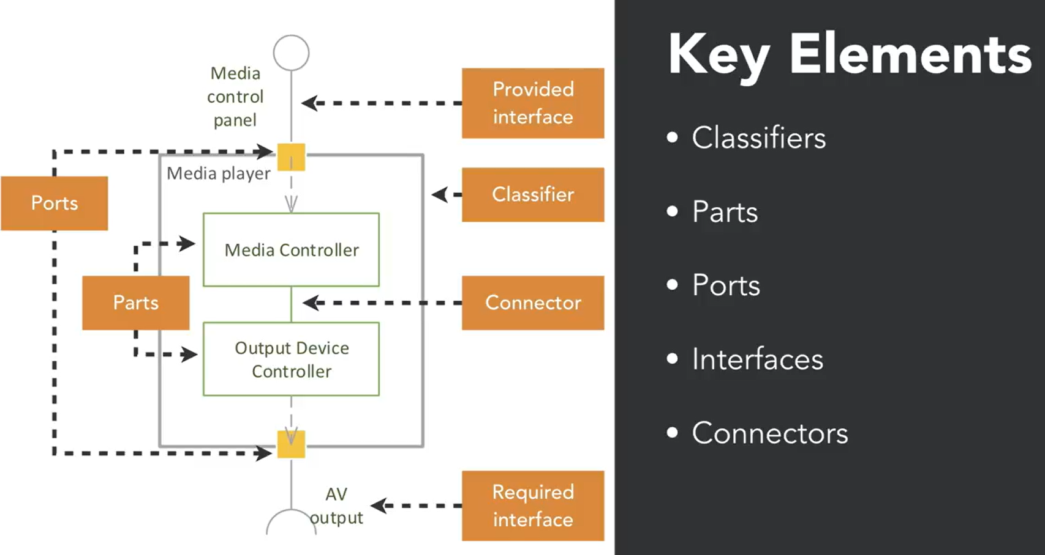
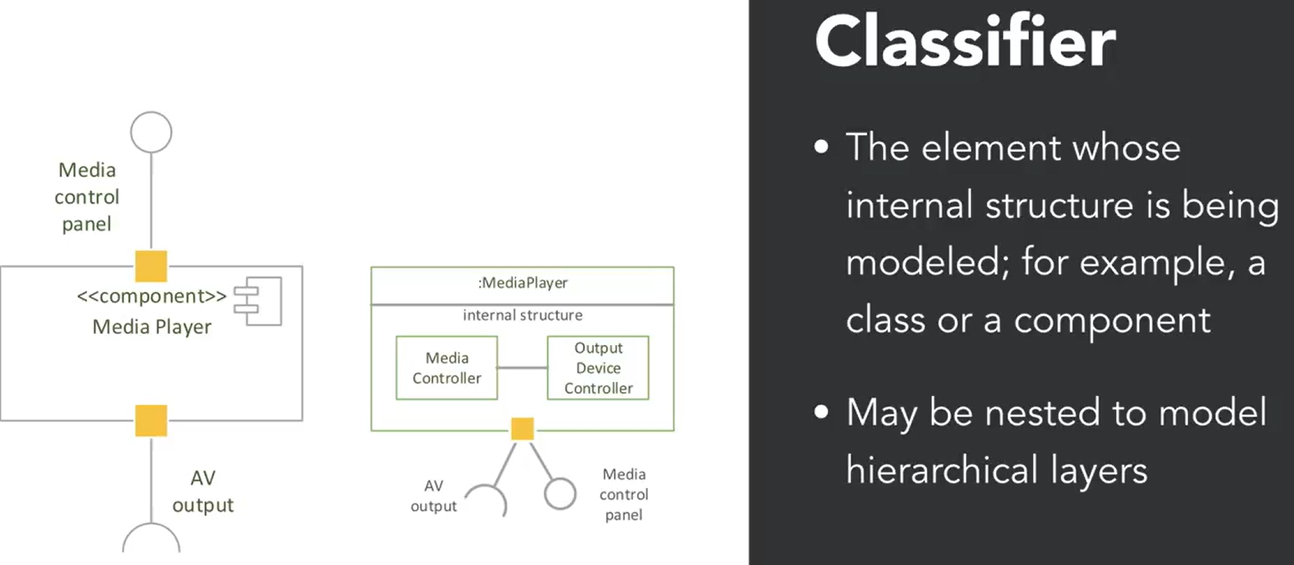
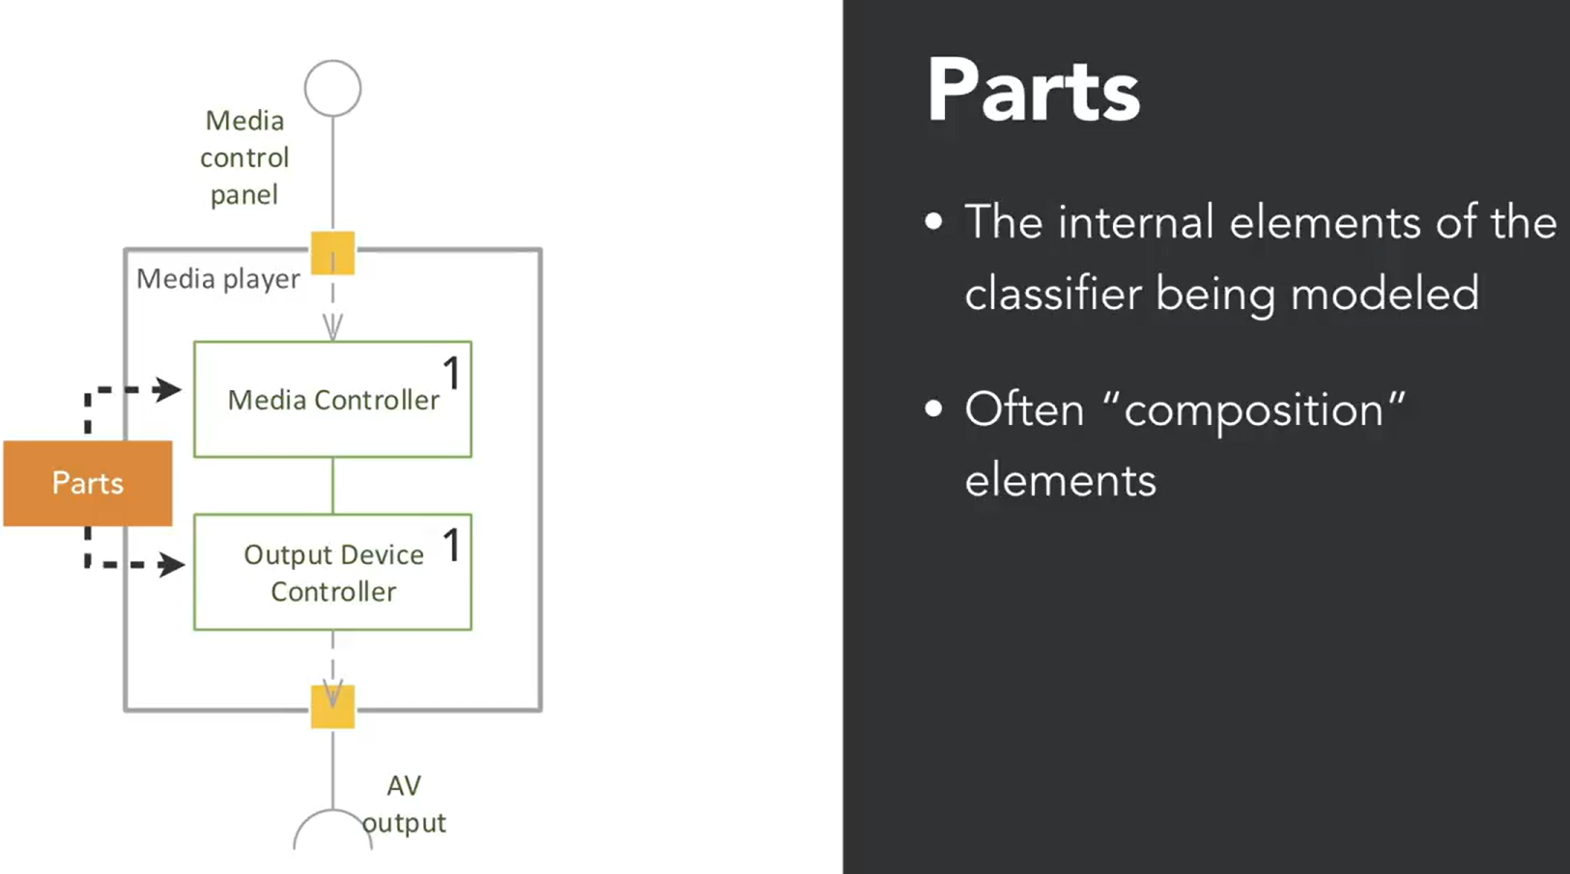
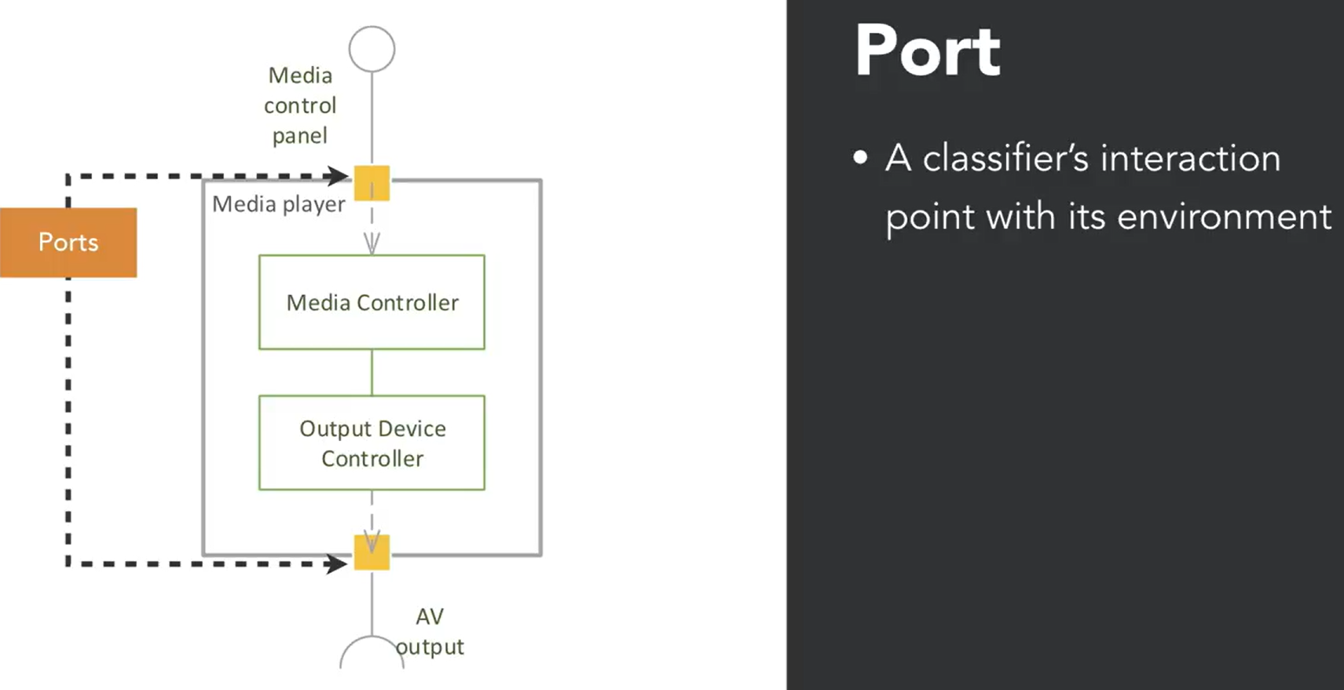
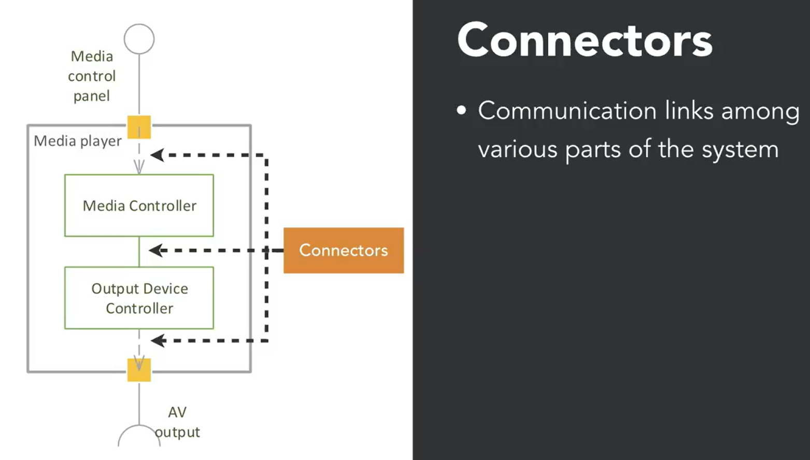

- Composite structure diagrams show the internal structure of a classifier or structural element, such as a class, component, or object.
- These diagrams model how different elements come together when the system is running, similar to component diagrams but also showing internal components.
- Key elements include classifiers, parts, ports, interfaces, and connectors, which help in understanding the internal and external connections within the system.
This video explains how these diagrams help in visualizing the internal workings of complex systems.
- Classifiers: These are structural entities in the system being modeled, such as a class, component, or object. They represent the main elements of the system. For example, in a media player system, the media controller and output device controller are classifiers.
- Parts: These are the internal components within a classifier. They represent elements that are fully contained within the classifier. For instance, in the media player example, the media controller and output device controller are parts within the media player classifier.
- Ports: These are external connection points of a classifier. They are depicted as small squares and are used to connect interfaces. Ports allow interaction between the classifier and the external environment. For example, the media control panel and audio/video output interfaces are connected to the media player through ports.
- Interfaces: These define the types of interactions that can occur at the ports. They are shown as lollipop (provided interface) and socket (required interface) symbols. In the media player example, the media control panel interface is provided by the media controller, and the AV output interface is required by the output device controller.
- Connectors: These are communication links between the internal parts of the system. They show how different parts are connected and interact with each other. In the media player example, connectors link the media controller and output device controller to show their interaction.
Interaction Diagram:
3.4 Timing Diagrams

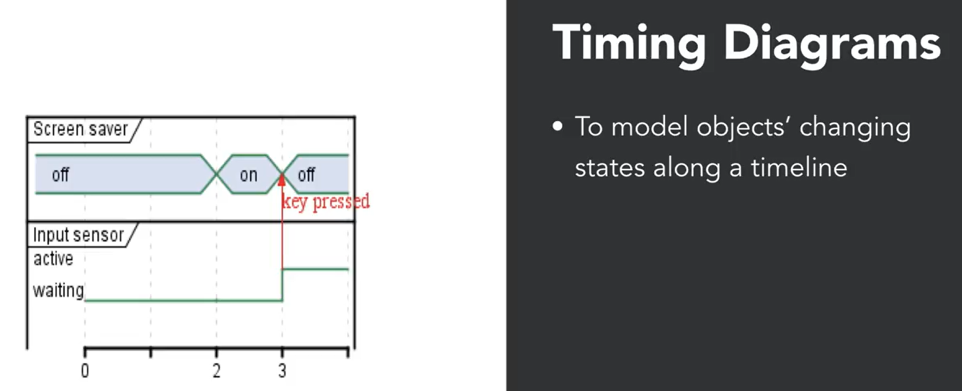
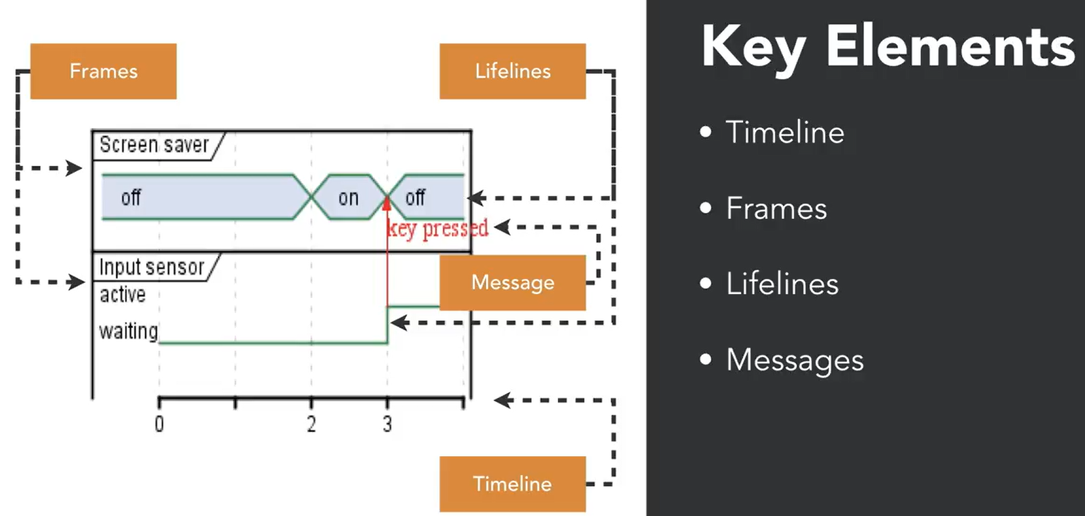
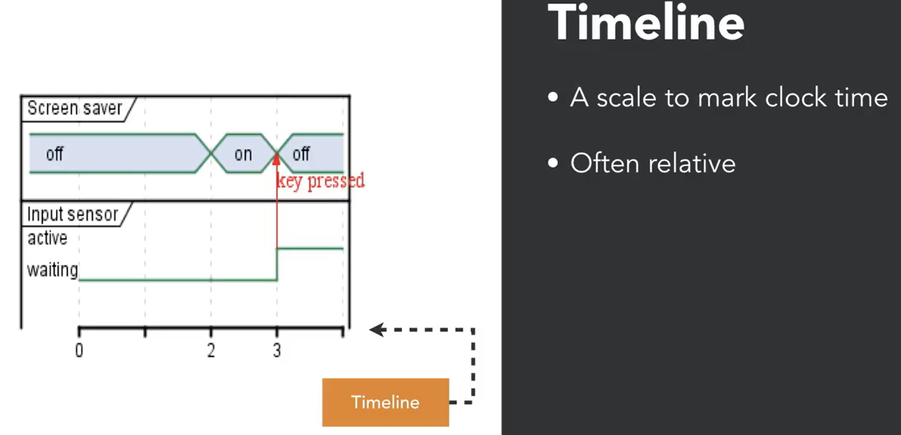
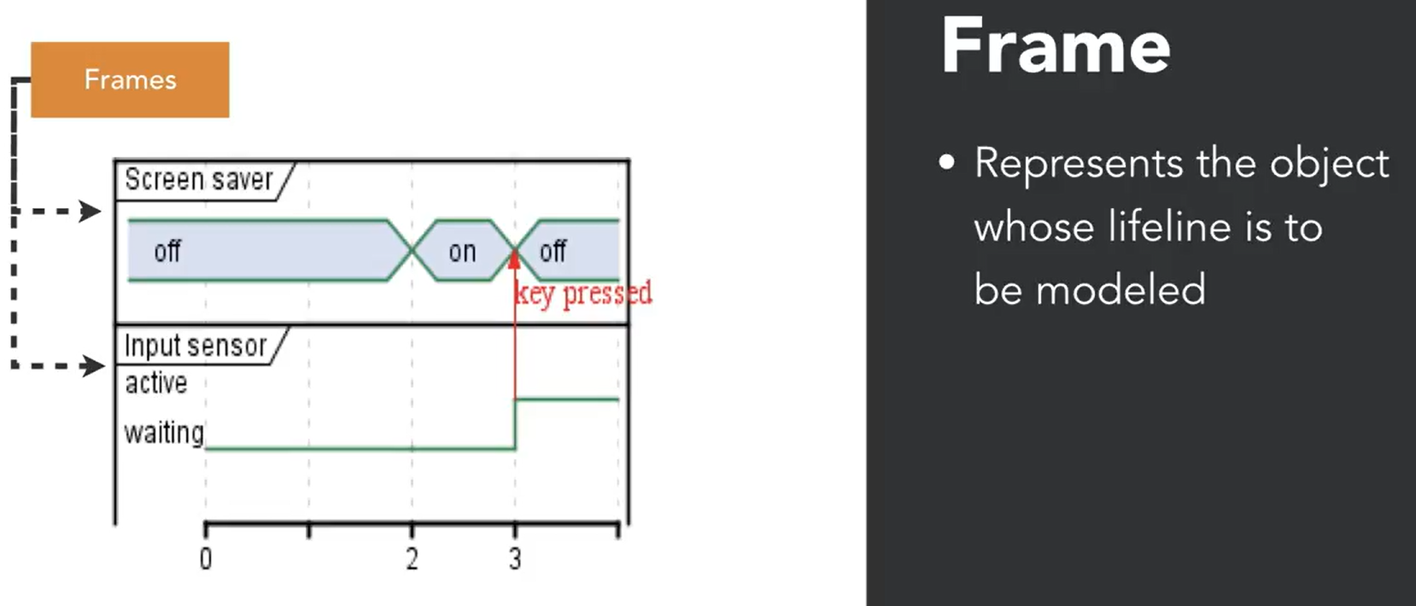
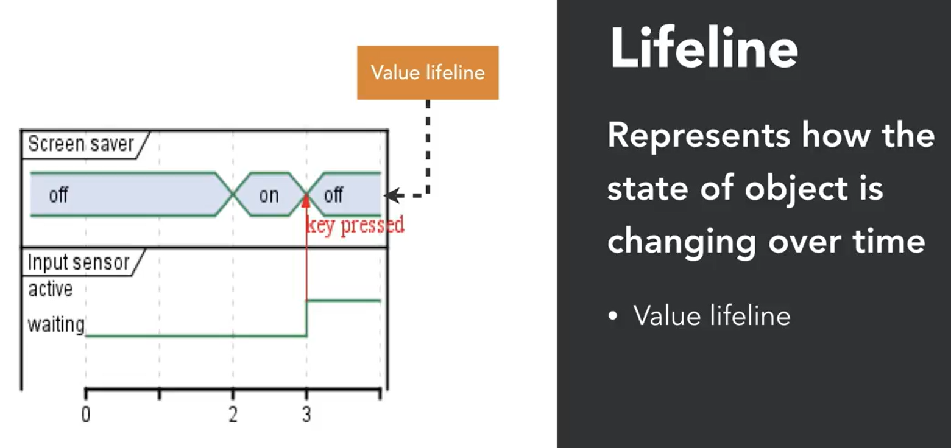
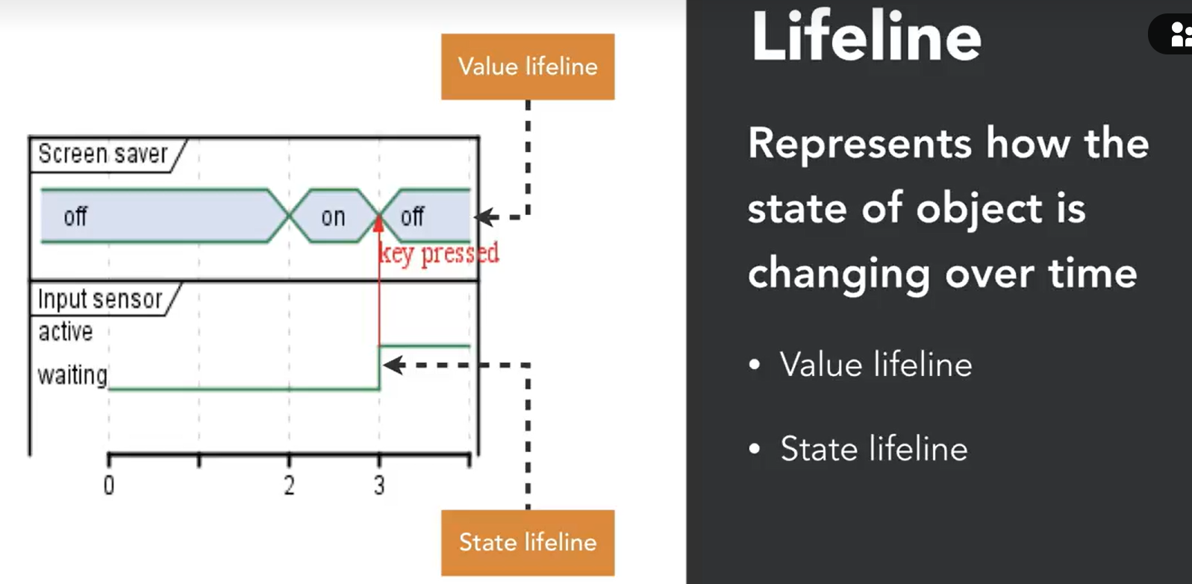
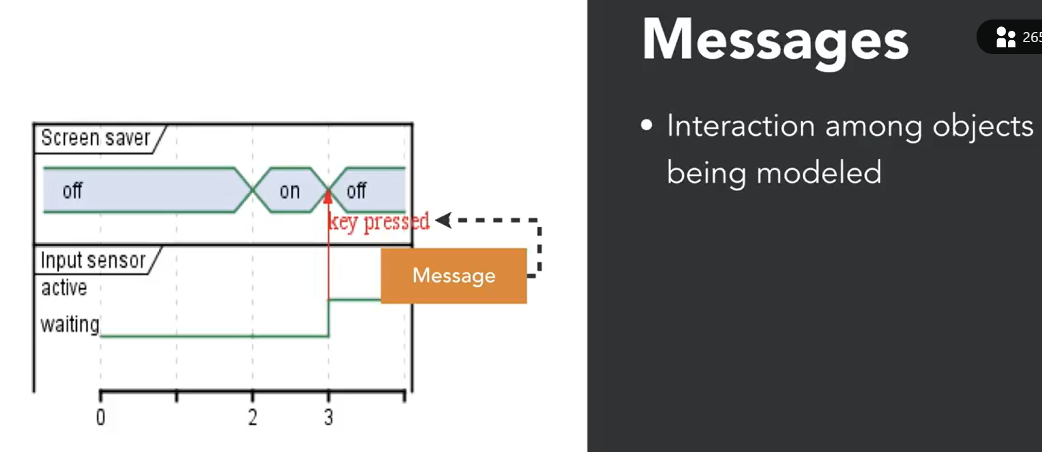
Here are the key takeaways from the "Timing diagrams" video:
- Purpose: Timing diagrams model how the states of different objects change over time, triggered by clock time or messages from other objects.
- Key Elements: The four key elements in timing diagrams are Timelines, Frames, Lifelines, and Messages.
  - Timelines: A scale marking clock time in any unit.
  - Frames: Space for modeling an object's lifeline.
  - Lifelines: Represent changing states of objects, with two notations: Value Lifeline and State Lifeline.
  - Messages: Indicate interactions between objects, such as a message from an input sensor to a screen saver.
This video uses an example of a screen saver and input sensor to illustrate these concepts.

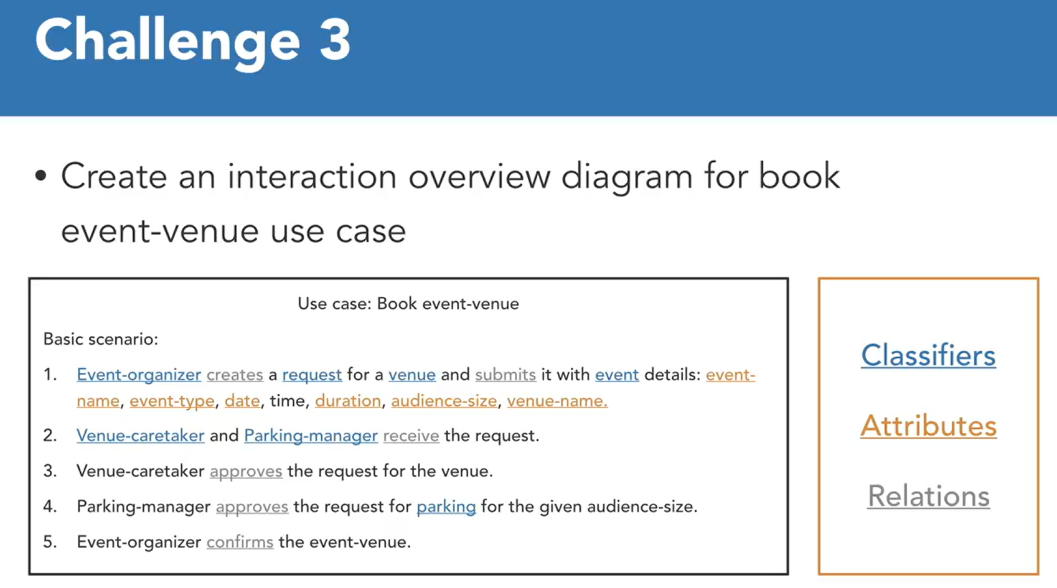

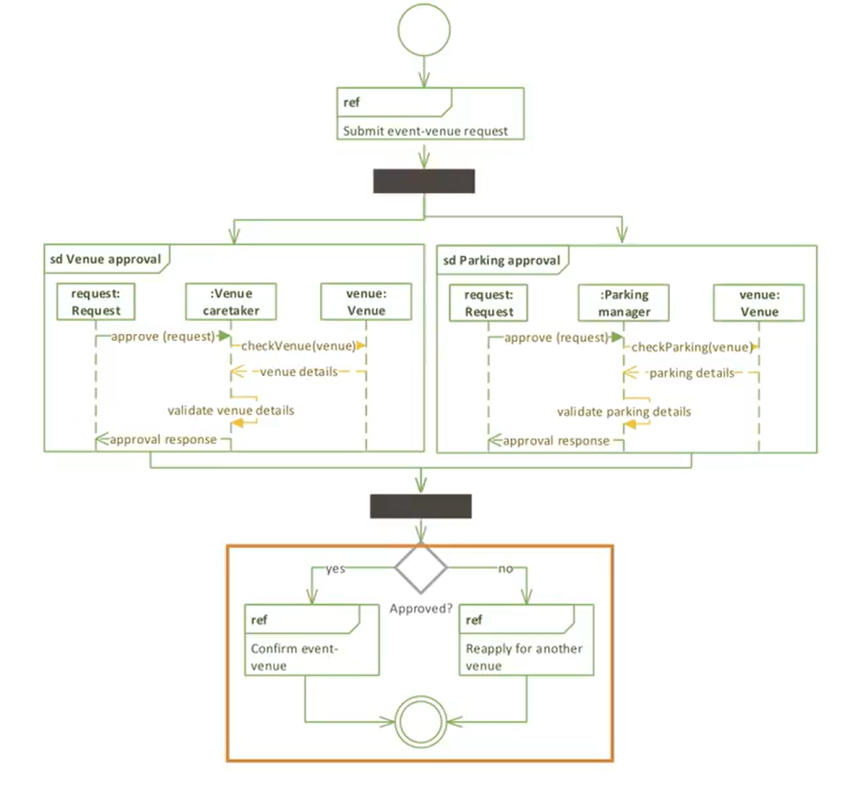
- Interaction Overview Diagram: Combines activity and interaction diagrams to show internal interactions among entities.
- Parallel Tracks: The diagram splits into two parallel tracks for venue and parking approval, showing interactions among three objects within each track.
- Conditional Flow: After approval, the tracks join, and based on whether the request was approved, the event venue is either confirmed or a new request is created.

