Google Ads Audit Report

# Campaign Performance (w/ Benchmark Overlay)

|  |  |  |  |  |  |  |  |  |  |
| --- | --- | --- | --- | --- | --- | --- | --- | --- | --- |
| Campaign Name | CTR | Cost ($) | Clicks | Impressions | CTR Flag | Avg CPC | Avg CPC Flag | CPA ($) | CPA ($) Flag |
| VPP_Search_Leads_USA_03/08/2024 (Exp 1) | 8.48% | $1929.53 | 173 | 2041 | Above | $11.15 | Above | $148.43 | Above |

# Campaign Insights

# Campaign Insights

|  |  |  |
| --- | --- | --- |
| Characteristic | Insight | Recommendation |
| Cost Per Acquisition (CPA) | The campaign has generated 13 conversions at a CPA of $148.43. | Analyze the search term report to identify and add irrelevant or low-converting queries as negative keywords. Evaluate the conversion action settings to ensure only valuable conversions are being tracked, and consider implementing conversion value to better prioritize bids. |
| Average Cost Per Click (Avg CPC) | The campaign's Avg CPC is $11.15, which significantly impacts the high CPA of $148.43. | Focus on improving Quality Score by enhancing ad relevance and landing page experience. Conduct keyword research to identify long-tail keywords with lower competition and higher intent. Review bid adjustments for devices, locations, or audiences that show higher CPCs without proportional conversion rates. |
| Budget Utilization and Potential Scale | The campaign has fully utilized its daily budget of $50, accumulating a total cost of $1929.53, and achieved 2041 impressions. | Prioritize optimizing the CPA before considering budget increases. Once CPA is within an acceptable range, gradually increase the daily budget by 10-20% while closely monitoring performance to capture additional eligible impression share and scale conversion volume. |
| Click-Through Rate (CTR) | The campaign exhibits a strong CTR of 8.48%, indicating high ad relevance to user searches and effective ad copy. | Capitalize on the high CTR by ensuring the landing page experience is seamless and highly relevant to the ad copy. Implement A/B tests on landing page elements (e.g., CTAs, forms, value propositions) to improve conversion rates and maximize the value of each click. Continue refining ad copy for even stronger calls to action. |

# Keyword Performance

|  |  |  |  |  |  |  |  |  |
| --- | --- | --- | --- | --- | --- | --- | --- | --- |
| Ad Group | Keyword | Match Type | Quality Score | Impressions | Clicks | CTR | Avg CPC | CPA ($) |
| Video Mailers | video mailers | PHRASE | 3 | 239 | 24 | 10.04% | $14.05 | $168.56 |
| VPP Brochures | video brochures | PHRASE | 5 | 309 | 20 | 6.47% | $14.56 | $145.59 |
| Video Books | promotional video book | PHRASE | 6 | 70 | 10 | 14.29% | $14.16 | $0.00 |
| Video Box | video box | PHRASE | 3 | 359 | 21 | 5.85% | $5.36 | $0.00 |
| Video Box | box with video screen | PHRASE | 4 | 25 | 7 | 28.00% | $13.82 | $96.75 |
| Video Box | video box marketing | PHRASE | 6 | 68 | 7 | 10.29% | $11.73 | $82.11 |
| Video Mailers | video mailers marketing | PHRASE | 7 | 73 | 6 | 8.22% | $11.74 | $0.00 |
| Video Mailers | custom video mailers | PHRASE | 5 | 46 | 6 | 13.04% | $10.98 | $65.85 |
| Video Mailers | video brochure mailer | PHRASE | 4 | 31 | 2 | 6.45% | $32.27 | $43.03 |
| Video Box | custom video box | PHRASE | 5 | 37 | 4 | 10.81% | $15.01 | $0.00 |
| VPP Brochures | video brochure card | PHRASE | 4 | 95 | 5 | 5.26% | $9.54 | $0.00 |
| Video Books | personalized video books | PHRASE | 5 | 86 | 11 | 12.79% | $4.30 | $47.31 |
| Video Books | video book marketing | PHRASE | 6 | 81 | 7 | 8.64% | $5.69 | $19.93 |
| Video Mailers | video card mailer | PHRASE | 3 | 15 | 3 | 20.00% | $12.41 | $37.24 |
| Video Books | custom video books | PHRASE | 5 | 102 | 8 | 7.84% | $4.63 | $0.00 |
| VPP Brochures | video brochure manufacturer | PHRASE | 3 | 3 | 2 | 66.67% | $11.74 | $0.00 |
| VPP Brochures | lcd video brochure | PHRASE | 3 | 5 | 1 | 20.00% | $13.72 | $0.00 |
| VPP Brochures | video brochure marketing | PHRASE | 5 | 2 | 1 | 50.00% | $12.49 | $0.00 |
| VPP Brochures | video brochure pricing | PHRASE | 0 | 10 | 1 | 10.00% | $11.03 | $0.00 |
| VPP Brochures | lcd screen video brochure | PHRASE | 4 | 11 | 1 | 9.09% | $10.84 | $0.00 |
| VPP Brochures | video brochure book | PHRASE | 5 | 2 | 1 | 50.00% | $9.41 | $0.00 |
| Video Box | video gift box | PHRASE | 5 | 41 | 3 | 7.32% | $2.85 | $0.00 |
| VPP Brochures | 4.3 inch video brochure | PHRASE | 0 | 3 | 1 | 33.33% | $7.84 | $0.00 |
| VPP Brochures | brochure with video screen | PHRASE | 5 | 3 | 1 | 33.33% | $7.42 | $0.00 |
| Video Box | gift box with video screen | PHRASE | 1 | 2 | 1 | 50.00% | $5.91 | $0.00 |
| Video Mailers | lcd video mailers | EXACT | 0 | 1 | 1 | 100.00% | $5.87 | $0.00 |
| VPP Brochures | custom video brochures | PHRASE | 7 | 37 | 2 | 5.41% | $2.52 | $10.10 |
| Video Box | promotional video box | PHRASE | 3 | 4 | 1 | 25.00% | $3.77 | $0.00 |
| VPP Brochures | video brochure usa | PHRASE | 4 | 25 | 1 | 4.00% | $2.51 | $0.00 |
| VPP Brochures | video screen brochure | PHRASE | 5 | 12 | 0 | 0.00% | $0.00 | $0.00 |
| VPP Brochures | media fast video brochure | PHRASE | 1 | 5 | 0 | 0.00% | $0.00 | $0.00 |
| VPP Brochures | video brochure maker | PHRASE | 4 | 2 | 0 | 0.00% | $0.00 | $0.00 |
| Video Books | lcd video book | PHRASE | 5 | 4 | 0 | 0.00% | $0.00 | $0.00 |
| VPP Brochures | digital video brochures | PHRASE | 4 | 4 | 0 | 0.00% | $0.00 | $0.00 |
| Video Mailers | mailer with video screen | PHRASE | 4 | 1 | 0 | 0.00% | $0.00 | $0.00 |
| Video Mailers | video mailer box | PHRASE | 5 | 4 | 0 | 0.00% | $0.00 | $0.00 |
| Video Box | video brochure box | PHRASE | 2 | 7 | 0 | 0.00% | $0.00 | $0.00 |
| Video Mailers | mediafast video mailer | PHRASE | 2 | 22 | 0 | 0.00% | $0.00 | $0.00 |
| Video Box | video presentation box | PHRASE | 2 | 5 | 0 | 0.00% | $0.00 | $0.00 |
| Video Box | lcd video box | PHRASE | 5 | 4 | 0 | 0.00% | $0.00 | $0.00 |

# Keyword Insights

# Keyword Insights

|  |  |  |
| --- | --- | --- |
| Characteristic | Insight | Recommendation |
| High Spend, Zero Conversions | The keywords 'promotional video book' has accrued $141.59 in cost, 'video box' has accrued $112.52, and 'custom video box' has accrued $60.06, all without generating any conversions. This indicates wasted ad spend. | Pause or significantly reduce bids for 'promotional video book', 'video box', and 'custom video box'. Analyze search query reports for these keywords to identify negative keyword opportunities or more relevant exact match targets. |
| Low Quality Score Keywords | Keywords such as 'video mailers' (QS 3), 'video box' (QS 3), 'video brochure pricing' (QS 0), and '4.3 inch video brochure' (QS 0) exhibit critically low Quality Scores (below 5). This negatively impacts ad rank and CPC. | For keywords with QS 0, pause them immediately. For those with QS 1-4, review ad copy to ensure it directly aligns with keyword intent, optimize landing page content for relevance, and test different ad formats or extensions to improve ad relevance and expected CTR. |
| High Cost Per Acquisition (CPA) | Keywords like 'video mailers' and 'video brochures' are generating conversions but at very high costs, with CPAs of $168.56 and $145.59 respectively (each with 2 conversions). | Implement bid strategies focused on target CPA for these keywords, or manually reduce bids incrementally. Simultaneously, improve ad relevance and landing page experience to potentially lower CPC and thus CPA, and add more specific negative keywords to filter out irrelevant traffic. |
| High Conversion Rate, Opportunity for Optimization | The keyword 'video brochure mailer' shows an exceptionally high Conversion Rate of 75% (1.5 conversions from 2 clicks), but it has a low Quality Score of 4 and a high Average CPC of $32.28. | Increase bids and budget allocation for 'video brochure mailer' to capture more volume. Focus on improving its Quality Score by optimizing ad copy for higher CTR and ensuring the landing page is highly relevant and user-friendly, which could reduce CPC and further improve performance. |
| Underperforming Keyword with Impressions | The keyword 'video screen brochure' has received 12 impressions but zero clicks, resulting in a 0% CTR. This suggests the keyword is either irrelevant, the ad copy is unappealing, or competition is too high for the current bid. | Review the search terms for 'video screen brochure' to determine if it's genuinely relevant. If relevant, rewrite ad copy to be more compelling and directly address user intent. If not, consider pausing the keyword or adding it as a negative keyword to conserve budget. |

# Wasted Spend Insights

# Wasted Spend Insights

|  |  |  |
| --- | --- | --- |
| Characteristic | Insight | Recommendation |
| Highest Spend, Abysmal CTR, High CPC, Zero Conversions | The keyword 'promotional video book' has incurred the highest cost of $141.59 with a critically low CTR of 0.14% and a high Avg CPC of $14.16, resulting in zero conversions. | Immediately pause 'promotional video book'. This keyword is a significant budget drain due to its poor engagement and lack of conversions. Consider adding 'book' as a negative keyword to related terms if it implies a product you don't offer, or if your product is a 'video book' but the ad/landing page is not resonating. Investigate search terms to identify exact match intent that might be triggering this broad match. |
| High Spend, Extremely Low CTR, Very Low Quality Score, Zero Conversions | The keyword 'video box' has spent $112.52 with an abysmal CTR of 0.06% and a very poor Quality Score of 3, leading to no conversions. | Pause 'video box' due to its extremely low engagement and Quality Score. This indicates a severe mismatch between user intent, ad copy, and/or landing page. Analyze search terms for irrelevant queries. If this is a core product, consider rebuilding the ad group with very specific ad copy and a dedicated landing page, focusing on high Quality Score components like Ad Relevance and Landing Page Experience, or move it to a negative keyword list if truly irrelevant. |
| High Spend, Very Low CTR, High CPC, Zero Conversions | The keyword 'video mailers marketing' has cost $70.46 with a very low CTR of 0.08% and a high Avg CPC of $11.74, yielding zero conversions despite a decent Quality Score of 7. | Review the ad copy and landing page for 'video mailers marketing'. The high Quality Score suggests good relevance, but the low CTR indicates the ad isn't compelling enough, and zero conversions highlight an offer or landing page issue. A/B test new ad copy focusing on strong value propositions and clear calls-to-action. Ensure the landing page directly addresses 'marketing' needs for video mailers and has a clear conversion path. |
| High Spend, Low CTR, Extremely High CPC, Zero Conversions | The keyword 'custom video box' has spent $60.06 with a low CTR of 0.11% and the highest Avg CPC of $15.01 among problematic keywords, resulting in zero conversions. | Reduce bids significantly for 'custom video box' or pause it. This keyword is extremely expensive per click with very little engagement or conversion value. Implement aggressive negative keywords to refine traffic, and consider moving 'custom video box' to an exact match only campaign to control spend and ensure high relevance if it's a key offering. |
| Significant Spend, Abysmal CTR, Low Quality Score, Zero Conversions | The keyword 'video brochure card' has spent $47.71 with an extremely low CTR of 0.05% and a low Quality Score of 4, leading to no conversions. | Pause 'video brochure card'. The combination of high spend, abysmal CTR, and low Quality Score indicates a complete breakdown in relevance and performance. Verify that 'brochure card' accurately describes your product. If so, create a highly specific ad group with dedicated ads and a landing page that directly addresses 'video brochure cards' to improve all Quality Score components. |
| Moderate Spend, High CTR, Very Low Quality Score, Zero Conversions | The keyword 'video brochure manufacturer' has spent $23.48 with a high CTR of 0.67% but a very poor Quality Score of 3, and zero conversions. | This high CTR for 'video brochure manufacturer' suggests ad copy is appealing, but the very low Quality Score points to a problematic landing page experience or relevance, ultimately leading to zero conversions. Audit the landing page for 'video brochure manufacturer' for speed, mobile-friendliness, clear call-to-actions, and content relevance. If you are not a manufacturer, add 'manufacturer' as a negative keyword to avoid unqualified clicks. |
| High-Intent Keyword, Problematic Quality Score, Zero Conversions | The keyword 'video brochure pricing' has spent $11.03 with zero conversions, and an unusual/problematic Quality Score of 0. (Note: A Quality Score of 0 is typically indicative of insufficient data or an extreme system error, implying severe underlying issues.) | Immediately investigate the Quality Score for 'video brochure pricing' and thoroughly review the landing page for this high-intent keyword. Users searching for 'pricing' are usually close to conversion. Ensure the landing page provides clear pricing information, a quote request form, or direct contact options. Consider pausing if the Quality Score cannot be improved to a reasonable level, as this keyword is clearly underperforming despite intent. |
| High CTR, Extremely Low Quality Score (1), Zero Conversions | The keyword 'gift box with video screen' has spent $5.91 with a high CTR of 0.50% but an extremely poor Quality Score of 1, resulting in zero conversions. | The high CTR for 'gift box with video screen' suggests ad copy effectiveness, but a Quality Score of 1 indicates a critical issue with the landing page experience and/or ad relevance to the keyword. Perform an immediate, thorough audit of the landing page's speed, mobile usability, content match to ad/keyword, and conversion funnel. If your product is not primarily a 'gift box', add 'gift' as a negative keyword to filter out irrelevant searches. |

# Landing Page Audit Insights

## Landing Page: https://videoplusprint.com/video-in-print-products

# Landing Page Insights

|  |  |  |  |
| --- | --- | --- | --- |
| URL | Characteristic | Insight | Recommendation |
| https://videoplusprint.com/video-in-print-products | Conversion Rate & CPA Analysis | With a 7.5% conversion rate, the page is effective at generating leads. However, the high CPA of $148.43 suggests either a very high customer lifetime value, or inefficiencies in ad targeting, lead qualification, or pricing competitiveness. | Conduct a deep dive into post-conversion lead quality. Are these leads converting into paying customers at a profitable rate? If not, refine Google Ads targeting to ensure higher intent traffic. Explore offering a lower-friction conversion point (e.g., 'Download a Product Guide' or 'Request a Sample Kit' for a nominal fee) for earlier funnel engagement to potentially reduce CPA. |
| https://videoplusprint.com/video-in-print-products | Call to Action (CTA) | The 'GET A FREE QUOTE' CTA is clear and repeated, which is good for direct response. However, its prominent placement and singular focus might overwhelm users who are not yet ready to commit to a full quote request. | A/B test the primary CTA. Consider variations like 'Request a Custom Quote,' 'Get Pricing & Options,' or 'Start Your Project Today' to see if different phrasing resonates better. Additionally, introduce a secondary, lower-commitment CTA (e.g., 'See Case Studies' or 'View Product Gallery') for visitors who need more nurturing before requesting a quote. |
| https://videoplusprint.com/video-in-print-products | Lead Form User Experience | The immediate placement of the detailed quote form above the fold is direct but introduces high friction upfront. The length of dropdowns (Country, Quantity, Screen Size) can be cumbersome, potentially leading to abandonment, especially on mobile. | Implement a multi-step form to reduce initial perceived friction. Optimize dropdowns by pre-populating common countries (e.g., USA, Canada, UK) at the top, and offering 'Other' options instead of exhaustive lists for quantity and screen size. Clearly state what happens *after* submission (e.g., 'Expect a personalized quote within 24 business hours'). |
| https://videoplusprint.com/video-in-print-products | Trust Signals and Social Proof | The inclusion of testimonials from recognizable brands like Volvo, Volkswagen, and Commonwealth Bank is a powerful trust signal and a significant strength of the page. This builds credibility effectively. | Ensure no repetition of testimonials (the Volvo quote appears twice). Consider adding more visual trust signals such as security badges (e.g., 'Secure Form'), industry awards, or 'As Seen In' logos if applicable. Explore integrating video testimonials for even higher impact. |
| https://videoplusprint.com/video-in-print-products | Content Clarity and Information Hierarchy | The headline 'Premium Video-In-Print Turn Your Brand into an Experience' clearly communicates the offering. The bullet points 'Fully Customizable, Low Minimum Order, Trusted by Global Brands, Proven Engagement Booster' are strong value propositions. However, specific use cases beyond the general product types could be clearer. | Expand on specific use cases for each product type (e.g., 'Video Business Cards for high-impact networking events'). Add a 'How It Works' section to guide users through the process from inquiry to delivery, managing expectations and reducing uncertainty. Consider a dedicated FAQ section to proactively answer common questions about production time, design, and shipping. |
| https://videoplusprint.com/video-in-print-products | Competitor Benchmark | Based on the CPA, the cost per acquisition is relatively high for a B2B lead, suggesting potential competitive pressure or a need to justify the value more robustly against alternatives. | Research direct competitors' landing page strategies. Analyze their lead generation forms (length, required fields), pricing models (transparent vs. quote-based), and value propositions. Identify industry benchmarks for B2B lead generation CPAs in the custom video print space to validate if the current CPA is competitive or requires aggressive optimization. |
| https://videoplusprint.com/video-in-print-products | Conversion Rate / CPA | The CPA of $148.43 is exceptionally high, indicating a severe disconnect between the ad click and the user taking a conversion action. Users are expensive to acquire and the page is failing to convert them efficiently. The 13 conversions from 173 clicks suggest a conversion rate of roughly 7.5%, which, while not terrible in B2B, is clearly not efficient enough for the current ad spend. | Prioritize a comprehensive CRO sprint focusing on the conversion funnel. Conduct user testing to identify specific friction points. Implement A/B tests on the main headline, value proposition statement, and primary call-to-action (CTA) above the fold to directly address the high cost per acquisition. |
| https://videoplusprint.com/video-in-print-products | Above-the-Fold Messaging & Clarity | The provided content snippet abruptly begins with 'vent, that’s why we chose to use this concept for our event'. This strongly suggests a missing or poorly optimized above-the-fold section, which is critical for immediate user engagement. Without a clear, compelling headline and value proposition visible upon arrival, users are likely confused or disengaged quickly. | Redesign the entire above-the-fold experience. Ensure a strong, benefit-driven headline (e.g., 'Elevate Your Marketing with Interactive Video in Print'), a clear sub-headline articulating the unique value proposition, and a prominent, concise primary CTA are visible without scrolling. This immediate clarity is crucial for reducing bounce rates and guiding user intent. |
| https://videoplusprint.com/video-in-print-products | Call-to-Action (CTA) Strategy | While 'Get A FREE Video Brochure QUOTE' is specific, it may not resonate with all users in their initial consideration phase, especially for a complex, potentially high-value product. The page offers various 'video in print products,' but the CTA is singular to 'Video Brochure,' potentially limiting perceived relevance for other product interests. | Optimize CTA placement and variation. Ensure the primary CTA is highly visible and repeated strategically throughout the page. Consider A/B testing CTA copy to 'Request a Custom Quote' or 'Get a FREE Consultation' to broaden appeal. Also, explore secondary CTAs for deeper engagement, such as 'Download Case Studies' or 'See Product Demos,' to cater to users at different stages of the buying cycle. |
| https://videoplusprint.com/video-in-print-products | Trust Signals & Credibility | The statement 'Since 2009, Video Plus Print has delivered video-in-print solutions with over 40 years of expertise' creates a confusing credibility gap. A company founded in 2009 cannot have 40 years of *its own* expertise, potentially eroding trust. The 'Most Valuable Company 2016' award is also dated, reducing its immediate impact. | Immediately clarify or rephrase the '40 years of expertise' statement to accurately reflect combined team experience if that's the case, or remove it if it cannot be justified. Prioritize showcasing more recent client testimonials, current industry awards, and detailed case studies (beyond just client names) to build contemporary trust and social proof. |
| https://videoplusprint.com/video-in-print-products | Value Proposition & Product Showcasing | The text effectively lists various video-in-print products and their benefits (e.g., 'Engage and impress,' 'captivate, convert'), and outlines use cases ('Sales, Marketing, Branding'). However, for a product whose primary appeal is visual and interactive, the textual description alone is insufficient to convey the 'wow' factor and unique selling proposition. | Integrate compelling, high-quality visual content. This includes professional product photography, short demonstration videos showcasing the interactive elements (screens, buttons, unboxing experiences), and potentially a gallery or interactive module where users can explore different product types. The visual experience must match the product's promise. |
| https://videoplusprint.com/video-in-print-products | Competitor Benchmark | Leading competitors in the custom video brochure space (e.g., MediaFast, PrintAVideo) often leverage interactive product builders or extensive video galleries that allow users to virtually experience the product's quality and customization options. Their landing pages typically offer a clearer visual pathway to understanding complex products and overcoming initial purchase hesitation, which seems to be a major hurdle here given the high CPA. | Conduct a competitive analysis of top-performing 'video in print' landing pages. Identify their strategies for visual engagement, how they structure pricing expectations (even for custom quotes), and the specific trust signals they emphasize. Adapt and implement similar high-impact visual and interactive elements to improve perceived value and guide users towards conversion more effectively. |
| https://videoplusprint.com/video-in-print-products | Conversion Rate & CPA Efficiency | A conversion rate of approximately 7.5% is decent for B2B lead generation, but the CPA of $148.43 is quite high. This suggests either the cost per click is very high, the lead quality isn't justifying the cost, or the funnel has friction points preventing higher conversion efficiency. Visitors might be hesitant to request a quote due to perceived cost or lack of immediate value clarity. | Implement lead nurturing tracks for visitors not ready for a quote. Consider adding a 'soft' conversion CTA above the fold, such as 'Download a Video Brochure Idea Guide' or 'See Our Portfolio,' to capture early-stage leads at a lower CPA. Experiment with pre-qualifying questions in the form to ensure higher lead quality and potentially reduce overall CPA by optimizing ad spend towards more engaged users. |
| https://videoplusprint.com/video-in-print-products | Call to Action (CTA) Prominence & Repetition | The CTA 'Get A FREE Video Brochure QUOTE' is clear and offers a benefit. As it appears at the end of the provided content chunk, it's likely positioned at the bottom of the page. This 'bottom-of-page' placement, without clear repetition or earlier prominence, might contribute to the high CPA as users have to scroll extensively or miss the primary conversion goal. | Ensure the primary 'GET A FREE QUOTE' CTA is prominently displayed in the hero section (above the fold) and potentially repeated in a sticky bar or floating element as the user scrolls. Test different CTA button colors and sizes for maximum contrast and visual hierarchy. Consider micro-copy testing around the CTA, e.g., 'Start Your Custom Quote' vs. 'Get A FREE Quote Today.' |
| https://videoplusprint.com/video-in-print-products | Value Proposition & Affordability Messaging | The page states video brochures are 'affordable and effective.' While 'affordability' is mentioned, it's subjective. Without any pricing context (e.g., 'starting from' or typical ranges), potential customers might be hesitant to request a quote, fearing the cost. This ambiguity can be a significant UX blocker, especially for a high CPA product. | Provide some level of pricing transparency or context. This could be 'Starting from $X per unit' (even if it's for bulk orders), 'Custom quotes based on volume,' or a calculator to give an estimate. If direct pricing is not feasible, elaborate on the ROI and long-term value to justify the investment more clearly with specific use-case examples or statistics. |
| https://videoplusprint.com/video-in-print-products | Trust Signals & Social Proof | The copyright '© 2009-2024; Video Plus Print' indicates a long-standing business, which is a subtle trust signal. However, given the high CPA and the nature of custom print products, more explicit trust signals are likely needed. The content mentions 'business owners, marketers, and agencies' but lacks specific customer endorsements or examples. | Integrate stronger social proof elements. Feature testimonials from satisfied clients, case studies showcasing successful campaigns, or logos of recognizable brands (with permission). Display security badges (e.g., SSL certificate, data privacy compliance) near the quote form to alleviate concerns about submitting personal information. |
| https://videoplusprint.com/video-in-print-products | Ad-Page Congruence & User Intent Fulfillment | The CTR of 3.17% indicates moderate ad relevance, but the high CPA suggests a possible disconnect between specific ad queries and the immediate content presented on the landing page. If users search for highly specific 'video business cards' or 'video brochures for product launches,' and the main page content is too generic, it might lead to bounce or delayed conversion. | Review Google Ads search terms and ad copy that lead to this page. Ensure the hero section (headline, sub-headline, and imagery) of the landing page directly reflects the primary intent of the top-performing keywords. Consider creating distinct landing page variations for highly segmented ad groups (e.g., a specific page for 'video business cards' if that's a high-volume keyword) to improve message match and conversion rates. |
| https://videoplusprint.com/video-in-print-products | Competitor Benchmark (Lead Generation Funnel & CPA) | A CPA of $148.43 for a quote request is high compared to typical B2B lead generation benchmarks across many industries. Competitors in this space might be optimizing their funnel by offering more granular information (e.g., tiered pricing, customization options), providing instant gratification (e.g., interactive calculators, downloadable samples), or capturing leads at a lower cost through content marketing offers. | Conduct a deep dive into competitor landing pages (especially those ranking high for similar keywords). Analyze their conversion paths, pricing communication, and trust-building elements. Specifically, identify how they manage pricing expectations or offer 'softer' conversion points, and consider A/B testing these strategies to lower your CPA and improve conversion efficiency. |

# Geographical Performance

|  |  |  |  |  |  |  |  |  |  |
| --- | --- | --- | --- | --- | --- | --- | --- | --- | --- |
| City | Region | Country | Type | Impressions | Clicks | Conversions | Cost ($) | CVR | CPA ($) |
| United States |  |  | Country | 1897 | 157 | 11.0 | $1842.90 | 0.07006369426751592 | $167.54 |
| United States |  |  | Country | 144 | 16 | 2.0 | $86.63 | 0.125 | $43.31 |

# Geographical Insights

# Geographical Insights

|  |  |  |
| --- | --- | --- |
| Characteristic/ Location | Insight | Recommendation |
| United States (High CPA Segment) | This United States segment represents a significant portion of ad spend ($1842.90) for 11 conversions, resulting in a high Cost-Per-Acquisition (CPA) of $167.54 and a conversion rate (CVR) of 7.01%. | Implement negative bid adjustments (e.g., -20% to -40%) for this specific segment to reduce its CPA. Conduct an immediate review of keywords and search terms to identify and negative out irrelevant or high-cost, low-converting terms. Test new ad copy focused on higher conversion intent. |
| United States (High-Performance Segment) | This United States segment demonstrates exceptional efficiency with a very low CPA of $43.31 and a high conversion rate (CVR) of 12.50% from 2 conversions, on a modest spend of $86.63. | Increase budget allocation and bid adjustments (e.g., +20% to +50%) for this segment to capture more conversions at an efficient CPA. Analyze the specific targeting, keywords, and ad creatives of this segment to identify and replicate successful elements in other areas or campaigns. |

# Hourly Performance Pivot

CVR

|  |  |  |  |  |  |  |  |  |  |  |
| --- | --- | --- | --- | --- | --- | --- | --- | --- | --- | --- |
| Day/Hour | 3 | 5 | 7 | 11 | 12 | 14 | 19 | 20 | 22 | 23 |
| Monday |  |  |  |  |  |  | 1.00 |  | 1.00 |  |
| Tuesday |  | 1.00 |  |  | 1.00 |  | 1.00 |  |  |  |
| Wednesday |  |  | 1.00 |  |  |  |  | 0.50 |  |  |
| Thursday | 0.50 |  | 0.50 | 0.33 |  | 0.33 |  |  |  | 0.50 |

Clicks

|  |  |  |  |  |  |  |  |  |  |  |  |  |  |  |  |  |  |  |  |  |  |  |  |
| --- | --- | --- | --- | --- | --- | --- | --- | --- | --- | --- | --- | --- | --- | --- | --- | --- | --- | --- | --- | --- | --- | --- | --- |
| Day/Hour | 0 | 1 | 2 | 3 | 4 | 5 | 6 | 7 | 8 | 9 | 10 | 11 | 12 | 13 | 14 | 15 | 17 | 18 | 19 | 20 | 21 | 22 | 23 |
| Monday |  |  |  |  |  |  |  |  |  |  |  |  |  |  |  |  |  |  |  |  |  |  |  |
| Tuesday |  |  |  |  |  |  |  |  |  |  |  |  |  |  |  |  |  |  |  |  |  |  |  |
| Wednesday |  |  |  |  |  |  |  |  |  |  |  |  |  |  |  |  |  |  |  |  |  |  |  |
| Thursday |  |  |  |  |  |  |  |  |  |  |  |  |  |  |  |  |  |  |  |  |  |  |  |
| Friday |  |  |  |  |  |  |  |  |  |  |  |  |  |  |  |  |  |  |  |  |  |  |  |
| Saturday |  |  |  |  |  |  |  |  |  |  |  |  |  |  |  |  |  |  |  |  |  |  |  |
| Sunday |  |  |  |  |  |  |  |  |  |  |  |  |  |  |  |  |  |  |  |  |  |  |  |

Conversions

|  |  |  |  |  |  |  |  |  |  |  |
| --- | --- | --- | --- | --- | --- | --- | --- | --- | --- | --- |
| Day/Hour | 3 | 5 | 7 | 11 | 12 | 14 | 19 | 20 | 22 | 23 |
| Monday |  |  |  |  |  |  | 1.00 |  | 1.00 |  |
| Tuesday |  | 1.00 |  |  | 2.00 |  | 1.00 |  |  |  |
| Wednesday |  |  | 1.00 |  |  |  |  | 1.00 |  |  |
| Thursday | 1.00 |  | 1.00 | 1.00 |  | 1.00 |  |  |  | 1.00 |

Cost ($)

|  |  |  |  |  |  |  |  |  |  |  |  |  |  |  |  |  |  |  |  |  |  |  |  |
| --- | --- | --- | --- | --- | --- | --- | --- | --- | --- | --- | --- | --- | --- | --- | --- | --- | --- | --- | --- | --- | --- | --- | --- |
| Day/Hour | 0 | 1 | 2 | 3 | 4 | 5 | 6 | 7 | 8 | 9 | 10 | 11 | 12 | 13 | 14 | 15 | 17 | 18 | 19 | 20 | 21 | 22 | 23 |
| Monday | 45.34 | 20.53 | 1.65 | 13.34 | 11.28 | 54.61 | 2.32 |  | 36.75 | 15.58 | 7.06 |  | 9.74 | 23.48 |  | 12.31 |  |  | 6.60 |  | 3.77 | 15.61 |  |
| Tuesday | 39.32 | 75.95 |  | 17.99 | 34.92 | 10.17 | 8.81 | 16.65 | 4.97 | 22.60 |  | 9.03 | 44.24 |  | 2.51 |  |  |  | 9.07 |  |  |  |  |
| Wednesday | 2.86 | 32.52 | 112.01 | 57.51 | 36.88 |  |  | 4.51 | 7.81 |  | 6.47 | 10.53 | 3.77 | 5.90 |  | 1.83 | 12.58 |  |  | 9.51 |  |  |  |
| Thursday | 85.88 |  |  | 39.39 | 31.03 |  |  | 41.53 | 2.24 |  | 50.64 | 16.29 |  |  | 12.13 | 7.84 |  |  | 2.70 | 4.40 |  | 2.57 | 23.67 |
| Friday | 32.45 | 47.76 | 50.79 | 48.66 |  | 12.49 | 12.36 |  |  | 9.84 |  | 8.07 |  | 1.14 |  |  |  |  |  |  |  |  | 2.56 |
| Saturday | 39.21 | 40.99 | 32.73 | 5.12 | 19.72 | 18.15 | 24.64 | 34.94 | 3.39 | 2.63 |  |  |  |  |  |  |  | 18.95 |  | 5.74 |  | 14.53 | 11.58 |
| Sunday |  |  | 24.74 | 12.14 | 14.93 | 3.99 | 5.01 | 10.97 | 6.07 |  | 19.12 | 15.75 |  | 42.13 | 39.35 | 2.90 |  |  |  | 13.34 | 3.56 |  | 15.90 |

# Hourly Patterns Insights

# Hourly Patterns Insights

|  |  |  |
| --- | --- | --- |
| Characteristic | Insight | Recommendation |
| Consistent high spend during late night and early morning hours (0-6 AM) across most days of the week. | A significant portion of the budget is allocated to hours that consistently generate clicks but zero conversions. This indicates highly inefficient spend during these periods. | Implement strong negative bid adjustments or pause ad delivery completely for the hours between 0 AM and 6 AM daily to reallocate budget towards more productive times. Re-evaluate if any conversions occur in these hours over a longer period before completely stopping. |
| Scattered conversions occurring throughout the day, particularly Monday 19, Monday 22, Tuesday 5, Tuesday 12 (highest conversion volume), Tuesday 19, Wednesday 7, Wednesday 20, Thursday 3, Thursday 7, Thursday 11, Thursday 14, and Thursday 23. | Conversions are not concentrated in a single 'peak' time slot but are spread across various hours. While volume is low per hour, some hours show 100% CVR (e.g., Monday 19, Monday 22, Tuesday 5, Tuesday 12, Tuesday 19, Wednesday 7), indicating high intent for those specific clicks. | Maintain campaign activity during these conversion-generating hours. For Tuesday 12, which had the highest conversion count (2 conversions), consider a minor positive bid adjustment. For hours with high CVR but low clicks, ensure budget availability without aggressive bidding, as the low click volume might make large bid changes ineffective. |
| Absence of conversions on Sundays, Fridays, and Saturdays across all recorded hours, despite significant ad spend. | These specific days appear to be completely unproductive in terms of conversions, suggesting that the target audience for conversions is not active or responsive on weekends, or the ad messaging is misaligned for these days. | Implement significant negative bid adjustments or pause campaigns entirely for Sunday, Friday, and Saturday. Review search terms and audience behavior on these days to understand the disconnect between clicks and conversions. Consider reallocating the saved budget to mid-week peak hours. |
| Several hours show very high Cost per Click (CPC) for a single or few clicks without conversions (e.g., Sunday 14: $39.35 for 1 click, Saturday 0: $39.21 for 1 click, Tuesday 1: $75.95 for 5 clicks). | Certain hours exhibit extremely high CPCs without yielding any conversion value, indicating potentially expensive and irrelevant traffic, or highly competitive bids for low-value queries. | Investigate the keywords and search queries driving clicks during these specific high-cost, no-conversion hours. Add negative keywords if irrelevant. Consider reducing bids or pausing these specific isolated high-cost hours if the trend persists and is not explained by high-value, delayed conversions. |

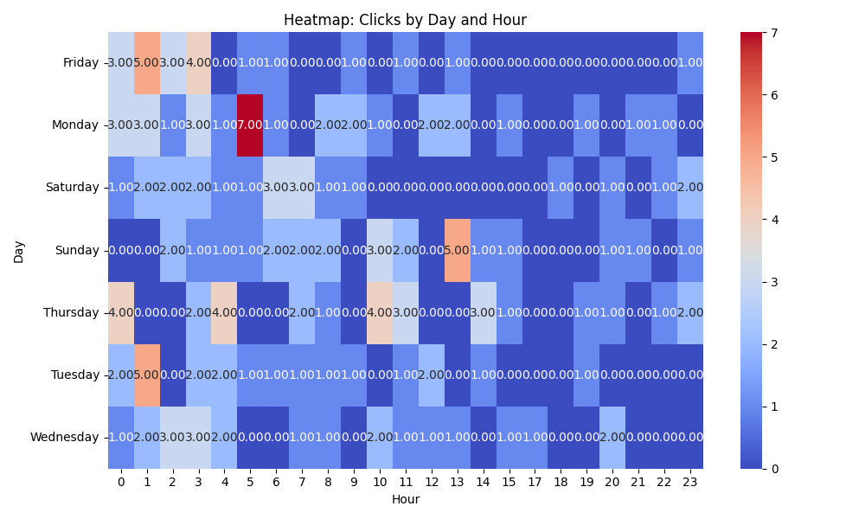

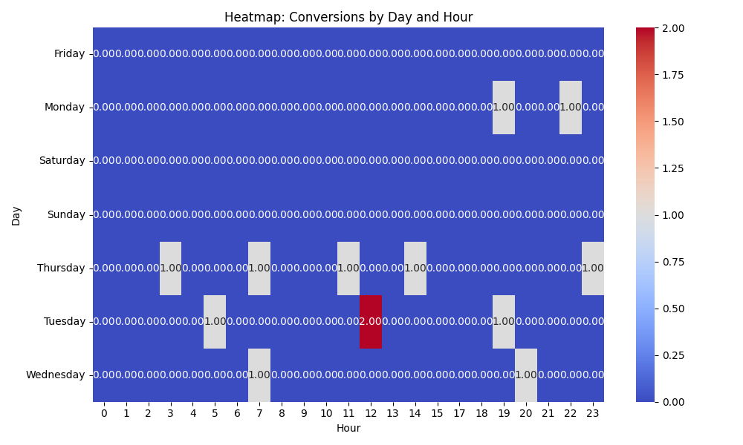

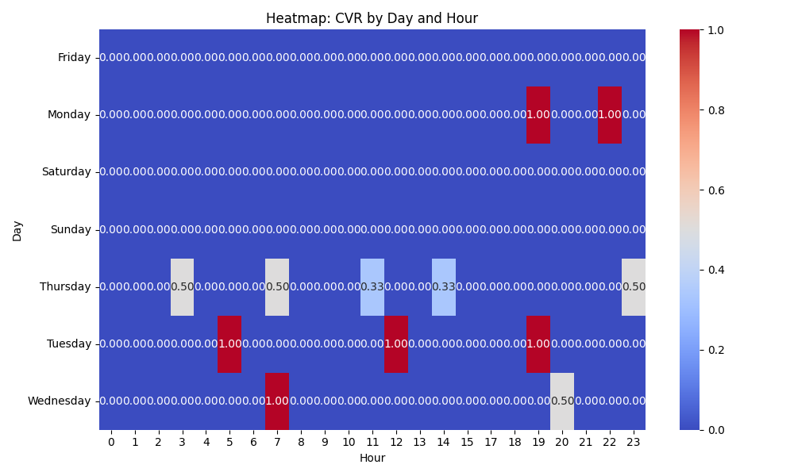

# Competitor Intelligence

# Top Competitor Insights

|  |  |  |
| --- | --- | --- |
| Competitor | Strengths | Recommendations |
|  | The competitor consistently uses strong, benefit-driven, and aspirational language across their ads (e.g., 'The Future Of Print Is Here,' 'Wow Your Customers,' 'Elevate Your Brand,' 'Transform Your Sales Pitch,' 'Stand Out From The Crowd'). They focus heavily on the ultimate outcome and value for the customer, emphasizing innovation and impact. Beyond 'Get A Quote,' the competitor utilizes a broader range of CTAs such as 'Learn More,' 'Request A Free Sample,' and 'Order Yours Today.' This caters to users at different stages of the buying funnel, particularly 'Request A Free Sample' which lowers the barrier to initial engagement. The competitor keeps their ad creatives concise by broadly mentioning 'Video Brochures, Cards & Boxes' or 'Video In Print' and 'Video Marketing Solutions.' This simplifies the message for an initial impression, focusing on the overarching concept and its universal benefits rather than detailed product variations. The competitor's ads focus purely on the aspirational benefits and product features, without explicitly mentioning social proof or specific USPs like 'low minimum order' directly in the ad copy. Their strength lies in direct benefit communication. | While our landing page clearly outlines benefits, our ad creatives should incorporate more of these high-impact, future-focused, and aspirational phrases. We can test ad copy that directly challenges the status quo or promises significant transformation (e.g., 'Redefine Your Marketing,' 'Experience Unforgettable Engagement') to capture attention and differentiate ourselves earlier in the customer journey. Evaluate the feasibility of offering a 'Request A Free Sample' or a 'Download a Brochure/Case Study' option on our landing page and incorporate these CTAs into our Google Ads. This could attract leads who are not yet ready for a full quote but are interested in experiencing the product or learning more, potentially increasing our lead volume and diversifying our funnel entry points. Our landing page details a comprehensive range of products (Brochures, Mailers, Books, Packaging, Folders, POS, Business Cards). While this is excellent for conversion on the page, our ad copy could sometimes benefit from similar generalization to broaden initial appeal. We can use ad groups for specific product types, but for broader keywords, a general 'Video In Print' or 'Interactive Marketing Solutions' approach in ads could cast a wider net, directing users to our detailed landing page for specifics. Our landing page's strength lies in its extensive social proof ('Trusted by Global Brands,' numerous testimonials) and unique selling proposition ('Low Minimum Order'). We should consider A/B testing ad creatives that incorporate these trust signals and practical advantages (e.g., 'Trusted by Volvo & VW' or 'Low MOQ Video Brochures') to immediately differentiate ourselves and build credibility even before the user clicks through to the landing page. |
| mediafast.com › video-mailer | Their ad creatives consistently lead with 'Video Mailer,' which is a specific product name. This precise keyword targeting likely helps them achieve high relevance for users searching for this exact product, potentially leading to better ad rankings and click-through rates for specific 'video mailer' searches. The competitor uses strong benefit-driven adjectives like 'Custom' and 'High-Impact' directly in their ad headline. This immediately communicates value and key selling points to the user at the ad level. The competitor's ad uses 'You ...' implying a direct, user-centric benefit or action. This personalizes the ad message and speaks directly to the searcher's needs or aspirations. By focusing narrowly on 'Video Mailer' in their ad, MediaFast might be effectively segmenting their audience and optimizing their budget for a specific, high-intent product category. This can lead to more qualified leads for that particular product. | While our landing page includes 'Video Mailers' as a product type, our main headline is 'Video Brochure: The Ultimate Sales and Marketing Tool.' For ad campaigns targeting 'video mailer' keywords, consider creating or modifying ad creatives and potentially landing page sections to prominently feature 'Video Mailer' in the main headline or immediately visible content. This improves ad-to-landing-page congruence and reduces user friction. Our landing page also uses 'customized' and 'high-impact,' which is a strong alignment. Ensure these benefit-driven terms are consistently emphasized in our ad copy and throughout the initial visible sections of our landing page. Leverage our 'Fully Customizable' and 'Proven Engagement Booster' points more prominently in ad extensions or headline variations. While our landing page's sub-headline ('Turn Your Brand into an Experience', 'Captivate your audience') is benefit-driven, review our current Google ad creatives (if available) to ensure they use more direct, second-person language ('You', 'Your'). This personal touch in ad copy can increase immediate relevance and engagement for the user before they even click. If 'Video Mailer' is a high-value product for us, consider creating dedicated, tightly themed ad groups and potentially even specific landing pages (or sections with anchor links) for 'Video Mailers.' This would allow for hyper-focused ad copy, keyword targeting, and a more streamlined user journey compared to a broader 'Video Brochure' landing page. |
| thevideocards.com | Their ad creative 'Video Brochures, Video Boxes, & Video Mailers' is remarkably clear, concise, and uses highly searchable and universally understood product terms. This directness is effective for users with specific purchase intent and optimizes for limited ad character space. The competitor's ad focuses purely on product types, which is excellent for capturing high-intent searches. It assumes the user already understands the value and is looking for a specific item. The competitor's brand name, 'theVideoCards,' itself acts as a strong, generic keyword that broadly encompasses many 'video in print' solutions. This can attract a wider range of search queries beyond just specific product types. | Our Google Ad creatives should prioritize this level of direct product naming for our main campaigns. While our landing page details a broader range of products (e.g., Video Business Cards, Video Folders, Video POS), the primary ad messaging should mirror the competitor's directness on the most common categories. We can use ad extensions or more granular ad groups for the niche offerings. Our landing page excels at communicating the *benefit* ('The Ultimate Sales and Marketing Tool,' 'wow, inform, and convert'). Our ad strategy should aim to combine the competitor's product clarity with our unique value proposition. Consider A/B testing ad headlines like 'Video Brochures: Wow & Convert' or 'High-Impact Video Mailers for Sales' to balance direct product naming with the benefit-driven messaging that resonates with our target audience. While our brand name might not be as generic, our ad strategy should ensure that our headlines and display URLs explicitly state our core offerings ('Video Brochures,' 'Video Packaging'). We should also explore using 'Video In Print' or 'Video Cards' as broad keywords in our campaigns to capture users searching for the overall concept, similar to how the competitor's brand name operates. |
| dir.indiamart.com › ... › Advertising Novelties | ❌ Parse Error: 'list' object has no attribute 'strip' | N/A |
| videobrochuresindia.com | The competitor's ad creative, 'Video Brochures Manufacturers, Suppliers, Dealers: ENRG | videobrochuresindia.com', is highly effective for audiences specifically searching for direct procurement or supply chain partners. Its strength lies in its clear, functional language ('Manufacturers, Suppliers, Dealers'), which directly addresses bottom-of-funnel intent for businesses seeking to source products. The '.in' domain signals a strong geographical focus on the Indian market, making it highly relevant for India-specific searches related to supply. The competitor's ad immediately communicates their specific role in the supply chain (manufacturer/supplier). For a user explicitly looking to find a 'manufacturer' or 'supplier' of video brochures, this ad provides precisely what they are searching for, leading to high relevance and potentially strong click-through rates for those precise keywords. | Our landing page positions video brochures as an 'Ultimate Sales and Marketing Tool' focused on creating an 'Experience' and achieving 'conversion'. This is a much more strategic, benefit-driven approach, targeting marketing and sales professionals. To counter the competitor and strengthen our position, we should: 1. Ensure our ad creatives clearly communicate the value and strategic benefit ('wow, inform, convert,' 'proven engagement booster') rather than just functional descriptions. 2. Highlight our global appeal and 'Trusted by Global Brands' in ad copy to differentiate from the competitor's regional focus. 3. Lean into our strength as a premium solution provider, not just a commodity supplier. While the competitor focuses on the 'who' (manufacturer/supplier), our landing page excels at explaining the 'why' and 'what for' of video brochures (as a sales and marketing tool, for brand experience). We should create ad copy that mirrors this benefit-driven approach, using compelling phrases like 'Unlock Engagement', 'Boost Sales', or 'Premium Brand Experience' in our headlines and descriptions. We can also hint at our broader offering (video packaging, POS, business cards) in our ad creatives to capture a wider range of high-intent queries beyond just 'video brochures' and showcase our versatility. |

# Top 3 Risks & Opportunities

## ⚠️ Risks

# Risks

|  |  |  |
| --- | --- | --- |
| Characteristic | Insight | Recommendation |
| Severe Budget Constraint Relative to CPA | The daily budget of $50 is critically low compared to the Cost Per Acquisition of $148.43. This implies it takes nearly 3 days to achieve a single conversion at the current rate, causing significant throttling and preventing the campaign from achieving consistent daily conversions. This severe limitation starves the Target CPA bid strategy of the necessary conversion volume to learn and optimize effectively, leading to inefficient spend over the long term and missed conversion opportunities. | Immediately increase the daily budget to at least 2-3 times the current CPA (e.g., $300-$450/day). This will provide the Target CPA strategy sufficient funding to acquire conversions more frequently, enabling the algorithm to learn faster and optimize bidding for better performance and scalability. |
| High Cost Per Acquisition (CPA) for Lead Generation | The actual CPA of $148.43 is high, especially for a lead generation campaign (VPPSearchLeads). While the exact value of a lead is unknown, a high CPA can severely limit profitability and make scaling challenging if the downstream conversion rate to sales is not exceptionally high. This cost per lead suggests a competitive market or potential inefficiencies in the conversion funnel. | Conduct a deep dive into the post-click user experience, including landing page performance, form completion rates, and the quality of leads generated. Implement A/B tests on landing pages to improve conversion rates, which will directly reduce the effective CPA. Simultaneously, review lead qualification criteria to ensure high-value leads are prioritized and bidding is optimized for them. |
| Insufficient Conversion Volume for Smart Bidding Optimization | With only 13 conversions accumulated over an extended period (approximately 39 days given the total cost), the Target CPA bid strategy lacks sufficient data points to adequately learn and optimize bids. Smart Bidding algorithms require a consistent stream of conversion data to identify patterns and make intelligent bidding decisions, and the current volume is too low to unlock its full potential. | As a priority, address the budget constraint to drive higher conversion volume. If immediate budget increase is not feasible, consider temporarily switching the bid strategy to 'Maximize Conversions' for a period to generate more data. Once a more robust conversion history is established (ideally 30+ conversions per month), switch back to Target CPA for more targeted optimization. |

## ✅ Opportunities

# Opportunities

|  |  |  |
| --- | --- | --- |
| Characteristic | Insight | Recommendation |
| Excellent Click-Through Rate (CTR) | The campaign demonstrates a very strong Click-Through Rate (CTR) of 8.48%. This indicates that the ad copy, ad extensions, and keyword targeting are highly relevant and compelling to the target audience, effectively capturing attention and driving clicks from search results. | Leverage this strength by expanding into closely related keywords and audience segments that align with current high-performing queries. Conduct A/B tests on ad variations to identify specific headlines or descriptions that contribute most to the high CTR and apply these learnings across other ad groups or campaigns. Explore new ad formats like Responsive Search Ads (RSAs) to maximize reach with winning copy elements. |
| Potential for CPA Improvement through Full Bid Strategy Enablement | The campaign is utilizing a Target CPA bid strategy, which has significant potential to optimize performance, but is currently hampered by budget limitations and low conversion volume. Once these constraints are lifted, the algorithm will have the necessary data and flexibility to more effectively identify optimal bid points and potentially drive down the Cost Per Acquisition. | Prioritize the recommended budget increase to empower the Target CPA strategy. Closely monitor the CPA and conversion volume after the budget adjustment, allowing the machine learning time to adapt (typically 2-4 weeks). Regularly review the 'Bid Strategy Report' within Google Ads to track optimization progress and identify any further adjustments needed to reach target CPA goals. |
| Optimization of High Average Cost Per Click (CPC) | The average CPC of $11.15 is high, suggesting competitive keywords or potentially inefficient spending on less qualified clicks. While a high CTR indicates good ad relevance, refining the keywords and search queries could further improve efficiency without sacrificing quality or volume. | Conduct a detailed analysis of the Search Term Report to identify and add irrelevant or high-cost, low-converting search queries as negative keywords. Review keyword match types, considering a tighter match type strategy for high-cost terms. Explore opportunities to improve Quality Score for expensive keywords through more relevant ad copy and landing page content, which can reduce CPCs. Consider audience targeting adjustments to ensure clicks are coming from the most valuable segments. |