Google Ads Audit Report

# Campaign Performance (w/ Benchmark Overlay)

|  |  |  |  |  |  |  |  |  |  |
| --- | --- | --- | --- | --- | --- | --- | --- | --- | --- |
| Campaign Name | CTR | Cost ($) | Clicks | Impressions | CTR Flag | Avg CPC | Avg CPC Flag | CPA ($) | CPA ($) Flag |
| VPP_Search_Leads_USA_03/08/2024 (Exp 1) | 8.89% | $2024.12 | 181 | 2036 | Above | $11.18 | Above | $144.58 | Above |

# Campaign Insights

# Campaign Insights

|  |  |  |
| --- | --- | --- |
| Characteristic | Insight | Recommendation |
| Cost Per Acquisition (CPA) & Conversion Rate | The campaign achieved 14 conversions at a CPA of $144.58. The conversion rate (Conversions/Clicks) is 7.73% (14 conversions from 181 clicks). | Since the bid strategy is Target CPA, gradually lower the target CPA by 5-10% (e.g., to $130-$137) to prompt the system to find more efficient conversions. Simultaneously, conduct a thorough landing page audit to identify and resolve potential user experience issues that might be hindering the 7.73% conversion rate. |
| Ad Relevance and Click-Through Rate (CTR) | The campaign shows strong ad relevance with a CTR of 8.89% (181 clicks from 2036 impressions), which is well above average for search campaigns. | Leverage this strong CTR by implementing more Responsive Search Ads (RSAs) to test a wider variety of headlines and descriptions. This can help identify even more compelling ad copy combinations and potentially improve ad strength, leading to better ad rankings and click quality. |
| Cost Per Click (CPC) & Spend Pacing | The average CPC is $11.18. The campaign has spent $2024.12, utilizing a significant portion of the daily budget ($35.00/day over approximately 57.8 days). | Review the Search Terms Report diligently to identify any irrelevant or broad queries that are accumulating clicks at the $11.18 CPC without converting. Add these as negative keywords to reduce wasted spend and reallocate budget towards more profitable terms. Consider applying bid adjustments for specific devices, locations, or audiences if performance varies significantly. |

# Keyword Performance

|  |  |  |  |  |  |  |  |  |
| --- | --- | --- | --- | --- | --- | --- | --- | --- |
| Ad Group | Keyword | Match Type | Quality Score | Impressions | Clicks | CTR | Avg CPC | CPA ($) |
| Video Mailers | video mailers | PHRASE | 3 | 242 | 24 | 9.92% | $14.05 | $168.56 |
| VPP Brochures | video brochures | PHRASE | 5 | 309 | 21 | 6.80% | $14.31 | $150.24 |
| Video Books | promotional video book | PHRASE | 6 | 68 | 10 | 14.71% | $14.16 | $0.00 |
| Video Box | video box | PHRASE | 3 | 363 | 21 | 5.79% | $5.42 | $0.00 |
| Video Box | box with video screen | PHRASE | 4 | 25 | 7 | 28.00% | $13.82 | $96.75 |
| Video Box | video box marketing | PHRASE | 6 | 68 | 7 | 10.29% | $11.73 | $82.11 |
| Video Mailers | video mailers marketing | PHRASE | 7 | 63 | 6 | 9.52% | $11.74 | $0.00 |
| Video Mailers | custom video mailers | PHRASE | 5 | 45 | 6 | 13.33% | $10.98 | $65.85 |
| Video Books | personalized video books | PHRASE | 5 | 85 | 13 | 15.29% | $4.99 | $64.82 |
| Video Mailers | video brochure mailer | PHRASE | 4 | 31 | 2 | 6.45% | $32.27 | $43.03 |
| Video Box | custom video box | PHRASE | 5 | 35 | 4 | 11.43% | $15.01 | $0.00 |
| VPP Brochures | video brochure card | PHRASE | 4 | 95 | 5 | 5.26% | $9.54 | $0.00 |
| Video Books | video book marketing | PHRASE | 6 | 84 | 8 | 9.52% | $5.35 | $21.41 |
| VPP Brochures | video brochure usa | PHRASE | 4 | 27 | 2 | 7.41% | $19.33 | $38.66 |
| Video Mailers | video card mailer | PHRASE | 3 | 15 | 3 | 20.00% | $12.41 | $37.24 |
| Video Books | custom video books | PHRASE | 5 | 101 | 8 | 7.92% | $4.63 | $0.00 |
| VPP Brochures | custom video brochures | PHRASE | 7 | 39 | 3 | 7.69% | $9.36 | $56.19 |
| VPP Brochures | video brochure manufacturer | PHRASE | 3 | 3 | 2 | 66.67% | $11.74 | $0.00 |
| VPP Brochures | lcd video brochure | PHRASE | 3 | 5 | 1 | 20.00% | $13.72 | $0.00 |
| VPP Brochures | video brochure marketing | PHRASE | 5 | 2 | 1 | 50.00% | $12.49 | $0.00 |
| Video Box | video gift box | PHRASE | 5 | 44 | 4 | 9.09% | $2.88 | $0.00 |
| VPP Brochures | video brochure pricing | PHRASE | 0 | 10 | 1 | 10.00% | $11.03 | $0.00 |
| VPP Brochures | lcd screen video brochure | PHRASE | 4 | 11 | 1 | 9.09% | $10.84 | $0.00 |
| VPP Brochures | video brochure book | PHRASE | 5 | 2 | 1 | 50.00% | $9.41 | $0.00 |
| VPP Brochures | 4.3 inch video brochure | PHRASE | 0 | 3 | 1 | 33.33% | $7.84 | $0.00 |
| VPP Brochures | brochure with video screen | PHRASE | 5 | 3 | 1 | 33.33% | $7.42 | $0.00 |
| Video Box | gift box with video screen | PHRASE | 1 | 2 | 1 | 50.00% | $5.91 | $0.00 |
| Video Mailers | lcd video mailers | EXACT | 0 | 3 | 1 | 33.33% | $5.87 | $0.00 |
| Video Box | promotional video box | PHRASE | 3 | 4 | 1 | 25.00% | $3.77 | $0.00 |
| VPP Brochures | video screen brochure | PHRASE | 5 | 14 | 1 | 7.14% | $1.44 | $0.00 |
| VPP Brochures | media fast video brochure | PHRASE | 1 | 5 | 0 | 0.00% | $0.00 | $0.00 |
| VPP Brochures | video brochure maker | PHRASE | 4 | 2 | 0 | 0.00% | $0.00 | $0.00 |
| Video Books | lcd video book | PHRASE | 5 | 4 | 0 | 0.00% | $0.00 | $0.00 |
| VPP Brochures | digital video brochures | PHRASE | 4 | 4 | 0 | 0.00% | $0.00 | $0.00 |
| Video Mailers | mailer with video screen | PHRASE | 4 | 1 | 0 | 0.00% | $0.00 | $0.00 |
| Video Mailers | video mailer box | PHRASE | 5 | 4 | 0 | 0.00% | $0.00 | $0.00 |
| Video Box | video brochure box | PHRASE | 2 | 7 | 0 | 0.00% | $0.00 | $0.00 |
| Video Mailers | mediafast video mailer | PHRASE | 2 | 22 | 0 | 0.00% | $0.00 | $0.00 |
| Video Box | video presentation box | PHRASE | 2 | 4 | 0 | 0.00% | $0.00 | $0.00 |
| Video Box | lcd video box | PHRASE | 5 | 4 | 0 | 0.00% | $0.00 | $0.00 |

# Keyword Insights

# Keyword Insights

|  |  |  |
| --- | --- | --- |
| Characteristic | Insight | Recommendation |
| Significant Spend on Non-Converting Keywords | Keywords like 'promotional video book' ($141.59 cost), 'video box' ($113.74 cost), 'video mailers marketing' ($70.46 cost), 'video brochure card' ($47.71 cost), and 'custom video books' ($37.08 cost) have collectively spent $410.58 without generating any conversions. These five keywords represent a substantial portion of the overall budget inefficiency. | Immediately pause 'promotional video book', 'video box', 'video mailers marketing', 'video brochure card', and 'custom video books'. Reallocate their budget to high-performing keywords or to testing new, highly targeted exact match keywords. Conduct a thorough search term report review for these keywords before pausing to identify potential negative keyword additions. |
| Critically Low Quality Scores | Several keywords have extremely low Quality Scores (QS 0-3), notably 'lcd video mailers' (QS 0, $5.87 cost), 'video brochure pricing' (QS 0, $11.03 cost), 'gift box with video screen' (QS 1, $5.91 cost), 'video mailers' (QS 3), and 'video box' (QS 3). Low QS indicates poor relevance and leads to higher CPCs and limited ad visibility. | Pause 'lcd video mailers' and 'video brochure pricing' immediately due to their QS 0. For keywords with QS 1-3 ('gift box with video screen', 'video mailers', 'video box', 'video card mailer', 'video brochure manufacturer', 'promotional video box'), conduct a deep dive into ad copy relevance and landing page experience. Consider creating more specific ad groups with tighter keyword themes, highly relevant ad copy, and optimized landing pages to improve QS and reduce CPCs. |
| High-Performing, Cost-Efficient Converting Keywords | The keywords 'video book marketing' (CPA $21.41, CVR 0.25), 'video card mailer' (CPA $37.24, CVR 0.33), 'video brochure usa' (CPA $38.66, CVR 0.50), and 'video brochure mailer' (CPA $43.03, CVR 0.75) are highly effective in driving conversions at a low cost, demonstrating strong ROI. 'video brochure mailer' specifically has an exceptional CVR of 0.75. | Increase daily budget and bids for 'video book marketing', 'video card mailer', 'video brochure usa', and 'video brochure mailer' to capture more conversion volume. Monitor their performance closely to ensure CPA remains within acceptable targets as volume increases. Explore similar keyword variations (e.g., exact match) and consider creating dedicated campaigns for these top performers to maximize their impact. |
| High Cost-Per-Acquisition Keywords | The keywords 'video mailers' (CPA $168.56 from $337.13 cost) and 'video brochures' (CPA $150.24 from $300.48 cost) are generating conversions but at a very high cost. These CPAs are significantly higher than the campaign's more efficient converting keywords. | Reduce bids on 'video mailers' and 'video brochures' by at least 15-20% to test for a lower CPA while maintaining conversion volume. Simultaneously, review their associated ad copy and landing pages for opportunities to improve conversion rates, and add more specific negative keywords to refine traffic quality, aiming to bring their CPA closer to the campaign's profitable range. |
| High CTR with Zero Conversions - Possible Intent Mismatch | The keyword 'video brochure manufacturer' shows a very high CTR (0.666667) but has generated 0 conversions for a cost of $23.48. This suggests that while the ad attracts clicks, the user intent might be informational (e.g., looking to supply/partner) rather than transactional (e.g., looking to buy the product). | Review the Search Term Report for 'video brochure manufacturer' to understand the exact queries. If the intent is not buyer-oriented (e.g., 'how to become a video brochure manufacturer'), add those specific terms as negative keywords. If the intent is genuinely commercial but for a different service (e.g., custom manufacturing capabilities), consider creating a dedicated ad and landing page tailored to that specific need, or pause the keyword if no suitable offering exists. |

# Wasted Spend Insights

# Wasted Spend Insights

|  |  |  |
| --- | --- | --- |
| Characteristic | Insight | Recommendation |
| High Cost & Zero Conversions | The keyword 'promotional video book' has spent $141.59 with 0 conversions, making it the highest budget drain without any return. | Immediately pause 'promotional video book' to prevent further budget waste. Conduct a thorough search term analysis to identify the exact queries driving these clicks. If intent seems relevant, test a dedicated landing page specifically for 'promotional video book' with a clear offer and refined ad copy. |
| High Avg CPC | For 'promotional video book', the Avg CPC is very high at $14.16, indicating highly competitive bidding or low ad relevance leading to higher costs per click. | If deemed a valuable keyword post-analysis, consider a substantial bid reduction for 'promotional video book' (e.g., -50%) to see if a lower position can still generate relevant clicks, or switch to a Target CPA bidding strategy if historical conversion data from other keywords supports it. |
| Suboptimal Quality Score | The Quality Score for 'promotional video book' is 6, which indicates room for improvement in expected CTR, ad relevance, and landing page experience. | Review and revise ad copy for 'promotional video book' to better align with user intent and highlight unique selling propositions. Ensure the landing page for 'promotional video book' is highly relevant, loads quickly, and offers a clear, compelling call to action to boost Quality Score and conversion rates. |
| High Cost & Zero Conversions with Very Low Quality Score | The keyword 'video box' has incurred $113.74 in cost with 0 conversions and a critically low Quality Score of 3, signaling a major disconnect between search intent, ad, and landing page. | Immediately pause 'video box'. This QS of 3 indicates severe problems. Investigate the search terms that triggered 'video box' to understand if the keyword itself is too broad or if the intent is mismatched. Overhaul ad copy to be hyper-relevant, or create a dedicated landing page for 'video box' that directly addresses user intent with clear value propositions and a strong CTA. |
| High Cost & Zero Conversions Despite Good Quality Score | The keyword 'video mailers marketing' spent $70.46 with 0 conversions, despite having a relatively good Quality Score of 7. This suggests the issue is likely post-click, such as landing page experience or offer misalignment. | While Quality Score for 'video mailers marketing' is good, focus troubleshooting on the landing page. Analyze user behavior metrics (bounce rate, time on site) for traffic from 'video mailers marketing'. Test different landing page variations, clear value propositions, or lead magnets directly related to 'video mailers marketing' services/products. Ensure the offer meets the user's commercial intent. |
| High Cost & Zero Conversions with Extremely High Avg CPC | The keyword 'custom video box' has accumulated $60.06 in cost with 0 conversions, and an exceptionally high Avg CPC of $15.01, indicating a highly competitive and unprofitable term currently. | Pause 'custom video box' immediately. The high CPC combined with zero conversions is unsustainable. If this is a high-value product, consider a more restrictive match type (e.g., exact match) and focus on negative keywords to refine traffic. Explore alternative, lower-cost keywords that capture similar intent or re-evaluate the ad group strategy for 'custom video box' to improve relevancy and reduce costs. |
| Significant Cost & Zero Conversions with Low Quality Score | The keyword 'video brochure card' has spent $47.71 with 0 conversions and a low Quality Score of 4, indicating a problem with relevance or user experience. | Review ad copy for 'video brochure card' to ensure it's compelling and directly addresses user needs. The low Quality Score suggests a mismatch, so analyze the landing page's content, load speed, and call-to-action for 'video brochure card' to ensure it's optimized for conversion. |
| Significant Cost & Zero Conversions | The keyword 'custom video books' has spent $37.08 with 0 conversions, indicating a notable investment without return. | Review the search intent behind 'custom video books'. It's possible users are seeking design inspiration, DIY guides, or comparing manufacturers rather than making a direct purchase. Adjust ad copy or landing page content to better align with the likely intent, or consider adding negative keywords for non-commercial queries. |
| Zero Conversions with Extremely High CTR and Very Low Quality Score | The keyword 'video brochure manufacturer' shows an exceptionally high CTR of 66.67% and a very low Quality Score of 3, despite 0 conversions and a high Avg CPC of $11.74. This suggests the ad is highly compelling but the landing page or the searcher's intent is severely mismatched with the offer. | This keyword indicates a high probability of supplier-seeking intent. If your business is a manufacturer, ensure the landing page for 'video brochure manufacturer' highlights manufacturing capabilities, bulk pricing, and B2B services clearly. If you are a reseller, add 'reseller' or 'supplier' as negative keywords and refine your ad copy for 'video brochure manufacturer' to target end-users more directly, or pause if this intent is not valuable. |
| Zero Conversions with Very Low Quality Score & High Avg CPC | The keyword 'lcd video brochure' has spent $13.72 with 0 conversions, an Avg CPC of $13.72, and a low Quality Score of 3, indicating poor performance and high cost per click. | Given the low Quality Score for 'lcd video brochure', focus on improving ad relevance and landing page experience. Ensure the landing page clearly showcases LCD video brochures, their features, and direct benefits. Consider breaking out 'lcd video brochure' into its own ad group to tailor ads and landing pages precisely. |
| Zero Conversions with Critically Low Quality Score (0) | The keyword 'video brochure pricing' has spent $11.03 with 0 conversions and an alarming Quality Score of 0. This extreme score suggests fundamental issues with ad relevance, expected CTR, or landing page experience. | Immediately pause 'video brochure pricing'. A Quality Score of 0 is highly problematic and usually indicates very limited or no data available for evaluation by Google, or extreme irrelevance. Review the ad group, ad copy, and landing page for 'video brochure pricing' for any major misconfigurations or content gaps that could lead to such a low score. Re-evaluate if this keyword should be targeted at all, given its current performance. |
| Zero Conversions with Critically Low Quality Score (0) & High CTR | The keyword '4.3 inch video brochure' shows 0 conversions with $7.84 spent, a high CTR of 33.33%, and a critically low Quality Score of 0. This combination suggests that while the ad is attracting clicks, the user experience post-click is severely deficient or the keyword is completely irrelevant to the business. | Pause '4.3 inch video brochure' immediately. Investigate why a QS of 0 is being reported (data issue, extreme irrelevance). If you offer this specific product, ensure the landing page prominently features '4.3 inch video brochure' with all necessary details and a clear path to purchase. The high CTR implies the ad itself is engaging, but the follow-through is failing. |
| Zero Conversions with Critically Low Quality Score (1) & Extremely High CTR | The keyword 'gift box with video screen' spent $5.91 with 0 conversions, an extremely high CTR of 50%, and a Quality Score of 1. This is a clear indicator of a highly engaging ad that is failing to convert due to a poor landing page experience or a complete mismatch with user intent. | Review the landing page for 'gift box with video screen' as a top priority. Despite the ad's success, the QS of 1 points to severe issues with the page's relevance, clarity, or load time. Ensure the page immediately shows relevant 'gift box with video screen' products/services and has a compelling CTA. Consider A/B testing different landing page elements. |
| Zero Conversions with Critically Low Quality Score (0) | The keyword 'lcd video mailers' has spent $5.87 with 0 conversions and a Quality Score of 0. This is a critical issue indicating a complete lack of relevance or data for evaluation. | Pause 'lcd video mailers' immediately. A QS of 0 is a red flag. Re-evaluate the purpose and relevancy of targeting 'lcd video mailers'. If it's a core product, reconstruct the ad group focusing on highly relevant ad copy and a dedicated landing page that explicitly addresses 'lcd video mailers' products/services. If not relevant, consider it a strong negative keyword candidate. |
| Zero Conversions & Wasted Spend with Very Low Quality Score | The keyword 'promotional video box' has spent $3.77 with 0 conversions and a Quality Score of 3, indicating wasted ad spend due to poor relevance. | Consider pausing 'promotional video box' or reducing its bid significantly. Given the low Quality Score, improve ad copy to be more specific and ensure the landing page for 'promotional video box' provides immediate value and relevant information to the searcher's intent. |

# Landing Page Audit Insights

## Landing Page: https://videoplusprint.com/video-in-print-products

# Landing Page Insights

|  |  |  |  |
| --- | --- | --- | --- |
| URL | Characteristic | Insight | Recommendation |
| https://videoplusprint.com/video-in-print-products | Call to Action (CTA) & Conversion Goal Alignment | The primary CTA 'GET A FREE QUOTE' is prominent and repeated, clearly stating the conversion goal. However, the associated form is quite extensive, potentially creating a high barrier to entry for users who may be in an early research phase and not ready for a detailed quote. | Consider a multi-stage funnel with a lower-friction initial conversion goal. For example, offer a 'Download Our Product Catalog' or 'Watch a Demo Video' CTA in the hero section, leading to a simpler form (email only), and then nurture these leads towards the 'Get a Free Quote' form. This could improve overall conversion volume. |
| https://videoplusprint.com/video-in-print-products | Lead Form Friction & User Experience | The 'Get Free Quote' form demands a significant amount of information upfront (Name, Email, Country, Phone, Product Type, Quantity, Screen Size, Message). For a first interaction, this level of detail is a major UX blocker and likely contributes to form abandonment. | Optimize the form by either reducing the number of required fields for an initial inquiry (e.g., Name, Email, and Product Type only), or implementing a multi-step form to make the process appear less daunting. Clearly articulate *why* specific details (like quantity or screen size) are needed for an accurate quote directly above those fields. |
| https://videoplusprint.com/video-in-print-products | Page Content Clarity and Value Proposition | The headline 'Video Brochure: The Ultimate Sales and Marketing Tool' and hero content 'Turn Your Brand into an Experience' effectively communicate the core value. The bullet points like 'Low Minimum Order' and 'Trusted by Global Brands' are strong selling points. | Continue to highlight both the 'low minimum order' and 'global brand trust' as they appeal to different segments. Ensure consistency in messaging; if targeting smaller businesses with low minimums, ensure testimonials also reflect outcomes relevant to them, alongside the large enterprise examples. |
| https://videoplusprint.com/video-in-print-products | Social Proof & Credibility | The 'Our Happy Customers' section with detailed testimonials from recognizable brands (Volvo, Volkswagen, Commonwealth Bank) is an extremely strong trust signal and provides excellent social proof. | Excellent use of testimonials. Ensure there's no accidental repetition (e.g., the Volvo testimonial appears twice). Consider adding logos of these brands more prominently near the hero section or testimonials to instantly build trust. A/B test displaying testimonials above the fold. |
| https://videoplusprint.com/video-in-print-products | Performance Data: CPA & Conversion Efficiency | A CPA of $144.58 for a 'free quote' indicates a very high cost per acquisition. While the CTR of 3.30% suggests good ad relevance, the high CPA points to significant inefficiency on the landing page in converting clicks into qualified leads. | Prioritize A/B testing form length, CTA variations, and potentially different conversion goals (as suggested above) to reduce the CPA. Evaluate the quality of the leads generated at this CPA; if the close rate for these leads is high, the CPA might be acceptable, but optimization is still crucial for scalability. |
| https://videoplusprint.com/video-in-print-products | Competitor Benchmark | Without competitor data, it's challenging to definitively benchmark the $144.58 CPA. For a highly specialized B2B product with a high average order value and long customer lifetime value, this CPA could be sustainable if the lead-to-customer conversion rate is robust. | Conduct a competitive analysis to understand typical CPAs for custom B2B marketing products in your industry. This will provide context for whether your current CPA is an outlier or falls within industry norms, guiding future budgeting and optimization strategies. |
| https://videoplusprint.com/video-in-print-products | Mobile Responsiveness & Usability (Implied) | While not explicitly provided, a long form with multiple dropdowns can be particularly challenging and cumbersome for mobile users, impacting conversion rates on mobile devices. | Ensure the form and entire page are fully optimized for mobile devices. Test the user experience of filling out all form fields on various mobile screen sizes. Consider implementing larger touch targets for dropdowns and fields to improve usability. |
| https://videoplusprint.com/video-in-print-products | Value Proposition Clarity & Persuasion | The page clearly defines 'Video In Print Products' and lists various applications (brochures, mailers, books, packaging). Key benefits like 'Engage and impress,' 'captivate, convert,' and 'elevate premium promotions' are highlighted. The 'How does Video Plus Print achieve success for you?' section articulates quality, reach, impact, and a compelling '23% sales lift' ROI statistic. | While the core message is clear, strengthen the immediate value proposition in the hero section. Instead of a general headline, incorporate a more specific, benefit-driven statement (e.g., 'Transform Your Marketing with Video In Print: Proven to Boost Sales by 23%'). This instantly communicates a key differentiator and provides a stronger hook for visitors arriving from Google Ads. |
| https://videoplusprint.com/video-in-print-products | Call-to-Action (CTA) Effectiveness & Placement | The CTAs 'Get A FREE Video Brochure QUOTE' and 'GET A FREE QUOTE' are clear, benefit-oriented, and use strong action verbs. However, only two CTAs are visible in the provided content chunk, suggesting potential scarcity on a longer page, which might require excessive scrolling for conversion points. | Implement additional, strategically placed CTAs throughout the page content, especially after major benefit sections, trust signals, or the list of use cases. Consider varying CTA phrasing, such as 'Request a Custom Consultation,' 'See Our Portfolio,' or 'Get Started Today' to cater to different user motivations and reduce fatigue from repetitive 'quote' CTAs, potentially improving conversion rate for the $144.58 CPA. |
| https://videoplusprint.com/video-in-print-products | Trust and Authority Signals | The page includes strong trust signals such as being 'Most Valuable Company 2016 in Hong Kong,' 'Since 2009' establishment with 'over 40 years of expertise,' the '23% sales lift' statistic, and prominent client logos like UPS and Exxon Mobil. This is excellent for building credibility. | While the 2016 award is good, it's dated. Seek to add more recent accolades, industry certifications, or, more importantly, fresh client testimonials (with names, titles, and company logos if possible). Consider adding 'As Seen In' badges if featured in relevant publications, further reinforcing authority and reducing perceived risk for high-value B2B prospects. |
| https://videoplusprint.com/video-in-print-products | Social Proof & Case Studies | The inclusion of recognizable client names like 'Saudi Ministry,' 'UPS,' and 'Exxon Mobil' is powerful social proof, indicating experience with high-profile clients, which is crucial for a potentially high-value B2B service. | Elevate these client mentions into concise, impactful mini-case studies or 'success stories.' Instead of just listing names, briefly describe the client's challenge, how Video Plus Print's solution addressed it, and the key positive outcome or measurable result. This transforms names into compelling evidence of value, directly supporting the justification for the CPA of $144.58 by showcasing real-world ROI. |
| https://videoplusprint.com/video-in-print-products | Offer & Lead Magnet Optimization | The primary lead magnet is a 'FREE Video Brochure QUOTE.' While direct, a 'quote' can be perceived as a high-commitment action, especially for a complex product. The CPA of $144.58 suggests the cost per quote lead is significant, indicating that some visitors might not be ready for a direct quote. | Diversify lead magnet options to capture visitors at different stages of the buying journey. Introduce a lower-commitment lead magnet, such as a 'Guide to Interactive Video Marketing,' a 'Video-in-Print Idea Book,' or a 'Custom Sample Pack Request.' This could increase overall lead volume and potentially lower the average CPA by capturing top-of-funnel interest that can then be nurtured towards a quote. |
| https://videoplusprint.com/video-in-print-products | Relevance to Ad Intent & Keyword Performance | The 3.30% CTR indicates strong ad copy relevance to the keywords being searched (likely 'video in print products'). The landing page content directly addresses and expands upon this core offering, reinforcing user intent immediately upon arrival. | Continue monitoring keyword performance closely. Leverage 'What We Do?' and 'The Power of Video Brochures in Modern Marketing' sections to inform ad copy variations. Specifically highlight the customization ('suitable for all budgets') and ROI ('23% sales lift') in ads to pre-qualify users and attract those most likely to convert, optimizing the quality of traffic for the $144.58 CPA. |
| https://videoplusprint.com/video-in-print-products | Competitor Benchmark | Given the niche and specialized nature of 'video in print products,' the CPA of $144.58, while seemingly high, may be acceptable for a high-value B2B lead that could result in substantial order values. Competitors in this space often compete on quality, customization, and proven results rather than just price. | Conduct a thorough competitive analysis focusing on other video-in-print providers. Analyze their landing page structures, lead generation strategies (e.g., demo requests, content downloads), pricing transparency, and the perceived value proposition. This will help determine if the current CPA aligns with industry norms for high-value B2B leads or if there are opportunities to reduce it through differentiating offers or a more streamlined conversion path. |
| https://videoplusprint.com/video-in-print-products | High CPA & Strong Conversion Rate | The conversion rate of 7.7% (14 conversions / 181 clicks) is excellent for a B2B lead generation page, indicating the page effectively converts relevant traffic. However, the CPA of $144.58 suggests the cost per click (CPC) or overall ad spend for the clicks is high, or that the lifetime value of a conversion needs to be substantial to justify this cost. | Focus Google Ads optimization efforts on reducing CPCs through improved ad quality scores, more precise negative keyword targeting, and A/B testing ad copy that pre-qualifies users. Simultaneously, analyze the quality of the 14 conversions to confirm they are high-value leads justifying the current CPA, or explore ways to increase average order value. |
| https://videoplusprint.com/video-in-print-products | Landing Page Navigation | The page retains a full website navigation bar (Home, About Us, Products, Blog, Contact). While useful for general site exploration, on a dedicated landing page, this can create 'leaky' funnels by offering multiple exit points and distracting visitors from the primary conversion goal of requesting a quote. | Test simplifying or removing the main navigation on this specific landing page. Replace it with a minimal header that perhaps only features the logo (linked to home, if necessary) and the primary call-to-action button, ensuring visitors remain focused on the conversion path. |
| https://videoplusprint.com/video-in-print-products | Value Proposition & Trust Signals | The page clearly articulates the value proposition ('captivate your audience,' 'transform marketing materials') and leverages strong trust signals like prominent client logos (Intel, Coca-Cola, Porsche) and testimonials. This is a significant strength contributing directly to the observed high conversion rate. | Continue to amplify these strong trust signals. Consider adding quantifiable results to testimonials if possible (e.g., 'Increased event attendance by X%') or integrating more detailed mini-case studies directly on the page showing the product in action for specific use cases (e.g., 'How Company X boosted product launches'). |
| https://videoplusprint.com/video-in-print-products | Call-to-Action (CTA) Clarity & Placement | The primary CTA 'GET A FREE QUOTE' is clear, concise, and directly aligns with the user's likely intent on this page. Its strategic placement above the fold and repetition throughout the page ensures visibility and consistent guidance towards conversion. | While effective, consider A/B testing minor variations in CTA copy (e.g., 'Request Your Custom Quote,' 'Get a Project Estimate') or button design (color, size, animation on hover) to identify if even a marginal improvement in click-through rate to the form can be achieved. |
| https://videoplusprint.com/video-in-print-products | Missing Pricing Transparency | The page, while geared towards custom quotes, does not offer any preliminary pricing information, such as 'starting from' figures or a general pricing range. This absence might deter some potential leads who are price-sensitive or wish to gauge affordability quickly without committing to a full quote request. | Consider adding a subtle pricing indicator. This could be a small disclaimer like 'Custom pricing based on volume & features' or 'Starting at $X for basic configurations.' This manages expectations, pre-qualifies leads, and might reduce form abandonment from those primarily seeking general cost information. |
| https://videoplusprint.com/video-in-print-products | Competitor Benchmark | Leading B2B custom marketing solutions often enhance engagement by providing interactive tools or a deeper dive into product specifics before the quote stage. While this page excels in trust, it could further immerse the user. | Explore integrating a small interactive element, such as a multi-step questionnaire to help users define their project needs (e.g., 'How many units?', 'What size?'). This can both qualify leads further and provide a more personalized experience, leading to higher quality quote requests. |
| https://videoplusprint.com/video-in-print-products | Ad-Page Relevance (Inferred) | Given the strong 7.7% conversion rate, it is highly probable that the Google Ads keywords and ad copy driving traffic to this page are exceptionally well-aligned with the page's content, effectively pre-qualifying visitors for a 'quote' stage. | Continuously monitor Search Query Reports in Google Ads to identify new relevant keywords and refine negative keywords. A/B test ad copies that highlight specific use cases or benefits mentioned on the landing page (e.g., 'Video Brochures for Product Launches' leading to that section) to potentially improve CTR and further refine lead quality. |

# Geographical Performance

|  |  |  |  |  |  |  |  |  |  |
| --- | --- | --- | --- | --- | --- | --- | --- | --- | --- |
| City | Region | Country | Type | Impressions | Clicks | Conversions | Cost ($) | CVR | CPA ($) |
| United States |  |  | Country | 1892 | 164 | 12.0 | $1934.53 | 0.07317073170731707 | $161.21 |
| United States |  |  | Country | 144 | 17 | 2.0 | $89.60 | 0.11764705882352941 | $44.80 |

# Geographical Insights

# Geographical Insights

|  |  |  |
| --- | --- | --- |
| Characteristic/ Location | Insight | Recommendation |
| United States (High CPA Segment) | This segment accounts for a high spend of $1934.53, but yields an inefficient Cost Per Acquisition (CPA) of $161.21 and a lower Conversion Rate (CVR) of 7.32%. This is significantly worse performance compared to the other United States segment, which has a CPA of $44.80 and CVR of 11.76%. | Immediately review the targeting (e.g., keywords, audiences), ad creatives, and bid strategy within this specific segment. Consider reducing its budget by 30-50% (e.g., by $580.36 - $967.27) to reallocate spend to more efficient areas. Focus on A/B testing new ad copy or landing page experiences to improve the CVR from 7.32% and drive down the CPA from $161.21. |
| United States (Low CPA Segment) | This segment is highly efficient, achieving conversions at an excellent CPA of $44.80 and a strong Conversion Rate (CVR) of 11.76%, with a relatively low spend of $89.60. It significantly outperforms the other United States segment (CPA of $161.21, CVR of 7.32%). | Capitalize on this segment's strong performance by increasing its budget by 100-200% (e.g., an additional $89.60 - $179.20, bringing the total to $179.20 - $268.80) to capture more conversions at the current efficient CPA. Analyze the specific successful elements (e.g., exact match keywords, high-performing audiences, or unique ad groups) within this segment to replicate success or expand similar targeting strategies to other campaigns. |

# Hourly Performance Pivot

CVR

|  |  |  |  |  |  |  |  |  |  |  |  |
| --- | --- | --- | --- | --- | --- | --- | --- | --- | --- | --- | --- |
| Day/Hour | 3 | 5 | 7 | 11 | 12 | 13 | 14 | 19 | 20 | 22 | 23 |
| Monday |  |  |  |  |  | 0.33 |  | 1.00 |  | 1.00 |  |
| Tuesday |  | 1.00 |  |  | 1.00 |  |  | 1.00 |  |  |  |
| Wednesday |  |  | 1.00 |  |  |  |  |  | 0.50 |  |  |
| Thursday | 0.50 |  | 0.50 | 0.33 |  |  | 0.33 |  |  |  | 0.50 |

Clicks

|  |  |  |  |  |  |  |  |  |  |  |  |  |  |  |  |  |  |  |  |  |  |  |  |
| --- | --- | --- | --- | --- | --- | --- | --- | --- | --- | --- | --- | --- | --- | --- | --- | --- | --- | --- | --- | --- | --- | --- | --- |
| Day/Hour | 0 | 1 | 2 | 3 | 4 | 5 | 6 | 7 | 8 | 9 | 10 | 11 | 12 | 13 | 14 | 15 | 17 | 18 | 19 | 20 | 21 | 22 | 23 |
| Monday |  |  |  |  |  |  |  |  |  |  |  |  |  |  |  |  |  |  |  |  |  |  |  |
| Tuesday |  |  |  |  |  |  |  |  |  |  |  |  |  |  |  |  |  |  |  |  |  |  |  |
| Wednesday |  |  |  |  |  |  |  |  |  |  |  |  |  |  |  |  |  |  |  |  |  |  |  |
| Thursday |  |  |  |  |  |  |  |  |  |  |  |  |  |  |  |  |  |  |  |  |  |  |  |
| Friday |  |  |  |  |  |  |  |  |  |  |  |  |  |  |  |  |  |  |  |  |  |  |  |
| Saturday |  |  |  |  |  |  |  |  |  |  |  |  |  |  |  |  |  |  |  |  |  |  |  |
| Sunday |  |  |  |  |  |  |  |  |  |  |  |  |  |  |  |  |  |  |  |  |  |  |  |

Conversions

|  |  |  |  |  |  |  |  |  |  |  |  |
| --- | --- | --- | --- | --- | --- | --- | --- | --- | --- | --- | --- |
| Day/Hour | 3 | 5 | 7 | 11 | 12 | 13 | 14 | 19 | 20 | 22 | 23 |
| Monday |  |  |  |  |  | 1.00 |  | 1.00 |  | 1.00 |  |
| Tuesday |  | 1.00 |  |  | 2.00 |  |  | 1.00 |  |  |  |
| Wednesday |  |  | 1.00 |  |  |  |  |  | 1.00 |  |  |
| Thursday | 1.00 |  | 1.00 | 1.00 |  |  | 1.00 |  |  |  | 1.00 |

Cost ($)

|  |  |  |  |  |  |  |  |  |  |  |  |  |  |  |  |  |  |  |  |  |  |  |  |
| --- | --- | --- | --- | --- | --- | --- | --- | --- | --- | --- | --- | --- | --- | --- | --- | --- | --- | --- | --- | --- | --- | --- | --- |
| Day/Hour | 0 | 1 | 2 | 3 | 4 | 5 | 6 | 7 | 8 | 9 | 10 | 11 | 12 | 13 | 14 | 15 | 17 | 18 | 19 | 20 | 21 | 22 | 23 |
| Monday | 48.30 | 21.97 | 24.69 | 13.34 | 26.87 | 54.61 | 5.29 |  | 36.75 | 15.58 | 24.57 |  | 9.74 | 59.63 |  | 12.31 |  |  | 6.60 |  | 3.77 | 15.61 |  |
| Tuesday | 39.32 | 75.95 |  | 17.99 | 34.92 | 10.17 | 8.81 | 16.65 | 4.97 | 22.60 |  | 9.03 | 44.24 |  | 2.51 |  |  |  | 9.07 |  |  |  |  |
| Wednesday | 2.86 | 32.52 | 112.01 | 57.51 | 36.88 |  |  | 4.51 | 7.81 |  | 6.47 | 10.53 | 3.77 | 5.90 |  | 1.83 | 12.58 |  |  | 9.51 |  |  |  |
| Thursday | 85.88 |  |  | 39.39 | 31.03 |  |  | 41.53 | 2.24 |  | 50.64 | 16.29 |  |  | 12.13 | 7.84 |  |  | 2.70 | 4.40 |  | 2.57 | 23.67 |
| Friday | 32.45 | 47.76 | 50.79 | 48.66 |  | 12.49 | 12.36 |  |  | 9.84 |  | 8.07 |  | 1.14 |  |  |  |  |  |  |  |  | 2.56 |
| Saturday | 39.21 | 40.99 | 32.73 | 5.12 | 19.72 | 18.15 | 24.64 | 29.87 | 3.39 | 2.63 |  |  |  |  |  |  |  | 18.95 |  | 5.74 |  | 14.53 | 11.58 |
| Sunday |  |  | 24.74 | 12.14 | 14.93 | 3.99 | 5.01 | 10.97 | 6.07 |  | 19.12 | 15.75 |  | 42.13 | 39.35 | 2.90 |  |  |  | 13.34 | 3.56 |  | 15.90 |

# Hourly Patterns Insights

# Hourly Patterns Insights

|  |  |  |
| --- | --- | --- |
| Characteristic | Insight | Recommendation |
| Significant cost and clicks during early morning hours (0:00 - 4:00) with virtually no conversions. | The period from midnight to 4 AM across all days demonstrates extremely poor performance, indicating a lack of relevant audience or intent during these hours, leading to wasted ad spend. | Implement aggressive negative bid adjustments (e.g., -90% to -100%) or completely pause ads for hours 0, 1, 2, 3, and 4 on all days to eliminate inefficient spending. |
| Exceptional Conversion Rates observed in specific day-hour combinations: Tuesday 12:00, Monday 19:00, Tuesday 19:00, and Monday 22:00. | These specific slots exhibit very high CVR (100% or significantly high) suggesting prime user engagement and conversion intent, despite relatively lower click volume. These are highly efficient conversion drivers. | Apply significant positive bid adjustments (e.g., +30% to +50%) for Tuesday 12:00, Monday 19:00, Tuesday 19:00, and Monday 22:00 to increase ad visibility and capture more converting traffic during these optimal times. |
| Several hours throughout the day (e.g., 6:00, 8:00, 9:00, 10:00, 15:00, 17:00, 18:00, 21:00) show clicks and associated cost but consistently zero conversions. | These specific hourly segments are consuming budget without contributing to conversion goals, indicating low value traffic or poor targeting effectiveness during these times. | Analyze these non-converting hours more deeply. If the trend persists, apply moderate to significant negative bid adjustments (-20% to -50%) for these general hourly blocks across all days to improve overall campaign efficiency. |

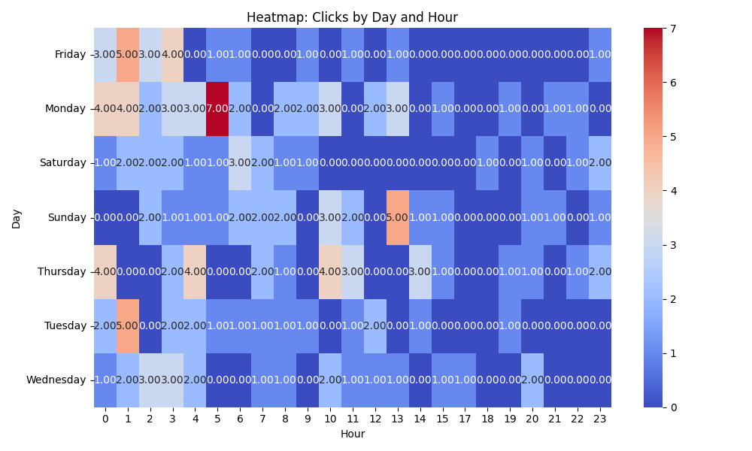

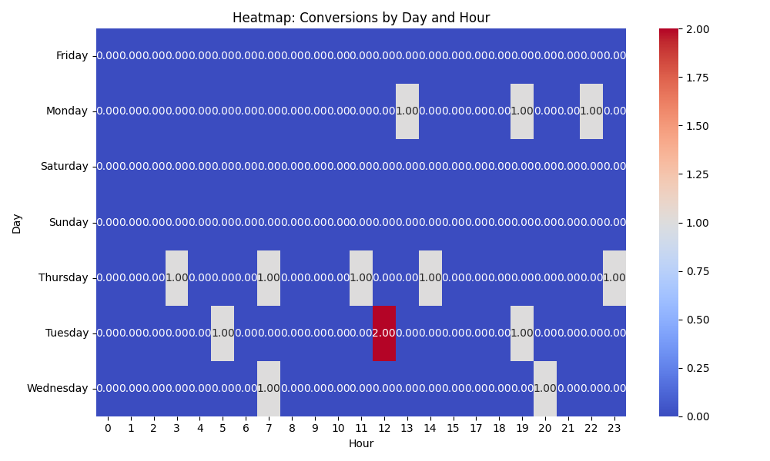

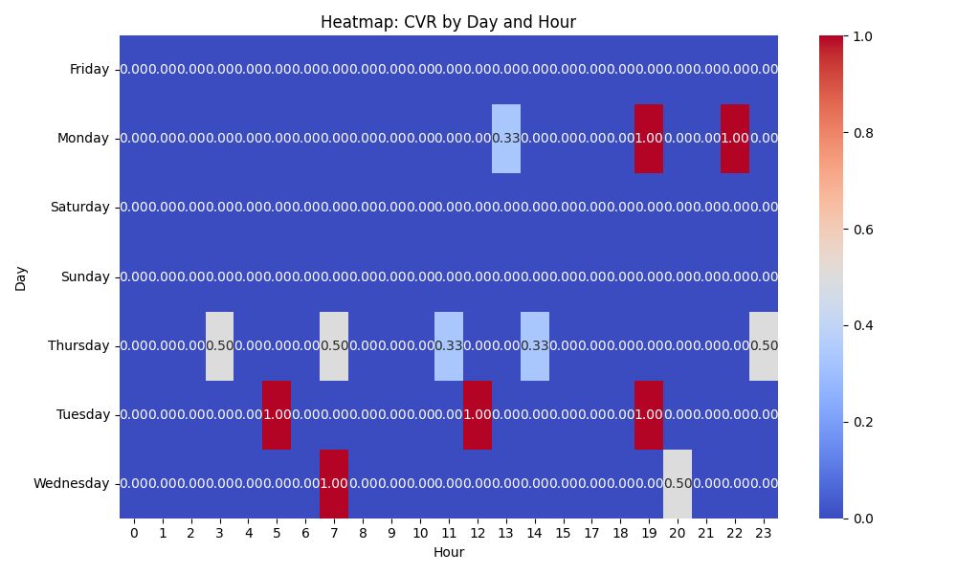

# Competitor Intelligence

# Top Competitor Insights

|  |  |  |
| --- | --- | --- |
| Competitor | Strengths | Recommendations |
|  | This ad creative directly addresses a core desire of marketers – to effectively engage their target audience. It's a clear, benefit-driven hook that immediately resonates. This messaging focuses directly on a key business outcome: conversion. It speaks to the ROI and bottom-line impact, which is highly appealing to decision-makers looking for tangible results. This positions the competitor as innovative and forward-thinking, appealing to businesses looking for cutting-edge solutions to stay ahead. It evokes a sense of novelty and progress. This ad creative clearly articulates two critical, tangible business objectives that video brochures can achieve. It's comprehensive, addressing both lead generation/revenue and brand building, appealing to a broader set of marketing goals. This messaging highlights the versatility and tailorability of their product, reassuring potential customers that the solution can be adapted to their specific needs, regardless of their sector. It broadens the perceived market applicability. | While our landing page uses 'Captivate your audience' in the sub-headline, consider elevating 'Captivate' or 'Engage' to an even more prominent position, perhaps as a direct H1 or a very visible bullet point in the hero section. Emphasize how our premium product achieves this superior captivation. Our page mentions 'designed to wow, inform, and convert.' Make the conversion promise more explicit and central in the main hero section or value proposition. Consider a prominent headline or sub-headline like 'Boost Your Conversion Rates with Video-In-Print' or 'Drive Higher ROI Through Immersive Video Brochures.' Incorporate metrics or case studies related to conversion if available. Our page uses 'Turn Your Brand into an Experience,' which aligns conceptually, but doesn't explicitly state 'future.' Add language that positions our products as innovative, next-generation, or a strategic competitive advantage. Examples include 'Unlock the Next Generation of Marketing' or 'Pioneering Immersive Brand Experiences' to resonate with clients seeking innovation. Our landing page alludes to these benefits ('Ultimate Sales and Marketing Tool,' testimonials about 'knocking their socks off'). Explicitly combine and highlight these dual benefits prominently. Consider a statement like 'Achieve Unprecedented Sales Growth & Elevate Brand Recognition' in a key visible area to immediately communicate comprehensive value. Our landing page effectively communicates 'Fully Customizable' and showcases diverse global brands in testimonials. While implied, consider explicitly stating 'Custom Solutions For Every Industry' or 'Tailored for Your Unique Needs, Across All Sectors' in a prominent location to directly address this common client query and reinforce our versatility. |
| mediafast.com | Their Google Ad creative 'Video Brochures, Video Mailers & Video Boxes | MediaFast' is highly direct and immediately communicates their core product range in a concise manner. It lists three distinct product categories, which can broaden their appeal to users searching for any of those specific items and sets clear expectations upfront. The competitor's brand name, 'MediaFast', inherently suggests speed and efficiency in media production. This can be a compelling differentiator for clients who prioritize quick turnaround times for their video marketing materials, creating an immediate perception of a key benefit. The competitor's ad is purely product-focused, which is efficient for users who know exactly what they're looking for. It avoids overly descriptive marketing jargon in the initial ad creative, leading to very direct and unambiguous messaging. | Revise our Google Ad headlines and descriptions to explicitly list a wider range of our most popular 'Video In Print' products beyond just 'Video Brochures'. Consider including 'Video Mailers', 'Video Boxes/Packaging', and 'Video Business Cards' in ad copy to instantly convey our breadth of offerings and capture a wider set of specific user searches. For example, 'Custom Video Brochures, Mailers & Packaging'. Assess if 'speed of delivery' or 'fast turnaround' is a genuine and competitive advantage for us. If so, consider incorporating this benefit into our ad copy or prominently on our landing page, perhaps alongside our 'Fully Customizable' and 'Low Minimum Order' points. If not, double down on our existing strengths like 'Premium Quality', 'Proven Engagement Booster', and 'Trusted by Global Brands' to clearly differentiate our value proposition and reinforce our unique selling points. While our landing page effectively communicates the 'why' (ultimate sales tool, turn brand into an experience, wow, inform, convert), our ad copy should strike a balance between benefit-driven language and clear product specificity. Ensure that our Google Ads clearly articulate *what* we sell (e.g., 'Video Brochures & Custom Print') while also hinting at the *value* (e.g., 'Elevate Your Brand'). This combines the competitor's directness with our stronger, benefit-driven value proposition to appeal to both informed and exploring customers. |
| thevideocards.com | The competitor's ad creative explicitly and directly communicates their core product offerings (Video Brochures, Video Boxes, & Video Mailers). This immediate clarity is highly effective in capturing the attention of users with specific product search intent, as it directly matches their potential queries. Their ad creative's simplicity and product-first approach makes their offering very easy to understand at a glance. This functional approach is beneficial for users seeking straightforward product information and can lead to efficient initial clicks. Their ad creative presents a clean, unambiguous statement of their product categories, which can streamline the user's decision-making process for initial clicks by immediately confirming they offer what the user is seeking. | Revise our Google Ad headlines and descriptions to explicitly mention our diverse product range, mirroring the competitor's directness while highlighting our full suite of solutions. For example, incorporating 'Video Brochures, Boxes, & Mailers' into key ad copy will broaden appeal and improve relevance for specific long-tail searches, immediately setting us apart as a comprehensive provider. While our landing page excels at conveying high-level benefits ('Ultimate Sales and Marketing Tool', 'Turn Your Brand into an Experience'), ensure our ad creative balances this with clear product identification. Incorporate concise, benefit-infused product descriptors (e.g., 'Custom Video Brochures: Engage & Convert') to clearly state what we offer while hinting at the value proposition, creating a more compelling click-through proposition. Capitalize on our significant competitive advantage in social proof and brand trust, which is prominently featured on our landing page. Integrate powerful phrases like 'Trusted by Global Brands' or mention specific high-profile clients (e.g., 'Used by Volvo & VW') directly into our Google Ad headlines or descriptions. This provides immediate credibility and differentiation, which the competitor's ad lacks, compelling users to choose us over a generic listing. |
| mediafast.com › video-mailer | Their ad creative 'Video Mailer | Custom, High-Impact Video Brochure You ... | MediaFast' is highly specific and keyword-rich, directly targeting 'Video Mailer' and 'Video Brochure'. This precision likely leads to excellent ad relevance for those specific search queries. The phrasing 'You ...' subtly implies a direct benefit to the user, creating intrigue and a call to action without explicitly stating it in the headline. The competitor's ad is concise and immediately communicates two key value propositions: 'Custom' and 'High-Impact'. These are compelling benefits for the target audience looking for unique and effective marketing tools. The competitor's ad is likely pointing to a very specific landing page for 'Video Mailers', suggesting a focused conversion funnel for this product. This tight ad-to-landing-page alignment can significantly improve conversion rates for users interested in that particular product. The competitor's brand name 'MediaFast' itself subtly communicates speed and efficiency, which can be an attractive characteristic for businesses looking for quick turnarounds. | Ensure our Google Ad campaigns have equally precise ad groups and creatives for specific product types like 'Video Mailer'. While our landing page is comprehensive, ad copy should be as targeted as the competitor's to maximize quality score and click-through rates for high-intent queries. Consider testing ad headlines that imply a direct, personal benefit to the user, similar to the competitor's 'You...' approach. Our landing page strongly emphasizes 'Customized' and 'High-Impact', which is excellent for consistency. We should ensure these core benefits are prominent in our ad headlines and descriptions too, perhaps even more explicitly than the competitor if space allows, to capture attention immediately. Test ad variants that lead with these benefits. While our current landing page covers 'Video Mailers' as part of our 'Video In Print Products', if 'Video Mailer' is a high-volume, high-value search term, consider creating or optimizing a dedicated section, or even a separate, highly relevant landing page specifically for 'Video Mailers'. This would mirror the competitor's presumed strategy and potentially improve our ad quality score and conversion rates for those specific searches by providing hyper-relevant content immediately upon click. Our brand might not inherently communicate speed, but our landing page *does* highlight 'Low Minimum Order' and 'Trusted by Global Brands'. These are powerful unique selling propositions (USPs). Incorporate these USPs, possibly via sitelink extensions or even within ad descriptions, to differentiate ourselves in search results. Emphasize our proven engagement and the 'wow' factor derived from global brand trust to build immediate credibility against competitors. |

# Top 3 Risks & Opportunities

## ⚠️ Risks

# Risks

|  |  |  |
| --- | --- | --- |
| Characteristic | Insight | Recommendation |
| High Cost Per Acquisition (CPA) | The campaign's CPA of $144.58 is exceptionally high, consuming approximately four days' worth of the daily budget ($35/day) for each conversion. This indicates significant inefficiency and potential unprofitability if the value of a conversion does not substantially exceed this cost. | Urgently conduct a profitability analysis based on the average value of a conversion. If unprofitable, immediately review and revise the Target CPA bid, potentially lowering it incrementally. Implement aggressive negative keyword strategies and refine audience targeting to attract more qualified leads. |
| Low Conversion Volume and Frequency | Over an estimated 58-day operational period (calculated from total cost and daily budget), the campaign has generated only 14 conversions. This translates to an average of one conversion approximately every four days, indicating a severe struggle to consistently acquire desired outcomes and limits scalability. | Perform an in-depth audit of the entire conversion funnel. This includes assessing landing page experience (load speed, clarity, call-to-action effectiveness), form submission processes, and potential technical issues preventing conversion tracking. Consider A/B testing different landing page variations to improve conversion rates. |
| Ineffective Target CPA Bid Strategy Performance | Despite utilizing a Target CPA bid strategy, the actual CPA remains high at $144.58. This suggests the strategy is either struggling to effectively optimize for a lower cost per conversion, or the initial target set is too ambitious or simply too high relative to the desired efficiency. | Ensure sufficient conversion data exists for the Target CPA strategy to learn effectively. Review the current Target CPA setting and consider gradually lowering it by a small percentage (e.g., 5-10%) while closely monitoring the impact on conversion volume. Explore other bid strategies like Maximize Conversions if Target CPA isn't yielding desired results after adjustments. |

## ✅ Opportunities

# Opportunities

|  |  |  |
| --- | --- | --- |
| Characteristic | Insight | Recommendation |
| Strong Click-Through Rate (CTR) | The campaign boasts an impressive CTR of 8.89%, which is significantly above average for search campaigns. This indicates excellent ad copy relevance, compelling ad creatives, and effective keyword targeting, successfully capturing user interest. | Capitalize on this strong engagement by ensuring continuity and relevance from ad click to landing page experience. Maintain the current ad copy and keyword structures that contribute to this high CTR. Focus further optimization efforts on improving the post-click user journey to convert this strong interest into conversions. |
| High Potential for Conversion Rate Optimization (CRO) | The disconnect between a high CTR and the high CPA with low conversion volume suggests a substantial opportunity to improve the conversion rate from clicks to actual conversions. Users are clearly interested, but something is impeding their final action. | Prioritize a comprehensive landing page optimization initiative. This includes A/B testing different headlines, calls-to-action, form layouts, and content simplification. Ensure the landing page is mobile-responsive and loads quickly. Implement user behavior analytics tools (e.g., heatmaps, session recordings) to identify specific points of user friction. |
| Bid Strategy Fine-Tuning and Data Leverage | With 14 recorded conversions, the Target CPA bid strategy has accumulated foundational data. This provides a valuable opportunity to refine the strategy, leveraging the algorithm's learning to drive more efficient conversion costs over time. | Beyond merely lowering the Target CPA, review conversion delays and adjust conversion window settings if applicable. Consider exploring different attribution models (e.g., data-driven) to ensure all contributing touchpoints are recognized. Continuously feed the system with accurate conversion data to optimize its performance. |