Google Ads Audit Report

# Campaign Performance (w/ Benchmark Overlay)

|  |  |  |  |  |  |  |  |  |  |
| --- | --- | --- | --- | --- | --- | --- | --- | --- | --- |
| Campaign Name | CTR | Cost ($) | Clicks | Impressions | CTR Flag | Avg CPC | Avg CPC Flag | CPA ($) | CPA ($) Flag |
| VPP_Search_Leads_USA_03/08/2024 (Exp 1) | 9.06% | $2086.49 | 187 | 2064 | Above | $11.16 | Above | $139.10 | Above |

# Campaign Insights

# Campaign Insights

|  |  |  |
| --- | --- | --- |
| Characteristic | Insight | Recommendation |
| Engagement Rate | The campaign exhibits a strong Click-Through Rate (CTR) of 9.06% (187 clicks from 2064 impressions), indicating high ad relevance and user interest. | Leverage this high CTR by expanding keyword coverage (e.g., exploring phrase or broad match variants of high-performing exact match keywords based on search terms) or creating more granular ad groups. Ensure landing page experience aligns perfectly with ad messaging to maintain post-click engagement. |
| Conversion Performance & Cost Efficiency | The campaign has generated 15.0 conversions at a Cost Per Acquisition (CPA) of $139.10, with a total cost of $2086.49. | Evaluate the profitability of these 15.0 conversions against your business's average conversion value or target CPA. If the $139.10 CPA is acceptable, consider incrementally increasing the daily budget beyond $35.0 to capture more conversion volume. If too high, investigate conversion quality (e.g., lead scoring) and consider bid adjustments or adding more precise negative keywords. |
| Bid Strategy Effectiveness (Target CPA) | Operating under a TARGETCPA bid strategy, the campaign achieved 15.0 conversions at an average CPA of $139.10. | Review the historical target CPA setting for this campaign. If $139.10 is higher than the desired target, consider gradually lowering the target CPA (e.g., by 5-10%) to optimize for lower costs, while closely monitoring conversion volume. If the achieved CPA is on target or better, consider a slight increase to the target CPA to potentially gain more conversion volume if budget allows. |
| Budget Pacing & Longevity | With a daily budget of $35.0, the campaign has accumulated a total cost of $2086.49, implying it has been active for approximately 60 days (2086.49 / $35.0 = 59.6 days) since its 2024-08-10 start date. | Given the campaign's consistent spend over ~60 days, if conversion volume and CPA targets are being met, assess the opportunity to increase the daily budget beyond $35.0 to capture additional conversions, especially if the campaign is frequently budget-constrained. Monitor performance closely after any budget adjustments to ensure CPA remains stable. |

# Keyword Performance

|  |  |  |  |  |  |  |  |  |
| --- | --- | --- | --- | --- | --- | --- | --- | --- |
| Ad Group | Keyword | Match Type | Quality Score | Impressions | Clicks | CTR | Avg CPC | CPA ($) |
| Video Mailers | video mailers | PHRASE | 3 | 251 | 26 | 10.36% | $13.50 | $175.45 |
| VPP Brochures | video brochures | PHRASE | 5 | 320 | 21 | 6.56% | $14.31 | $150.24 |
| Video Books | promotional video book | PHRASE | 6 | 66 | 10 | 15.15% | $14.16 | $0.00 |
| Video Box | video box | PHRASE | 3 | 360 | 21 | 5.83% | $5.42 | $0.00 |
| Video Box | box with video screen | PHRASE | 4 | 28 | 8 | 28.57% | $13.21 | $105.68 |
| Video Box | video box marketing | PHRASE | 6 | 69 | 8 | 11.59% | $11.80 | $94.41 |
| Video Books | video book marketing | PHRASE | 6 | 96 | 12 | 12.50% | $6.26 | $25.04 |
| Video Mailers | video mailers marketing | PHRASE | 7 | 63 | 6 | 9.52% | $11.74 | $0.00 |
| Video Mailers | custom video mailers | PHRASE | 5 | 46 | 6 | 13.04% | $10.98 | $65.85 |
| Video Mailers | video brochure mailer | PHRASE | 4 | 31 | 2 | 6.45% | $32.27 | $43.03 |
| Video Books | personalized video books | PHRASE | 5 | 83 | 12 | 14.46% | $5.27 | $63.21 |
| Video Box | custom video box | PHRASE | 5 | 35 | 3 | 8.57% | $18.40 | $0.00 |
| VPP Brochures | video brochure card | PHRASE | 4 | 96 | 5 | 5.21% | $9.54 | $0.00 |
| VPP Brochures | video brochure usa | PHRASE | 4 | 27 | 2 | 7.41% | $19.33 | $38.66 |
| Video Mailers | video card mailer | PHRASE | 3 | 16 | 3 | 18.75% | $12.41 | $37.24 |
| Video Books | custom video books | PHRASE | 5 | 99 | 8 | 8.08% | $4.63 | $0.00 |
| VPP Brochures | custom video brochures | PHRASE | 7 | 41 | 3 | 7.32% | $9.88 | $59.27 |
| VPP Brochures | video brochure manufacturer | PHRASE | 3 | 3 | 2 | 66.67% | $11.74 | $0.00 |
| VPP Brochures | lcd video brochure | PHRASE | 3 | 5 | 1 | 20.00% | $13.72 | $0.00 |
| VPP Brochures | video brochure marketing | PHRASE | 5 | 2 | 1 | 50.00% | $12.49 | $0.00 |
| Video Box | video gift box | PHRASE | 5 | 42 | 4 | 9.52% | $2.88 | $0.00 |
| VPP Brochures | video brochure pricing | PHRASE | 0 | 10 | 1 | 10.00% | $11.03 | $0.00 |
| VPP Brochures | lcd screen video brochure | PHRASE | 4 | 13 | 1 | 7.69% | $10.84 | $0.00 |
| VPP Brochures | video brochure book | PHRASE | 5 | 2 | 1 | 50.00% | $9.41 | $0.00 |
| VPP Brochures | 4.3 inch video brochure | PHRASE | 0 | 3 | 1 | 33.33% | $7.84 | $0.00 |
| VPP Brochures | brochure with video screen | PHRASE | 5 | 3 | 1 | 33.33% | $7.42 | $0.00 |
| Video Box | gift box with video screen | PHRASE | 1 | 2 | 1 | 50.00% | $5.91 | $0.00 |
| Video Mailers | lcd video mailers | EXACT | 0 | 3 | 1 | 33.33% | $5.87 | $0.00 |
| Video Box | promotional video box | PHRASE | 3 | 4 | 1 | 25.00% | $3.77 | $0.00 |
| VPP Brochures | video screen brochure | PHRASE | 5 | 14 | 1 | 7.14% | $1.44 | $0.00 |
| VPP Brochures | media fast video brochure | PHRASE | 1 | 5 | 0 | 0.00% | $0.00 | $0.00 |
| VPP Brochures | video brochure maker | PHRASE | 4 | 2 | 0 | 0.00% | $0.00 | $0.00 |
| Video Books | lcd video book | PHRASE | 5 | 4 | 0 | 0.00% | $0.00 | $0.00 |
| VPP Brochures | digital video brochures | PHRASE | 4 | 4 | 0 | 0.00% | $0.00 | $0.00 |
| Video Mailers | mailer with video screen | PHRASE | 4 | 1 | 0 | 0.00% | $0.00 | $0.00 |
| Video Mailers | video mailer box | PHRASE | 5 | 4 | 0 | 0.00% | $0.00 | $0.00 |
| Video Box | video brochure box | PHRASE | 2 | 7 | 0 | 0.00% | $0.00 | $0.00 |
| Video Mailers | mediafast video mailer | PHRASE | 2 | 22 | 0 | 0.00% | $0.00 | $0.00 |
| Video Box | video presentation box | PHRASE | 2 | 2 | 0 | 0.00% | $0.00 | $0.00 |
| Video Box | lcd video box | PHRASE | 5 | 4 | 0 | 0.00% | $0.00 | $0.00 |

# Keyword Insights

# Keyword Insights

|  |  |  |
| --- | --- | --- |
| Characteristic | Insight | Recommendation |
| High-Converting, Efficient Keyword | The keyword 'video book marketing' in the 'Video Books' ad group is highly successful, generating 3.0 conversions at an exceptional CPA of $25.04 and a robust Conversion Rate (CVR) of 25.00%. Its Quality Score of 6 indicates good relevance. | Increase bid adjustments for 'video book marketing' by 15-20% and allocate additional budget to this ad group to capitalize on its strong performance. Consider creating dedicated ad copy variations that specifically highlight the value proposition for 'video book marketing' searches. |
| High Spend, Low Quality Score, Moderate Conversions | The top spending keyword 'video mailers' (Video Mailers Ad Group) has cost $350.90 for 2.0 conversions, but has a low Quality Score of 3 and a high Average CPC of $13.50. Similarly, 'video brochures' (VPP Brochures Ad Group) cost $300.48 for 2.0 conversions with a QS of 5 and Avg CPC of $14.31, indicating potential inefficiency. | Conduct a thorough ad copy and landing page audit for 'video mailers' to improve its Quality Score and reduce CPC. For both keywords, analyze the Search Terms Report to identify and add irrelevant queries as negative keywords, ensuring spend is focused on higher-intent searches. |
| Significant Spend, Zero Conversions | Several keywords have incurred substantial costs without yielding any conversions: 'promotional video book' (Video Books) spent $141.59, 'video box' (Video Box) spent $113.74, and 'video mailers marketing' (Video Mailers) spent $70.46. While 'promotional video book' has a QS of 6, its lack of conversions is concerning. | Immediately pause 'video box' due to its low QS (3) and high unconvertible spend. For 'promotional video book' and 'video mailers marketing', implement aggressive bid reductions (e.g., 50-70%) and closely monitor performance for the next 7-14 days. If no conversions occur, pause these keywords to reallocate budget. |
| High Conversion Rate, Low Volume Potential | Keywords such as 'video brochure mailer' (Video Mailers) with a 75.00% CVR (1.5 conversions for $64.55 cost), 'video brochure usa' (VPP Brochures) with a 50.00% CVR (1.0 conversion for $38.66 cost), and 'video card mailer' (Video Mailers) with a 33.33% CVR (1.0 conversion for $37.24 cost) demonstrate strong commercial intent, despite their relatively low impression volume. | Increase bids for these specific keywords by 10-15% to increase impression share and click volume. Develop dedicated landing pages or specific sections on existing pages that directly address the high-intent nature of these queries to maximize conversion potential. |
| Extremely Low Quality Score Keywords | Keywords 'video brochure pricing' (VPP Brochures) and 'lcd video mailers' (Video Mailers) both have a Quality Score of 0, while 'gift box with video screen' (Video Box) has a QS of 1. These keywords are accumulating cost ($11.03 for 'video brochure pricing', $5.87 for 'lcd video mailers', $5.91 for 'gift box with video screen') with no conversions. | Pause all keywords with a Quality Score of 0 or 1 immediately, as they are highly inefficient. If these terms are strategically important, consider re-adding them as Exact Match with highly specific ad copy and a precisely aligned landing page to improve relevance signals. |
| High CTR, Zero Conversions on Low Volume | Keywords like 'video brochure manufacturer' (VPP Brochures) with a 66.67% CTR (2 clicks, $23.48 cost) and 'video brochure book' (VPP Brochures) with a 50.00% CTR, despite low volume, show strong user engagement but zero conversions, suggesting a disconnect post-click. | Investigate the landing page experience and ad-to-landing page messaging alignment for these keywords. Conduct A/B tests on alternative landing pages or modify existing content to better address the intent implied by these high-CTR, specific queries. Also, review the Search Terms Report to ensure the actual searches match the intended audience. |

# Wasted Spend Insights

# Wasted Spend Insights

|  |  |  |
| --- | --- | --- |
| Characteristic | Insight | Recommendation |
| High Spend, Very Low CTR, High Avg CPC, Zero Conversions | The keyword 'promotional video book' incurred a substantial cost of $141.59 with an alarmingly low CTR of 0.15% and a very high Avg CPC of $14.16, leading to 0 conversions. The Quality Score of 6, while not critical, is insufficient to offset the poor engagement and high costs. | Immediately pause 'promotional video book'. Analyze the Search Terms Report for irrelevant queries being matched. Re-evaluate if the product offered truly aligns with 'promotional video book' intent. If relevant, rewrite ad copy to be highly specific and compelling, ensuring the landing page clearly showcases the product's promotional value. Consider a more precise match type to prevent broad matches. |
| High Spend, Extremely Low CTR, Very Low Quality Score, Zero Conversions | The keyword 'video box' consumed $113.74, resulting in 0 conversions, an exceptionally low CTR of 0.06%, and a critical Quality Score of 3. This indicates a fundamental misalignment between user intent, ad relevancy, and landing page experience. | Immediately pause 'video box' due to its low Quality Score and high spend with no conversions. This keyword is overly generic and likely attracts irrelevant searches. Add 'video box' as a negative keyword (exact or phrase match depending on search terms analysis). Focus budget on more specific, long-tail keywords that clearly define the product. |
| Significant Spend, Very Low CTR, High Avg CPC, Zero Conversions Despite Decent Quality Score | The keyword 'video mailers marketing' spent $70.46 with 0 conversions. Despite a decent Quality Score of 7, its CTR is only 0.10% and Avg CPC is a high $11.74, indicating that while Google perceives some relevance, user engagement is extremely low. | Review the Search Terms Report for 'video mailers marketing' to identify any irrelevant queries. Test new ad copy that specifically highlights how video mailers are used for 'marketing purposes' (e.g., lead generation, direct mail campaigns). Ensure the landing page clearly demonstrates the marketing benefits and has a strong, clear call to action. Consider adjusting match type to be more restrictive if broad matches are occurring. |
| High Spend, Extremely High Avg CPC, Very Low CTR, Poor Quality Score, Zero Conversions | The keyword 'custom video box' cost $55.19, leading to 0 conversions, with an exceptionally high Avg CPC of $18.40 and a very low CTR of 0.09%. The Quality Score of 5 confirms poor ad relevance and/or landing page experience, making this an extremely inefficient keyword. | Immediately pause 'custom video box'. This keyword is draining budget rapidly with no return. Deep dive into the Search Terms Report. Improve the landing page content to specifically address 'custom video box' needs (e.g., customization options, order process, examples). Reassess search intent: are users looking to purchase or for DIY instructions? If the latter, add it as a negative keyword. |
| High Spend, Extremely Low CTR, High Avg CPC, Very Poor Quality Score, Zero Conversions | The keyword 'video brochure card' incurred $47.71 in costs with 0 conversions, suffering from an abysmal CTR of 0.05% and a very poor Quality Score of 4. The Avg CPC of $9.54 suggests an expensive and inefficient keyword. | Pause 'video brochure card' due to its low Quality Score and high cost for zero conversions. Ensure the ad copy explicitly mentions 'video brochure card' to maximize relevance. Drastically improve the landing page to specifically highlight 'video brochure cards', their unique features, and applications, potentially with clear product images/videos and pricing information. Explore if 'video brochure card' is the most common or accurate term for the product, or if a slight variation is more effective. |
| Significant Spend, High CTR, Very High Avg CPC, Very Low Quality Score, Zero Conversions | The keyword 'video brochure manufacturer' spent $23.48 with 0 conversions. Despite a strong CTR of 0.67%, it suffers from a critical Quality Score of 3 and a very high Avg CPC of $11.74, indicating that while the ad attracts clicks, the landing page experience or the overall relevance of the offering to a 'manufacturer' query is severely lacking. | Immediately determine if the business *is* a video brochure manufacturer. If not, add 'video brochure manufacturer' as a negative keyword, as this search intent is for B2B procurement, not direct product purchase. If the business is a manufacturer, the landing page must be drastically improved to cater to B2B inquiries (e.g., bulk ordering, partnership information, detailed technical specifications). The low Quality Score suggests a strong mismatch after the click. |
| Moderate Spend, Extremely High Avg CPC, Very Low Quality Score, Zero Conversions | The keyword 'lcd video brochure' spent $13.72 with 0 conversions, displaying a low CTR of 0.20% and a critical Quality Score of 3. The Avg CPC of $13.72 strongly suggests either a single, very expensive click or consistently high costs for extremely irrelevant engagement. | Pause 'lcd video brochure' due to its low Quality Score and extremely high cost per click. Enhance the landing page to prominently feature 'LCD video brochures' with clear product details, benefits, and pricing. If the low Quality Score persists, consider if the product offering truly matches this specific query or if there's a better way to describe it in ads and on the landing page. |
| Moderate Spend, High CTR, Very High Avg CPC, Poor Quality Score, Zero Conversions | The keyword 'video brochure marketing' incurred $12.49 with 0 conversions. Despite a good CTR of 0.50%, it has a high Avg CPC of $12.49 and a poor Quality Score of 5, indicating that while the ad is clicked, the subsequent landing page experience or offering may not align with the user's marketing-specific intent. | Improve the landing page for 'video brochure marketing' to specifically address how video brochures can be used for marketing purposes (e.g., case studies, ROI examples, direct mail campaigns). Review ad copy to ensure it directly answers 'marketing' queries. The high CTR but poor Quality Score suggests the ad is effective but the landing page isn't meeting expectations set by the ad. |
| Moderate Spend, Very Low CTR, Extremely High Avg CPC, Critical Quality Score (0), Zero Conversions | The keyword 'video brochure pricing' spent $11.03 with 0 conversions. It shows an alarming Quality Score of 0 (indicating severe issues with relevance or insufficient data), a very low CTR of 0.10%, and an extremely high Avg CPC of $11.03. | Immediately pause 'video brochure pricing.' This keyword clearly indicates someone is looking for pricing information. The landing page must provide clear, accessible pricing details, a simple quote request form, or transparent pricing tiers. If the landing page doesn't directly address pricing, this keyword will never convert effectively. Investigate why Quality Score is 0, which is a major red flag. |

# Landing Page Audit Insights

## Landing Page: https://videoplusprint.com/video-in-print-products

# Landing Page Insights

|  |  |  |  |
| --- | --- | --- | --- |
| URL | Characteristic | Insight | Recommendation |
| https://videoplusprint.com/video-in-print-products | Conversion Rate & CPA | A conversion rate of 8.02% is strong for a B2B lead generation page, especially for a custom product requiring detailed inputs. However, the CPA of $139.10 is quite high. The provided cost data of 0.00 is likely incomplete or erroneous, making a full CPA analysis difficult without actual cost data. | Given the decent conversion rate, focus on validating the value per lead with sales data to confirm if the $139.10 CPA is sustainable. If not, explore further conversion rate optimization by improving lead qualification or clarity, or optimizing ad targeting to reduce CPCs and acquire more cost-effective clicks for the target audience. |
| https://videoplusprint.com/video-in-print-products | Page Clarity & Messaging | The page clearly articulates the product type ('Video-In-Print'), its core benefits ('wow, inform, and convert'), and key differentiators like 'Fully Customizable,' 'Low Minimum Order,' and 'Trusted by Global Brands.' The form fields effectively segment product interest and quantity. | Continue to emphasize the 'Low Minimum Order' as it directly addresses a common barrier for custom product procurement. While clear, consider refining the main page title/meta title (currently appearing as 'Video Brochure: The Ultimate Sales and Marketing Tool Menu Our Products...') to be more concise and directly reflect the 'Video-in-Print Products' focus for improved SEO and user clarity in search results. |
| https://videoplusprint.com/video-in-print-products | Call to Action (CTA) | The primary CTA 'GET A FREE QUOTE' is prominent, consistent, and well-positioned above the fold and repeated, aligning perfectly with the lead generation goal for a custom product. The immediate visibility of the form is a strength. | While the current CTA is effective, A/B test subtle variations like 'Request Your Custom Quote' or 'Start Your Project Quote' to see if more personalized or action-oriented language resonates better with high-value prospects. Consider adding a small reassurance line, e.g., 'No Obligation Quote,' near the form submission button to potentially reduce perceived commitment. |
| https://videoplusprint.com/video-in-print-products | Trust Signals | The page leverages strong trust signals through the explicit 'Trusted by Global Brands' claim and an extensive collection of detailed testimonials from recognizable companies such as Volvo, Volkswagen, and Commonwealth Bank. These provide specific positive feedback. | Ensure all testimonials are current and varied; address the minor repetition of the Volvo testimonial to maintain a polished professional appearance. Explore adding visual proof, like company logos alongside testimonials (with permission), to further reinforce the 'Trusted by Global Brands' claim. |
| https://videoplusprint.com/video-in-print-products | UX & Navigation | The immediate availability of the quote form is excellent for capturing lead intent. However, the presence of full website navigation (Menu, Our Products, About Us, etc.) implies this is a standard website page rather than a dedicated landing page designed solely for conversion. | To maximize conversion rates, transform this into a dedicated landing page by removing all global navigation links (header and footer), unnecessary internal links, and external distractions. The goal is to create a focused funnel where the primary action is completing the quote request form, minimizing 'leakage' from the page. |
| https://videoplusprint.com/video-in-print-products | Visual Content (Implied Missing) | The provided HTML content audit does not explicitly detail visual elements (images or videos) beyond text descriptions. For a product like 'Video-In-Print,' high-quality visuals are crucial for demonstrating the physical product, its 'wow' factor, and functionality. | Integrate prominent, high-resolution images and, critically, videos showcasing the various 'video-in-print' products (brochures, business cards, packaging) in action. Show close-ups of screens, print quality, and how they are used in real-world scenarios to convey the product's impact and address common questions visually. |
| https://videoplusprint.com/video-in-print-products | Competitor Benchmark | Many competitors in the custom B2B print space increasingly offer interactive elements such as instant quote calculators for basic configurations, 3D mock-up tools, or highly visual product galleries that dynamically update based on selections. The current page relies solely on a form for a custom quote, without offering an immediate visual or cost estimate. | Research leading competitors' landing pages. If they provide interactive configurators or a 'soft' price range for standard items, consider if integrating a simplified version or a dynamic gallery that visually adapts as users select options in the form (e.g., showing a 7-inch screen brochure) could reduce friction, increase engagement, and pre-qualify leads before they even request a formal quote. |
| https://videoplusprint.com/video-in-print-products | Conversion Rate vs. Cost Per Acquisition (CPA) | The reported conversion rate of 8.02% is exceptionally high for a B2B product, indicating strong page effectiveness at converting highly qualified visitors. However, the CPA of $139.10 is also high. This suggests that while the page converts well, the cost per click for the target keywords might be expensive, or the overall traffic volume is low relative to spend. The 'Cost: 0.00' is a severe data anomaly; assuming the CPA is accurate, the page itself is not the primary blocker to conversions, but rather the cost efficiency of the ad traffic. | Given the strong conversion rate, focus efforts on optimizing ad targeting and keywords to reduce CPCs and increase qualified traffic volume without sacrificing conversion quality. Immediately investigate the 'Cost: 0.00' tracking issue to ensure accurate performance measurement and avoid misinterpreting future data. |
| https://videoplusprint.com/video-in-print-products | Call to Action (CTA) Clarity and Prominence | The CTA 'Get A FREE Video Brochure QUOTE' and 'GET A FREE QUOTE' are clear and offer a low-friction entry point for prospects, with 'FREE' reducing perceived risk. However, without full page context, it's unclear if this CTA is present strategically throughout the page, especially above the fold and after key value propositions. | Ensure the primary 'Get A FREE Quote' CTA is prominently displayed above the fold, near the top value proposition, and strategically repeated after sections detailing products, benefits, and social proof. Consider A/B testing variations like 'Request a Custom Quote' or 'Start Your Video Brochure Project' to see if different phrasing resonates more effectively with the target audience. |
| https://videoplusprint.com/video-in-print-products | Trust and Authority Signals | The page effectively uses strong trust signals like '40 years of expertise,' named client examples (UPS, Exxon Mobil), and a quantitative ROI claim (23% sales lift). However, the 'Most Valuable Company 2016 in Hong Kong' award, while positive, is dated and could unintentionally raise questions about more recent achievements or relevance. | Prioritize featuring more recent awards, certifications, or updated testimonials if available. Integrate trust signals visually (e.g., client logos prominently displayed, a 'since 2009' badge near the header). For existing testimonials or awards, consider adding 'as seen in' or 'featured by' language to leverage their past prestige more effectively. |
| https://videoplusprint.com/video-in-print-products | Product Clarity and Visual Integration | The text describes various products (brochures, mailers, books, packaging, business cards) and highlights specific features. However, for a product like 'video in print,' visual demonstration is paramount to convey the 'wow' factor and differentiate offerings. Text descriptions alone are likely insufficient to fully engage and educate a visitor on such an innovative and sensory product. | Prioritize high-quality product images and video demonstrations for each product type. Implement an interactive gallery or short explainer videos that showcase the products in action, highlighting embedded screens, buttons, and overall user experience. Ensure these compelling visuals are prominently featured above the fold to immediately capture attention and demonstrate the product's value. |
| https://videoplusprint.com/video-in-print-products | Ad Intent Alignment and Keyword Matching | The content provided ('video-in-print-products') directly matches the assumed ad intent for keywords like 'video in print products,' 'video brochures,' etc. This strong alignment likely contributes to the relatively good CTR (3.35%) and high conversion rate (8.02%). However, without the actual keywords driving traffic, there's a risk that broader or less qualified keywords could be driving up the CPA. | Continuously review search query reports in Google Ads to ensure keywords are highly specific and align with the page's offerings. If traffic volume warrants, consider creating more granular landing pages for specific product types (e.g., a dedicated 'video brochures' landing page vs. a general 'video in print products' page) to improve ad relevancy and potentially lower CPCs. |
| https://videoplusprint.com/video-in-print-products | Competitor Benchmark | Without specific competitor performance data, it's difficult to gauge the competitiveness of the current CPA ($139.10). In the B2B custom print/marketing solutions industry, CPAs can range widely depending on deal size and lead quality. However, a strong conversion rate (8%) is a competitive advantage, suggesting the page converts effectively once highly interested visitors arrive. | Conduct a comprehensive competitive analysis to understand average CPCs, conversion rates, and typical lead acquisition costs for similar custom video marketing solutions. This will provide essential context for the current CPA and highlight opportunities to differentiate messaging or improve cost efficiency based on competitor strategies and industry norms. |
| https://videoplusprint.com/video-in-print-products | High CPA & Data Anomaly | The reported Cost per Acquisition (CPA) of $139.10 is high, indicating significant friction in the conversion process or a misalignment between ad spend and conversion value. The 'Cost: 0.00' data point is highly unusual for paid traffic and suggests a critical tracking or reporting issue, making accurate ROI assessment challenging and casting doubt on the precise origin of the 15 conversions. | Immediately investigate the tracking setup to ensure all ad costs are accurately attributed and conversions are correctly tracked and sourced. If the CPA is indeed this high for qualified leads, conduct user surveys and A/B tests to pinpoint specific points of friction or gaps in the value proposition that deter conversions after the click. |
| https://videoplusprint.com/video-in-print-products | Value Proposition Clarity & Depth | The page mentions 'affordability' and 'effectiveness' as key benefits and lists use cases, but it lacks specific quantitative proof or detailed explanation of the tangible Return on Investment (ROI) for 'video in print products.' While 'captivating viewers' is stated, the deeper business value for a B2B audience isn't fully elaborated to justify a significant investment. | Incorporate specific examples, success stories, or statistics that demonstrate the ROI of video brochures (e.g., 'X% higher engagement rates,' 'Y% increase in lead conversion from events,' 'Z% faster sales cycle'). Clearly articulate the unique selling proposition that differentiates Video Plus Print from competitors beyond generic benefits like 'lasting impression.' |
| https://videoplusprint.com/video-in-print-products | Call to Action (CTA) Effectiveness & Urgency | The CTA 'Get A FREE Video Brochure QUOTE' is clear and present multiple times, which is good for visibility. However, offering a standard 'free quote' does not create a sense of urgency or highlight a unique benefit for taking immediate action, potentially leading prospects to delay or explore alternatives. | Enhance the CTA's value proposition. Consider adding urgency (e.g., 'Get Your Custom Quote in 24 Hours' or 'Limited-Time Design Consultation'), a specific benefit (e.g., 'Unlock Exclusive Design Ideas - Get a Free Quote'), or clarify the next steps (e.g., 'Receive a Detailed Project Proposal'). Ensure the quote request process itself is concise and low-friction. |
| https://videoplusprint.com/video-in-print-products | Trust and Credibility Signals | While the copyright date (2009-2024) indicates longevity, the provided content chunk lacks overt trust signals crucial for B2B conversions, such as client testimonials, recognizable client logos, industry awards, or detailed 'About Us' information. This absence can increase perceived risk and reduce confidence for potential buyers of a custom product. | Integrate strong social proof prominently. Add client logos (especially well-known brands that have used the product), direct quotes from satisfied customers, or short video testimonials. Consider a 'How It Works' section to demystify the process and build confidence. Display any relevant industry certifications, awards, or media mentions. |
| https://videoplusprint.com/video-in-print-products | Competitor Benchmark | Many competitors in the custom video marketing materials space differentiate themselves by offering extensive visual galleries of past projects, detailed product specification options, or transparent (even if estimated) pricing tiers that allow users to get a better sense of investment before committing to a quote. | Research leading competitors to identify their successful conversion elements beyond just a quote form. Consider adding interactive elements like a customizable product configurator, a rich project gallery with examples across different industries, or a tiered pricing guide (e.g., 'Starts at $X for Y quantity') to provide more immediate value and transparency to the user. |
| https://videoplusprint.com/video-in-print-products | Messaging Focus & Ad-Page Congruence | The page title is 'video-in-print-products,' but the content within this chunk broadens to include 'video brochures, video boxes, and video business cards.' If ad campaigns are highly specific (e.g., primarily targeting 'video brochures'), introducing multiple product types without clear prioritization or distinct sections could dilute the message and increase cognitive load for a prospect seeking one specific solution. | Ensure a tight keyword-to-ad-to-landing-page congruence. If the majority of paid traffic is for 'video brochures,' optimize the landing page to primarily focus on that product, perhaps with clear secondary sections or links to 'video boxes' or 'video business cards.' Consider creating distinct landing pages for each core product if they are significant ad targets to maintain high relevance and focus. |

# Geographical Performance

|  |  |  |  |  |  |  |  |  |  |
| --- | --- | --- | --- | --- | --- | --- | --- | --- | --- |
| City | Region | Country | Type | Impressions | Clicks | Conversions | Cost ($) | CVR | CPA ($) |
| United States |  |  | Country | 1916 | 170 | 13.0 | $1996.90 | 0.07647058823529412 | $153.61 |

# Geographical Insights

# Geographical Insights

|  |  |  |
| --- | --- | --- |
| Characteristic/ Location | Insight | Recommendation |
| United States (Country) | The United States as a whole has incurred a significant cost of $1996.90, resulting in 13 conversions at a high Cost Per Acquisition (CPA) of $153.61. While the Conversion Rate (CVR) is a healthy 7.65%, the high CPA suggests inefficiencies in the current broad targeting. | To improve the overall CPA from $153.61, break down the United States into more granular geographic targets (e.g., states, Designated Market Areas, or major cities). Conduct a geo-report to identify specific sub-regions within the US that are contributing to the high cost without generating sufficient conversions. Apply significant negative bid modifiers (-20% to -50%) to these underperforming regions, and reallocate budget or apply positive bid modifiers to areas that demonstrate stronger performance to optimize spend efficiency. |

# Hourly Performance Pivot

CVR

|  |  |  |  |  |  |  |  |  |  |  |  |  |
| --- | --- | --- | --- | --- | --- | --- | --- | --- | --- | --- | --- | --- |
| Day/Hour | 1 | 3 | 5 | 7 | 11 | 12 | 13 | 14 | 19 | 20 | 22 | 23 |
| Monday |  |  |  |  |  |  | 0.33 |  | 1.00 |  | 1.00 |  |
| Tuesday | 0.14 |  | 1.00 |  |  | 1.00 |  |  | 1.00 |  |  |  |
| Wednesday |  |  |  | 1.00 |  |  |  |  |  | 0.50 |  |  |
| Thursday |  | 0.50 |  | 0.50 | 0.33 |  |  | 0.33 |  |  |  | 0.50 |

Clicks

|  |  |  |  |  |  |  |  |  |  |  |  |  |  |  |  |  |  |  |  |  |  |  |  |
| --- | --- | --- | --- | --- | --- | --- | --- | --- | --- | --- | --- | --- | --- | --- | --- | --- | --- | --- | --- | --- | --- | --- | --- |
| Day/Hour | 0 | 1 | 2 | 3 | 4 | 5 | 6 | 7 | 8 | 9 | 10 | 11 | 12 | 13 | 14 | 15 | 17 | 18 | 19 | 20 | 21 | 22 | 23 |
| Monday |  |  |  |  |  |  |  |  |  |  |  |  |  |  |  |  |  |  |  |  |  |  |  |
| Tuesday |  |  |  |  |  |  |  |  |  |  |  |  |  |  |  |  |  |  |  |  |  |  |  |
| Wednesday |  |  |  |  |  |  |  |  |  |  |  |  |  |  |  |  |  |  |  |  |  |  |  |
| Thursday |  |  |  |  |  |  |  |  |  |  |  |  |  |  |  |  |  |  |  |  |  |  |  |
| Friday |  |  |  |  |  |  |  |  |  |  |  |  |  |  |  |  |  |  |  |  |  |  |  |
| Saturday |  |  |  |  |  |  |  |  |  |  |  |  |  |  |  |  |  |  |  |  |  |  |  |
| Sunday |  |  |  |  |  |  |  |  |  |  |  |  |  |  |  |  |  |  |  |  |  |  |  |

Conversions

|  |  |  |  |  |  |  |  |  |  |  |  |  |
| --- | --- | --- | --- | --- | --- | --- | --- | --- | --- | --- | --- | --- |
| Day/Hour | 1 | 3 | 5 | 7 | 11 | 12 | 13 | 14 | 19 | 20 | 22 | 23 |
| Monday |  |  |  |  |  |  | 1.00 |  | 1.00 |  | 1.00 |  |
| Tuesday | 1.00 |  | 1.00 |  |  | 2.00 |  |  | 1.00 |  |  |  |
| Wednesday |  |  |  | 1.00 |  |  |  |  |  | 1.00 |  |  |
| Thursday |  | 1.00 |  | 1.00 | 1.00 |  |  | 1.00 |  |  |  | 1.00 |

Cost ($)

|  |  |  |  |  |  |  |  |  |  |  |  |  |  |  |  |  |  |  |  |  |  |  |  |
| --- | --- | --- | --- | --- | --- | --- | --- | --- | --- | --- | --- | --- | --- | --- | --- | --- | --- | --- | --- | --- | --- | --- | --- |
| Day/Hour | 0 | 1 | 2 | 3 | 4 | 5 | 6 | 7 | 8 | 9 | 10 | 11 | 12 | 13 | 14 | 15 | 17 | 18 | 19 | 20 | 21 | 22 | 23 |
| Monday | 48.30 | 21.97 | 24.69 | 13.34 | 26.87 | 54.61 | 5.29 |  | 36.75 | 15.58 | 24.57 |  | 9.74 | 59.63 |  | 12.31 |  |  | 6.60 |  | 3.77 | 15.61 |  |
| Tuesday | 48.24 | 93.14 | 23.40 | 22.01 | 39.36 | 10.17 | 13.67 | 16.65 | 4.97 | 22.60 | 8.91 | 9.03 | 44.24 |  | 2.51 |  |  |  | 9.07 |  |  |  |  |
| Wednesday | 2.86 | 32.52 | 112.01 | 57.51 | 36.88 |  |  | 4.51 | 7.81 |  | 6.47 | 10.53 | 3.77 | 5.90 |  | 1.83 | 12.58 |  |  | 9.51 |  |  |  |
| Thursday | 85.88 |  |  | 39.39 | 31.03 |  |  | 41.53 | 2.24 |  | 50.64 | 16.29 |  |  | 12.13 | 7.84 |  |  | 2.70 | 4.40 |  | 2.57 | 23.67 |
| Friday | 32.45 | 47.76 | 50.79 | 48.66 |  | 12.49 | 12.36 |  |  | 9.84 |  | 8.07 |  | 1.14 |  |  |  |  |  |  |  |  | 2.56 |
| Saturday | 39.21 | 40.99 | 32.73 | 5.12 | 19.72 | 18.15 | 24.64 | 29.87 | 3.39 | 2.63 |  |  |  |  |  |  |  | 18.95 |  | 5.74 |  | 14.53 | 11.58 |
| Sunday |  |  | 24.74 | 12.14 | 14.93 | 3.99 | 0.14 | 10.97 | 6.07 |  | 19.12 | 15.75 |  | 40.52 | 39.35 |  |  |  |  | 13.34 | 3.56 |  | 15.90 |

# Hourly Patterns Insights

# Hourly Patterns Insights

|  |  |  |
| --- | --- | --- |
| Characteristic | Insight | Recommendation |
| Overnight and very early morning hours (0:00-4:59) exhibit consistently high cumulative cost with extremely low or zero conversions across most days. | Significant budget is being spent during periods when user intent to convert is minimal, leading to high inefficiency and wasted ad spend. | Implement substantial negative bid adjustments, or pause campaigns entirely, for the 0:00-4:59 time block daily to reallocate budget to more productive hours. |
| Mid-morning (Tuesday 12:00 and Wednesday 7:00) show exceptionally high Conversion Rates (100%) with 1-2 conversions for relatively low costs. | These specific day-hour combinations indicate moments of high user intent and effective ad performance, representing prime opportunities for capturing conversions efficiently. | Apply significant positive bid adjustments specifically for Tuesday 12:00-12:59 and Wednesday 7:00-7:59 to maximize presence and capture more conversions during these highly efficient periods. |
| Evening and late-night hours (19:00-23:59) also show scattered conversions with good CVR on specific days, such as Monday 19:00, Tuesday 19:00, Monday 22:00, Wednesday 20:00, and Thursday 23:00. | Users during these late hours may be actively researching or ready to convert, suggesting valuable pockets of performance outside of typical business hours. | Apply moderate positive bid adjustments for campaigns during 19:00-23:59, especially focusing on the specific days and hours that have demonstrated conversions, to capitalize on this evening and late-night demand. |
| Several daytime hours (8:00-10:59, 15:00-18:59, and 21:00) consistently incur costs without generating any conversions. | These periods are currently inefficient, suggesting that the audience reached during these times may not be ready to convert or the targeting/messaging is not optimal. | Implement negative bid adjustments for the 8:00-10:59, 15:00-18:59, and 21:00-21:59 time blocks to reduce wasted spend and improve overall campaign efficiency. Consider reviewing ad copy and targeting for these periods if maintaining presence is crucial. |

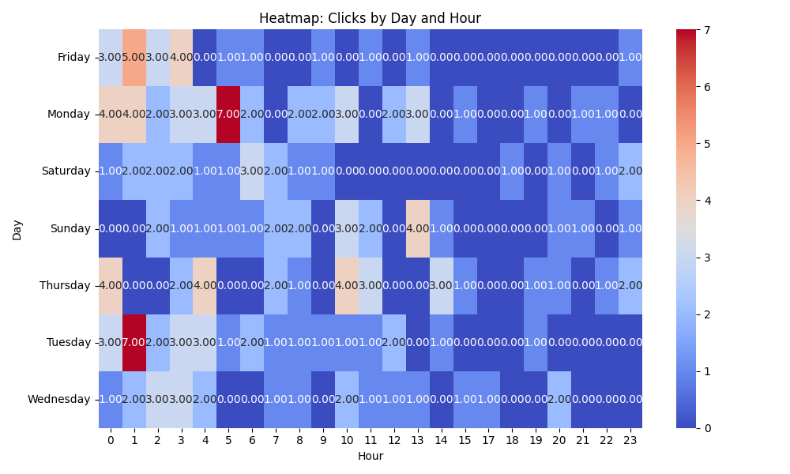

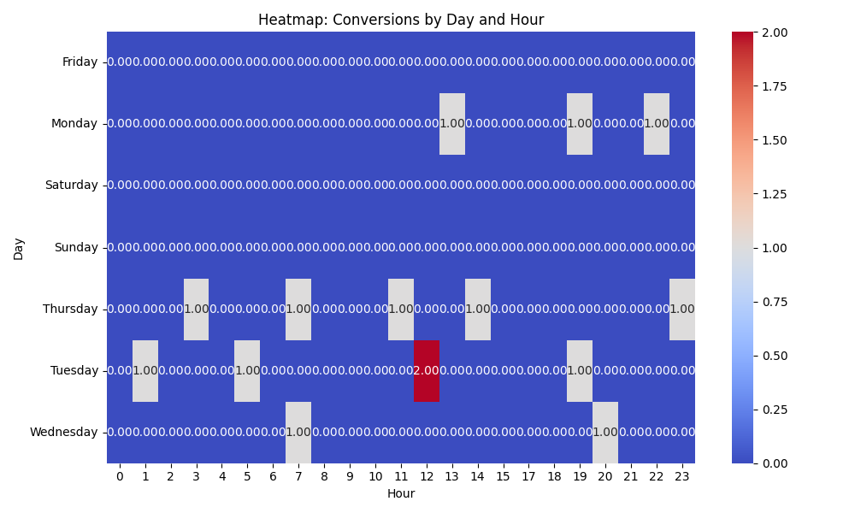

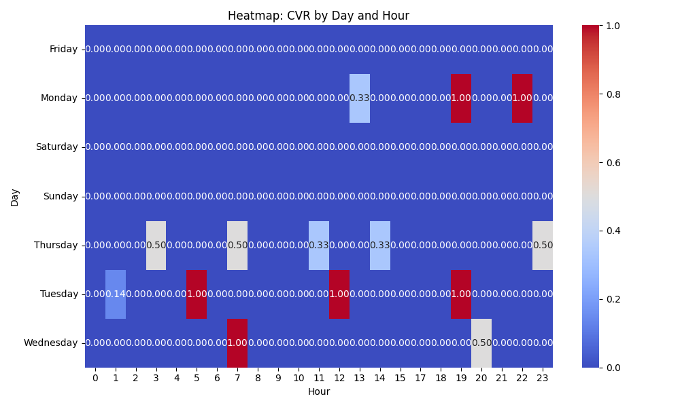

# Competitor Intelligence

# Top Competitor Insights

|  |  |  |
| --- | --- | --- |
| Competitor | Strengths | Recommendations |
|  | The competitor's ad creatives, represented by '- | ', convey no discernible message, product information, or unique selling proposition. This indicates a complete absence of strategic messaging and clarity, offering no competitive strength in attracting user attention or conveying value. The ' - | ' ad creatives provide no insight into the competitor's market positioning or differentiation. This lack of a defined value proposition means they are not creating a compelling reason for users to choose them, representing a significant strategic weakness rather than a strength. The ad creatives ' - | ' contain no explicit or implied call to action, leaving users with no clear next step. This indicates a significant flaw in guiding the user journey and converting interest into action, demonstrating no strength in driving conversions. | Capitalize aggressively on this messaging void. Our Google Ad creatives must be exceptionally clear, direct, and benefit-oriented. Utilize strong headlines like 'Video Brochures: Boost Sales & Engagement' and 'Custom Video-In-Print Solutions.' Ensure descriptions highlight core benefits ('Turn Your Brand into an Experience,' 'Proven Engagement Booster') and address pain points our products solve. Focus on high-intent keywords to capture qualified traffic that the competitor's generic ads will miss. Dominate the market by clearly articulating our unique value propositions and differentiators in our ad copy and extensions. Emphasize our 'Low Minimum Order,' 'Fully Customizable' options, and our comprehensive product range (Video Brochures, Packaging, Business Cards). Crucially, leverage our 'Trusted by Global Brands' social proof (e.g., mentioning Volvo, Volkswagen in callout extensions or ad copy) to build immediate credibility and establish us as the premium, reliable choice. Ensure all our Google Ad creatives feature prominent and compelling calls to action (CTAs) that align directly with our landing page's 'GET A FREE QUOTE.' Experiment with various CTAs in ad copy such as 'Get Your Free Quote Now,' 'Request Custom Sample,' or 'Speak to an Expert.' Implement robust ad extensions, including sitelinks for 'Our Products,' 'About Us,' and 'Get a Free Quote,' to provide multiple pathways for engagement and facilitate a seamless transition from ad click to conversion on our well-optimized landing page. |
| mediafast.com | Extremely clear and concise product-focused messaging in ad creatives. Their ads directly state the primary products 'Video Brochures, Video Mailers & Video Boxes', which is highly effective for users searching for these specific items with strong purchase intent. This directness ensures high relevance to exact-match keyword searches, leading to potentially strong click-through rates for those specific terms. | Our landing page messaging is significantly more benefit-driven and comprehensive. We should leverage our unique value propositions, such as 'The Ultimate Sales and Marketing Tool' and 'Turn Your Brand into an Experience,' directly in our ad creatives. While the competitor's ads are descriptive, ours can be persuasive. Highlight key differentiators like 'Fully Customizable,' 'Low Minimum Order,' 'Trusted by Global Brands,' and 'Proven Engagement Booster' within ad headlines and descriptions to stand out. Consider A/B testing ad variations that combine specific product keywords (like the competitor) with our unique benefits and a strong call to action, or expand ad groups to feature our broader product range (e.g., Video Business Cards, Video Packaging, Video POS) with tailored benefits. |
| mediafast.com › video-mailer | Their ad creative 'Video Mailer | Custom, High-Impact Video Brochure You ...' directly uses 'Video Mailer' as a primary product identifier in the ad title, suggesting a highly targeted ad group for this specific product. This directness can lead to higher click-through rates from users specifically searching for 'video mailers'. MediaFast prominently features 'Custom' and 'High-Impact' in their ad title. These are strong value propositions that immediately convey quality and personalization, which are key decision-making factors for potential buyers. The truncated ad title 'Video Brochure You ...' suggests a benefit-oriented angle directly addressing the user. This personal touch in an ad creative can resonate more strongly than a purely descriptive headline. | Ensure our Google Ad campaigns have specific ad groups and creatives tailored to each product type (e.g., 'Video Mailer Ad Group'). For 'Video Mailer' campaigns, our ad headline should explicitly feature 'Video Mailer' and its key benefits upfront to directly compete with MediaFast's targeted approach, even though our landing page covers it later. While our landing page content already uses 'customized' and 'high-impact' effectively, we should double down on these keywords in our ad headlines and descriptions. Experiment with different ad variations that lead with 'Custom' and 'High-Impact' to capture the attention of prospects seeking these specific attributes. In our ad copy, consider experimenting with headlines or descriptions that directly address the user and highlight a benefit they will receive. For example, instead of just 'The Ultimate Sales and Marketing Tool', we could test variations like 'Your Ultimate Sales Tool' or 'See Your Brand Wow Audiences'. |

# Top 3 Risks & Opportunities

## ⚠️ Risks

# Risks

|  |  |  |
| --- | --- | --- |
| Characteristic | Insight | Recommendation |
| Severe Budget Constraint & Low Conversion Volume | The campaign is operating with a daily budget of $35 and has generated only 15 conversions over an approximate 60-day period (based on total spend vs. daily budget), averaging 0.25 conversions/day. This severe budget constraint, combined with a high average CPC ($11.16), significantly limits impressions, clicks, and the volume of conversion data available for the Target CPA bid strategy to optimize effectively, hindering its scalability. | Conduct a comprehensive review of the budget allocation. If the current CPA of $139.09 is within acceptable limits for the client, propose a substantial increase in the daily budget (e.g., 3-5x current) to allow the campaign to gain more traction, accumulate sufficient data for smart bidding, and capture more high-intent traffic. |
| High Average CPC Relative to Budget | An average CPC of $11.16 means that the $35 daily budget can only accommodate approximately 3 clicks per day. This significantly restricts reach and impression share, preventing the campaign from fully capitalizing on market demand and hindering the Target CPA strategy's ability to learn and optimize efficiently due to insufficient daily data points. | Investigate high-cost keywords and consider refining keyword targeting by implementing more exact match types for highly relevant terms, exploring long-tail keywords, or adding new negative keywords to reduce spend on irrelevant or overly expensive queries. Simultaneously, focus on improving Quality Score for key terms through ad relevance and landing page experience optimization to potentially lower CPCs. |
| Inconsistent Start Date Data | The reported 'Start Date' for the campaign (2024-08-10) is in the future, which directly contradicts the presence of historical performance metrics (Impressions, Clicks, Cost, Conversions). This indicates a potential data entry error or mislabeling within the dataset, raising concerns about the overall accuracy and reliability of the provided information for time-dependent analyses. | Immediately verify the true start date and the specific reporting period for this campaign's performance data with the data source. Correct the 'Start Date' field to reflect the actual campaign launch date or the beginning of the reporting period to ensure accurate historical context and avoid misinterpretations in future analyses. |

## ✅ Opportunities

# Opportunities

|  |  |  |
| --- | --- | --- |
| Characteristic | Insight | Recommendation |
| Excellent Click-Through Rate (CTR) | The campaign boasts an impressive CTR of 9.06%. This is a strong indicator that the ad copy is highly relevant and compelling to the target audience's search queries, and that keyword selection is exceptionally effective. This high relevance contributes positively to Quality Score and ad positioning. | Capitalize on this strength by increasing the daily budget (as mentioned in Risks) to gain more impressions and clicks from this highly relevant audience. Experiment with ad variations and ad extensions to further enhance clickability and stand out, potentially improving the already strong CTR and driving more qualified traffic. |
| Proven Conversion Capability | Despite the severe budget constraints and high CPC, the campaign is successfully generating conversions (15 conversions), indicating that the combination of keywords, ad copy, and landing page effectively guides users through the conversion funnel. The Target CPA strategy, though data-limited, is successfully identifying converting actions. | Focus on optimizing the conversion rate on the landing page and post-click experience. Conduct A/B tests on landing page elements (headlines, CTAs, forms, value propositions) to improve conversion efficiency. If applicable, explore conversion value optimization within Google Ads to bid more strategically on higher-value leads, further improving campaign profitability. |
| Significant Scalability Potential (if CPA is viable) | With a strong CTR and demonstrated ability to convert users, if the current CPA of $139.09 aligns with or is within an acceptable range for the client's target cost per acquisition and lead value, this campaign holds significant potential for scaling lead volume by increasing budget and reach. | Collaborate closely with the client to confirm the acceptable CPA range and lifetime value (LTV) of a lead. If the current CPA is deemed profitable, develop a phased strategy to gradually increase the daily budget, while continuously monitoring CPA and conversion volume to ensure sustainable growth and maximize profitable lead generation without compromising efficiency. |