Google Ads Audit Report

# Campaign Performance (w/ Benchmark Overlay)

|  |  |  |  |  |  |  |  |  |  |
| --- | --- | --- | --- | --- | --- | --- | --- | --- | --- |
| Campaign Name | CTR | Cost ($) | Clicks | Impressions | CTR Flag | Avg CPC | Avg CPC Flag | CPA ($) | CPA ($) Flag |
| VPP_Search_Leads_USA_03/08/2024 (Exp 1) | 8.81% | $2194.44 | 199 | 2258 | Above | $11.03 | Above | $137.15 | Above |

# Campaign Insights

# Campaign Insights

|  |  |  |
| --- | --- | --- |
| Characteristic | Insight | Recommendation |
| "Characteristic": "Cost Per Acquisition (CPA) | Conversion Volume | Budget Allocation", |
| "Characteristic": "Click-Through Rate (CTR) | Ad Relevance | Search Intent", |
| "Characteristic": "Daily Budget | Average CPC | Impression Share Potential |

# Keyword Performance

|  |  |  |  |  |  |  |  |  |
| --- | --- | --- | --- | --- | --- | --- | --- | --- |
| Ad Group | Keyword | Match Type | Quality Score | Impressions | Clicks | CTR | Avg CPC | CPA ($) |
| Video Mailers | video mailers | PHRASE | 3 | 290 | 28 | 9.66% | $13.52 | $126.23 |
| VPP Brochures | video brochures | PHRASE | 5 | 358 | 23 | 6.42% | $14.04 | $322.89 |
| Video Books | promotional video book | PHRASE | 6 | 77 | 12 | 15.58% | $13.36 | $160.34 |
| Video Box | video box | PHRASE | 3 | 407 | 24 | 5.90% | $5.17 | $0.00 |
| Video Box | box with video screen | PHRASE | 4 | 33 | 9 | 27.27% | $12.02 | $108.17 |
| Video Box | video box marketing | PHRASE | 6 | 70 | 7 | 10.00% | $12.54 | $0.00 |
| Video Mailers | video mailers marketing | PHRASE | 7 | 62 | 7 | 11.29% | $11.68 | $0.00 |
| Video Mailers | video brochure mailer | PHRASE | 4 | 34 | 3 | 8.82% | $26.37 | $31.64 |
| Video Books | video book marketing | PHRASE | 6 | 100 | 13 | 13.00% | $6.06 | $26.27 |
| Video Mailers | custom video mailers | PHRASE | 5 | 49 | 6 | 12.24% | $10.98 | $65.85 |
| Video Books | personalized video books | PHRASE | 5 | 81 | 11 | 13.58% | $5.58 | $61.41 |
| Video Box | custom video box | PHRASE | 5 | 38 | 3 | 7.89% | $18.40 | $0.00 |
| VPP Brochures | video brochure card | PHRASE | 4 | 104 | 5 | 4.81% | $9.54 | $0.00 |
| Video Books | custom video books | PHRASE | 5 | 105 | 9 | 8.57% | $4.59 | $0.00 |
| Video Mailers | video card mailer | PHRASE | 3 | 18 | 3 | 16.67% | $12.41 | $37.24 |
| VPP Brochures | video brochure usa | PHRASE | 4 | 25 | 1 | 4.00% | $36.15 | $36.15 |
| VPP Brochures | custom video brochures | PHRASE | 7 | 57 | 3 | 5.26% | $9.88 | $59.27 |
| VPP Brochures | video brochure manufacturer | PHRASE | 3 | 3 | 2 | 66.67% | $11.74 | $0.00 |
| Video Box | video gift box | PHRASE | 5 | 46 | 5 | 10.87% | $2.97 | $0.00 |
| VPP Brochures | lcd video brochure | PHRASE | 3 | 5 | 1 | 20.00% | $13.72 | $0.00 |
| VPP Brochures | video brochure marketing | PHRASE | 5 | 2 | 1 | 50.00% | $12.49 | $0.00 |
| VPP Brochures | video brochure pricing | PHRASE | 0 | 10 | 1 | 10.00% | $11.03 | $0.00 |
| VPP Brochures | lcd screen video brochure | PHRASE | 4 | 17 | 1 | 5.88% | $10.84 | $0.00 |
| VPP Brochures | video brochure book | PHRASE | 5 | 2 | 1 | 50.00% | $9.41 | $0.00 |
| VPP Brochures | 4.3 inch video brochure | PHRASE | 0 | 3 | 1 | 33.33% | $7.84 | $0.00 |
| VPP Brochures | brochure with video screen | PHRASE | 5 | 4 | 1 | 25.00% | $7.42 | $0.00 |
| Video Box | gift box with video screen | PHRASE | 1 | 2 | 1 | 50.00% | $5.91 | $0.00 |
| Video Mailers | lcd video mailers | EXACT | 0 | 4 | 1 | 25.00% | $5.87 | $0.00 |
| Video Box | promotional video box | PHRASE | 3 | 6 | 1 | 16.67% | $3.77 | $0.00 |
| VPP Brochures | video screen brochure | PHRASE | 5 | 14 | 1 | 7.14% | $1.44 | $0.00 |
| VPP Brochures | media fast video brochure | PHRASE | 3 | 7 | 0 | 0.00% | $0.00 | $0.00 |
| VPP Brochures | video brochure maker | PHRASE | 4 | 2 | 0 | 0.00% | $0.00 | $0.00 |
| Video Books | lcd video book | PHRASE | 5 | 4 | 0 | 0.00% | $0.00 | $0.00 |
| VPP Brochures | digital video brochures | PHRASE | 4 | 4 | 0 | 0.00% | $0.00 | $0.00 |
| Video Mailers | video mailer box | PHRASE | 5 | 4 | 0 | 0.00% | $0.00 | $0.00 |
| Video Mailers | mediafast video mailer | PHRASE | 2 | 22 | 0 | 0.00% | $0.00 | $0.00 |
| Video Box | video brochure box | PHRASE | 2 | 7 | 0 | 0.00% | $0.00 | $0.00 |
| Video Box | video presentation box | PHRASE | 2 | 2 | 0 | 0.00% | $0.00 | $0.00 |
| Video Box | lcd video box | PHRASE | 5 | 4 | 0 | 0.00% | $0.00 | $0.00 |
| Video Box | video screen box | PHRASE | 3 | 1 | 0 | 0.00% | $0.00 | $0.00 |

# Keyword Insights

# Keyword Insights

|  |  |  |
| --- | --- | --- |
| Characteristic | Insight | Recommendation |
| Wasted Spend on Non-Converting Keywords | Keywords such as 'video box' ($124.02 cost, 0 conversions), 'video box marketing' ($87.81 cost, 0 conversions), 'video mailers marketing' ($81.78 cost, 0 conversions), 'custom video box' ($55.19 cost, 0 conversions), and 'video brochure card' ($47.71 cost, 0 conversions) have collectively spent $396.51 with zero conversions. | Pause these specific keywords immediately to prevent further budget waste. Conduct a thorough search term report analysis for these keywords to identify irrelevant searches and add them as negative keywords across relevant ad groups. |
| Low Quality Score on High-Spend Keywords | The keyword 'video mailers' has a low Quality Score of 3 despite being the highest spending keyword at $378.68. Similarly, 'video box' also has a Quality Score of 3, incurring $124.02 with no conversions. This indicates poor ad relevance, landing page experience, or expected CTR issues for these high-visibility terms. | For 'video mailers', prioritize A/B testing ad copy to improve relevance and expected CTR. Simultaneously, optimize the landing page for user experience and content related to 'video mailers' to improve landing page experience and conversion rates. For 'video box', if it's reinstated, ensure ad copy and landing page are perfectly aligned with the keyword's intent. |
| High Conversion Rate & Efficient CPA Performers | Keywords like 'video brochure mailer' (CPA $31.64, CVR 83.33%), 'video book marketing' (CPA $26.27, CVR 23.07%), 'video brochure usa' (CPA $36.15, CVR 100%), and 'video card mailer' (CPA $37.24, CVR 33.33%) demonstrate strong conversion efficiency and high conversion rates. | Increase bids and/or allocate additional budget to these high-performing keywords to capture more converting traffic. Consider creating highly specific ad copy variants and, if possible, dedicated landing pages for these terms to further maximize their efficiency and conversion volume. |
| Underperforming Ad Group 'VPP Brochures' | The 'VPP Brochures' Ad Group contains several keywords with high costs and poor conversion performance, notably 'video brochures' ($322.89 cost, 1 conversion, CPA $322.89) and 'video brochure card' ($47.71 cost, 0 conversions), indicating a general inefficiency within this ad group's keyword targeting or messaging. | Perform a comprehensive search term report review for the 'VPP Brochures' Ad Group to identify and exclude irrelevant search queries. Evaluate and refine ad copy and landing page content for the entire ad group to ensure strong message match with the keywords and align with conversion goals. |
| Promising Keyword in Underperforming Ad Group | The keyword 'box with video screen' within the 'Video Box' Ad Group stands out with an excellent CTR of 27.27% and a strong CVR of 11.11%, leading to 1 conversion at a CPA of $108.17, despite other keywords in the same ad group being non-converting money sinks. | Extract 'box with video screen' into its own dedicated ad group. Develop very specific ad copy and a tailored landing page focusing solely on this product or service. Explore exact and phrase match variations of this keyword ('[box with video screen]', '"box with video screen"') to capture more relevant high-intent traffic while controlling costs more effectively. |

# Wasted Spend Insights

# Wasted Spend Insights

|  |  |  |
| --- | --- | --- |
| Characteristic | Insight | Recommendation |
| High Spend, Very Poor Performance | The keyword 'video box' spent $124.02 with a critically low CTR of 0.059% and a very poor Quality Score of 3, leading to zero conversions. This indicates a severe mismatch between search intent, ad relevance, and/or landing page experience. | Pause 'video box' immediately to prevent further wasted spend. Investigate search terms reports for this keyword to identify irrelevant queries for negative keywords. Consider re-evaluating if 'video box' aligns with core offerings, and if so, rebuild with highly specific ad copy and a dedicated landing page, or segment into a very precise ad group. |
| High Spend, Low Engagement, High Cost | The keyword 'video box marketing' incurred a significant cost of $87.81 with a low CTR of 0.10% and a high Avg CPC of $12.54, resulting in zero conversions. Despite a Quality Score of 6, the high cost per click combined with low engagement suggests ads are not compelling enough or targeting an audience not ready to convert. | Implement A/B tests for ad copy for 'video box marketing' focusing on stronger calls to action and benefits. Review landing page content to ensure it directly addresses 'marketing' intent and offers clear conversion paths. Consider lowering bids to reduce Avg CPC while testing improved ad relevance. |
| High Spend, Extremely High CPC, Low Engagement | The keyword 'custom video box' accumulated $55.19 in spend with an exceptionally high Avg CPC of $18.39 and a low CTR of 0.079%, failing to generate any conversions. This indicates an extremely inefficient use of budget, potentially due to intense competition or very specific niche. | Drastically reduce bids or pause 'custom video box' to prevent further exorbitant spending. Analyze the competitive landscape for this exact phrase. If kept, ensure ad copy explicitly mentions 'custom' options and directs to a highly relevant landing page showcasing customization details to justify the high CPC. Explore more specific long-tail variants. |
| Significant Spend, Critical Engagement Failure | The keyword 'video brochure card' spent $47.71 with an alarmingly low CTR of 0.048% and a low Quality Score of 4, yielding zero conversions. This suggests a major disconnect between the keyword, the ads shown, and/or the user's intent, leading to a complete lack of interest. | Pause 'video brochure card' due to its extremely poor performance. Review the search intent for 'video brochure card' to confirm if it aligns with a purchasable product. If relevant, rewrite ad copy to specifically mention 'card' features and ensure the landing page prominently displays video brochure cards with clear pricing or quote options. |
| High Cost Per (Fractional) Conversion, Low Engagement | The keyword 'custom video brochures' accrued $29.63 with a very low CTR of 0.053% and a high Avg CPC of $9.88, resulting in only 0.5 conversions. This implies an extremely high Cost Per Conversion for this keyword, indicating poor efficiency despite a good Quality Score of 7. | Optimize the ad copy for 'custom video brochures' to better highlight unique selling propositions of custom options, potentially using Dynamic Keyword Insertion. Enhance the landing page experience to specifically showcase custom video brochure examples and a streamlined quote/order process. Increase negative keywords for irrelevant 'custom' searches. If efficiency doesn't improve, consider pausing. |
| High CTR, Low Quality Score, Misaligned Intent | The keyword 'video brochure manufacturer' has a high CTR of 0.667% but an alarmingly low Quality Score of 3 and $23.48 spend with zero conversions. This points to ads being clicked, but either the landing page experience is poor, or the search intent ('manufacturer' implies B2B supplier/production inquiry) does not align with the conversion goal (e.g., direct purchase by end-user). | Re-evaluate the target audience for 'video brochure manufacturer.' If the goal is direct sales to businesses looking for manufacturers, ensure the landing page facilitates this specific B2B inquiry (e.g., bulk order forms, partnership info). If the goal is consumer sales, consider negative keywords for 'manufacturer' or 'supplier' to avoid misaligned traffic. Improve landing page relevance and load speed to address Quality Score. |
| Low Quality Score, High CPC, No Conversions | The keyword 'lcd video brochure' spent $13.72 with a very high Avg CPC of $13.72 and a critically low Quality Score of 3, leading to zero conversions. This suggests that Google deems the ad or landing page highly irrelevant for this search term, driving up costs without results. | Improve the Quality Score for 'lcd video brochure' by optimizing ad copy and landing page content to be highly specific to 'LCD' video brochures. Ensure the landing page showcases products with LCD screens prominently. Consider pausing if QS does not improve after significant optimization efforts. |
| Critical Quality Score Issue, No Conversions | The keyword 'video brochure pricing' spent $11.03 with a Quality Score of 0 and no conversions. A Quality Score of 0 typically indicates a severe problem, such as the keyword being paused, ineligible, or having extremely low data, which is highly unusual for a keyword with recorded spend. | Investigate the status of 'video brochure pricing' immediately within Google Ads. Confirm if it's active and eligible. If it is, this QS anomaly indicates a critical ad relevance or landing page issue. Given the 'pricing' intent, ensure ads directly address pricing (e.g., 'get a quote,' 'starting at $X') and link to a pricing-focused landing page. If the issue is persistent, consider pausing or restructuring. |
| Critical Quality Score Issue, No Conversions | The keyword '4.3 inch video brochure' spent $7.84 with a Quality Score of 0 and no conversions. Similar to other QS 0 keywords, this is a severe performance indicator, suggesting a fundamental problem with keyword eligibility or relevance as perceived by Google. | Verify the active status and eligibility of '4.3 inch video brochure' in Google Ads. Ensure ad copy and landing page specifically mention '4.3 inch' and clearly display or offer this specific product size. A QS of 0 means almost no chance of effective bidding. If the issue persists, pause the keyword and potentially re-add it if data shows a high search volume. |
| Extremely Low Quality Score, High CTR, No Conversions | The keyword 'gift box with video screen' incurred $5.91 in spend with a high CTR of 0.50% but an extremely poor Quality Score of 1 and zero conversions. The high CTR suggests ad relevance, but the QS of 1 points to a very poor landing page experience, preventing conversions. | Focus entirely on improving the landing page experience for 'gift box with video screen.' Ensure the page is highly relevant, loads quickly, clearly displays gift boxes with video screens, has prominent calls-to-action, and is mobile-friendly. A low Quality Score (especially 1) will make this keyword very expensive if continued. If the landing page cannot be significantly improved, consider pausing. |
| Critical Quality Score Issue, No Conversions | The keyword 'lcd video mailers' spent $5.87 and has a Quality Score of 0 with no conversions. This indicates a severe underlying problem with how Google perceives the relevance and experience of this keyword's ads and landing page. | Immediately check the eligibility and status of 'lcd video mailers.' If active, dedicate resources to creating hyper-relevant ad copy that specifically mentions 'LCD video mailers' and directs to a landing page solely focused on this product type, with clear visuals and purchase options. Without improving QS, any spend is likely wasted. Consider pausing if quick improvements are not feasible. |

# Landing Page Audit Insights

## Landing Page: https://videoplusprint.com/video-in-print-products

# Landing Page Insights

|  |  |  |  |
| --- | --- | --- | --- |
| URL | Characteristic | Insight | Recommendation |
| https://videoplusprint.com/video-in-print-products | Conversion Rate & CPA Analysis | The reported 8.04% conversion rate (16 conversions from 199 clicks) is remarkably strong for a B2B, high-consideration product, indicating the page resonates well with visitors. However, the `Cost: 0.00` combined with a `CPA: 137.15` suggests a significant data tracking inconsistency. If the CPA is accurate, the actual cost is substantial, implying high-value leads. | Prioritize resolving the discrepancy in cost tracking within Google Ads to ensure accurate CPA calculation and robust ROI analysis. Given the high CPA, continue to focus on lead qualification within the form to ensure sales efforts are directed towards the most valuable prospects. Explore opportunities to nurture leads who don't immediately convert but show interest. |
| https://videoplusprint.com/video-in-print-products | Above-the-Fold Messaging & Value Proposition | The headline 'Premium Video-In-Print Turn Your Brand into an Experience' and supporting text clearly communicate the product's core benefit ('Captivate...wow, inform, and convert'). The immediate presence of the 'GET A FREE QUOTE' CTA and key differentiators like 'Low Minimum Order' effectively guides user action and addresses common B2B concerns. | For a 'video in print' product, visual impact is paramount. While not provided in the text, ensure the actual page features a prominent, high-quality visual or a short video showcasing the product in action above the fold. This immediate visual reinforcement would further strengthen the value proposition and capture attention more effectively than text alone. |
| https://videoplusprint.com/video-in-print-products | Trust Signals & Social Proof | The page leverages exceptional social proof through detailed testimonials from reputable, global brands such as Volvo, Volkswagen, and Commonwealth Bank. The depth and specificity of these reviews, along with the 'Trusted by Global Brands' claim, significantly enhance credibility and likely contribute directly to the high conversion rate. | Capitalize further on this strong asset. Consider integrating company logos alongside the testimonials for even stronger visual association. Explore opportunities to obtain short video testimonials from these clients, which would be incredibly impactful for a 'video in print' product, providing dynamic and authentic social proof. |
| https://videoplusprint.com/video-in-print-products | Lead Qualification Form | The comprehensive 'Get a Free Quote' form effectively qualifies leads by asking for specific details like Product Type, Quantity, and Screen Size. This ensures that the sales team receives highly qualified inquiries, reducing wasted effort on unqualified leads. | While excellent for qualification, a multi-field form can introduce friction. Monitor form abandonment rates to identify potential drop-off points. As an A/B test, consider a two-step progressive disclosure form: capturing essential contact details first, then revealing the more detailed product specifications, potentially increasing initial submission rates without sacrificing lead quality. |
| https://videoplusprint.com/video-in-print-products | Call to Action (CTA) Effectiveness | The primary CTA, 'GET A FREE QUOTE,' is clear, direct, and well-positioned multiple times throughout the page. This direct call to action aligns well with a high-intent user searching for a custom B2B solution and simplifies the user's next step. | Maintain the strong, clear 'GET A FREE QUOTE' CTA. To capture users who may not be ready for a quote, consider introducing a secondary, softer CTA. Examples could include 'Request a Sample Kit' or 'Download a Product Catalog' (if available), providing an alternative path for earlier-stage prospects to engage with the brand. |
| https://videoplusprint.com/video-in-print-products | Ad Intent Match (Inferred) | The landing page's content, particularly the product categories mentioned (video brochures, business cards, packaging), aligns well with the URL path and broad 'video in print products' intent. This strong page-to-product relevance helps affirm to the user they've landed in the right place. | Without specific keyword performance data, assuming generic 'video in print' queries. If ads are highly specific (e.g., 'video business cards'), consider implementing dynamic text replacement on the landing page or creating dedicated, hyper-relevant landing pages for specific, high-volume keyword groups to maximize ad-to-page scent and improve Quality Score. |
| https://videoplusprint.com/video-in-print-products | Competitor Benchmark | Many top-performing competitors in the custom B2B visual media space excel at transparently showcasing product variations and offering clear pathways for customization and understanding their process. While the form covers customization, the content provided doesn't detail process or show all product variations clearly. | Beyond strong visuals, provide a brief, visual 'how it works' section outlining the design, production, and delivery process. This transparency builds trust and manages expectations. Additionally, create a visual gallery or dedicated sections for each product type (e.g., Video Business Cards, Video Packaging) to fully showcase the breadth of offerings and inspire potential applications for the user. |
| https://videoplusprint.com/video-in-print-products | Conversion Rate & CPA | A CPA of $137.15 is high for lead generation, even for a B2B product, suggesting either expensive traffic or, more likely, a low conversion rate. While the 'Cost: 0.00' is likely a data error, assuming a real cost for the CPA, this indicates significant friction or a misalignment between visitor intent and the page's conversion goal. | Implement A/B tests on the hero section's value proposition and call-to-action (CTA) to reduce perceived friction. Given the high CPA, consider adding a lower-commitment conversion point (e.g., 'Download a Free Idea Guide', 'Request a Sample Pack') to capture leads earlier in their buying journey, potentially increasing lead volume and lowering the effective CPA. |
| https://videoplusprint.com/video-in-print-products | Value Proposition & Clarity | The page effectively describes the individual video-in-print products and their benefits (e.g., 'captivate, convert, and build trust' for mailers). However, the overarching unique selling proposition of Video Plus Print as a company, and what truly differentiates them from competitors beyond the product type itself, is not immediately clear from the provided content chunk. The '40 years of expertise' is ambiguous (company vs. cumulative team experience). | Refine the hero section (assuming it's at the top of the page) with a concise, compelling headline and sub-headline that clearly articulates Video Plus Print's unique benefit and why a customer should choose them specifically. Clarify the '40 years of expertise' claim to enhance credibility (e.g., 'Our team brings over 40 years of combined industry expertise'). |
| https://videoplusprint.com/video-in-print-products | Call to Action (CTA) Strategy | The primary CTA 'Get A FREE Video Brochure QUOTE' is clear, but requesting a 'quote' can be a high-friction action for a first-time visitor exploring a potentially new product category. This high barrier to entry might contribute to the observed low conversion volume and high CPA. | Introduce a secondary, lower-commitment CTA that caters to visitors not yet ready for a direct quote. Options could include 'Watch Our Product Demo Video,' 'Download Case Studies,' or 'Browse Our Portfolio.' Ensure multiple, strategically placed CTAs throughout the page to guide users towards conversion points relevant to their stage in the buying cycle. |
| https://videoplusprint.com/video-in-print-products | Trust Signals & Social Proof | The page features strong trust signals including client logos (UPS, Exxon Mobil), a specific ROI statistic ('A 23% sales lift from video packaging'), and an award ('Most Valuable Company 2016 in Hong Kong'). The company's tenure ('Since 2009') also builds trust. This is a significant strength. | While strong, the 2016 award is quite dated. If possible, integrate more recent awards, certifications, or updated client success stories/testimonials. Consider embedding short video testimonials from key clients, which would align well with the 'video' product offering and enhance the 'wow' factor. |
| https://videoplusprint.com/video-in-print-products | Competitor Benchmark | A CPA of $137.15 is significantly higher than many B2B lead generation benchmarks (often $50-$100 or less depending on industry). This suggests that competitors in the video-in-print or luxury promotional materials market might be converting at a higher rate due to clearer value propositions, more transparent processes, or effective lead nurturing funnels. | Conduct a thorough competitive analysis on direct competitors' landing pages (e.g., competitors offering video brochures). Analyze their hero sections, main CTAs, information hierarchy, and lead capture forms. Identify industry best practices for showcasing similar products, particularly focusing on how they reduce perceived risk or friction in the sales process (e.g., sample kits, detailed pricing guides, or virtual consultations). |
| https://videoplusprint.com/video-in-print-products | Engagement & Visual Communication | The product itself is highly visual and impactful ('wow factor', 'multi-sensory'). However, the provided content is text-heavy. Without seeing the full page, it's crucial that the page's design and media effectively convey the product's innovative and engaging nature. Lack of strong visual representation (e.g., interactive elements, high-quality embedded videos of products in action) can lead to disconnect and lower engagement. | Ensure the landing page prominently features high-resolution imagery and, crucially, embedded videos demonstrating the video-in-print products in action. Showcase different use cases and the 'unboxing' experience. Leverage interactive elements (e.g., image carousels, expandable sections) to make the content more engaging and truly reflect the innovative nature of the products being sold. |
| https://videoplusprint.com/video-in-print-products | Performance Data Interpretation (CPA & Cost) | The reported 'Cost: 0.00' makes the CPA of 137.15 suspect or indicates missing data. Assuming the CPA of $137.15 is accurate and not a data error, it represents a significant investment per conversion. While B2B products often have higher CPAs, its profitability hinges on the Lifetime Value (LTV) of a converted customer. | Verify the accuracy of cost data in Google Ads to ensure the CPA is truly reflective. If accurate, conduct a detailed LTV analysis for leads acquired through this page. If the LTV doesn't justify the CPA, focus on conversion rate optimization to lower CPA or improve lead qualification to increase LTV per conversion. |
| https://videoplusprint.com/video-in-print-products | Call to Action (CTA) Clarity & Placement | The CTAs 'Get A FREE Video Brochure QUOTE' and 'GET A FREE QUOTE' are clear and benefit-driven, but their appearance only at the end of the provided content chunk suggests they might be placed too far down the page (below the fold) or not prominently enough in the initial view. | Ensure the primary CTA is prominently displayed above the fold within the hero section, making it immediately visible. Repeat the CTA strategically throughout the page, especially after key value propositions, and consider a sticky CTA element for mobile users to improve accessibility. |
| https://videoplusprint.com/video-in-print-products | Value Proposition & Unique Selling Points (USPs) | The page effectively communicates the benefits of video brochures ('captivate viewers,' 'affordability,' 'effectiveness') and identifies target audiences (business owners, marketers, agencies) and versatile applications. 'Affordability' is highlighted as a key differentiator. | Strengthen the initial hook by featuring the most compelling USP (e.g., 'affordability meets impact' or 'leave a lasting impression') within the main headline or hero section. Where possible, quantify 'affordability' or 'effectiveness' with specific metrics or comparative statements to make them more tangible. |
| https://videoplusprint.com/video-in-print-products | Trust Signals & Credibility | The copyright '© 2009-2024; Video Plus Print' indicates a long-standing business (15 years), which is a foundational trust signal. However, the provided content chunk lacks other critical social proof elements that could further build trust and confidence. | Integrate prominent trust signals such as recognizable client logos, concise customer testimonials (with names and company where possible), or industry awards/certifications. Showcase actual case studies or success stories with quantifiable results to provide concrete evidence of product effectiveness. |
| https://videoplusprint.com/video-in-print-products | Ad Relevance & User Intent Alignment | A 3.30% CTR indicates reasonable ad-to-keyword relevance, and the page content directly addresses 'video in print products' and related terms, aligning with typical user intent. This suggests a good initial match between the ad click and the page's offering. | Conduct a deeper review of the specific ad copy and keywords driving traffic to ensure the ad's main promise or unique selling proposition is immediately reinforced visually and textually upon landing. A/B test headlines and hero messaging that directly mirror the ad's core message to create a seamless user journey. |
| https://videoplusprint.com/video-in-print-products | Product Demonstration & Visual Content | Given that the core product is 'video in print,' the absence of explicit mention or description of actual video demonstrations or comprehensive product imagery within the provided content chunk is a significant missed opportunity for conveying product value and functionality. | Feature compelling product videos prominently on the landing page, ideally in the hero section or a dedicated 'how it works' section. Include high-resolution images showcasing various product types (brochures, boxes, cards) in use, highlighting customization options, and demonstrating the tactile experience of the product. |
| https://videoplusprint.com/video-in-print-products | Competitor Benchmark | Top competitors in the 'video in print' space often excel at showcasing extensive product portfolios, client success stories, and clear processes for quotation or customization. This sets a high bar for demonstrating credibility and simplifying the buyer's journey. | Analyze leading competitor landing pages for similar products. Identify best practices in presenting product variety, client results, and simplifying the 'request a quote' or ordering process. Implement elements like interactive product galleries, detailed client testimonials, or a simplified step-by-step guide to the quote process to differentiate and convert more effectively. |
| https://videoplusprint.com/video-in-print-products | Lead Qualification & Form Friction | The CTA 'Get A FREE Video Brochure QUOTE' implies a lead generation form. A high CPA, if truly accurate, could point to friction within the quote request process, potentially due to form length or complexity, leading to abandonment or lower quality leads. | Audit the quote request form to minimize friction. Reduce the number of required fields to only the essentials for initial contact. Clearly communicate what happens after submission (e.g., 'Expect a personalized quote within 24 hours') to manage expectations. Consider multi-step forms or options for different levels of engagement (e.g., 'Quick Quote' vs. 'Detailed Consultation'). |

# Geographical Performance

|  |  |  |  |  |  |  |  |  |  |
| --- | --- | --- | --- | --- | --- | --- | --- | --- | --- |
| City | Region | Country | Type | Impressions | Clicks | Conversions | Cost ($) | CVR | CPA ($) |
| United States |  |  | Country | 2122 | 185 | 15.0 | $2114.58 | 0.08108108108108109 | $140.97 |

# Geographical Insights

# Geographical Insights

|  |  |  |
| --- | --- | --- |
| Characteristic/ Location | Insight | Recommendation |
| United States (Country) | The United States campaign accumulated $2114.57 in cost to generate 15 conversions, resulting in a Cost Per Acquisition (CPA) of $140.97 and a Conversion Rate (CVR) of 8.1% from 185 clicks. | To enhance campaign efficiency, evaluate if the current CPA of $140.97 is sustainable for your profit margins. Implement A/B tests on landing pages and ad copy to improve the 8.1% Conversion Rate. Additionally, conduct a thorough search term report analysis to identify and add negative keywords, thereby refining targeting and optimizing the $2114.57 spend on irrelevant clicks. |

# Hourly Performance Pivot

CVR

|  |  |  |  |  |  |  |  |  |  |  |  |
| --- | --- | --- | --- | --- | --- | --- | --- | --- | --- | --- | --- |
| Day/Hour | 1 | 3 | 5 | 7 | 11 | 12 | 13 | 14 | 19 | 22 | 23 |
| Monday |  |  |  |  |  |  | 0.33 |  |  | 1.00 |  |
| Tuesday | 0.14 |  | 1.00 |  |  | 1.00 |  |  | 1.00 |  |  |
| Wednesday | 0.33 |  |  | 1.00 |  |  |  |  |  |  |  |
| Thursday |  | 0.50 | 1.00 | 0.50 | 0.33 |  |  | 0.33 |  |  | 0.33 |
| Friday |  |  |  |  |  |  |  |  |  | 0.50 |  |

Clicks

|  |  |  |  |  |  |  |  |  |  |  |  |  |  |  |  |  |  |  |  |  |  |  |  |
| --- | --- | --- | --- | --- | --- | --- | --- | --- | --- | --- | --- | --- | --- | --- | --- | --- | --- | --- | --- | --- | --- | --- | --- |
| Day/Hour | 0 | 1 | 2 | 3 | 4 | 5 | 6 | 7 | 8 | 9 | 10 | 11 | 12 | 13 | 14 | 15 | 17 | 18 | 19 | 20 | 21 | 22 | 23 |
| Monday |  |  |  |  |  |  |  |  |  |  |  |  |  |  |  |  |  |  |  |  |  |  |  |
| Tuesday |  |  |  |  |  |  |  |  |  |  |  |  |  |  |  |  |  |  |  |  |  |  |  |
| Wednesday |  |  |  |  |  |  |  |  |  |  |  |  |  |  |  |  |  |  |  |  |  |  |  |
| Thursday |  |  |  |  |  |  |  |  |  |  |  |  |  |  |  |  |  |  |  |  |  |  |  |
| Friday |  |  |  |  |  |  |  |  |  |  |  |  |  |  |  |  |  |  |  |  |  |  |  |
| Saturday |  |  |  |  |  |  |  |  |  |  |  |  |  |  |  |  |  |  |  |  |  |  |  |
| Sunday |  |  |  |  |  |  |  |  |  |  |  |  |  |  |  |  |  |  |  |  |  |  |  |

Conversions

|  |  |  |  |  |  |  |  |  |  |  |  |
| --- | --- | --- | --- | --- | --- | --- | --- | --- | --- | --- | --- |
| Day/Hour | 1 | 3 | 5 | 7 | 11 | 12 | 13 | 14 | 19 | 22 | 23 |
| Monday |  |  |  |  |  |  | 1.00 |  |  | 1.00 |  |
| Tuesday | 1.00 |  | 1.00 |  |  | 2.00 |  |  | 1.00 |  |  |
| Wednesday | 1.00 |  |  | 1.00 |  |  |  |  |  |  |  |
| Thursday |  | 1.00 | 1.00 | 1.00 | 1.00 |  |  | 1.00 |  |  | 1.00 |
| Friday |  |  |  |  |  |  |  |  |  | 1.00 |  |

Cost ($)

|  |  |  |  |  |  |  |  |  |  |  |  |  |  |  |  |  |  |  |  |  |  |  |  |
| --- | --- | --- | --- | --- | --- | --- | --- | --- | --- | --- | --- | --- | --- | --- | --- | --- | --- | --- | --- | --- | --- | --- | --- |
| Day/Hour | 0 | 1 | 2 | 3 | 4 | 5 | 6 | 7 | 8 | 9 | 10 | 11 | 12 | 13 | 14 | 15 | 17 | 18 | 19 | 20 | 21 | 22 | 23 |
| Monday | 48.30 | 21.97 | 24.69 | 13.34 | 26.87 | 54.61 | 5.29 |  | 36.75 | 15.58 | 24.57 |  | 9.74 | 59.63 |  | 12.31 |  |  |  |  | 3.77 | 15.61 |  |
| Tuesday | 48.24 | 93.14 | 23.40 | 22.01 | 39.36 | 10.17 | 13.67 | 16.65 | 4.97 | 22.60 | 8.91 | 9.03 | 44.24 |  |  |  |  |  | 9.07 |  |  |  |  |
| Wednesday | 2.86 | 51.11 | 112.01 | 57.51 | 36.88 |  |  | 4.51 | 12.08 |  | 4.67 | 10.53 | 6.26 | 5.90 |  | 1.83 | 12.58 |  |  | 4.09 | 3.60 |  |  |
| Thursday | 85.88 |  |  | 39.39 | 42.35 | 11.88 |  | 41.53 | 2.24 |  | 60.89 | 16.29 |  |  | 12.13 | 7.84 |  |  | 2.70 | 4.40 |  | 2.57 | 29.36 |
| Friday | 32.45 | 58.31 | 50.79 | 48.66 |  | 16.38 | 12.36 | 2.79 |  | 19.03 |  | 8.07 |  | 1.14 |  |  |  |  |  |  |  | 29.77 | 2.56 |
| Saturday | 39.21 | 40.99 | 32.73 | 5.12 | 19.72 | 18.15 | 24.64 | 29.87 | 3.39 | 2.63 |  |  |  |  |  |  |  | 18.95 |  | 5.74 |  | 14.53 | 11.58 |
| Sunday |  |  | 24.74 | 12.14 | 14.93 | 3.99 | 0.14 | 10.97 | 6.07 |  | 19.12 | 15.75 |  | 40.52 | 39.35 |  |  |  |  | 13.34 | 3.56 |  | 15.90 |

# Hourly Patterns Insights

# Hourly Patterns Insights

|  |  |  |
| --- | --- | --- |
| Characteristic | Insight | Recommendation |
| High aggregate cost and consistently zero conversions across nearly all days between midnight (00:00) and 04:00. | The audience is likely inactive or not in a conversion-oriented mindset during these very early hours, leading to inefficient ad spend. | Implement a blanket negative bid adjustment of at least -70% to -100% or pause ads for all days between 00:00 and 04:00, with the exception of specific converting periods like Tuesday 01:00, Wednesday 01:00, and Thursday 03:00, which should be reviewed individually for potential positive adjustments if volume is sufficient. |
| Specific day-hour combinations incur substantial ad spend with no recorded conversions, for instance, Thursday 00:00 ($85.88), Wednesday 02:00 ($112.00), Monday 05:00 ($54.60), Thursday 10:00 ($60.89), Sunday 13:00 ($40.52), and Sunday 14:00 ($39.35). | These individual time blocks are significant drains on the budget without contributing to performance, highlighting immediate areas for cost savings. | Apply specific, targeted negative bid adjustments of -100% (or pause ads) for these identified high-cost, zero-conversion day-hour slots to eliminate wasted spend. |
| Several day-hour combinations show high conversion rates (e.g., 50% to 100% CVR) and successful conversions, such as Tuesday 05:00, Thursday 05:00, Wednesday 07:00, Tuesday 12:00, Tuesday 19:00, and Monday 22:00. | These periods represent peak performance times when the target audience is most receptive and likely to convert, indicating strong return on ad spend. | Implement positive bid adjustments (+15% to +50%) for these high-performing day-hour segments to increase impression share and capture more valuable conversions. |
| Hours like 06:00, 08:00, 09:00, 20:00, and 21:00 across most days consistently show zero conversions, even with moderate costs. | While not as expensive as the absolute earliest hours, these periods still represent inefficient spend where budget could be reallocated to better performing times. | Apply moderate negative bid adjustments (-20% to -50%) for these non-converting hours to reduce costs and improve overall campaign efficiency. |

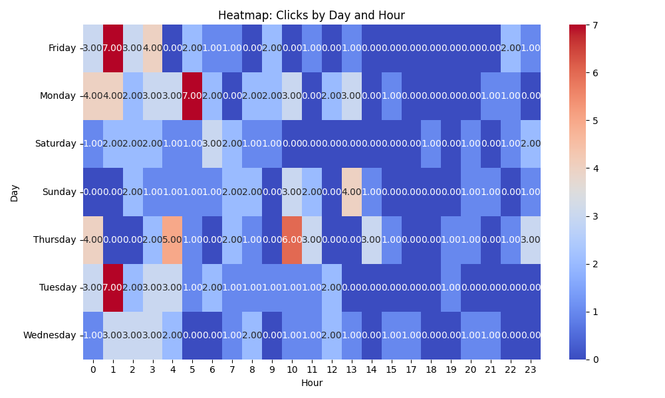

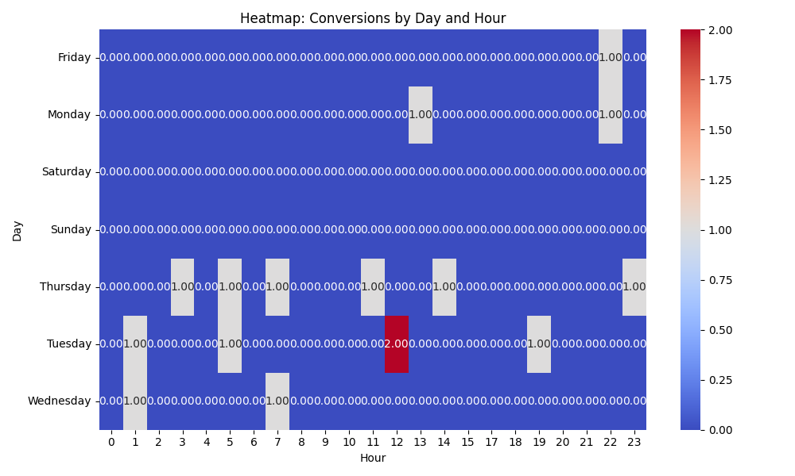

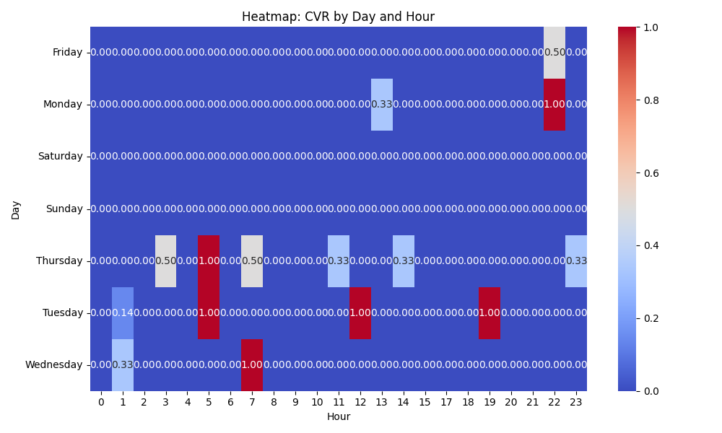

# Competitor Intelligence

# Top Competitor Insights

|  |  |  |
| --- | --- | --- |
| Competitor | Strengths | Recommendations |
|  | Their ad copy is highly direct, immediately communicating a strong solution-oriented benefit. The repetition of this core message across multiple ad creatives reinforces their primary positioning and likely resonates with prospects seeking a powerful sales aid. By explicitly calling out 'High-Quality,' they preemptively build trust and address a potential concern for buyers of custom print/tech products. This clear, definitive statement is easily digestible in an ad format. This specific phrasing targets a marketing-oriented audience, highlighting innovation and compactness. It creates a niche appeal beyond just sales tools, broadening their potential reach within the marketing sector. | While our landing page headline 'Video Brochure: The Ultimate Sales and Marketing Tool' is strong, we should ensure our Google Ad creatives similarly lead with or heavily feature this powerful 'Ultimate Sales and Marketing Tool' positioning. Consider testing ad variations that mirror the competitor's directness and repetition of this core benefit. Our landing page implies quality through 'Premium Video-In-Print' and strong testimonials. However, our ad creatives could benefit from more explicit messaging around 'High-Quality' or 'Exceptional Quality' to instantly convey our commitment to superior products, similar to the competitor. Consider A/B testing ad headlines and descriptions that include these explicit quality claims. Although our landing page mentions 'Marketing Tool' and 'Proven Engagement Booster,' we could develop more specific ad creatives that speak directly to the 'innovative marketing' or 'next-level engagement' aspect of our products. Consider ad copy that positions our video products as cutting-edge marketing solutions, potentially using phrases like 'Innovative Video Marketing' or 'Transform Your Marketing Campaigns with Video-in-Print.' |
| mediafast.com › video-mailer | MediaFast's ad creative 'Video Mailer | Custom, High-Impact Video Brochure You...' directly leads with a specific product type ('Video Mailer'). This precise keyword targeting in the headline directly addresses a niche search intent, likely leading to higher click-through rates and better ad relevance for users specifically looking for video mailers. It creates a perception of being a specialist in that particular video-in-print category. MediaFast's ad uses 'Custom, High-Impact Video Brochure,' clearly highlighting key benefits that appeal to businesses seeking effective and personalized marketing tools. The term 'High-Impact' is a strong, benefit-driven word, promising significant results to the customer. The 'You...' in the ad also subtly implies a direct benefit to the user. The competitor's ad maintains a focused message primarily on 'Video Mailer' and 'Video Brochure.' This focused approach in the ad might simplify the message for the user, making it easier to immediately understand if the offering matches their specific need without overwhelming them with too many options in the ad copy itself. | While our landing page comprehensively lists 'Video Mailers' as a product, our main ad creative strategy could benefit from creating more granular ad groups and ad copy specifically targeting high-volume product keywords like 'Video Mailer'. This means tailoring ad headlines and descriptions to lead with the specific product (e.g., 'Video Mailers | Custom Solutions') rather than always using the broader 'Video Brochure' umbrella term, enhancing relevance and conversion probability for specific product searches. Our landing page effectively uses similar language ('customized, high-impact,' 'designed to wow, inform, and convert'). We must ensure our ad creatives consistently and prominently feature these powerful, benefit-oriented terms. Consider A/B testing ad copy that leads with 'High-Impact' or 'Custom' combined with our unique selling points like 'Proven Engagement Booster' or 'Trusted by Global Brands' to directly compete on these value propositions and demonstrate superior results. Our landing page highlights a broad range of 'Video-In-Print' products (Brochures, Mailers, Packaging, Business Cards, etc.). While this breadth is a strong selling point on the page, our general ad creatives could benefit from either explicitly stating this range concisely (e.g., 'Video Brochures & More: All Video-In-Print Solutions') or by creating specific ads for each product category we wish to emphasize. For broader 'Video Brochure' searches, ensure our ad creative conveys the 'ultimate tool' and 'experience' angle, supported by our diverse product line and strong social proof (testimonials from Volvo, Volkswagen, etc.) to differentiate us as a comprehensive and trusted provider. |

# Top 3 Risks & Opportunities

## ⚠️ Risks

# Risks

|  |  |  |
| --- | --- | --- |
| Characteristic | Insight | Recommendation |
| Suboptimal Cost Per Acquisition (CPA) | The campaign's CPA of $137.15 is significantly high for a lead generation campaign, suggesting that the cost to acquire each conversion is potentially exceeding desired profitability targets or industry benchmarks. This indicates an inefficient spend of ad budget. | Conduct a deep dive into the conversion funnel and lead quality. Implement aggressive negative keyword targeting to eliminate wasted spend on irrelevant queries. Focus on optimizing landing page conversion rates to maximize conversions from existing clicks. Re-evaluate the target CPA if set too high or low. |
| Elevated Average Cost Per Click (Avg CPC) | An average CPC of $11.03 is substantial and directly contributes to the high overall campaign cost and CPA. This could be a symptom of intense market competition, lower Quality Scores for targeted keywords, or a sub-optimal bidding strategy. | Prioritize improving Quality Score across all keywords by ensuring tight relevance between keywords, ad copy, and landing page content. Explore bid adjustments for specific devices, locations, or audiences that show higher CPA. Consider adjusting the bid strategy or bid limits if competitive pressure is consistently driving up CPCs without sufficient return. |
| Inconsistent Campaign Naming and Start Date | The discrepancy between the campaign name (VPPSearchLeadsUSA03/08/2024) and the recorded Start Date (2024-08-10) indicates a potential process issue or mislabeling. This can lead to confusion in reporting, historical data analysis, and overall campaign management. | Standardize campaign naming conventions to ensure clarity, consistency, and accurate historical tracking across all campaigns. Verify the correct start date and the exact period for which this performance data is valid to prevent future analytical errors and ensure proper context for optimization efforts. |

## ✅ Opportunities

# Opportunities

|  |  |  |
| --- | --- | --- |
| Characteristic | Insight | Recommendation |
| Campaign is Driving Conversions | Despite the high CPA, the campaign has successfully generated 16 conversions. This demonstrates that there is demand for the product/service and the conversion tracking mechanism is functional, providing a solid foundation to build upon. | Analyze the specific keywords, ad groups, and audience segments that are driving these conversions. Double down on these high-performing elements by allocating more budget or focusing optimization efforts on them. Explore opportunities to scale efforts where conversion signals are strongest. |
| Significant Impression Volume | With 2258 impressions, the campaign has established a strong baseline visibility within the target market. This indicates that the chosen keywords and targeting are capable of reaching a substantial audience, providing ample data for further refinement and efficiency improvements. | Leverage this impression data to refine targeting and ad copy. Focus on improving ad relevance and Click-Through Rate (CTR) to convert more of these impressions into qualified clicks and ultimately, conversions. Analyze impression share to identify any missed opportunities at current bid levels. |
| Potential for Click-Through Rate (CTR) Improvement | A CTR of 8.81%, while not extremely low, suggests there is significant room for improvement. Enhancing CTR will likely lead to better Quality Scores, which can reduce CPC and improve ad position, thereby increasing overall campaign efficiency and potentially lowering CPA. | Implement continuous A/B testing on ad creatives (headlines, descriptions, and calls-to-action) to identify variations that resonate more strongly with the target audience. Maximize the use of all relevant ad extensions (sitelinks, callouts, structured snippets) to enhance ad visibility and provide more compelling information, boosting ad rank and CTR. |