Google Ads Audit Report

# Campaign Performance (w/ Benchmark Overlay)

|  |  |  |  |  |  |  |  |  |  |
| --- | --- | --- | --- | --- | --- | --- | --- | --- | --- |
| Campaign Name | CTR | Cost ($) | Clicks | Impressions | CTR Flag | Avg CPC | Avg CPC Flag | CPA ($) | CPA ($) Flag |
| Search - Financial Advisor - (USA) - 250K+ 2024 | 2.36% | $11637.94 | 1972 | 83525 | Below | $5.90 | Above | $122.50 | Above |
| Search - Retirement Advisor - Phrase - USA - 250K+ (tCPA) | 2.09% | $3341.42 | 505 | 24203 | Below | $6.62 | Above | $175.86 | Above |
| Search - Brand - (USA) - 2025 | 25.19% | $3045.02 | 299 | 1187 | Above | $10.18 | Above | $97.18 | Above |
| Search - Financial Advisor - (USA) - 250K+ 2024 Mayank_NewForm | 2.69% | $1290.74 | 216 | 8031 |  | $5.98 | Above | $92.20 | Above |
| Search - Retirement Advisor - Phrase - USA - 250K+ (tCPA) Mayank_NewForm_02 | 2.42% | $130.98 | 27 | 1118 |  | $4.85 | Above | $130.98 | Above |

# Campaign Insights

# Campaign Insights

|  |  |  |
| --- | --- | --- |
| Characteristic | Insight | Recommendation |
| Brand Campaign Efficiency & CPA | The "Search - Brand - (USA) - 2025" campaign (ID 22262639231) demonstrates exceptional efficiency with a high CTR of 25.19% and the lowest CPA of $97.18 across all campaigns, despite having a relatively high Avg CPC of $10.18. It has generated 31.33 conversions. | Given its strong performance and low CPA, consider gradually increasing the daily budget for the "Search - Brand - (USA) - 2025" campaign (currently $100/day) to capture more valuable, high-intent brand traffic, while closely monitoring the CPA to ensure efficiency is maintained. |
| Target CPA Performance & Scaling Opportunity | The "Search - Financial Advisor - (USA) - 250K+ 2024 Mayank_NewForm" campaign (ID 22890991583) has achieved the lowest CPA among all Target CPA campaigns at $92.20, significantly outperforming the older "Search - Financial Advisor - (USA) - 250K+ 2024" campaign (ID 768543760) which has a CPA of $122.50. However, its total cost ($1290.74) and conversions (14) are low relative to its $800 daily budget, indicating significant underspend. | Prioritize investigating the conversion path and bidding signals of the "Mayank_NewForm" campaign (ID 22890991583) to understand its efficiency drivers. Reallocate a portion of the budget from the older "Financial Advisor" campaign (ID 768543760) to this newer, more efficient campaign to scale conversions at a lower CPA. |
| High CPA & Underperforming Keywords/Structure | The "Search - Retirement Advisor - Phrase - USA - 250K+ (tCPA)" campaign (ID 77950089) has the highest CPA at $175.86 and a relatively low CTR of 2.09%, despite having the highest daily budget of $1500. This suggests inefficiencies in keyword targeting, ad creative, or landing page experience. | Conduct a comprehensive audit of the "Search - Retirement Advisor - Phrase - USA - 250K+ (tCPA)" campaign (ID 77950089) focusing on negative keywords, ad group segmentation, ad copy relevance, and landing page conversion rates to improve its CPA. If improvements are not feasible, consider reducing its budget and reallocating to more efficient campaigns. |
| New Campaign Low Volume Despite Better Efficiency | The new "Search - Retirement Advisor - Phrase - USA - 250K+ (tCPA) Mayank_NewForm_02" campaign (ID 22895148214) shows a lower Avg CPC ($4.85) and a better CPA ($130.98) compared to its older counterpart (ID 77950089, Avg CPC $6.62, CPA $175.86). However, it has significantly fewer impressions (1118 vs 24203) and only 1 conversion, indicating a severe volume issue. | Investigate why the "Mayank_NewForm_02" campaign (ID 22895148214) is receiving such low volume despite showing signs of better efficiency. Check for constrained bid limits, limited keyword sets, low Ad Rank due to Quality Score, or narrow audience targeting. Focus on scaling this campaign by addressing these volume limitations while preserving its current efficiency. |

# Keyword Performance

|  |  |  |  |  |  |  |  |  |
| --- | --- | --- | --- | --- | --- | --- | --- | --- |
| Ad Group | Keyword | Match Type | Quality Score | Impressions | Clicks | CTR | Avg CPC | CPA ($) |
| Financial Advisor | financial advisor | BROAD | 3 | 32682 | 741 | 2.27% | $6.22 | $139.66 |
| Financial Advisor | fidelity independent advisor | BROAD | 5 | 13020 | 421 | 3.23% | $5.17 | $167.51 |
| Brand Only | wiseradvisor | EXACT | 8 | 787 | 187 | 23.76% | $9.19 | $74.69 |
| Financial Advisor | financial advisor | BROAD | 5 | 5541 | 159 | 2.87% | $6.40 | $119.80 |
| Brand Only | wiser advisor | EXACT | 8 | 249 | 85 | 34.14% | $10.46 | $106.69 |
| Financial Advisor | wealth advice | BROAD | 0 | 4100 | 67 | 1.63% | $7.61 | $84.99 |
| Retirement Advisor Phrase | retirement financial advisor | BROAD | 5 | 2877 | 63 | 2.19% | $8.06 | $169.35 |
| Financial Advisor | financial management advisory | BROAD | 0 | 4973 | 89 | 1.79% | $5.21 | $231.64 |
| Brand Only | wiseradvisor reviews | EXACT | 5 | 148 | 25 | 16.89% | $16.81 | $0.00 |
| Financial Advisor | financial advisor ratings | BROAD | 5 | 2190 | 90 | 4.11% | $4.43 | $398.39 |
| Retirement Advisor Phrase | retirement financial advisors | BROAD | 0 | 2158 | 48 | 2.22% | $7.65 | $183.61 |
| Financial Advisor | best financial advisor | BROAD | 5 | 2127 | 55 | 2.59% | $6.49 | $89.28 |
| Retirement Advisor Phrase | federal retirement advisors | BROAD | 3 | 1529 | 60 | 3.92% | $5.56 | $111.15 |
| Financial Advisor | need a financial advisor | BROAD | 0 | 3274 | 55 | 1.68% | $5.94 | $163.45 |
| Financial Advisor | financial advisory fees | BROAD | 5 | 1904 | 67 | 3.52% | $4.20 | $140.57 |
| Financial Advisor | financial advisor local | BROAD | 0 | 1729 | 42 | 2.43% | $6.13 | $42.92 |
| Financial Advisor | finding a financial advisor | BROAD | 1 | 2357 | 39 | 1.65% | $6.59 | $85.62 |
| Retirement Advisor Phrase | retirement financial advisors near me | BROAD | 0 | 1612 | 35 | 2.17% | $6.90 | $241.58 |
| Financial Advisor | the best financial advisors | BROAD | 8 | 1418 | 39 | 2.75% | $5.81 | $75.53 |
| Retirement Advisor Phrase | retirement advisory | BROAD | 3 | 1176 | 27 | 2.30% | $8.25 | $0.00 |
| Retirement Advisor Phrase | retirement planning financial advisor | BROAD | 0 | 1934 | 35 | 1.81% | $6.31 | $110.36 |
| Financial Advisor - Generic | local financial advisor | BROAD | 2 | 932 | 27 | 2.90% | $7.25 | $195.65 |
| Financial Advisor | wealth advisor services | BROAD | 0 | 1042 | 28 | 2.69% | $6.86 | $48.00 |
| Retirement Advisor Phrase | retirement income financial planner | BROAD | 0 | 1110 | 28 | 2.52% | $6.32 | $88.52 |
| Financial Advisor | how to choose a financial advisor for retirement | BROAD | 0 | 1228 | 23 | 1.87% | $7.47 | $85.93 |
| Financial Advisor | reputable financial advisors | BROAD | 7 | 1226 | 24 | 1.96% | $7.07 | $169.67 |
| Financial Advisor | compare financial advisor fees | BROAD | 0 | 1193 | 42 | 3.52% | $3.94 | $165.61 |
| Retirement Advisor Phrase | retirement planning advisor | BROAD | 0 | 940 | 21 | 2.23% | $6.97 | $0.00 |
| Retirement Advisor Phrase | retirement financial advisor near me | BROAD | 3 | 1285 | 22 | 1.71% | $6.60 | $0.00 |
| Retirement Advisor Phrase | retirement investment advisors | BROAD | 3 | 1341 | 22 | 1.64% | $5.90 | $0.00 |
| Retirement Advisor Phrase | financial advisor for retirees | BROAD | 7 | 931 | 21 | 2.26% | $4.96 | $52.08 |
| Financial Advisor | wealth planning advisors | BROAD | 0 | 1161 | 16 | 1.38% | $6.37 | $101.94 |
| Retirement Advisor Phrase | best retirement financial advisors near me | BROAD | 0 | 684 | 10 | 1.46% | $9.50 | $94.98 |
| Financial Advisor | private wealth consultants | BROAD | 1 | 664 | 20 | 3.01% | $4.58 | $91.61 |
| Retirement Advisor Phrase | retirement advisor | BROAD | 0 | 1149 | 13 | 1.13% | $6.86 | $0.00 |
| Retirement Advisor Phrase | retirement advisor near me | BROAD | 3 | 468 | 16 | 3.42% | $5.38 | $86.02 |
| Financial Advisor | fidelity independent advisor | BROAD | 3 | 574 | 19 | 3.31% | $4.47 | $0.00 |
| Retirement Advisor Phrase | retirement advisors in my area | BROAD | 3 | 421 | 16 | 3.80% | $5.30 | $0.00 |
| Financial Advisor | global financial advisor | BROAD | 3 | 496 | 14 | 2.82% | $5.81 | $81.30 |
| Nearby Financial Advisor | good financial advisor near me | BROAD | 0 | 671 | 8 | 1.19% | $10.15 | $0.00 |
| Financial Advisor | no fee financial advisor | BROAD | 0 | 589 | 13 | 2.21% | $6.20 | $40.32 |
| Financial Advisor | private wealth adviser | BROAD | 0 | 983 | 12 | 1.22% | $6.53 | $78.41 |
| Retirement Advisor Phrase | retirement advisors near me | BROAD | 3 | 673 | 13 | 1.93% | $5.46 | $70.99 |
| Retirement Advisor Phrase | retirement advisors near me | BROAD | 0 | 532 | 13 | 2.44% | $5.24 | $0.00 |
| Retirement Advisor Phrase | retirement financial planning advisor | BROAD | 0 | 494 | 11 | 2.23% | $5.80 | $0.00 |
| Financial Advisor | wealth management consulting firms | BROAD | 0 | 409 | 8 | 1.96% | $7.46 | $59.67 |
| Financial Advisor - Generic | senior financial advisor | BROAD | 3 | 149 | 2 | 1.34% | $29.57 | $59.13 |
| Retirement Advisor Phrase | retirement planning advisors | BROAD | 0 | 768 | 12 | 1.56% | $4.66 | $0.00 |
| Retirement Advisor Phrase | best retirement financial advisors | BROAD | 0 | 837 | 9 | 1.08% | $5.95 | $0.00 |
| Financial Advisor - Generic | financial advisor for individuals | BROAD | 0 | 1160 | 8 | 0.69% | $6.34 | $0.00 |

# Keyword Insights

# Keyword Insights

|  |  |  |
| --- | --- | --- |
| Characteristic | Insight | Recommendation |
| Brand Keywords (Exact Match) Performance | The Exact match brand keywords 'wiseradvisor' and 'wiser advisor' demonstrate exceptional performance, with an average CTR of 0.289, average CPC of $9.82, and average CPA of $90.68 across 31.33 conversions. This highlights strong brand recognition and conversion efficiency. | Increase daily budget allocation to the 'Brand Only' ad group to capture more high-intent branded searches. Explore creating ad variations that highlight unique selling propositions specific to branded searches to further enhance conversion rates. |
| Underperforming Brand Keyword | The Exact match keyword 'wiseradvisor reviews' generated 0 conversions despite accumulating $420.24 in cost from 148 impressions. This indicates a disconnect between search intent for reviews and the current conversion goal. | Pause 'wiseradvisor reviews' to stop wasted spend on a non-converting keyword. Instead, consider creating an informational campaign targeting review-oriented queries, leading users to a dedicated landing page with testimonials or comparison data, nurturing them rather than expecting an immediate conversion. |
| Top-Spending Broad Match Keyword Efficiency | The 'financial advisor' (BROAD) keyword pair is the highest spending, costing $5627.11 and driving 41.5 conversions. However, it operates at a high average CPA of $135.59 and a relatively low average CTR of 0.025, suggesting inefficiency for such a broad term. | Implement an aggressive negative keyword strategy for 'financial advisor' to filter out irrelevant or low-intent searches. Simultaneously, create new ad groups or expand existing ones with more specific Phrase or Exact match variants of 'financial advisor' (e.g., '+financial +advisor +fees', '[financial advisor near me]') to improve relevance and reduce CPA. |
| Low Quality Score (0-1) Broad Match Keywords with High CPA | Several Broad match keywords like 'financial management advisory' (QS 0, CPA $231.64 for 2 conversions), 'retirement financial advisors near me' (QS 0, CPA $241.57 for 1 conversion), and 'compare financial advisor fees' (QS 0, CPA $165.61 for 1 conversion) exhibit a Quality Score of 0 or 1. These keywords collectively spent $870.46 for only 4 conversions, indicating severe relevance and efficiency issues. | Immediately pause these specific broad match keywords due to their extremely poor Quality Scores and high CPAs. Re-evaluate if these terms are critical; if so, re-add them as Exact or Phrase match to enforce stricter targeting and improve Quality Score and ad relevance. |
| High-Performing Low Quality Score (0) Broad Match Keywords | Keywords such as 'financial advisor local' (QS 0, CPA $42.92, CVR 0.142857 from 6 conversions) and 'wealth advisor services' (QS 0, CPA $47.99, CVR 0.142857 from 4 conversions) are converting very efficiently despite a Quality Score of 0. | For these high-performing low QS keywords, prioritize ad copy and landing page optimization to better align with the specific intent (e.g., 'local', 'services'). Convert these to Phrase or Exact match to improve Quality Score, potentially lowering CPC further, and gain more precise control over highly converting traffic. |
| Non-Converting Keywords in 'Retirement Advisor Phrase' Ad Group | Multiple Broad match keywords within the 'Retirement Advisor Phrase' ad group, including 'retirement advisory' ($222.71 cost), 'retirement planning advisor' ($146.38 cost), 'retirement financial advisor near me' ($145.29 cost), and 'retirement investment advisors' ($129.70 cost), have generated 0 conversions, resulting in $644.08 of wasted spend. | Pause all identified broad match keywords in the 'Retirement Advisor Phrase' ad group that have incurred significant cost with zero conversions. Review the ad group's overall strategy and only reintroduce these concepts as highly targeted Phrase or Exact match keywords, with very specific ad copy and landing pages, to ensure relevance and conversion intent. |

# Wasted Spend Insights

# Wasted Spend Insights

|  |  |  |
| --- | --- | --- |
| Characteristic | Insight | Recommendation |
| High Cost & Research Intent Mismatch | The keyword 'wiseradvisor reviews' incurred a significant cost of $420.24 and generated zero conversions, despite a very high CTR of 16.89%. This suggests users are interested in review-related content but are not finding what they need on the landing page, or the intent is purely informational, not transactional. | Immediately review the landing page for 'wiseradvisor reviews' to ensure it caters specifically to users seeking reviews (e.g., dedicated testimonial pages, case studies, comparison guides). If the business primarily seeks transactional leads, consider adding this keyword as a negative or moving it to a top-of-funnel campaign with a specific content offer tailored for research-phase users. |
| High Cost, Low Quality Score & Low CTR | The keyword 'retirement advisory' spent $222.71 with zero conversions, an alarmingly low Quality Score of 3, and a poor CTR of 2.30%. This indicates significant issues with ad relevance and/or landing page experience, wasting considerable budget. | Pause or drastically reduce bids for 'retirement advisory'. Re-evaluate the ad copy for direct relevance to the keyword, ensure the landing page directly addresses 'retirement advisory' services with clear value propositions, and consider breaking out this broad term into more specific, tightly themed ad groups. |
| Critical Performance Issue (QS 0) | The keyword 'retirement planning advisor' spent $146.38 with zero conversions, an abysmal Quality Score of 0, and a low CTR of 2.23%. A Quality Score of 0 signals a critical breakdown in ad relevance, expected CTR, or landing page experience, indicating severe misalignment. | Immediately pause 'retirement planning advisor'. This keyword is critically misaligned. Conduct a thorough audit to determine if it can be assigned to a new, highly specific ad group with tailored ad copy and a relevant landing page, or if it should be added as a negative keyword entirely. |
| High Cost, Low Quality Score & Very Low CTR | The keyword 'retirement financial advisor near me' spent $145.30 with zero conversions, a very low Quality Score of 3, and a very low CTR of 1.71%. This indicates severe disconnects in ad messaging, user intent, and landing page experience, especially for a localized query. | Review ad copy for 'retirement financial advisor near me' to incorporate stronger calls to action and explicit local relevance. Ensure the landing page is mobile-friendly, loads quickly, and emphasizes 'near me' aspects (e.g., embedded map, local address, contact forms). Consider implementing location extensions and potentially dynamic location insertion. |
| High Cost, Low Quality Score & Very Low CTR | The keyword 'retirement investment advisors' consumed $129.71 without conversions, registering a low Quality Score of 3 and a very low CTR of 1.64%. This suggests poor ad-to-keyword relevance and/or a subpar landing page experience for a high-value search intent. | Restructure the ad group for 'retirement investment advisors' to include hyper-relevant ad copy that directly addresses specific investment advisory services. Improve the landing page to feature detailed investment solutions and relevant trust signals (e.g., credentials, client testimonials). Consider pausing if improvements do not yield results quickly. |
| Critical Performance Issue (QS 0) | The keyword 'retirement advisor' accumulated $89.14 in spend with no conversions, a critical Quality Score of 0, and an extremely low CTR of 1.13%. This keyword is fundamentally underperforming across all key metrics and is a significant budget drain. | Immediately pause 'retirement advisor'. Re-evaluate if this broad term is suitable for your current funnel stage. If it is, create a dedicated, tightly themed ad group with highly specific ad copy and a landing page that precisely matches the intent. Otherwise, add it as a broad match negative keyword. |
| Competitor Brand Term with Low Quality Score | The keyword 'fidelity independent advisor' spent $84.86 with zero conversions and a low Quality Score of 3, despite a decent CTR of 3.31%. This indicates that bidding on a competitor's brand term might be driving clicks but not qualified leads, or the landing page fails to convert visitors specifically seeking 'Fidelity' advisors. | Reconsider the strategy for 'fidelity independent advisor'. If the goal is to poach competitor traffic, ensure your ad clearly differentiates your offering and the landing page presents a compelling alternative with clear reasons to choose your service. If not converting, consider negating this keyword to avoid wasted spend on unconvertible traffic. |
| Significant Spend, Low Quality Score (Post-Click Issue) | The keyword 'retirement advisors in my area' spent $84.85 with no conversions and a low Quality Score of 3, even with a relatively good CTR of 3.80%. The low Quality Score despite a decent CTR strongly suggests issues with the landing page experience or the post-click user journey. | Focus immediately on optimizing the landing page for 'retirement advisors in my area'. Ensure it has a clear, prominent call-to-action, local phone numbers, addresses, and demonstrates local expertise or proximity. Improve page load speed and mobile responsiveness for optimal user experience. |
| Critical Performance Issue (QS 0) with High CPC | The keyword 'good financial advisor near me' incurred $81.24 in cost with zero conversions, an extremely high Avg CPC of $10.15, an abysmal Quality Score of 0, and an extremely low CTR of 1.19%. This keyword is hemorrhaging budget with no positive return. | Immediately pause 'good financial advisor near me'. The combination of high CPC, QS 0, and extremely low CTR indicates a complete misalignment and a critical failure. Focus on more specific, high-intent keywords with better quality scores. This term might be too subjective or broad to convert effectively. |
| Critical Performance Issue (QS 0) | The keyword 'retirement advisors near me' spent $68.16 with zero conversions, an abysmal Quality Score of 0, and a low CTR of 2.44%. Despite the clear 'near me' intent, performance is critically low across the board. | Immediately pause 'retirement advisors near me'. A Quality Score of 0 indicates a fundamental problem. If this keyword is crucial, create a new, tightly structured ad group specifically for local 'near me' queries with localized ad copy (e.g., using location insertion) and a landing page emphasizing local presence and easy contact methods. |
| Critical Performance Issue (QS 0) | The keyword 'retirement financial planning advisor' incurred $63.85 in cost with zero conversions, an abysmal Quality Score of 0, and a low CTR of 2.23%. This keyword shows severe underperformance and a lack of relevance. | Immediately pause 'retirement financial planning advisor'. A Quality Score of 0 means Google sees virtually no relevance. Re-evaluate if this keyword truly aligns with your ad copy and landing page. Consider if it needs to be broken down into more specific components or moved to a different, more relevant campaign or ad group. |
| Critical Performance Issue (QS 0) & Very Low CTR | The keyword 'retirement planning advisors' spent $55.90 with zero conversions, an abysmal Quality Score of 0, and a very low CTR of 1.56%. This keyword is highly ineffective and contributing to wasted spend. | Immediately pause 'retirement planning advisors'. The Quality Score of 0 indicates a total disconnect between the keyword, ad, and landing page. Ensure all ad groups have very tight keyword-to-ad copy-to-landing page relevance. If similar terms are performing poorly, consider a broader negative keyword strategy. |
| Critical Performance Issue (QS 0) & Extremely Low CTR | The keyword 'best retirement financial advisors' spent $53.55 with zero conversions, an abysmal Quality Score of 0, and an extremely low CTR of 1.08%. This 'best' term is a significant waste of budget given its performance. | Immediately pause 'best retirement financial advisors'. Terms like 'best' often indicate research intent. If you wish to capture this, ensure your landing page provides valuable comparative information or positions your service as the 'best' with clear evidence and trust signals. Given the QS 0, it's likely a complete mismatch currently. |
| Critical Performance Issue (QS 0) & Abysmally Low CTR | The keyword 'financial advisor for individuals' spent $50.69 with zero conversions, an abysmal Quality Score of 0, and an abysmally low CTR of 0.69%. This keyword is the worst performer in the list and represents a severe budget drain. | Immediately pause 'financial advisor for individuals'. This keyword is completely misaligned and bleeding budget with critical failure metrics. Its performance indicates a fundamental mismatch. Focus on more specific, high-intent keywords that resonate with your core offerings and target audience. |

# Landing Page Audit Insights

⚠️ Failed to parse LP audit JSON — showing raw output.

[]

⚠️ Failed to parse LP audit JSON — showing raw output.

[]

# Geographical Performance

|  |  |  |  |  |  |  |  |  |  |
| --- | --- | --- | --- | --- | --- | --- | --- | --- | --- |
| City | Region | Country | Type | Impressions | Clicks | Conversions | Cost ($) | CVR | CPA ($) |
| United States |  |  | Country | 136837 | 3380 | 177.333334 | $21850.07 | 0.05246548343195267 | $123.21 |

# Geographical Insights

# Geographical Insights

|  |  |  |
| --- | --- | --- |
| Characteristic/ Location | Insight | Recommendation |
| United States (Overall Country Performance) | The United States incurred the entire campaign cost of $21,850.07, generating 177.33 conversions at a Cost Per Acquisition (CPA) of $123.21 and a Conversion Rate (CVR) of 5.25%. This high overall spend and CPA suggest a need for more granular optimization within the country, as inefficiencies at a sub-region level could be impacting the overall performance. | Implement deeper geo-segmentation for the United States, focusing on states and major metropolitan areas. Analyze performance differences across these sub-regions to identify specific areas driving inefficient spend and disproportionately high CPAs. Based on this, reallocate budget from underperforming regions or apply negative bid adjustments to improve the overall country-level CPA of $123.21. |

# Hourly Performance Pivot

CVR

|  |  |  |  |  |  |  |  |  |  |  |  |  |  |  |  |  |  |  |  |  |  |  |  |
| --- | --- | --- | --- | --- | --- | --- | --- | --- | --- | --- | --- | --- | --- | --- | --- | --- | --- | --- | --- | --- | --- | --- | --- |
| Day/Hour | 0 | 1 | 2 | 3 | 4 | 5 | 7 | 8 | 9 | 10 | 11 | 12 | 13 | 14 | 15 | 16 | 17 | 18 | 19 | 20 | 21 | 22 | 23 |
| Monday |  | 0.20 |  | 0.50 |  | 0.67 |  | 0.08 | 0.06 | 0.04 | 0.05 | 0.29 | 0.30 | 0.57 | 0.28 |  | 0.07 |  | 0.05 | 0.09 | 0.14 | 2.27 | 1.07 |
| Tuesday | 0.09 |  |  |  |  |  |  |  |  |  |  | 0.08 | 1.20 | 0.13 |  | 0.44 | 0.25 |  | 0.33 | 0.20 |  |  | 0.25 |
| Wednesday | 1.00 |  | 3.00 |  |  | 0.33 |  |  |  |  | 0.83 | 0.06 | 0.17 | 0.47 | 0.49 |  | 0.05 |  | 0.26 | 0.83 | 0.10 | 0.33 | 0.50 |
| Thursday |  |  |  |  | 1.00 | 0.18 | 0.40 |  | 0.10 | 0.06 | 0.13 | 0.04 | 0.03 |  | 0.24 | 0.05 | 0.10 | 0.08 | 0.13 |  | 0.24 | 0.32 | 0.25 |
| Friday | 0.53 | 1.00 | 2.00 |  |  |  | 0.25 |  |  | 1.30 | 0.42 |  | 0.45 | 0.08 | 1.00 |  | 0.05 | 0.05 | 0.18 | 0.14 |  | 0.08 |  |
| Saturday |  |  |  |  |  |  |  | 0.25 |  |  | 0.12 |  |  |  | 0.14 |  |  |  | 0.35 | 0.07 |  |  |  |
| Sunday |  |  | 0.33 | 1.00 |  |  | 0.50 | 0.12 |  |  | 0.08 | 2.07 |  |  |  |  | 0.06 | 0.08 |  |  |  |  | 2.25 |

Clicks

|  |  |  |  |  |  |  |  |  |  |  |  |  |  |  |  |  |  |  |  |  |  |  |  |  |
| --- | --- | --- | --- | --- | --- | --- | --- | --- | --- | --- | --- | --- | --- | --- | --- | --- | --- | --- | --- | --- | --- | --- | --- | --- |
| Day/Hour | 0 | 1 | 2 | 3 | 4 | 5 | 6 | 7 | 8 | 9 | 10 | 11 | 12 | 13 | 14 | 15 | 16 | 17 | 18 | 19 | 20 | 21 | 22 | 23 |
| Monday |  |  |  |  |  |  |  |  |  |  |  |  |  |  |  |  |  |  |  |  |  |  |  |  |
| Tuesday |  |  |  |  |  |  |  |  |  |  |  |  |  |  |  |  |  |  |  |  |  |  |  |  |
| Wednesday |  |  |  |  |  |  |  |  |  |  |  |  |  |  |  |  |  |  |  |  |  |  |  |  |
| Thursday |  |  |  |  |  |  |  |  |  |  |  |  |  |  |  |  |  |  |  |  |  |  |  |  |
| Friday |  |  |  |  |  |  |  |  |  |  |  |  |  |  |  |  |  |  |  |  |  |  |  |  |
| Saturday |  |  |  |  |  |  |  |  |  |  |  |  |  |  |  |  |  |  |  |  |  |  |  |  |
| Sunday |  |  |  |  |  |  |  |  |  |  |  |  |  |  |  |  |  |  |  |  |  |  |  |  |

Conversions

|  |  |  |  |  |  |  |  |  |  |  |  |  |  |  |  |  |  |  |  |  |  |  |  |
| --- | --- | --- | --- | --- | --- | --- | --- | --- | --- | --- | --- | --- | --- | --- | --- | --- | --- | --- | --- | --- | --- | --- | --- |
| Day/Hour | 0 | 1 | 2 | 3 | 4 | 5 | 7 | 8 | 9 | 10 | 11 | 12 | 13 | 14 | 15 | 16 | 17 | 18 | 19 | 20 | 21 | 22 | 23 |
| Monday |  | 1.00 |  | 1.00 |  | 2.00 |  | 1.00 | 1.00 | 1.00 | 1.00 | 2.00 | 3.00 | 5.00 | 4.00 |  | 1.00 |  | 1.00 | 2.00 | 3.00 | 6.00 | 3.00 |
| Tuesday | 1.00 |  |  |  |  |  |  |  |  |  |  | 1.00 | 3.00 | 2.00 |  | 5.00 | 1.00 |  | 3.00 | 1.00 |  |  | 1.00 |
| Wednesday | 1.00 |  | 3.00 |  |  | 1.00 |  |  |  |  | 3.00 | 1.00 | 1.00 | 4.00 | 4.00 |  | 1.00 |  | 2.00 | 3.00 | 2.00 | 1.00 | 1.00 |
| Thursday |  |  |  |  | 2.00 | 2.00 | 2.00 |  | 2.00 | 1.00 | 2.00 | 1.00 | 1.00 |  | 2.33 | 2.00 | 2.00 | 1.00 | 2.00 |  | 2.00 | 4.00 | 1.00 |
| Friday | 2.00 | 1.00 | 2.00 |  |  |  | 1.00 |  |  | 4.00 | 3.00 |  | 5.00 | 2.00 | 1.00 |  | 1.00 | 1.00 | 2.00 | 1.00 |  | 1.00 |  |
| Saturday |  |  |  |  |  |  |  | 1.00 |  |  | 1.00 |  |  |  | 1.00 |  |  |  | 2.00 | 1.00 |  |  |  |
| Sunday |  |  | 1.00 | 1.00 |  |  | 2.00 | 1.00 |  |  | 1.00 | 3.00 |  |  |  |  | 1.00 | 1.00 |  |  |  |  | 3.00 |

Cost ($)

|  |  |  |  |  |  |  |  |  |  |  |  |  |  |  |  |  |  |  |  |  |  |  |  |  |
| --- | --- | --- | --- | --- | --- | --- | --- | --- | --- | --- | --- | --- | --- | --- | --- | --- | --- | --- | --- | --- | --- | --- | --- | --- |
| Day/Hour | 0 | 1 | 2 | 3 | 4 | 5 | 6 | 7 | 8 | 9 | 10 | 11 | 12 | 13 | 14 | 15 | 16 | 17 | 18 | 19 | 20 | 21 | 22 | 23 |
| Monday | 87.88 | 66.50 | 51.04 | 44.25 | 15.66 | 36.97 | 20.03 | 35.41 | 87.22 | 141.81 | 202.60 | 279.76 | 236.09 | 247.64 | 318.10 | 213.83 | 269.27 | 122.73 | 189.91 | 198.00 | 160.62 | 146.37 | 178.37 | 138.15 |
| Tuesday | 44.10 | 24.04 | 27.31 | 16.92 | 23.02 | 28.06 | 32.00 | 14.79 | 98.46 | 83.39 | 98.17 | 110.12 | 210.39 | 90.95 | 214.96 | 187.15 | 281.30 | 108.33 | 84.75 | 110.60 | 99.17 | 102.02 | 94.10 | 93.97 |
| Wednesday | 73.14 | 51.63 | 93.84 | 35.54 | 25.31 | 17.97 | 31.00 | 104.67 | 71.56 | 101.39 | 145.65 | 170.66 | 155.51 | 162.55 | 240.42 | 190.25 | 144.06 | 120.83 | 115.22 | 126.16 | 172.67 | 146.33 | 99.72 | 90.53 |
| Thursday | 47.21 | 71.12 | 35.14 | 58.05 | 43.29 | 104.89 | 53.82 | 96.71 | 86.84 | 194.74 | 259.26 | 255.52 | 196.73 | 308.73 | 328.37 | 329.24 | 382.64 | 193.27 | 228.96 | 132.89 | 263.38 | 206.35 | 172.49 | 179.27 |
| Friday | 59.17 | 101.18 | 90.71 | 91.32 | 62.63 | 63.75 | 110.56 | 112.95 | 161.39 | 97.79 | 165.49 | 290.32 | 166.35 | 313.56 | 224.04 | 221.25 | 212.39 | 175.46 | 149.06 | 102.53 | 132.69 | 131.12 | 125.24 | 144.97 |
| Saturday | 24.81 | 80.84 | 11.90 | 20.10 | 41.34 | 63.30 | 27.88 | 45.61 | 15.61 | 71.02 | 89.69 | 92.65 | 59.58 | 46.18 | 60.49 | 61.13 | 86.33 | 72.22 | 122.11 | 66.61 | 77.47 | 102.26 | 47.85 | 57.91 |
| Sunday | 41.91 | 21.43 | 25.04 | 21.90 | 40.97 | 20.98 | 60.52 | 16.60 | 59.24 | 83.13 | 39.50 | 95.94 | 89.48 | 75.66 | 98.93 | 93.51 | 129.96 | 202.43 | 106.89 | 92.49 | 133.32 | 89.73 | 76.17 | 97.73 |

# Hourly Patterns Insights

# Hourly Patterns Insights

|  |  |  |
| --- | --- | --- |
| Characteristic | Insight | Recommendation |
| Overall performance during Hour 6 (6 AM) | This hour shows zero conversions across all days, despite incurring significant clicks and cost, indicating a complete waste of ad budget. | Pause all ad campaigns for Hour 6 to prevent further inefficient spend. |
| Overall performance during Night Hours (00:00 - 01:00) and Late Evening (18:00) | Hours 0, 1, and 18 exhibit very low Conversion Rates (below 6% for Hour 0, 3.77% for Hour 1, 1.53% for Hour 18) and high Cost per Conversion (over $90, reaching $335.88 for Hour 18), indicating poor efficiency. | Implement strong negative bid adjustments for Hours 0, 1, and 18, and consider pausing if performance does not improve to acceptable levels. |
| Overall performance during Early Morning (02:00), Late Morning (05:00), and Late Night (22:00, 23:00) | These hours demonstrate significantly high Conversion Rates (ranging from 9.30% to 13.33%) and low Costs per Conversion (ranging from $55.93 to $95.44), indicating highly efficient conversion windows. | Apply significant positive bid adjustments for Hours 2, 5, 22, and 23 to maximize ad visibility and capture more conversions during these profitable times. |
| Overall performance during Mid-Morning (08:00 - 10:00), Mid-day (12:00), and Afternoon (16:00, 17:00) | These hours attract high click volume and significant cost but result in low CVR (2.56% to 3.76%) and high Cost per Conversion (over $169), indicating a less efficient spend during typical peak activity. | Apply negative bid adjustments to Hours 8, 9, 10, 12, 16, and 17 to optimize budget allocation towards more profitable periods. |
| Top performing day-hour segments | Multiple specific day-hour combinations, such as Monday 22:00 (33.33% CVR, $24.37 CpC), Wednesday 02:00 (42.86% CVR, $26.38 CpC), and Sunday 07:00 (40.00% CVR, $8.30 CpC), show exceptionally high conversion rates and low costs per conversion, indicating peak efficiency. | Implement strong positive bid adjustments for these and similar high-performing day-hour segments to maximize budget allocation where ROI is highest. |
| Persistent zero conversion day-hour segments with notable spend | A significant number of day-hour combinations, particularly in the early morning (e.g., Thursday 00:00-06:00, Saturday 00:00-06:00, Sunday 00:00-06:00), and some specific midday hours (e.g., Friday 12:00, Saturday 12:00), consistently yield zero conversions despite incurring ad spend. This indicates wasted budget for specific day-part segments. | Apply complete ad pauses or maximum negative bid adjustments for these identified zero-conversion day-hour segments to eliminate wasted ad spend and reallocate funds to converting periods. |

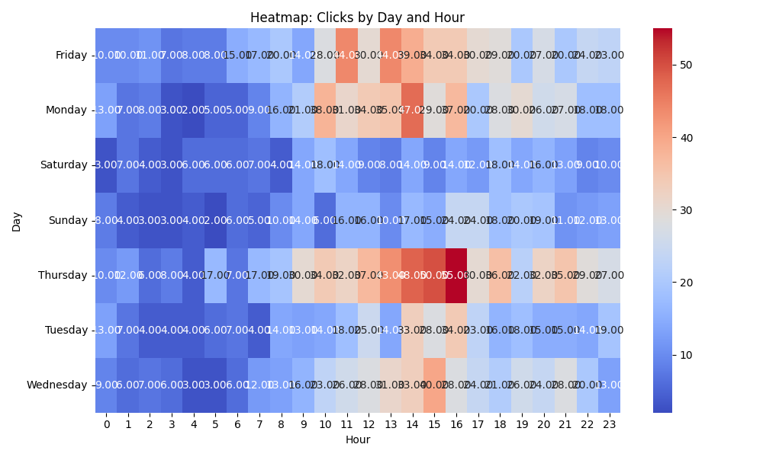

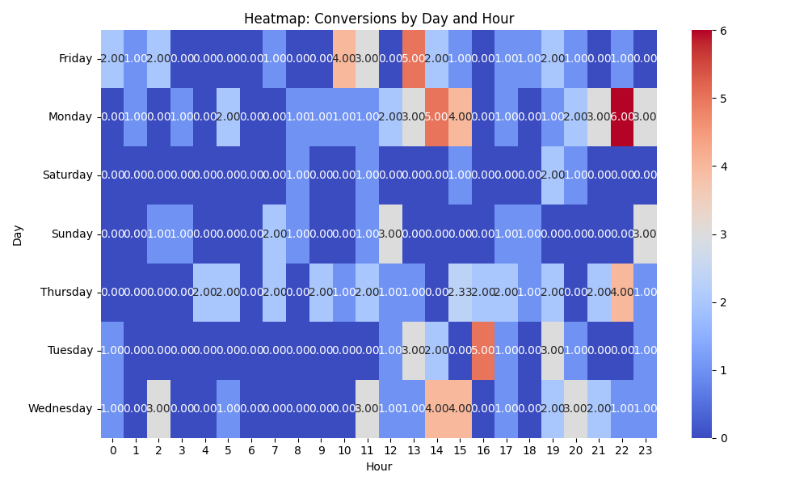

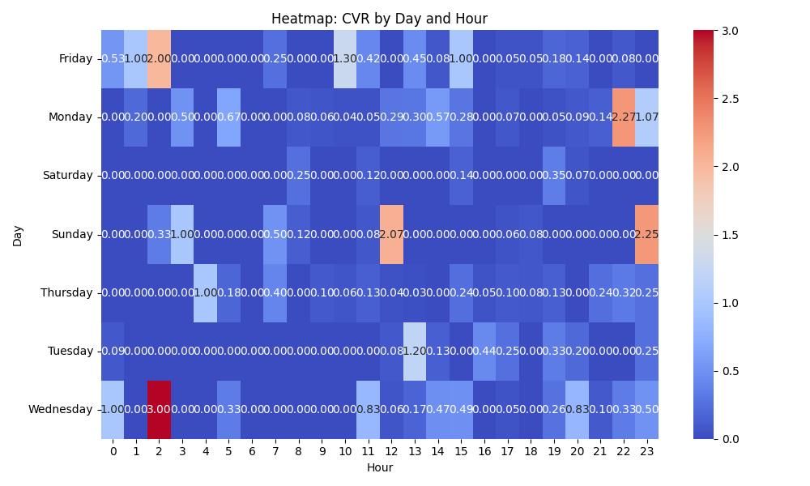

# Competitor Intelligence

# Top Competitor Insights

|  |  |  |
| --- | --- | --- |
| Competitor | Strengths | Recommendations |
| fincart.com › wealth-advisor | The ad creative 'Wealth Advisor and Planner in India, Hire Now' is exceptionally clear, direct, and high-intent. It immediately communicates the service offered, the target geography, and a strong call-to-action. This precision likely resonates well with users actively searching for wealth management services. The consistent messaging across all listed creatives indicates a very focused strategy on their primary service offering. This repetition reinforces their core value proposition in the user's mind, potentially increasing brand recall and click-through rates for users with clear intent. The ad's messaging perfectly aligns with the domain/path 'fincart.com > wealth-advisor', indicating strong congruence between the ad promise and the landing page content. This alignment builds trust and reduces bounce rates, signaling a well-structured campaign. | Ensure our ad creatives are equally clear and direct in stating our core service and call-to-action. We should focus on high-intent keywords similar to 'Wealth Advisor' and 'Planner' while ensuring our geographical targeting (if applicable) is explicit. Consider A/B testing various CTA phrasings beyond 'Hire Now' if our service involves a different initial engagement (e.g., 'Get a Free Consultation', 'Start Your Plan'). While the competitor maintains consistency, we should develop and rigorously test multiple ad variations. These variations could highlight different aspects of our service (e.g., our unique methodology, specific benefits, client success stories, fee structure) to appeal to a wider range of user motivations. This approach allows us to discover which messages resonate most effectively with our target audience and optimize performance continually. A crucial step is to ensure our ad creatives not only attract clicks but also directly align with the content and promises on our landing page. Our landing page must immediately fulfill the expectation set by the ad copy, providing relevant information and a clear path to conversion.   NOTE: A direct, comprehensive comparison between the competitor's messaging and our landing page content for 'messaging and positioning' insights is limited as our landing page content was not provided for this analysis. The recommendations are thus based on general best practices and the strengths observed in the competitor's ad strategy. |
|  | This creative immediately leads with a quantifiable, high-impact benefit (30% sales boost) and addresses a key pain point (acquisition costs). The mention of 'AI-powered' highlights advanced technology, and the 'free demo' offers a low-friction, clear call to action (CTA). It's highly benefit-driven and solution-oriented. This ad appeals to efficiency and growth. It highlights automation, which is a strong draw for businesses looking to save time and scale. The promise of 'less time, more customers' directly addresses common business objectives. 'Learn more' is a softer CTA that invites exploration. This creative speaks directly to users who prioritize compatibility and existing tech stack integration. Naming specific, popular CRMs (HubSpot, Salesforce) builds immediate trust and signals technical prowess. The focus on 'seamless workflow' and 'ultimate efficiency' reinforces a pain point solution. This ad directly addresses a common pain point ('Wasting Ad Spend') and positions the competitor as the solution provider. It uses powerful keywords like 'precision targeting' and 'real-time analytics' to convey advanced capabilities, and 'maximum ROI' directly links to financial benefit. The urgency in 'Start seeing results today!' is compelling. This ad focuses on building trust and reassuring potential customers about ongoing support. It highlights customer success as a priority and promises 'unparalleled service' and 'expert guidance.' This addresses a common concern about post-purchase experience and adds a human element to their offering. | Our landing page should prominently feature our primary value proposition with quantifiable benefits at the top. Instead of just listing features, focus on the 'so what' for the customer. Ensure our CTAs are specific, benefit-driven, and clearly visible, offering options like 'Request a Demo' or 'Start a Free Trial' to mirror this competitor's effectiveness. Our landing page content should clearly articulate how our solution saves time or improves efficiency for the user. We should weave narratives around automation and how it translates into tangible business growth. Consider having varying levels of CTAs – some for immediate conversion (like a demo), and others for deeper engagement (like 'Download Our Guide' or 'Explore Features'). If our product offers integrations, our landing page should dedicate a clear, prominent section to them, naming specific platforms we integrate with. Highlighting 'seamlessness' and 'workflow streamlining' will resonate with technical decision-makers and users concerned about implementation complexity. This builds confidence in our solution's ability to fit into existing operations. Our landing page needs to actively acknowledge and address customer pain points before presenting our solution. Instead of only showcasing features, articulate how our product solves specific problems (e.g., 'Are you struggling with X? Our solution helps you Y.'). Emphasize ROI and tangible outcomes, and consider integrating more urgent, benefit-driven CTAs that encourage immediate action towards desired results. While our landing page might mention reliability, we should expand on our commitment to customer success. Create a dedicated section for customer support, onboarding processes, and success resources. Include testimonials or case studies that specifically mention positive support experiences. This will differentiate us beyond product features and build deeper trust with prospects concerned about implementation and ongoing usage. |
| en.wikipedia.org › wiki › Wealth_management | The competitor, Wikipedia, leverages its inherent authority and brand recognition as a neutral, comprehensive informational source. The ad creative 'Wealth management - Wikipedia | People also ask' clearly signals its purpose, effectively attracting users who are in the early stages of their research and seeking to understand basic concepts or common questions about wealth management. This direct match to informational search intent ensures high relevance for broad, top-of-funnel queries. The messaging is transparent about its source (Wikipedia) and its purpose (providing information and answering frequently asked questions), setting clear expectations for the user. Its positioning as an authoritative, unbiased knowledge base builds immediate trust for users seeking factual understanding without commercial pressure or sales pitches. By clearly targeting informational queries, Wikipedia efficiently captures users at the very top of the conversion funnel, as they are beginning to explore or define their understanding of wealth management. This allows them to achieve broad visibility for general search terms related to the topic. | Our strategy must differentiate by focusing on commercial intent. While Wikipedia addresses 'what is' questions, our landing page (assumed to be a commercial service page) should answer 'how we help' and 'why choose us.' Our ad creatives should highlight our unique value proposition, expertise, and clear calls to action (e.g., 'Personalized Wealth Strategies,' 'Expert Financial Advisors,' 'Schedule a Consultation'). We should avoid competing directly on purely informational queries unless we have dedicated educational content designed to nurture leads towards our service offerings. Our messaging and positioning must be distinctly commercial, showcasing our unique service capabilities. Our landing page (assumed to be a commercial service page) should clearly articulate our specific wealth management services, their benefits, and our competitive differentiators. Messaging should convey trust through our expertise, client success stories, regulatory credentials, and a personalized approach. Prominent, action-oriented calls to action (e.g., 'Discover Our Services,' 'Get Your Free Financial Review,' 'Contact Our Advisors') should guide users toward engagement and conversion. We must position ourselves as the ultimate solution provider, not merely an information source. Our Google Ads strategy should prioritize capturing users further down the conversion funnel, those who have moved past initial research and are now actively evaluating service providers. This necessitates targeting more specific, intent-driven keywords (e.g., 'wealth management firms,' 'retirement planning services,' 'investment management advisors'). Our landing page content (assumed to be a commercial service page) must immediately resonate with these users' needs for solutions, offering clear pathways to conversion (e.g., lead forms, direct phone numbers, online booking tools). For early-stage user engagement, a separate content marketing strategy with blog posts or guides, designed to eventually funnel users to service pages, would be more appropriate than direct ad competition. |
| bcg.com › industries › financial-institutions | BCG leverages its strong global brand recognition, immediately conveying trust and authority. Their ad creative 'Wealth Management Consulting Services & Strategy' is highly specific, targeting a clear niche within financial institutions (Wealth Management) with defined service offerings (Consulting, Strategy). This direct and professional messaging likely attracts highly qualified prospects actively seeking strategic solutions. The ad creative's focus on 'Consulting Services & Strategy' positions BCG at a high-level, strategic decision-making point for financial institutions. This appeals to executives and decision-makers looking for overarching guidance rather than tactical execution. The phrasing suggests deep industry knowledge and thought leadership. The conciseness and clarity of the ad 'Wealth Management Consulting Services & Strategy | BCG |' efficiently communicates their core offering without jargon. It's direct and authoritative, aligning with a premium brand experience. | Our landing page must clearly articulate our unique selling proposition (USP) for wealth management. Since we lack 'our landing page content below', it's crucial to ensure our page immediately answers: What specific problem do we solve for wealth managers? How do we differentiate from a global leader like BCG? We should consider emphasizing niche expertise, a proprietary methodology, specific tangible results, or a more personalized client approach if global scale isn't our primary advantage. Our headline and initial content must be as direct and value-driven as BCG's ad, but tailored to our distinct competitive edge. Assuming our target audience is similar, our landing page should speak to the strategic needs of wealth management leaders. We need to move beyond generic service descriptions. Our content should demonstrate a deep understanding of industry challenges, future trends, and the strategic implications for wealth management firms. We should consider showcasing thought leadership (e.g., insights, research, unique frameworks) that positions us as a valuable strategic partner, capable of guiding complex decisions. If our content is more tactical, we need to elevate it to a strategic narrative or clarify our target audience's specific pain points and how we uniquely solve them at a higher level. Our landing page content needs to match or exceed this level of clarity and conciseness. We should review our headlines, subheadings, and introductory paragraphs to ensure they are immediately impactful, jargon-free, and clearly state our value proposition for wealth management. Every word should contribute to demonstrating expertise and building trust. We must avoid overwhelming visitors with too much information upfront and instead guide them through a clear narrative that reinforces our credibility and makes a compelling case for choosing us. A strong, clear call-to-action is also essential, prompting the next step in the user journey. |
| bain.com › financial-services › wealth-asset... | The ad creative 'Wealth & Asset Management Consulting | Bain & Company' leverages extreme brand authority and instant recognition. 'Bain & Company' itself conveys trust, prestige, and a track record of high-value engagements. The messaging is clear, concise, and precisely targets the service and industry, making it highly relevant for search queries. Bain's ad is very broad, appealing to a wide range of potential clients within the wealth and asset management sector. This breadth allows them to capture a large volume of relevant search traffic without pigeonholing themselves into a sub-niche. The ad's simplicity and directness are effective for a brand like Bain; it assumes the user is already familiar with their caliber and doesn't need detailed explanations in the ad copy itself. This allows for a very clean and professional ad display. | Since our brand may not carry the same global weight as Bain from an ad headline alone, our landing page content must immediately compensate with specificity and tangible value. We need to explicitly articulate our unique selling proposition (USP) and demonstrate our expertise. Instead of broad 'consulting,' focus on a specific niche (e.g., 'AI-driven investment strategies for boutique wealth managers' or 'Optimizing operational efficiency for mid-sized asset management firms'). Prominently feature case studies, client testimonials, or specific results (e.g., 'Reduced client acquisition costs by X%') to build trust quickly and differentiate ourselves beyond just being another consulting firm. If our firm is not a global generalist like Bain, attempting to compete on broad appeal is a losing strategy. Our landing page content should embrace specialization. Clearly define our ideal client profile (e.g., 'family offices with over $500M AUM,' or 'fintech startups disrupting traditional asset management'). Showcase deep thought leadership or proprietary methodologies related to our niche. This narrow focus will attract highly qualified leads who are specifically looking for our unique expertise, rather than broadly searching for 'consulting' and defaulting to a recognized name like Bain. Our landing page cannot assume prior brand recognition or inherent trust. It must work harder to engage and convert. We need to incorporate immediate 'problem-solution' messaging. Start with the challenges our target audience faces (e.g., 'Struggling with digital transformation in a competitive market?'), then pivot to how our specific services solve those exact problems, outlining clear benefits. Use compelling visuals, concise language, and a clear call to action (e.g., 'Schedule a discovery call,' 'Download our whitepaper on X topic') that guides the user towards the next step, rather than simply stating our service offering. |

# Top 3 Risks & Opportunities

No Risks identified.

No Opportunities identified.