Google Ads Audit Report

# Campaign Performance (w/ Benchmark Overlay)

|  |  |  |  |  |  |  |  |  |  |
| --- | --- | --- | --- | --- | --- | --- | --- | --- | --- |
| Campaign Name | CTR | Cost ($) | Clicks | Impressions | CTR Flag | Avg CPC | Avg CPC Flag | CPA ($) | CPA ($) Flag |
| VPP_Search_Leads_USA_03/08/2024 (Exp 1) | 8.79% | $2180.15 | 197 | 2242 | Above | $11.07 | Above | $155.72 | Above |

# Campaign Insights

# Campaign Insights

|  |  |  |
| --- | --- | --- |
| Characteristic | Insight | Recommendation |
| Conversion Performance & Bid Strategy Effectiveness | The campaign is utilizing a TARGETCPA bid strategy and has generated 14.0 conversions at an average CPA of $155.72. While conversions are occurring, the volume is relatively low over the campaign's lifespan given the daily budget. | Evaluate the current target CPA setting within the bid strategy. If the CPA of $155.72 is profitable, consider increasing the target CPA slightly or raising the daily budget from $35.0 to allow the strategy more flexibility to acquire higher conversion volume. Monitor the CPA closely after any changes. |
| User Engagement & Cost Efficiency | The campaign demonstrates strong user engagement with an excellent CTR of 0.087868 (8.79%), indicating good ad relevance. However, the Avg CPC is relatively high at $11.066728, contributing to the total cost of $2180.145402. | While CTR is robust, investigate the Quality Scores of high-cost keywords to identify opportunities for efficiency gains. Focus on optimizing landing page experience for better conversion rates, and explore adding more specific ad extensions (e.g., Structured Snippets, Callouts) to potentially reduce Avg CPC further and improve overall ad effectiveness. |
| Budget Utilization & Scaling Potential | With a daily budget of $35.0, the campaign has spent $2180.145402, suggesting full budget utilization over its operational period. This indicates a potential cap on conversion volume due to budget constraints. | If the CPA of $155.72 is within acceptable profitability thresholds, consider a phased increase in the daily budget. For example, increase the budget by 20-30% every few days, allowing the TARGETCPA strategy to adapt and potentially scale conversion volume beyond the current 14.0 conversions without drastically impacting CPA. |

# Keyword Performance

|  |  |  |  |  |  |  |  |  |
| --- | --- | --- | --- | --- | --- | --- | --- | --- |
| Ad Group | Keyword | Match Type | Quality Score | Impressions | Clicks | CTR | Avg CPC | CPA ($) |
| Video Mailers | video mailers | PHRASE | 3 | 294 | 28 | 9.52% | $13.52 | $126.23 |
| VPP Brochures | video brochures | PHRASE | 5 | 347 | 23 | 6.63% | $13.36 | $0.00 |
| Video Books | promotional video book | PHRASE | 6 | 76 | 12 | 15.79% | $13.36 | $160.34 |
| Video Box | video box | PHRASE | 3 | 411 | 24 | 5.84% | $5.17 | $0.00 |
| Video Box | box with video screen | PHRASE | 4 | 35 | 10 | 28.57% | $11.08 | $110.85 |
| Video Box | video box marketing | PHRASE | 6 | 70 | 7 | 10.00% | $12.54 | $0.00 |
| Video Mailers | video mailers marketing | PHRASE | 7 | 61 | 6 | 9.84% | $13.32 | $0.00 |
| Video Mailers | video brochure mailer | PHRASE | 4 | 34 | 3 | 8.82% | $26.37 | $31.64 |
| Video Books | video book marketing | PHRASE | 6 | 98 | 11 | 11.22% | $6.34 | $34.87 |
| Video Mailers | custom video mailers | PHRASE | 5 | 48 | 6 | 12.50% | $10.98 | $65.85 |
| Video Books | personalized video books | PHRASE | 5 | 80 | 11 | 13.75% | $5.58 | $61.41 |
| Video Box | custom video box | PHRASE | 5 | 37 | 3 | 8.11% | $18.40 | $0.00 |
| VPP Brochures | video brochure card | PHRASE | 4 | 100 | 5 | 5.00% | $9.54 | $0.00 |
| Video Books | custom video books | PHRASE | 5 | 105 | 9 | 8.57% | $4.59 | $0.00 |
| Video Mailers | video card mailer | PHRASE | 3 | 17 | 3 | 17.65% | $12.41 | $37.24 |
| VPP Brochures | video brochure usa | PHRASE | 4 | 18 | 1 | 5.56% | $36.15 | $36.15 |
| VPP Brochures | custom video brochures | PHRASE | 7 | 58 | 3 | 5.17% | $9.88 | $59.27 |
| VPP Brochures | lcd screen video brochure | PHRASE | 4 | 20 | 2 | 10.00% | $13.20 | $0.00 |
| VPP Brochures | video brochure manufacturer | PHRASE | 3 | 3 | 2 | 66.67% | $11.74 | $0.00 |
| Video Box | video gift box | PHRASE | 5 | 47 | 5 | 10.64% | $2.97 | $0.00 |
| VPP Brochures | lcd video brochure | PHRASE | 3 | 5 | 1 | 20.00% | $13.72 | $0.00 |
| VPP Brochures | video brochure marketing | PHRASE | 5 | 2 | 1 | 50.00% | $12.49 | $0.00 |
| VPP Brochures | video brochure pricing | PHRASE | 0 | 10 | 1 | 10.00% | $11.03 | $0.00 |
| VPP Brochures | video brochure book | PHRASE | 5 | 2 | 1 | 50.00% | $9.41 | $0.00 |
| VPP Brochures | 4.3 inch video brochure | PHRASE | 0 | 3 | 1 | 33.33% | $7.84 | $0.00 |
| VPP Brochures | brochure with video screen | PHRASE | 5 | 6 | 1 | 16.67% | $7.42 | $0.00 |
| Video Mailers | lcd video mailers | EXACT | 0 | 4 | 1 | 25.00% | $5.87 | $0.00 |
| Video Box | promotional video box | PHRASE | 3 | 5 | 1 | 20.00% | $3.77 | $0.00 |
| VPP Brochures | video screen brochure | PHRASE | 5 | 14 | 1 | 7.14% | $1.44 | $0.00 |
| VPP Brochures | digital video brochures | PHRASE | 4 | 4 | 0 | 0.00% | $0.00 | $0.00 |
| VPP Brochures | media fast video brochure | PHRASE | 3 | 7 | 0 | 0.00% | $0.00 | $0.00 |
| VPP Brochures | video brochure maker | PHRASE | 4 | 2 | 0 | 0.00% | $0.00 | $0.00 |
| Video Books | lcd video book | PHRASE | 5 | 4 | 0 | 0.00% | $0.00 | $0.00 |
| Video Box | video brochure box | PHRASE | 2 | 7 | 0 | 0.00% | $0.00 | $0.00 |
| Video Mailers | video mailer box | PHRASE | 5 | 4 | 0 | 0.00% | $0.00 | $0.00 |
| Video Mailers | mediafast video mailer | PHRASE | 2 | 21 | 0 | 0.00% | $0.00 | $0.00 |
| Video Box | lcd video box | PHRASE | 5 | 4 | 0 | 0.00% | $0.00 | $0.00 |
| Video Box | video presentation box | PHRASE | 2 | 2 | 0 | 0.00% | $0.00 | $0.00 |
| Video Box | video screen box | PHRASE | 3 | 1 | 0 | 0.00% | $0.00 | $0.00 |
| Video Box | gift box with video screen | PHRASE | 1 | 1 | 0 | 0.00% | $0.00 | $0.00 |

# Keyword Insights

# Keyword Insights

|  |  |  |
| --- | --- | --- |
| Characteristic | Insight | Recommendation |
| Inefficient Spending on Underperforming Keywords | The keyword 'video brochures' (VPP Brochures ad group) incurred $307.17 in cost with 0 conversions from 347 impressions. Similarly, 'video box' (Video Box ad group) spent $124.02 with 0 conversions from 411 impressions, indicating significant budget drain without return. | Review the search terms report for 'video brochures' and 'video box' to identify irrelevant queries and add them as negative keywords. Consider pausing 'video brochures' or significantly reducing its bid due to the high cost and zero conversions. For 'video box', optimize its landing page and ad copy to align better with user intent, or pause if performance doesn't improve within a defined timeframe. |
| High-Performing Conversion Drivers | 'video brochure mailer' (Video Mailers ad group) delivered an exceptional 83.33% Conversion Rate (CVR) at a Cost Per Acquisition (CPA) of $31.64, generating 2.5 conversions from just $79.10 in cost. 'video card mailer' (Video Mailers ad group) also showed strong results with a 33.33% CVR and $37.24 CPA. | Increase bids by 15-20% for 'video brochure mailer' and 'video card mailer' to maximize impression share and capture more volume. Create additional ad variations specifically tailored to these high-performing keywords to further improve ad relevance and Click-Through Rate (CTR), and ensure their landing pages offer a seamless conversion experience to scale success. |
| Costly Converting Keywords | 'video mailers' (Video Mailers ad group) is the highest spending keyword at $378.68, yielding 3 conversions but at a high CPA of $126.23. 'promotional video book' (Video Books ad group) has an even higher CPA of $160.34 for 1 conversion. | For 'video mailers', conduct a thorough search terms analysis to identify and add irrelevant queries as negative keywords, aiming to reduce wasteful spend. For both 'video mailers' and 'promotional video book', A/B test different ad copy iterations focusing on stronger value propositions or clearer calls to action to improve conversion rates and lower CPA. Explore lowering bids incrementally by 5-10% to find a more efficient CPA without significantly impacting conversion volume. |
| Underperforming Keywords Due to Low Quality Score | Keywords like 'video mailers' (Quality Score 3, Cost $378.68) and 'video box' (Quality Score 3, Cost $124.02) suffer from low Quality Scores, potentially leading to higher Avg CPCs ($13.52 and $5.17 respectively) and limited ad exposure. | Prioritize improving Quality Score for 'video mailers' and 'video box' by refining ad copy for better relevance to the keywords and ensuring the landing page experience is highly optimized and loads quickly. Consider breaking these into more specific ad groups if the current ad group contains too many broad themes, to boost ad relevance and expected CTR components of Quality Score. |
| Niche Keywords with High Conversion Potential | 'video brochure usa' (VPP Brochures ad group) shows excellent potential with a 100% CVR and $36.15 CPA, despite only 1 conversion from 18 impressions. 'box with video screen' (Video Box ad group) has a high CTR of 28.57% and 1 conversion for a $110.85 CPA. | For 'video brochure usa', increase bids by 20-30% to increase impression volume, and monitor closely for scaling opportunities given its high CVR. For 'box with video screen', analyze the search intent behind its high CTR and optimize the landing page to directly address user needs, aiming to reduce the CPA through an improved CVR. Consider creating more specific ad copy to enhance its relevance and post-click experience. |
| Keywords with Minimal or No Activity/Data | Several keywords, including 'video brochure pricing' (Quality Score 0, 10 impressions), '4.3 inch video brochure' (Quality Score 0, 3 impressions), and 'digital video brochures' (0 impressions, 0 cost), are generating no meaningful data or conversions. | Pause all keywords with a Quality Score of 0 and extremely low impressions (e.g., below 10-20 impressions) with no conversions, to conserve budget and clean up the account for better focus. For 'digital video brochures', either remove it entirely if it's deemed irrelevant or, if there's a strong belief in its potential, move it to a dedicated 'test' campaign with an experimental small bid increase to try and generate initial impressions and collect data. |

# Wasted Spend Insights

# Wasted Spend Insights

|  |  |  |
| --- | --- | --- |
| Characteristic | Insight | Recommendation |
| High Spend, Zero Conversions, Mediocre Quality Score | The keyword "video brochures" has consumed the largest portion of the budget at $307.17, yet has yielded 0 conversions. Its Quality Score of 5 suggests relevance issues, contributing to an average CPC of $13.35, which is unsustainable without conversions. | Immediately pause "video brochures" to stop budget drain. Re-evaluate keyword match type, search intent, and landing page alignment. Consider breaking this broad term into more specific long-tail keywords or negative keywords to refine traffic before re-enabling. |
| Significant Spend, Poor Quality Score, Zero Conversions | The keyword "video box" has spent $124.02 with 0 conversions. Its critically low Quality Score of 3 indicates severe ad relevance and landing page experience issues, despite a comparatively lower Avg CPC of $5.16. | Temporarily pause "video box". Conduct a thorough audit of the ad copy, landing page content, and potential negative keywords for "video box" to improve relevance. Focus on raising the Quality Score before considering reactivation. |
| High Spend, High CPC, Good CTR, Zero Conversions | The keyword "video box marketing" shows a concerning trend: $87.81 spent at a high Avg CPC of $12.54, with 0 conversions, despite a strong CTR of 0.10 (10%). This points to a mismatch between user intent and the conversion funnel after the click. | Review the landing page experience for "video box marketing" traffic. Ensure the page directly addresses the intent implied by "marketing" and has a clear, compelling call to action. Investigate conversion tracking accuracy for this keyword. |
| High Spend, High CPC, Good Quality Score & CTR, Zero Conversions | The keyword "video mailers marketing" has spent $79.94 at a high Avg CPC of $13.32, with 0 conversions, despite a good Quality Score of 7 and a CTR of 0.098 (9.8%). This strongly suggests a problem with the landing page, offer, or conversion tracking itself, as the ad journey is performing well until conversion. | Immediately conduct A/B tests on the landing page specifically for "video mailers marketing" traffic. Optimize for clearer messaging, stronger value propositions, and reduced friction. Double-check conversion tracking setup and test for data discrepancies. |
| Extremely High CPC, Mediocre Quality Score, Zero Conversions | The keyword "custom video box" is bleeding budget at an alarming Avg CPC of $18.39, accumulating $55.18 in spend with 0 conversions. The mediocre Quality Score of 5 suggests that high bids are compensating for relevance issues. | Drastically reduce the bid for "custom video box", or pause it entirely. Focus on improving ad relevance and landing page experience to boost Quality Score before considering higher bids. If this is a high-value term, consider creating a dedicated ad group and landing page to maximize relevance. |
| Critical Quality Score (0), Zero Conversions | The keyword "video brochure pricing" has a Quality Score of 0, which is an extremely rare and problematic signal, indicating severe relevance issues or data collection problems by Google. It has spent $11.03 with 0 conversions. | Pause "video brochure pricing" immediately. A Quality Score of 0 often means the keyword isn't even truly active or relevant. Re-add the keyword in a very specific, tightly themed ad group with highly relevant ad copy and landing page content, or consider if this keyword is truly viable given the current QS. |
| Critical Quality Score (0), Zero Conversions | The keyword "4.3 inch video brochure" has spent $7.84 with 0 conversions and an alarming Quality Score of 0. This indicates a complete disconnect in relevance or a technical issue with keyword activation. | Pause "4.3 inch video brochure". Verify that the ad group targeting this keyword has ads and a landing page that specifically mention "4.3 inch" or exact product specifications. If not, this keyword should be moved to a more specific ad group or removed. |
| Critical Quality Score (0), Zero Conversions | The keyword "lcd video mailers" has spent $5.87 with 0 conversions and a critical Quality Score of 0. This low score highlights significant issues with ad relevance, expected CTR, or landing page experience. | Pause "lcd video mailers" until a proper strategy is in place. Re-evaluate if there's sufficient search volume for this specific term. If so, create a hyper-relevant ad group and landing page that prominently features "LCD video mailers" to address the Quality Score issue. |

# Landing Page Audit Insights

## Landing Page: https://videoplusprint.com/video-in-print-products

# Landing Page Insights

|  |  |  |  |
| --- | --- | --- | --- |
| URL | Characteristic | Insight | Recommendation |
| https://videoplusprint.com/video-in-print-products | Lead Form Length & Friction | The lead form is extensive, requesting detailed information such as product type, quantity, and screen size upfront. While useful for qualification, this high commitment requirement before demonstrating value or providing immediate pricing acts as a significant conversion barrier, likely contributing to a lower conversion rate and the observed $155.72 CPA. | Implement a multi-step form or a simpler initial lead capture (e.g., name, email, phone) to lower the barrier to entry. Consider a 'Quick Quote' form with an option to provide more details later, or a configurator that gives an estimated price range before requiring a full quote request. |
| https://videoplusprint.com/video-in-print-products | Navigation & Focus | The presence of a full navigation menu ('Menu Our Products Video in Print Portfolios Video Brochures About Us') provides multiple exit points, diverting users from the primary conversion goal of requesting a quote. Landing pages should be highly focused funnels. | Remove the header navigation menu on this specific landing page. Limit clickable elements to only those supporting the primary conversion goal, such as the CTA buttons and essential legal links (privacy policy, terms) typically placed in the footer. |
| https://videoplusprint.com/video-in-print-products | Value Proposition & Problem/Solution Framing | While the headline mentions 'wow, inform, convert,' it lacks an immediate connection to a specific business pain point that video-in-print solves (e.g., low engagement with static materials, difficulty standing out). The focus is on the product features rather than the deeper benefits for the user's business. | Refine the hero section copy to explicitly address a key pain point that the target audience experiences (e.g., 'Struggling to capture attention at trade shows?', 'Boost ROI on direct mail campaigns') and then position video-in-print as the compelling solution. |
| https://videoplusprint.com/video-in-print-products | Trust Signals Placement | The page features excellent, detailed testimonials from well-known brands (e.g., Volvo, Volkswagen), which are powerful trust builders. However, these are placed significantly below the fold, after a lengthy form, meaning many users might abandon before seeing this critical social proof. | Move a selection of the most impactful, recognizable testimonials or a 'Trusted by' logo strip higher on the page, ideally immediately after the initial value proposition or near the top of the quote form, to build immediate credibility and encourage form completion. |
| https://videoplusprint.com/video-in-print-products | Competitor Benchmark - Lead Capture Strategy | Many B2B competitors for high-value, customizable products often utilize lead magnets like sample packs, detailed product guides, or configurators that provide estimated pricing, rather than pushing for a full detailed quote form immediately. This lowers commitment and increases initial lead volume. | Research direct competitors' lead capture strategies. Consider offering a lower-commitment conversion action, such as a 'Request a Free Sample Pack' or a downloadable 'Guide to Engaging Video Marketing Materials' to capture leads earlier in their buying journey and potentially reduce the $155.72 CPA by increasing conversion rate. |
| https://videoplusprint.com/video-in-print-products | Call to Action (CTA) Clarity & Urgency | The CTA 'GET A FREE QUOTE' is clear but could be more compelling or specific to encourage immediate action. The repetition of the CTA is good, but the call itself could be stronger to overcome the friction of the long form. | A/B test variations of the CTA, such as 'Get Your Custom Video Print Quote', 'Start Your Project Now', or 'Design Your Video Brochure'. Consider adding an element of urgency or scarcity if applicable (e.g., 'Limited Time Offer: Get Your Free Quote'). |
| https://videoplusprint.com/video-in-print-products | Performance Data Integrity | The reported 'Cost: 0.00' is contradictory to the calculated CPA of $155.72. This suggests an issue with the data integration or reporting, making accurate ROI analysis and campaign optimization challenging. | Verify that Google Ads cost data is correctly being imported and attributed within the analytics platform where conversions are tracked. Ensure all necessary tracking parameters are in place to get a true picture of campaign performance and profitability (LTV/CAC). |
| https://videoplusprint.com/video-in-print-products | Conversion Rate & CPA Context | A 7.1% conversion rate for 'Get a Quote' is quite strong for a B2B lead generation page, suggesting good ad-page relevance and initial user interest. However, the reported CPA of $155.72, especially with 'Cost: 0.00', indicates a critical data integrity issue or a very high cost per lead for what might be an initial inquiry for a brochure. If accurate, this CPA is high and requires the resulting leads to be of extremely high quality or lead to substantial order values. | Immediately audit and verify Google Ads conversion tracking and cost data. If the $155.72 CPA is indeed accurate and not sustainable, implement lead qualification questions within the form or optimize ad targeting/keywords to attract higher-intent prospects. Consider integrating lead scoring post-conversion to differentiate between quote quality. |
| https://videoplusprint.com/video-in-print-products | Clarity of Expertise & Trust Signals | The page states '40 years of expertise' alongside 'Since 2009, Video Plus Print has delivered...' and a 'Most Valuable Company 2016' award. This creates ambiguity about the 40 years (is it individual vs. company?) and the award is quite dated, potentially eroding trust for visitors seeking current market leaders. | Clarify the '40 years of expertise' (e.g., 'Our team brings over 40 years of combined industry experience'). Prioritize showcasing more recent accolades, case studies, or testimonials. If no new awards exist, focus on the volume of projects completed or client satisfaction metrics. |
| https://videoplusprint.com/video-in-print-products | Call to Action (CTA) Effectiveness & Placement | The CTA 'GET A FREE QUOTE' is clear and benefit-driven ('FREE'). Its repetition in the provided text chunk is good for reinforcement. However, without seeing the full page, its visual prominence above the fold, sticky nature (on scroll), and integration with the actual quote form are unknown variables crucial for conversion. | Ensure the 'GET A FREE QUOTE' CTA button is visually prominent and immediately visible upon page load. Implement multiple, well-spaced CTAs throughout the page. For mobile users, consider a sticky CTA bar or button that remains visible as they scroll, making the conversion path always accessible. |
| https://videoplusprint.com/video-in-print-products | Addressing Common Objections | The statement 'customizable and suitable for all budgets' is a good start to address cost concerns. However, common B2B custom manufacturing objections like minimum order quantities (MOQ), typical lead times, or a brief overview of the design and production process are not explicitly covered in the provided content. This can lead to friction or unqualified quote requests. | Add a concise FAQ section or a dedicated content block addressing these common B2B objections: explain typical MOQs, average lead times from design to delivery, and briefly outline the design and ordering process. This preempts questions and builds confidence. |
| https://videoplusprint.com/video-in-print-products | Social Proof & Client Examples | Mentioning high-profile clients like Saudi Ministry, UPS, and Exxon Mobil is a powerful trust signal. However, they are currently listed as simple text examples, which diminishes their visual impact and perceived value compared to a dedicated 'Our Clients' section with logos. | Elevate the visual prominence of high-profile client mentions by displaying their logos prominently, ideally above the fold or in a dedicated 'Clients' or 'Case Studies' section. If possible, link these to mini-case studies or testimonials to add more depth and credibility. |
| https://videoplusprint.com/video-in-print-products | Competitor Benchmark | Many competitors in the custom video marketing materials space differentiate by offering more interactive elements (e.g., online design tools, instant estimators for basic configurations, or extensive video galleries showcasing product functionality). A simple 'Get a Quote' form, while effective, might lack the immediate engagement some competitors provide. | Research key competitors' landing page experiences. If they offer more interactive tools or granular pricing options, consider enhancing the 'Get a Quote' experience by providing a configurator for basic options (e.g., screen size, memory) to give users a sense of control and preliminary cost, even if a final quote still requires a consultation. |
| https://videoplusprint.com/video-in-print-products | Content Readability & Scanability | While the content provides valuable information, the provided 'chunk 2/3' appears text-heavy. Without proper formatting (e.g., more subheadings, bullet points, or visual aids), it can be overwhelming and difficult for users to quickly scan and extract key benefits or product details. | Break down dense text blocks into smaller, more digestible sections using clear, benefit-driven subheadings. Incorporate bullet points for lists of features or benefits. Use compelling imagery and short videos to visually explain products and their impact, improving overall scanability and engagement. |
| https://videoplusprint.com/video-in-print-products | Performance Data Discrepancy (Cost vs. CPA) | The reported 'Cost: 0.00' is inconsistent with a 'CPA: 155.72'. This data anomaly makes it impossible to accurately assess the true ad spend efficiency and profitability. Assuming the CPA is valid, a cost of $155.72 per conversion is high and requires justification through high customer lifetime value (CLTV). | Verify Google Ads tracking and reporting setup (e.g., conversion tracking, cost data import) to resolve the data inconsistency. If the $155.72 CPA is indeed accurate, conduct a profitability analysis to ensure this cost per lead is sustainable relative to the average order value or CLTV for 'video in print' products. |
| https://videoplusprint.com/video-in-print-products | High Cost Per Acquisition (CPA) & Average Click-Through Rate (CTR) | A CPA of $155.72, coupled with an average CTR of 3.28%, suggests that while the landing page converts a decent portion of traffic (7.1%), the overall cost to acquire a lead is high. This can stem from high competition for keywords, broad targeting leading to irrelevant clicks, or insufficient ad copy relevance. | Conduct an in-depth Google Ads keyword audit to identify and pause high-cost, low-converting, or irrelevant search terms. Implement aggressive negative keyword lists. Refine ad group structures and ad copy to improve ad relevance and CTR, attracting more qualified traffic at a lower cost. |
| https://videoplusprint.com/video-in-print-products | Conversion Rate & Landing Page Effectiveness | A conversion rate of 7.1% is strong for many B2B lead generation models, indicating the page's messaging and CTAs are effective in convincing visitors to convert, once they arrive. The content successfully highlights benefits like 'affordability' and 'effectiveness' and specifies 'Product Launches' and 'Events' as key use cases. | While the page converts well, focus on optimizing the 'quality' of conversions. Ensure the ad campaigns are targeting high-intent keywords that align precisely with the product. Explore lead qualification questions within the quote form to filter out less serious inquiries, further improving the efficiency of the high CPA. |
| https://videoplusprint.com/video-in-print-products | Call-to-Action (CTA) Clarity and Placement | The CTAs 'Get A FREE Video Brochure QUOTE' and 'GET A FREE QUOTE' are clear and action-oriented. Their presence at the end of the provided content chunk is good, guiding the user towards the desired action after learning about the product's benefits and applications. | Ensure the primary 'Get A FREE Quote' CTA is prominently placed above the fold and highly visible without scrolling. Consider adding multiple instances of the CTA throughout the page, especially after key benefit statements or use-case examples, to provide frequent opportunities for conversion. Test variations in button color and text for optimal engagement. |
| https://videoplusprint.com/video-in-print-products | Lack of Visual Product Demonstration | For a product centered around 'video in print', the provided content does not explicitly mention or imply the presence of embedded video demonstrations or a rich visual gallery showcasing the actual products in use. This is a significant missed opportunity to engage visitors and clearly demonstrate the unique value proposition. | Integrate high-quality video demonstrations of the 'video in print' products (brochures, boxes, business cards) in action. Create a visual gallery with diverse examples, close-ups, and perhaps a 'how it works' section to fully convey the product's functionality and premium feel, aligning with the product's core offering. |
| https://videoplusprint.com/video-in-print-products | Trust Signals and Credibility | The copyright date (2009-2024) provides a subtle signal of longevity and experience. However, the provided content chunk lacks other critical trust signals such as customer testimonials, case studies with quantifiable results, client logos, or security badges, which are crucial for building confidence in a B2B purchase. | Implement strong social proof elements. Add specific customer testimonials, ideally with photos or company names. Feature a 'Clients We've Worked With' section with recognizable brand logos. Consider adding a mini-case study showcasing how 'Video Plus Print' helped a business achieve its goals, directly linking to the 'drive results' claim. |
| https://videoplusprint.com/video-in-print-products | Competitor Benchmark | Many 'video in print' competitors leverage robust product configurators, detailed portfolio sections, and transparent (or indicative) pricing models to streamline the sales process. While the current page aims for a quote request, competitors often provide more immediate gratification or a richer exploration experience, potentially leading to higher lead quality and lower CPA for similar conversion rates. | Research leading competitors in the 'video in print' space. Identify what makes their landing pages effective, particularly regarding interactive elements, detailed product customization options, and lead nurturing. Consider offering a 'quick quote' estimator or a more comprehensive 'portfolio' section to match or exceed competitor offerings and enhance the user's decision-making process. |

# Geographical Performance

|  |  |  |  |  |  |  |  |  |  |
| --- | --- | --- | --- | --- | --- | --- | --- | --- | --- |
| City | Region | Country | Type | Impressions | Clicks | Conversions | Cost ($) | CVR | CPA ($) |
| United States |  |  | Country | 2116 | 185 | 14.0 | $2109.34 | 0.07567567567567568 | $150.67 |

# Geographical Insights

# Geographical Insights

|  |  |  |
| --- | --- | --- |
| Characteristic/ Location | Insight | Recommendation |
| United States (Country) | The campaign in the United States accumulated a total cost of $2109.34, yielding 14 conversions. This translates to a Cost Per Acquisition (CPA) of $150.67 and a Conversion Rate (CVR) of 7.57%. While the CVR is respectable, the high CPA could indicate efficiency challenges or a high-value product/service. | Given the $150.67 CPA, immediately calculate the Return on Ad Spend (ROAS) for the United States by comparing the $2109.34 cost to the revenue generated by the 14 conversions. If the ROAS is below target, consider refining audience targeting within the US or reducing max CPC bids. If more granular data were available (e.g., state, DMA), further geo-segmentation analysis would be recommended to identify specific underperforming areas for exclusion or bid modification. |

# Hourly Performance Pivot

CVR

|  |  |  |  |  |  |  |  |  |  |
| --- | --- | --- | --- | --- | --- | --- | --- | --- | --- |
| Day/Hour | 1 | 3 | 5 | 7 | 12 | 13 | 14 | 19 | 22 |
| Monday |  |  |  |  |  | 0.33 |  |  | 1.00 |
| Tuesday | 0.14 |  | 1.00 |  | 1.00 |  |  | 1.00 |  |
| Wednesday | 0.33 |  |  | 1.00 |  |  |  |  |  |
| Thursday |  | 0.50 | 1.00 | 0.50 |  |  | 0.33 |  |  |
| Friday |  |  |  |  |  |  |  |  | 0.50 |

Clicks

|  |  |  |  |  |  |  |  |  |  |  |  |  |  |  |  |  |  |  |  |  |  |  |  |
| --- | --- | --- | --- | --- | --- | --- | --- | --- | --- | --- | --- | --- | --- | --- | --- | --- | --- | --- | --- | --- | --- | --- | --- |
| Day/Hour | 0 | 1 | 2 | 3 | 4 | 5 | 6 | 7 | 8 | 9 | 10 | 11 | 12 | 13 | 14 | 15 | 17 | 18 | 19 | 20 | 21 | 22 | 23 |
| Monday |  |  |  |  |  |  |  |  |  |  |  |  |  |  |  |  |  |  |  |  |  |  |  |
| Tuesday |  |  |  |  |  |  |  |  |  |  |  |  |  |  |  |  |  |  |  |  |  |  |  |
| Wednesday |  |  |  |  |  |  |  |  |  |  |  |  |  |  |  |  |  |  |  |  |  |  |  |
| Thursday |  |  |  |  |  |  |  |  |  |  |  |  |  |  |  |  |  |  |  |  |  |  |  |
| Friday |  |  |  |  |  |  |  |  |  |  |  |  |  |  |  |  |  |  |  |  |  |  |  |
| Saturday |  |  |  |  |  |  |  |  |  |  |  |  |  |  |  |  |  |  |  |  |  |  |  |
| Sunday |  |  |  |  |  |  |  |  |  |  |  |  |  |  |  |  |  |  |  |  |  |  |  |

Conversions

|  |  |  |  |  |  |  |  |  |  |
| --- | --- | --- | --- | --- | --- | --- | --- | --- | --- |
| Day/Hour | 1 | 3 | 5 | 7 | 12 | 13 | 14 | 19 | 22 |
| Monday |  |  |  |  |  | 1.00 |  |  | 1.00 |
| Tuesday | 1.00 |  | 1.00 |  | 2.00 |  |  | 1.00 |  |
| Wednesday | 1.00 |  |  | 1.00 |  |  |  |  |  |
| Thursday |  | 1.00 | 1.00 | 1.00 |  |  | 1.00 |  |  |
| Friday |  |  |  |  |  |  |  |  | 1.00 |

Cost ($)

|  |  |  |  |  |  |  |  |  |  |  |  |  |  |  |  |  |  |  |  |  |  |  |  |
| --- | --- | --- | --- | --- | --- | --- | --- | --- | --- | --- | --- | --- | --- | --- | --- | --- | --- | --- | --- | --- | --- | --- | --- |
| Day/Hour | 0 | 1 | 2 | 3 | 4 | 5 | 6 | 7 | 8 | 9 | 10 | 11 | 12 | 13 | 14 | 15 | 17 | 18 | 19 | 20 | 21 | 22 | 23 |
| Monday | 48.30 | 21.97 | 24.69 | 13.34 | 26.87 | 54.61 | 5.29 |  | 36.75 | 15.58 | 24.57 |  | 9.74 | 59.63 |  | 12.31 |  |  |  |  | 3.77 | 15.61 |  |
| Tuesday | 48.24 | 93.14 | 23.40 | 22.01 | 39.36 | 10.17 | 13.67 | 16.65 | 4.97 | 22.60 | 8.91 | 9.03 | 44.24 |  |  |  |  |  | 9.07 |  |  |  |  |
| Wednesday | 2.86 | 51.11 | 112.01 | 57.51 | 36.88 |  |  | 4.51 | 12.08 |  | 4.67 | 10.53 | 6.26 | 5.90 |  | 1.83 | 12.58 |  |  | 4.09 | 3.60 |  |  |
| Thursday | 85.88 |  |  | 39.39 | 40.51 | 11.88 |  | 41.53 | 2.24 |  | 60.89 | 7.23 |  |  | 12.13 | 7.84 |  |  | 2.70 | 4.40 |  | 2.57 | 5.69 |
| Friday | 32.45 | 58.31 | 50.79 | 48.66 |  | 16.38 | 12.36 | 2.79 |  | 19.03 |  | 8.07 |  | 1.14 |  |  |  |  |  |  |  | 29.77 | 2.56 |
| Saturday | 39.21 | 40.99 | 50.32 | 5.12 | 19.72 | 18.15 | 24.64 | 29.87 | 3.39 | 2.63 |  |  |  |  |  |  |  | 18.95 |  | 5.74 |  | 17.21 | 11.58 |
| Sunday |  |  | 24.74 | 12.14 | 14.93 | 3.99 | 0.14 | 10.97 | 6.07 |  | 19.12 | 15.75 |  | 40.52 | 39.35 |  |  |  |  | 13.34 | 3.56 |  | 15.90 |

# Hourly Patterns Insights

# Hourly Patterns Insights

|  |  |  |
| --- | --- | --- |
| Characteristic | Insight | Recommendation |
| Consistent Poor Performance (00:00 - 04:00 AM) | The aggregated data for hours 0, 2, and 4 shows zero conversions despite incurring a combined significant cost of over $700 and 46 clicks. Hour 3 also has very low conversion (1 conv out of 18 clicks) for nearly $200. This indicates a high waste of budget during these times. | Implement significant negative bid adjustments (e.g., -90% or higher) or pause ads entirely for the 00:00-04:00 AM block across all days to prevent further wasted spend. |
| Zero Conversions on Weekends | Both Saturday and Sunday exhibit absolutely zero conversions across all hours, accumulating a combined cost of over $280. This strongly suggests that the target audience is not active or is not converting during weekend periods. | Pause all campaigns on Saturdays and Sundays to reallocate budget towards more profitable weekday periods, or implement aggressive negative bid adjustments (e.g., -100%) for these days. |
| High Performing Mid-day and Evening Weekday Hours | Hours 12 (Tuesday, 100% CVR), 19 (Tuesday, 100% CVR), and 22 (Monday 100% CVR, Friday 50% CVR) consistently yield high conversion rates, indicating strong buying intent during these specific times. | Apply strong positive bid adjustments (e.g., +20% to +50%) for these high-performing weekday hours (Tuesday 12:00-13:00, Tuesday 19:00-20:00, Monday 22:00-23:00, Friday 22:00-23:00) to maximize impression share and capture more conversions. |
| Niche Early Morning Weekday Conversion Efficiency | Despite general early morning weakness, Hour 5 (Tuesday 100% CVR, Thursday 100% CVR) and Hour 7 (Wednesday 100% CVR, Thursday 50% CVR) show exceptional conversion rates, indicating specific pockets of high-value traffic. | Apply targeted positive bid adjustments for these specific efficient early morning hours (Tuesday 05:00-06:00, Thursday 05:00-06:00, Wednesday 07:00-08:00, Thursday 07:00-08:00) to capitalize on these highly converting segments, while maintaining bid cuts for other non-converting early morning hours. |
| Intermittent Zero-Conversion Weekday Hours | Numerous individual hours throughout the weekdays (e.g., 6 AM, 8 AM, 9 AM, 10 AM, 11 AM, 15 PM, 17 PM, 18 PM, 20 PM, 21 PM, 23 PM) consistently show zero conversions despite some clicks and cost, suggesting inefficient targeting or ad relevance during these periods. | Conduct a deeper dive into search terms and audience behavior for these specific non-converting hours. Consider applying moderate negative bid adjustments or pausing ads for specific hours that show a consistent pattern of zero conversions over a longer period, especially where costs are significant. |

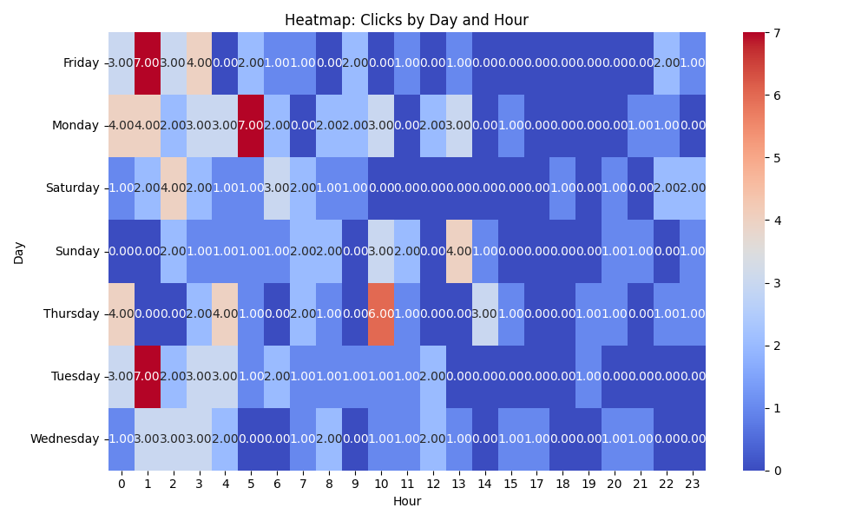

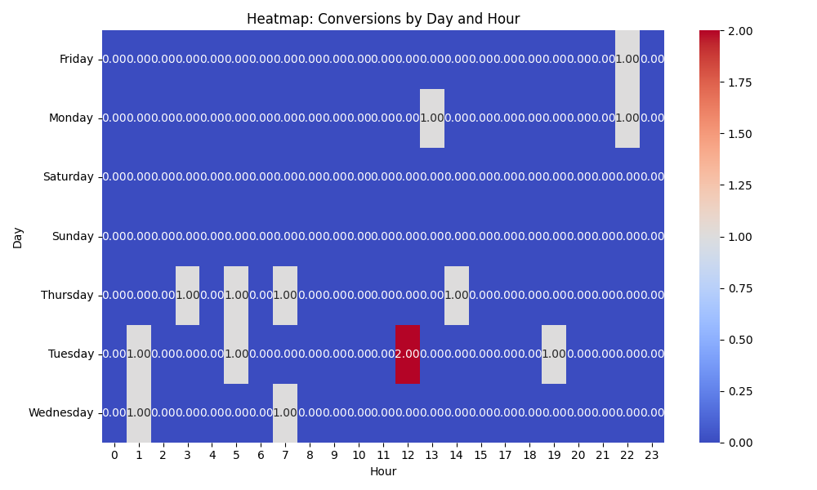

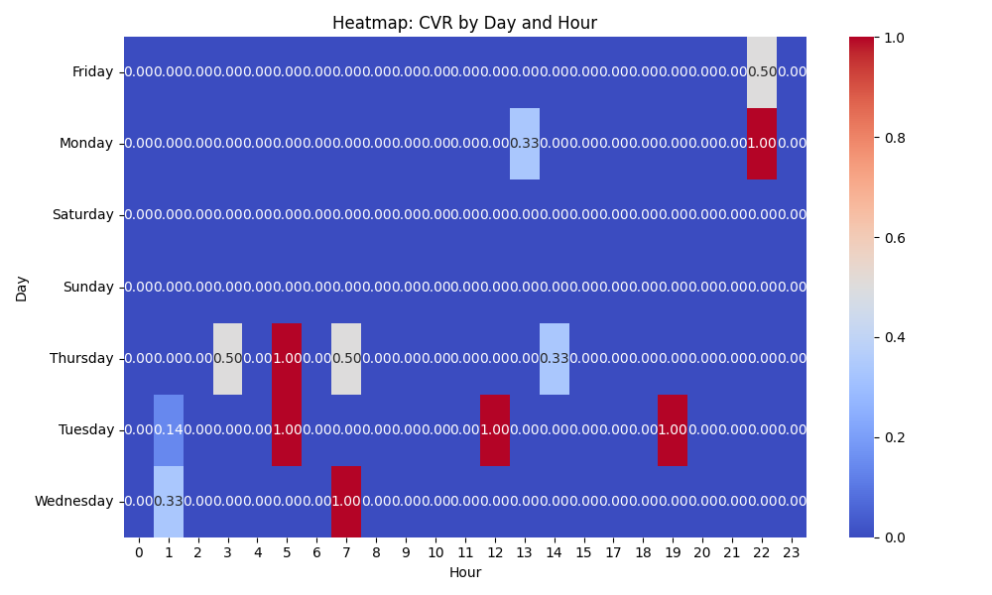

# Competitor Intelligence

# Top Competitor Insights

|  |  |  |
| --- | --- | --- |
| Competitor | Strengths | Recommendations |
| thevideocards.com | Their ad creatives are direct and immediately state their core product offerings (Video Brochures, Video Boxes, Video Mailers). This simple, product-focused messaging is clear and effective for users with specific search intent, potentially leading to a higher click-through rate for exact match queries. The repetition of the same ad creative across multiple instances indicates a strong focus on these three product categories, suggesting they are their primary offerings and potentially have optimized bidding strategies around them. Their brand name, 'thevideocards.com,' is highly literal and keyword-rich, which can contribute to strong ad relevance and quality scores for generic 'video cards' searches. | While their directness is a strength, it lacks any unique value proposition or emotional appeal. Our ad strategy should leverage our richer landing page content by featuring benefit-driven headlines such as 'Turn Your Brand into an Experience' or 'Captivate Your Audience'. We can use ad extensions (like structured snippets) to list our broader product range, while primary ad copy focuses on the 'wow, inform, and convert' aspect, which is a significant differentiator. Our landing page articulates powerful differentiators such as 'Fully Customizable,' 'Low Minimum Order,' 'Trusted by Global Brands,' and 'Proven Engagement Booster.' These are key selling points that the competitor's ad creatives completely miss. We should prominently feature these advantages in our ad headlines and descriptions to immediately convey our superior offering and build trust, rather than just listing products. Our landing page showcases a significantly broader and more detailed product range with specific use cases (e.g., 'Video Business Cards- Best for Events & VIP Outreach', 'Video Packaging- Perfect for Product Launches'). We should utilize this specificity in our ad campaigns through more granular ad groups, targeted keywords, and ad copy that speaks directly to these diverse needs. Furthermore, our extensive customer testimonials from global brands (Volvo, Volkswagen, Commonwealth Bank) are a massive trust-builder. We must incorporate these social proofs, perhaps via review extensions or by mentioning 'Trusted by Global Brands' directly in ad copy, to differentiate ourselves from a competitor that shows no such validation in their ads. |
|  | This type of ad is direct, immediately identifies the core offering, and likely captures a broad audience searching for the primary product. It often includes a concise benefit that differentiates them. This ad directly appeals to a specific persona (marketers) by addressing their goals like 'elevating strategy,' 'boosting engagement,' and 'ROI.' This focused messaging resonates powerfully with users seeking tangible business outcomes. This type of ad directly addresses common procurement concerns such as quality, speed, and competitive pricing, appealing to buyers focused on the logistical and cost aspects of production. This ad effectively combines the appeal of a unique, tailored solution with immediate relevance by suggesting practical applications like 'product launches, events, & corporate gifts.' This ad caters to users seeking a quick, convenient, and self-service purchasing option by highlighting ease of ordering and secure delivery. By delivering highly relevant ad copy for specific queries (e.g., 'marketing,' 'printing,' 'buy'), they are likely achieving higher click-through rates and better conversion efficiency for those particular user intents. | Ensure our ad copy for broad 'video brochure' searches is equally direct and impactful. We should immediately connect to our unique selling propositions such as 'The Ultimate Sales and Marketing Tool' and 'Turn Your Brand into an Experience' in headlines and descriptions, setting a premium, benefit-driven tone. Capitalize on our existing messaging, 'Ultimate Sales and Marketing Tool' and 'Proven Engagement Booster,' by making it more prominent in ad copy for marketing-focused keywords. Utilize ad extensions (e.g., callouts, structured snippets) to highlight specific marketing benefits or ideal use cases like 'Perfect for Product Pitches' or 'Build Trust, Loyalty, and Sales' from our product types. While our landing page emphasizes 'Premium Video-In-Print' and 'Fully Customizable,' our ad copy for production-oriented searches should be more explicit about our capabilities. Consider including ad extensions that highlight 'Low Minimum Order' and, if applicable, 'Fast Turnaround Times' or 'Exceptional Quality Manufacturing,' as reinforced by our strong customer testimonials. Our landing page already details various product types and their ideal uses. We should ensure our ad copy for 'custom video brochure' keywords includes 1-2 compelling use cases directly in the ad (e.g., 'Perfect for Product Launches' or 'Ideal for VIP Outreach'), alongside our 'Fully Customizable' and 'Turn Your Brand into an Experience' messaging to align with specific user needs. Given our 'Get A Free Quote' model, which implies a more custom or consultative process, we must manage expectations for these highly transactional keywords. We should avoid bidding on 'buy online' if we don't offer direct e-commerce. If we do bid, our ad copy must clearly reframe it, for instance, by emphasizing the value of our tailored service: 'Get Your Custom Video Brochure Quote Now' or 'Personalized Solutions for Your Brand,' highlighting 'Fully Customizable' and 'Low Minimum Order' as benefits of our bespoke approach. Adopt a more granular ad group and ad copy strategy that precisely mirrors diverse user intents. Leverage our strong landing page content—especially our 'More Than Just Video Brochures' USPs and compelling customer testimonials—by incorporating them into these targeted ads and via various ad extensions to strongly differentiate our premium, results-oriented value proposition across the entire customer journey. |
| mediafast.com › video-mailer | The competitor effectively uses both 'Video Mailer' and 'Video Brochure' in their ad creative, indicating a strong understanding of varied search intent. Their landing page path specifically uses 'video-mailer', suggesting optimized content for direct mail applications, which is a key use case. Their ad copy 'Custom, High-Impact Video Brochure You...' is concise and powerful. The ellipsis effectively creates intrigue and implies a direct benefit or action for the user, encouraging clicks within character limits. The competitor's ad title strongly aligns with their domain and landing page path, indicating a focused and consistent message from ad to destination. | While our landing page lists 'Video Mailers' as a product, it's not as prominent in our initial messaging or URL structure. We should consider creating specific ad groups and creatives that lead with 'Video Mailer' for related keywords, potentially linking to a dedicated section or landing page optimized for this specific product type and its benefits (e.g., 'Deliver your brand’s message with direct-mail video mailers'). Our landing page messaging is robust, using 'customized, high-impact' and benefits like 'wow, inform, and convert'. For ad creatives, we can learn from their brevity. We should test ad headlines that are equally concise, leading with a strong benefit and perhaps a more direct implied outcome for the user within the limited ad space, like 'Your Brand Elevated: Custom Video Brochures' or 'Drive Sales: High-Impact Video Mailers'. Ensure our Google Ads campaigns maintain this high level of consistency. For each ad group, the primary keyword and ad creative should directly mirror the most prominent headline and offering on the landing page it directs to. For instance, if an ad targets 'video mailers', the landing page should immediately emphasize 'Video Mailers' rather than requiring users to scroll or infer. |

# Top 3 Risks & Opportunities

## ⚠️ Risks

# Risks

|  |  |  |
| --- | --- | --- |
| Characteristic | Insight | Recommendation |
| Significant Budget Overrun & Daily Budget Mismatch | The actual cost ($2180.14) vastly exceeds the daily budget ($35) over any plausible period since the 2024-08-10 start date, leading to a calculated average daily spend far above the set limit. This indicates a severe budget control issue or a misconfigured daily budget. The campaign is spending money at a rate significantly higher than intended, leading to premature budget depletion and potential negative ROI. | Immediately investigate budget history for changes and reconcile the actual spend period to understand the discrepancy. If the $35/day was truly the intended limit, halt the campaign or drastically reduce the current daily budget to prevent further overspending. Implement account-level budget caps if not already in place to ensure financial control. |
| Insufficient Daily Budget for Target CPA Strategy | The daily budget ($35) is significantly lower than the Cost Per Acquisition ($155.72). This mismatch means the campaign cannot consistently generate even one conversion per day (0.22 conversions per day based on current CPA), which is critical for the Target CPA bid strategy to learn, optimize, and deliver stable performance. It starves the algorithm of necessary conversion data. | To allow the Target CPA bid strategy to function effectively and gather sufficient data for optimization, the daily budget should be significantly increased to at least 2-3 times the Target CPA (e.g., $300-$500/day minimum, if $155 CPA is acceptable). Alternatively, if the budget cannot be increased, consider lowering the target CPA or temporarily switching to a Max Conversions bid strategy to accumulate more data before re-applying Target CPA. |
| High and Potentially Unprofitable CPA | The current CPA is $155.72 for leads. Without knowing the client's target CPA or the average value/profitability of a generated lead, this CPA could be financially unsustainable. If the profit per conversion is less than this, the campaign is losing money. Even if marginally profitable, it indicates a high cost per lead that might limit scalability and overall campaign efficiency. | Conduct a thorough profitability analysis for leads generated at this CPA, factoring in lead-to-opportunity and opportunity-to-sale conversion rates, as well as average customer lifetime value. If deemed too high or unprofitable, prioritize optimization efforts to reduce CPA through improved targeting, granular negative keywords, ad copy relevance, and landing page conversion rate optimization. Re-evaluate the bidding strategy and target CPA value accordingly. |

## ✅ Opportunities

# Opportunities

|  |  |  |
| --- | --- | --- |
| Characteristic | Insight | Recommendation |
| Strong Ad Relevance and User Engagement (CTR) | The campaign exhibits a high Click-Through Rate (CTR) of 8.79%. This indicates that the ad copy is highly relevant and compelling to users searching for the targeted keywords, leading to strong initial engagement. This is a fundamental strength for search campaigns, showing that the message resonates with the audience. | Leverage this strength by continuous A/B testing of ad copy headlines and descriptions to identify even better-performing variations and maximize relevance. Explore using all available ad extensions (sitelinks, callouts, structured snippets, etc.) to increase ad prominence, provide more information, and potentially drive even higher CTR and quality clicks. |
| Conversion Potential & Data Availability | Despite the challenges, the campaign has successfully generated 14 conversions since its launch. This confirms that the campaign is capable of driving valuable conversions and provides a critical foundation of data for analyzing performance trends and identifying specific areas for further optimization to improve efficiency. | Perform an in-depth analysis of the 14 conversions, looking for common attributes such as specific keywords, ad groups, device types, demographics, and time of day that led to conversions. Use these insights to refine audience targeting, implement granular bid adjustments, refine negative keywords, and optimize landing page experiences to increase conversion rates and ultimately reduce CPA. |
| Scalability Through Impression Share Expansion | While 2242 impressions have been served, the significant daily budget overrun issue suggests that the campaign is likely not capturing its full potential impression share. Assuming the campaign can be made profitable at an acceptable CPA, there is likely untapped search volume within the target market. Increasing impression share will allow the campaign to capture more relevant traffic and potentially scale lead generation. | Once the budget stability and CPA efficiency issues are effectively addressed, strategically increase bids or budget to capture a larger share of eligible impressions. Monitor Auction Insights reports to identify key competitors and bid more competitively where profitable, aiming to expand reach and volume while maintaining the desired CPA targets and ensuring positive ROI. |