Google Ads Audit Report

# Campaign Performance (w/ Benchmark Overlay)

|  |  |  |  |  |  |  |  |  |  |
| --- | --- | --- | --- | --- | --- | --- | --- | --- | --- |
| Campaign Name | CTR | Cost ($) | Clicks | Impressions | CTR Flag | Avg CPC | Avg CPC Flag | CPA ($) | CPA ($) Flag |
| VPP_Search_Leads_USA_03/08/2024 (Exp 1) | 8.79% | $2180.15 | 197 | 2242 | Above | $11.07 | Above | $155.72 | Above |

# Campaign Insights

# Campaign Insights

|  |  |  |
| --- | --- | --- |
| Characteristic | Insight | Recommendation |
| Campaign Duration & Spend | The "VPP_Search_Leads_USA_03/08/2024 (Exp 1)" campaign has spent $2180.15 with a daily budget of $35.0, indicating it has run for approximately 62 days. | Given this is labeled as an 'Experiment 1' and has accrued significant spend and duration, thoroughly review its performance against pre-defined success metrics and determine whether to fully roll out, adjust, or pause the experiment. |
| Conversion Performance | The campaign has achieved 14 conversions at a Cost Per Acquisition (CPA) of $155.72 using a Target CPA bid strategy. | Assess if the $155.72 CPA aligns with the desired lead acquisition cost. If not, consider gradually lowering the Target CPA, improving landing page experience, or refining targeting to optimize conversion efficiency. |
| Traffic Quality & Cost | The campaign maintains a high Click-Through Rate (CTR) of 8.79% but incurs a high Average Cost Per Click (CPC) of $11.07. | Leverage the strong CTR by focusing on improving Quality Score for high-volume keywords to potentially reduce the $11.07 Avg CPC. Explore negative keywords and audience exclusions to minimize irrelevant clicks and further optimize spend. |

# Keyword Performance

|  |  |  |  |  |  |  |  |  |
| --- | --- | --- | --- | --- | --- | --- | --- | --- |
| Ad Group | Keyword | Match Type | Quality Score | Impressions | Clicks | CTR | Avg CPC | CPA ($) |
| Video Mailers | video mailers | PHRASE | 3 | 294 | 28 | 9.52% | $13.52 | $126.23 |
| VPP Brochures | video brochures | PHRASE | 5 | 347 | 23 | 6.63% | $13.36 | $0.00 |
| Video Books | promotional video book | PHRASE | 6 | 76 | 12 | 15.79% | $13.36 | $160.34 |
| Video Box | video box | PHRASE | 3 | 411 | 24 | 5.84% | $5.17 | $0.00 |
| Video Box | box with video screen | PHRASE | 4 | 35 | 10 | 28.57% | $11.08 | $110.85 |
| Video Box | video box marketing | PHRASE | 6 | 70 | 7 | 10.00% | $12.54 | $0.00 |
| Video Mailers | video mailers marketing | PHRASE | 7 | 61 | 6 | 9.84% | $13.32 | $0.00 |
| Video Mailers | video brochure mailer | PHRASE | 4 | 34 | 3 | 8.82% | $26.37 | $31.64 |
| Video Books | video book marketing | PHRASE | 6 | 98 | 11 | 11.22% | $6.34 | $34.87 |
| Video Mailers | custom video mailers | PHRASE | 5 | 48 | 6 | 12.50% | $10.98 | $65.85 |
| Video Books | personalized video books | PHRASE | 5 | 80 | 11 | 13.75% | $5.58 | $61.41 |
| Video Box | custom video box | PHRASE | 5 | 37 | 3 | 8.11% | $18.40 | $0.00 |
| VPP Brochures | video brochure card | PHRASE | 4 | 100 | 5 | 5.00% | $9.54 | $0.00 |
| Video Books | custom video books | PHRASE | 5 | 105 | 9 | 8.57% | $4.59 | $0.00 |
| Video Mailers | video card mailer | PHRASE | 3 | 17 | 3 | 17.65% | $12.41 | $37.24 |
| VPP Brochures | video brochure usa | PHRASE | 4 | 18 | 1 | 5.56% | $36.15 | $36.15 |
| VPP Brochures | custom video brochures | PHRASE | 7 | 58 | 3 | 5.17% | $9.88 | $59.27 |
| VPP Brochures | lcd screen video brochure | PHRASE | 4 | 20 | 2 | 10.00% | $13.20 | $0.00 |
| VPP Brochures | video brochure manufacturer | PHRASE | 3 | 3 | 2 | 66.67% | $11.74 | $0.00 |
| Video Box | video gift box | PHRASE | 5 | 47 | 5 | 10.64% | $2.97 | $0.00 |
| VPP Brochures | lcd video brochure | PHRASE | 3 | 5 | 1 | 20.00% | $13.72 | $0.00 |
| VPP Brochures | video brochure marketing | PHRASE | 5 | 2 | 1 | 50.00% | $12.49 | $0.00 |
| VPP Brochures | video brochure pricing | PHRASE | 0 | 10 | 1 | 10.00% | $11.03 | $0.00 |
| VPP Brochures | video brochure book | PHRASE | 5 | 2 | 1 | 50.00% | $9.41 | $0.00 |
| VPP Brochures | 4.3 inch video brochure | PHRASE | 0 | 3 | 1 | 33.33% | $7.84 | $0.00 |
| VPP Brochures | brochure with video screen | PHRASE | 6 | 6 | 1 | 16.67% | $7.42 | $0.00 |
| Video Mailers | lcd video mailers | EXACT | 0 | 4 | 1 | 25.00% | $5.87 | $0.00 |
| Video Box | promotional video box | PHRASE | 3 | 5 | 1 | 20.00% | $3.77 | $0.00 |
| VPP Brochures | video screen brochure | PHRASE | 5 | 14 | 1 | 7.14% | $1.44 | $0.00 |
| VPP Brochures | digital video brochures | PHRASE | 4 | 4 | 0 | 0.00% | $0.00 | $0.00 |
| VPP Brochures | media fast video brochure | PHRASE | 3 | 7 | 0 | 0.00% | $0.00 | $0.00 |
| VPP Brochures | video brochure maker | PHRASE | 4 | 2 | 0 | 0.00% | $0.00 | $0.00 |
| Video Books | lcd video book | PHRASE | 5 | 4 | 0 | 0.00% | $0.00 | $0.00 |
| Video Box | video brochure box | PHRASE | 2 | 7 | 0 | 0.00% | $0.00 | $0.00 |
| Video Mailers | video mailer box | PHRASE | 5 | 4 | 0 | 0.00% | $0.00 | $0.00 |
| Video Mailers | mediafast video mailer | PHRASE | 2 | 21 | 0 | 0.00% | $0.00 | $0.00 |
| Video Box | lcd video box | PHRASE | 5 | 4 | 0 | 0.00% | $0.00 | $0.00 |
| Video Box | video presentation box | PHRASE | 2 | 2 | 0 | 0.00% | $0.00 | $0.00 |
| Video Box | video screen box | PHRASE | 3 | 1 | 0 | 0.00% | $0.00 | $0.00 |
| Video Box | gift box with video screen | PHRASE | 1 | 1 | 0 | 0.00% | $0.00 | $0.00 |

# Keyword Insights

# Keyword Insights

|  |  |  |
| --- | --- | --- |
| Characteristic | Insight | Recommendation |
| Significant Wasted Spend on Non-Converting Keywords | Several keywords have accumulated substantial costs without generating any conversions. Key examples include 'video brochures' (VPP Brochures ad group) with $307.17 cost, 'video box' (Video Box ad group) with $124.02 cost, 'video box marketing' (Video Box ad group) with $87.81 cost, and 'video mailers marketing' (Video Mailers ad group) with $79.94 cost. Cumulatively, these four keywords alone account for $598.00 in spend with zero conversions. | Immediately pause 'video brochures', 'video box', 'video box marketing', and 'video mailers marketing'. Conduct a comprehensive Search Query Report (SQR) for these terms to identify irrelevant search queries that consumed budget and add them as exact or phrase negative keywords to prevent future wasted spend. Consider if new, more specific keywords should be added based on any relevant queries identified. |
| Highly Efficient Converting Keywords | A strong set of keywords are driving conversions at excellent Cost Per Acquisition (CPA) rates. 'video brochure mailer' (Video Mailers) achieved 2.5 conversions at a CPA of $31.64 and 83.33% CVR. 'video book marketing' (Video Books) generated 2.0 conversions at $34.87 CPA. 'video card mailer' (Video Mailers) delivered 1.0 conversion at $37.24 CPA with a high 17.65% CTR. 'video brochure usa' (VPP Brochures) had 1.0 conversion at $36.15 CPA with an outstanding 100% CVR. | Increase bids for these high-performing keywords to maximize impression share and click volume, given their proven efficiency. Analyze their respective Search Query Reports to find additional high-intent long-tail keywords or variations that can be added as exact match terms to capture more converting traffic efficiently. |
| Top Converter with High CPA and Low Quality Score | The keyword 'video mailers' (Video Mailers ad group) is the highest converting term, driving 3.0 conversions, but at a high CPA of $126.23 and a significant cost of $378.68. It also exhibits a low Quality Score of 3. | Prioritize Quality Score improvement for 'video mailers'. This includes refining ad copy to enhance relevance, ensuring the landing page experience is highly optimized for this specific query, and considering more precise ad group segmentation. Simultaneously, implement negative bid adjustments for less profitable times of day or demographics if data supports it, or test exact match variations of this keyword to improve targeting and reduce CPA. |
| Keywords with Critical Quality Score (0) | Keywords such as 'video brochure pricing' (VPP Brochures, $11.03 cost), '4.3 inch video brochure' (VPP Brochures, $7.84 cost), and 'lcd video mailers' (Video Mailers, EXACT match, $5.87 cost) all have a Quality Score of 0. This indicates severe relevance issues across ad, keyword, and landing page, leading to inefficient spend with no conversions. | Immediately pause all keywords with a Quality Score of 0. For any of these keywords that are truly critical to the campaign strategy, a complete re-evaluation is necessary, including a full rewrite of ad copy, a specific landing page experience, and potentially placing them into a new, tightly themed ad group to improve relevance signals. |
| Converting Keywords with High CPA | While converting, 'promotional video book' (Video Books ad group) has a CPA of $160.34 for 1.0 conversion, and 'box with video screen' (Video Box ad group) has a CPA of $110.85 for 1.0 conversion. These CPAs are significantly higher than other converting keywords. | Analyze the profitability of these specific conversions. If the margin allows, test modest negative bid adjustments to gradually lower CPCs, or refine ad copy to better qualify clicks and improve conversion rates, thereby reducing CPA. Review the landing page experience for these terms to ensure clear calls to action and compelling offers that justify the cost per click. |

# Wasted Spend Insights

# Wasted Spend Insights

|  |  |  |
| --- | --- | --- |
| Characteristic | Insight | Recommendation |
| High Spend, No Conversions, Average Quality Score | The keyword 'video brochures' has spent a significant $307.17 with zero conversions, despite having an average Quality Score of 5 and a CTR of 6.63% at an Avg CPC of $13.36. This indicates a disconnect between user intent and the conversion path or offering. | Conduct a detailed search term report analysis for 'video brochures' to identify irrelevant queries and add them as negative keywords. Audit the landing page experience for clarity, offer relevance, and call-to-action effectiveness. Consider A/B testing different ad copies focusing on unique selling propositions or direct offers. |
| High Spend, No Conversions, Very Low Quality Score | The keyword 'video box' incurred a cost of $124.02 without any conversions and suffers from a very low Quality Score of 3, despite a decent CTR of 5.84% and an Avg CPC of $5.17. This low Quality Score points to significant issues with ad relevance and/or landing page experience. | Immediately review the ad copy and landing page content for 'video box' to ensure strong relevance to the keyword. Implement more specific ad groups for 'video box' queries. Explore adding negative keywords to exclude broad searches. Improve landing page load time and mobile-friendliness to boost landing page experience. |
| High Spend, No Conversions, High CTR | The keyword 'video box marketing' has spent $87.81 with no conversions, yet it boasts an excellent CTR of 10.00% and a respectable Quality Score of 6 at an Avg CPC of $12.54. This suggests that the ad copy is highly compelling and relevant to the search query, but the post-click experience is failing to convert users. | Focus efforts on optimizing the landing page for 'video box marketing'. Ensure the landing page directly addresses the 'marketing' aspect, highlights benefits, and features a clear, prominent call-to-action. Consider implementing A/B tests on landing page elements, forms, and offers to improve conversion rates. Verify conversion tracking is correctly set up for this specific user journey. |
| High Spend, No Conversions, Good Quality Score, High CTR | The keyword 'video mailers marketing' has spent $79.94 without conversions, despite a strong Quality Score of 7 and an impressive CTR of 9.84% at an Avg CPC of $13.32. This performance mirrors 'video box marketing,' indicating successful ad engagement but a clear bottleneck in the conversion funnel. | Similar to 'video box marketing', the primary focus should be on landing page optimization for 'video mailers marketing'. Review content to ensure it meets the specific intent of someone searching for 'marketing' solutions related to video mailers. Test different offers, value propositions, and trust signals on the landing page to drive conversions. Consider user session recordings or heatmaps for deeper insights into user behavior. |
| High Spend, No Conversions, Very High Avg CPC | The keyword 'custom video box' has spent $55.19 with zero conversions and a remarkably high Avg CPC of $18.40, despite a good CTR of 8.11% and an average Quality Score of 5. This high cost per click without conversion makes it a significant drain on budget. | For 'custom video box', review the competitive landscape and bid strategy. Consider using a more targeted match type (e.g., [custom video box]) to prevent broader, more expensive matches. Enhance ad relevance and landing page experience to try and improve Quality Score, which could lower CPC. If conversion remains elusive, pause this keyword or significantly reduce its bid to reallocate budget. |
| Medium Spend, No Conversions, Low Quality Score | The keyword 'video brochure card' has spent $47.71 with no conversions and a low Quality Score of 4, coupled with a 5.00% CTR and $9.54 Avg CPC. The low Quality Score indicates that ads or landing pages aren't sufficiently aligned with the keyword's intent. | Improve the Quality Score for 'video brochure card' by refining ad copy to explicitly include 'card' and ensuring the landing page prominently features 'video brochure cards' with relevant details and pricing. Consider creating a dedicated landing page just for 'video brochure cards.' Review search terms for this keyword and add negatives to improve relevance. |
| Medium Spend, No Conversions, Low Quality Score, High CTR | The keyword 'lcd screen video brochure' has spent $26.39 with no conversions and a low Quality Score of 4, despite a very good CTR of 10.00% at an Avg CPC of $13.20. The low Quality Score suggests issues with ad relevance or landing page, while the high CTR indicates compelling ad copy that isn't leading to desired action. | Address the Quality Score of 4 for 'lcd screen video brochure' by optimizing ad copy to include 'LCD screen' and ensuring the landing page is highly relevant and specific to products featuring LCD screens. Verify that the landing page accurately reflects the ad's promise and guides users towards conversion efficiently, perhaps by showcasing various LCD screen sizes or features directly. |
| Medium Spend, No Conversions, Extremely High CTR, Very Low Quality Score | The keyword 'video brochure manufacturer' has spent $23.48 with no conversions, and while it shows an exceptionally high CTR of 66.67%, it alarmingly has a Quality Score of 3 at an Avg CPC of $11.74. This extreme discrepancy suggests either a very low impression volume exaggerating CTR or a major disconnect between the ad's message, user intent (perhaps looking for B2B wholesale vs. direct purchase), and the landing page experience. | Investigate the impression volume for 'video brochure manufacturer' to understand if the CTR is statistically significant. Given the 'manufacturer' intent, ensure the landing page specifically addresses wholesale, bulk orders, or B2B inquiries if that is the business model. If not, consider adding 'manufacturer' as a negative keyword. Simultaneously, address the Quality Score 3 by improving ad relevance and landing page experience for potential B2B leads. |
| Low Spend, No Conversions, Critical Quality Score | The keyword 'video brochure pricing' has spent $11.03 with zero conversions and critically, a Quality Score of 0, despite a 10.00% CTR at an Avg CPC of $11.03. A Quality Score of 0 means the keyword is effectively inactive or severely misconfigured by Google, preventing it from serving effectively. | Immediately investigate why 'video brochure pricing' has a Quality Score of 0. This typically means the keyword is disapproved, paused, or Google cannot serve ads for it. Resolve any disapproval issues, ensure the keyword is active, and confirm it's in a relevant ad group with highly specific ads and a landing page that directly addresses 'pricing' information (e.g., a pricing page, quote request form, or clear pricing tiers). |
| Low Spend, No Conversions, Critical Quality Score | The keyword '4.3 inch video brochure' has spent $7.84 without conversions and exhibits a critical Quality Score of 0, despite a very high CTR of 33.33% at an Avg CPC of $7.84. Similar to other QS 0 keywords, this indicates a severe issue with its eligibility or relevance within Google Ads. | Address the Quality Score 0 issue for '4.3 inch video brochure' immediately. Check for keyword disapproval, ad group pause, or account issues. Ensure there's a specific ad copy that mentions '4.3 inch' and directs to a landing page where a 4.3-inch video brochure is prominently featured or directly selectable, providing specific details or product options. |
| Low Spend, No Conversions, Critical Quality Score | The keyword 'lcd video mailers' has spent $5.87 with no conversions and a critical Quality Score of 0, despite a high CTR of 25.00% at an Avg CPC of $5.87. This indicates a fundamental problem with the keyword's ability to serve ads effectively. | Resolve the Quality Score 0 for 'lcd video mailers' by checking for disapprovals or policy violations. Ensure the ad group contains highly relevant ad copy for 'LCD video mailers' and the landing page specifically showcases or mentions LCD video mailers with clear product details, specifications, and a path to purchase. |
| Low Spend, No Conversions, Very Low Quality Score, High CTR | The keyword 'lcd video brochure' spent $13.72 with no conversions, a Quality Score of 3, and a high CTR of 20.00% at an Avg CPC of $13.72. The low Quality Score combined with high engagement suggests that while the ad is clicked, the underlying relevance to the landing page or the user's ultimate intent is poor. | Improve the Quality Score for 'lcd video brochure' by creating ad copy that explicitly uses 'LCD' and leads to a landing page specifically featuring or highlighting LCD video brochures. Review the landing page to ensure it clearly differentiates LCD products, provides adequate information, and offers clear next steps (e.g., specifications, purchase options). Consider exact match type if not already used. |

# Landing Page Audit Insights

## Landing Page: https://videoplusprint.com/video-in-print-products

# Landing Page Insights

|  |  |  |  |
| --- | --- | --- | --- |
| URL | Characteristic | Insight | Recommendation |
| https://videoplusprint.com/video-in-print-products | Call to Action (CTA) Clarity & Placement | The primary CTA 'GET A FREE QUOTE' is clear, action-oriented, and strategically placed multiple times above and below the fold, including within the navigation and after key benefit statements. This excellent repetition and prominence guide users efficiently towards the conversion goal. | The current CTA strategy is effective. While not immediately necessary, consider A/B testing micro-variations of the CTA text, such as 'Get Your Custom Quote' or 'Start Your Project Now', to potentially optimize click-through rates further. Ensure the CTA button stands out visually with sufficient contrast. |
| https://videoplusprint.com/video-in-print-products | Value Proposition & Unique Selling Points | The page clearly articulates the core value ('Turn Your Brand into an Experience') and key benefits ('Fully Customizable', 'Low Minimum Order', 'Trusted by Global Brands', 'Proven Engagement Booster'). These points effectively address common user needs and highlight competitive advantages for a premium product. | While 'Low Minimum Order' is a strong unique selling point, it's currently vague. Specify the actual low minimum quantity (e.g., 'Minimum order from 30 units') directly in the benefits section. This provides immediate clarity and reduces a potential point of friction for prospects with smaller projects, even though the form provides this detail later. |
| https://videoplusprint.com/video-in-print-products | Social Proof & Trust Signals | The page leverages powerful social proof with testimonials from highly recognizable global brands (Volvo, Volkswagen, Commonwealth Bank agency). This significantly builds trust and credibility, especially for a high-value product, and the specific feedback highlights the 'wow' factor. | One testimonial ('We had a lot of positive reactions on the video card for the event, that’s why we chose to use this concept for our event') appears duplicated. This minor oversight should be corrected immediately by removing the duplicate or replacing it with new, unique content to maintain professionalism and perceived attention to detail. |
| https://videoplusprint.com/video-in-print-products | Lead Capture Form Optimization | The lead form is comprehensive, gathering important qualification details like product type, quantity, and screen size upfront. This is valuable for pre-qualifying leads, which is essential given the high CPA ($155.72) and the custom, high-value nature of the product. | While thoroughness is beneficial for lead quality, a lengthy form can increase perceived friction. Consider adding a brief explanation next to the form fields on 'why' this information is needed (e.g., 'Help us provide the most accurate and fastest quote'). For higher volume inquiries, A/B test a shorter initial form (Name, Email, Product Type) with subsequent qualification steps after the initial submission. |
| https://videoplusprint.com/video-in-print-products | Visual Content & Product Showcase | The provided text content describes 'video in print' products, which inherently suggests a strong visual component. However, the text audit doesn't convey the presence of actual high-quality images or videos of the products themselves. For a product centered on visual engagement and 'wow' factor, a lack of prominent visual demonstration would be a significant conversion blocker. | Ensure the landing page prominently features high-resolution images and, critically, *embedded videos* demonstrating the video brochures in action, showing the screen quality, activation, and physical product. Consider including a hero video or a gallery of diverse use cases to immediately convey the product's impact and quality to visitors. |
| https://videoplusprint.com/video-in-print-products | Match with Ad Intent & Keyword Performance | With a CTR of 3.28%, ads are drawing some interest, but the CPA of $155.72 indicates a high cost per conversion. The page content strongly aligns with 'video in print' and 'video brochures', suggesting good on-page relevance to typical search queries. | Given the high CPA, re-evaluate the ad copy and keyword targeting. If users searching for 'cheap video brochures' are clicking, the 'Premium Video-In-Print' positioning might lead to high bounce rates or unqualified leads. Consider segmenting ad groups to target distinct user intents (e.g., 'premium custom video brochures' vs. 'affordable video mailers') and tailoring landing page experiences accordingly to reduce misqualified clicks and improve CPA. |
| https://videoplusprint.com/video-in-print-products | Competitor Benchmark | Leading competitors in the custom premium print and B2B marketing solutions often provide not just testimonials, but detailed case studies with measurable outcomes (e.g., ROI, engagement rates), interactive product configurators, and transparent outlines of their design/production process. | To further reinforce the 'proven engagement booster' claim and differentiate, develop and feature detailed case studies with quantifiable results (e.g., 'Increased event attendance by X%', 'Generated Y leads'). Additionally, explore incorporating an interactive tool or configurator that allows users to visualize design options, potentially increasing engagement and self-qualification before submitting a quote request. |
| https://videoplusprint.com/video-in-print-products | Conversion Rate & CPA | A CPA of $155.72 is exceptionally high for a lead generation funnel, especially if conversions are just inquiries/quotes, not sales. This indicates either a very low conversion rate from clicks to conversions, an extremely high cost per click not justified by lead value, or that the cost data is incomplete (given 'Cost: 0.00'). If this CPA is accurate for a qualified lead, the lifetime value of a customer must be substantial to justify it. | Conduct a thorough analysis of the true cost per conversion and the value of a converted lead. Implement event tracking for all micro-conversions (e.g., video plays, brochure downloads, time on page) to identify engagement points. Explore strategies to reduce friction in the quote process or offer lower-barrier conversion options like a 'Request a Sample' or 'Download a Pricing Guide' to improve conversion volume and lower CPA. |
| https://videoplusprint.com/video-in-print-products | Call to Action (CTA) Clarity & Prominence | The CTAs 'Get A FREE Video Brochure QUOTE' and 'GET A FREE QUOTE' are clear in their offer. However, their strategic placement and visual prominence throughout the page are critical and cannot be assessed from the provided text. If these CTAs are not above the fold or sufficiently repeated after key value propositions, user engagement will drop before they reach the conversion point. | Ensure the primary CTA is immediately visible above the fold and repeated logically after each major product section or benefit block. Use contrasting colors and button-like styling to make CTAs highly noticeable. Consider adding a sticky CTA bar for longer pages or exit-intent pop-ups with the same offer to capture abandoning users. |
| https://videoplusprint.com/video-in-print-products | Trust Signals & Credibility | The page includes good trust signals like client logos (UPS, Exxon Mobil) and a 'Proven ROI A 23% sales lift from video packaging proves it' statement. However, the 'Most Valuable Company 2016 in Hong Kong' award is outdated, and the claim 'Since 2009, Video Plus Print has delivered video-in-print solutions with over 40 years of expertise' creates ambiguity (Is it company age or collective team experience?). Inconsistencies or outdated information can erode trust. | Update or remove outdated awards to maintain a fresh and credible image. Clarify the '40 years of expertise' – if it's collective team experience, phrase it as such. Feature more recent testimonials or case studies that include specific client names, industries, and quantifiable results to build stronger social proof. Consider adding any relevant industry certifications or memberships. |
| https://videoplusprint.com/video-in-print-products | Value Proposition & Messaging Tone | The page effectively communicates the various applications and benefits of video-in-print products (e.g., 'Engage and impress,' 'captivate, convert, and build trust'). The breakdown by use case (Sales, Marketing, Branding) is helpful. However, language such as 'The ” Interactive Video Marketing” products bandwagon is fast evolving; and it’s your chance to get harness its power and rake in the profits' is overly salesy and lacks the professional tone expected for B2B high-value products. | Refine the copy to adopt a more professional, benefit-driven, and concise tone. Focus on solving specific business challenges and delivering measurable outcomes rather than using 'salesy' jargon. Emphasize the unique selling points that differentiate 'Video Plus Print' beyond generic product descriptions. |
| https://videoplusprint.com/video-in-print-products | Ad-Page Relevance (CTR & Content Match) | A CTR of 3.28% suggests a decent level of ad relevance to user queries, implying that users searching for 'video in print products' are finding relevant ad copy. The landing page content directly addresses the 'video in print products' category and its various forms (brochures, mailers, books, packaging), indicating a strong topical match. | While the overall match is good, consider optimizing for specific long-tail keywords or ad groups. Implement dynamic text replacement on the landing page so that the headline or a key benefit statement matches the user's specific search query, enhancing personalization and perceived relevance. |
| https://videoplusprint.com/video-in-print-products | User Experience (Information Density) | The provided content chunk, despite being only 2/3 of the page, appears quite text-dense with various product descriptions, benefits, and company information. Without visual hierarchy (headings, bullet points, images) and clear spacing (which cannot be confirmed from text alone), this density can lead to cognitive overload and users quickly scanning or bouncing. | Implement strong visual hierarchy using clear headings, subheadings, and bullet points to break up information. Integrate high-quality product images, videos, or infographics to visually demonstrate the products and their applications. Ensure ample white space around text blocks and elements to improve readability and guide the user's eye. |
| https://videoplusprint.com/video-in-print-products | Competitor Benchmark | Many competitors in the custom marketing collateral space offer clearer insights into their process or pricing on their landing pages. Some provide estimated lead times, material options, or even basic tiered pricing to manage expectations before requiring a full quote. The current page's primary conversion point is a direct quote request, which might be a higher barrier compared to competitors offering more immediate information. | Research competitor landing pages to understand their typical sales funnel and information architecture. Consider adding a 'How It Works' section with a simple step-by-step process (e.g., '1. Request Quote -> 2. Design & Proof -> 3. Production & Delivery'). Explore offering a customizable configurator or a basic pricing calculator to give users a preliminary idea of cost without requiring a full commitment, thereby lowering the initial conversion barrier. |
| https://videoplusprint.com/video-in-print-products | Cost Data Anomaly | The provided cost data is listed as 0.00, which is inaccurate for paid advertising campaigns. This discrepancy makes it impossible to directly calculate the true Return on Ad Spend (ROAS) or fully understand the efficiency of the ad spend, despite a CPA being provided. | Integrate accurate and granular cost data directly from Google Ads into your analytics and reporting systems. This will enable precise ROI calculations and allow for more informed optimization decisions. Assume the CPA of $155.72 implies a significant underlying cost is being incurred. |
| https://videoplusprint.com/video-in-print-products | High CPA | A CPA of $155.72 for a quote request, without context of the average deal size or the lead-to-customer conversion rate, suggests a potentially high cost per acquisition. This indicates that either the leads generated are of extremely high value, or the conversion rate on the page is suboptimal, leading to inefficient ad spend. | Implement A/B tests focused on improving the conversion rate. Test variations of the primary value proposition, headline, and the structure/ease of the quote request form. Analyze the quality of leads generated at this CPA to determine if the cost is justified by downstream revenue, and if not, prioritize conversion rate optimization. |
| https://videoplusprint.com/video-in-print-products | Call to Action (CTA) Effectiveness | The CTAs 'Get A FREE Video Brochure QUOTE' and 'GET A FREE QUOTE' are present at the end of the provided content chunk. While 'FREE' is good, their placement might be too late in the user journey on the page, and the phrasing could be more compelling or benefit-driven. | Ensure the primary CTA is highly visible and placed strategically above the fold, and repeated at logical points throughout the page. Test variations that emphasize the specific benefit of getting a quote (e.g., 'Get Your Custom Video Brochure Quote Now' or 'Unlock Innovative Marketing: Request Your Free Quote'). Consider a sticky CTA for longer pages. |
| https://videoplusprint.com/video-in-print-products | Trust Signals & Social Proof | The copyright notice indicates longevity (2009-2024), which is a basic trust signal. However, typical B2B trust signals like prominent client logos, specific testimonials with names/companies, or detailed case studies demonstrating success are not evident in this content chunk, which are crucial for high-value B2B lead generation. | Integrate more robust trust signals. Add a dedicated section for client testimonials, display logos of recognizable past clients (with permission), or provide brief case studies highlighting specific results and ROI achieved for customers. This builds immediate credibility and reduces perceived risk for potential buyers. |
| https://videoplusprint.com/video-in-print-products | Product Visualization & Specificity | While the content clearly describes 'video in print' products and their applications, the provided chunk doesn't indicate the presence of strong visual aids (e.g., a gallery, product videos) or specific, tangible examples that help a visitor fully grasp the product's quality, design possibilities, and real-world impact. | Enhance the landing page with high-quality images and videos showcasing the actual 'video in print' products in various use cases. Develop specific mock-ups or examples tailored to key industries or common applications (e.g., for real estate, corporate onboarding, product launches) to make the offering more concrete and desirable. |
| https://videoplusprint.com/video-in-print-products | Competitor Benchmark | A CPA of $155.72 for a B2B quote request may or may not be competitive depending on the niche and average deal size. Without direct competitor performance data or industry benchmarks for similar 'video in print' marketing solutions, it's challenging to ascertain if this CPA is sustainable, efficient, or indicative of a competitive disadvantage. | Conduct a thorough competitor analysis to understand their landing page strategies, lead capture methods, and value propositions. Research industry benchmarks for B2B marketing product lead generation to establish a realistic target CPA range and identify opportunities for competitive differentiation in messaging or offerings. |
| https://videoplusprint.com/video-in-print-products | Ad-Page Message Match (Inferred) | While the page content aligns broadly with 'video in print' products, if the Google Ads are highly specific (e.g., targeting 'video brochures for corporate events' or 'custom video business cards'), the landing page might not immediately address that specific user intent with tailored messaging above the fold, potentially leading to a disconnect. | Review your top-performing keywords and ad copy. Ensure the landing page's primary headline and the initial content directly reflect the specific intent of the ad that led the user to the page. Consider creating separate, highly tailored landing page variations for distinct keyword clusters or specific ad groups to improve relevance and conversion rates. |

# Geographical Performance

|  |  |  |  |  |  |  |  |  |  |
| --- | --- | --- | --- | --- | --- | --- | --- | --- | --- |
| City | Region | Country | Type | Impressions | Clicks | Conversions | Cost ($) | CVR | CPA ($) |
| United States |  |  | Country | 2116 | 185 | 14.0 | $2109.34 | 0.07567567567567568 | $150.67 |

# Geographical Insights

# Geographical Insights

|  |  |  |
| --- | --- | --- |
| Characteristic/ Location | Insight | Recommendation |
| United States (Country) | The campaign has allocated 100% of its budget, totaling $2109.34, to the United States. This spend has resulted in 14 conversions, yielding a Cost Per Acquisition (CPA) of $150.67 and a Conversion Rate (CVR) of 7.57%. | To identify more granular optimization opportunities and potentially reduce the $150.67 CPA, immediately implement state or city-level targeting within the United States. This will enable the identification of specific geographic areas that are over- or under-performing relative to the current 7.57% CVR and allow for targeted bid adjustments or exclusions, thereby optimizing the total $2109.34 spend. |

# Hourly Performance Pivot

CVR

|  |  |  |  |  |  |  |  |  |  |
| --- | --- | --- | --- | --- | --- | --- | --- | --- | --- |
| Day/Hour | 1 | 3 | 5 | 7 | 12 | 13 | 14 | 19 | 22 |
| Monday |  |  |  |  |  | 0.33 |  |  | 1.00 |
| Tuesday | 0.14 |  | 1.00 |  | 1.00 |  |  | 1.00 |  |
| Wednesday | 0.33 |  |  | 1.00 |  |  |  |  |  |
| Thursday |  | 0.50 | 1.00 | 0.50 |  |  | 0.33 |  |  |
| Friday |  |  |  |  |  |  |  |  | 0.50 |

Clicks

|  |  |  |  |  |  |  |  |  |  |  |  |  |  |  |  |  |  |  |  |  |  |  |  |
| --- | --- | --- | --- | --- | --- | --- | --- | --- | --- | --- | --- | --- | --- | --- | --- | --- | --- | --- | --- | --- | --- | --- | --- |
| Day/Hour | 0 | 1 | 2 | 3 | 4 | 5 | 6 | 7 | 8 | 9 | 10 | 11 | 12 | 13 | 14 | 15 | 17 | 18 | 19 | 20 | 21 | 22 | 23 |
| Monday |  |  |  |  |  |  |  |  |  |  |  |  |  |  |  |  |  |  |  |  |  |  |  |
| Tuesday |  |  |  |  |  |  |  |  |  |  |  |  |  |  |  |  |  |  |  |  |  |  |  |
| Wednesday |  |  |  |  |  |  |  |  |  |  |  |  |  |  |  |  |  |  |  |  |  |  |  |
| Thursday |  |  |  |  |  |  |  |  |  |  |  |  |  |  |  |  |  |  |  |  |  |  |  |
| Friday |  |  |  |  |  |  |  |  |  |  |  |  |  |  |  |  |  |  |  |  |  |  |  |
| Saturday |  |  |  |  |  |  |  |  |  |  |  |  |  |  |  |  |  |  |  |  |  |  |  |
| Sunday |  |  |  |  |  |  |  |  |  |  |  |  |  |  |  |  |  |  |  |  |  |  |  |

Conversions

|  |  |  |  |  |  |  |  |  |  |
| --- | --- | --- | --- | --- | --- | --- | --- | --- | --- |
| Day/Hour | 1 | 3 | 5 | 7 | 12 | 13 | 14 | 19 | 22 |
| Monday |  |  |  |  |  | 1.00 |  |  | 1.00 |
| Tuesday | 1.00 |  | 1.00 |  | 2.00 |  |  | 1.00 |  |
| Wednesday | 1.00 |  |  | 1.00 |  |  |  |  |  |
| Thursday |  | 1.00 | 1.00 | 1.00 |  |  | 1.00 |  |  |
| Friday |  |  |  |  |  |  |  |  | 1.00 |

Cost ($)

|  |  |  |  |  |  |  |  |  |  |  |  |  |  |  |  |  |  |  |  |  |  |  |  |
| --- | --- | --- | --- | --- | --- | --- | --- | --- | --- | --- | --- | --- | --- | --- | --- | --- | --- | --- | --- | --- | --- | --- | --- |
| Day/Hour | 0 | 1 | 2 | 3 | 4 | 5 | 6 | 7 | 8 | 9 | 10 | 11 | 12 | 13 | 14 | 15 | 17 | 18 | 19 | 20 | 21 | 22 | 23 |
| Monday | 48.30 | 21.97 | 24.69 | 13.34 | 26.87 | 54.61 | 5.29 |  | 36.75 | 15.58 | 24.57 |  | 9.74 | 59.63 |  | 12.31 |  |  |  |  | 3.77 | 15.61 |  |
| Tuesday | 48.24 | 93.14 | 23.40 | 22.01 | 39.36 | 10.17 | 13.67 | 16.65 | 4.97 | 22.60 | 8.91 | 9.03 | 44.24 |  |  |  |  |  | 9.07 |  |  |  |  |
| Wednesday | 2.86 | 51.11 | 112.01 | 57.51 | 36.88 |  |  | 4.51 | 12.08 |  | 4.67 | 10.53 | 6.26 | 5.90 |  | 1.83 | 12.58 |  |  | 4.09 | 3.60 |  |  |
| Thursday | 85.88 |  |  | 39.39 | 40.51 | 11.88 |  | 41.53 | 2.24 |  | 60.89 | 7.23 |  |  | 12.13 | 7.84 |  |  | 2.70 | 4.40 |  | 2.57 | 5.69 |
| Friday | 32.45 | 58.31 | 50.79 | 48.66 |  | 16.38 | 12.36 | 2.79 |  | 19.03 |  | 8.07 |  | 1.14 |  |  |  |  |  |  |  | 29.77 | 2.56 |
| Saturday | 39.21 | 40.99 | 50.32 | 5.12 | 19.72 | 18.15 | 24.64 | 29.87 | 3.39 | 2.63 |  |  |  |  |  |  |  | 18.95 |  | 5.74 |  | 17.21 | 11.58 |
| Sunday |  |  | 24.74 | 12.14 | 14.93 | 3.99 | 0.14 | 10.97 | 6.07 |  | 19.12 | 15.75 |  | 40.52 | 39.35 |  |  |  |  | 13.34 | 3.56 |  | 15.90 |

# Hourly Patterns Insights

# Hourly Patterns Insights

|  |  |  |
| --- | --- | --- |
| Characteristic | Insight | Recommendation |
| Significant ad spend with zero conversions during specific late night and early morning hours. | A considerable portion of the budget is being wasted on non-converting clicks, particularly between 00:00 and 04:00 on most weekdays (e.g., Monday, Wednesday, Thursday, Friday) and throughout Sunday. | Implement aggressive negative bid adjustments or pause campaigns entirely during unproductive late night/early morning hours (e.g., Monday 00:00-04:00, Wednesday 02:00-04:00, Thursday 00:00-04:00, Friday 00:00-04:00, Saturday 00:00-06:00). Strongly consider pausing all ad activity on Sunday given the complete lack of conversions. |
| Highly efficient conversions observed during specific early morning windows. | Certain early morning hours, such as Tuesday 05:00, Wednesday 07:00, and Thursday 05:00, demonstrate excellent conversion rates (100% CVR) at a very low cost per conversion, indicating high user intent or lower competition. | Apply significant positive bid adjustments for campaigns running during Tuesday 05:00, Wednesday 07:00, and Thursday 05:00 to capitalize on these highly efficient conversion opportunities. |
| Conversions are spread across a wide range of hours, not limited to traditional business hours. | The converting audience is active and making purchases at various times, including late evening (e.g., Monday 22:00, Tuesday 19:00, Friday 22:00) and mid-day (e.g., Tuesday 12:00, Thursday 14:00), suggesting diverse user schedules. | Avoid blanket time-based exclusions. Instead, maintain advertising presence throughout the day but use granular hourly bid adjustments based on the profitability of each specific time slot. |
| Significant variability in Cost Per Conversion (CPC) among converting hours. | Even hours that yield conversions show vastly different cost efficiencies, ranging from very low (e.g., Tuesday 19:00 at $9.07) to very high (e.g., Tuesday 01:00 at $93.14), indicating fluctuating competition or audience quality. | Conduct a deeper analysis into specific keywords, device performance, and audience segments during high-cost converting hours (e.g., Monday 13:00, Tuesday 01:00) to identify areas for optimization. Apply additional positive bid adjustments to highly efficient hours to maximize ROI. |

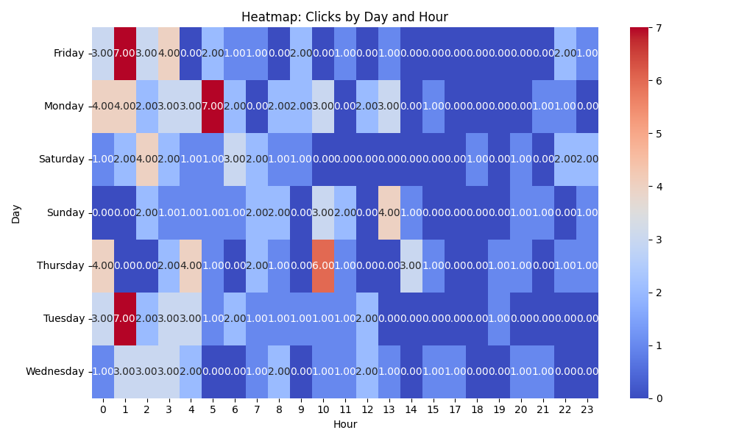

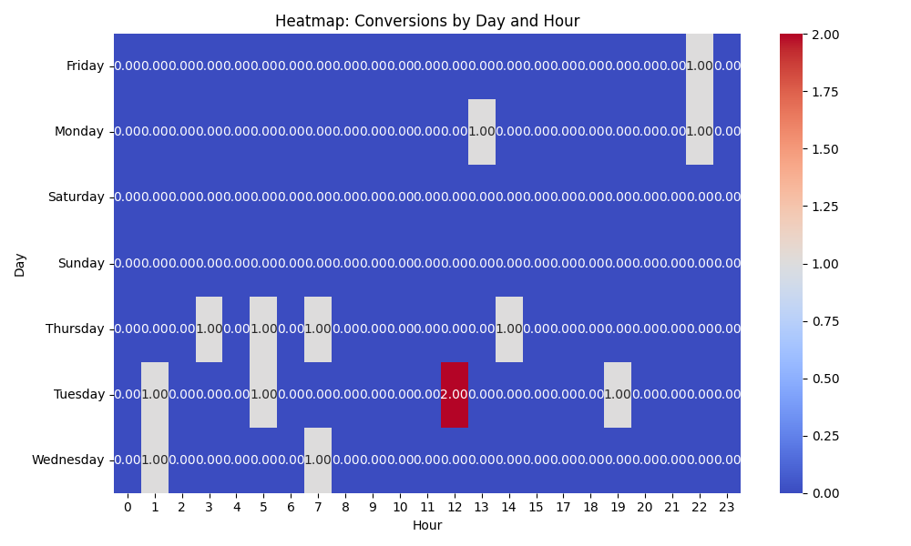

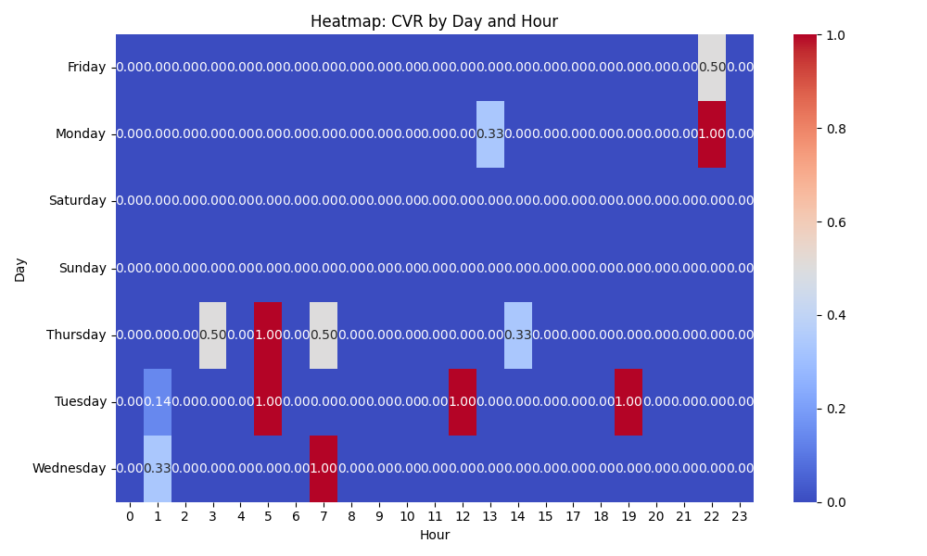

# Competitor Intelligence

No competitor insights found or could be parsed.

# Top 3 Risks & Opportunities

No Risks identified.

No Opportunities identified.