Google Ads Audit Report

# Campaign Performance (w/ Benchmark Overlay)

|  |  |  |  |  |  |  |  |  |  |
| --- | --- | --- | --- | --- | --- | --- | --- | --- | --- |
| Campaign Name | CTR | Cost ($) | Clicks | Impressions | CTR Flag | Avg CPC | Avg CPC Flag | CPA ($) | CPA ($) Flag |
| VPP_Search_Leads_USA_03/08/2024 (Exp 1) | 8.79% | $2180.15 | 197 | 2242 | Above | $11.07 | Above | $155.72 | Above |

# Campaign Insights

⚠️ Unable to parse structured insights — showing raw output below.

[{'Characteristic': 'Conversion Efficiency', 'Insight': 'The "VPP_Search_Leads_USA_03/08/2024 (Exp 1)" campaign has achieved 14 conversions at an average CPA of $155.72.', 'Recommendation': 'Verify the target CPA currently set for this campaign. If $155.72 is higher than the desired target, consider lowering the target CPA by 5-10% to encourage the system to bid more efficiently for conversions. If the CPA is acceptable, consider gradually increasing the daily budget from $35.0 to scale conversion volume while monitoring efficiency.'}, {'Characteristic': 'Ad Relevancy and Engagement', 'Insight': 'The "VPP_Search_Leads_USA_03/08/2024 (Exp 1)" campaign exhibits a strong CTR of 8.79% from 2242 impressions.', 'Recommendation': 'Leverage the high CTR by conducting a deep dive into the Search Term Report to identify new exact and phrase match keywords that generated high clicks and conversions. Additionally, expand on the most successful ad variations by creating similar headlines and descriptions to maintain this high level of engagement and relevancy.'}, {'Characteristic': 'Budget Pacing and Performance', 'Insight': 'The "VPP_Search_Leads_USA_03/08/2024 (Exp 1)" campaign has spent $2180.15 with a daily budget of $35.0 using a TARGET_CPA strategy.', 'Recommendation': 'Ensure the daily budget of $35.0 is sufficient for the TARGET_CPA strategy to consistently achieve its conversion goals without being limited by budget. If the campaign is regularly maxing out its budget and meeting CPA targets, consider a gradual increase in the daily budget to capture more available impression share and conversion volume.'}]

# Keyword Performance

|  |  |  |  |  |  |  |  |  |
| --- | --- | --- | --- | --- | --- | --- | --- | --- |
| Ad Group | Keyword | Match Type | Quality Score | Impressions | Clicks | CTR | Avg CPC | CPA ($) |
| Video Mailers | video mailers | PHRASE | 3 | 294 | 28 | 9.52% | $13.52 | $126.23 |
| VPP Brochures | video brochures | PHRASE | 5 | 347 | 23 | 6.63% | $13.36 | $0.00 |
| Video Books | promotional video book | PHRASE | 6 | 76 | 12 | 15.79% | $13.36 | $160.34 |
| Video Box | video box | PHRASE | 3 | 411 | 24 | 5.84% | $5.17 | $0.00 |
| Video Box | box with video screen | PHRASE | 4 | 35 | 10 | 28.57% | $11.08 | $110.85 |
| Video Box | video box marketing | PHRASE | 6 | 70 | 7 | 10.00% | $12.54 | $0.00 |
| Video Mailers | video mailers marketing | PHRASE | 7 | 61 | 6 | 9.84% | $13.32 | $0.00 |
| Video Mailers | video brochure mailer | PHRASE | 4 | 34 | 3 | 8.82% | $26.37 | $31.64 |
| Video Books | video book marketing | PHRASE | 6 | 98 | 11 | 11.22% | $6.34 | $34.87 |
| Video Mailers | custom video mailers | PHRASE | 5 | 48 | 6 | 12.50% | $10.98 | $65.85 |
| Video Books | personalized video books | PHRASE | 5 | 80 | 11 | 13.75% | $5.58 | $61.41 |
| Video Box | custom video box | PHRASE | 5 | 37 | 3 | 8.11% | $18.40 | $0.00 |
| VPP Brochures | video brochure card | PHRASE | 4 | 100 | 5 | 5.00% | $9.54 | $0.00 |
| Video Books | custom video books | PHRASE | 5 | 105 | 9 | 8.57% | $4.59 | $0.00 |
| Video Mailers | video card mailer | PHRASE | 3 | 17 | 3 | 17.65% | $12.41 | $37.24 |
| VPP Brochures | video brochure usa | PHRASE | 4 | 18 | 1 | 5.56% | $36.15 | $36.15 |
| VPP Brochures | custom video brochures | PHRASE | 7 | 58 | 3 | 5.17% | $9.88 | $59.27 |
| VPP Brochures | lcd screen video brochure | PHRASE | 4 | 20 | 2 | 10.00% | $13.20 | $0.00 |
| VPP Brochures | video brochure manufacturer | PHRASE | 3 | 3 | 2 | 66.67% | $11.74 | $0.00 |
| Video Box | video gift box | PHRASE | 5 | 47 | 5 | 10.64% | $2.97 | $0.00 |
| VPP Brochures | lcd video brochure | PHRASE | 3 | 5 | 1 | 20.00% | $13.72 | $0.00 |
| VPP Brochures | video brochure marketing | PHRASE | 5 | 2 | 1 | 50.00% | $12.49 | $0.00 |
| VPP Brochures | video brochure pricing | PHRASE | 0 | 10 | 1 | 10.00% | $11.03 | $0.00 |
| VPP Brochures | video brochure book | PHRASE | 5 | 2 | 1 | 50.00% | $9.41 | $0.00 |
| VPP Brochures | 4.3 inch video brochure | PHRASE | 0 | 3 | 1 | 33.33% | $7.84 | $0.00 |
| VPP Brochures | brochure with video screen | PHRASE | 6 | 6 | 1 | 16.67% | $7.42 | $0.00 |
| Video Mailers | lcd video mailers | EXACT | 0 | 4 | 1 | 25.00% | $5.87 | $0.00 |
| Video Box | promotional video box | PHRASE | 3 | 5 | 1 | 20.00% | $3.77 | $0.00 |
| VPP Brochures | video screen brochure | PHRASE | 5 | 14 | 1 | 7.14% | $1.44 | $0.00 |
| VPP Brochures | digital video brochures | PHRASE | 4 | 4 | 0 | 0.00% | $0.00 | $0.00 |
| VPP Brochures | media fast video brochure | PHRASE | 3 | 7 | 0 | 0.00% | $0.00 | $0.00 |
| VPP Brochures | video brochure maker | PHRASE | 4 | 2 | 0 | 0.00% | $0.00 | $0.00 |
| Video Books | lcd video book | PHRASE | 5 | 4 | 0 | 0.00% | $0.00 | $0.00 |
| Video Box | video brochure box | PHRASE | 2 | 7 | 0 | 0.00% | $0.00 | $0.00 |
| Video Mailers | video mailer box | PHRASE | 5 | 4 | 0 | 0.00% | $0.00 | $0.00 |
| Video Mailers | mediafast video mailer | PHRASE | 2 | 21 | 0 | 0.00% | $0.00 | $0.00 |
| Video Box | lcd video box | PHRASE | 5 | 4 | 0 | 0.00% | $0.00 | $0.00 |
| Video Box | video presentation box | PHRASE | 2 | 2 | 0 | 0.00% | $0.00 | $0.00 |
| Video Box | video screen box | PHRASE | 3 | 1 | 0 | 0.00% | $0.00 | $0.00 |
| Video Box | gift box with video screen | PHRASE | 1 | 1 | 0 | 0.00% | $0.00 | $0.00 |

# Keyword Insights

# Keyword Insights

|  |  |  |
| --- | --- | --- |
| Characteristic | Insight | Recommendation |
| Underperforming High-Spend Keywords | The keywords 'video brochures' (Ad Group: VPP Brochures) incurred $307.17 in cost with 0 conversions, and 'video box' (Ad Group: Video Box) spent $124.02 with 0 conversions. These represent significant budget drains without any return. | Immediately pause 'video brochures' and 'video box' keywords. Conduct a thorough search term report analysis for these terms to identify irrelevant queries that should be added as negative keywords before considering reactivating with a more targeted approach. |
| Poor Quality Score on Primary Keywords | Core keywords such as 'video mailers' and 'video box' both have a Quality Score of 3, leading to higher Avg CPCs ($13.52 and $5.17 respectively) and potentially limiting ad visibility despite accumulating impressions (294 and 411). | Focus on improving ad relevance and landing page experience for 'video mailers' and 'video box'. Create highly specific ad copy that directly mirrors these keywords, and ensure the landing pages are optimized for user experience, speed, and clear calls to action, which should drive Quality Score up and reduce CPC. |
| Efficient & High-Converting Keywords | The keyword 'video brochure mailer' (Ad Group: Video Mailers) exhibits a strong Conversion Rate of 83.33% and an efficient CPA of $31.64. Similarly, 'video book marketing' (Ad Group: Video Books) has a 18.18% CVR and a CPA of $34.87, while 'video brochure usa' (Ad Group: VPP Brochures) achieved a 100% CVR at $36.15 CPA (though on limited volume). | Increase bids by 10-20% for 'video brochure mailer' and 'video book marketing' to gain more impression share and capture additional converting traffic. For 'video brochure usa', given its excellent CVR, create a dedicated ad group with hyper-relevant ads and landing page content, and increase its bid aggressively to scale this efficient conversion point. |
| Keywords with High Cost Per Acquisition (CPA) | Several keywords are generating conversions at an excessively high CPA. 'promotional video book' has a CPA of $160.34, 'video mailers' has a CPA of $126.23, and 'box with video screen' has a CPA of $110.85. | For 'promotional video book' and 'video mailers', lower bids by 15-20% to reduce CPA to a more sustainable level. Simultaneously, conduct A/B tests on ad copy and landing pages for these keywords to improve conversion rates, specifically focusing on clarifying the value proposition and aligning with user intent. For 'box with video screen', analyze the user journey post-click for any friction points on the landing page that might be driving up cost per conversion. |
| Zero Quality Score Keywords | Keywords like 'video brochure pricing' and '4.3 inch video brochure' show a Quality Score of 0, indicating they are either not active, not getting impressions, or are extremely irrelevant, despite having some bid associated. | These keywords are effectively dormant and wasteful. Either remove them entirely to streamline account management, or if they are strategically important, conduct a full re-evaluation of their ad group, ad copy, and landing page relevance to ensure they meet minimum quality standards for activation and impression volume. |

# Wasted Spend Insights

# Wasted Spend Insights

|  |  |  |
| --- | --- | --- |
| Characteristic | Insight | Recommendation |
| High Spend, Low Ad Effectiveness | The keyword "video brochures" has incurred the highest cost at $307.17 with zero conversions. Its CTR of 0.066282 is significantly low, indicating poor ad relevance or user intent mismatch. This results in a high Avg CPC of $13.35, while its Quality Score of 5 suggests there's room for improvement across all components. | Immediately pause "video brochures" to stop further budget drain. Conduct a granular search term analysis to identify exact user queries and add irrelevant terms as negative keywords. If relaunched, segment this keyword into a dedicated ad group with hyper-specific ad copy addressing the core product "video brochures" and directing to a highly relevant, optimized landing page. |
| Significant Spend, Poor Quality Score | The keyword "video box" has spent $124.02 with zero conversions. Its Quality Score of 3 is critically low, combined with an extremely poor CTR of 0.058394. This indicates a severe misalignment between the keyword, ad copy, and landing page experience, wasting considerable budget. | Pause "video box" and re-evaluate its overall fit within the campaign. If deemed relevant, create a new, tightly themed ad group for "video box". Develop new ad copy that closely matches the search term and highlight unique selling propositions of your video box products. Ensure the landing page is highly relevant and encourages direct action. |
| Extremely High Cost Per Click, Zero Conversions | The keyword "custom video box" is highly inefficient, costing an exorbitant Avg CPC of $18.39, accumulating $55.18 in spend with zero conversions. Despite a mediocre Quality Score of 5, the high cost per click and lack of return signal a severe profitability issue for "custom video box". | Implement an aggressive negative keyword strategy for "custom video box" to exclude broad or irrelevant searches. Reduce bids significantly (e.g., by 50%) to test a lower CPC threshold. Simultaneously, enhance the landing page specifically for "custom video box" offerings, showcasing customization options and clear calls to action to improve conversion rates and potentially Quality Score. |
| Significant Spend, Extremely Low CTR & Poor Quality | The keyword "video brochure card" has spent $47.71 with zero conversions. Its CTR of 0.05 is extremely low, coupled with a poor Quality Score of 4. This signifies a fundamental mismatch between the search intent for "video brochure card", the ads displayed, and the subsequent user experience on the landing page. | Pause "video brochure card". Perform a competitor analysis to understand what offers are resonating for "video brochure card". Redesign ad copy to be very specific to "video brochure cards" and point to a landing page that directly showcases these specific products, their features, and pricing, ensuring high relevance and a clear path to conversion. |
| High CTR Anomaly, Zero Conversions, Poor Quality Score | The keyword "video brochure manufacturer" shows a puzzling scenario with a high CTR of 0.666667, suggesting strong ad relevance, yet zero conversions and a poor Quality Score of 3 after spending $23.48. This discrepancy indicates the ad is attracting clicks, but the user intent (likely B2B or sourcing) is not met on the landing page, leading to a poor experience and no conversions. | Investigate the search intent behind "video brochure manufacturer". If the business targets B2B/wholesale, adjust the landing page to a dedicated B2B inquiry form or contact page. If the business is primarily B2C and not a manufacturer, add "manufacturer" as a negative keyword to prevent irrelevant clicks and wasted spend. |
| Critical Quality Score (0), Zero Conversions | The keyword "video brochure pricing" has a critical Quality Score of 0, despite spending $11.03, resulting in zero conversions. This indicates a severe and fundamental issue with Google Ads' assessment of the relevance and quality of the advertising experience for this specific term. | Immediately pause "video brochure pricing". Re-evaluate if your landing page directly addresses pricing inquiries for "video brochures". If so, create a new ad group with specific ad copy that directly mentions pricing (e.g., "See Pricing", "Get a Quote") and links to a dedicated pricing page or quote request form to improve relevance and potentially generate conversions. |
| Critical Quality Score (0), Zero Conversions | The keyword "4.3 inch video brochure" has spent $7.84 with zero conversions and a critical Quality Score of 0. While its CTR of 0.333333 is relatively high, the zero Quality Score indicates a significant problem with the ad's relevance or the landing page experience for such a specific product. | Pause "4.3 inch video brochure". Verify that a 4.3-inch video brochure product is actively offered and prominently featured on the landing page. If so, rebuild the ad group to ensure the ad copy explicitly states "4.3 inch video brochure" and points directly to the product page for this specific size, improving ad relevance and user experience. |
| Critical Quality Score (0), Zero Conversions | The keyword "lcd video mailers" has spent $5.87 with zero conversions and a critical Quality Score of 0. Despite a decent CTR of 0.25, the zero Quality Score points to a severe disconnect between the ad, landing page, or Google's understanding of relevance for "lcd video mailers". | Pause "lcd video mailers". Determine if "LCD video mailers" is a specific product offered. If yes, ensure there is a dedicated landing page for this product with clear product details and a call to action. If not, add "lcd video mailers" as a negative keyword to prevent further wasted spend on irrelevant searches. |

# Landing Page Audit Insights

## Landing Page: https://videoplusprint.com/video-in-print-products

# Landing Page Insights

|  |  |  |  |
| --- | --- | --- | --- |
| URL | Characteristic | Insight | Recommendation |
| https://videoplusprint.com/video-in-print-products | Value Proposition Clarity & ROI Justification | The page effectively communicates the product's benefit of 'wow, inform, and convert' but lacks explicit messaging on the tangible ROI or specific business problems these high-ticket products solve. This absence may lead to quick exits from price-sensitive visitors who don't immediately grasp the value proposition relative to the implied high cost, contributing to the high CPA. | Integrate clear statements or a dedicated section that articulates the potential return on investment (e.g., 'Increase event engagement by X%', 'Improve sales pitch close rates by Y%', 'Stand out in competitive markets'). Showcase case studies (beyond testimonials) that quantify success metrics achieved by clients. |
| https://videoplusprint.com/video-in-print-products | Lead Qualification Form Design | The quote form, placed prominently, asks for detailed information (Product Type, Quantity, Screen Size) upfront. While excellent for pre-qualifying leads and enabling precise quotes for the sales team, the length might create friction for visitors who are in an earlier research phase, potentially reducing the overall conversion rate for initial inquiries. | Consider a multi-step form or a simpler initial inquiry form (Name, Email, Phone, Product Type) to reduce perceived effort. The more detailed questions could then be asked on a subsequent step or during the sales follow-up call. Alternatively, add a 'Why we ask these questions' explanation to justify the detail. |
| https://videoplusprint.com/video-in-print-products | Visual Content & Product Demonstration | As a 'Video-in-Print' product, the user experience and perceived value are heavily dependent on visual demonstration. Based on the provided content, there's no mention of high-quality images or videos of the products in action, which are crucial for showcasing the 'wow' factor and screen quality. This omission likely impacts engagement and conversion rates. | Prioritize integrating high-resolution product images, close-ups of screens, and, most importantly, compelling video demonstrations showing the products in use (e.g., unboxing, a hand interacting with the brochure, video playback quality). These visuals should be prominent, especially in the hero section. |
| https://videoplusprint.com/video-in-print-products | Credibility & Social Proof | The page features strong testimonials from reputable brands (Volvo, Volkswagen, Commonwealth Bank agencies), which significantly boosts trust. However, one Volvo testimonial is duplicated, and some are quite lengthy, potentially reducing readership. | Remove the duplicate Volvo testimonial. For longer testimonials, highlight the most impactful quote or phrase to encourage quick scanning. Consider adding logos of other 'Trusted by Global Brands' prominently, and potentially include a 'Why Choose Us?' section that summarizes unique selling propositions or company expertise. |
| https://videoplusprint.com/video-in-print-products | Call to Action (CTA) Clarity & Journey Mapping | The 'GET A FREE QUOTE' CTA is clear and consistent. However, the page doesn't explicitly outline what happens immediately after a user submits the quote request (e.g., 'What's next?', 'How long until I hear back?'). This lack of clarity can create uncertainty and post-conversion anxiety, potentially leading to missed opportunities or unfulfilled expectations. | Add a brief statement near the CTA or directly below the form clarifying the next steps in the process (e.g., 'Our team will contact you within 1 business day to discuss your custom project,' or 'Expect a personalized quote delivered to your inbox within 24-48 hours.'). |
| https://videoplusprint.com/video-in-print-products | Competitor Benchmark (Pricing Transparency) | While offering custom products requires a quote, the absence of any pricing context (e.g., 'starting from' price, price range for common configurations, or factors influencing cost) on the page, coupled with a high CPA, might lead to a high bounce rate from visitors looking for initial price estimates or those with limited budgets. Competitors often provide some level of pricing guidance even for custom orders. | Research how competitors handle pricing transparency for similar custom products. Consider adding a section like 'Pricing Guide' or 'What Influences the Cost?' to set expectations. This could include minimum order quantities, a general price range for specific product types (e.g., 'Video Business Cards typically range from $X-$Y per unit depending on quantity and screen size'), or a breakdown of factors affecting the final quote. This helps qualify leads more effectively upstream, potentially reducing CPA by attracting more budget-aligned inquiries. |
| https://videoplusprint.com/video-in-print-products | Visuals & Product Representation | The page describes highly innovative and visual products like 'Video Brochures' and 'Video Mailers' with compelling text. However, within the provided content chunk, there's a critical absence of actual images or videos showcasing these products. Users purchasing a premium, multi-sensory item need to see it in action to understand its form factor, quality, and 'wow' factor. This forces visitors to conceptualize the product based solely on text, creating friction and potentially lowering engagement and perceived value, especially given the high CPA. | Integrate high-quality product images, 360-degree views, and short demonstration videos for each product type (e.g., Video Brochures, Video Mailers, Video Books, Video Packaging) prominently on the page. Consider a hero video above the fold that visually explains the 'video in print' concept. Visual content will drastically improve user comprehension, desirability, and trust, justifying the investment for a lead. |
| https://videoplusprint.com/video-in-print-products | Call to Action (CTA) Clarity & Variety | The primary CTA 'Get A FREE Video Brochure QUOTE' is clear and present multiple times, which is good. However, offering only a direct 'quote' might be too high-commitment for all visitors, especially those still in the research or consideration phase for a relatively niche and potentially high-cost B2B product. A high CPA suggests users need more convincing before committing to a direct sales inquiry. | Introduce secondary, lower-commitment CTAs to capture leads at different stages of the buying journey. Examples include 'Request a Sample Pack,' 'Download Our Product Catalog/Case Studies,' or 'Schedule a Free Consultation.' This broadens the conversion funnel and provides options for users who aren't immediately ready for a quote but are still qualified prospects. |
| https://videoplusprint.com/video-in-print-products | Trust Signals & Recency | The mention of 'Most Valuable Company 2016 in Hong Kong' is a strong award, but its date (8 years old) might subtly undermine its impact on modern visitors looking for current relevance and excellence, especially for an 'interactive video marketing' product described as 'fast evolving.' While the specific client names (UPS, Exxon Mobil) are excellent social proof, the dated award is a minor detractor. | Update and highlight more recent trust signals. This could include newer awards, more recent client testimonials (especially video testimonials), updated case studies with quantifiable results from the last 1-2 years, or a 'latest news' section demonstrating ongoing innovation. If no newer awards, consider rephrasing the 2016 award as a foundational achievement while emphasizing current successes. |
| https://videoplusprint.com/video-in-print-products | Value Proposition & CPA Justification | The page states 'A 23% sales lift from video packaging proves it' and references 'rake in the profits,' which are strong points. However, with a high CPA of $155.72, the page needs to even more explicitly and quickly justify the significant investment users would be making. The 'cost' for visitors isn't just the product's price, but the perceived effort and risk of engagement. | Amplify the ROI messaging. Beyond the 23% sales lift, provide more specific examples or a simplified calculation demonstrating how these products lead to increased customer engagement, higher conversion rates, reduced sales cycles, or improved brand recall that directly translates into a positive return on investment. Consider an interactive ROI calculator or a 'how it pays for itself' section. |
| https://videoplusprint.com/video-in-print-products | Data Integrity (Internal Audit Point) | The provided performance data shows 'Cost: 0.00' while simultaneously listing a 'CPA: 155.72'. This inconsistency makes it impossible to accurately interpret the true cost-effectiveness of the ad spend and raises questions about the reliability of the performance metrics presented. An accurate CPA requires a correct cost figure. | Prioritize investigating the data tracking and reporting setup for this campaign. Ensure that Google Ads (or the advertising platform used) is correctly attributing and reporting all associated costs. Without accurate cost data, optimizing bids, budgets, and ad copy to lower the CPA becomes speculative and inefficient. This is a foundational issue that needs immediate attention before further optimization. |
| https://videoplusprint.com/video-in-print-products | Competitor Benchmark | With a high CPA of $155.72, it's crucial to understand how the page's offering, messaging, and user experience compare to direct competitors. Competitors might be offering more transparent pricing, a simpler customization process, faster turnaround times, or more compelling guarantees that reduce perceived risk for a similar product type, thus attracting more cost-sensitive leads. | Conduct a detailed competitor analysis. Identify 3-5 direct competitors offering similar 'video in print' solutions. Analyze their landing pages for unique selling propositions, pricing models (if public), range of services, form complexity, and the type of CTAs they use. Use this insight to refine Video Plus Print's unique differentiators and highlight them more prominently on the landing page to justify the premium cost or enhance the perceived value. |
| https://videoplusprint.com/video-in-print-products | Ad-Page Messaging Match & User Intent | While the page effectively covers the broad 'video-in-print' category, if the incoming ad traffic is highly specific (e.g., from 'video business card' keywords or 'video packaging for luxury goods'), the current layout requires users to scan through multiple product types to find their specific interest. This slight disconnect between specific ad intent and initial page focus can lead to increased bounce rates for targeted queries. | If specific keyword clusters drive significant traffic, consider creating more tailored landing page variations or utilizing dynamic text replacement. For example, if a user clicks an ad for 'video business cards,' the headline and initial content should immediately address 'video business cards' with specific benefits, before branching out to other product lines. This instant validation of user intent improves relevancy and engagement. |
| https://videoplusprint.com/video-in-print-products | High CPA & Low CTR | The CPA of $155.72 is extremely high, indicating a costly conversion. Coupled with a low CTR of 3.28%, it suggests potential issues with ad relevance, keyword targeting, or a significant mismatch between user expectation from the ad and the landing page experience, leading to high abandonment rates and inefficient ad spend. | Conduct a comprehensive review of Google Ads keywords, ad copy, and targeting to ensure strict relevance. Implement more specific ad groups and test ad copy variations that clearly articulate the unique value proposition to attract more qualified clicks. Focus on improving Quality Score to lower CPCs. |
| https://videoplusprint.com/video-in-print-products | Lack of Strong Trust Signals | The provided content lacks specific trust elements like customer testimonials, case studies, prominent client logos, or quantifiable success metrics. For a product with a high cost per acquisition, visitors will naturally seek strong social proof and credibility before converting, which appears to be missing. | Integrate compelling customer testimonials, perhaps with headshots and company names, into key sections of the page. Develop and showcase detailed case studies highlighting how video brochures have driven measurable results for past clients. Consider adding logos of recognizable brands you've worked with. |
| https://videoplusprint.com/video-in-print-products | Value Proposition Clarity & Differentiation | While the page explains 'Why Video Brochures Stand Out' and lists benefits like 'affordability and effectiveness,' it lacks a clear, concise, and unique selling proposition for *Video Plus Print* specifically. Visitors may not immediately understand what makes this company better or different from competitors, leading to indecision. | Refine the above-the-fold messaging to immediately convey Video Plus Print's unique value proposition. Highlight specific differentiators such as customizability, quality of materials, speed of delivery, or unique technological features not offered by competitors. Consider a punchy headline that instantly grabs attention and communicates distinct value. |
| https://videoplusprint.com/video-in-print-products | Call to Action Effectiveness | The CTA 'Get A FREE Video Brochure QUOTE' is clear and present but may be too high-friction for all visitors, especially those in the early stages of research. The placement (bottom of the content chunk) also means it might not be immediately visible upon landing. | Introduce a softer, lower-friction micro-conversion CTA earlier on the page (e.g., 'Watch Product Demo,' 'Download Brochure,' 'View Portfolio'). Additionally, ensure the primary 'GET A FREE QUOTE' CTA is strategically placed above the fold and repeated logically throughout the page, perhaps as a sticky element on scroll, to maximize visibility and reduce friction for ready-to-convert users. |
| https://videoplusprint.com/video-in-print-products | Content Engagement & Visual Proof (Inferred) | For a 'video in print' product, the effectiveness of the landing page heavily relies on visual and video content that demonstrates the product's unique features and impact. Based on the text content alone, there's no explicit mention of embedded videos showcasing the product in action, which could be a significant engagement blocker. | Ensure the landing page prominently features high-quality video demonstrations of the video brochures, video boxes, and video business cards. Show the product in use, highlight its unique features, and provide examples of various applications. This visual proof is critical for a product of this nature and can significantly boost engagement and conversion rates. |
| https://videoplusprint.com/video-in-print-products | Competitor Benchmark | Leading competitors in the video marketing materials space often heavily leverage interactive galleries, detailed customisation options, and transparent pricing information (even if indicative). The current page, based on the text provided, appears to focus on the general benefits of video brochures rather than detailed product specifics or a robust visual experience. | Benchmark against top competitors regarding their visual content strategy, product customisation configurators (if applicable), and how they manage pricing expectations. Consider adding an interactive gallery of past projects, a simple configurator for immediate quotes, or a dedicated FAQ section to proactively address common questions about customisation, lead times, and pricing models, aligning with competitor best practices. |

# Geographical Performance

|  |  |  |  |  |  |  |  |  |  |
| --- | --- | --- | --- | --- | --- | --- | --- | --- | --- |
| City | Region | Country | Type | Impressions | Clicks | Conversions | Cost ($) | CVR | CPA ($) |
| United States |  |  | Country | 2116 | 185 | 14.0 | $2109.34 | 0.07567567567567568 | $150.67 |

# Geographical Insights

# Geographical Insights

|  |  |  |
| --- | --- | --- |
| Characteristic/ Location | Insight | Recommendation |
| United States (Country-level Aggregate) | The United States is performing with a strong Conversion Rate (CVR) of 7.57%. It has driven 14 conversions at a total cost of $2109.34, resulting in a Cost Per Acquisition (CPA) of $150.67. | Given the positive country-wide CVR of 7.57%, the next critical step is to analyze geographic performance at more granular levels within the United States (e.g., State, DMA, or City). Focus on identifying specific regions that contribute to the current CPA of $150.67. Overperforming areas should receive increased budget allocation or higher bid adjustments, while underperforming regions (e.g., high CPA, low CVR) should be considered for bid reductions or exclusion to optimize the $2109.34 spend and maximize conversions. |

# Hourly Performance Pivot

CVR

|  |  |  |  |  |  |  |  |  |  |
| --- | --- | --- | --- | --- | --- | --- | --- | --- | --- |
| Day/Hour | 1 | 3 | 5 | 7 | 12 | 13 | 14 | 19 | 22 |
| Monday |  |  |  |  |  | 0.33 |  |  | 1.00 |
| Tuesday | 0.14 |  | 1.00 |  | 1.00 |  |  | 1.00 |  |
| Wednesday | 0.33 |  |  | 1.00 |  |  |  |  |  |
| Thursday |  | 0.50 | 1.00 | 0.50 |  |  | 0.33 |  |  |
| Friday |  |  |  |  |  |  |  |  | 0.50 |

Clicks

|  |  |  |  |  |  |  |  |  |  |  |  |  |  |  |  |  |  |  |  |  |  |  |  |
| --- | --- | --- | --- | --- | --- | --- | --- | --- | --- | --- | --- | --- | --- | --- | --- | --- | --- | --- | --- | --- | --- | --- | --- |
| Day/Hour | 0 | 1 | 2 | 3 | 4 | 5 | 6 | 7 | 8 | 9 | 10 | 11 | 12 | 13 | 14 | 15 | 17 | 18 | 19 | 20 | 21 | 22 | 23 |
| Monday |  |  |  |  |  |  |  |  |  |  |  |  |  |  |  |  |  |  |  |  |  |  |  |
| Tuesday |  |  |  |  |  |  |  |  |  |  |  |  |  |  |  |  |  |  |  |  |  |  |  |
| Wednesday |  |  |  |  |  |  |  |  |  |  |  |  |  |  |  |  |  |  |  |  |  |  |  |
| Thursday |  |  |  |  |  |  |  |  |  |  |  |  |  |  |  |  |  |  |  |  |  |  |  |
| Friday |  |  |  |  |  |  |  |  |  |  |  |  |  |  |  |  |  |  |  |  |  |  |  |
| Saturday |  |  |  |  |  |  |  |  |  |  |  |  |  |  |  |  |  |  |  |  |  |  |  |
| Sunday |  |  |  |  |  |  |  |  |  |  |  |  |  |  |  |  |  |  |  |  |  |  |  |

Conversions

|  |  |  |  |  |  |  |  |  |  |
| --- | --- | --- | --- | --- | --- | --- | --- | --- | --- |
| Day/Hour | 1 | 3 | 5 | 7 | 12 | 13 | 14 | 19 | 22 |
| Monday |  |  |  |  |  | 1.00 |  |  | 1.00 |
| Tuesday | 1.00 |  | 1.00 |  | 2.00 |  |  | 1.00 |  |
| Wednesday | 1.00 |  |  | 1.00 |  |  |  |  |  |
| Thursday |  | 1.00 | 1.00 | 1.00 |  |  | 1.00 |  |  |
| Friday |  |  |  |  |  |  |  |  | 1.00 |

Cost ($)

|  |  |  |  |  |  |  |  |  |  |  |  |  |  |  |  |  |  |  |  |  |  |  |  |
| --- | --- | --- | --- | --- | --- | --- | --- | --- | --- | --- | --- | --- | --- | --- | --- | --- | --- | --- | --- | --- | --- | --- | --- |
| Day/Hour | 0 | 1 | 2 | 3 | 4 | 5 | 6 | 7 | 8 | 9 | 10 | 11 | 12 | 13 | 14 | 15 | 17 | 18 | 19 | 20 | 21 | 22 | 23 |
| Monday | 48.30 | 21.97 | 24.69 | 13.34 | 26.87 | 54.61 | 5.29 |  | 36.75 | 15.58 | 24.57 |  | 9.74 | 59.63 |  | 12.31 |  |  |  |  | 3.77 | 15.61 |  |
| Tuesday | 48.24 | 93.14 | 23.40 | 22.01 | 39.36 | 10.17 | 13.67 | 16.65 | 4.97 | 22.60 | 8.91 | 9.03 | 44.24 |  |  |  |  |  | 9.07 |  |  |  |  |
| Wednesday | 2.86 | 51.11 | 112.01 | 57.51 | 36.88 |  |  | 4.51 | 12.08 |  | 4.67 | 10.53 | 6.26 | 5.90 |  | 1.83 | 12.58 |  |  | 4.09 | 3.60 |  |  |
| Thursday | 85.88 |  |  | 39.39 | 40.51 | 11.88 |  | 41.53 | 2.24 |  | 60.89 | 7.23 |  |  | 12.13 | 7.84 |  |  | 2.70 | 4.40 |  | 2.57 | 5.69 |
| Friday | 32.45 | 58.31 | 50.79 | 48.66 |  | 16.38 | 12.36 | 2.79 |  | 19.03 |  | 8.07 |  | 1.14 |  |  |  |  |  |  |  | 29.77 | 2.56 |
| Saturday | 39.21 | 40.99 | 50.32 | 5.12 | 19.72 | 18.15 | 24.64 | 29.87 | 3.39 | 2.63 |  |  |  |  |  |  |  | 18.95 |  | 5.74 |  | 17.21 | 11.58 |
| Sunday |  |  | 24.74 | 12.14 | 14.93 | 3.99 | 0.14 | 10.97 | 6.07 |  | 19.12 | 15.75 |  | 40.52 | 39.35 |  |  |  |  | 13.34 | 3.56 |  | 15.90 |

# Hourly Patterns Insights

# Hourly Patterns Insights

|  |  |  |
| --- | --- | --- |
| Characteristic | Insight | Recommendation |
| Significant cumulative spend with zero conversions during early morning hours (0-4 AM). Specifically, Hour 0, Hour 2, Hour 4, and Hour 10 across all days show substantial costs with no conversions. | These specific early morning hours consistently consume budget without yielding any conversions, indicating a mismatch between ad exposure and user intent or availability for conversion. | Apply aggressive negative bid adjustments (-90% to -100%) or pause campaigns entirely for hours 0, 2, 4, and 10 across all days to eliminate wasted spend. |
| Isolated high-cost, zero-conversion day-hour combinations such as Thursday 0 AM ($85.88 cost), Wednesday 2 AM ($112.00 cost), Monday 5 AM ($54.60 cost), and Thursday 10 AM ($60.89 cost). | These individual day-hour segments represent highly inefficient spend where a significant budget is consumed without any return on investment. | Implement precise negative bid adjustments (e.g., -100%) for these specific day-hour slots (Thursday 0 AM, Wednesday 2 AM, Monday 5 AM, Thursday 10 AM) to prevent further budget waste. |
| Exceptional conversion rates (100% CVR) at low to moderate costs observed in periods like Tuesday 5 AM, Thursday 5 AM, Wednesday 7 AM, Tuesday 12 PM, Tuesday 19 PM, and Monday 22 PM, as well as high CVR for Thursday 14 PM and Friday 22 PM. | These periods are highly efficient at driving conversions with strong user intent and favorable cost-per-conversion, indicating peak performance times. | Apply significant positive bid adjustments (+20% to +50%) to these specific day-hour slots to maximize impression share and capture more conversions during these highly profitable windows. |
| Generally poor performance with very few or zero conversions and some significant spend during weekend hours (Saturday and Sunday), especially during non-peak times. | Weekend periods, particularly early morning (0-4 AM) and some later hours, appear to be less effective for generating conversions, leading to inefficient ad spend. | Implement overall negative bid adjustments for Saturday and Sunday, focusing on hours with zero conversions and higher costs (e.g., Saturday 0-2 AM, Sunday 13-14 PM), or consider pausing campaigns entirely during these unproductive weekend periods. |
| Some converting hours show a high cost per conversion despite a decent CVR, such as Tuesday 1 AM ($93.14/conv), Wednesday 1 AM ($51.11/conv), Monday 13 PM ($59.63/conv), and Thursday 7 AM ($41.53/conv). | While these periods deliver conversions, the cost efficiency is suboptimal, suggesting potential for refinement to reduce the cost per acquisition. | Investigate underlying factors like keyword relevance, ad copy effectiveness, and audience targeting for these specific day-hour combinations. Consider slight negative bid adjustments (-10% to -20%) or A/B testing different ad strategies to improve efficiency. |

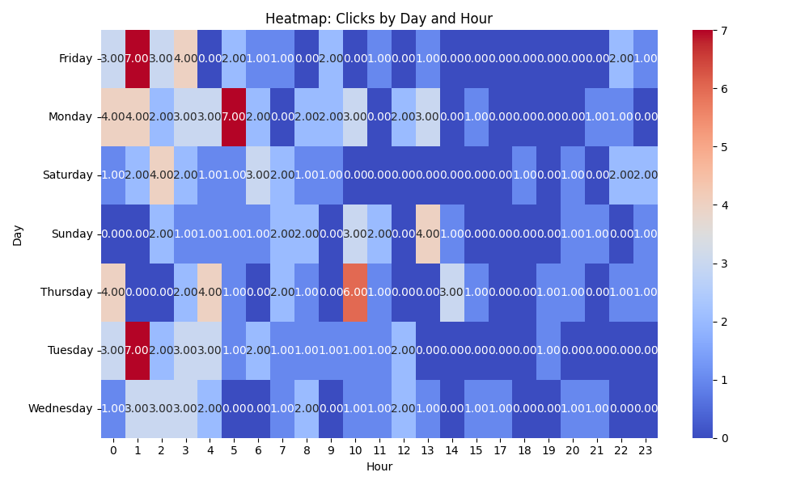

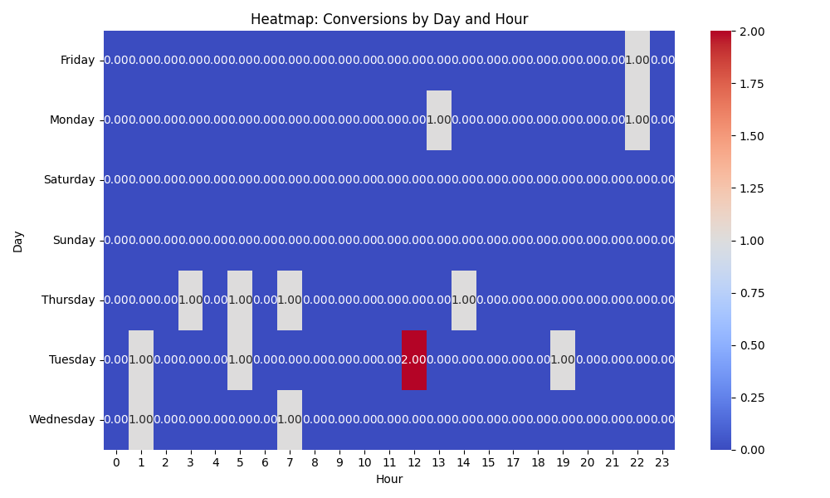

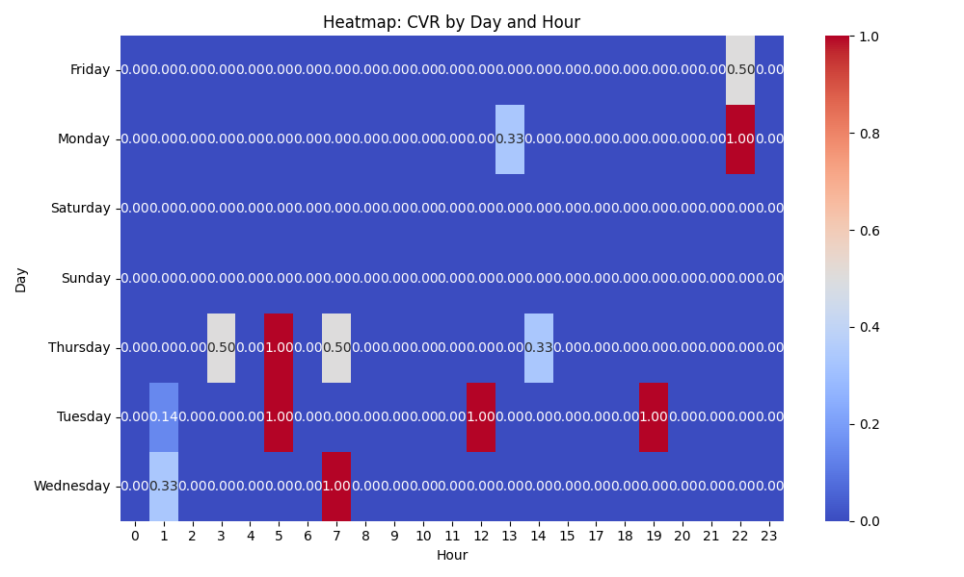

# Competitor Intelligence

# Top Competitor Insights

|  |  |  |
| --- | --- | --- |
| Competitor | Strengths | Recommendations |
|  | ❌ Parse Error: 'list' object has no attribute 'strip' | N/A |
| mediafast.com | ❌ Parse Error: 'list' object has no attribute 'strip' | N/A |
| mediafast.com › video-mailer | The competitor explicitly includes 'Video Mailer' in their ad headline, suggesting they have optimized their ad targeting and messaging for this specific product or search query. This directness can lead to high relevance and click-through rates for users specifically looking for video mailers. The immediate mention of 'Custom' and 'High-Impact' clearly communicates key benefits upfront. The competitor's ad creative is concise and highlights 'Custom, High-Impact' as core attributes. This brevity is effective in an ad format, quickly conveying key value propositions that resonate with a B2B audience seeking unique and effective marketing tools. By focusing on 'Video Mailer' and 'Video Brochure,' the competitor maintains a tight focus in their ad, which can improve ad quality scores for those specific keywords. The ad's simplicity makes it easy to digest quickly. | While our landing page covers 'Video Mailers' as a product, it's not immediately featured in our primary hero copy. If 'Video Mailer' is a high-volume search term or a strategic product for us, we should consider creating dedicated ad groups and ad creatives that specifically mention 'Video Mailer' in headlines and descriptions. This would mirror the competitor's precision and ensure we capture specific user intent more effectively. We could also consider making 'Video Mailers' more prominent on the landing page if direct traffic to this page is expected for that term. Our landing page also prominently features 'customized, high-impact' messaging. This is a strength and an alignment with what the market is seeking. We should continue to emphasize these terms in our ad copy across all relevant ad groups. Experiment with ad headlines that combine these attributes with a strong call to value, such as 'Custom, High-Impact Video Brochures: Get Quote.' Our landing page showcases a broader range of 'Video-In-Print' products (Video Brochures, Mailers, Books, Packaging, Business Cards, etc.), which is a competitive advantage in terms of offering variety and catering to diverse needs. Our ad strategy should leverage this breadth. Instead of a single broad ad, we should develop distinct ad groups and ad creatives tailored to each major product type (e.g., 'Video Business Cards,' 'Video Packaging') to capture highly specific search intent. The current landing page effectively supports this multi-product approach, allowing for specific ads to lead to a comprehensive page. Our landing page offers a much deeper and more compelling value proposition, highlighting 'The Ultimate Sales and Marketing Tool,' 'Premium,' 'Trusted by Global Brands,' 'Low Minimum Order,' 'Proven Engagement Booster,' and extensive customer testimonials. This comprehensive value is a significant differentiator. Our ad creatives should aim to hint at this richer value proposition where character limits allow, perhaps through the use of ad extensions like sitelinks (e.g., 'See Global Brands'), callouts ('Low Minimums'), or structured snippets ('Product Types: Brochures, Mailers, Packaging'). The strong testimonials should also be considered for review extensions or integrated into ad copy when possible to build immediate trust. |

# Top 3 Risks & Opportunities

No Risks identified.

No Opportunities identified.