Google Ads Audit Report

# Campaign Performance (w/ Benchmark Overlay)

|  |  |  |  |  |  |  |  |  |  |
| --- | --- | --- | --- | --- | --- | --- | --- | --- | --- |
| Campaign Name | CTR | Cost ($) | Clicks | Impressions | CTR Flag | Avg CPC | Avg CPC Flag | CPA ($) | CPA ($) Flag |
| VPP_Search_Leads_USA_03/08/2024 (Exp 1) | 8.79% | $2180.15 | 197 | 2242 | Above | $11.07 | Above | $155.72 | Above |

# Campaign Insights

⚠️ Unable to parse structured insights — showing raw output below.

[{'Characteristic': 'Cost Per Acquisition (CPA) Performance', 'Insight': 'The campaign has generated 14 conversions at an average CPA of $155.72, with a total cost of $2180.15 using a Target CPA bid strategy.', 'Recommendation': "Review the $155.72 CPA against your business's desired profitability targets. If this CPA is too high, consider gradually lowering the Target CPA bid by 10-15% increments and monitor conversion volume closely to ensure efficiency without drastically impacting lead flow."}, {'Characteristic': 'Click-Through Rate (CTR)', 'Insight': "The campaign's CTR is 8.79% (197 Clicks from 2242 Impressions).", 'Recommendation': 'While 8.79% is a good starting point for Search campaigns, evaluate ad copy relevancy by reviewing the Search Terms report for new negative keywords. Test different ad headlines and descriptions, and ensure all relevant ad extensions (e.g., Sitelinks, Callouts, Structured Snippets) are active and compelling to further boost CTR.'}, {'Characteristic': 'Budget Utilization and Spend History', 'Insight': 'The campaign has accumulated a total cost of $2180.15 against a daily budget of $35.00, indicating it has been running for approximately 62 days since its start date of 2024-08-10.', 'Recommendation': 'Given the consistent spend over an extended period, analyze the conversion trend over time. If the CPA of $155.72 remains stable and profitable, consider increasing the daily budget to capture more conversion volume, especially since Target CPA optimizes for conversions within budget constraints.'}, {'Characteristic': 'Target CPA Bid Strategy Optimization', 'Insight': 'The campaign utilizes a Target CPA bid strategy and has achieved 14 conversions, with an average CPA of $155.72.', 'Recommendation': "Verify that conversion tracking is accurately capturing all valuable actions and is robust. For optimal performance, ensure the campaign is consistently generating at least 15-30 conversions per month to provide sufficient data for the Target CPA algorithm to learn and optimize effectively. If conversion volume remains low, consider temporarily switching to 'Maximize Conversions' to build data."}]

# Keyword Performance

|  |  |  |  |  |  |  |  |  |
| --- | --- | --- | --- | --- | --- | --- | --- | --- |
| Ad Group | Keyword | Match Type | Quality Score | Impressions | Clicks | CTR | Avg CPC | CPA ($) |
| Video Mailers | video mailers | PHRASE | 3 | 294 | 28 | 9.52% | $13.52 | $126.23 |
| VPP Brochures | video brochures | PHRASE | 5 | 347 | 23 | 6.63% | $13.36 | $0.00 |
| Video Books | promotional video book | PHRASE | 6 | 76 | 12 | 15.79% | $13.36 | $160.34 |
| Video Box | video box | PHRASE | 3 | 411 | 24 | 5.84% | $5.17 | $0.00 |
| Video Box | box with video screen | PHRASE | 4 | 35 | 10 | 28.57% | $11.08 | $110.85 |
| Video Box | video box marketing | PHRASE | 6 | 70 | 7 | 10.00% | $12.54 | $0.00 |
| Video Mailers | video mailers marketing | PHRASE | 7 | 61 | 6 | 9.84% | $13.32 | $0.00 |
| Video Mailers | video brochure mailer | PHRASE | 4 | 34 | 3 | 8.82% | $26.37 | $31.64 |
| Video Books | video book marketing | PHRASE | 6 | 98 | 11 | 11.22% | $6.34 | $34.87 |
| Video Mailers | custom video mailers | PHRASE | 5 | 48 | 6 | 12.50% | $10.98 | $65.85 |
| Video Books | personalized video books | PHRASE | 5 | 80 | 11 | 13.75% | $5.58 | $61.41 |
| Video Box | custom video box | PHRASE | 5 | 37 | 3 | 8.11% | $18.40 | $0.00 |
| VPP Brochures | video brochure card | PHRASE | 4 | 100 | 5 | 5.00% | $9.54 | $0.00 |
| Video Books | custom video books | PHRASE | 5 | 105 | 9 | 8.57% | $4.59 | $0.00 |
| Video Mailers | video card mailer | PHRASE | 3 | 17 | 3 | 17.65% | $12.41 | $37.24 |
| VPP Brochures | video brochure usa | PHRASE | 4 | 18 | 1 | 5.56% | $36.15 | $36.15 |
| VPP Brochures | custom video brochures | PHRASE | 7 | 58 | 3 | 5.17% | $9.88 | $59.27 |
| VPP Brochures | lcd screen video brochure | PHRASE | 4 | 20 | 2 | 10.00% | $13.20 | $0.00 |
| VPP Brochures | video brochure manufacturer | PHRASE | 3 | 3 | 2 | 66.67% | $11.74 | $0.00 |
| Video Box | video gift box | PHRASE | 5 | 47 | 5 | 10.64% | $2.97 | $0.00 |
| VPP Brochures | lcd video brochure | PHRASE | 3 | 5 | 1 | 20.00% | $13.72 | $0.00 |
| VPP Brochures | video brochure marketing | PHRASE | 5 | 2 | 1 | 50.00% | $12.49 | $0.00 |
| VPP Brochures | video brochure pricing | PHRASE | 0 | 10 | 1 | 10.00% | $11.03 | $0.00 |
| VPP Brochures | video brochure book | PHRASE | 5 | 2 | 1 | 50.00% | $9.41 | $0.00 |
| VPP Brochures | 4.3 inch video brochure | PHRASE | 0 | 3 | 1 | 33.33% | $7.84 | $0.00 |
| VPP Brochures | brochure with video screen | PHRASE | 6 | 6 | 1 | 16.67% | $7.42 | $0.00 |
| Video Mailers | lcd video mailers | EXACT | 0 | 4 | 1 | 25.00% | $5.87 | $0.00 |
| Video Box | promotional video box | PHRASE | 3 | 5 | 1 | 20.00% | $3.77 | $0.00 |
| VPP Brochures | video screen brochure | PHRASE | 5 | 14 | 1 | 7.14% | $1.44 | $0.00 |
| VPP Brochures | digital video brochures | PHRASE | 4 | 4 | 0 | 0.00% | $0.00 | $0.00 |
| VPP Brochures | media fast video brochure | PHRASE | 3 | 7 | 0 | 0.00% | $0.00 | $0.00 |
| VPP Brochures | video brochure maker | PHRASE | 4 | 2 | 0 | 0.00% | $0.00 | $0.00 |
| Video Books | lcd video book | PHRASE | 5 | 4 | 0 | 0.00% | $0.00 | $0.00 |
| Video Box | video brochure box | PHRASE | 2 | 7 | 0 | 0.00% | $0.00 | $0.00 |
| Video Mailers | video mailer box | PHRASE | 5 | 4 | 0 | 0.00% | $0.00 | $0.00 |
| Video Mailers | mediafast video mailer | PHRASE | 2 | 21 | 0 | 0.00% | $0.00 | $0.00 |
| Video Box | lcd video box | PHRASE | 5 | 4 | 0 | 0.00% | $0.00 | $0.00 |
| Video Box | video presentation box | PHRASE | 2 | 2 | 0 | 0.00% | $0.00 | $0.00 |
| Video Box | video screen box | PHRASE | 3 | 1 | 0 | 0.00% | $0.00 | $0.00 |
| Video Box | gift box with video screen | PHRASE | 1 | 1 | 0 | 0.00% | $0.00 | $0.00 |

# Keyword Insights

# Keyword Insights

|  |  |  |
| --- | --- | --- |
| Characteristic | Insight | Recommendation |
| Significant Spend on Non-Converting Keywords | The keywords 'video brochures' and 'video box' incurred the highest non-converting costs at $307.17 and $124.02 respectively (0 conversions each). Additional keywords like 'video box marketing' ($87.81) and 'video mailers marketing' ($79.94) also spent significant budget without any conversions. | Immediately pause or drastically reduce bids for 'video brochures', 'video box', 'video box marketing', and 'video mailers marketing'. Conduct a thorough search term report analysis for these keywords to identify and add irrelevant queries as negative keywords, ensuring budget is not wasted on misaligned searches. |
| High-Performing Keywords with Excellent Conversion Metrics | The keyword 'video brochure mailer' shows exceptional performance with a Conversion Rate (CVR) of 83.33% and Cost Per Acquisition (CPA) of $31.64 (2.5 conversions). 'video book marketing' and 'video card mailer' also demonstrate strong results with CPAs of $34.87 (CVR 18.18%, 2 conversions) and $37.24 (CVR 33.33%, 1 conversion) respectively. 'video brochure usa' delivered a 100% CVR at $36.15 CPA (1 conversion). | Increase bids and potentially daily budget allocations for 'video brochure mailer', 'video book marketing', 'video card mailer', and 'video brochure usa' to maximize impression share and capture more converting traffic. Consider creating dedicated ad groups with these keywords as exact match to improve Quality Score and bid control. |
| Low Quality Scores Impacting Performance on High-Spend Keywords | Keywords like 'video mailers' (QS 3, Cost $378.68, CPA $126.23) and 'video box' (QS 3, Cost $124.02, 0 conversions) exhibit low Quality Scores, potentially leading to higher CPCs and lower ad positions, especially given their high spend. Keywords with a Quality Score of 0, such as 'video brochure pricing' ($11.03 cost), '4.3 inch video brochure' ($7.84 cost), and 'lcd video mailers' ($5.87 cost), are also present with no conversions. | For 'video mailers', perform A/B tests on ad copy headlines and descriptions to more closely align with the keyword, and ensure the landing page directly addresses 'video mailers' to improve QS and reduce CPA. For 'video box' and 'video brochure card' (QS 4) that have no conversions, prioritize improving relevance or pausing. Immediately pause keywords with QS 0, as they are highly inefficient and waste budget; if critical, rebuild these ad groups with hyper-relevant ads and dedicated landing pages. |
| High Click-Through Rate with Poor or Inconsistent Conversion Performance | The keyword 'box with video screen' has a very strong CTR of 28.57% (1 conversion, CPA $110.85), indicating excellent ad relevance. However, 'video brochure manufacturer' (CTR 66.67%) and 'video box' (CTR 5.84% across 411 impressions) have zero conversions despite their respectable CTRs. | For 'box with video screen', evaluate if the CPA of $110.85 aligns with your conversion value; if profitable, consider increasing bids to gain more impression share. For 'video brochure manufacturer' and 'video box', despite good ad performance, the lack of conversions suggests a landing page or offer disconnect. Audit the landing page experience for these keywords to ensure it provides a clear value proposition, addresses user intent directly, and offers a strong call to action. Alternatively, assess if the keyword intent ('manufacturer' may be too early in the funnel) is suitable for a direct conversion. |

# Wasted Spend Insights

# Wasted Spend Insights

|  |  |  |
| --- | --- | --- |
| Characteristic | Insight | Recommendation |
| Highest Cost, High Avg CPC, Low CTR, Below Average Quality Score, Zero Conversions | The keyword 'video brochures' spent a significant $307.17 with zero conversions, an Avg CPC of $13.35, and a low Quality Score of 5. The CTR of 0.066 indicates low ad relevance or engagement, suggesting a misalignment between the keyword, ad copy, and landing page for 'video brochures'. | Immediately review the search terms for 'video brochures' to identify irrelevant queries and add them as negative keywords. Test new ad copy that directly addresses the intent of users searching for 'video brochures', highlighting unique selling propositions. Improve the landing page experience and ensure it is highly relevant and encourages conversion actions for 'video brochures' searches. |
| High Cost, Very Low Quality Score, Low CTR, Zero Conversions | The keyword 'video box' incurred $124.02 in cost with no conversions, a very low Quality Score of 3, and a poor CTR of 0.058. This indicates significant issues with ad relevance and potentially landing page experience for 'video box'. | Pause 'video box' if it's a broad match to prevent wasteful spend. If this keyword is strategic, create a highly specific ad group for 'video box' with tailored ad copy and landing page content that exactly matches user intent. Focus on improving the landing page experience and ad relevance to boost Quality Score for 'video box', or consider removing it if it's too generic for your product/service. |
| High Cost, High Avg CPC, No Conversions, Decent CTR/QS | The keyword 'video box marketing' spent $87.81 at a high Avg CPC of $12.54 without generating any conversions. While its Quality Score of 6 and CTR of 0.100 are reasonable, the lack of conversion suggests a disconnect in the conversion funnel for 'video box marketing'. | Analyze the search intent for 'video box marketing' (it might be an informational query). Adjust bid strategy for 'video box marketing' to focus on conversion (e.g., Target CPA) rather than clicks. Re-evaluate the landing page for 'video box marketing' to ensure it clearly offers a solution for marketing professionals or businesses looking to use video boxes for marketing, with clear calls-to-action. |
| High Cost, High Avg CPC, Good Quality Score, No Conversions | The keyword 'video mailers marketing' spent $79.94 at a high Avg CPC of $13.32 with zero conversions, despite a good Quality Score of 7 and decent CTR of 0.098. This indicates that traffic is relevant but not converting, likely due to landing page issues or misaligned offer for 'video mailers marketing'. | Review the landing page experience for 'video mailers marketing' to ensure it directly addresses the needs of someone interested in marketing with video mailers. Optimize the Call-to-Action (CTA) and consider A/B testing different offers or value propositions specific to 'video mailers marketing'. Confirm conversion tracking is correctly implemented. |
| Extremely High Avg CPC, No Conversions, Mid Quality Score | The keyword 'custom video box' has an alarming Avg CPC of $18.39, resulting in $55.18 spent with no conversions. Its Quality Score of 5 suggests there's room for improvement in ad relevance or landing page experience for 'custom video box'. | Reduce bids significantly for 'custom video box' to control spend. Re-evaluate the competition for 'custom video box' and ensure your ad copy clearly differentiates your custom offerings. Optimize the landing page to showcase customization options and benefits prominently, and ensure clear CTAs for 'custom video box'. |
| Low CTR, Low Quality Score, No Conversions | The keyword 'video brochure card' spent $47.71 without conversions, suffering from a very low CTR of 0.050 and a low Quality Score of 4. This indicates poor ad relevance or competitiveness for 'video brochure card'. | Test new, compelling ad copy for 'video brochure card' that directly addresses the 'card' aspect, perhaps highlighting size, portability, or specific use cases. Review competitive ads for 'video brochure card' and adjust bidding strategy if necessary. Improve the landing page to explicitly feature 'video brochure cards'. |
| Moderate Cost, No Conversions, Mid Quality Score | The keyword 'custom video books' spent $41.35 with zero conversions and a Quality Score of 5. While its Avg CPC of $4.59 is reasonable, the lack of conversions suggests a misalignment in the user journey for 'custom video books'. | Review the search intent for 'custom video books'; it might be too broad or have varied interpretations. Ensure the landing page clearly showcases 'custom video books' with relevant examples and a strong Call to Action. Consider A/B testing different headline messages for 'custom video books' in ads. |
| Moderate Cost, Low Quality Score, No Conversions | The keyword 'lcd screen video brochure' spent $26.39 at a high Avg CPC of $13.19 with a low Quality Score of 4 and no conversions. The low QS indicates issues with ad relevance or landing page experience for 'lcd screen video brochure'. | Improve the ad copy for 'lcd screen video brochure' to emphasize the 'LCD screen' aspect and its benefits. Ensure the landing page specifically highlights products with LCD screens. Add more negative keywords to prevent irrelevant searches for 'lcd screen video brochure'. |
| Very High CTR, Very Low Quality Score, No Conversions, High Avg CPC | The keyword 'video brochure manufacturer' shows an exceptionally high CTR of 0.666 but a very low Quality Score of 3 and zero conversions, despite spending $23.48. This suggests ads are highly relevant to the query, but either the landing page is poor, or the search intent is purely informational/research and not conversion-oriented for 'video brochure manufacturer'. | Re-evaluate the intent for 'video brochure manufacturer'. This keyword might be attracting users looking to *become* manufacturers or research manufacturing processes. If the goal is to sell, ensure the landing page directly addresses buyers looking for a manufacturer to *produce* video brochures for them, not to learn how to manufacture. Improve the landing page experience significantly and add a strong, clear CTA for 'video brochure manufacturer'. Consider adding 'wholesale' or 'supplier' modifiers if relevant. |
| Low Cost, No Conversions, Mid Quality Score | The keyword 'video gift box' spent $14.85 with no conversions, though its Avg CPC of $2.97 is low and CTR is decent at 0.106. The Quality Score of 5 suggests a moderate relevance challenge for 'video gift box'. | Ensure the landing page for 'video gift box' clearly showcases products designed as gifts, perhaps with gift-specific messaging. Test ad copy that highlights emotional benefits or common gift occasions for 'video gift box'. |
| High Avg CPC, Very Low Quality Score, No Conversions | The keyword 'lcd video brochure' spent $13.72 with a high Avg CPC of $13.72 and a very low Quality Score of 3, yielding zero conversions. This points to fundamental issues with ad relevance and/or landing page experience for 'lcd video brochure'. | Drastically improve the landing page experience for 'lcd video brochure' by ensuring relevant content and clear product display. Revise ad copy to perfectly align with the term 'lcd video brochure'. Consider creating a dedicated ad group for 'lcd video brochure' if it's currently lumped into a broader one. |
| High CTR, High Avg CPC, No Conversions | The keyword 'video brochure marketing' shows a high CTR of 0.500 but no conversions, despite a spend of $12.49 and an Avg CPC of $12.49. The Quality Score of 5 suggests a decent ad relevance but the conversion funnel is broken for 'video brochure marketing'. | The high CTR suggests good ad copy, but the issue is conversion. Re-evaluate the landing page content and offer for 'video brochure marketing'. It might be attracting users looking for marketing advice rather than to purchase the product. Adjust the landing page to clearly present a solution for those looking to *use* video brochures for their marketing efforts, with strong CTAs to buy or get a quote. |
| Critical Quality Score, No Conversions, High Avg CPC | The keyword 'video brochure pricing' spent $11.03 with a critical Quality Score of 0 and no conversions. This indicates a complete misalignment with ad relevance, landing page experience, or potentially an invalid keyword due to the QS 0 for 'video brochure pricing'. | Immediately pause 'video brochure pricing' given the QS 0. Investigate why the Quality Score is 0 (often means system issues, very low expected CTR, or severely irrelevant landing page). If re-enabling, ensure the landing page directly features pricing details or a clear way to get a quote for 'video brochure pricing', and that ad copy is highly relevant. |
| Critical Quality Score, No Conversions, Good CTR | The keyword '4.3 inch video brochure' spent $7.84 with a critical Quality Score of 0 and no conversions, despite a good CTR of 0.333. A QS of 0 is highly problematic for '4.3 inch video brochure'. | Immediately pause '4.3 inch video brochure' due to the QS 0. If you wish to target this specific dimension, create a dedicated ad group for '4.3 inch video brochure', ensure your ads prominently mention this size, and the landing page specifically features a 4.3 inch video brochure with clear purchase options. Address the root cause of the QS 0 (e.g., ad relevance, landing page experience, keyword issues). |
| Low Cost, No Conversions, Good Quality Score | The keyword 'brochure with video screen' spent $7.41 with no conversions, though its Quality Score of 6 and CTR of 0.166 are decent. The issue likely lies further down the funnel for 'brochure with video screen'. | Ensure the landing page for 'brochure with video screen' clearly showcases relevant products with strong visuals and features. A/B test the Call-to-Action and form placement to optimize conversions. Implement aggressive negative keywords to prevent irrelevant searches for 'brochure with video screen'. |
| Critical Quality Score, No Conversions | The keyword 'lcd video mailers' spent $5.87 with a critical Quality Score of 0 and no conversions. This indicates severe problems with ad relevance, landing page experience, or keyword validity for 'lcd video mailers'. | Immediately pause 'lcd video mailers' due to the QS 0. When re-evaluating, create highly specific ad copy and landing page content that directly addresses 'lcd video mailers' products. Verify conversion tracking is active and correct for 'lcd video mailers'. |
| Low Cost, Very Low Quality Score, No Conversions | The keyword 'promotional video box' spent $3.77 with a very low Quality Score of 3 and zero conversions. This indicates poor relevance between the ad/landing page and the search intent for 'promotional video box'. | Improve the Quality Score for 'promotional video box' by creating hyper-relevant ad copy that highlights promotional uses and benefits. Ensure the landing page explicitly features 'promotional video box' solutions. Given the low spend, observe trends after making improvements before taking drastic action. |
| Very Low Spend, Low CTR, No Conversions | The keyword 'video screen brochure' spent only $1.44 with zero conversions and a low CTR of 0.071. While spend is minimal, the low CTR suggests poor ad relevance for 'video screen brochure'. | Given the minimal spend for 'video screen brochure', prioritize keywords with higher spend. If this keyword is deemed important, revise ad copy to improve relevance and potentially group it with similar terms in a more specific ad group. Monitor for increased spend and performance issues after changes. |

# Landing Page Audit Insights

## Landing Page: https://videoplusprint.com/video-in-print-products

# Landing Page Insights

|  |  |  |  |
| --- | --- | --- | --- |
| URL | Characteristic | Insight | Recommendation |
| https://videoplusprint.com/video-in-print-products | Conversion Funnel Friction | The 'Get a Free Quote' form is comprehensive, requiring detailed inputs such as product type, quantity, and screen size upfront. While excellent for qualifying leads, this extensive information request can create significant friction for prospects who are in an early research phase or simply want a quick ballpark estimate, potentially leading to abandonment, even with the decent conversion rate. | Implement a two-step form or progressive profiling. Start with essential contact information and a single 'What product are you interested in?' field. For users unsure of specific details (quantity, screen size), provide a 'Not sure yet' or 'Consultation needed' option, allowing the sales team to follow up for specific requirements rather than blocking the initial conversion. |
| https://videoplusprint.com/video-in-print-products | Cost Per Acquisition (CPA) & Conversion Rate (CR) Discrepancy | The conversion rate of approximately 7.1% (14 conversions / 197 clicks) is respectable for a B2B quote request. However, the high CPA of $155.72 suggests either extremely high Cost Per Click (CPC) from paid ads (given the $0.00 stated cost, this implies an underlying cost not provided, or a tracking error) or that a significant portion of these conversions may not be fully sales-qualified, making them expensive to acquire relative to their true value. | Focus on improving lead quality to justify the high CPA. Review Google Ads keyword targeting for higher commercial intent, and ensure ad copy filters for more serious buyers. Implement lead scoring based on form responses (e.g., higher quantity inquiries score higher) to prioritize sales follow-ups and improve ROI on the expensive leads. |
| https://videoplusprint.com/video-in-print-products | Call to Action (CTA) Clarity & Placement | The 'GET A FREE QUOTE' CTA is prominently displayed, clear, and action-oriented, appearing multiple times above and around the fold. This ensures users know the primary desired action upon landing. | While the CTA is strong, consider adding a secondary, softer conversion path below the fold for users not ready to request a full quote. This could be 'Download a Video Brochure Idea Guide,' 'View Case Studies,' or 'See Product Gallery' to capture leads earlier in their journey, providing value before requiring a full commitment. |
| https://videoplusprint.com/video-in-print-products | Trust Signals & Social Proof | The inclusion of testimonials from recognizable brands like Volvo, Volkswagen, and Commonwealth Bank is a powerful trust signal. This builds immediate credibility and validates the product's quality and impact. However, the duplicate Volvo testimonial reduces professionalism slightly. | Leverage these strong testimonials even more. Consider adding logos of these 'Trusted by Global Brands' directly in the hero section to immediately establish authority. Create a dedicated 'Clients' or 'Case Studies' section if not already present, possibly with images or short video clips from these satisfied customers. Correct the repeated Volvo testimonial. |
| https://videoplusprint.com/video-in-print-products | Value Proposition & Messaging | The headline 'Turn Your Brand into an Experience' and the supporting benefits ('Captivate your audience', 'designed to wow, inform, and convert') clearly articulate the value proposition. The 'Low Minimum Order' is a compelling differentiator for smaller businesses or new initiatives. | Visually emphasize 'Low Minimum Order' more, perhaps with an icon or distinct styling, as it directly addresses a common barrier for custom print products. Ensure the messaging consistently highlights the 'experience' and 'engagement' aspects throughout the page content (beyond the provided chunk) with relevant examples or use cases. |
| https://videoplusprint.com/video-in-print-products | Competitor Benchmark | Many competitors in the custom B2B print and packaging space offer tiered pricing, instant quote tools for standard configurations, or detailed product catalogs with pricing ranges. The current page exclusively funnels all inquiries into a detailed 'Get a Free Quote' form. | Research competitors' sales funnels. Consider implementing a simplified 'Instant Estimate' tool for basic video brochure configurations, or provide a 'Starting At' price range for specific product types. This can satisfy prospects seeking quick budgetary information and reduce reliance on manual quote requests for all inquiries, potentially lowering initial lead acquisition costs. |
| https://videoplusprint.com/video-in-print-products | CPA Justification & Value Proposition | A Cost Per Acquisition (CPA) of $155.72 for a quote request is high, suggesting a premium service. While the page mentions benefits like '23% sales lift,' it lacks comprehensive data, in-depth case studies, or a clear articulation of the *specific ROI* that justifies this significant investment per lead. The phrase 'suitable for all budgets' contradicts the implied premium nature and high CPA. | Strengthen the ROI narrative. Provide more detailed, quantifiable case studies with specific results (e.g., lead generation, conversion rate increases, brand recall). Clearly define the ideal client profile (e.g., specific industries, company sizes, campaign types) to pre-qualify leads and ensure they are prepared for the investment, aligning the messaging with a premium offering. |
| https://videoplusprint.com/video-in-print-products | Trust Signals & Credibility | The page leverages strong client logos (UPS, Exxon Mobil) which are excellent trust signals. However, the 'Most Valuable Company 2016 in Hong Kong' award, while positive, is nearly eight years old and may inadvertently signal a lack of recent accolades. The '40 years of expertise' claim is strong but isn't visually emphasized or detailed enough to stand out immediately. | Prioritize and visually elevate the most impactful trust signals. Consider removing or updating outdated awards with more current achievements or industry recognition. Make the '40+ years of expertise' a prominent, standalone trust element (e.g., in the hero section or a dedicated 'Our Experience' module) with a brief explanation of what that experience entails. |
| https://videoplusprint.com/video-in-print-products | Call to Action (CTA) Effectiveness & Placement | The CTA 'GET A FREE QUOTE' is clear and appears multiple times, which is generally good for conversion. However, without the full page context, it's impossible to confirm optimal placement (e.g., above the fold, sticky on scroll) and if the quote form itself introduces unnecessary friction. The implied premium nature of the products might also benefit from a CTA that emphasizes consultation or custom solutions rather than just a 'quote'. | Ensure the primary CTA is prominently displayed above the fold and repeated strategically as the user scrolls, possibly as a sticky element. Test alternative CTA phrasings like 'Request a Custom Proposal,' 'Schedule a Free Consultation,' or 'Get Your Personalized Solution' to better align with the high-value nature of the offering and potentially attract more qualified leads. |
| https://videoplusprint.com/video-in-print-products | User Experience (UX) - Visual Engagement & Content Structure | Based on the text content provided, the page appears quite text-heavy. For 'video in print' products, visual demonstrations (product videos, unboxing experiences, high-quality images of the screens in action) are crucial to convey the 'wow' factor and perceived quality. The information, while structured with headings, could benefit from more visual breaks. | Integrate high-quality, professional visuals throughout the page. Include short, impactful product demonstration videos, clear product photography, and possibly even an interactive element that showcases the video playback within the brochures/packaging. Use more whitespace, clear iconography, and bulleted lists to improve scannability and reduce cognitive load. |
| https://videoplusprint.com/video-in-print-products | Ad-to-Landing Page Congruence & Keyword Intent | While the page clearly defines various 'video in print' products, if the Google Ads campaigns are driving traffic from highly specific keywords (e.g., 'custom video brochures'), the landing page's initial focus should immediately confirm that specific intent. The current content dives into a list of products, which is good, but the initial headline/hero section (not provided) is critical for immediate alignment. | Analyze the top-performing keywords driving traffic to this page. Ensure the hero section of the landing page dynamically adapts or explicitly addresses the most common search intents. For specific searches (e.g., 'video brochures'), the page should immediately showcase video brochures before detailing other product types to minimize bounce rates and maximize relevance. |
| https://videoplusprint.com/video-in-print-products | Competitor Benchmark | A CPA of $155.72 for a quote is high, indicating a premium market or aggressive bidding. Competitors in the video marketing product space likely present their value propositions, pricing, and lead capture methods differently. Understanding what makes their pages convert (or not) at similar price points is crucial. | Conduct a thorough competitive analysis of other 'video in print' or 'video marketing products' providers. Evaluate their landing page structures, unique selling propositions, trust signals, CTA effectiveness, and pricing transparency (if any). Identify best practices and gaps in their offerings that Video Plus Print can leverage to better justify its premium positioning and optimize its conversion funnel. |
| https://videoplusprint.com/video-in-print-products | Conversion Tracking & Data Accuracy | The reported 'Cost: 0.00' makes the 'CPA: 155.72' completely unreliable. This indicates a critical issue with Google Ads conversion tracking or data import, preventing any meaningful analysis of ad spend ROI, effective bidding, or campaign optimization. | Immediately audit and fix Google Ads conversion tracking to ensure accurate cost data, conversion values (if applicable), and proper attribution. This is the foundational step for any effective paid advertising strategy. Verify that the conversion action (e.g., 'QUOTE' form submission) is firing correctly and being recorded with associated costs. |
| https://videoplusprint.com/video-in-print-products | Call to Action (CTA) Prominence & Clarity | The CTA 'Get A FREE Video Brochure QUOTE' is clear and relevant to the offer. However, based on the snippet, it appears only at the very bottom of the content. This placement means users might need to scroll extensively or could abandon the page before encountering the primary conversion opportunity. | Implement multiple, strategically placed CTAs throughout the page. Include an prominent CTA above the fold, within key benefit sections (e.g., after 'Versatile Applications'), and at the end of the content. Use contrasting colors for CTAs to ensure high visibility. Consider a sticky CTA button for mobile users to maintain accessibility as they scroll. |
| https://videoplusprint.com/video-in-print-products | Value Proposition & Unique Selling Points (USPs) | The page states 'affordability and effectiveness' and 'unique ability to engage audiences,' which are positive but relatively generic claims. The snippet doesn't strongly articulate what specifically makes 'Video Plus Print' superior or different from competitors in terms of product quality, customization, service, or turnaround time. | Deepen the value proposition by highlighting concrete differentiators. For a 'video in print' product, this could include details on screen quality, battery life, memory capacity, unique design capabilities, eco-friendly options, or rapid prototyping services. Provide specific examples or statistics to back up claims of effectiveness or affordability. |
| https://videoplusprint.com/video-in-print-products | Trust & Credibility Signals | The presence of a copyright notice (2009-2024) provides a basic level of company establishment. However, the provided content snippet lacks more impactful trust signals crucial for a high-value lead generation, such as client testimonials, prominent client logos, case studies, security badges, or clear 'About Us' information on the landing page. | Integrate compelling social proof elements. Add authentic customer testimonials (preferably with names, companies, or photos), display logos of reputable clients, and consider showcasing short success stories or mini-case studies that demonstrate the ROI for specific industries or use cases. Ensure any data capture forms have clear security indicators (e.g., SSL certificate badge). |
| https://videoplusprint.com/video-in-print-products | Competitor Benchmark | Leading competitors in the video-in-print market often leverage rich media (e.g., product videos, 3D renders) extensively to showcase the product's premium feel and functionality. They also frequently provide more transparent information on customization options, production timelines, and sometimes even guide-level pricing or clear quoting processes to set expectations. | Conduct a detailed analysis of top-performing competitor landing pages. Identify how they visualize their products, structure their information architecture, manage pricing expectations, and convey their unique selling propositions. Consider embedding a short, high-quality video demonstrating the 'video in print' products in action directly on the landing page to enhance engagement and provide immediate value. |
| https://videoplusprint.com/video-in-print-products | User Experience (UX) - Content Engagement | The content is structured with headings, which aids readability. However, for a visually driven product like 'video in print,' relying heavily on text, as implied by the snippet, might not be the most engaging approach. Users may struggle to visualize the product's impact or differentiators without sufficient visual aids integrated directly into the content flow. | Enhance the visual storytelling. Break up text sections with high-quality images of the video brochures, video boxes, and video business cards in various contexts. Use infographics or icons to quickly convey benefits or features. Consider embedding short video clips showcasing the product's functionality and the 'wow' factor of video in print, as this aligns directly with the product's core offering. |

# Geographical Performance

|  |  |  |  |  |  |  |  |  |  |
| --- | --- | --- | --- | --- | --- | --- | --- | --- | --- |
| City | Region | Country | Type | Impressions | Clicks | Conversions | Cost ($) | CVR | CPA ($) |
| United States |  |  | Country | 2116 | 185 | 14.0 | $2109.34 | 0.07567567567567568 | $150.67 |

# Geographical Insights

# Geographical Insights

|  |  |  |
| --- | --- | --- |
| Characteristic/ Location | Insight | Recommendation |
| United States (Country) | The overall campaign performance for the United States shows a total cost of $2109.34, resulting in 14 conversions. This leads to an average Cost Per Acquisition (CPA) of $150.67 and a Conversion Rate (CVR) of 7.57% across the entire country. | To uncover potential high-impact areas, implement more granular geographic targeting. Start by breaking down performance at the State or major Metropolitan Statistical Area (MSA) level within the United States. This will provide specific CPA and CVR data for smaller segments, enabling future tactical optimizations such as increasing bids by 15-20% in areas with a CPA significantly lower than $150.67 or creating exclusions for regions exhibiting disproportionately high CPAs and low CVRs. |

# Hourly Performance Pivot

CVR

|  |  |  |  |  |  |  |  |  |  |
| --- | --- | --- | --- | --- | --- | --- | --- | --- | --- |
| Day/Hour | 1 | 3 | 5 | 7 | 12 | 13 | 14 | 19 | 22 |
| Monday |  |  |  |  |  | 0.33 |  |  | 1.00 |
| Tuesday | 0.14 |  | 1.00 |  | 1.00 |  |  | 1.00 |  |
| Wednesday | 0.33 |  |  | 1.00 |  |  |  |  |  |
| Thursday |  | 0.50 | 1.00 | 0.50 |  |  | 0.33 |  |  |
| Friday |  |  |  |  |  |  |  |  | 0.50 |

Clicks

|  |  |  |  |  |  |  |  |  |  |  |  |  |  |  |  |  |  |  |  |  |  |  |  |
| --- | --- | --- | --- | --- | --- | --- | --- | --- | --- | --- | --- | --- | --- | --- | --- | --- | --- | --- | --- | --- | --- | --- | --- |
| Day/Hour | 0 | 1 | 2 | 3 | 4 | 5 | 6 | 7 | 8 | 9 | 10 | 11 | 12 | 13 | 14 | 15 | 17 | 18 | 19 | 20 | 21 | 22 | 23 |
| Monday |  |  |  |  |  |  |  |  |  |  |  |  |  |  |  |  |  |  |  |  |  |  |  |
| Tuesday |  |  |  |  |  |  |  |  |  |  |  |  |  |  |  |  |  |  |  |  |  |  |  |
| Wednesday |  |  |  |  |  |  |  |  |  |  |  |  |  |  |  |  |  |  |  |  |  |  |  |
| Thursday |  |  |  |  |  |  |  |  |  |  |  |  |  |  |  |  |  |  |  |  |  |  |  |
| Friday |  |  |  |  |  |  |  |  |  |  |  |  |  |  |  |  |  |  |  |  |  |  |  |
| Saturday |  |  |  |  |  |  |  |  |  |  |  |  |  |  |  |  |  |  |  |  |  |  |  |
| Sunday |  |  |  |  |  |  |  |  |  |  |  |  |  |  |  |  |  |  |  |  |  |  |  |

Conversions

|  |  |  |  |  |  |  |  |  |  |
| --- | --- | --- | --- | --- | --- | --- | --- | --- | --- |
| Day/Hour | 1 | 3 | 5 | 7 | 12 | 13 | 14 | 19 | 22 |
| Monday |  |  |  |  |  | 1.00 |  |  | 1.00 |
| Tuesday | 1.00 |  | 1.00 |  | 2.00 |  |  | 1.00 |  |
| Wednesday | 1.00 |  |  | 1.00 |  |  |  |  |  |
| Thursday |  | 1.00 | 1.00 | 1.00 |  |  | 1.00 |  |  |
| Friday |  |  |  |  |  |  |  |  | 1.00 |

Cost ($)

|  |  |  |  |  |  |  |  |  |  |  |  |  |  |  |  |  |  |  |  |  |  |  |  |
| --- | --- | --- | --- | --- | --- | --- | --- | --- | --- | --- | --- | --- | --- | --- | --- | --- | --- | --- | --- | --- | --- | --- | --- |
| Day/Hour | 0 | 1 | 2 | 3 | 4 | 5 | 6 | 7 | 8 | 9 | 10 | 11 | 12 | 13 | 14 | 15 | 17 | 18 | 19 | 20 | 21 | 22 | 23 |
| Monday | 48.30 | 21.97 | 24.69 | 13.34 | 26.87 | 54.61 | 5.29 |  | 36.75 | 15.58 | 24.57 |  | 9.74 | 59.63 |  | 12.31 |  |  |  |  | 3.77 | 15.61 |  |
| Tuesday | 48.24 | 93.14 | 23.40 | 22.01 | 39.36 | 10.17 | 13.67 | 16.65 | 4.97 | 22.60 | 8.91 | 9.03 | 44.24 |  |  |  |  |  | 9.07 |  |  |  |  |
| Wednesday | 2.86 | 51.11 | 112.01 | 57.51 | 36.88 |  |  | 4.51 | 12.08 |  | 4.67 | 10.53 | 6.26 | 5.90 |  | 1.83 | 12.58 |  |  | 4.09 | 3.60 |  |  |
| Thursday | 85.88 |  |  | 39.39 | 40.51 | 11.88 |  | 41.53 | 2.24 |  | 60.89 | 7.23 |  |  | 12.13 | 7.84 |  |  | 2.70 | 4.40 |  | 2.57 | 5.69 |
| Friday | 32.45 | 58.31 | 50.79 | 48.66 |  | 16.38 | 12.36 | 2.79 |  | 19.03 |  | 8.07 |  | 1.14 |  |  |  |  |  |  |  | 29.77 | 2.56 |
| Saturday | 39.21 | 40.99 | 50.32 | 5.12 | 19.72 | 18.15 | 24.64 | 29.87 | 3.39 | 2.63 |  |  |  |  |  |  |  | 18.95 |  | 5.74 |  | 17.21 | 11.58 |
| Sunday |  |  | 24.74 | 12.14 | 14.93 | 3.99 | 0.14 | 10.97 | 6.07 |  | 19.12 | 15.75 |  | 40.52 | 39.35 |  |  |  |  | 13.34 | 3.56 |  | 15.90 |

# Hourly Patterns Insights

# Hourly Patterns Insights

|  |  |  |
| --- | --- | --- |
| Characteristic | Insight | Recommendation |
| Consistently Non-Converting Hours | Hours 0, 2, 4, 6, 8, 9, 10, 11, 15, 17, 18, 20, 21, and 23 show zero conversions across all days they recorded clicks and spend. This indicates these are highly inefficient periods for ad spend. | Apply a -100% bid adjustment or pause ads entirely for hours 0, 2, 4, 6, 8, 9, 10, 11, 15, 17, 18, 20, 21, and 23 across all days of the week. |
| Tuesday's Peak Conversion Hours | Tuesday demonstrates excellent conversion performance and efficiency during hours 1 (0.14 CVR), 5 (1.0 CVR), 12 (1.0 CVR), and 19 (1.0 CVR). These hours represent strong return on ad spend. | Implement significant positive bid adjustments (e.g., +30% to +50%) for Tuesday during hours 1, 5, 12, and 19 to maximize lead generation. |
| Thursday's Efficient Conversion Hours | Thursday exhibits effective conversion rates in hours 3 (0.5 CVR), 5 (1.0 CVR), 7 (0.5 CVR), and 14 (0.33 CVR), indicating a receptive audience during these times. | Apply positive bid adjustments (e.g., +20% to +40%) for Thursday during hours 3, 5, 7, and 14 to capture more valuable conversions. |
| Late Evening Conversion Success | Monday at hour 22 (1.0 CVR) and Friday at hour 22 (0.5 CVR) both show strong conversion activity, suggesting an engaged audience later in the evening on these specific days. | Implement positive bid adjustments (e.g., +25% to +45%) for Monday and Friday during hour 22 to capitalize on these high-intent periods. |
| Targeted Spend Waste Identified | Certain specific day-hour combinations like Friday at 01:00 ($58.30 for 7 clicks, 0 conversions), Monday at 05:00 ($54.60 for 7 clicks, 0 conversions), Sunday at 13:00 ($40.52 for 4 clicks, 0 conversions), Sunday at 14:00 ($39.35 for 1 click, 0 conversions), and Saturday at 22:00 ($17.21 for 2 clicks, 0 conversions) show significant wasted spend. | Apply specific, strong negative bid adjustments (e.g., -80% to -100%) or exclude these precise day-hour segments to prevent budget depletion on non-converting traffic. |
| General Sunday Inefficiency | Sunday consistently shows minimal or no conversions across almost all hours where spend occurred, indicating it is broadly an inefficient day for this campaign's current targeting and messaging. | Apply significant negative bid adjustments across all Sunday hours (e.g., -70% to -90%) or consider pausing ads entirely on Sundays, and re-evaluate if conversion patterns change. |

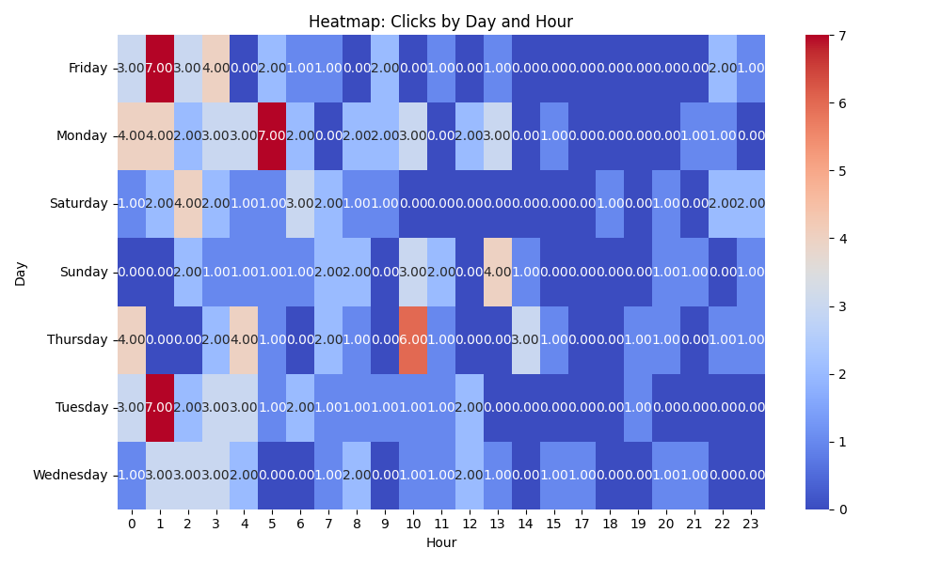

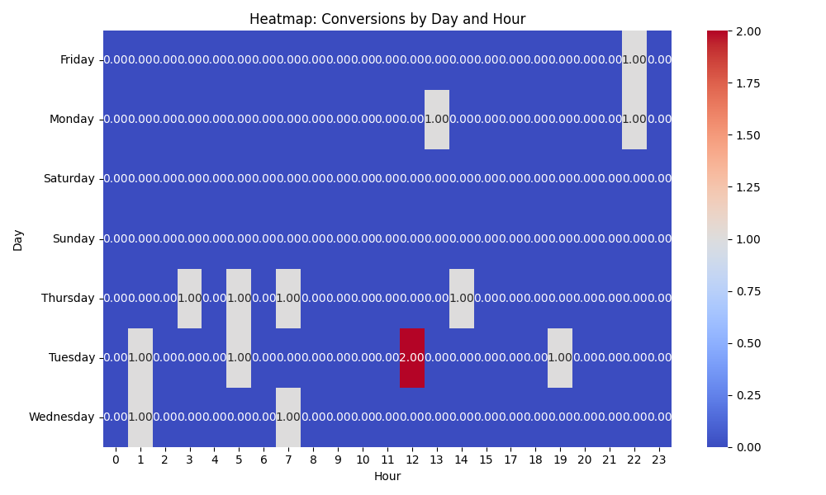

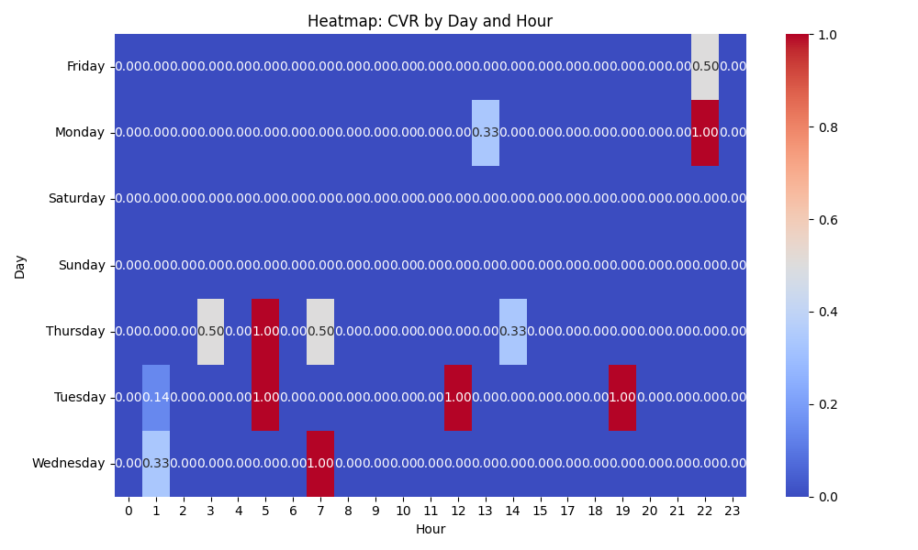

# Competitor Intelligence

# Top Competitor Insights

|  |  |  |
| --- | --- | --- |
| Competitor | Strengths | Recommendations |
|  | Competitor X’s ad copy directly links their product to strong business outcomes like 'Better ROI' and positions it as 'Next-Level Marketing' and 'The Future of Promotional Material'. This speaks to the strategic value and long-term benefits beyond just visual appeal. The mention of 'Interactive Video Brochures' also suggests advanced features that might drive these improved outcomes. Many of Competitor X's ads directly address common pain points and desires of businesses, such as needing to 'Stand Out in a Crowded Market,' making messages 'Pop,' or achieving 'Unique Presentations & Pitches.' Their messaging is concise and problem/solution-oriented, making it highly relatable and impactful for immediate ad-click motivation. Competitor X's ad strategy appears to leverage a diverse set of singular, powerful benefits across multiple creatives (e.g., 'Ultimate Sales & Marketing Tool,' 'High-Impact,' 'Lasting Impression,' 'Better ROI'). This allows them to appeal to various search intents and highlight different facets of their product's value in a targeted way. | While our landing page emphasizes 'wow, inform, and convert' and 'proven engagement booster', we can more explicitly connect our products to measurable business results and innovation. Incorporate language that highlights how our video-in-print solutions lead to improved ROI, competitive advantage, or future-proof marketing strategies. If our products offer interactive features, these should be prominently showcased and explained in terms of their benefit to business outcomes, potentially with a dedicated section. Our landing page focuses on creating an 'experience' and 'captivating' audiences, which is good, but we could be more explicit about solving the core business challenge of differentiation and impact in a noisy market. Beyond 'wow,' reinforce how our products directly help clients overcome challenges like low engagement or blending in. For instance, frame benefits in terms of 'cutting through the clutter' or 'ensuring your message can't be ignored' to align with the problem/solution focus seen in the competitor's ads. While our landing page includes several benefits and features, we can optimize the initial message and flow to immediately articulate these benefits more pointedly. Consider organizing the top of the landing page to quickly convey the breadth of 'why' someone would choose us, beyond just the 'wow' factor. We could also explore developing more targeted landing pages or sections within our existing page that directly align with these specific benefit-driven ad themes (e.g., a section specifically on how our products boost sales, another on enhancing brand perception, etc.) to improve ad-to-page congruency for diverse campaigns. |
| mediafast.com › video-mailer | Their Google Ad creatives are highly repetitive and focused, clearly targeting 'Video Mailer' and 'Video Brochure' with the benefits 'Custom, High-Impact'. This suggests a very clear, concise, and potentially highly targeted keyword strategy that maximizes ad relevance for these specific search terms. The ad copy is direct and leaves no ambiguity about the product offered, which can lead to strong ad-to-query matching. The competitor's ad copy prominently features 'Video Mailer' and 'Video Brochure' in the headline, indicating strong keyword alignment with common search queries. This directness likely contributes to higher click-through rates and improved quality scores due to perceived relevance by Google's algorithm. Their ad is simple and direct, which can cut through noise. It doesn't try to convey too many messages, sticking to the core product and two key benefits ('Custom, High-Impact'). | Review our Google Ad strategy to ensure we have equally targeted ad groups and creatives for specific high-volume search terms like 'video mailer' and 'video brochure'. While our landing page is comprehensive, our ads could be more singular in their focus to match immediate user intent. Consider creating ad variations that mirror the competitor's directness, specifically highlighting 'Video Mailer' or 'Video Brochure' as the primary offer in the headline and description, ensuring a strong keyword-to-ad-to-landing-page relevancy. Evaluate our current ad copy for competitive terms. Ensure our ad headlines and descriptions explicitly leverage keywords like 'Video Mailer' and 'Video Brochure' where appropriate, particularly for campaigns targeting these terms. While our landing page mentions 'Video Mailers' further down and focuses on 'Video Brochure' in the main heading, our ad creatives should immediately assure searchers they've found what they're looking for, potentially by testing ad copies like 'Video Mailer | Custom & Captivating | [Your Brand]' or 'Video Brochure | Ultimate Sales Tool | [Your Brand]' to match specific search intents more closely. Leverage our unique selling propositions (USPs) more explicitly in ad copy where character limits allow. Our landing page highlights 'Low Minimum Order' and 'Trusted by Global Brands,' which are strong differentiators. While the competitor's ad is direct, we can aim to be direct AND highlight our competitive advantages. For instance, an ad for 'Video Mailer' could include a benefit like 'Low Minimums' to attract a broader range of businesses, or 'Trusted by Volvo' to add immediate credibility, standing out from generic 'custom' or 'high-impact' claims. |

# Top 3 Risks & Opportunities

No Risks identified.

No Opportunities identified.