Google Ads Audit Report

# Campaign Performance (w/ Benchmark Overlay)

|  |  |  |  |  |  |  |  |  |  |
| --- | --- | --- | --- | --- | --- | --- | --- | --- | --- |
| Campaign Name | CTR | Cost ($) | Clicks | Impressions | CTR Flag | Avg CPC | Avg CPC Flag | CPA ($) | CPA ($) Flag |
| VPP_Search_Leads_USA_03/08/2024 (Exp 1) | 8.79% | $2180.15 | 197 | 2242 | Above | $11.07 | Above | $155.72 | Above |

# Campaign Insights

⚠️ Unable to parse structured insights — showing raw output below.

[{'Characteristic': 'Cost Per Acquisition (CPA)', 'Insight': 'The campaign has achieved 14 conversions at a Cost Per Acquisition (CPA) of $155.72.', 'Recommendation': 'Evaluate if the CPA of $155.72 aligns with the desired profitability margin for leads. If too high, consider gradually lowering the Target CPA bid to optimize for more cost-efficient conversions.'}, {'Characteristic': 'Campaign Budget Utilization', 'Insight': 'The campaign has a daily budget of $35.0 but has accumulated a total cost of $2180.15 since its start date of 2024-08-10.', 'Recommendation': "Given the significant total cost relative to the daily budget, confirm if the campaign's overall spend over time is aligned with monthly or long-term budget goals. If not, adjust daily budgets or monitor pacing more closely to prevent overspending on specific days."}, {'Characteristic': 'Click-Through Rate (CTR)', 'Insight': 'The campaign demonstrates a strong CTR of 8.79% (from 197 clicks and 2242 impressions).', 'Recommendation': 'Leverage this high CTR by continually testing new ad copy variations and ad extensions to further enhance user engagement and ad quality, which could potentially improve Quality Score and reduce Avg CPC ($11.07) over time.'}]

# Keyword Performance

|  |  |  |  |  |  |  |  |  |
| --- | --- | --- | --- | --- | --- | --- | --- | --- |
| Ad Group | Keyword | Match Type | Quality Score | Impressions | Clicks | CTR | Avg CPC | CPA ($) |
| Video Mailers | video mailers | PHRASE | 3 | 294 | 28 | 9.52% | $13.52 | $126.23 |
| VPP Brochures | video brochures | PHRASE | 5 | 347 | 23 | 6.63% | $13.36 | $0.00 |
| Video Books | promotional video book | PHRASE | 6 | 76 | 12 | 15.79% | $13.36 | $160.34 |
| Video Box | video box | PHRASE | 3 | 411 | 24 | 5.84% | $5.17 | $0.00 |
| Video Box | box with video screen | PHRASE | 4 | 35 | 10 | 28.57% | $11.08 | $110.85 |
| Video Box | video box marketing | PHRASE | 6 | 70 | 7 | 10.00% | $12.54 | $0.00 |
| Video Mailers | video mailers marketing | PHRASE | 7 | 61 | 6 | 9.84% | $13.32 | $0.00 |
| Video Mailers | video brochure mailer | PHRASE | 4 | 34 | 3 | 8.82% | $26.37 | $31.64 |
| Video Books | video book marketing | PHRASE | 6 | 98 | 11 | 11.22% | $6.34 | $34.87 |
| Video Mailers | custom video mailers | PHRASE | 5 | 48 | 6 | 12.50% | $10.98 | $65.85 |
| Video Books | personalized video books | PHRASE | 5 | 80 | 11 | 13.75% | $5.58 | $61.41 |
| Video Box | custom video box | PHRASE | 5 | 37 | 3 | 8.11% | $18.40 | $0.00 |
| VPP Brochures | video brochure card | PHRASE | 4 | 100 | 5 | 5.00% | $9.54 | $0.00 |
| Video Books | custom video books | PHRASE | 5 | 105 | 9 | 8.57% | $4.59 | $0.00 |
| Video Mailers | video card mailer | PHRASE | 3 | 17 | 3 | 17.65% | $12.41 | $37.24 |
| VPP Brochures | video brochure usa | PHRASE | 4 | 18 | 1 | 5.56% | $36.15 | $36.15 |
| VPP Brochures | custom video brochures | PHRASE | 7 | 58 | 3 | 5.17% | $9.88 | $59.27 |
| VPP Brochures | lcd screen video brochure | PHRASE | 4 | 20 | 2 | 10.00% | $13.20 | $0.00 |
| VPP Brochures | video brochure manufacturer | PHRASE | 3 | 3 | 2 | 66.67% | $11.74 | $0.00 |
| Video Box | video gift box | PHRASE | 5 | 47 | 5 | 10.64% | $2.97 | $0.00 |
| VPP Brochures | lcd video brochure | PHRASE | 3 | 5 | 1 | 20.00% | $13.72 | $0.00 |
| VPP Brochures | video brochure marketing | PHRASE | 5 | 2 | 1 | 50.00% | $12.49 | $0.00 |
| VPP Brochures | video brochure pricing | PHRASE | 0 | 10 | 1 | 10.00% | $11.03 | $0.00 |
| VPP Brochures | video brochure book | PHRASE | 5 | 2 | 1 | 50.00% | $9.41 | $0.00 |
| VPP Brochures | 4.3 inch video brochure | PHRASE | 0 | 3 | 1 | 33.33% | $7.84 | $0.00 |
| VPP Brochures | brochure with video screen | PHRASE | 6 | 6 | 1 | 16.67% | $7.42 | $0.00 |
| Video Mailers | lcd video mailers | EXACT | 0 | 4 | 1 | 25.00% | $5.87 | $0.00 |
| Video Box | promotional video box | PHRASE | 3 | 5 | 1 | 20.00% | $3.77 | $0.00 |
| VPP Brochures | video screen brochure | PHRASE | 5 | 14 | 1 | 7.14% | $1.44 | $0.00 |
| VPP Brochures | digital video brochures | PHRASE | 4 | 4 | 0 | 0.00% | $0.00 | $0.00 |
| VPP Brochures | media fast video brochure | PHRASE | 3 | 7 | 0 | 0.00% | $0.00 | $0.00 |
| VPP Brochures | video brochure maker | PHRASE | 4 | 2 | 0 | 0.00% | $0.00 | $0.00 |
| Video Books | lcd video book | PHRASE | 5 | 4 | 0 | 0.00% | $0.00 | $0.00 |
| Video Box | video brochure box | PHRASE | 2 | 7 | 0 | 0.00% | $0.00 | $0.00 |
| Video Mailers | video mailer box | PHRASE | 5 | 4 | 0 | 0.00% | $0.00 | $0.00 |
| Video Mailers | mediafast video mailer | PHRASE | 2 | 21 | 0 | 0.00% | $0.00 | $0.00 |
| Video Box | lcd video box | PHRASE | 5 | 4 | 0 | 0.00% | $0.00 | $0.00 |
| Video Box | video presentation box | PHRASE | 2 | 2 | 0 | 0.00% | $0.00 | $0.00 |
| Video Box | video screen box | PHRASE | 3 | 1 | 0 | 0.00% | $0.00 | $0.00 |
| Video Box | gift box with video screen | PHRASE | 1 | 1 | 0 | 0.00% | $0.00 | $0.00 |

# Keyword Insights

# Keyword Insights

|  |  |  |
| --- | --- | --- |
| Characteristic | Insight | Recommendation |
| Cost-Ineffective Top Spenders | The keyword "video mailers" is the highest spender at $378.68, resulting in a very high CPA of $126.23 for 3 conversions. Similarly, "promotional video book" has a very high CPA of $160.34 for its single conversion ($160.34 cost). | Reduce bids by 20-30% on "video mailers" and "promotional video book" to immediately lower their Cost-Per-Click and overall spend. Simultaneously, conduct a granular search term report analysis for both to identify and add irrelevant queries as negative keywords, refining traffic quality. |
| Significant Wasted Spend | "video brochures" (VPP Brochures ad group) incurred $307.17 in cost with 0 conversions. Other significant non-converting keywords include "video box" ($124.02 cost) and "video box marketing" ($87.81 cost). Combined, these three keywords spent $519.00 without any return. | Immediately pause "video brochures", "video box", and "video box marketing" to stop further wasted spend. Allocate the freed-up budget to keywords demonstrating positive conversion performance or promising metrics, such as those in the 'High-Performing Conversion Drivers' insight. |
| High-Performing Conversion Drivers | "video brochure mailer" generated 2.5 conversions at an efficient CPA of $31.64 and an excellent CVR of 0.83. "video card mailer" (1 conversion, $37.24 CPA, 0.33 CVR) and "video brochure usa" (1 conversion, $36.15 CPA, 1.0 CVR) also show strong profitability. | Increase bids by 15-25% for "video brochure mailer," "video card mailer," and "video brochure usa" to maximize impression share and capture more volume from these highly efficient keywords. Explore creating similar keyword variations or expanding match types (e.g., broad match modifier if not already using) to capitalize on their strong performance. |
| Poor Quality Score & Visibility Issues | Keywords like "video brochure pricing" (QS 0), "4.3 inch video brochure" (QS 0), and "lcd video mailers" (QS 0) have critical Quality Scores of 0, indicating severe relevance issues. Additionally, "video mailers" (QS 3) and "video box" (QS 3) are performing with below-average Quality Scores. | For keywords with QS 0, set them to 'Paused' immediately as they are highly unlikely to become profitable. For "video mailers" and "video box," focus on improving landing page experience relevancy to the keyword, and refine ad copy to better align with user intent, aiming to raise Quality Score to 5 or higher by improving expected CTR, ad relevance, and landing page experience. |
| Disparate Ad Group Performance | The "Video Mailers" ad group contains both the highest spending, high CPA keyword ("video mailers" at $378.68, CPA $126.23) and highly efficient converting keywords ("video brochure mailer" at $79.10, CPA $31.64). This indicates a lack of specificity in ad group structure. | Restructure the "Video Mailers" ad group. Create a new, highly specific ad group (e.g., 'Generic Video Mailers') for the "video mailers" keyword to allow for tailored ad copy and landing page content specifically for this high-volume term. This enables more precise optimization efforts for both high-volume and high-performing terms, preventing budget from being disproportionately allocated to less efficient keywords. |

# Wasted Spend Insights

# Wasted Spend Insights

|  |  |  |
| --- | --- | --- |
| Characteristic | Insight | Recommendation |
| High Spend, Low Engagement, Zero Conversions | The keyword 'video brochures' accrued a significant cost of $307.17 with zero conversions, indicating a complete disconnect between spend and outcome. Its low CTR of 6.6% and mediocre Quality Score of 5 suggest poor ad relevance or user intent mismatch. | Immediately pause 'video brochures'. Investigate search queries for this broad match type. If it's capturing irrelevant traffic, switch to a more precise match type (e.g., phrase or exact match), refine ad copy to be highly specific, and ensure the landing page directly addresses user intent for 'video brochures'. Consider using negative keywords to block unrelated searches. |
| Significant Spend, Extremely Low Relevance & Zero Conversions | The keyword 'video box' consumed $124.02 without any conversions. Its alarmingly low Quality Score of 3 and CTR of 5.8% indicate severe ad-to-query mismatch and poor landing page experience. This keyword is highly inefficient. | 'video box' should be immediately paused. A Quality Score of 3 signifies fundamental issues. Review the search terms to understand user intent. This broad term might be attracting generic 'video storage' or 'TV box' queries. Add this keyword as an exact match negative if the product is not a 'video box'. If it is a video box product, a complete overhaul of ad copy, landing page content, and potential audience targeting is necessary before reactivating. |
| High Spend, Conversion Failure, Potential Intent Mismatch | The keyword 'video box marketing' consumed $87.81 with zero conversions, despite a respectable CTR of 10% and Quality Score of 6. This suggests that while ads are relevant and engaging users, the landing page or the offer itself is failing to convert them. It's also possible users are looking for marketing services using video boxes, not to buy video boxes. | Conduct a comprehensive audit of the landing page for 'video box marketing'. Ensure the page clearly distinguishes between selling video boxes and offering marketing services related to them. If the latter is not your business, add 'marketing services' and similar terms as negative keywords. If selling the product, optimize the page for conversion (clear product benefits, pricing, CTA). Consider if this keyword should be in a separate campaign/ad group focused on specific marketing use cases rather than general product sales. |
| High Spend, Conversion Failure, Good Relevance | The keyword 'video mailers marketing' spent $79.94 with zero conversions, despite good engagement metrics (CTR 9.8%) and a strong Quality Score of 7. This indicates that while the keyword, ad, and landing page relevance are good, there's a significant bottleneck in the conversion funnel itself. | Given the strong QS 7 and good CTR for 'video mailers marketing,' the problem lies post-click. Focus immediate efforts on Conversion Rate Optimization (CRO) for the landing page tied to this keyword. Review the page's content, calls-to-action, form fields, page load speed, and mobile responsiveness. A/B test different offers or incentives. Also, double-check that the conversion tracking is correctly implemented and firing for this specific traffic. |
| High CPC, Moderate Spend, Low Engagement, Zero Conversions | The keyword 'custom video box' accumulated $55.18 in spend with zero conversions, compounded by an extremely high average CPC of $18.39. Its CTR of 8.1% and Quality Score of 5 suggest moderate relevance issues, but the cost per click is unsustainable for zero return. | Reduce bids significantly for 'custom video box', or pause it temporarily. Analyze the competition bidding on this term and their ad copy/landing pages. Test new, more compelling ad copy that highlights unique selling points for custom video boxes. Ensure the landing page is highly optimized for conversion (clear call to action, relevant content, strong offer). Consider Audience analysis if high bids are from specific demographics. |
| Moderate Spend, Very Low Engagement, Poor Relevance, Zero Conversions | 'video brochure card' spent $47.71 with zero conversions. Its very low CTR of 5% and poor Quality Score of 4 point to significant relevance problems with the ad copy and/or landing page, leading to wasted spend. | Pause 'video brochure card'. This keyword likely requires a full ad group restructuring. Create a new ad group specifically for 'video brochure card' and similar terms. Develop highly specific ad copy that directly mentions 'card' features (e.g., 'slim video card brochures'). Ensure the landing page focuses solely on video brochure cards. Also, review search terms to ensure user intent for 'card' is being met. |
| Moderate Spend, Poor Relevance, Zero Conversions | Despite a decent CTR of 10%, 'lcd screen video brochure' spent $26.39 with zero conversions, and a poor Quality Score of 4. This suggests the ads are attracting clicks, but the landing page or offer isn't converting, or the clicks are not relevant enough to the product. | While the CTR for 'lcd screen video brochure' is acceptable, the QS of 4 indicates a mismatch. Review the ad copy to ensure it aligns perfectly with the term and its implied user intent (e.g., specify LCD screen features). Critically review the landing page for this keyword: does it prominently feature LCD screen video brochures? Is the user experience intuitive? Is the CTA clear? Focus on improving landing page experience and ad relevance to boost Quality Score and conversions. |
| Moderate Spend, Deceptively High CTR, Extremely Low Relevance, Zero Conversions | 'video brochure manufacturer' has a remarkably high CTR of 66.6%, yet an abysmal Quality Score of 3 and zero conversions for $23.48 spent. This is a critical issue; the high CTR is misleading, likely indicating either irrelevant brand searches (for a specific manufacturer you are not) or users seeking information rather than purchase intent, which is then exacerbated by poor landing page experience. | Immediately pause 'video brochure manufacturer'. The QS 3 overrides the high CTR. Investigate the actual search terms triggering this keyword. If users are searching for specific manufacturers, add those as negative keywords. If the intent is genuinely to find a manufacturer for procurement, the landing page and ad copy must be completely restructured to address a B2B audience with high-intent language (e.g., 'wholesale video brochures,' 'bulk orders,' 'custom manufacturing solutions'). This keyword likely needs to be in a very specific, carefully managed campaign segment or be excluded entirely. |
| Lower Spend, Good Engagement, Extremely Low Relevance, Zero Conversions | 'lcd video brochure' has a good CTR of 20%, but its Quality Score of 3 and zero conversions for $13.72 spent indicate a significant disconnect. Users are clicking, but the relevance from the ad to the landing page is poor, or the product/offer isn't meeting their needs. | Despite its lower spend, the QS of 3 for 'lcd video brochure' is a red flag. Focus on optimizing the landing page specifically for 'lcd video brochures,' ensuring clear product imagery, specifications, and a compelling call to action. Review ad copy to ensure it accurately sets expectations for the landing page. Consider A/B testing different landing page experiences to improve conversion rate. |
| Lower Spend, Excellent Engagement, Conversion Failure | 'video brochure marketing' shows an outstanding CTR of 50% but zero conversions for $12.49 spent. This indicates excellent ad appeal and relevance to the query, but a severe failure on the landing page or the offer itself to convert the highly engaged traffic. The QS 5 suggests ad and keyword are okay, but landing page experience might be average. | Given the exceptional CTR for 'video brochure marketing', this keyword is attracting very interested users. The issue is likely the conversion path. Conduct a thorough audit of the landing page for 'video brochure marketing': Is it clear what action users should take? Is the value proposition compelling? Are there any technical issues? Implement A/B tests on landing page elements, calls-to-action, and lead capture forms. Consider if the user intent is for 'marketing services' rather than 'products' and adjust accordingly with negative keywords if needed. |
| Moderate Spend, Complete Relevance Failure, Zero Conversions | 'video brochure pricing' spent $11.03 with zero conversions and an alarming Quality Score of 0. This indicates a complete failure in keyword-to-ad relevance and landing page experience, making every click extremely expensive and useless. | Immediately pause 'video brochure pricing'. A Quality Score of 0 means Google views your ads/landing page as completely irrelevant to this keyword. Re-evaluate if you can even compete for this keyword. If so, create a dedicated landing page that directly addresses 'pricing' (e.g., a pricing calculator, detailed tiers, request a quote form). Ad copy must clearly convey that pricing information is available. Otherwise, add 'pricing' as a negative keyword. |
| Lower Spend, High Engagement, Complete Relevance Failure, Zero Conversions | '4.3 inch video brochure' generated $7.84 in spend with zero conversions, despite a very high CTR of 33.3%. The critical issue is its Quality Score of 0, indicating a total disconnect between the ad/landing page and this highly specific keyword. Users are interested, but are being disappointed. | Immediately pause '4.3 inch video brochure'. The high CTR but QS 0 suggests that while users are explicitly looking for this size, your ads or landing page are completely failing to meet that specific need. Create a dedicated ad group for specific sizes (e.g., '4.3 inch video brochure') and build a landing page that directly showcases this exact product, complete with clear specifications, images, and pricing. Your current setup is actively burning budget. |
| Lower Spend, Good Engagement, Complete Relevance Failure, Zero Conversions | 'lcd video mailers' spent $5.87 with zero conversions, despite a good CTR of 25%. However, its Quality Score is 0, which means Google finds the ad and/or landing page completely irrelevant to this search query, leading to wasted clicks. | Immediately pause 'lcd video mailers'. Similar to other QS 0 keywords, the system perceives no relevance. If you offer 'lcd video mailers', create a hyper-relevant ad group and landing page specifically for this product. Ensure the landing page features products explicitly matching this description and has a clear call to action. If you do not offer this specific product, add 'lcd video mailers' as a negative keyword. |

# Landing Page Audit Insights

## Landing Page: https://videoplusprint.com/video-in-print-products

# Landing Page Insights

|  |  |  |  |
| --- | --- | --- | --- |
| URL | Characteristic | Insight | Recommendation |
| https://videoplusprint.com/video-in-print-products | Call to Action (CTA) Clarity & Placement | The 'GET A FREE QUOTE' CTA is clear and prominently placed above the fold. However, the immediate presentation of a long, detailed quote request form (Name, Email, Country, Phone, Product Type, Quantity, Screen Size, Message) acts as a high barrier to entry for users who may just be exploring or comparing options. | Consider a two-step approach: an initial short form (e.g., Email, Name, Product Interest) for a 'Quick Estimate' or 'Digital Brochure,' followed by the detailed quote form on a subsequent page or after more product education. Alternatively, hide the detailed fields and expand them only when a user indicates readiness, or make some optional. This could reduce initial friction and increase micro-conversions. |
| https://videoplusprint.com/video-in-print-products | Conversion Funnel Friction | The primary conversion point is a complex quote request form. While suitable for high-intent users, a conversion rate of 7.1% with a high CPA ($155.72) suggests potential for optimization. Some users might be deterred by the immediate commitment required by the long form before fully understanding the product's value proposition or seeing more examples. | Introduce mid-funnel content and CTAs. For instance, 'View Product Gallery,' 'Download Case Studies,' or 'Book a Discovery Call' could serve as lower-friction conversion points. This allows users to engage at their comfort level, nurturing them towards the ultimate quote request, potentially improving lead quality and reducing CPA over time by increasing overall conversion volume. |
| https://videoplusprint.com/video-in-print-products | Trust Signals & Social Proof | The page includes strong trust signals such as 'Trusted by Global Brands' and numerous detailed testimonials from well-known companies like Volvo and Volkswagen. This is highly effective in building credibility. | Maintain and expand on these. However, there is a repetitive Volvo testimonial which should be corrected to avoid appearing unprofessional or inauthentic. Consider adding video testimonials if available, or logos of all brands mentioned for quick visual scanning. |
| https://videoplusprint.com/video-in-print-products | Content Hierarchy & Education | The page effectively states the product's purpose ('Turn Your Brand into an Experience') and lists key benefits ('Customizable,' 'Low Minimum Order'). However, it relies heavily on text to describe 'Video in Print' products without clear visual demonstrations (videos, high-quality images, interactive examples) which are crucial for a product whose core value is visual and interactive. | Integrate compelling hero videos or interactive galleries showcasing the video brochures, packaging, and cards in action. Visually demonstrate the 'wow' factor and how the video elements function. This will engage users more effectively and educate them on the product's unique features before they commit to a detailed quote. |
| https://videoplusprint.com/video-in-print-products | Navigation & Focus | The presence of a full navigation bar ('Menu Our Products Video in Print Portfolios Video Brochures About Us Get A Free Quote') on a landing page designed for conversion can distract users and provide multiple exit points, diverting them from the primary conversion goal. | For dedicated Google Ads landing pages, remove or minimize the navigation bar. Focus the user's attention solely on the content relevant to the ad intent and the primary call to action. A minimalistic header with only a logo and the primary CTA (or a 'Contact Us' link) is often more effective for conversion-focused pages. |
| https://videoplusprint.com/video-in-print-products | Mismatch with Ad Intent / Keyword Performance | The CTR of 3.28% indicates decent ad relevance for keywords like 'video-in-print-products.' The page content aligns well with product search intent, presenting various video-in-print product types. The high CPA of $155.72, despite a 7.1% conversion rate, suggests either a very high average deal value or potential inefficiency in lead qualification/ad targeting. | Given the high CPA, re-evaluate ad targeting to ensure it's reaching decision-makers or those with budget. Implement conversion tracking beyond just form submission (e.g., tracking the value of leads or sales) to get a clearer picture of profitability. Consider A/B testing shorter forms or a lead magnet to capture more top-of-funnel interest and nurture leads over time, potentially lowering the overall cost per qualified lead. |
| https://videoplusprint.com/video-in-print-products | Competitor Benchmark | Many competitors in the custom B2B product space utilize configurators, tiered pricing guides, or multi-step forms to ease users into the quoting process. The immediate full form might be perceived as more demanding compared to competitors offering a 'quick estimate' or 'design your own' option. | Research competitor landing page experiences for similar custom products. If competitors offer shorter initial forms or interactive tools, consider implementing a 'Quick Quote Builder' or a pricing estimator on the page. This can provide immediate value to the user, qualify their interest, and potentially increase the volume of initial engagements before pushing for the full detailed quote. |
| https://videoplusprint.com/video-in-print-products | Conversion Rate & Cost Efficiency | The conversion rate of 7.1% (14 conversions / 197 clicks) is reasonable for a specialized product, indicating a degree of interest from visitors. However, the stated 'Cost: 0.00' is a critical anomaly. If this represents a tracking error, the CPA of $155.72 becomes highly concerning for 14 conversions, suggesting a potentially unsustainable cost per lead if the average order value isn't significantly high. If 'Cost: 0.00' means no ad spend, then the CPA is irrelevant, but raises questions about campaign activity. | Immediately audit and resolve the 'Cost: 0.00' data. If it's a tracking error, ensure all costs are accurately captured to calculate a true CPA and assess ROI. If the $155.72 CPA is accurate, conduct a detailed profitability analysis for each conversion to determine if the campaign is viable. Implement micro-conversion tracking (e.g., video plays, scroll depth, brochure downloads) to identify user engagement points before the main conversion. |
| https://videoplusprint.com/video-in-print-products | Ad-Page Relevance (Based on CTR) | A CTR of 3.28% suggests that the ad copy and targeting are generally effective in attracting relevant clicks. The page content, focusing heavily on 'Video In Print Products' and specific types like 'Video Brochures' and 'Video Mailers,' clearly aligns with what a user searching for these terms would expect. | Leverage the strong ad-page alignment by ensuring the page's hero section prominently features a compelling headline that directly echoes the ad's main promise. Consider A/B testing ad copy to include specific unique selling points (e.g., '40+ Years Expertise' or 'Proven ROI') to pre-qualify users further, potentially leading to even higher quality clicks and improved conversion rates. |
| https://videoplusprint.com/video-in-print-products | Call to Action (CTA) Clarity & Prominence | The CTAs 'Get A FREE Video Brochure QUOTE' and 'GET A FREE QUOTE' are clear, benefit-oriented, and set proper expectations for a custom product. Their presence multiple times on the page (implied by content chunk) is beneficial. | Ensure the primary 'GET A FREE QUOTE' CTA is visually distinct and placed strategically above the fold, mid-page after key benefits, and at the bottom. A/B test the CTA button's color, size, and micro-copy (e.g., 'Request Your Custom Design Quote', 'Get Pricing & Details') to maximize click-through rates. Consider adding a secondary, lower-friction CTA like 'Download Product Catalog' if applicable. |
| https://videoplusprint.com/video-in-print-products | Trust Signals & Social Proof | The page effectively uses strong trust signals: 'Since 2009' operation, '40 years of expertise,' and a powerful 'Proven ROI A 23% sales lift' statistic. The mention of high-profile clients like UPS and Exxon Mobil significantly boosts credibility. However, the 'Most Valuable Company 2016' award is outdated, potentially raising questions about current recognition. | Prioritize updating or adding more recent awards and testimonials. If no newer awards are available, rephrase the 2016 award to emphasize long-standing industry recognition rather than recent achievement. Actively solicit new client testimonials, particularly video testimonials, and integrate them prominently. Consider adding a third-party review platform widget if applicable. |
| https://videoplusprint.com/video-in-print-products | Value Proposition & Product Clarity | The page clearly defines various video-in-print products and highlights their benefits (e.g., 'engage and impress,' 'captivate, convert'). The 'transform your promotional print materials' statement clearly articulates the core service. The '23% sales lift' is an excellent, tangible value proposition. | While benefits are clear, the unique selling proposition (USP) against competitors could be more prominent. Beyond 'quality' and 'expertise,' identify and highlight what makes Video Plus Print *distinctly* better. For instance, if their 'customizable and suitable for all budgets' offers unique flexibility, make that a headline or a dedicated section. |
| https://videoplusprint.com/video-in-print-products | Information Hierarchy & User Flow | The page is well-structured, moving from product categories to company credentials, success methodology, client examples, and the 'Power of Video Brochures.' This logical flow guides the user effectively through the sales argument. | To further reduce friction for a custom solution, add a concise 'How It Works' or 'Our Process' section. This would outline the steps a client goes through from requesting a quote to receiving their final product, setting clear expectations and removing uncertainty about the purchasing journey. |
| https://videoplusprint.com/video-in-print-products | Objection Handling | The statement 'Tell us what you need and we will create solutions that are customizable and suitable for all budgets' is a strong piece of objection handling, directly addressing potential concerns about cost or specific requirements for bespoke products. | Identify other common objections for custom video marketing solutions (e.g., production lead times, minimum order quantities, post-sales support, integration with existing marketing). Create a concise FAQ section or integrate answers within relevant content blocks to proactively address these concerns and further reduce barriers to conversion. |
| https://videoplusprint.com/video-in-print-products | Competitor Benchmark | The page showcases strong internal strengths like deep experience and proven ROI. However, it lacks an overt comparison or positioning against competitors in the video-in-print market. Without understanding what makes them specifically better or different from rivals (e.g., production speed, proprietary technology, specific niche expertise), potential customers might default to price or familiar brands. | Conduct a competitive analysis of key rivals (e.g., MediaFast, Video Brochures Direct). Identify their weaknesses in areas like quality, customization, service, or turnaround times. Then, subtly or explicitly weave in language on the landing page that highlights Video Plus Print's superiority in those specific areas, turning competitor weaknesses into your strengths. |
| https://videoplusprint.com/video-in-print-products | Post-Conversion Clarity | While the CTA asks for a 'QUOTE,' the provided content does not detail the immediate next steps after a user submits the form. This lack of clarity can create uncertainty and lead to drop-offs or unengaged leads if the user doesn't know what to expect or how long they'll wait. | Add a short sentence or two near each CTA explaining the immediate post-submission process. For example, 'What Happens Next? We'll contact you within X hours to discuss your project and provide a tailored quote.' This sets clear expectations and reinforces trust. |
| https://videoplusprint.com/video-in-print-products | Performance Data Integrity | The reported 'Cost: 0.00' with a 'CPA: 155.72' is a critical data discrepancy. A non-zero CPA indicates ad spend occurred, making the zero cost value unreliable. This prevents an accurate assessment of ad spend efficiency. | Immediately investigate the Google Ads account to identify the true ad spend for these clicks and conversions. Accurate cost data is fundamental for calculating a reliable CPA and determining campaign profitability. Ensure conversion tracking is robust and cost data is importing correctly into any reporting dashboards. |
| https://videoplusprint.com/video-in-print-products | Conversion Rate & Lead Quality | With 14 conversions from 197 clicks, the conversion rate of approximately 7.1% is remarkably strong for a B2B lead generation page, especially for a custom product like 'video in print'. This suggests the page resonates well with the audience that lands on it. | Given the high conversion rate, the focus should shift from solely increasing conversion volume to optimizing lead *quality*. Review the lead qualification process: what questions are asked on the quote form? Can additional fields (e.g., company size, approximate quantity needed, project timeline) be added without significantly impacting conversion rate to pre-qualify leads for the sales team? |
| https://videoplusprint.com/video-in-print-products | Call to Action (CTA) Clarity & Placement | The page prominently features clear calls to action like 'Get A FREE Video Brochure QUOTE' and 'GET A FREE QUOTE'. Their directness aligns well with a B2B audience looking for custom solutions, and their repetition (implied by the content chunk) reinforces the primary conversion goal. | While the CTAs are clear, consider A/B testing variations of the button copy or surrounding microcopy to see if it can further improve click-through rates to the form, or perhaps specify the 'free' aspect even more prominently. Ensure the quote form itself is concise and frictionless, minimizing required fields to only essential lead qualification data. |
| https://videoplusprint.com/video-in-print-products | Trust Signals & Social Proof | While the content effectively explains the product's benefits and target audience, the provided snippet lacks explicit trust signals such as client testimonials, case studies, or prominent client logos. The '© 2009-2024' indicates longevity, which is a subtle trust signal, but more direct social proof is missing. | Integrate specific trust signals. Add a dedicated section or carousel for testimonials from satisfied clients. Develop concise case studies highlighting successful applications of 'video in print' for different industries. Display logos of well-known clients if permitted. This will build stronger confidence, especially for a premium B2B product, and potentially further reduce friction for high-value quote requests. |
| https://videoplusprint.com/video-in-print-products | Competitor Benchmark | Without specific competitor conversion rates or average CPAs for similar 'video in print' products, it's challenging to ascertain if the 7.1% conversion rate is truly exceptional within the niche, or if the CPA (once corrected) is competitive. This context is vital for strategic scaling. | Conduct a competitive analysis focusing on direct competitors offering 'video in print' solutions. Research their landing page strategies, pricing models (if public), and estimated traffic sources. Seek industry benchmarks for conversion rates in the B2B custom print/marketing materials sector to contextualize current performance and identify opportunities for differentiation and market positioning. |

# Geographical Performance

|  |  |  |  |  |  |  |  |  |  |
| --- | --- | --- | --- | --- | --- | --- | --- | --- | --- |
| City | Region | Country | Type | Impressions | Clicks | Conversions | Cost ($) | CVR | CPA ($) |
| United States |  |  | Country | 2116 | 185 | 14.0 | $2109.34 | 0.07567567567567568 | $150.67 |

# Geographical Insights

# Geographical Insights

|  |  |  |
| --- | --- | --- |
| Characteristic/ Location | Insight | Recommendation |
| United States (Country-level aggregate) | The United States campaign generated 14 conversions from $2109.34 spend, resulting in a Cost Per Acquisition (CPA) of $150.67 and a Conversion Rate (CVR) of 7.57%. This represents the current overall campaign efficiency within the country. | Given the strong overall CVR of 7.57%, the immediate tactical step is to segment this performance. Analyze the data by State and/or Designated Market Area (DMA) within the United States. Prioritize immediate bid increases (e.g., +15% to +25%) or budget reallocation towards specific sub-regions demonstrating significantly lower CPAs (e.g., <$100) and higher CVRs (e.g., >10%). Concurrently, identify and consider negative geo-targeting or significant bid decreases (e.g., -30% to -50%) for any sub-regions where CPA consistently exceeds $200 and CVR drops below 5%, to reallocate budget to more profitable areas and improve overall campaign ROI. |

# Hourly Performance Pivot

CVR

|  |  |  |  |  |  |  |  |  |  |
| --- | --- | --- | --- | --- | --- | --- | --- | --- | --- |
| Day/Hour | 1 | 3 | 5 | 7 | 12 | 13 | 14 | 19 | 22 |
| Monday |  |  |  |  |  | 0.33 |  |  | 1.00 |
| Tuesday | 0.14 |  | 1.00 |  | 1.00 |  |  | 1.00 |  |
| Wednesday | 0.33 |  |  | 1.00 |  |  |  |  |  |
| Thursday |  | 0.50 | 1.00 | 0.50 |  |  | 0.33 |  |  |
| Friday |  |  |  |  |  |  |  |  | 0.50 |

Clicks

|  |  |  |  |  |  |  |  |  |  |  |  |  |  |  |  |  |  |  |  |  |  |  |  |
| --- | --- | --- | --- | --- | --- | --- | --- | --- | --- | --- | --- | --- | --- | --- | --- | --- | --- | --- | --- | --- | --- | --- | --- |
| Day/Hour | 0 | 1 | 2 | 3 | 4 | 5 | 6 | 7 | 8 | 9 | 10 | 11 | 12 | 13 | 14 | 15 | 17 | 18 | 19 | 20 | 21 | 22 | 23 |
| Monday |  |  |  |  |  |  |  |  |  |  |  |  |  |  |  |  |  |  |  |  |  |  |  |
| Tuesday |  |  |  |  |  |  |  |  |  |  |  |  |  |  |  |  |  |  |  |  |  |  |  |
| Wednesday |  |  |  |  |  |  |  |  |  |  |  |  |  |  |  |  |  |  |  |  |  |  |  |
| Thursday |  |  |  |  |  |  |  |  |  |  |  |  |  |  |  |  |  |  |  |  |  |  |  |
| Friday |  |  |  |  |  |  |  |  |  |  |  |  |  |  |  |  |  |  |  |  |  |  |  |
| Saturday |  |  |  |  |  |  |  |  |  |  |  |  |  |  |  |  |  |  |  |  |  |  |  |
| Sunday |  |  |  |  |  |  |  |  |  |  |  |  |  |  |  |  |  |  |  |  |  |  |  |

Conversions

|  |  |  |  |  |  |  |  |  |  |
| --- | --- | --- | --- | --- | --- | --- | --- | --- | --- |
| Day/Hour | 1 | 3 | 5 | 7 | 12 | 13 | 14 | 19 | 22 |
| Monday |  |  |  |  |  | 1.00 |  |  | 1.00 |
| Tuesday | 1.00 |  | 1.00 |  | 2.00 |  |  | 1.00 |  |
| Wednesday | 1.00 |  |  | 1.00 |  |  |  |  |  |
| Thursday |  | 1.00 | 1.00 | 1.00 |  |  | 1.00 |  |  |
| Friday |  |  |  |  |  |  |  |  | 1.00 |

Cost ($)

|  |  |  |  |  |  |  |  |  |  |  |  |  |  |  |  |  |  |  |  |  |  |  |  |
| --- | --- | --- | --- | --- | --- | --- | --- | --- | --- | --- | --- | --- | --- | --- | --- | --- | --- | --- | --- | --- | --- | --- | --- |
| Day/Hour | 0 | 1 | 2 | 3 | 4 | 5 | 6 | 7 | 8 | 9 | 10 | 11 | 12 | 13 | 14 | 15 | 17 | 18 | 19 | 20 | 21 | 22 | 23 |
| Monday | 48.30 | 21.97 | 24.69 | 13.34 | 26.87 | 54.61 | 5.29 |  | 36.75 | 15.58 | 24.57 |  | 9.74 | 59.63 |  | 12.31 |  |  |  |  | 3.77 | 15.61 |  |
| Tuesday | 48.24 | 93.14 | 23.40 | 22.01 | 39.36 | 10.17 | 13.67 | 16.65 | 4.97 | 22.60 | 8.91 | 9.03 | 44.24 |  |  |  |  |  | 9.07 |  |  |  |  |
| Wednesday | 2.86 | 51.11 | 112.01 | 57.51 | 36.88 |  |  | 4.51 | 12.08 |  | 4.67 | 10.53 | 6.26 | 5.90 |  | 1.83 | 12.58 |  |  | 4.09 | 3.60 |  |  |
| Thursday | 85.88 |  |  | 39.39 | 40.51 | 11.88 |  | 41.53 | 2.24 |  | 60.89 | 7.23 |  |  | 12.13 | 7.84 |  |  | 2.70 | 4.40 |  | 2.57 | 5.69 |
| Friday | 32.45 | 58.31 | 50.79 | 48.66 |  | 16.38 | 12.36 | 2.79 |  | 19.03 |  | 8.07 |  | 1.14 |  |  |  |  |  |  |  | 29.77 | 2.56 |
| Saturday | 39.21 | 40.99 | 50.32 | 5.12 | 19.72 | 18.15 | 24.64 | 29.87 | 3.39 | 2.63 |  |  |  |  |  |  |  | 18.95 |  | 5.74 |  | 17.21 | 11.58 |
| Sunday |  |  | 24.74 | 12.14 | 14.93 | 3.99 | 0.14 | 10.97 | 6.07 |  | 19.12 | 15.75 |  | 40.52 | 39.35 |  |  |  |  | 13.34 | 3.56 |  | 15.90 |

# Hourly Patterns Insights

# Hourly Patterns Insights

|  |  |  |
| --- | --- | --- |
| Characteristic | Insight | Recommendation |
| Overall Conversion Efficiency | The account demonstrates a very low overall conversion rate, with numerous clicks and significant spend leading to zero conversions across many hours and days. | Conduct a deeper analysis beyond dayparting, investigating keyword relevance, ad copy effectiveness, landing page experience, and audience targeting as the fundamental conversion mechanics appear suboptimal. |
| Weekend Performance (Sunday & Saturday) | Both Sunday and Saturday consistently show no conversions despite incurring substantial costs and clicks across multiple hours. | Pause campaigns entirely on Sundays and Saturdays, or implement a significant negative bid adjustment (-100%) as these days are not yielding any return on investment. |
| Early Morning Performance (00:00 - 06:00) | The early morning hours (00:00 to 06:00) consistently consume significant budget and clicks with very few or no conversions across most weekdays and weekends. Examples include Wednesday 2 ($112.01), Thursday 0 ($85.88), and Monday 5 ($54.61) all with zero conversions. | Implement strong negative bid adjustments (-80% to -100%) or pause ads completely during the 00:00-06:00 time block on all days to prevent wasteful spending. |
| Specific Underperforming Hours (High Cost, Zero Conversions) | Several specific hours during the week, such as Monday 0, 5, 8; Tuesday 0, 4; Wednesday 2, 3, 4; Thursday 0, 10; and Friday 0, 1, 2, 3, are consuming considerable budget without generating any conversions. | Apply significant negative bid adjustments (-80% to -100%) for these specific hours and days to drastically reduce or eliminate spend in these unproductive periods. |
| High-Performing Conversion Hours | A few hours demonstrate efficient conversions and high conversion rates, notably Monday 22, Tuesday 5, Tuesday 12, Tuesday 19, Wednesday 7, Thursday 5, and Thursday 14, often with a 100% CVR or good cost per conversion. | Apply positive bid adjustments (+20% to +50%) to these high-performing hours to maximize visibility and capture more conversions during these profitable windows. |
| Data Volume and Timeframe | The provided data covers a single week of hourly performance, which may not be fully representative of long-term trends or account for weekly seasonality. | Continue to collect and analyze hourly performance data for at least 3-4 weeks to confirm identified trends and refine dayparting adjustments, especially for hours with fewer data points or inconsistent performance. |

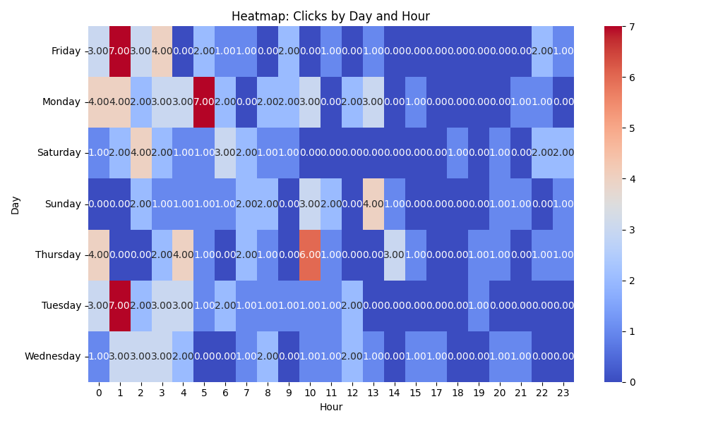

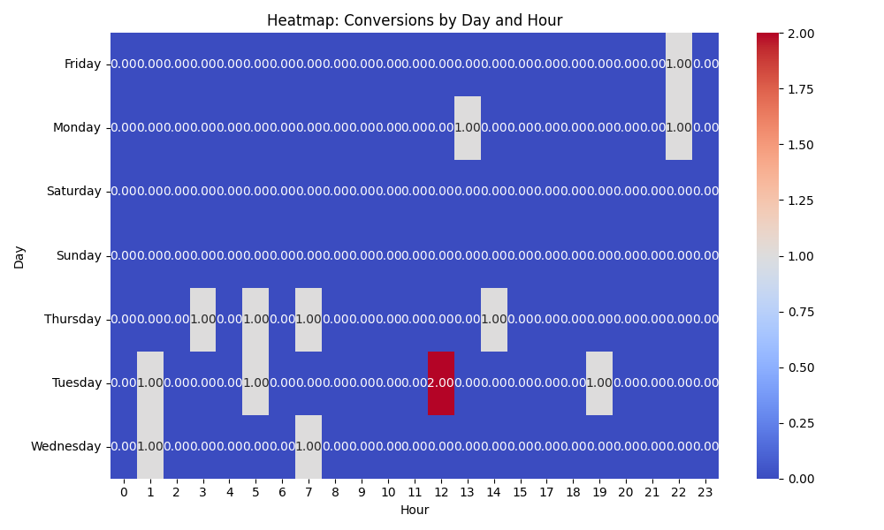

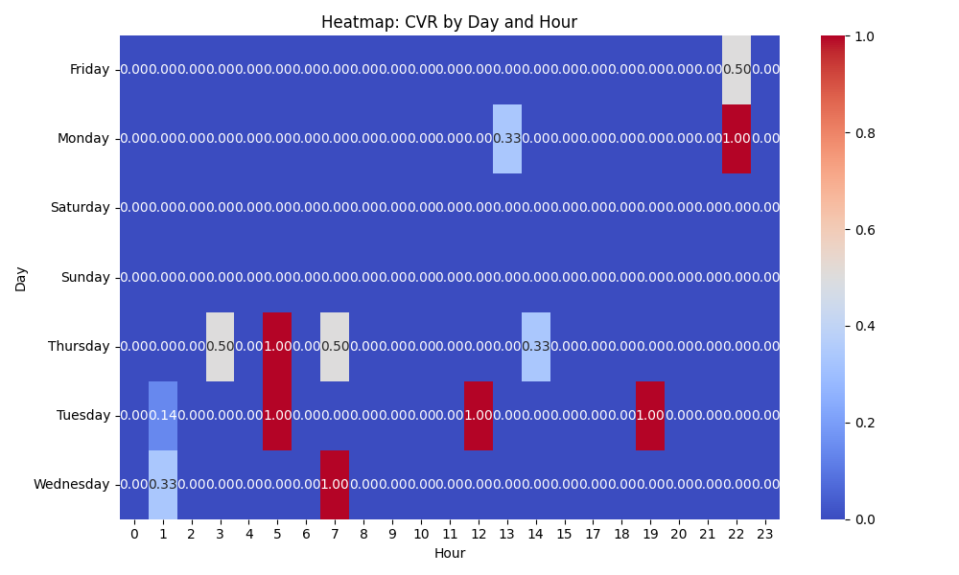

# Competitor Intelligence

# Top Competitor Insights

|  |  |  |
| --- | --- | --- |
| Competitor | Strengths | Recommendations |
|  | The competitor's consistent use of YouTube and implied visual ads suggests a strong focus on directly demonstrating the core value of a video brochure: the video itself. By showing the product in action, they immediately convey the unique 'wow' factor and how it works, which is highly effective for a visually-driven product. This leverages the ad medium (video) perfectly with the product (video-in-print). While the competitor's ad text isn't provided, their implied reliance on visual ads suggests they are building curiosity and brand recognition through demonstration rather than explicit textual claims in the ad itself. This can be effective for generating initial interest in a novel product. Their ad strategy appears to be broad, aiming to capture attention. This could be interpreted as a wide funnel approach, relying on the visual novelty of the product to draw in potential customers across various use cases. | Develop and prioritize visually compelling video ad creatives for Google (YouTube, Display Network) that showcase your video brochures, business cards, and packaging being opened and played. Focus on capturing the initial surprise and high-quality playback, mirroring the premium experience you promise on your landing page. Consider A/B testing different video lengths and calls-to-action. Integrate your most compelling value propositions and trust signals from your landing page directly into your ad copy for Search and Display ads, and as overlay text or voiceovers in your video ads. Phrases like 'The Ultimate Sales & Marketing Tool,' 'Trusted by Global Brands,' and 'Proven Engagement Booster' should be prominent to quickly establish credibility and clearly articulate benefits beyond just showing the product. Leverage the specific use cases and powerful testimonials from your 'Our Happy Customers' section within your ad creatives. Create distinct ad variations or even separate ad groups targeting specific applications (e.g., 'Video Business Cards for Events,' 'Video Packaging for Product Launches'). Consider using snippets of strong testimonials like 'Exceptional quality!' or 'Knocking their socks off' in your ad headlines or descriptions to build immediate social proof and intrigue. |
| mediafast.com › video-mailer | The competitor's ad creative immediately highlights 'Video Mailer' as a specific product, coupled with strong benefit-oriented keywords like 'Custom' and 'High-Impact'. This precise product focus, reinforced by the display URL, indicates highly targeted messaging that matches specific user intent. The 'You...' implies an immediate user benefit, making the ad very direct and appealing. Their ad headline 'Video Mailer | Custom, High-Impact Video Brochure You ...' is concise yet powerful. It blends the specific product ('Video Mailer'), key selling points ('Custom, High-Impact'), and a broader category ('Video Brochure') into a single, compelling statement. The implied user benefit ('You...') creates immediate relevance. The competitor places 'Custom' and 'High-Impact' directly in their ad headline, which are crucial differentiators and strong motivators for potential customers. This ensures their core value proposition is immediately visible to searchers. | Review our Google Ads strategy to ensure ad creatives are as specific as possible to the keywords being bid on. If we are bidding on 'video mailer,' our ad headline and description should prominently feature 'Video Mailer' and immediately tie it to key benefits like 'Custom' and 'High-Impact' for maximum relevance. Our current landing page introduces 'Video Brochures' broadly before mentioning 'Video Mailers' further down; for specific 'Video Mailer' searches, consider leading with that product on the landing page's hero section. Our ad creative headlines could adopt a similar structure, combining specific product names (e.g., 'Video Brochures,' 'Video Mailers') with our strongest value propositions like 'Customized' and 'High-Impact.' Ensure our ad copy clearly communicates the 'wow, inform, and convert' benefits directly in the ad before the user even reaches the landing page. While our landing page effectively uses 'customized' and 'high-impact' in its hero section and bullet points, we must ensure these critical keywords are equally prominent and emphasized in our Google Ad headlines and descriptions. Reiterate these benefits clearly and concisely in the ad creatives to attract users looking for personalized, effective marketing tools. |

# ⚠️ Risks

No Risk insights generated.

# ✅ Opportunities

# Opportunities

|  |  |  |
| --- | --- | --- |
| Characteristic | Insight | Recommendation |
|  |  |  |