Google Ads Audit Report

# Campaign Performance (w/ Benchmark Overlay)

|  |  |  |  |  |  |  |  |  |  |
| --- | --- | --- | --- | --- | --- | --- | --- | --- | --- |
| Campaign Name | CTR | Cost ($) | Clicks | Impressions | CTR Flag | Avg CPC | Avg CPC Flag | CPA ($) | CPA ($) Flag |
| VPP_Search_Leads_USA_03/08/2024 (Exp 1) | 8.79% | $2180.15 | 197 | 2242 | Above | $11.07 | Above | $155.72 | Above |

# Campaign Insights

⚠️ Unable to parse structured insights — showing raw output below.

[{'Characteristic': 'CPA Performance', 'Insight': 'The campaign has achieved 14 conversions at a Cost Per Acquisition (CPA) of $155.72.', 'Recommendation': 'Review if the current CPA of $155.72 aligns with business profitability goals; if too high, consider gradually lowering the Target CPA bid.'}, {'Characteristic': 'Click-Through Rate (CTR)', 'Insight': 'The campaign has a strong Click-Through Rate (CTR) of 8.79% (0.087868), indicating good ad relevance and appeal.', 'Recommendation': 'Capitalize on the high CTR by expanding highly relevant keyword coverage and continue A/B testing ad copy to sustain engagement.'}, {'Characteristic': 'Average Cost Per Click (Avg CPC)', 'Insight': 'The Average Cost Per Click (Avg CPC) is $11.07, which is relatively high.', 'Recommendation': 'Analyze search query reports to identify and negative high-cost, low-converting terms, and focus on improving Quality Score for core keywords to potentially reduce CPCs.'}, {'Characteristic': 'Budget and Spend', 'Insight': 'The campaign has accumulated $2180.15 in cost with a current daily budget of $35, resulting in 14 conversions.', 'Recommendation': 'Ensure the current $35 daily budget is sufficient to support desired conversion volume at the $155.72 CPA; if not, consider increasing the budget incrementally while monitoring CPA stability.'}]

# Keyword Performance

|  |  |  |  |  |  |  |  |  |
| --- | --- | --- | --- | --- | --- | --- | --- | --- |
| Ad Group | Keyword | Match Type | Quality Score | Impressions | Clicks | CTR | Avg CPC | CPA ($) |
| Video Mailers | video mailers | PHRASE | 3 | 294 | 28 | 9.52% | $13.52 | $126.23 |
| VPP Brochures | video brochures | PHRASE | 5 | 347 | 23 | 6.63% | $13.36 | $0.00 |
| Video Books | promotional video book | PHRASE | 6 | 76 | 12 | 15.79% | $13.36 | $160.34 |
| Video Box | video box | PHRASE | 3 | 411 | 24 | 5.84% | $5.17 | $0.00 |
| Video Box | box with video screen | PHRASE | 4 | 35 | 10 | 28.57% | $11.08 | $110.85 |
| Video Box | video box marketing | PHRASE | 6 | 70 | 7 | 10.00% | $12.54 | $0.00 |
| Video Mailers | video mailers marketing | PHRASE | 7 | 61 | 6 | 9.84% | $13.32 | $0.00 |
| Video Mailers | video brochure mailer | PHRASE | 4 | 34 | 3 | 8.82% | $26.37 | $31.64 |
| Video Books | video book marketing | PHRASE | 6 | 98 | 11 | 11.22% | $6.34 | $34.87 |
| Video Mailers | custom video mailers | PHRASE | 5 | 48 | 6 | 12.50% | $10.98 | $65.85 |
| Video Books | personalized video books | PHRASE | 5 | 80 | 11 | 13.75% | $5.58 | $61.41 |
| Video Box | custom video box | PHRASE | 5 | 37 | 3 | 8.11% | $18.40 | $0.00 |
| VPP Brochures | video brochure card | PHRASE | 4 | 100 | 5 | 5.00% | $9.54 | $0.00 |
| Video Books | custom video books | PHRASE | 5 | 105 | 9 | 8.57% | $4.59 | $0.00 |
| Video Mailers | video card mailer | PHRASE | 3 | 17 | 3 | 17.65% | $12.41 | $37.24 |
| VPP Brochures | video brochure usa | PHRASE | 4 | 18 | 1 | 5.56% | $36.15 | $36.15 |
| VPP Brochures | custom video brochures | PHRASE | 7 | 58 | 3 | 5.17% | $9.88 | $59.27 |
| VPP Brochures | lcd screen video brochure | PHRASE | 4 | 20 | 2 | 10.00% | $13.20 | $0.00 |
| VPP Brochures | video brochure manufacturer | PHRASE | 3 | 3 | 2 | 66.67% | $11.74 | $0.00 |
| Video Box | video gift box | PHRASE | 5 | 47 | 5 | 10.64% | $2.97 | $0.00 |
| VPP Brochures | lcd video brochure | PHRASE | 3 | 5 | 1 | 20.00% | $13.72 | $0.00 |
| VPP Brochures | video brochure marketing | PHRASE | 5 | 2 | 1 | 50.00% | $12.49 | $0.00 |
| VPP Brochures | video brochure pricing | PHRASE | 0 | 10 | 1 | 10.00% | $11.03 | $0.00 |
| VPP Brochures | video brochure book | PHRASE | 5 | 2 | 1 | 50.00% | $9.41 | $0.00 |
| VPP Brochures | 4.3 inch video brochure | PHRASE | 0 | 3 | 1 | 33.33% | $7.84 | $0.00 |
| VPP Brochures | brochure with video screen | PHRASE | 6 | 6 | 1 | 16.67% | $7.42 | $0.00 |
| Video Mailers | lcd video mailers | EXACT | 0 | 4 | 1 | 25.00% | $5.87 | $0.00 |
| Video Box | promotional video box | PHRASE | 3 | 5 | 1 | 20.00% | $3.77 | $0.00 |
| VPP Brochures | video screen brochure | PHRASE | 5 | 14 | 1 | 7.14% | $1.44 | $0.00 |
| VPP Brochures | digital video brochures | PHRASE | 4 | 4 | 0 | 0.00% | $0.00 | $0.00 |
| VPP Brochures | media fast video brochure | PHRASE | 3 | 7 | 0 | 0.00% | $0.00 | $0.00 |
| VPP Brochures | video brochure maker | PHRASE | 4 | 2 | 0 | 0.00% | $0.00 | $0.00 |
| Video Books | lcd video book | PHRASE | 5 | 4 | 0 | 0.00% | $0.00 | $0.00 |
| Video Box | video brochure box | PHRASE | 2 | 7 | 0 | 0.00% | $0.00 | $0.00 |
| Video Mailers | video mailer box | PHRASE | 5 | 4 | 0 | 0.00% | $0.00 | $0.00 |
| Video Mailers | mediafast video mailer | PHRASE | 2 | 21 | 0 | 0.00% | $0.00 | $0.00 |
| Video Box | lcd video box | PHRASE | 5 | 4 | 0 | 0.00% | $0.00 | $0.00 |
| Video Box | video presentation box | PHRASE | 2 | 2 | 0 | 0.00% | $0.00 | $0.00 |
| Video Box | video screen box | PHRASE | 3 | 1 | 0 | 0.00% | $0.00 | $0.00 |
| Video Box | gift box with video screen | PHRASE | 1 | 1 | 0 | 0.00% | $0.00 | $0.00 |

# Keyword Insights

# Keyword Insights

|  |  |  |
| --- | --- | --- |
| Characteristic | Insight | Recommendation |
| High-Spend, Non-Converting Keywords | The keyword 'video brochures' (VPP Brochures ad group) generated $307.17 in cost from 23 clicks with 0 conversions. Similarly, 'video box' (Video Box ad group) accrued $124.02 from 24 clicks with no conversions. These are the top two highest-spending keywords without any conversions. | Implement negative keywords to filter irrelevant search queries for 'video brochures' and 'video box' by analyzing their respective search terms reports. Review ad copy and landing page alignment for these keywords to improve conversion rates. Consider pausing 'video box marketing' if it continues to spend ($87.81 cost) without conversions after a deeper search term analysis. |
| Highly Efficient Converting Keywords | The keyword 'video brochure mailer' (Video Mailers ad group) delivered 2.5 conversions at a low CPA of $31.64, despite a higher Avg CPC of $26.37. 'video book marketing' (Video Books ad group) generated 2 conversions at a CPA of $34.87 with a lower Avg CPC of $6.34. These keywords demonstrate strong conversion efficiency relative to cost. | Increase budget and bids for 'video brochure mailer' and 'video book marketing' to maximize impression share and capture more conversions. Develop highly specific ad copy and dedicated landing pages tailored to the user intent of these high-performing terms, and explore similar exact match variations to scale success. |
| High CPA Keywords | The keyword 'video mailers' (Video Mailers ad group) is the highest spending keyword at $378.68 but has a high CPA of $126.23 for its 3 conversions. Additionally, 'promotional video book' (Video Books ad group) has a very high CPA of $160.34 for its single conversion. | For 'video mailers', analyze the search terms report to identify and add irrelevant queries as negative keywords, aiming to reduce non-converting spend. Review ad copy and landing page experience for core 'video mailers' terms to improve relevance. For 'promotional video book', re-evaluate its profitability; consider significantly lowering bids or pausing if it continues to exceed target CPA and contribute to inefficient spend. |
| Keywords with Poor Quality Score (QS 0-3) | Several keywords exhibit poor Quality Scores (QS 0-3), including high-spend terms like 'video mailers' (QS 3, Cost $378.68) and 'video box' (QS 3, Cost $124.02). Additionally, keywords like 'video brochure pricing' (QS 0, Cost $11.03), '4.3 inch video brochure' (QS 0, Cost $7.84), and 'lcd video mailers' (QS 0, Cost $5.87) have critical QS of 0. | For 'video mailers' and 'video box', prioritize improving ad copy relevance, landing page experience, and expected CTR to boost Quality Score and reduce CPC. For keywords with a Quality Score of 0, such as 'video brochure pricing' and '4.3 inch video brochure', pause them immediately as they indicate a fundamental disconnect between the keyword, ad, and landing page, leading to wasted spend and minimal performance. |
| Untapped High Conversion Rate Potential | The keyword 'video brochure usa' (VPP Brochures ad group) achieved 1 conversion from 1 click, resulting in a 100% CVR at a CPA of $36.15. Despite its extremely low volume (18 impressions, 1 click), this suggests very strong user intent when triggered. | Monitor 'video brochure usa' closely for more data. Consider a slight bid increase for this specific keyword to try and gain more impression share and capture additional high-converting traffic. Explore if there are specific geographic targeting opportunities or similar localized keywords that can leverage this strong intent. |

# Wasted Spend Insights

# Wasted Spend Insights

|  |  |  |
| --- | --- | --- |
| Characteristic | Insight | Recommendation |
| Highest Cost, Zero Conversions, Average Quality Score, Low CTR | The keyword 'video brochures' has incurred the highest cost at $307.17 with zero conversions, indicating a significant budget drain. Its Quality Score of 5 and low CTR of 0.066282 suggest poor ad relevance or user intent mismatch. This core term is failing to deliver. | Immediately review the search terms for 'video brochures' to identify irrelevant queries and add them as aggressive negative keywords (exact or phrase match). Develop new ad copy that precisely matches the commercial intent for 'video brochures', focusing on specific product benefits or unique selling propositions. Refine the landing page to clearly articulate the product's value and streamline the conversion path, potentially A/B testing different headlines or call-to-actions. Consider a temporary bid reduction to control spend while optimizations are implemented. |
| High Cost, Zero Conversions, Very Low Quality Score, Low CTR | The keyword 'video box' has spent $124.02 with no conversions and an alarmingly low Quality Score of 3. The CTR of 0.058394 confirms that ads are not resonating effectively, indicating 'video box' is likely too broad or irrelevant to user intent. | This keyword is highly problematic. Change the match type for 'video box' to exact match or tightly controlled phrase match to prevent broad matching. Analyze its search terms for specific, high-intent variants to re-structure into new, highly relevant ad groups. Given the very low Quality Score, it signals severe ad relevance or landing page experience issues; consider pausing 'video box' if its broad intent consistently leads to unqualified traffic. Alternatively, create a hyper-focused ad group with specific ad copy and a dedicated landing page that directly addresses what a 'video box' entails for the user. |
| Significant Cost, Zero Conversions, Decent Quality Score, Good CTR | The keyword 'video box marketing' has spent $87.81 with no conversions, despite a respectable Quality Score of 6 and a good CTR of 0.10. This combination suggests that while the ad attracts relevant clicks, the landing page experience or the conversion offer for 'video box marketing' is failing to convert users into leads or sales. | The primary focus for 'video box marketing' must be on landing page optimization. Ensure the landing page clearly articulates the marketing benefits of video boxes, offers compelling visuals, and features a prominent, clear call-to-action. Conduct A/B tests on headline messaging, imagery, and the primary conversion form or button. Review user behavior analytics (e.g., heatmaps, session recordings) on this specific landing page to identify friction points in the user journey. |
| Significant Cost, Zero Conversions, Good Quality Score, Good CTR | Similar to 'video box marketing', 'video mailers marketing' has spent $79.94 without conversions, but with a strong Quality Score of 7 and a good CTR of 0.098361. This pattern indicates excellent ad-to-keyword relevance but a clear breakdown in the conversion path once users land on the site. | Apply the same rigorous landing page optimization strategies as 'video box marketing' to 'video mailers marketing'. Ensure the landing page content is highly persuasive for those seeking 'marketing' solutions using video mailers. Test different lead magnets or offers, such as case studies, ROI calculators, or free samples, if the conversion goal is lead generation. Also, verify that conversion tracking is accurately implemented and firing correctly for this traffic segment. |
| Significant Cost, Zero Conversions, Average Quality Score, Very High CPC | The keyword 'custom video box' has accumulated $55.19 in cost with zero conversions, despite a Quality Score of 5. The Avg CPC of $18.395925 is extremely high, making it prohibitively expensive without any return. | Given the very high CPC and zero conversions for 'custom video box', immediately reduce bids significantly or pause this keyword. The high cost per click demands a much higher conversion rate. If kept active, ensure the ad copy for 'custom video box' specifically highlights customization options and that the landing page prominently features examples of custom work, a clear customization process, or a 'get a custom quote' call-to-action. Re-evaluate if the current pricing strategy for custom products aligns with user expectations from this keyword. |
| Significant Cost, Zero Conversions, Low Quality Score, Low CTR | The keyword 'video brochure card' has spent $47.71 with no conversions, suffering from both a low Quality Score of 4 and a poor CTR of 0.05. This indicates both ad relevance issues and a general lack of user engagement or interest in the displayed ads. | This specific keyword warrants a dedicated ad group. Create new, highly specific ad copy for 'video brochure card' that explicitly mentions 'cards' and highlights their unique features. Ensure the landing page is tailored to 'video brochure cards', showing product variations and benefits directly. If improvements in Quality Score and CTR are not observed after these optimizations, consider pausing 'video brochure card' or significantly lowering bids, as it might be too niche or unprofitable in its current setup. |
| Significant Cost, Zero Conversions, Average Quality Score, Moderate CTR | The keyword 'custom video books' has spent $41.35 with zero conversions and a Quality Score of 5. While the Avg CPC is relatively lower at $4.59, the lack of conversions indicates a disconnect in the user journey for this specific, custom product. | For 'custom video books', refine the ad copy to clearly showcase the 'custom' aspect and what it entails. The landing page needs to prominently feature examples of custom video books and guide users through a clear customization or ordering process. Ensure all product details, pricing, and customization options are transparent and easily accessible. Consider offering a clear incentive for customization inquiries, like a design consultation. |
| Significant Cost, Zero Conversions, Low Quality Score, Decent CTR | The keyword 'lcd screen video brochure' has incurred $26.39 in cost with no conversions, and a low Quality Score of 4. While the CTR is decent at 0.10, the low QS suggests a misalignment between the keyword, ad, and landing page related to the 'LCD screen' specificity. | Create hyper-specific ad copy for 'lcd screen video brochure' that highlights the LCD screen feature prominently. The landing page must directly feature and provide detailed specifications for video brochures with LCD screens. Investigate if users searching for this term have different intent (e.g., technical specifications, display quality) than those searching for generic video brochures. Optimizing ad relevance and landing page experience for the 'LCD screen' aspect is critical to improving QS and driving conversions. |
| Moderate Cost, Zero Conversions, Very Low Quality Score, Exceptionally High CTR | The keyword 'video brochure manufacturer' spent $23.48 with 0 conversions and a very low Quality Score of 3. The unusually high CTR of 0.666667 is a strong signal that the ad is highly relevant to the search query 'manufacturer', but the intent is likely not for purchasing your product as an end-user, but rather seeking a supply chain partner or wholesale relationship. | Immediately investigate the search intent for 'video brochure manufacturer'. If your business model does not involve selling to manufacturers or offering wholesale partnerships, this keyword should be paused or added as a negative exact match to prevent wasted spend. If you do serve manufacturers, the landing page must clearly cater to this B2B audience with specific information (e.g., bulk pricing, OEM capabilities, partnership programs) and the conversion action should reflect this (e.g., 'Request a Wholesale Quote', 'Become a Distributor'). |
| Moderate Cost, Zero Conversions, Very Low Quality Score, Moderate CTR | The keyword 'lcd video brochure' has spent $13.72 with zero conversions and a very low Quality Score of 3. Despite a moderate CTR of 0.20, the poor Quality Score indicates significant issues with ad relevance and landing page experience for this specific product variant. | Similar to 'lcd screen video brochure', create highly specific ad copy and a landing page that focuses exclusively on 'LCD video brochures'. Highlight the screen specifications, available sizes, and visual quality. The low Quality Score suggests a foundational problem, necessitating a thorough review of the ad group setup, ensuring keywords, ads, and landing pages are tightly themed. Consider creating a completely new ad group for this specific product. |
| Low Cost, Zero Conversions, Critically Low Quality Score (0) | The keyword 'video brochure pricing' has accumulated $11.03 in cost with zero conversions, and an alarming Quality Score of 0. This indicates a complete failure in Google's assessment of its relevance to your ads and landing page. | Immediately pause 'video brochure pricing'. A Quality Score of 0 makes this keyword unsalvageable in its current state, marking it as a significant drag on account performance. If 'pricing' is a critical query for your business, re-evaluate your strategy for such terms. A new, dedicated ad group with very specific ad copy that addresses pricing directly (e.g., 'Get a Quote', 'Pricing Guide') and a landing page with clear pricing information or a quote form would be required for any future attempts. |
| Low Cost, Zero Conversions, Critically Low Quality Score (0) | The keyword '4.3 inch video brochure' has spent $7.84 with zero conversions and an alarming Quality Score of 0, despite a decent CTR of 0.333333. This signifies a fundamental disconnect between what users are searching for and what is being presented. | Immediately pause '4.3 inch video brochure'. A Quality Score of 0 implies severe irrelevance in the current setup. If the '4.3 inch' size is a key product, a completely new, hyper-focused ad group is required. This new ad group must feature ad copy that explicitly mentions '4.3 inch' and link to a dedicated landing page showcasing the 4.3 inch video brochure with all its specifications and clear purchase options. |
| Low Cost, Zero Conversions, Critically Low Quality Score (0) | The keyword 'lcd video mailers' has spent $5.87 with zero conversions and a critically low Quality Score of 0, despite a moderate CTR of 0.25. This indicates a severe issue with ad relevance or landing page experience. | Immediately pause 'lcd video mailers'. A Quality Score of 0 indicates that this keyword is currently unusable and will drain budget without any possibility of performance. If 'LCD video mailers' are a product offering, it requires a complete overhaul: dedicated ad group, ad copy explicitly mentioning 'LCD video mailers', and a landing page that showcases this specific product in detail, ensuring clear product information and a compelling call-to-action. |

# Landing Page Audit Insights

## Landing Page: https://videoplusprint.com/video-in-print-products

# Landing Page Insights

|  |  |  |  |
| --- | --- | --- | --- |
| URL | Characteristic | Insight | Recommendation |
| https://videoplusprint.com/video-in-print-products | Form Friction & Qualification Strategy | The conversion form, while clearly visible, asks for extensive details (product type, quantity, screen size) upfront for a 'free quote'. This level of detail is typical for a later-stage lead, not necessarily someone just exploring pricing. This high friction point likely deters users who are in an earlier research phase or not yet ready to commit to specific product configurations, contributing to a high CPA ($155.72). | Implement a multi-step form where initial steps gather basic contact information, followed by an optional second step for detailed specifications. Alternatively, offer a simpler lead magnet (e.g., 'Download a Product Guide' or 'View Case Studies') for early-stage prospects, alongside the 'Get a Free Quote' for high-intent users. This allows for lead capture at different stages of the buying journey. |
| https://videoplusprint.com/video-in-print-products | Visual Communication & Product Demonstration | The provided HTML content does not include immediate visual examples of the video brochures, business cards, or packaging. For a product where 'video-in-print' is the core offering, seeing the product in action, its various sizes, and how the video displays is crucial to understanding its value and quality. This absence creates a gap in visualizing the premium experience described. | Integrate high-quality product images, interactive 3D models, or short video clips prominently in the hero section and throughout the page. Showcase diverse applications (e.g., brochures for sales, cards for VIPs, packaging for unboxing) to visually demonstrate the versatility and impact of the products. This can significantly improve engagement and perceived value. |
| https://videoplusprint.com/video-in-print-products | Call to Action (CTA) Variety & User Journey Alignment | The primary (and seemingly only) explicit call to action is 'GET A FREE QUOTE'. While clear, it may not cater to all user intents. Some visitors arriving from ads might be seeking more information, design inspiration, or a gallery of past work before requesting a direct quote. This singular CTA forces all users down the same, potentially high-friction, conversion path. | Introduce secondary CTAs that cater to different stages of the user journey. Examples include 'View Our Portfolio', 'Download a Brochure', 'See Customization Options', or 'Request a Sample Kit'. This allows users to engage with the brand at their comfort level, nurturing leads who aren't immediately ready for a quote and improving overall conversion potential. |
| https://videoplusprint.com/video-in-print-products | Value Proposition Elaboration & Benefit-Driven Content | While the headline and sub-headline establish a strong benefit ('Turn Your Brand into an Experience', 'wow, inform, and convert'), the subsequent content could delve deeper into *how* these products achieve this for the customer. Beyond 'Proven Engagement Booster', there's an opportunity to highlight specific problems solved (e.g., cutting through digital noise, improving sales pitch effectiveness, creating memorable brand touchpoints) and the ROI for different business types. | Expand on the specific benefits and use cases beyond generic statements. For example, include bullet points or a dedicated section detailing how video-in-print can improve trade show presence, enhance direct mail campaigns, or increase client retention. Provide more concrete examples of the 'wow, inform, and convert' in action, perhaps with mini-case studies or a 'Why Choose Us' section that emphasizes unique advantages. |
| https://videoplusprint.com/video-in-print-products | Competitor Benchmark | Many competitors in the custom print/packaging space offer tiered pricing, online configurators with instant price estimates, or a clear gallery of completed projects. The current page, while aiming for a quote, doesn't provide any immediate pricing context or a visual browsing experience to help users understand the range of options and potential costs. | Research leading competitors' landing pages for similar products. Consider implementing a basic pricing guide (e.g., 'Starting from X for Y quantity'), or a simple configurator that provides an estimated price range based on quantity and basic features, before requiring a full quote. This transparency can reduce friction, set expectations, and qualify leads more effectively by filtering out those with misaligned budgets. |
| https://videoplusprint.com/video-in-print-products | Trust Signals & Social Proof Presentation | The page features a significant number of strong testimonials from reputable brands (Volvo, Volkswagen, Commonwealth Bank). This is excellent social proof. However, some testimonials are quite long or repetitive ('We got the consignment…exceptional quality!!!! Well done to you and your team. Everyone here has appreciated it.' repeated for Volvo). This can make them less digestible and impactful for a quick scan. | Curate and condense testimonials, highlighting the most impactful sentences or phrases. Consider adding headshots of the reviewers (if permission is granted) to enhance authenticity. Organize them by industry or product type if possible. Additionally, consider adding other trust signals like 'X projects completed,' 'Y years in business,' or relevant certifications to further build credibility beyond just customer reviews. |
| https://videoplusprint.com/video-in-print-products | Conversion Rate & CPA | The CPA of $155.72 and conversion rate of approximately 7% (14 conversions / 197 clicks) indicate a significant conversion problem. While the CTR of 3.28% suggests decent ad relevance, the high CPA implies that either the leads are extremely high value, or the page is failing to convert otherwise interested visitors efficiently. | Prioritize A/B testing of high-impact elements like the main headline, value proposition statement, and primary CTA to increase conversion rate. Investigate if the current conversion point (quote request) is too high a barrier. Consider adding secondary, lower-friction conversion options to capture more leads. |
| https://videoplusprint.com/video-in-print-products | Value Proposition Clarity & Impact | The initial content 'vent, that’s why we chose to use this concept for our event' is confusing and doesn't immediately convey a strong, user-centric value proposition. While later sections highlight benefits like 'Engage and impress' and 'Proven ROI (23% sales lift),' these are not leveraged effectively in the critical above-the-fold area to hook visitors. | Redesign the hero section to feature a clear, benefit-driven headline that immediately addresses a core pain point (e.g., 'Cut through the noise: Drive 23% more sales with interactive video in print.'). Position the most compelling benefits and the proven ROI metric prominently to capture attention and differentiate the offering from the outset. |
| https://videoplusprint.com/video-in-print-products | Call to Action (CTA) Effectiveness | The primary CTA 'Get A FREE Video Brochure QUOTE' is clear but specific to 'Video Brochure' even though the page promotes multiple 'video in print' products. For many visitors, requesting a 'quote' may be too high a commitment as a first interaction, especially without transparent pricing expectations or more in-depth product education. | Implement tiered CTAs to cater to different stages of the buyer journey. While retaining 'Get A FREE Quote' for high-intent visitors, add softer, educational CTAs like 'Download Product Catalog,' 'Watch a Demo Video,' or 'Request a Sample Pack.' Ensure the primary quote CTA is broader (e.g., 'Get A FREE Quote for Your Custom Video Marketing'). |
| https://videoplusprint.com/video-in-print-products | Trust Signals & Credibility | The page mentions 'Most Valuable Company 2016' and '40 years of expertise' with 'Since 2009,' which is ambiguous. Client mentions like 'UPS,' 'Exxon Mobil' are present but buried within text, not prominently displayed as visual logos. This underutilizes strong social proof. | Clarify the '40 years of expertise' (e.g., 'Our team brings over 40 years of combined experience'). Showcase client logos prominently in a dedicated 'Our Clients' or 'Trusted By' section near the top. Consider adding more recent awards or testimonials if available. Implement security badges if applicable to the quote form. |
| https://videoplusprint.com/video-in-print-products | User Experience & Content Hierarchy | The provided text implies a potentially long, text-heavy page. For a highly visual and innovative product like 'video in print,' relying heavily on text descriptions without ample high-quality imagery or embedded videos creates a less engaging and harder-to-digest experience, especially for users quickly scanning for information. | Break up large blocks of text with compelling, high-resolution product images and, crucially, embedded video demonstrations for each product type. Use clear, concise headings and bullet points to improve scannability. Employ more whitespace and a clean layout to enhance readability and visual appeal. Ensure mobile responsiveness. |
| https://videoplusprint.com/video-in-print-products | Ad-Page Message Match & Intent Fulfillment | The reasonable CTR suggests that the Google Ads are attracting relevant traffic. However, the low conversion rate and high CPA indicate that the landing page might not be fully addressing the specific intent or questions of these visitors post-click. There may be a disconnect between what users expect after clicking the ad and what they find on the page. | Conduct a thorough analysis of the keywords driving traffic to this page. Tailor specific sections of the landing page to directly answer the implied questions from these keywords. For example, if users search for 'video brochure pricing,' ensure the page addresses pricing early on, even if it's a 'request a custom quote' message with typical ranges. |
| https://videoplusprint.com/video-in-print-products | Missing Information / Objection Handling | The page states 'customizable and suitable for all budgets' but offers no pricing tiers, examples of budget ranges, or typical lead times. This lack of transparency regarding cost and logistics is a common conversion blocker, as visitors are left to guess or assume the product is out of their budget, leading them to abandon the page. | Add a dedicated section for 'How It Works' or 'Pricing Considerations.' Provide clear information on factors influencing cost (e.g., quantity, screen size, battery life, memory). While exact pricing might require a quote, offering 'starting from' prices or typical ranges for common configurations can reduce friction and address cost-related objections upfront. |
| https://videoplusprint.com/video-in-print-products | Competitor Benchmark | Leading competitors in the custom print/video space often provide interactive tools (e.g., product builders), offer free sample kits, and prominently feature high-quality video case studies or product demonstrations directly on their landing pages to showcase the product's unique features and immediate impact. | Research top competitors for 'video in print' or 'video brochures.' Consider offering a low-friction option like 'Request a Free Sample Kit' to lower the entry barrier. Crucially, invest in high-quality, short, compelling video content to embed directly on the landing page, demonstrating the product's functionality and premium feel, which is essential for a visual product. |
| https://videoplusprint.com/video-in-print-products | CPA & Conversion Rate Dynamics | The reported conversion rate of 7.11% is exceptionally strong, indicating the page is highly effective at converting the traffic it receives. However, the CPA of $155.72 is high. This suggests that the cost per click (CPC) for relevant keywords is substantial, or the product represents a high-value, niche offering where a higher acquisition cost is acceptable for a qualified lead. The page successfully converts valuable traffic, so the focus shifts from fixing a low conversion rate to justifying the high cost per lead. | Given the high CPA, ensure the landing page's content comprehensively justifies the investment a potential client would make. Incorporate more detailed ROI projections, specific use cases demonstrating significant impact (e.g., 'increase event engagement by X%,' 'reduce sales cycle by Y days'), and possibly a clear articulation of the premium quality or service provided that warrants the cost. This reinforces the value proposition for high-cost leads. |
| https://videoplusprint.com/video-in-print-products | Trust and Credibility Signals | The provided content snippet primarily focuses on product features and benefits, ending with a copyright notice. For a B2B product like custom video brochures, especially when acquiring leads at a high CPA, trust and credibility are paramount. Lack of overt social proof or robust company information on the landing page can deter potential clients who need reassurance before requesting a quote for a specialized, potentially high-value service. | Integrate prominent trust signals throughout the page. This includes adding client testimonials, logos of recognizable companies that have used the service, clear 'About Us' section or company history (beyond copyright date), industry awards, or certifications. Consider adding a section highlighting the company's experience ('2009-2024' mentioned in copyright, good to feature this longevity). This builds confidence and reduces perceived risk for the user. |
| https://videoplusprint.com/video-in-print-products | Call to Action Clarity and Friction | The CTAs 'Get A FREE Video Brochure QUOTE' and 'GET A FREE QUOTE' are clear and emphasize 'FREE,' which reduces perceived initial cost. While effective for driving the current conversion rate, the high CPA means each quote request is expensive. The user journey to 'quote' might still have hidden friction (e.g., a long form, unclear next steps post-submission) not evident from the snippet. | Audit the entire quote request process. Ensure the form fields are minimal and necessary, or if long, clearly explain why each piece of information is needed. Consider using a multi-step form with progress indicators to reduce perceived effort. Add micro-copy near the CTA to set expectations, e.g., 'Receive your custom quote within 24 hours' or 'Our experts will contact you to understand your needs and provide a tailored proposal.' |
| https://videoplusprint.com/video-in-print-products | 'Affordability' Messaging vs. CPA | The content mentions 'affordability' as a key selling point for video brochures. However, a $155.72 CPA suggests that acquiring a lead for this 'affordable' product is quite costly for the advertiser. This creates a potential disconnect between the page's messaging and the user's perception of value or the actual cost of the lead. | Re-evaluate the use of 'affordability.' If the product is affordable relative to its *impact* or *competitor's premium options*, reframe the messaging to focus on 'cost-effectiveness,' 'high ROI,' or 'investment for impactful marketing' rather than just 'affordability.' If the product truly targets a budget-conscious market, the high CPA indicates a mismatch with current ad targeting or pricing expectations. Consider adding 'starting from' pricing or indicative ranges to manage price expectations upfront for potential clients. |
| https://videoplusprint.com/video-in-print-products | Competitor Benchmark | Leading competitors in the custom video print product space often leverage more interactive elements on their landing pages, such as immediate pricing calculators for standard configurations, extensive case study libraries segmented by industry, or virtual product builders. While the current page drives conversions, it might be missing opportunities to engage visitors who are in an earlier research phase or prefer more self-service options before committing to a direct quote request. | Research leading competitor landing pages for similar products. Evaluate if implementing features like a simple online configurator for basic video brochure specs (e.g., screen size, memory), a detailed product gallery with technical specifications, or downloadable industry-specific whitepapers could improve lead quality and capture users at different stages of the buying journey. This can diversify lead generation beyond direct quotes and potentially lower the effective CPA over time by nurturing leads. |

# Geographical Performance

|  |  |  |  |  |  |  |  |  |  |
| --- | --- | --- | --- | --- | --- | --- | --- | --- | --- |
| City | Region | Country | Type | Impressions | Clicks | Conversions | Cost ($) | CVR | CPA ($) |
| United States |  |  | Country | 2116 | 185 | 14.0 | $2109.34 | 0.07567567567567568 | $150.67 |

# Geographical Insights

# Geographical Insights

|  |  |  |
| --- | --- | --- |
| Characteristic/ Location | Insight | Recommendation |
| United States - Country Level Performance | The United States as a whole is converting at a solid 7.57% Conversion Rate (CVR) from 185 clicks, resulting in 14 conversions. The overall Cost Per Acquisition (CPA) is $150.67, with a total spend of $2109.34. This indicates a healthy baseline performance for the country. | To further optimize the $2109.34 spend, conduct a detailed geographic performance report at the state and city level. Identify specific sub-regions that demonstrate significantly lower CPAs or higher CVRs than the country average ($150.67 CPA, 7.57% CVR) to implement positive bid adjustments. Conversely, pinpoint any regions with a higher CPA or lower CVR to consider negative bid adjustments or exclusions, ensuring budget efficiency. |

# Hourly Performance Pivot

CVR

|  |  |  |  |  |  |  |  |  |  |
| --- | --- | --- | --- | --- | --- | --- | --- | --- | --- |
| Day/Hour | 1 | 3 | 5 | 7 | 12 | 13 | 14 | 19 | 22 |
| Monday |  |  |  |  |  | 0.33 |  |  | 1.00 |
| Tuesday | 0.14 |  | 1.00 |  | 1.00 |  |  | 1.00 |  |
| Wednesday | 0.33 |  |  | 1.00 |  |  |  |  |  |
| Thursday |  | 0.50 | 1.00 | 0.50 |  |  | 0.33 |  |  |
| Friday |  |  |  |  |  |  |  |  | 0.50 |

Clicks

|  |  |  |  |  |  |  |  |  |  |  |  |  |  |  |  |  |  |  |  |  |  |  |  |
| --- | --- | --- | --- | --- | --- | --- | --- | --- | --- | --- | --- | --- | --- | --- | --- | --- | --- | --- | --- | --- | --- | --- | --- |
| Day/Hour | 0 | 1 | 2 | 3 | 4 | 5 | 6 | 7 | 8 | 9 | 10 | 11 | 12 | 13 | 14 | 15 | 17 | 18 | 19 | 20 | 21 | 22 | 23 |
| Monday |  |  |  |  |  |  |  |  |  |  |  |  |  |  |  |  |  |  |  |  |  |  |  |
| Tuesday |  |  |  |  |  |  |  |  |  |  |  |  |  |  |  |  |  |  |  |  |  |  |  |
| Wednesday |  |  |  |  |  |  |  |  |  |  |  |  |  |  |  |  |  |  |  |  |  |  |  |
| Thursday |  |  |  |  |  |  |  |  |  |  |  |  |  |  |  |  |  |  |  |  |  |  |  |
| Friday |  |  |  |  |  |  |  |  |  |  |  |  |  |  |  |  |  |  |  |  |  |  |  |
| Saturday |  |  |  |  |  |  |  |  |  |  |  |  |  |  |  |  |  |  |  |  |  |  |  |
| Sunday |  |  |  |  |  |  |  |  |  |  |  |  |  |  |  |  |  |  |  |  |  |  |  |

Conversions

|  |  |  |  |  |  |  |  |  |  |
| --- | --- | --- | --- | --- | --- | --- | --- | --- | --- |
| Day/Hour | 1 | 3 | 5 | 7 | 12 | 13 | 14 | 19 | 22 |
| Monday |  |  |  |  |  | 1.00 |  |  | 1.00 |
| Tuesday | 1.00 |  | 1.00 |  | 2.00 |  |  | 1.00 |  |
| Wednesday | 1.00 |  |  | 1.00 |  |  |  |  |  |
| Thursday |  | 1.00 | 1.00 | 1.00 |  |  | 1.00 |  |  |
| Friday |  |  |  |  |  |  |  |  | 1.00 |

Cost ($)

|  |  |  |  |  |  |  |  |  |  |  |  |  |  |  |  |  |  |  |  |  |  |  |  |
| --- | --- | --- | --- | --- | --- | --- | --- | --- | --- | --- | --- | --- | --- | --- | --- | --- | --- | --- | --- | --- | --- | --- | --- |
| Day/Hour | 0 | 1 | 2 | 3 | 4 | 5 | 6 | 7 | 8 | 9 | 10 | 11 | 12 | 13 | 14 | 15 | 17 | 18 | 19 | 20 | 21 | 22 | 23 |
| Monday | 48.30 | 21.97 | 24.69 | 13.34 | 26.87 | 54.61 | 5.29 |  | 36.75 | 15.58 | 24.57 |  | 9.74 | 59.63 |  | 12.31 |  |  |  |  | 3.77 | 15.61 |  |
| Tuesday | 48.24 | 93.14 | 23.40 | 22.01 | 39.36 | 10.17 | 13.67 | 16.65 | 4.97 | 22.60 | 8.91 | 9.03 | 44.24 |  |  |  |  |  | 9.07 |  |  |  |  |
| Wednesday | 2.86 | 51.11 | 112.01 | 57.51 | 36.88 |  |  | 4.51 | 12.08 |  | 4.67 | 10.53 | 6.26 | 5.90 |  | 1.83 | 12.58 |  |  | 4.09 | 3.60 |  |  |
| Thursday | 85.88 |  |  | 39.39 | 40.51 | 11.88 |  | 41.53 | 2.24 |  | 60.89 | 7.23 |  |  | 12.13 | 7.84 |  |  | 2.70 | 4.40 |  | 2.57 | 5.69 |
| Friday | 32.45 | 58.31 | 50.79 | 48.66 |  | 16.38 | 12.36 | 2.79 |  | 19.03 |  | 8.07 |  | 1.14 |  |  |  |  |  |  |  | 29.77 | 2.56 |
| Saturday | 39.21 | 40.99 | 50.32 | 5.12 | 19.72 | 18.15 | 24.64 | 29.87 | 3.39 | 2.63 |  |  |  |  |  |  |  | 18.95 |  | 5.74 |  | 17.21 | 11.58 |
| Sunday |  |  | 24.74 | 12.14 | 14.93 | 3.99 | 0.14 | 10.97 | 6.07 |  | 19.12 | 15.75 |  | 40.52 | 39.35 |  |  |  |  | 13.34 | 3.56 |  | 15.90 |

# Hourly Patterns Insights

# Hourly Patterns Insights

|  |  |  |
| --- | --- | --- |
| Characteristic | Insight | Recommendation |
| Sunday Performance (All Hours) | All clicks on Sunday resulted in zero conversions, despite accumulating significant cost (e.g., over $40 in Sunday 13:00 and Sunday 14:00). This indicates a complete lack of effectiveness for the current targeting on Sundays. | Pause all campaigns on Sundays to prevent further budget waste. Reallocate budget to days and times with proven conversion performance. |
| High Spend, Zero Conversion Hours (e.g., Wednesday 02:00, Thursday 00:00, Friday 01:00, Saturday 02:00) | Specific late night and early morning hours consistently incur high costs without generating any conversions. Wednesday 02:00 is particularly egregious with over $112 spent for zero conversions. | Implement aggressive negative bid adjustments or outright pause campaigns during these specific high-cost, zero-conversion hours to stop immediate budget drain. |
| General Late Night & Early Morning Hours (00:00-06:00) Inefficiency | Apart from a few isolated successes, the overall period between 00:00 and 06:00 generally shows low conversion rates and poor cost efficiency across most days of the week. | Apply general negative bid adjustments for the entire 00:00-06:00 time block. Consider refining targeting or ad copy for specific hours that did convert within this block, while being strict with underperforming segments. |
| Exceptionally High Converting Hours (Monday 22:00, Tuesday 05:00, Tuesday 12:00, Tuesday 19:00, Wednesday 07:00, Thursday 05:00) | These specific hours consistently delivered a 100% conversion rate, indicating highly relevant and engaged traffic during these times. | Apply strong positive bid adjustments (e.g., +50%) for these high-performing hours to maximize visibility and capture more of this valuable converting traffic. |
| Other Converting Hours with Moderate CVR (e.g., Monday 13:00, Tuesday 01:00, Wednesday 01:00, Thursday 03:00, Thursday 07:00, Thursday 14:00, Friday 22:00) | These hours show positive conversion activity and contribute to overall performance, though not at 100% efficiency. They represent valuable pockets of converting demand. | Maintain standard bids or apply moderate positive bid adjustments (e.g., +10% to +20%) for these hours. Focus on ongoing ad copy and landing page optimization to improve their conversion rates further. |

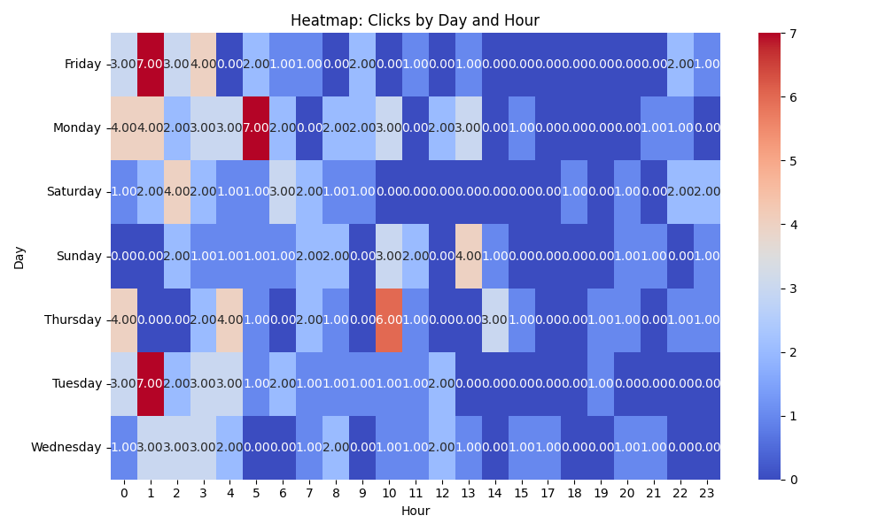

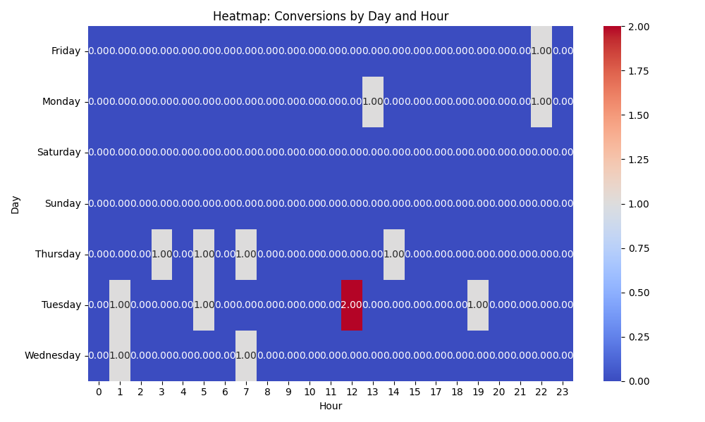

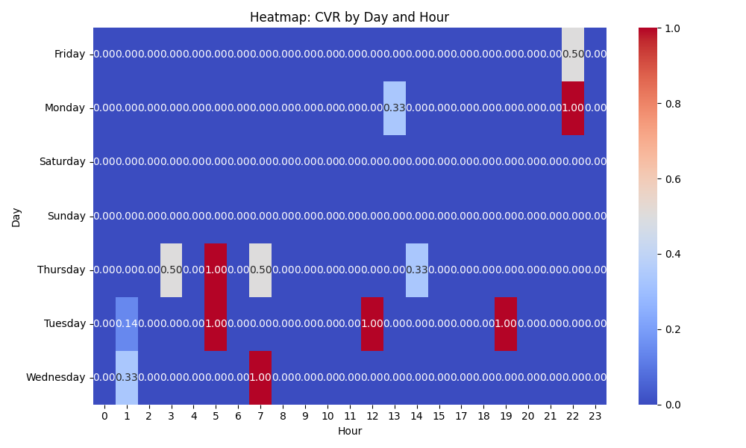

# Competitor Intelligence

# Top Competitor Insights

|  |  |  |
| --- | --- | --- |
| Competitor | Strengths | Recommendations |
| thevideocards.com | Their ad creatives are incredibly direct and product-focused, immediately communicating the core offerings (Video Brochures, Video Boxes, & Video Mailers). This simplicity can be effective for users with clear product intent. The consistency in their ad creatives suggests a clear, albeit narrow, focus on specific product types, which can lead to very targeted clicks if those are their most profitable items. The brevity of their ads implies a strategy to get users to the landing page quickly without much pre-qualification, relying on the landing page to do the heavy lifting. There are no clear unique selling propositions or trust signals evident in the competitor's ad creative itself, suggesting they rely heavily on brand recognition or generic search intent. | While our landing page showcases a broader range of products (Folders, POS, Business Cards), ensure our Google Ad headlines and descriptions clearly feature our primary product categories (Brochures, Boxes, Mailers) to match common search queries. We can then use ad extensions or more specific ad groups to highlight the wider range. Our landing page positions our products as 'The Ultimate Sales and Marketing Tool' that 'Turn Your Brand into an Experience,' focusing on impact and conversion. We should integrate more of these benefit-driven and emotional USPs into our ad headlines and descriptions to differentiate ourselves beyond just product listing. For example, 'Video Brochures: Wow & Convert' or 'Custom Video Mailers for Sales & Marketing.' Our landing page highlights strong differentiators like 'Fully Customizable,' 'Low Minimum Order,' and 'Trusted by Global Brands.' These specific value propositions are missing from the competitor's ad copy. We should actively incorporate these into our ad creatives, especially using callout extensions or prominent headlines, to immediately showcase our competitive advantages and pre-qualify leads before they click. Leverage our powerful social proof (testimonials from Volvo, Volkswagen, Commonwealth Bank) and the 'Trusted by Global Brands' claim in our ad extensions (e.g., structured snippets for 'Brands,' callouts for 'Proven Engagement Booster') to build immediate credibility and stand out from competitors who aren't showcasing such validation in their initial ad messaging. |
|  | This ad clearly states the product and offers a compelling benefit ('Engage Your Audience') followed by a direct call to action ('Get Your Quote Today'). The benefit is broad yet powerful, appealing to a wide range of marketing objectives. This ad creative focuses on an aspirational, high-level benefit: creating 'Unforgettable Brand Experiences'. It speaks to brand reputation and emotional impact, resonating with marketers aiming for premium positioning. This ad is highly specific to a product ('Video Business Cards') and provides a clear, concise benefit tailored to that product's primary use case ('Make a Lasting Impression'). This specificity likely drives highly qualified clicks. This ad directly addresses a key business metric: 'Marketing ROI'. It appeals to performance-driven marketers and decision-makers by promising a tangible return on investment, making the product a strategic solution rather than just a promotional item. This ad positions 'Video Books' as a premium product and connects it to a powerful, aspirational benefit: 'Elevate Your Brand's Story'. This appeals to brands focused on high-value content, narrative, and luxurious presentation. This ad taps into a popular consumer trend ('unboxing') and offers a clear, desirable benefit for brands launching products or creating unique experiences ('Enhance Product Unboxing'). It's highly relevant for e-commerce and premium brands. | Our landing page already highlights 'Proven Engagement Booster' and 'Captivate your audience'. We should ensure our primary Google Ads for 'Video Brochures' prominently feature 'Engage Your Audience' or similar direct engagement benefits in the headlines or descriptions, directly matching this powerful phrasing. Our current hero statement 'The Ultimate Sales and Marketing Tool' is strong, but adding 'Engage Your Audience' in supporting ad copy can strengthen the direct appeal. Our landing page's sub-headline 'Turn Your Brand into an Experience' aligns well, but the competitor's use of 'Unforgettable' adds an extra layer of impact. We should test ad variations that explicitly use terms like 'Unforgettable Brand Experiences' or 'Create Lasting Impressions' for our general Video Brochure campaigns, leveraging that emotional resonance. This complements our 'wow, inform, and convert' messaging effectively. Our landing page lists 'Video Business Cards' and mentions they are 'Best for Events & VIP Outreach'. We should create dedicated ad groups and creatives specifically for 'Video Business Cards' that leverage this precise benefit-driven language, e.g., 'Make a Lasting Impression at Events' or 'Unforgettable VIP Outreach'. This will ensure our ads speak directly to the intent of users searching for this niche product. Our 'Video Mailers' section on the landing page states 'captivate, convert, and build trust, loyalty, and sales', which implies ROI. For our 'Video Mailers' ad campaigns, we should explicitly integrate 'Boost Your Marketing ROI' or 'Maximize Direct Mail ROI' into our ad copy. This strengthens the business case and directly addresses a critical pain point for marketers. Our landing page describes 'Video Books' as 'multi-page, special-edition' and for 'elevate premium promotions'. We should ensure our ad copy for 'Video Books' explicitly uses 'Premium' and the concept of 'Elevating Your Brand's Story'. This language strongly resonates with brands seeking sophisticated, high-impact storytelling tools and aligns perfectly with our product description. Our landing page already states 'Create memorable unboxing experiences with luxury gift boxes' for 'Video Packaging'. This is a direct match in messaging. We should ensure our ad creatives for 'Custom Video Packaging' prominently feature 'Enhance Product Unboxing' or similar language, capitalizing on this highly relevant and appealing benefit for product-focused brands. |
| mediafast.com › video-mailer | Their ad creatives are highly focused, directly using the primary product terms 'Video Mailer' and 'Video Brochure'. This ensures strong keyword relevance and immediate clarity for searchers looking for these specific products. The inclusion of 'Custom, High-Impact' immediately communicates key benefits and value propositions upfront in the ad title, appealing to user needs for differentiation and effectiveness. The consistent, concise, and repeated ad creative for 'Video Mailer' suggests a very clear, successful brand message. This singular focus helps establish MediaFast as an authority or specialist in this specific product, making their offering unambiguous to the searcher. The truncated 'You ...' in their ad title, while seemingly incomplete, subtly implies direct user benefit or a call to action directed at the searcher, making the ad personally relevant. This can create a psychological hook, encouraging clicks. | Develop highly specific ad groups and creatives targeting 'video mailer' and 'video brochure' keywords. Ensure our ad headlines explicitly use these terms (e.g., 'Video Mailer | Custom & High-Impact') and align closely with the language of our landing page's 'Video Mailers' section. This will likely improve our Quality Score and click-through rates for these specific queries, directly competing with MediaFast's precise targeting. While our landing page effectively showcases a broader range of 'Video In Print' products, our ad copy for specific search terms like 'video mailer' or 'video brochure' could benefit from a similar level of focused simplicity. Consider A/B testing ad creatives that are more singular in their focus (e.g., 'Video Mailers: Your Custom Solution' or 'High-Impact Video Brochures'), leveraging our key benefits like 'Proven Engagement Booster'. Use ad extensions (e.g., structured snippets for product types, callouts for benefits) to convey the breadth of our offerings without diluting the main ad's core message. Review our ad copy for opportunities to subtly or explicitly include user-centric language that emphasizes the direct benefit to the searcher. For example, test headlines or descriptions that use 'Your' or speak directly to the customer's needs, such as 'Turn Your Brand into an Experience' directly in ad copy, or 'Video Mailers Designed for You'. This personal touch can enhance engagement and perceived relevance beyond just a direct product description, complementing our strong 'GET A FREE QUOTE' CTAs on the landing page. |

# ⚠️ Risks

# Risks

|  |  |  |
| --- | --- | --- |
| Characteristic | Insight | Recommendation |
| Extremely High Cost Per Acquisition (CPA) relative to daily budget | The current CPA of $155.72 is approximately 4.5 times the daily budget of $35, making the campaign highly inefficient and unsustainable for scaling or positive ROI. | Immediately review and potentially lower the Target CPA bid. Prioritize rapid A/B testing of ad copy, landing pages, and negative keywords to drastically improve conversion rates and reduce CPA. |
| Full budget consumption with inefficient conversion results | The campaign is consistently spending its entire daily budget but at a high CPA, indicating that the allocated spend is not yielding cost-effective conversions. | Identify and pause underperforming keywords or ad groups to prevent further inefficient spend. Reallocate budget to higher-performing areas or consider temporarily reducing the daily budget until CPA efficiency improves. |
| Potential for irrelevant clicks despite decent CTR | While an 8.79% CTR is good, the high CPA suggests that many clicks may not be from users with strong conversion intent, leading to wasted ad spend on unqualified traffic. | Conduct a thorough Search Term Report analysis to identify and add a comprehensive list of negative keywords. Refine keyword match types to ensure higher quality, conversion-oriented traffic. |

# ✅ Opportunities

# Opportunities

|  |  |  |
| --- | --- | --- |
| Characteristic | Insight | Recommendation |
| Campaign is successfully generating conversions | The campaign has acquired 14 conversions, confirming that conversion tracking is active and there is a clear path for users to complete the desired action. | Analyze the characteristics of existing converters (e.g., demographics, location, device) to identify common patterns and refine targeting to attract more high-probability prospects. |
| Sufficient conversion volume for bidding strategy optimization | With 14 conversions, the Target CPA bid strategy has accumulated enough data to learn and optimize performance, allowing the system to improve its efficiency over time. | Allow the Target CPA strategy more time to optimize. Monitor performance closely and consider small, incremental adjustments to the Target CPA goal (e.g., a 10-20% reduction) if performance stabilizes. |
| Strong Click-Through Rate (CTR) | An 8.79% CTR indicates that the ad creatives and initial keyword targeting are highly relevant and compelling, effectively capturing user attention in search results. | Leverage insights from high-performing ad variations to refine and expand ad creative testing. Focus on optimizing the landing page experience to capitalize on the strong initial engagement and drive higher conversion rates. |