Google Ads Audit Report

# Campaign Performance (w/ Benchmark Overlay)

|  |  |  |  |  |  |  |  |  |  |
| --- | --- | --- | --- | --- | --- | --- | --- | --- | --- |
| Campaign Name | CTR | Cost ($) | Clicks | Impressions | CTR Flag | Avg CPC | Avg CPC Flag | CPA ($) | CPA ($) Flag |
| Search - Financial Advisor - (USA) - 250K+ 2024 | 2.38% | $11540.41 | 1936 | 81374 | Below | $5.96 | Above | $122.77 | Above |
| Search - Retirement Advisor - Phrase - USA - 250K+ (tCPA) | 2.14% | $3367.96 | 514 | 24036 | Below | $6.55 | Above | $168.40 | Above |
| Search - Brand - (USA) - 2025 | 25.72% | $2961.05 | 294 | 1143 | Above | $10.07 | Above | $88.83 | Above |
| Search - Financial Advisor - (USA) - 250K+ 2024 Mayank_NewForm | 3.00% | $2071.43 | 311 | 10373 |  | $6.66 | Above | $109.02 | Above |
| Search - Retirement Advisor - Phrase - USA - 250K+ (tCPA) Mayank_NewForm_02 | 2.74% | $462.22 | 73 | 2661 |  | $6.33 | Above | $154.07 | Above |

# Campaign Insights

⚠️ Unable to parse structured insights — showing raw output below.

[]

# Keyword Performance

|  |  |  |  |  |  |  |  |  |
| --- | --- | --- | --- | --- | --- | --- | --- | --- |
| Ad Group | Keyword | Match Type | Quality Score | Impressions | Clicks | CTR | Avg CPC | CPA ($) |
| Financial Advisor | financial advisor | BROAD | 3 | 32190 | 730 | 2.27% | $6.28 | $134.79 |
| Financial Advisor | fidelity independent advisor | BROAD | 5 | 11467 | 395 | 3.44% | $5.11 | $155.13 |
| Brand Only | wiseradvisor | EXACT | 8 | 753 | 184 | 24.44% | $9.10 | $67.00 |
| Financial Advisor | financial advisor | BROAD | 5 | 6750 | 209 | 3.10% | $7.25 | $131.85 |
| Brand Only | wiser advisor | EXACT | 8 | 243 | 83 | 34.16% | $10.22 | $101.76 |
| Financial Advisor | wealth advice | BROAD | 0 | 4261 | 71 | 1.67% | $7.79 | $92.24 |
| Retirement Advisor Phrase | retirement financial advisor | BROAD | 5 | 2730 | 61 | 2.23% | $7.85 | $159.58 |
| Financial Advisor | financial management advisory | BROAD | 0 | 4906 | 91 | 1.85% | $5.23 | $238.09 |
| Brand Only | wiseradvisor reviews | EXACT | 5 | 144 | 25 | 17.36% | $16.81 | $0.00 |
| Financial Advisor | financial advisor ratings | BROAD | 5 | 2179 | 88 | 4.04% | $4.44 | $390.38 |
| Retirement Advisor Phrase | retirement financial advisors | BROAD | 0 | 2046 | 45 | 2.20% | $7.69 | $173.07 |
| Retirement Advisor Phrase | federal retirement advisors | BROAD | 3 | 1483 | 61 | 4.11% | $5.54 | $112.57 |
| Financial Advisor | best financial advisor | BROAD | 5 | 1988 | 50 | 2.52% | $6.46 | $80.81 |
| Financial Advisor | need a financial advisor | BROAD | 0 | 3135 | 53 | 1.69% | $6.09 | $161.48 |
| Financial Advisor | finding a financial advisor | BROAD | 1 | 2374 | 41 | 1.73% | $7.83 | $80.29 |
| Financial Advisor | financial advisory fees | BROAD | 5 | 1906 | 68 | 3.57% | $4.18 | $142.14 |
| Financial Advisor | financial advisor local | BROAD | 0 | 1759 | 42 | 2.39% | $5.87 | $41.09 |
| Financial Advisor | the best financial advisors | BROAD | 8 | 1371 | 41 | 2.99% | $5.92 | $121.32 |
| Retirement Advisor Phrase | retirement advisory | BROAD | 3 | 1178 | 29 | 2.46% | $8.20 | $0.00 |
| Retirement Advisor Phrase | retirement financial advisors near me | BROAD | 0 | 1518 | 34 | 2.24% | $6.95 | $236.28 |
| Retirement Advisor Phrase | retirement planning financial advisor | BROAD | 0 | 1947 | 36 | 1.85% | $6.25 | $112.58 |
| Financial Advisor - Generic | local financial advisor | BROAD | 2 | 937 | 27 | 2.88% | $7.35 | $198.57 |
| Financial Advisor | wealth advisor services | BROAD | 0 | 1011 | 28 | 2.77% | $6.85 | $95.95 |
| Retirement Advisor Phrase | retirement income financial planner | BROAD | 0 | 1168 | 28 | 2.40% | $6.32 | $88.52 |
| Retirement Advisor Phrase | retirement financial advisor near me | BROAD | 0 | 810 | 26 | 3.21% | $6.71 | $174.43 |
| Financial Advisor | how to choose a financial advisor for retirement | BROAD | 0 | 1283 | 23 | 1.79% | $7.47 | $85.93 |
| Financial Advisor | reputable financial advisors | BROAD | 7 | 1227 | 24 | 1.96% | $7.07 | $169.67 |
| Financial Advisor | compare financial advisor fees | BROAD | 0 | 1156 | 42 | 3.63% | $3.94 | $165.61 |
| Retirement Advisor Phrase | retirement planning advisor | BROAD | 0 | 907 | 20 | 2.21% | $7.00 | $0.00 |
| Financial Advisor | best financial advisor | BROAD | 0 | 540 | 19 | 3.52% | $7.27 | $46.02 |
| Retirement Advisor Phrase | retirement financial advisor near me | BROAD | 3 | 1212 | 20 | 1.65% | $6.85 | $0.00 |
| Financial Advisor | fidelity independent advisor | BROAD | 3 | 818 | 26 | 3.18% | $4.92 | $0.00 |
| Retirement Advisor Phrase | retirement investment advisors | BROAD | 3 | 1254 | 22 | 1.75% | $5.69 | $0.00 |
| Retirement Advisor Phrase | financial advisor for retirees | BROAD | 7 | 993 | 25 | 2.52% | $4.98 | $41.53 |
| Retirement Advisor Phrase | retirement advisors near me | BROAD | 0 | 887 | 22 | 2.48% | $5.42 | $0.00 |
| Financial Advisor | wealth planning advisors | BROAD | 0 | 1123 | 15 | 1.34% | $6.72 | $100.87 |
| Retirement Advisor Phrase | best retirement financial advisors near me | BROAD | 0 | 767 | 11 | 1.43% | $8.98 | $98.75 |
| Financial Advisor | private wealth consultants | BROAD | 1 | 659 | 19 | 2.88% | $4.69 | $89.16 |
| Financial Advisor | finding a financial advisor | BROAD | 0 | 313 | 9 | 2.88% | $9.78 | $87.98 |
| Financial Advisor | global financial advisor | BROAD | 3 | 504 | 15 | 2.98% | $5.83 | $87.44 |
| Retirement Advisor Phrase | retirement advisor near me | BROAD | 3 | 458 | 16 | 3.49% | $5.38 | $86.02 |
| Retirement Advisor Phrase | retirement advisors in my area | BROAD | 3 | 434 | 16 | 3.69% | $5.30 | $0.00 |
| Nearby Financial Advisor | good financial advisor near me | BROAD | 0 | 670 | 8 | 1.19% | $10.15 | $0.00 |
| Retirement Advisor Phrase | retirement advisor | BROAD | 0 | 1084 | 12 | 1.11% | $6.76 | $0.00 |
| Financial Advisor | no fee financial advisor | BROAD | 0 | 607 | 13 | 2.14% | $6.20 | $40.32 |
| Financial Advisor | private wealth adviser | BROAD | 0 | 981 | 12 | 1.22% | $6.53 | $78.41 |
| Retirement Advisor Phrase | best retirement financial advisors | BROAD | 0 | 863 | 12 | 1.39% | $6.09 | $0.00 |
| Retirement Advisor Phrase | retirement advisors near me | BROAD | 3 | 657 | 13 | 1.98% | $5.46 | $70.99 |
| Retirement Advisor Phrase | federal retirement advisors | BROAD | 3 | 327 | 10 | 3.06% | $6.71 | $67.07 |
| Retirement Advisor Phrase | retirement financial advisor | BROAD | 7 | 278 | 7 | 2.52% | $8.97 | $62.81 |

# Keyword Insights

⚠️ Unable to parse structured insights — showing raw output below.

# Wasted Spend Insights

# Wasted Spend Insights

|  |  |  |
| --- | --- | --- |
| Characteristic | Insight | Recommendation |
| High Spend, Zero Conversions, Moderate Quality Score, High CPC for Informational Intent | The keyword wiseradvisor reviews incurred the highest cost at $420.24 with zero conversions, indicating a significant budget waste. While its CTR is relatively high at 17.36%, the Avg CPC is extremely high at $16.81. The Quality Score of 5 suggests some relevance, but the lack of conversions points to a fundamental mismatch in user intent (likely research/informational) versus the campaign's conversion goal. | Immediately add 'reviews', 'review', 'scam', 'complaints' as negative keywords to prevent matching informational searches. Re-evaluate the landing page for wiseradvisor reviews; if current intent is commercial, ensure it directly offers a service or alternative, not just information. Consider adjusting ad copy to pivot from reviews to a direct service offering. |
| High Spend, Zero Conversions, Extremely Low Quality Score & CTR for Broad Term | The broad keyword retirement advisory spent $237.79 with no conversions. Its Quality Score is critically low at 3, and CTR is abysmal at 2.46%. This indicates severe irrelevance to user search intent or poor ad creative/landing page experience, leading to high Avg CPC ($8.20) for non-performing clicks. | Immediately pause retirement advisory due to its generic nature and poor performance. Shift budget to more specific long-tail or exact match keywords like '[retirement advisory services]' or '[find a retirement advisor]'. Ensure any re-enabled, refined versions are in tightly themed ad groups with highly relevant ad copy and landing pages. |
| Significant Spend, Zero Conversions, Critically Low Quality Score & CTR | The keyword retirement planning advisor incurred $139.91 in cost with zero conversions. Its Quality Score is effectively zero (indicating critical issues), and CTR is extremely poor at 2.21%. This points to a fundamental mismatch between the keyword, ad copy, and landing page, resulting in wasted spend and inefficient Avg CPC ($7.00). | Pause retirement planning advisor immediately. If this keyword is highly relevant, re-enable it as an exact match '[retirement planning advisor]' or phrase match 'retirement planning advisor' in a dedicated ad group. Conduct a thorough ad copy and landing page audit to ensure hyper-relevance, featuring clear CTAs for consultation or service inquiries. |
| High Spend, Zero Conversions, Poor Quality Score & Extremely Low CTR for High-Intent Local Search | The keyword retirement financial advisor near me spent $137.03 with zero conversions, despite being a high-intent local search term. Its Quality Score of 3 and extremely low CTR of 1.65% are concerning. This suggests the ad copy or landing page is failing to capture local searchers effectively, leading to wasted spend at an Avg CPC of $6.85. | Optimize ad copy for retirement financial advisor near me with highly localized messaging, location extensions, and phone numbers. Ensure the landing page is mobile-friendly, highlights local services prominently, and has clear calls-to-action (e.g., 'Schedule a Free Local Consultation'). Review geographic targeting for precision. |
| Significant Spend, Zero Conversions, Low Quality Score & CTR for Brand-Specific Term | The keyword fidelity independent advisor cost $127.81 with no conversions. The Quality Score is low at 3, and CTR is low at 3.18%. This keyword implies users are seeking Fidelity-affiliated advisors. If your service is not Fidelity, your ad or landing page is failing to redirect or offer a compelling alternative, leading to wasted budget at an Avg CPC of $4.92. | If not a Fidelity affiliate, revise ad copy for fidelity independent advisor to immediately clarify and pivot to your unique selling proposition (e.g., 'Seeking an Independent Advisor? We Offer X, Y, Z Benefits'). Ensure the landing page directly addresses the Fidelity query and offers your distinct advantages. Consider adding 'fidelity' as a negative keyword if your service has no direct competitive offering or relation. |
| Significant Spend, Zero Conversions, Very Low Quality Score & CTR | The keyword retirement investment advisors has spent $125.10 with no conversions. Its Quality Score is poor at 3, and CTR is extremely low at 1.75%. This indicates a major disconnect between user intent for retirement investment advisors and your ad/landing page, leading to inefficient spend at an Avg CPC of $5.69. | Ensure retirement investment advisors is running on an appropriate match type (Phrase or Exact); restrict if currently broad. Create highly specific ad copy that explicitly mentions 'retirement investment' benefits and services. Conduct a deep dive on the landing page to ensure it explicitly focuses on retirement investment strategies and advisor services with strong calls to action. |
| Significant Spend, Zero Conversions, Critically Low Quality Score & Very Low CTR for High-Intent Local Search | The keyword retirement advisors near me spent $119.21 with zero conversions. Its Quality Score is critically low (effectively zero), and CTR is very poor at 2.48%. This is a high-intent local search term, and its underperformance (Avg CPC $5.42) indicates a severe lack of ad-to-query relevance or a poor local landing page experience. | Immediately enhance ad copy for retirement advisors near me to prominently feature local elements, use dynamic location insertion, and include call/location extensions. Direct traffic to a dedicated, mobile-optimized landing page explicitly showcasing local advisors, testimonials, and clear 'near me' language. Audit geo-targeting for precision. |
| Significant Spend, Zero Conversions, Low Quality Score & Low CTR for Local Search | The keyword retirement advisors in my area incurred $84.85 in cost with no conversions. Its Quality Score is low at 3, and CTR is low at 3.69%. This high-intent local query is performing poorly at an Avg CPC of $5.30, indicating a failure to resonate with users actively seeking local assistance. | Implement ad customizers to dynamically insert the user's city or area into ad copy for retirement advisors in my area to increase personalization. Ensure the landing page is robust with local information, area-specific testimonials, and clear contact details. Consider testing call-only campaigns for such immediate-intent local terms to drive direct phone calls. |
| Significant Spend, Zero Conversions, Critically Low Quality Score & Extremely Low CTR at Very High CPC for High-Intent Local Search | The keyword good financial advisor near me incurred $81.24 with no conversions. Its Quality Score is effectively zero, and CTR is incredibly low at 1.19%, despite its high commercial and local intent. The Avg CPC is alarmingly high at $10.15, indicating severe inefficiency and irrelevance, leading to wasted budget. | Pause good financial advisor near me immediately due to critical performance issues. If re-enabled, consider it as an exact match '[good financial advisor near me]' within a highly focused ad group. Develop ad copy that builds immediate trust and authority (e.g., 'Highly Rated Local Advisors,' 'Experienced & Trusted'). The landing page must prominently feature awards, certifications, or client success stories to address the user's desire for a 'good' advisor. |
| Significant Spend, Zero Conversions, Critically Low Quality Score & Extremely Low CTR for Broad Commercial Term | The keyword retirement advisor spent $81.07 with no conversions. Its Quality Score is critically low (effectively zero), and CTR is incredibly poor at 1.11%. This broad term is highly inefficient, leading to wasted clicks at an Avg CPC of $6.76, indicating a fundamental mismatch between the keyword's broad nature and the current campaign's ability to convert. | Pause retirement advisor immediately. Implement an aggressive negative keyword strategy to prevent matching irrelevant searches (e.g., 'jobs', 'salary', 'definition'). Shift budget to more specific exact match keywords like '[best retirement advisor]' or '[local retirement advisor]'. If re-enabled, ensure ad copy and landing page are highly specific to the service provided by a 'retirement advisor', focusing on benefits and outcomes. |
| Significant Spend, Zero Conversions, Critically Low Quality Score & Extremely Low CTR for High-Intent 'Best Of' Search | The keyword best retirement financial advisors spent $73.09 with zero conversions. Its Quality Score is critically low (effectively zero), and CTR is extremely poor at 1.39%. This suggests a failure to convince users that your service is indeed among the 'best,' leading to wasted clicks at an Avg CPC of $6.09. | Craft ad copy for best retirement financial advisors that uses strong trust signals and social proof (e.g., 'Award-Winning Advisors,' 'Top-Rated,' 'Recognized Experts'). Direct users to a landing page that showcases awards, certifications, client testimonials, or clear differentiators establishing your service as 'best-in-class.' Ensure this is either an exact or phrase match keyword; if broad, restrict it immediately. |

# Landing Page Audit Insights

⚠️ Failed to parse LP audit JSON — showing raw output.

[]

⚠️ Failed to parse LP audit JSON — showing raw output.

[]

⚠️ Failed to parse LP audit JSON — showing raw output.

[]

⚠️ Failed to parse LP audit JSON — showing raw output.

[]

⚠️ Failed to parse LP audit JSON — showing raw output.

[]

⚠️ Failed to parse LP audit JSON — showing raw output.

[]

⚠️ Failed to parse LP audit JSON — showing raw output.

[]

# Geographical Performance

|  |  |  |  |  |  |  |  |  |  |
| --- | --- | --- | --- | --- | --- | --- | --- | --- | --- |
| City | Region | Country | Type | Impressions | Clicks | Conversions | Cost ($) | CVR | CPA ($) |
| United States |  |  | Country | 135794 | 3460 | 184.333334 | $22669.40 | 0.05327553005780347 | $122.98 |

# Geographical Insights

⚠️ Unable to parse structured insights — showing raw output below.

# Hourly Performance Pivot

CVR

|  |  |  |  |  |  |  |  |  |  |  |  |  |  |  |  |  |  |  |  |  |  |  |  |
| --- | --- | --- | --- | --- | --- | --- | --- | --- | --- | --- | --- | --- | --- | --- | --- | --- | --- | --- | --- | --- | --- | --- | --- |
| Day/Hour | 0 | 1 | 2 | 3 | 4 | 5 | 7 | 8 | 9 | 10 | 11 | 12 | 13 | 14 | 15 | 16 | 17 | 18 | 19 | 20 | 21 | 22 | 23 |
| Monday |  | 0.20 |  | 0.50 |  | 0.67 |  | 0.08 | 0.06 | 0.04 | 0.05 | 0.29 | 0.30 | 0.57 | 0.28 |  | 0.07 |  | 0.05 | 0.09 | 0.14 | 2.27 | 1.07 |
| Tuesday | 0.09 |  |  |  |  |  |  |  |  |  |  | 0.08 | 1.20 | 0.13 |  | 0.44 | 0.25 |  | 0.33 | 0.20 |  |  | 0.25 |
| Wednesday | 1.00 |  | 3.00 |  |  | 0.33 |  |  |  |  | 0.83 | 0.06 | 0.17 | 0.47 | 0.49 |  | 0.05 |  | 0.26 | 0.83 | 0.10 | 0.33 | 0.50 |
| Thursday |  |  |  |  | 0.50 | 0.20 | 0.42 |  | 0.13 | 0.07 | 0.17 | 0.06 | 0.04 |  | 0.28 | 0.07 | 0.14 | 0.08 | 0.17 |  | 0.24 | 0.23 | 0.25 |
| Friday | 0.53 | 1.00 | 2.00 |  |  |  | 0.25 |  |  | 1.30 | 0.42 |  | 0.45 | 0.08 | 1.00 |  | 0.05 | 0.05 | 0.18 | 0.14 |  | 0.08 |  |
| Saturday | 0.20 | 1.00 | 2.00 | 0.50 |  | 0.50 |  | 0.14 | 0.17 |  | 0.08 | 0.11 |  | 0.24 | 0.11 |  |  |  | 0.31 | 0.05 |  | 0.48 |  |
| Sunday |  |  | 0.33 | 1.00 |  |  | 0.50 | 0.12 |  |  | 0.08 | 2.07 |  |  |  |  | 0.06 | 0.08 |  |  |  |  | 2.25 |

Clicks

|  |  |  |  |  |  |  |  |  |  |  |  |  |  |  |  |  |  |  |  |  |  |  |  |  |
| --- | --- | --- | --- | --- | --- | --- | --- | --- | --- | --- | --- | --- | --- | --- | --- | --- | --- | --- | --- | --- | --- | --- | --- | --- |
| Day/Hour | 0 | 1 | 2 | 3 | 4 | 5 | 6 | 7 | 8 | 9 | 10 | 11 | 12 | 13 | 14 | 15 | 16 | 17 | 18 | 19 | 20 | 21 | 22 | 23 |
| Monday |  |  |  |  |  |  |  |  |  |  |  |  |  |  |  |  |  |  |  |  |  |  |  |  |
| Tuesday |  |  |  |  |  |  |  |  |  |  |  |  |  |  |  |  |  |  |  |  |  |  |  |  |
| Wednesday |  |  |  |  |  |  |  |  |  |  |  |  |  |  |  |  |  |  |  |  |  |  |  |  |
| Thursday |  |  |  |  |  |  |  |  |  |  |  |  |  |  |  |  |  |  |  |  |  |  |  |  |
| Friday |  |  |  |  |  |  |  |  |  |  |  |  |  |  |  |  |  |  |  |  |  |  |  |  |
| Saturday |  |  |  |  |  |  |  |  |  |  |  |  |  |  |  |  |  |  |  |  |  |  |  |  |
| Sunday |  |  |  |  |  |  |  |  |  |  |  |  |  |  |  |  |  |  |  |  |  |  |  |  |

Conversions

|  |  |  |  |  |  |  |  |  |  |  |  |  |  |  |  |  |  |  |  |  |  |  |  |
| --- | --- | --- | --- | --- | --- | --- | --- | --- | --- | --- | --- | --- | --- | --- | --- | --- | --- | --- | --- | --- | --- | --- | --- |
| Day/Hour | 0 | 1 | 2 | 3 | 4 | 5 | 7 | 8 | 9 | 10 | 11 | 12 | 13 | 14 | 15 | 16 | 17 | 18 | 19 | 20 | 21 | 22 | 23 |
| Monday |  | 1.00 |  | 1.00 |  | 2.00 |  | 1.00 | 1.00 | 1.00 | 1.00 | 2.00 | 3.00 | 5.00 | 4.00 |  | 1.00 |  | 1.00 | 2.00 | 3.00 | 6.00 | 3.00 |
| Tuesday | 1.00 |  |  |  |  |  |  |  |  |  |  | 1.00 | 3.00 | 2.00 |  | 5.00 | 1.00 |  | 3.00 | 1.00 |  |  | 1.00 |
| Wednesday | 1.00 |  | 3.00 |  |  | 1.00 |  |  |  |  | 3.00 | 1.00 | 1.00 | 4.00 | 4.00 |  | 1.00 |  | 2.00 | 3.00 | 2.00 | 1.00 | 1.00 |
| Thursday |  |  |  |  | 1.00 | 2.00 | 2.00 |  | 2.00 | 1.00 | 2.00 | 1.00 | 1.00 |  | 2.33 | 2.00 | 2.00 | 1.00 | 2.00 |  | 2.00 | 2.00 | 1.00 |
| Friday | 2.00 | 1.00 | 2.00 |  |  |  | 1.00 |  |  | 4.00 | 3.00 |  | 5.00 | 2.00 | 1.00 |  | 1.00 | 1.00 | 2.00 | 1.00 |  | 1.00 |  |
| Saturday | 1.00 | 1.00 | 2.00 | 1.00 |  | 1.00 |  | 1.00 | 1.00 |  | 1.00 | 1.00 |  | 2.00 | 1.00 |  |  |  | 2.00 | 1.00 |  | 2.00 |  |
| Sunday |  |  | 1.00 | 1.00 |  |  | 2.00 | 1.00 |  |  | 1.00 | 3.00 |  |  |  |  | 1.00 | 1.00 |  |  |  |  | 3.00 |

Cost ($)

|  |  |  |  |  |  |  |  |  |  |  |  |  |  |  |  |  |  |  |  |  |  |  |  |  |
| --- | --- | --- | --- | --- | --- | --- | --- | --- | --- | --- | --- | --- | --- | --- | --- | --- | --- | --- | --- | --- | --- | --- | --- | --- |
| Day/Hour | 0 | 1 | 2 | 3 | 4 | 5 | 6 | 7 | 8 | 9 | 10 | 11 | 12 | 13 | 14 | 15 | 16 | 17 | 18 | 19 | 20 | 21 | 22 | 23 |
| Monday | 87.88 | 66.50 | 51.04 | 44.25 | 15.66 | 36.97 | 20.03 | 35.41 | 87.22 | 141.81 | 202.60 | 279.76 | 236.09 | 247.64 | 318.10 | 213.83 | 269.27 | 122.73 | 189.91 | 198.00 | 160.62 | 146.37 | 178.37 | 138.15 |
| Tuesday | 44.10 | 24.04 | 27.31 | 16.92 | 23.02 | 28.06 | 32.00 | 14.79 | 98.46 | 83.39 | 98.17 | 110.12 | 210.39 | 90.95 | 214.96 | 187.15 | 281.30 | 108.33 | 84.75 | 110.60 | 99.17 | 102.02 | 94.10 | 93.97 |
| Wednesday | 73.14 | 51.63 | 93.84 | 35.54 | 25.31 | 17.97 | 31.00 | 104.67 | 71.56 | 101.39 | 145.65 | 170.66 | 155.51 | 162.55 | 240.42 | 190.25 | 144.06 | 120.83 | 115.22 | 126.16 | 172.67 | 146.33 | 99.72 | 90.53 |
| Thursday | 42.50 | 59.76 | 27.46 | 58.05 | 31.26 | 77.92 | 49.20 | 82.29 | 81.54 | 166.87 | 234.49 | 208.05 | 141.16 | 253.05 | 260.34 | 248.69 | 330.53 | 96.02 | 187.72 | 106.05 | 209.71 | 192.45 | 146.72 | 129.00 |
| Friday | 59.17 | 101.18 | 90.71 | 91.32 | 62.63 | 63.75 | 110.56 | 112.95 | 161.39 | 97.79 | 165.49 | 290.32 | 166.35 | 313.56 | 224.04 | 221.25 | 212.39 | 175.46 | 149.06 | 102.53 | 132.69 | 131.12 | 125.24 | 144.97 |
| Saturday | 55.90 | 96.53 | 40.91 | 30.65 | 72.14 | 138.33 | 35.35 | 81.65 | 109.79 | 243.94 | 195.55 | 163.18 | 151.98 | 149.30 | 221.75 | 119.59 | 191.73 | 124.07 | 240.03 | 254.56 | 133.73 | 156.19 | 113.70 | 89.42 |
| Sunday | 41.91 | 21.43 | 25.04 | 21.90 | 40.97 | 20.98 | 60.52 | 16.60 | 59.24 | 83.13 | 39.50 | 95.94 | 89.48 | 75.66 | 98.93 | 93.51 | 129.96 | 202.43 | 106.89 | 92.49 | 133.32 | 89.73 | 76.17 | 97.73 |

# Hourly Patterns Insights

⚠️ Unable to parse structured insights — showing raw output below.

[]

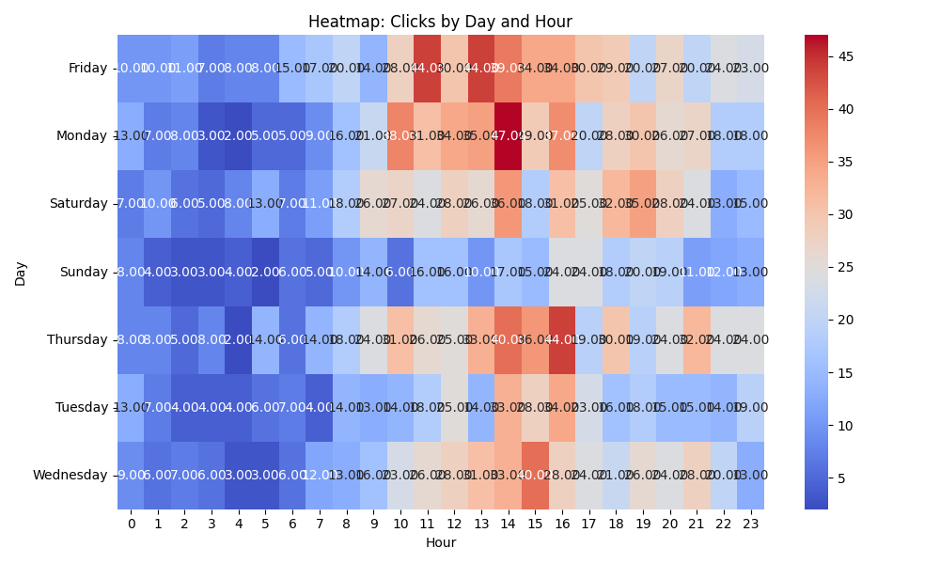

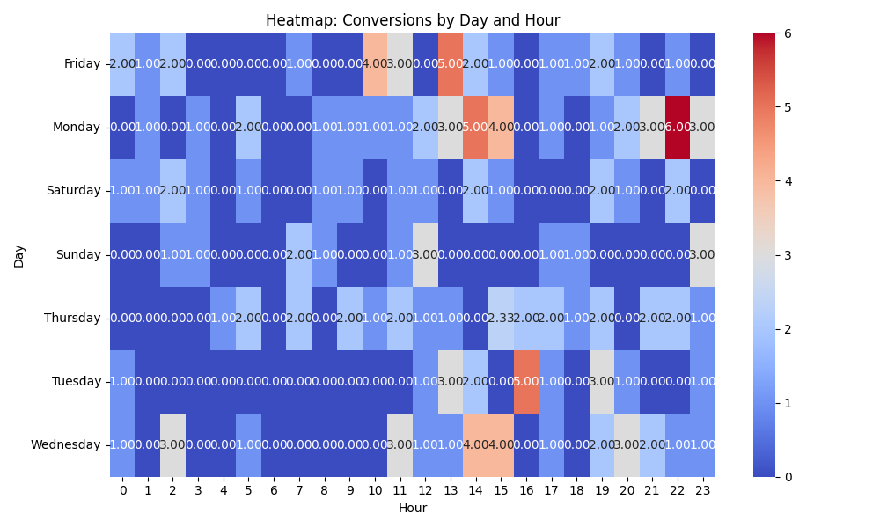

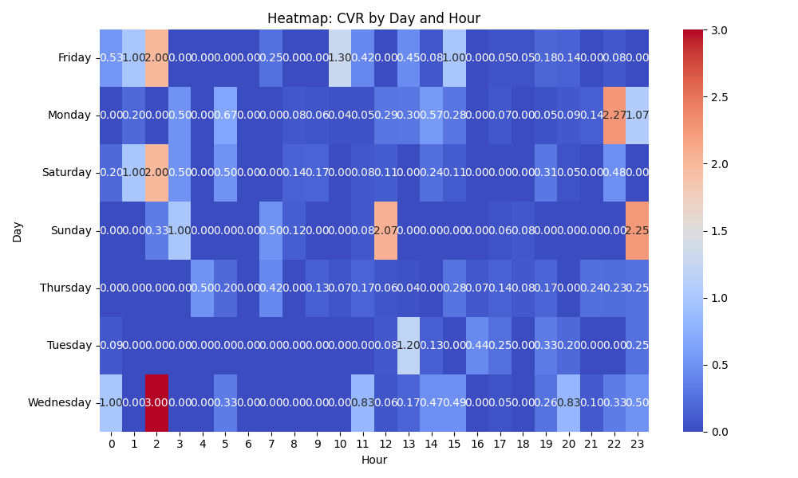

# Competitor Intelligence

# Top Competitor Insights

|  |  |  |
| --- | --- | --- |
| Competitor | Strengths | Recommendations |
|  | ❌ Parse Error: Could not extract valid JSON | N/A |
| tiaa.org › wealth-management › perspectives | ❌ Parse Error: Could not extract valid JSON | N/A |
| wiseradvisor.com | ❌ Parse Error: Could not extract valid JSON | N/A |
| 980+ followers | ❌ Parse Error: Could not extract valid JSON | N/A |

# ⚠️ Risks

# Risks

|  |  |  |
| --- | --- | --- |
| Characteristic | Insight | Recommendation |
| Insufficient Conversion Volume for New Smart Bidding Campaigns | The 'Search - Retirement Advisor - Phrase - USA - 250K+ (tCPA) MayankNewForm02' campaign (ID 22895148214) has only 3 conversions for $462.22 cost, which is critically low for Target CPA bidding to learn and optimize effectively, especially given its high daily budget of $1500. | Pause this new campaign or switch to a volume-driven bid strategy (e.g., Max Conversions or Max Clicks with a cap) until consistent conversion volume (minimum 15-30 conversions per month) is achieved, then re-evaluate tCPA. Review targeting and ad relevance immediately. |
| Potential for Campaign Cannibalization and Redundancy | The presence of multiple campaigns with very similar names (e.g., two 'Financial Advisor' and two 'Retirement Advisor' campaigns, differentiated by start dates or 'MayankNewForm' labels) suggests potential keyword overlap and internal competition, which can inflate CPCs and dilute data for smart bidding algorithms. | Conduct a comprehensive audit of keyword targeting and negative keywords across all similar campaigns. Consider consolidating highly overlapping campaigns or implementing strict segmentation to ensure unique value propositions and avoid internal bidding wars. |
| High CPA and Inefficiency in Mature Retirement Advisor Campaign | The 'Search - Retirement Advisor - Phrase - USA - 250K+ (tCPA)' campaign (ID 77950089), despite being very mature (started 2012) and having a high daily budget ($1500), exhibits a high CPA ($168.40) and lower conversion efficiency compared to other top-spending campaigns. | Implement aggressive optimization. This includes detailed search query report analysis for new negative keywords, refreshing ad copy and landing pages, testing new audience signals, and potentially lowering the Target CPA or experimenting with Maximize Conversions to improve cost efficiency. |

# ✅ Opportunities

# Opportunities

|  |  |  |
| --- | --- | --- |
| Characteristic | Insight | Recommendation |
| Exceptional Brand Campaign Performance | The 'Search - Brand' campaign (ID 22262639231) shows outstanding performance with a 25.72% CTR and the lowest CPA ($88.83), indicating strong brand recognition and highly efficient conversions from high-intent searches. | Ensure this brand campaign has sufficient budget to capture all available impressions and clicks. Explore further optimization of ad extensions and sitelinks to maximize visibility and click-through rates, potentially expanding to defensive strategies like competitor brand bidding if appropriate and permitted. |
| Improved CPA in New Financial Advisor Campaign Iteration | The 'Search - Financial Advisor - (USA) - 250K+ 2024 MayankNewForm' campaign (ID 22890991583) is achieving a lower CPA ($109.02) compared to its older counterpart ($122.77), suggesting that the 'MayankNewForm' iteration incorporates effective improvements in targeting or ad experience. | Thoroughly analyze the specific differences (e.g., ad copy, landing page, targeting settings, keyword selection) in the 'MayankNewForm' campaign that are contributing to the lower CPA. Systematically test and apply these successful elements to the older, higher-volume 'Financial Advisor' campaign to improve overall account efficiency. |
| Data-Driven Optimization Potential from New Campaign Tests | The new 'MayankNewForm' campaigns, despite their nascent stage, are providing valuable A/B testing data on newer strategies, ad creatives, and landing pages. The performance of the new Financial Advisor campaign specifically highlights a potentially more efficient approach. | Prioritize gathering more conversion data for the promising 'MayankNewForm' campaigns. Systematically extract and test successful components from these newer campaigns (e.g., ad headlines, descriptions, landing page designs, audience targeting) and implement them across older, higher-spending campaigns to drive broader performance improvements. |