Google Ads Audit Report

# Campaign Performance (w/ Benchmark Overlay)

|  |  |  |  |  |  |  |  |  |  |
| --- | --- | --- | --- | --- | --- | --- | --- | --- | --- |
| Campaign Name | CTR | Cost ($) | Clicks | Impressions | CTR Flag | Avg CPC | Avg CPC Flag | CPA ($) | CPA ($) Flag |
| VPP_Search_Leads_USA_03/08/2024 (Exp 1) | 8.79% | $2180.15 | 197 | 2242 | Above | $11.07 | Above | $155.72 | Above |

# Campaign Insights

⚠️ Unable to parse structured insights — showing raw output below.

[]

# Keyword Performance

|  |  |  |  |  |  |  |  |  |
| --- | --- | --- | --- | --- | --- | --- | --- | --- |
| Ad Group | Keyword | Match Type | Quality Score | Impressions | Clicks | CTR | Avg CPC | CPA ($) |
| Video Mailers | video mailers | PHRASE | 3 | 294 | 28 | 9.52% | $13.52 | $126.23 |
| VPP Brochures | video brochures | PHRASE | 5 | 347 | 23 | 6.63% | $13.36 | $0.00 |
| Video Books | promotional video book | PHRASE | 6 | 76 | 12 | 15.79% | $13.36 | $160.34 |
| Video Box | video box | PHRASE | 3 | 411 | 24 | 5.84% | $5.17 | $0.00 |
| Video Box | box with video screen | PHRASE | 4 | 35 | 10 | 28.57% | $11.08 | $110.85 |
| Video Box | video box marketing | PHRASE | 6 | 70 | 7 | 10.00% | $12.54 | $0.00 |
| Video Mailers | video mailers marketing | PHRASE | 7 | 61 | 6 | 9.84% | $13.32 | $0.00 |
| Video Mailers | video brochure mailer | PHRASE | 4 | 34 | 3 | 8.82% | $26.37 | $31.64 |
| Video Books | video book marketing | PHRASE | 6 | 98 | 11 | 11.22% | $6.34 | $34.87 |
| Video Mailers | custom video mailers | PHRASE | 5 | 48 | 6 | 12.50% | $10.98 | $65.85 |
| Video Books | personalized video books | PHRASE | 5 | 80 | 11 | 13.75% | $5.58 | $61.41 |
| Video Box | custom video box | PHRASE | 5 | 37 | 3 | 8.11% | $18.40 | $0.00 |
| VPP Brochures | video brochure card | PHRASE | 4 | 100 | 5 | 5.00% | $9.54 | $0.00 |
| Video Books | custom video books | PHRASE | 5 | 105 | 9 | 8.57% | $4.59 | $0.00 |
| Video Mailers | video card mailer | PHRASE | 3 | 17 | 3 | 17.65% | $12.41 | $37.24 |
| VPP Brochures | video brochure usa | PHRASE | 4 | 18 | 1 | 5.56% | $36.15 | $36.15 |
| VPP Brochures | custom video brochures | PHRASE | 7 | 58 | 3 | 5.17% | $9.88 | $59.27 |
| VPP Brochures | lcd screen video brochure | PHRASE | 4 | 20 | 2 | 10.00% | $13.20 | $0.00 |
| VPP Brochures | video brochure manufacturer | PHRASE | 3 | 3 | 2 | 66.67% | $11.74 | $0.00 |
| Video Box | video gift box | PHRASE | 5 | 47 | 5 | 10.64% | $2.97 | $0.00 |
| VPP Brochures | lcd video brochure | PHRASE | 3 | 5 | 1 | 20.00% | $13.72 | $0.00 |
| VPP Brochures | video brochure marketing | PHRASE | 5 | 2 | 1 | 50.00% | $12.49 | $0.00 |
| VPP Brochures | video brochure pricing | PHRASE | 0 | 10 | 1 | 10.00% | $11.03 | $0.00 |
| VPP Brochures | video brochure book | PHRASE | 5 | 2 | 1 | 50.00% | $9.41 | $0.00 |
| VPP Brochures | 4.3 inch video brochure | PHRASE | 0 | 3 | 1 | 33.33% | $7.84 | $0.00 |
| VPP Brochures | brochure with video screen | PHRASE | 6 | 6 | 1 | 16.67% | $7.42 | $0.00 |
| Video Mailers | lcd video mailers | EXACT | 0 | 4 | 1 | 25.00% | $5.87 | $0.00 |
| Video Box | promotional video box | PHRASE | 3 | 5 | 1 | 20.00% | $3.77 | $0.00 |
| VPP Brochures | video screen brochure | PHRASE | 5 | 14 | 1 | 7.14% | $1.44 | $0.00 |
| VPP Brochures | digital video brochures | PHRASE | 4 | 4 | 0 | 0.00% | $0.00 | $0.00 |
| VPP Brochures | media fast video brochure | PHRASE | 3 | 7 | 0 | 0.00% | $0.00 | $0.00 |
| VPP Brochures | video brochure maker | PHRASE | 4 | 2 | 0 | 0.00% | $0.00 | $0.00 |
| Video Books | lcd video book | PHRASE | 5 | 4 | 0 | 0.00% | $0.00 | $0.00 |
| Video Box | video brochure box | PHRASE | 2 | 7 | 0 | 0.00% | $0.00 | $0.00 |
| Video Mailers | video mailer box | PHRASE | 5 | 4 | 0 | 0.00% | $0.00 | $0.00 |
| Video Mailers | mediafast video mailer | PHRASE | 2 | 21 | 0 | 0.00% | $0.00 | $0.00 |
| Video Box | lcd video box | PHRASE | 5 | 4 | 0 | 0.00% | $0.00 | $0.00 |
| Video Box | video presentation box | PHRASE | 2 | 2 | 0 | 0.00% | $0.00 | $0.00 |
| Video Box | video screen box | PHRASE | 3 | 1 | 0 | 0.00% | $0.00 | $0.00 |
| Video Box | gift box with video screen | PHRASE | 1 | 1 | 0 | 0.00% | $0.00 | $0.00 |

# Keyword Insights

⚠️ Unable to parse structured insights — showing raw output below.

# Wasted Spend Insights

No insights generated by Gemini.

# Landing Page Audit Insights

⚠️ Failed to parse LP audit JSON — showing raw output.

[]

# Geographical Performance

|  |  |  |  |  |  |  |  |  |  |
| --- | --- | --- | --- | --- | --- | --- | --- | --- | --- |
| City | Region | Country | Type | Impressions | Clicks | Conversions | Cost ($) | CVR | CPA ($) |
| United States |  |  | Country | 2116 | 185 | 14.0 | $2109.34 | 0.07567567567567568 | $150.67 |

# Geographical Insights

⚠️ Unable to parse structured insights — showing raw output below.

# Hourly Performance Pivot

CVR

|  |  |  |  |  |  |  |  |  |  |
| --- | --- | --- | --- | --- | --- | --- | --- | --- | --- |
| Day/Hour | 1 | 3 | 5 | 7 | 12 | 13 | 14 | 19 | 22 |
| Monday |  |  |  |  |  | 0.33 |  |  | 1.00 |
| Tuesday | 0.14 |  | 1.00 |  | 1.00 |  |  | 1.00 |  |
| Wednesday | 0.33 |  |  | 1.00 |  |  |  |  |  |
| Thursday |  | 0.50 | 1.00 | 0.50 |  |  | 0.33 |  |  |
| Friday |  |  |  |  |  |  |  |  | 0.50 |

Clicks

|  |  |  |  |  |  |  |  |  |  |  |  |  |  |  |  |  |  |  |  |  |  |  |  |
| --- | --- | --- | --- | --- | --- | --- | --- | --- | --- | --- | --- | --- | --- | --- | --- | --- | --- | --- | --- | --- | --- | --- | --- |
| Day/Hour | 0 | 1 | 2 | 3 | 4 | 5 | 6 | 7 | 8 | 9 | 10 | 11 | 12 | 13 | 14 | 15 | 17 | 18 | 19 | 20 | 21 | 22 | 23 |
| Monday |  |  |  |  |  |  |  |  |  |  |  |  |  |  |  |  |  |  |  |  |  |  |  |
| Tuesday |  |  |  |  |  |  |  |  |  |  |  |  |  |  |  |  |  |  |  |  |  |  |  |
| Wednesday |  |  |  |  |  |  |  |  |  |  |  |  |  |  |  |  |  |  |  |  |  |  |  |
| Thursday |  |  |  |  |  |  |  |  |  |  |  |  |  |  |  |  |  |  |  |  |  |  |  |
| Friday |  |  |  |  |  |  |  |  |  |  |  |  |  |  |  |  |  |  |  |  |  |  |  |
| Saturday |  |  |  |  |  |  |  |  |  |  |  |  |  |  |  |  |  |  |  |  |  |  |  |
| Sunday |  |  |  |  |  |  |  |  |  |  |  |  |  |  |  |  |  |  |  |  |  |  |  |

Conversions

|  |  |  |  |  |  |  |  |  |  |
| --- | --- | --- | --- | --- | --- | --- | --- | --- | --- |
| Day/Hour | 1 | 3 | 5 | 7 | 12 | 13 | 14 | 19 | 22 |
| Monday |  |  |  |  |  | 1.00 |  |  | 1.00 |
| Tuesday | 1.00 |  | 1.00 |  | 2.00 |  |  | 1.00 |  |
| Wednesday | 1.00 |  |  | 1.00 |  |  |  |  |  |
| Thursday |  | 1.00 | 1.00 | 1.00 |  |  | 1.00 |  |  |
| Friday |  |  |  |  |  |  |  |  | 1.00 |

Cost ($)

|  |  |  |  |  |  |  |  |  |  |  |  |  |  |  |  |  |  |  |  |  |  |  |  |
| --- | --- | --- | --- | --- | --- | --- | --- | --- | --- | --- | --- | --- | --- | --- | --- | --- | --- | --- | --- | --- | --- | --- | --- |
| Day/Hour | 0 | 1 | 2 | 3 | 4 | 5 | 6 | 7 | 8 | 9 | 10 | 11 | 12 | 13 | 14 | 15 | 17 | 18 | 19 | 20 | 21 | 22 | 23 |
| Monday | 48.30 | 21.97 | 24.69 | 13.34 | 26.87 | 54.61 | 5.29 |  | 36.75 | 15.58 | 24.57 |  | 9.74 | 59.63 |  | 12.31 |  |  |  |  | 3.77 | 15.61 |  |
| Tuesday | 48.24 | 93.14 | 23.40 | 22.01 | 39.36 | 10.17 | 13.67 | 16.65 | 4.97 | 22.60 | 8.91 | 9.03 | 44.24 |  |  |  |  |  | 9.07 |  |  |  |  |
| Wednesday | 2.86 | 51.11 | 112.01 | 57.51 | 36.88 |  |  | 4.51 | 12.08 |  | 4.67 | 10.53 | 6.26 | 5.90 |  | 1.83 | 12.58 |  |  | 4.09 | 3.60 |  |  |
| Thursday | 85.88 |  |  | 39.39 | 40.51 | 11.88 |  | 41.53 | 2.24 |  | 60.89 | 7.23 |  |  | 12.13 | 7.84 |  |  | 2.70 | 4.40 |  | 2.57 | 5.69 |
| Friday | 32.45 | 58.31 | 50.79 | 48.66 |  | 16.38 | 12.36 | 2.79 |  | 19.03 |  | 8.07 |  | 1.14 |  |  |  |  |  |  |  | 29.77 | 2.56 |
| Saturday | 39.21 | 40.99 | 50.32 | 5.12 | 19.72 | 18.15 | 24.64 | 29.87 | 3.39 | 2.63 |  |  |  |  |  |  |  | 18.95 |  | 5.74 |  | 17.21 | 11.58 |
| Sunday |  |  | 24.74 | 12.14 | 14.93 | 3.99 | 0.14 | 10.97 | 6.07 |  | 19.12 | 15.75 |  | 40.52 | 39.35 |  |  |  |  | 13.34 | 3.56 |  | 15.90 |

# Hourly Patterns Insights

⚠️ Unable to parse structured insights — showing raw output below.

[]

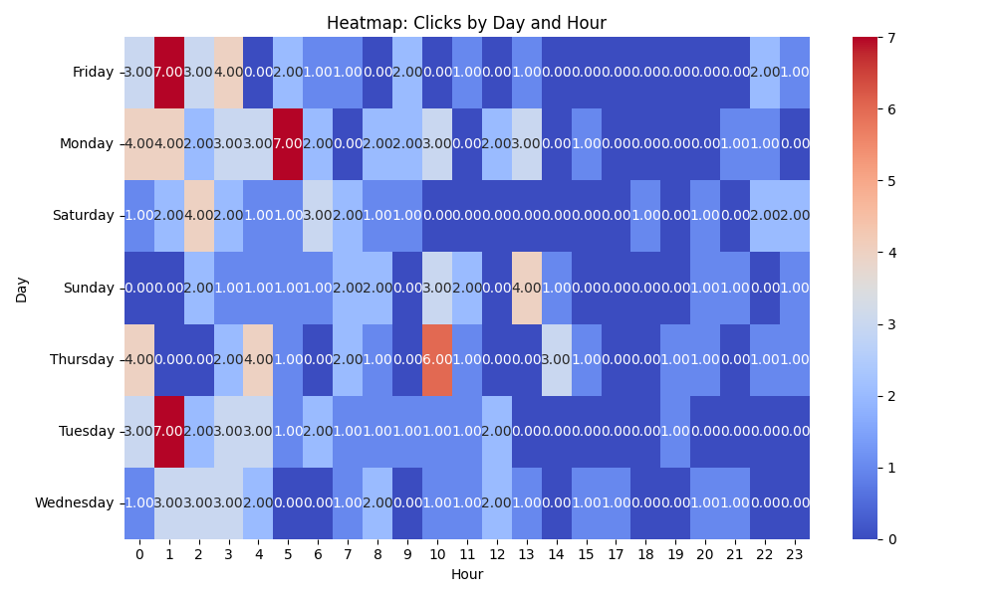

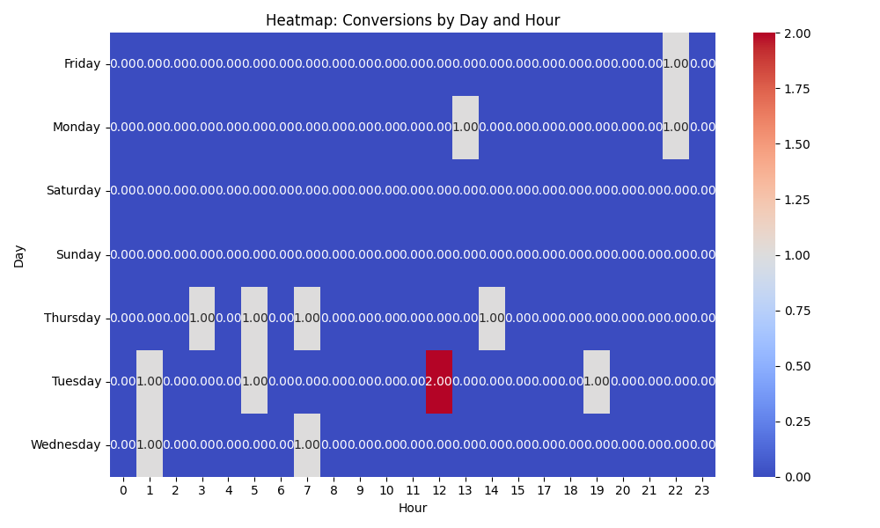

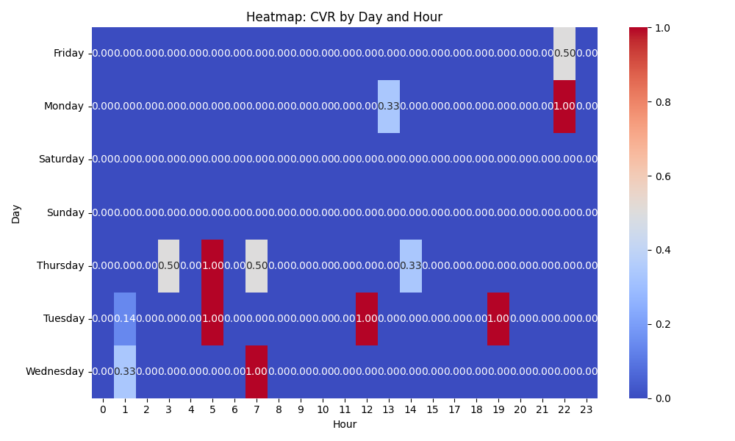

# Competitor Intelligence

# Top Competitor Insights

|  |  |  |
| --- | --- | --- |
| Competitor | Strengths | Recommendations |
|  | ❌ Parse Error: Could not extract valid JSON | N/A |
| mediafast.com › video-mailer | ❌ Parse Error: Could not extract valid JSON | N/A |

# ⚠️ Risks

No Risk insights generated.

# ✅ Opportunities

No Opportunity insights generated.