**Case Study Assignment: Exploring Field Test Mode on Smartphones**

**Objective:**

The goal of this case study is for students to explore and understand key networking information

available on their own smartphones. By using the Field Test Mode or other diagnostic tools on

Android, iPhone, or Samsung devices, students will learn how to gather technical details about

their phone’s network settings and performance.

**Key Network Parameters:**

**○IMEI Number (International Mobile Equipment Identity)**

IMEI (International Mobile Equipment Identity) is a 15-17-digit code that is given to every mobile phone. This number is used by service providers to uniquely identify valid devices. Specifically, IMEI code can enable a Global System for Mobile communication (GSM) or Universal Mobile Telecommunications Service (UMTS) network to prevent a misplaced or stolen phone from initiating calls. IMEI is also a part of mobile device management.

It’s like the bio-identification for a phone.

Uses of IME:

Individuals who buy used phones can look up the IMEI number to check and see the phone is valid. Checking the number can also inform users on the country and network from which a device originated, the warranty, carrier information, and more similar details. Both law enforcement and intelligence services could also use an IMEI number in order to track devices within the accuracy of a few meters. The service provider can use the IMEI number to create a blacklist of stolen devices. If a user reports a phone as stolen, the service provider can add the number to the blacklist and block the phone from their network. The United Kingdom has a voluntary charter that is operated by mobile networks that helps ensure that any operator's blacklisting of a handset is communicated to the CEIR (Central Equipment Identity Register), then to all other networks within 48 hours.

**○ MAC Address (Media Access Control address)**

A MAC address (short for medium access control address) is a unique identifier assigned to a network interface controller (NIC) for use as a network address in communications within a network segment. This use is common in most IEEE 802 networking technologies, including Ethernet, Wi-Fi, and Bluetooth. Within the Open Systems Interconnection (OSI) network model, MAC addresses are used in the medium access control protocol sublayer of the data link layer.

MAC addresses are primarily assigned by device manufacturers, and are therefore often referred to as the burned-in address, or as an Ethernet hardware address, hardware address, or physical address. Each address can be stored in the interface hardware, such as its read-only memory, or by a firmware mechanism. Many network interfaces, however, support changing their MAC addresses.

If IP is like an address then MAC are like the Name of a person.

**○ IP Address (Internet Protocol address)**

An Internet Protocol (IP) address is the unique identifying number assigned to every device connected to the internet. An IP address definition is a numeric label assigned to devices that use the internet to communicate. Computers that communicate over the internet or via local networks share information to a specific location using IP addresses.

IP addresses have two distinct versions or standards. The Internet Protocol version 4 (IPv4) address is the older of the two, which has space for up to 4 billion IP addresses and is assigned to all computers. The more recent Internet Protocol version 6 (IPv6) has space for trillions of IP addresses, which accounts for the new breed of devices in addition to computers.

A public IP address, or external-facing IP address, applies to the main device people use to connect their business or home internet network to their internet service provider (ISP).

A private IP address, or internal-facing IP address, is assigned by an office or home intranet (or local area network) to devices, or by the internet service provider (ISP).

IPs can make you susceptible to doxing attacks on the internet. As you can see in the following image the website <https://whatismyipaddress.com/> shows you your location on the globe based on your IP.

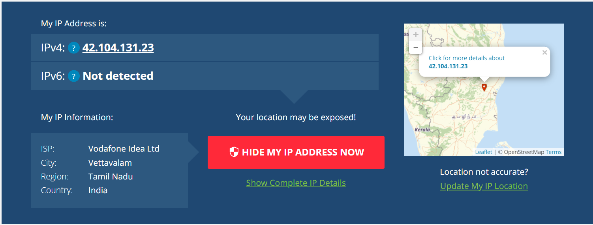

**○ Network Operator/Brand (Name of the cellular provider)**A Network Operator is a provider of wired and wireless communications services that owns or controls the infrastructure necessary to sell and deliver services to Mobile Network Operators (MO), Virtual Network Operators, and end users.

**○ Network Type (4G LTE, 5G, etc.)**The tyoe of network determines the amount of bandwidth, the type of connection, type of algorithm use for data transfer, and latency to name a few features. These are the different generations of wireless connectivity in mobile carriers.

**○ Signal Strength (Measured in dBm)**

The signal strength is the wireless signal power level received by the wireless client. Strong signal strength results in more reliable connections and higher speeds. Signal strength is represented in -dBm format (0 to -100). This is the power ratio in decibels (dB) of the measured power referenced to one milliwatt. The closer the value is to 0, the stronger the signal. For example, -41dBm is better signal strength than -61dBm.

**○ Download/Upload Bandwidth (Physical channel configuration and speed)**

Bandwidth refers to the maximum amount of data that a network or communication channel can transmit in a given period. Higher bandwidth enables more data to be transmitted at once, resulting in faster network speeds.

**○ Mobile Location Information (LAC - Location Area Code and CID - Cell ID)**

* **LAC:** Location Area Code (LAC) defines the geographical boundaries of individual location areas within a cellular network. It serves as a unique identifier for each location area, enabling precise location tracking and efficient call routing.
* **Cell ID:** Cell ID, on the other hand, refers to the unique identifier assigned to individual cells within a cellular network. Unlike LAC, which delineates larger geographical areas, Cell ID identifies specific cells or base stations within the network, facilitating granular network management and optimization.

**Experiment:**

**Key parameters:**

**○ IMEI Number :**

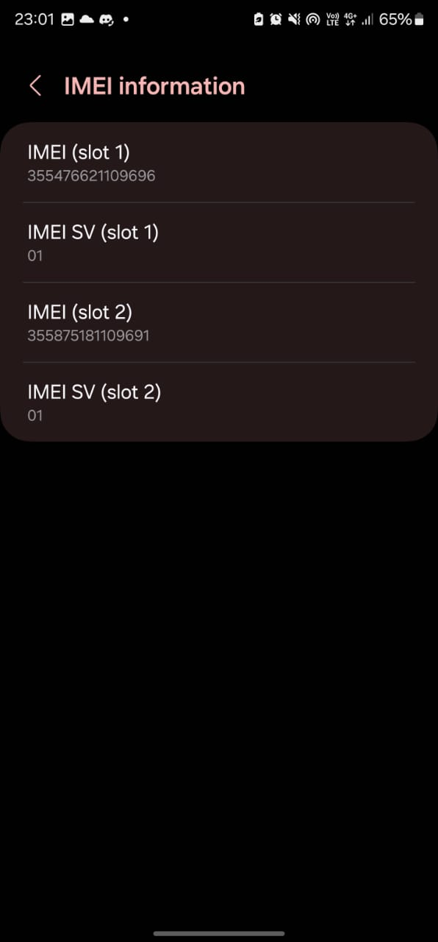

**○ MAC Address :**

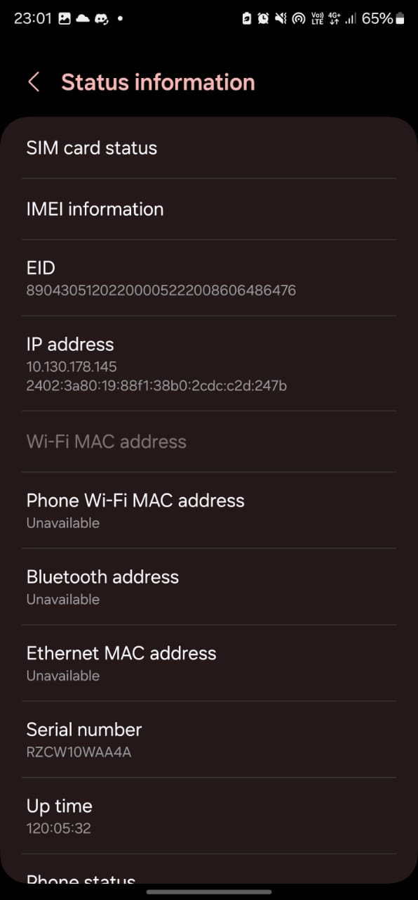

**○ IP Address :**



**○ Network Operator/Brand :**

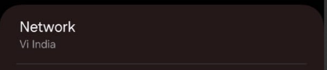

**○ Network Type :**

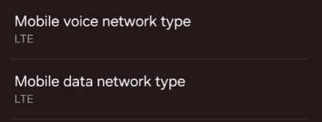

**○ Signal Strength :**

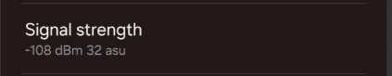

**○ Download/Upload Bandwidth :**

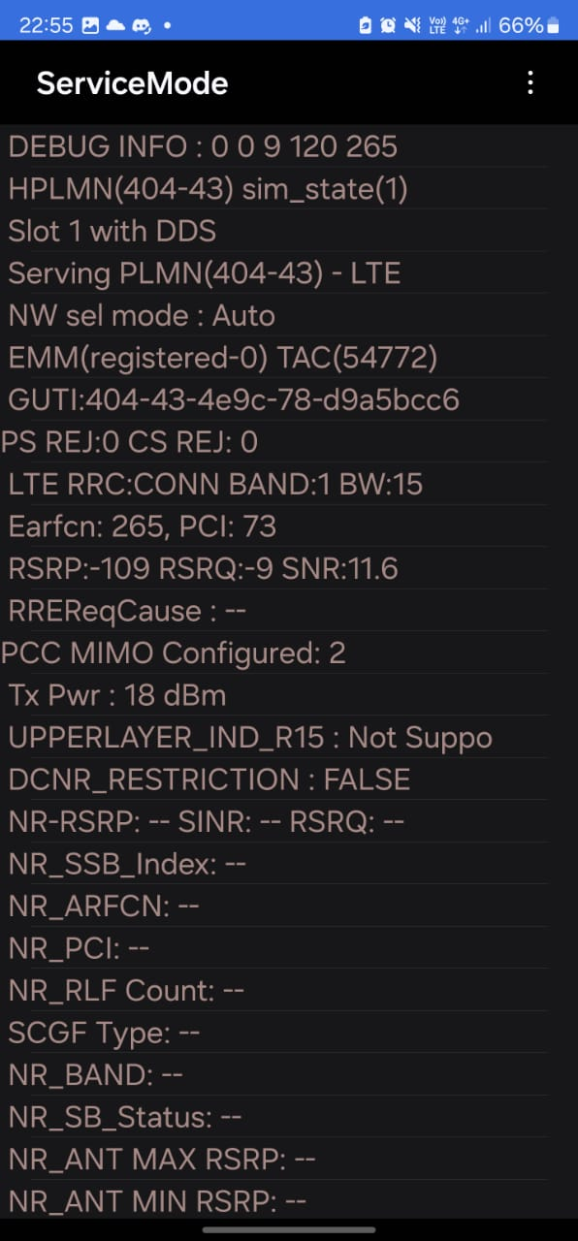

**○ Mobile Location Information :**

