STATISTICAL METHODS IN AI
ASSIGNMENT 5:
DIMENSIONALITY REDUCTION AND CLUSTERING

Name – Kalpish Singhal
Roll No – 201505513
Course – M.Tech CSE(PG1)

AIM:
The aim of this assignment is to experiment with dimensionality reduction and clustering
techniques we learned in the class on real world problems.

CODE :
A) Dimensionality Reduction

PCA on Iris Data Set :

import csv
import numpy as np
import matplotlib.pyplot as plt
dataset_name="iris.data"
def class_avrg(l):
col=np.asarray([0])
for data in l:
new_list = []
data=data[0:-1]
for item in data:
new_list.append(float(item))
data=new_list
col=np.append(col,data)
col=np.delete(col,0).reshape(150,4).transpose()
avg1,avg2,avg3,avg4=col[0].mean(),col[1].mean(),col[2].mean(),col[3].mean()
return avg1,avg2,avg3,avg4,col

pass
def cal_eigen(col):
eigenvalue, eigenvector=np.linalg.eig(np.dot(col,col.T))
#print eigenvalue
#print eigenvector
eigen_value_vector = [(np.abs(eigenvalue[i]), eigenvector[:,i]) for i in range(0,len(eigenvalue))]
#eigen_value_vector=sorted(zip(eigenvalue,eigenvector))
sorted(eigen_value_vector,reverse=True)
#print eigen_value_vector
return eigen_value_vector
def save_plot(pca_plot,label_1,label_2,name):
plt.ylabel(label_1)
plt.xlabel(label_2)
class1,class2,class3=plt.plot(pca_plot[0,:50],pca_plot[1,:50],'go',label="Iris-setosa"),plt.plot(pca_plot[0,50:100],pca_plot[1,50:100],'bo',label="Iris-versicolor"),plt.plot(pca_plot[0,100:151],pca_plot[1,100:151],'ro',label="Iris-virginica")
plt.legend(loc='lower right')
plt.savefig(name)
plt.close()

def plot(eigen_value_vector,col):
#pc12 = np.hstack((eigen_value_vector[0][1].reshape(4,1), eigen_value_vector[1][1].reshape(4,1)))

pca_plot=np.dot(np.hstack((eigen_value_vector[0][1].reshape(4,1), eigen_value_vector[1][1].reshape(4,1))).T,col)
#print pca_plot
save_plot(pca_plot,'PC2','PC1','pca12.png')
pca_plot=np.dot(np.hstack((eigen_value_vector[1][1].reshape(4,1), eigen_value_vector[2][1].reshape(4,1))).T,col)
save_plot(pca_plot,'PC3','PC2','pca23.png')
pca_plot=np.dot(np.hstack((eigen_value_vector[0][1].reshape(4,1), eigen_value_vector[2][1].reshape(4,1))).T,col)
save_plot(pca_plot,'PC3','PC1','pca13.png')

def main():

with open(dataset_name,'rb') as file_f:
l=list(csv.reader(file_f))
avg1,avg2,avg3,avg4,col=class_avrg(l)
#print col
#print avg1,avg2,avg3,avg4
for i in range(0,len(col[0])):
col[0][i]=col[0][i]-avg1
for i in range(0,len(col[1])):
col[1][i]=col[1][i]-avg2
for x in xrange(0,len(col[2])):
col[2][x]=col[2][x]-avg3
for x in xrange(0,len(col[3])):
col[3][x]=col[3][x]-avg4
#print col
eigen_value_vector=cal_eigen(col)
plot(eigen_value_vector,col)

main()
SAMPLE OUTPUT:
Projection of the original data in PCA space

PC1 versus PC2
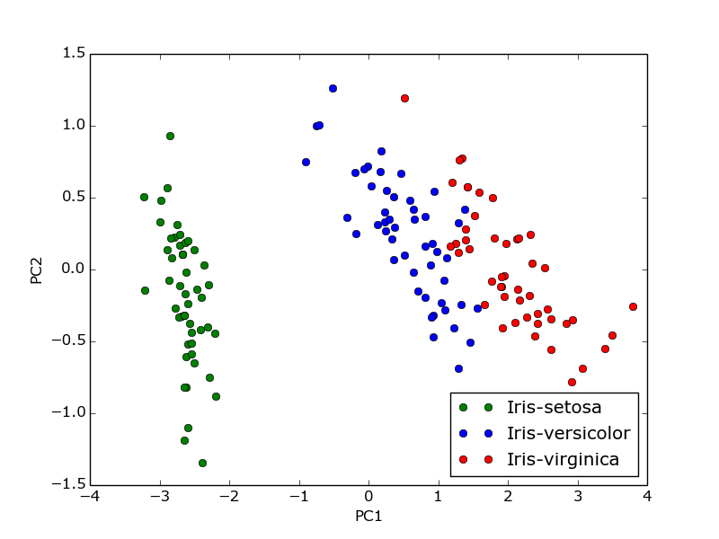

PC1 versus PC3
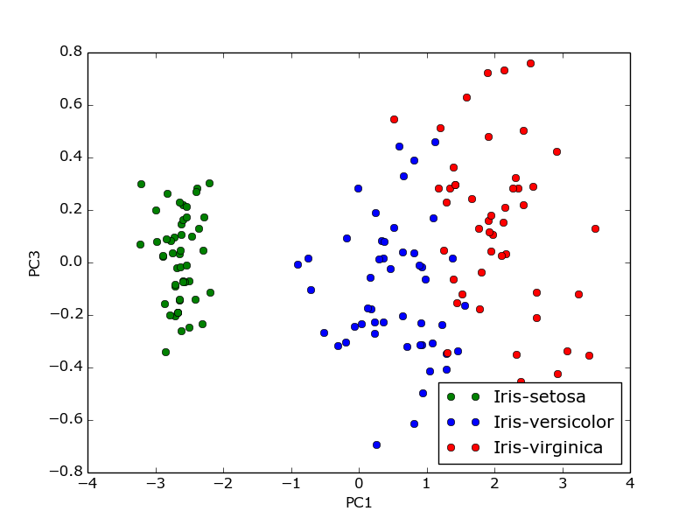
PC2 versus PC3
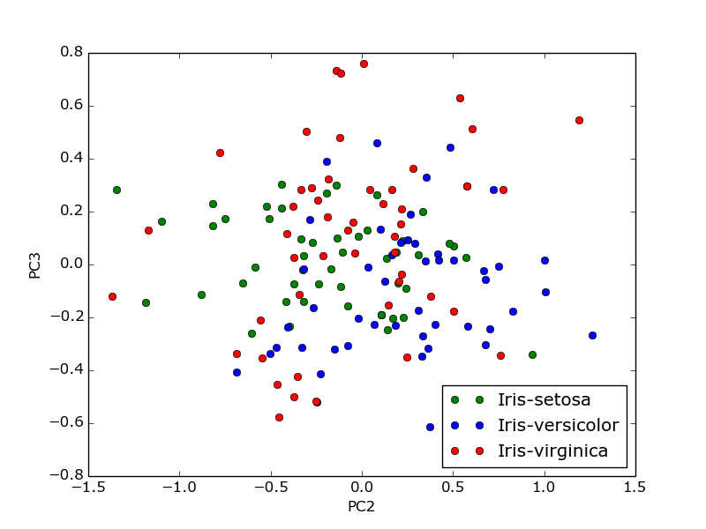
PCA on Arcene Data Set (Data Set with large Dimensions) :

import numpy as np
import matplotlib.pyplot as plt
import csv

def loaddata():
name_file='arcene_train.data'
lables_name='arcene_train.labels'
with open(name_file,'rb') as file_name:
l=list(csv.reader(file_name,delimiter=' '))
with open(lables_name,'rb') as f:
lables=list(csv.reader(f))
return l,lables

def cal_pca(p,col):
result_pca=np.dot(p.T,col)
return result_pca
def plot_pca(lables,result_pca):
x1,x2,y1,y2=[],[],[],[]
plt.ylabel('PC2')
plt.xlabel('PC1')
for i in range(0,100):
if labels[i]==['1']:
x1.append(result_pca[0][i])
y1.append(result_pca[1][i])
elif lables[i]==['-1']:
x2.append(result_pca[0][i])
y2.append(result_pca[1][i])
plt1,plt2=plt.plot(x1,y1,'go',label="1"),plt.plot(x2,y2,'ro',label="-1")
plt.legend(loc='lower right')
plt.savefig('pca_cancer_data.png')
plt.close()

def cal_eigen(col):
eigenvalue, eigenvector=np.linalg.eig(np.dot(col,col.T))
index=np.argsort(eigenvalue)
p=np.hstack((eigenvector[index[-1]].reshape(10000,1), eigenvector[index[-2]].reshape(10000,1)))
return p,sorted(eigenvalue,reverse=True)

def col_avrg(l):
col=np.asarray([0])
avg=np.zeros(10000)
for data in l:
new_list = []
data=data[:-1]
for item in data:
new_list.append(float(item))
data=new_list
col=np.append(col,data)
col=np.delete(col,0).reshape(100,10000).transpose()
for i in range(0,10000):
avg[i]=col[i].mean()

for i in range(0,10000):
length_comp=len(col[i])
for x in range(0,length_comp):
col[i][x]=col[i][x]-avg[i]
return col

def plot_eigenval(x,eigenvalue):
plt.ylabel('eigenvalue')
plt.xlabel('factor number')
plt2=plt.plot(x,eigenvalue)
plt.legend(loc='lower right')
plt.savefig('plot_screen.png')
plt.close()

def main():
l,lables=loaddata()
col=col_avrg(l)
p,eigenvalue=cal_eigen(col)
result_pca=cal_pca(p,col)
print result_pca
plot_pca(lables,result_pca)
x=[i for i in range(1,10001)]
plot_eigenval(x,eigenvalue)

main()
SAMPLE OUTPUT:
Projection of the original data in PCA space

PC1 versus PC2
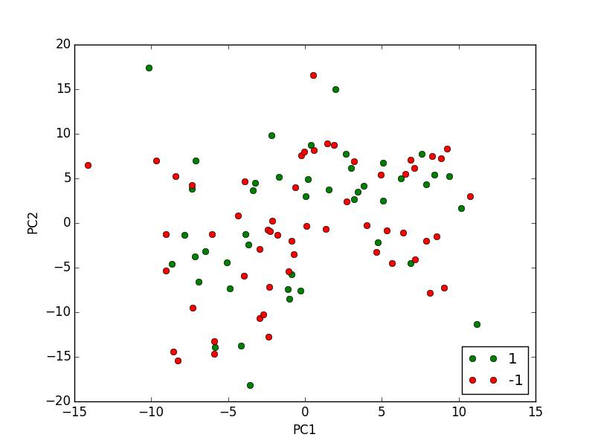

How many components to choose for explaining 85%, 90%, 95% and 99% of the variance of the data.

Steps to get required variance of the data :
- The arcrene dataset produced 10000 eigen values.
- The summation of all eigenvalues is generated.
- Divide the eigenvalues by the sum generated.
- If the ratio so obtained is .82 then this implies that the eigenvalue is able to campture 82% variance of the data and 8% is the loss.
- So, as to make the variance 85%, we need to choose a component which capture 3% of the data, making to the sum of 85% and to make it further to 90%, we will add more eigenvalues, and finally more to make it 99%.

Thus, it suggestes that we can be selective in choosing the eigenvalues to reduce dimensions so as to produces the dataset of the required variance i.e. 85%, 90%, 95%, 99%.

LDA and PCA : Similaries & Differences:
Similarities:
- They are both implemented in many software packages for topic modelling.
- Both LDA and PCA can be used for topic modelling.
- Both LDA and PCA are linear transformation techniques

Differences:
- PCA is a more generic dimensionality reduction technique whereas LDA is a more specialized generative method.
- LDA is a supervised whereas PCA is unsupervised (ignores class labels).
- PCA is a technique that finds the directions of maximal variance and LDA is a technique that also cares about class separability ( LDA would be a very bad linear discriminant)
LDA makes assumptions about normally distributed classes and equal class covariances.

LDA on Iris Data Set :

import csv
import numpy as np
import matplotlib.pyplot as plt
def loaddata():
name_file='iris.data'
#lables_name='arcene_train.labels'
with open(name_file,'rb') as file_name:
l=list(csv.reader(file_name))
return l

def main():
l=loaddata()
m=np.zeros(12)
col,class1,class2,class3=np.asarray([0]),np.asarray([0]),np.asarray([0]),np.asarray([0])
m=m.reshape(3,4)
for data in l:
if data[-1]=='Iris-setosa':

m[0][0],m[0][1],m[0][2],m[0][3]=m[0][0]+float(data[0]),m[0][1]+float(data[1]),m[0][2]+float(data[2]),m[0][3]+float(data[3])
temp=[float(i) for i in data[:-1]]
class1=np.append(class1,temp)
elif data[-1]=='Iris-versicolor':
m[1][0],m[0][1],m[1][2],m[1][3]=m[1][0]+float(data[0]),m[1][1]+float(data[1]),m[1][2]+float(data[2]),m[1][3]+float(data[3])
temp=[float(i) for i in data[:-1]]
class2=np.append(class2,temp)

elif data[-1]=='Iris-virginica':
m[2][0],m[0][1],m[2][2],m[2][3]=m[2][0]+float(data[0]),m[2][1]+float(data[1]),m[2][2]+float(data[2]),m[2][3]+float(data[3])
temp=[float(i) for i in data[:-1]]
class3=np.append(class3,temp)
data=[float(i) for i in data[:-1]]
col=np.append(col,data)
col=np.delete(col,0).reshape(150,4).transpose()
m/=float(50)

class1=np.delete(class1,0).reshape(50,4)
class2=np.delete(class2,0).reshape(50,4)
class3=np.delete(class3,0).reshape(50,4)
for i in range(0,50):
class1[i],class2[i],class3[i]=class1[i]-m[0],class2[i]-m[1],class3[i]-m[2]
class1,class2,class3=class1.transpose(),class2.transpose(),class3.transpose()
scatterw=np.dot(class1,class1.T)+np.dot(class2,class2.T)+np.dot(class3,class3.T)
for i in range(3):
m[i][0]=m[i][0]-col[0].mean()
m[i][1]=m[i][1]-col[1].mean()
m[i][2]=m[i][2]-col[2].mean()
m[i][3]=m[i][3]-col[3].mean()
eigenvalue, eigenvector = np.linalg.eig(np.linalg.inv(scatterw).dot(50*np.dot(m.T,m)))
eigen_value_vector=sorted([(np.abs(eigenvalue[i]), eigenvector[:,i]) for i in range(0,len(eigenvalue))],reverse=True)
lda = np.dot(col.T,np.hstack((eigen_value_vector[0][1].reshape(4,1))))
plt.xlabel('LDA')

y=50*[0]
x1,x2,x3=lda[:50],lda[50:100],lda[100:]
class1,class2,class3==plt.plot(x1,y,'ro',label="Iris-setosa"),plt.plot(x2,y,'bo',label="Iris-versicolor"),plt.plot(x3,y,'go',label="Iris-virginica")
plt.legend(loc='lower right')

plt.savefig('Lda_iris.png')
plt.close()

main()

SAMPLE OUTPUT:
Projection of the original data in PCA space

Plot for LDA in One-Dimension:

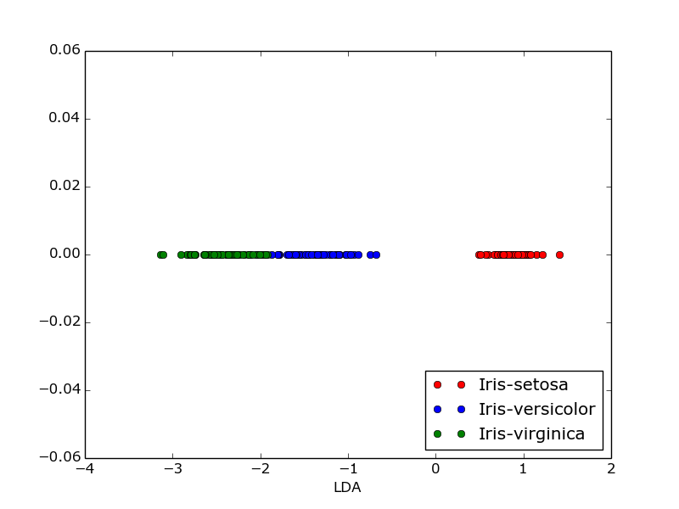
LDA on Arcene Data Set (Data Set with large Dimensions) :

LDA on Arcene data set is not possible since the with-in-class scatter matrix Sw is not
invertible in this case.

Representation of data in the Lower Dimensional Subspace:

Representation of data in the lower dimensional space may lead to the data with lower varaince, and a loss, but computationally the data so obtained will be fast, to produced result, as only the required features which defines the data dominately are selected. The complexity of computations are reduced with the lower dimensional data.

Feature extraction is used for this. It transforms the data in the high-dimensional space to a space of fewer dimensions. The main linear technique for dimensionality reduction, principal component analysis, performs a linear mapping of the data to a lower-dimensional space in such a way that the variance of the data in the low-dimensional representation is maximized.

B) Clustering
Iris Data Set :

from random import *
import numpy as np
import matplotlib.pyplot as plt
import csv
from math import *

def load_dataset():
with open('iris.data','rb') as file_open:
list_l=list(csv.reader(file_open))
shuffle(list_l)
length_sample=len(list_l)
for x in xrange(length_sample):
length_sample_xth=len(list_l[x])-1
for y in xrange(length_sample_xth):
list_l[x][y] = float(list_l[x][y])
list_l[x].extend('0')
return list_l
#print list_l
def calculating_distances(data, list_m):
m1,m2,m3,dist1, dist2, dist3,mindist=list_m[0],list_m[1],list_m[2],-1.0, -1.0, -1.0,10000.0
temp1, temp2, temp3=np.asarray(m1[:-2]),np.asarray( m2[:-2]), np.asarray(m3[:-2])
dist1,dist2,dist3 = data-temp1,data-temp2,data-temp3
# print"************************printing this**************************"
# print np.dot(dist1, dist1),np.dot(dist2, dist2),np.dot(dist3, dist3)
# print"*******************end****************************************"
return np.dot(dist1, dist1),np.dot(dist2, dist2),np.dot(dist3, dist3)

def finding_min_distance(sample,dist1, dist2, dist3):
sample[-1],mindist='1',dist1
if dist2<mindist:
mindist,sample[-1]=dist2,'2'
if dist3<mindist:
mindist,sample[-1]=dist3,'3'
return sample,mindist

def cal_k_mean_clustring(sample):
m1,m2,m3,no_of_iterations,flag=[],[],[],0,0
m1 = sample[0]
m1[-1]='1'
previous_m1=m1[:]
m2=sample[1]
m2[-1]='2'
previous_m2=m2[:]
m3= sample[2]
m3[-1]='3'
previous_m3 = m3[:]

while flag==0:
no_of_iterations=no_of_iterations+1
length=len(sample)
for x in xrange(0,length):
previous_m1=m1[:]
previous_m2=m2[:]
previous_m3 = m3[:]
list_m=[]
data=np.asarray(sample[x][:-2])
list_m.append(m1)
list_m.append(m2)
list_m.append(m3)
dist1, dist2, dist3 = calculating_distances(data,list_m)
sample[x],mindist = finding_min_distance(sample[x],dist1, dist2, dist3)
cnt1, cnt2, cnt3,m = 0,0,0,np.zeros(12).reshape(3,4)
#print "hii"
print dist1, dist2, dist3

for data in sample:
len_data=len(data)-2
if data[-1]=='1':
cnt1=cnt1+1
for j in range(0,len_data):
m[0][j]+=data[j]
elif data[-1]=='2':
cnt2=cnt2+1
for j in range(0,len_data):
m[1][j]+=data[j]
elif data[-1]=='3':
cnt3=cnt3+1
for j in xrange(0,len_data):
m[2][j]+=data[j]
for x in range(0,4):
if x==0:
m[0]=(m[0]/cnt1)
m[1],m[2]=(m[1]/cnt2),(m[2]/cnt3)
if x>=0:
temp1=m[0][x]
temp2=m[1][x]
temp3=m[2][x]
m1[x],m2[x],m3[x]=temp1,temp2,temp3
pass

if previous_m1==m1:
if previous_m2 == m2:
if previous_m3 == m3:
flag = 1
print "No of iterations",no_of_iterations

return sample

def confusion_matrix_func(actual_classes, predictions,c):
confusion_matrix={'1':[0,0,0,0]}
confusion_matrix.update({'2':[0,0,0,0]})
confusion_matrix.update({'3':[0,0,0,0]})
len_prediction=len(predictions)
for i in xrange(0,len_prediction):
for j in confusion_matrix.keys():
temp_predict=predictions[i]
if j==temp_predict:
temp_actual=actual_classes[i]
if temp_actual==c[0]:
confusion_matrix[j][0],confusion_matrix[j][3]=confusion_matrix[j][0]+1,confusion_matrix[j][3]+1
elif temp_actual==c[1]:
confusion_matrix[j][1],confusion_matrix[j][3]=confusion_matrix[j][1]+1,confusion_matrix[j][3]+1
elif temp_actual==c[2]:
confusion_matrix[j][2],confusion_matrix[j][3]=confusion_matrix[j][2]+1,confusion_matrix[j][3]+1
print "**********************confusion matrix****************************"
print confusion_matrix
return confusion_matrix

def plot(sample):
x1, x2, x3, = [], [] ,[]
length_sample=len(sample)
y1, y2, y3 = [], [], []
plt.xlabel("Sepal Width")
plt.ylabel("Petal Width")
for i in range(0,length_sample):
check_class=sample[i][-1]
temp_x=sample[i][1]
temp_y=sample[i][3]
if check_class == '1':
x1.append(temp_x)
y1.append(temp_y)
elif check_class == '2':
x2.append(temp_x)
y2.append(temp_y)
elif check_class =='3':
y3.append(temp_y)
x3.append(temp_x)
plt1,plt2,pl3=plt.plot(x1,y1,'gs',label="1"),plt.plot(x2,y2,'bs',label="2"),plt.plot(x3,y3,'ro',label="3")
plt.legend(loc='lower left')
plt.savefig("clustering.png")
plt.close()
def external_measures(confusion_matrix,purity,f_measure):
for i in confusion_matrix.keys():
maximum=0.0
len_confu_matrix_i=len(confusion_matrix[i])-1
for j in xrange(0,len_confu_matrix_i):
temp=confusion_matrix[i][j]
if maximum<temp:
maximum=temp
tij = confusion_matrix['1'][j] + confusion_matrix['2'][j] + confusion_matrix['3'][j]
temp_conf=float(confusion_matrix[i][3])
purity+=(float(maximum)/temp_conf)
#print maximum
f_measure=f_measure+(float(2*float(maximum))/float(temp_conf+float(tij)))
print '***********External Measures***************\nPURTY IS:',(purity/3.0)
print "F-Measure IS:",(f_measure/3.0)
def internal_measures(confusion_matrix_op, sample,beta_cv,normalised_cut,w_in, w_out):
n=[]
N_in, N_out=0.0, 0.0
for datai in sample:
for dataj in sample:
c1= np.asarray(datai[:-2])
c2=np.asarray(dataj[:-2])
dist=sqrt(np.dot(c1-c2,c1-c2))
if datai[-1]!=dataj[-1]:
w_out=w_out+dist
else:
w_in=w_in+dist
for i in confusion_matrix_op.keys():
max_value=0.0
len_confu_matrix_i=len(confusion_matrix_op[i])-1
for j in range(0,len_confu_matrix_i):
temp=confusion_matrix_op[i][j]
if temp>max_value:
max_value=temp
n.append(max_value)
N_in+=((factorial(max_value)/float(factorial(max_value-2)))/2.0)
N_out=n[0]*n[1]+n[0]*n[2]
N_out+=n[0]*n[1]
w_in/=2.0
w_out/=2.0
beta_cv=float(float(w_in)/float(N_in))/float(float(w_out)/float(N_out))
print "***********Internal Measures***************\nBeta-CV..........: ",beta_cv
print "Normalised Cut...:",1/float(float(w_in)/float(w_out)+1)

def main():
list_l=load_dataset()
sample=cal_k_mean_clustring(list_l)
plot(sample)
defined_c = ['Iris-virginica', 'Iris-setosa', 'Iris-versicolor']
confusion_matrix_op=confusion_matrix_func(np.array(sample)[:,-2], np.array(sample)[:,-1],defined_c)
external_measures(confusion_matrix_op,0.0,0.0)
internal_measures(confusion_matrix_op, sample,0.0,0.0,0.0,0.0)
print "*************************************************************"

main()

SAMPLE OUTPUT:
15.86 15.22 3.74
17.0937641723 10.4859851852 0.453864795918
17.220339343 6.62652150206 0.36850518814
17.1820336453 3.13458674992 0.414833933404
17.1813084862 2.03882437068 0.580270288376
17.1812937106 1.61381869161 0.708241269879
17.1812934091 1.4348142862 0.778697391945
17.1812934029 1.29439617624 0.849255628873
17.1812934028 1.22908220217 0.886040426751
17.1812934028 1.08623702635 1.00643325047
17.1812934028 1.00674411049 1.09474998192
17.1812934028 0.878142940582 1.27627301006
17.1812934028 0.82533870534 1.37322149671
17.1812934028 0.795611754043 1.44869089685
17.1812934028 0.764541072597 1.53917992778
17.1812934028 0.732150243114 1.61532195128
17.1812934028 0.731634362343 1.61730243369
17.1812934028 0.73162604339 1.61735323378
17.1812934028 0.731625909214 1.61735453636
17.1812934028 0.73162590705 1.61735456976
17.1812934028 0.731625907015 1.61735457061
17.1812934028 0.731625907014 1.61735457064
17.1812934028 0.731625907014 1.61735457064
17.1812934028 0.731625907014 1.61735457064
No of iterations 24

**********************confusion matrix****************************
{'1': [0, 49, 0, 49], '3': [36, 0, 3, 39], '2': [14, 1, 47, 62]}

***********External Measures***************
PURTY IS: 0.893713813069
F-Measure IS: 0.879391156077
***********Internal Measures***************
Beta-CV..........: 0.284982638478
Normalised Cut...: 0.876348598803

Plot for Clustering for IRIS -Dataset:
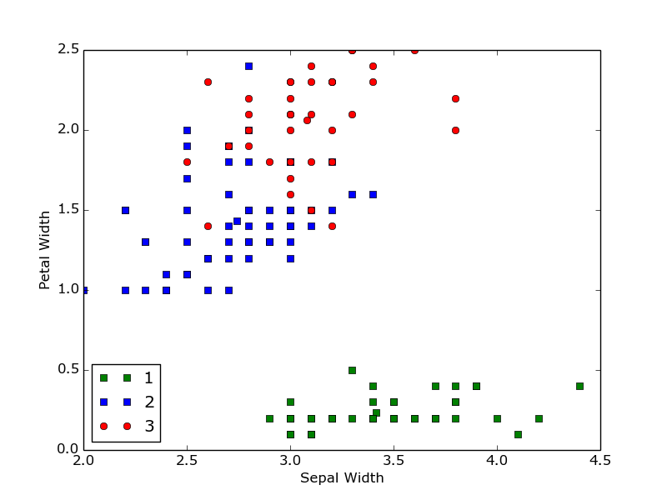
CONFUSION MATRIX:
{'1': [0, 49, 0, 49], '3': [36, 0, 3, 39], '2': [14, 1, 47, 62]}

Clusters | Iris-virginica | Iris-setosa | Iris-versicolor
1 (49) | 0 | 49 | 0
2 (39) | 36 | 0 | 3
3 (62) | 14 | 1 | 47

ANALYSIS & DISCUSSION OF THE RESULTS-
Cluster validation measures - External Measure:
Matching Based Measure : Purity:

It quatifies the extent that cluster Ci contains points from only one partition.
Total purity of whole cluster is the sum of the purity of all the clusters divided by the number of clusters .
Purity value for IRIS Data Set: 0.893713813069
Perfect clustering is the one if purity = 1.

Analysis: In our clustering method, few classes are clustered as a diffferent one and hence purity reduced to this value.

F-Measure:

F-Measure is the harmonic mean of precision and recall. Precision value is equivalent to purity.
F measure = 2*nij / ni + mj
Total F_measure for IRIS data set = Sum of all the f_measures/no of clusters
= 0.879391156077

Cluster validation measures - Internal Measure:

Beta_CV Measure:
A trade-off in maximizing intra-cluster compactiness and inter-cluster separation.
Given a clustering C = {c1, c2,....ck} with k clusters, cluster Ci, containing ni = |Ci| points.
We calculate the sum of all intra-cluster weights over all clusters.
And, we calculate the sum of all the inter-cluster weights.
The number of distinct intra-cluster edges, and inter-cluster edges are calculated.
The Beta-CV measure is the ratio of the mean intra cluster distance to the mean inter-cluster distance.

The smaller the value, the better is the clustering.
Beta-CV measure value IRIS-Data Set = 0.284982638478

Normalised Cut:

The higher the normalised cut value, the better the clustering.
Normalised Cut value for Iris Data Set : 0.876348598803
Clustring on Breast-Cancer-Wisconsin Data Set :

from random import *
import numpy as np
import matplotlib.pyplot as plt
import csv
from math import *

def load_dataset():
with open('breast-cancer-wisconsin.data','rb') as file_open:
list_l=list(csv.reader(file_open))
shuffle(list_l)
length_sample=len(list_l)
for x in xrange(length_sample):
length_sample_xth=len(list_l[x])-1
for y in xrange(length_sample_xth):
list_l[x][y] = float(list_l[x][y])
list_l[x].extend('0')
return list_l
#print list_l
def calculating_distances(data, list_m):
m1,m2,m3,dist1, dist2, dist3,mindist=list_m[0],list_m[1],list_m[2],-1.0, -1.0, -1.0,10000.0
temp1, temp2, temp3=np.asarray(m1[:-2]),np.asarray( m2[:-2]), np.asarray(m3[:-2])
dist1,dist2,dist3 = data-temp1,data-temp2,data-temp3
# print"************************printing this**************************"
# print np.dot(dist1, dist1),np.dot(dist2, dist2),np.dot(dist3, dist3)
# print"*******************end****************************************"
return np.dot(dist1, dist1),np.dot(dist2, dist2),np.dot(dist3, dist3)

def finding_min_distance(sample,dist1, dist2, dist3):
sample[-1],mindist='1',dist1
if dist2<mindist:
mindist,sample[-1]=dist2,'2'
if dist3<mindist:
mindist,sample[-1]=dist3,'3'
return sample,mindist

def cal_k_mean_clustring(sample):
m1,m2,m3,no_of_iterations,flag=[],[],[],0,0
m1 = sample[0]
m1[-1]='1'
previous_m1=m1[:]
m2=sample[1]
m2[-1]='2'
previous_m2=m2[:]
m3= sample[2]
m3[-1]='3'
previous_m3 = m3[:]

while flag==0:
no_of_iterations=no_of_iterations+1
length=len(sample)
for x in xrange(0,length):
previous_m1=m1[:]
previous_m2=m2[:]
previous_m3 = m3[:]
list_m=[]
data=np.asarray(sample[x][:-2])
list_m.append(m1)
list_m.append(m2)
list_m.append(m3)
dist1, dist2, dist3 = calculating_distances(data,list_m)
sample[x],mindist = finding_min_distance(sample[x],dist1, dist2, dist3)
cnt1, cnt2, cnt3,m = 0,0,0,np.zeros(12).reshape(3,4)
#print "hii"
print dist1, dist2, dist3

for data in sample:
len_data=len(data)-2
if data[-1]=='1':
cnt1=cnt1+1
for j in range(0,len_data):
m[0][j]+=data[j]
elif data[-1]=='2':
cnt2=cnt2+1
for j in range(0,len_data):
m[1][j]+=data[j]
elif data[-1]=='3':
cnt3=cnt3+1
for j in xrange(0,len_data):
m[2][j]+=data[j]
for x in range(0,4):
if x==0:
m[0]=(m[0]/cnt1)
m[1],m[2]=(m[1]/cnt2),(m[2]/cnt3)
if x>=0:
temp1=m[0][x]
temp2=m[1][x]
temp3=m[2][x]
m1[x],m2[x],m3[x]=temp1,temp2,temp3
pass

if previous_m1==m1:
if previous_m2 == m2:
if previous_m3 == m3:
flag = 1
print "No of iterations",no_of_iterations

return sample

def confusion_matrix_func(actual_classes, predictions,c):
confusion_matrix={'1':[0,0,0,0]}
confusion_matrix.update({'2':[0,0,0,0]})
confusion_matrix.update({'3':[0,0,0,0]})
len_prediction=len(predictions)
for i in xrange(0,len_prediction):
for j in confusion_matrix.keys():
temp_predict=predictions[i]
if j==temp_predict:
temp_actual=actual_classes[i]
if temp_actual==c[0]:
confusion_matrix[j][0],confusion_matrix[j][3]=confusion_matrix[j][0]+1,confusion_matrix[j][3]+1
elif temp_actual==c[1]:
confusion_matrix[j][1],confusion_matrix[j][3]=confusion_matrix[j][1]+1,confusion_matrix[j][3]+1
elif temp_actual==c[2]:
confusion_matrix[j][2],confusion_matrix[j][3]=confusion_matrix[j][2]+1,confusion_matrix[j][3]+1
print "**********************confusion matrix****************************"
print confusion_matrix
return confusion_matrix

def plot(sample):
x1, x2, x3, = [], [] ,[]
length_sample=len(sample)
y1, y2, y3 = [], [], []
plt.xlabel("Sepal Width")
plt.ylabel("Petal Width")
for i in range(0,length_sample):
check_class=sample[i][-1]
temp_x=sample[i][1]
temp_y=sample[i][3]
if check_class == '1':
x1.append(temp_x)
y1.append(temp_y)
elif check_class == '2':
x2.append(temp_x)
y2.append(temp_y)
elif check_class =='3':
y3.append(temp_y)
x3.append(temp_x)
plt1,plt2,pl3=plt.plot(x1,y1,'gs',label="1"),plt.plot(x2,y2,'bs',label="2"),plt.plot(x3,y3,'ro',label="3")
plt.legend(loc='lower left')
plt.savefig("clustering.png")
plt.close()
def external_measures(confusion_matrix,purity,f_measure):
for i in confusion_matrix.keys():
maximum=0.0
len_confu_matrix_i=len(confusion_matrix[i])-1
for j in xrange(0,len_confu_matrix_i):
temp=confusion_matrix[i][j]
if maximum<temp:
maximum=temp
tij = confusion_matrix['1'][j] + confusion_matrix['2'][j] + confusion_matrix['3'][j]
temp_conf=float(confusion_matrix[i][3])
purity+=(float(maximum)/temp_conf)
#print maximum
f_measure=f_measure+(float(2*float(maximum))/float(temp_conf+float(tij)))
print '***********External Measures***************\nPURTY IS:',(purity/3.0)
print "F-Measure IS:",(f_measure/3.0)
def internal_measures(confusion_matrix_op, sample,beta_cv,normalised_cut,w_in, w_out):
n=[]
N_in, N_out=0.0, 0.0
for datai in sample:
for dataj in sample:
c1= np.asarray(datai[:-2])
c2=np.asarray(dataj[:-2])
dist=sqrt(np.dot(c1-c2,c1-c2))
if datai[-1]!=dataj[-1]:
w_out=w_out+dist
else:
w_in=w_in+dist
for i in confusion_matrix_op.keys():
max_value=0.0
len_confu_matrix_i=len(confusion_matrix_op[i])-1
for j in range(0,len_confu_matrix_i):
temp=confusion_matrix_op[i][j]
if temp>max_value:
max_value=temp
n.append(max_value)
N_in+=((factorial(max_value)/float(factorial(max_value-2)))/2.0)
N_out=n[0]*n[1]+n[0]*n[2]
N_out+=n[0]*n[1]
w_in/=2.0
w_out/=2.0
beta_cv=float(float(w_in)/float(N_in))/float(float(w_out)/float(N_out))
print "***********Internal Measures***************\nBeta-CV..........: ",beta_cv
print "Normalised Cut...:",1/float(float(w_in)/float(w_out)+1)

def main():
list_l=load_dataset()
sample=cal_k_mean_clustring(list_l)
plot(sample)
defined_c = ['2', '4']
confusion_matrix_op=confusion_matrix_func(np.array(sample)[:,-2], np.array(sample)[:,-1],defined_c)
external_measures(confusion_matrix_op,0.0,0.0)
internal_measures(confusion_matrix_op, sample,0.0,0.0,0.0,0.0)
print "*************************************************************"

main()

SAMPLE OUTPUT:

13 255
5.2872383758 224.949806768
4.77491827725 213.243942524
4.53596651126 205.926446456
4.47256699606 204.337013434
4.47243358863 204.33024328
4.47243330175 204.330214348
4.47243330113 204.330214224
4.47243330113 204.330214224
4.47243330113 204.330214224
4.47243330113 204.330214224

No of Iterations 11

Confusion Matrix
{'1': [447, 18, 465], '2': [11, 223, 234]}

***********External Measures***************
PURTY.............: 0.957140887786
F-Measure........: 0.95376404174

***********Internal Measures***************
Beta-CV...............: 0.331704165291
Normalised Cut...: 0.707176741294
*******************************************

CONFUSION MATRIX:
{'1': [447, 18, 465], '2': [11, 223, 234]}

Clusters | '2' | '4'
1 (465) | 447 | 18
2 (234) | 11 | 223

ANALYSIS & DISCUSSION OF THE RESULTS-
Cluster validation measures - External Measure:

Matching Based Measure : Purity:
Purity value for Wisconsin Data Set: 0.957140887786
Perfect clustering is the one if purity = 1.
In our clustering method, few classes are clustered as a diffferent one and hence purity reduced to this value.

F-Measure:

Total F_measure for Wisconsin data set = (f_measure_1 + f_measure_2 /2
= 0.95376404174

Cluster validation measures - Internal Measure:

Beta_CV Measure:

Beta-CV measure value Wisconsin-Data Set = 0.331704165291

Normalised Cut:

Normalised Cut value for Wisconsin Data Set : 0.707176741294
QUESTIONS TO BE ANSWERED:

Q-1 Compare and contrast K-Means, K-median and K-medoid approaches – when do you use each method, what are the differences in the objective function that is optimized in each case.

K-Means

k-means clustering aims to partition n observations into k clusters in which each observation belongs to the cluster with the nearest mean, serving as a prototype of the cluster. This results in a partitioning of the data space into Voronoi cells.
k-means minimizes within-cluster variance, which equals squared Euclidean distances. In general, the arithmetic mean does this. It does not optimize distances, but squared deviations from the mean.

If the distance is squared Euclidean distance, we use k-means.

K-Median

k-medians clustering is a cluster analysis algorithm. It is a variation of k-means clustering where instead of calculating the mean for each cluster to determine its centroid, one instead calculates the median. This has the effect of minimizing error over all clusters with respect to the 1-norm distance metric, as opposed to the square of the 2-norm distance metric (which k-means does.)
k-medians minimizes absolute deviations, which equals Manhattan distance. In general, the median does this. It is a good estimator for the mean, if you want to minimize absolute deviations, instead of squared ones.

If the distance is squared Euclidean distance, we use k-means.

K-Medoid

The k-medoids algorithm is a clustering algorithm related to the k-means algorithm and the medoidshift algorithm. Both the k-means and k-medoids algorithms are partitional (breaking the dataset up into groups) and both attempt to minimize the distance between points labeled to be in a cluster and a point designated as the center of that cluster. In contrast to the k-means algorithm, k-medoids chooses datapoints as centers (medoids or exemplars).
It could be more robust to noise and outliers as compared to k-means because it minimizes a sum of general pairwise dissimilarities instead of a sum of squared Euclidean distances. The possible choice of the dissimilarity function is very rich but in our applet we used the squared Euclidean distance.

If we have any other distance, we use k-medoids.

Q-2 What is the difference between using Covariance matrix versus Correlation matrix for doing PCA on data? When do you recommend using one over the other? Demonstrate this on a small dataset to support your argument.

Ans.

A correlation matrix is a covariance matrix of the standardized (i.e. not just centered but also rescaled) data; that is, a covariance matrix (as if) of another, different dataset. So it is natural and it shouldn't bother you that the results differ.

PCA on correlations vs on covariances:

- PCA on correlation is much more informative and reveals some structure in the data and relationships between variable Example : For iris dataset, both corealtion and covariance matric result in same set of eigen value, eigen vector pair.
- We would prefer to do PCA on correlations instead of doing it on covariance when one wants the analysis to reflect just and only linear associations.
- We would prefer to do PCA on correlations instead of doing it on covariances when one wants the associations to reflect relative co-deviatedness (from the mean) rather than raw co-deviatedness. The correlation is based on distributions, their spreads, while the covariance is based on the original measurement scale.
- We use covariance matrix when the variable scales are similar and the correlation matrix when variables are on different scales.

Q-3 Show the process of kernelizing PCA. What kind of dimensionality reduction does kernel-PCA accomplish?

Kernel Principal Component Analysis (Kernal PCA):

Kernel PCA with linear kernel is exactly equivalent to the standard PCA. Kernel principal component analysis (kernel PCA) is an extension of principal component analysis (PCA) using techniques of kernel methods. Using a kernel, the originally linear operations of PCA are done in a reproducing kernel Hilbert space with a non-lnear mapping.

Standard PCA only allows linear dimensionality reduction. However, if the data has more complicated structures which cannot be well represented in a linear subspace, standard PCA will not be very helpful. Fortunately, kernel PCA allows us to generalize standard PCA to nonlinear dimensionality reduction.

- Construct the kernel matrix K from the training data set
- Compute the Gram matrix G
- Solve for vector Ai
- Compute the kernel principal components Yk(x)

