AI ASSISTED CODING
LAB 14.1
NAME: MEGHA AKANKSHA
HT NO: 2303A52058
BATCH 39

Task1
http://127.0.0.1:5500/index.html

Prompt 1
Create a clean portfolio website HTML.

Requirements:
- Navigation bar with links: About, Projects, Contact
- Sections with IDs: about, projects, contact
- Add headings and sample content
- Use semantic HTML (nav, section)
- Beginner-friendly code

Prompt 2
Generate CSS for my portfolio website.

Requirements:
- Fixed navigation bar at top
- Use Flexbox for layout
- Full screen height sections
- Professional color palette
- Clean fonts and spacing

Prompt 3
Update my CSS to make the portfolio website responsive for mobile and tablet using media queries.

Prompt 4
Write JavaScript to implement smooth scrolling when clicking navigation links in a portfolio website.

Prompt 5
Improve my portfolio UI:
- Add hover effects on navigation links
- Add smooth transitions
- Improve spacing and layout
- Make it modern and visually appealing

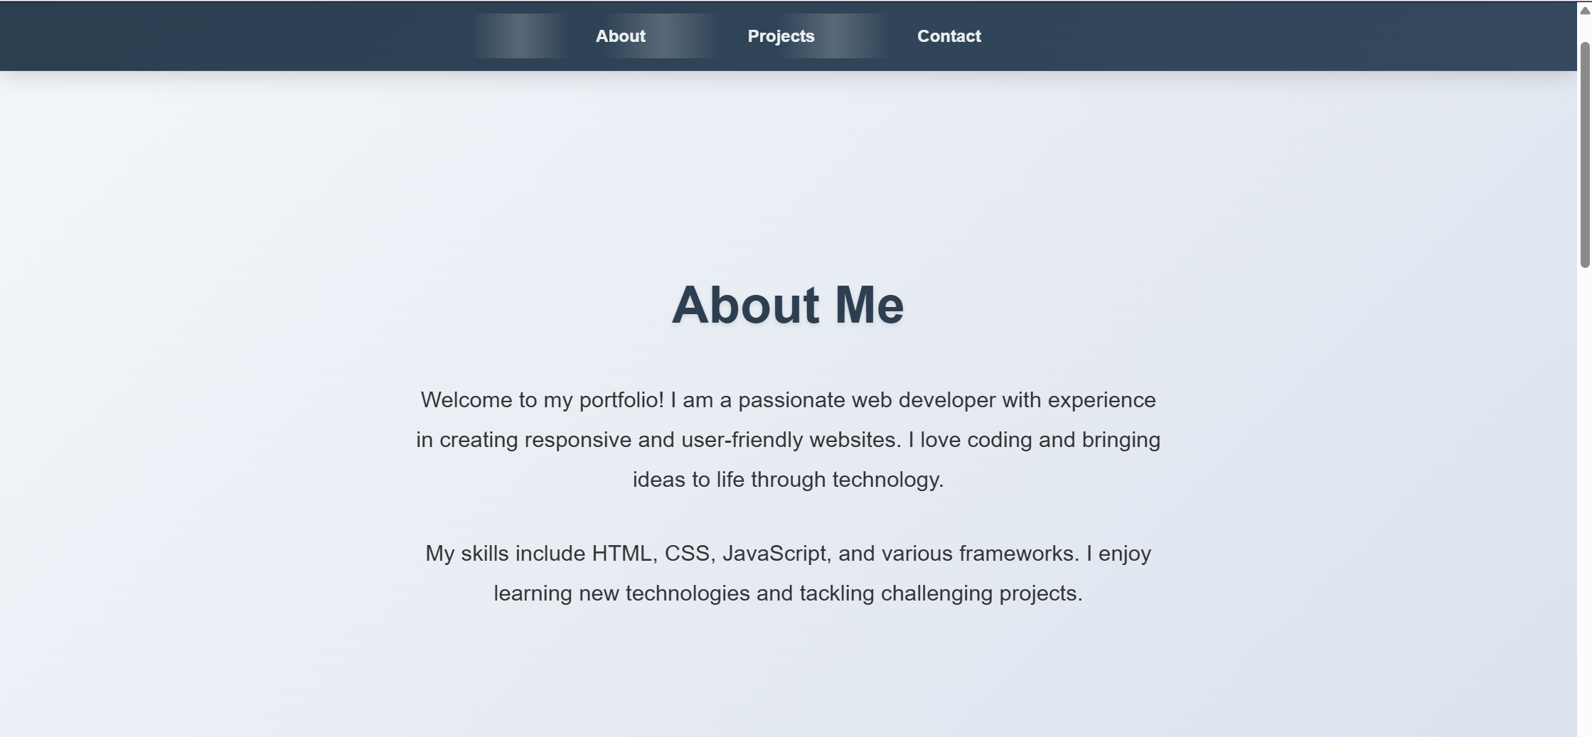
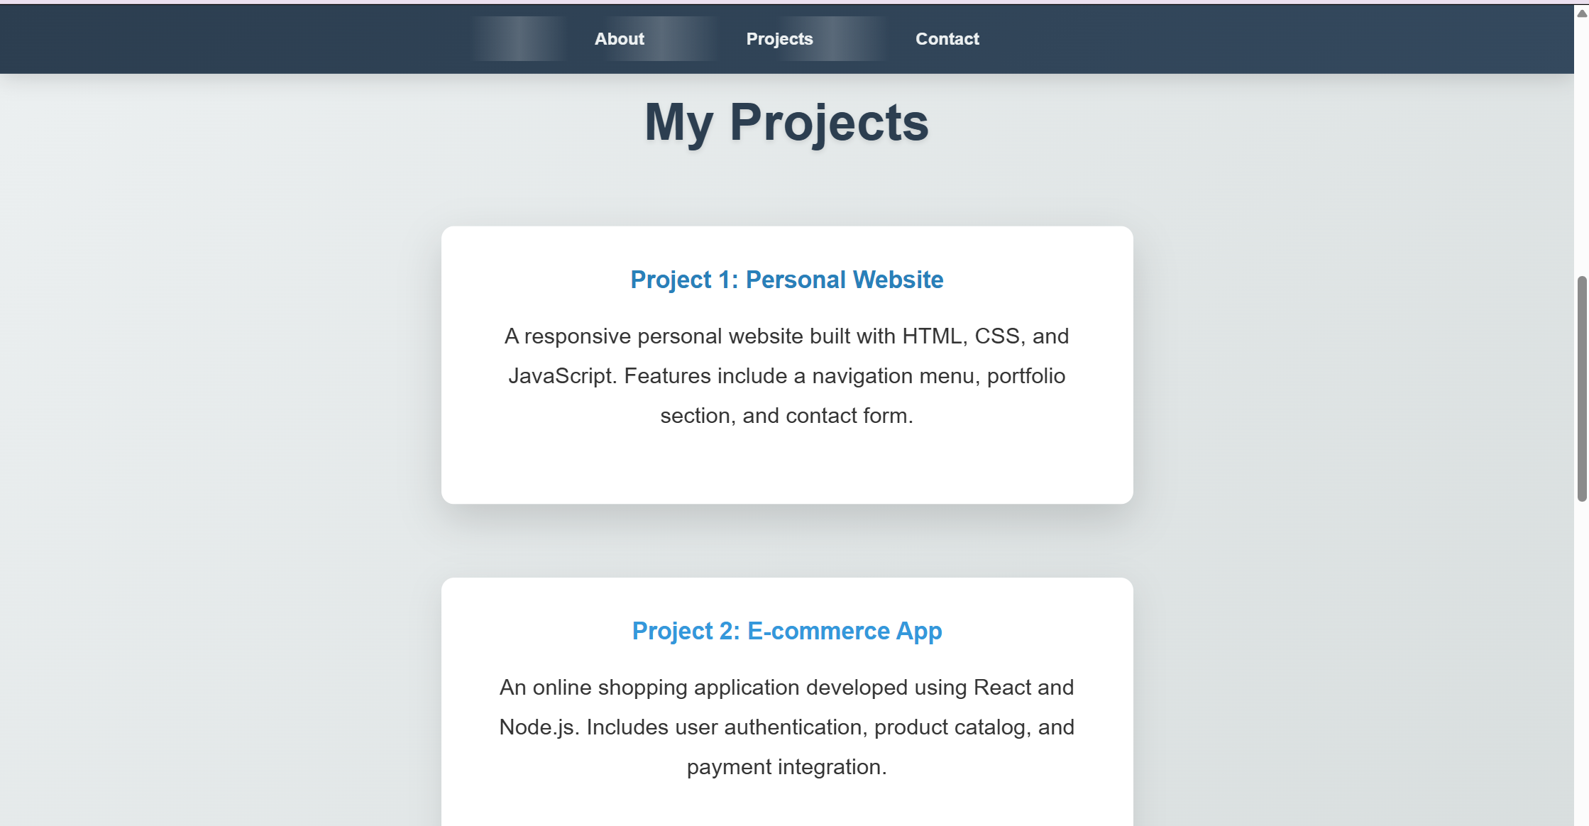

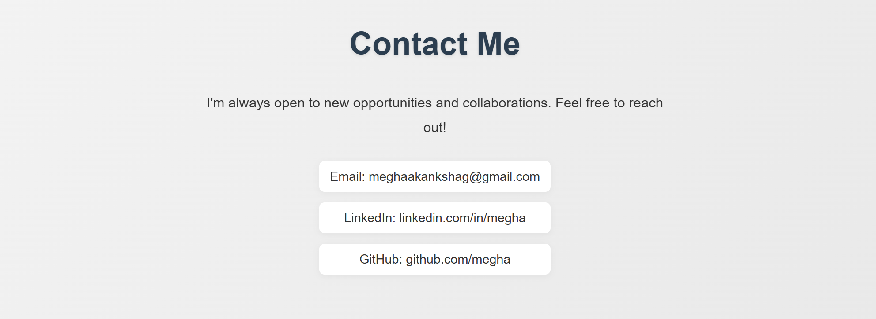

Task 2
http://127.0.0.1:5500/t2_index.html

Prompt 1
Create a product page for an online store using HTML.

Requirements:
- Display product image
- Product title
- Price
- "Add to Cart" button
- Clean and simple structure

Prompt 2
Generate CSS for an online store product page.

Requirements:
- Use BEM naming methodology
- Style product card with border, padding, and shadow
- Center the product on the page
- Add hover effects on the product card and button
- Make it look modern and clean

Prompt 3
Update my CSS to make the product page responsive using media queries for mobile and tablet.

Prompt 4
Write JavaScript for an online store page:
- When user clicks "Add to Cart" button
- Show an alert saying "Product added to cart"
- Keep code simple

Prompt 5
Improve the product page UI:
- Add button hover animation
- Add smooth transitions
- Improve spacing and alignment
- Use attractive colors
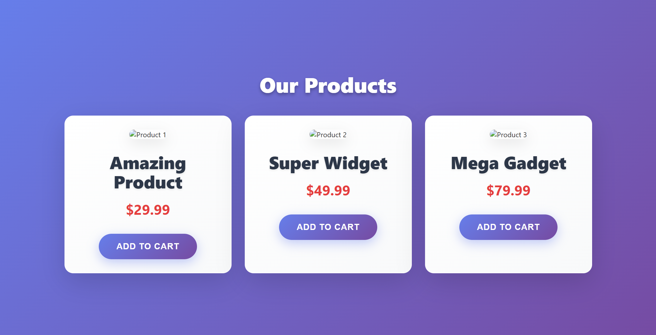
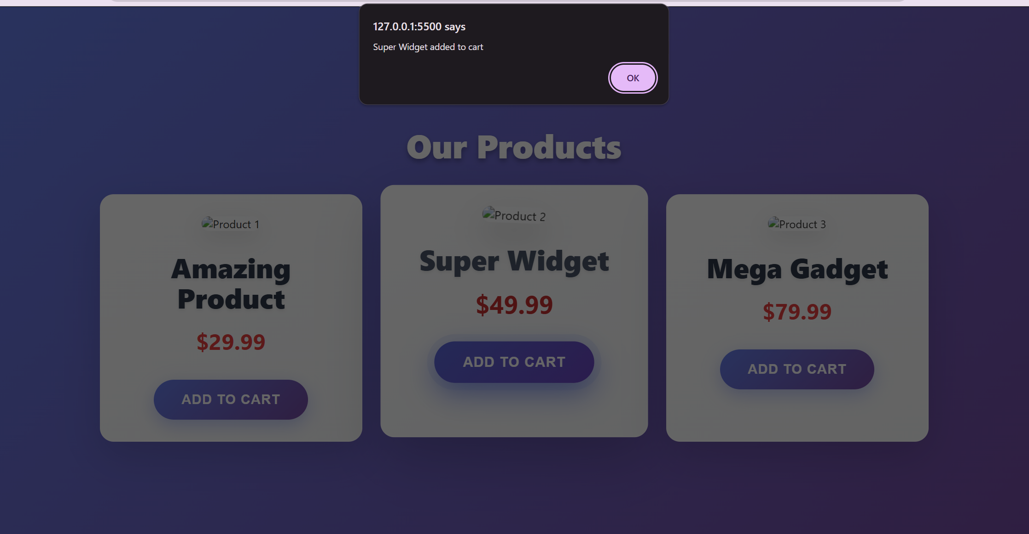

Task 3
http://127.0.0.1:5500/t3_index.html

Prompt 1
Create an event registration form using HTML.

Requirements:
- Input fields: Name, Email, Phone Number
- Dropdown for session selection
- Submit button
- Use labels for accessibility
- Use proper semantic HTML

Prompt 2
Generate CSS for an event registration form.

Requirements:
- Center the form on the page
- Add padding, border, and shadow
- Use professional colors
- Style input fields and button
- Make it clean and modern

Prompt 3
Update my CSS to make the form responsive for mobile and tablet using media queries.

Prompt 4
Write JavaScript to validate an event registration form.

Requirements:
- Name should not be empty
- Email should be valid format
- Phone number should be 10 digits
- Show alert messages for invalid input
- Prevent form submission if invalid

Prompt 5
Improve my form accessibility:
- Ensure all inputs have labels
- Add ARIA attributes where needed
- Improve usability for screen readers

Prompt 6
Improve form UI:
- Add hover effects on button
- Add focus styles on input fields
- Add smooth transitions
- Improve spacing

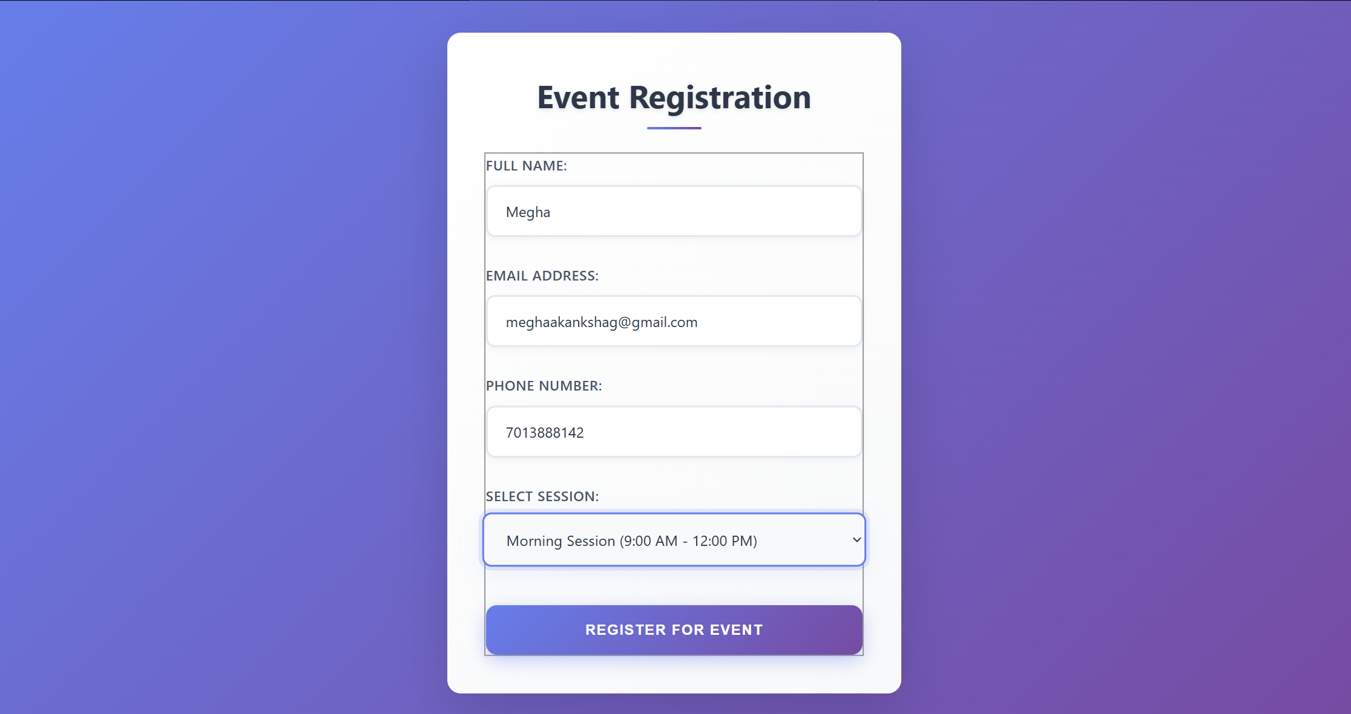

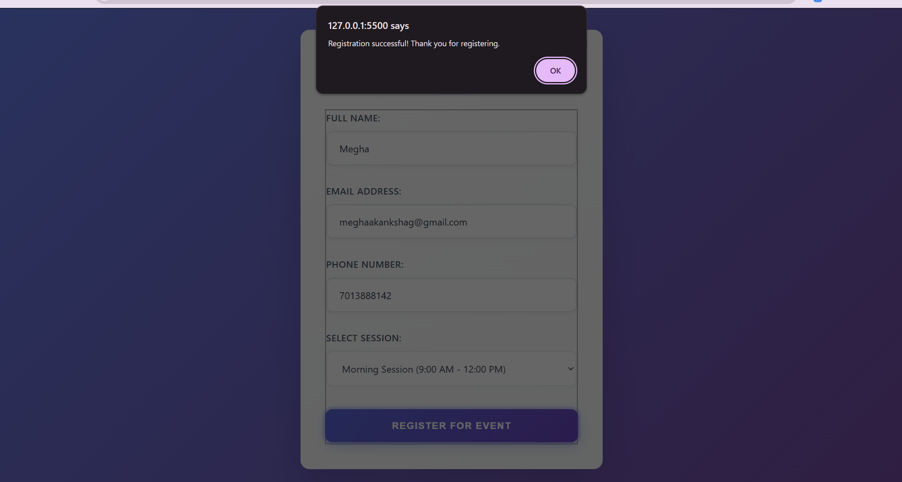

Task 4
http://127.0.0.1:5500/t4_index.html#experience

Prompt 1
Create a one-page resume website using HTML.

Requirements:
- Sections: Profile Summary, Skills, Education, Experience
- Navigation links to each section
- Clean and professional structure
- Use semantic HTML

Prompt 2
Generate CSS for a resume website.

Requirements:
- Use CSS Grid for layout
- Align sections neatly
- Professional typography
- Clean spacing and layout
- Use a minimal color palette

Prompt 3
Update my CSS to make the resume website responsive for mobile and tablet using media queries.

Prompt 4
Write JavaScript to implement smooth scrolling between sections in a resume website when navigation links are clicked.

Prompt 5
Improve resume UI:
- Add hover effects on navigation
- Improve typography (font sizes, spacing)
- Add subtle transitions
- Make it clean and professional
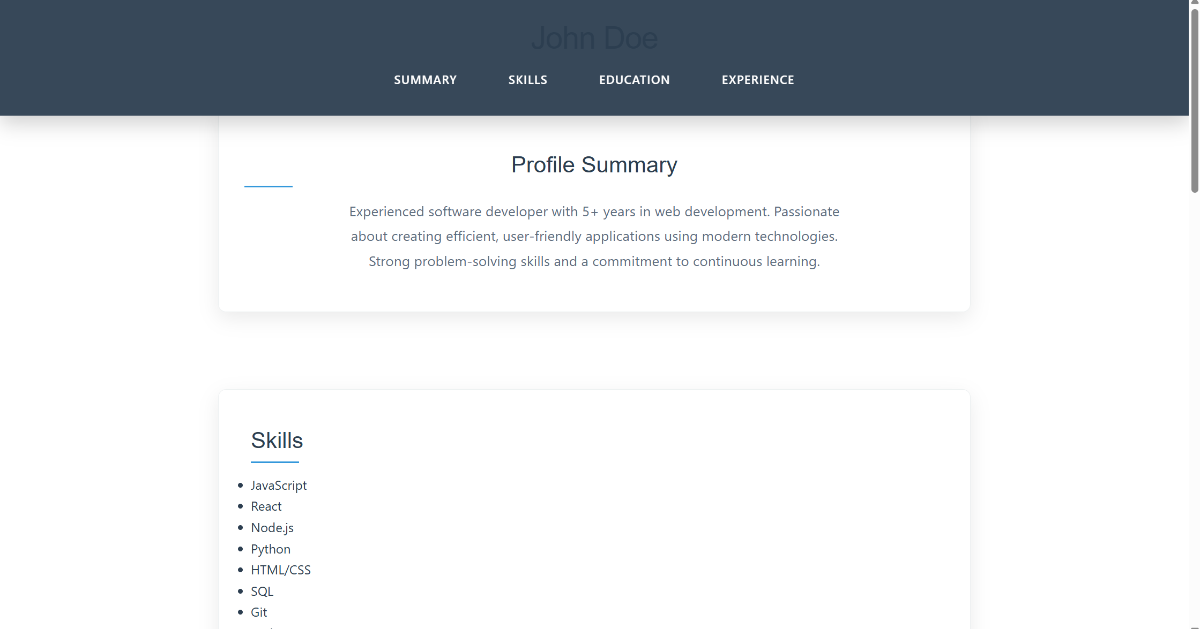

Task 5
http://127.0.0.1:5500/t5_index.html

Prompt 1
Create a restaurant menu page using HTML.

Requirements:
- Display menu items with name, description, and price
- Use multiple menu items (at least 4–6)
- Use a clean and structured layout
- Use semantic HTML
Prompt 2
Generate CSS for a restaurant menu page.

Requirements:
- Use a card-based layout for menu items
- Use a food-friendly color palette (warm colors)
- Add spacing and shadows
- Make layout responsive using Flexbox or Grid
- Make it visually appealing

Prompt 3
Update my CSS to make the restaurant menu responsive for mobile and tablet using media queries.

Prompt 4
Improve menu UI:
- Add hover effects on menu cards
- Add smooth transitions
- Improve typography and spacing
- Make it modern and attractive

Prompt 5
Write simple JavaScript for a restaurant menu page:
- Show an alert when a menu item is clicked
- Keep it simple and beginner friendly

