AI ASSISTED CODING
LAB 19.2
NAME: MEGHA AKANKSHA
HT NO: 2303A52058
BATCH 39

Task 1 – Python to Java Conversion Task:
Convert a Python program that performs file handling operations into an equivalent Java program using AI assistance. Instructions:
- Prompt AI to translate a Python script that reads from and writes to a file into Java.
- Ensure proper handling of file streams, exceptions, and input/output formatting.
- Verify that the Java program produces the same file content and console output as the Python version.
- Test both implementations with sample input files.
Prompt:
Convert this Python file handling program into Java. The Java program should do the same work as the Python program. It should write data into a file, read the same file, and display the same output on the console. Use proper Java file handling and handle exceptions
correctly. Keep the Java code simple and easy to understand. Add comments in the code. Also explain the Java program in simple language and make sure it produces the same file content and console output as the Python version. Give the final answer with Python code, Java code, explanation, sample output, and how to run it.
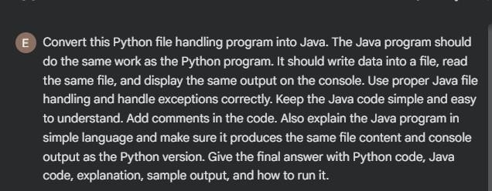
Code:

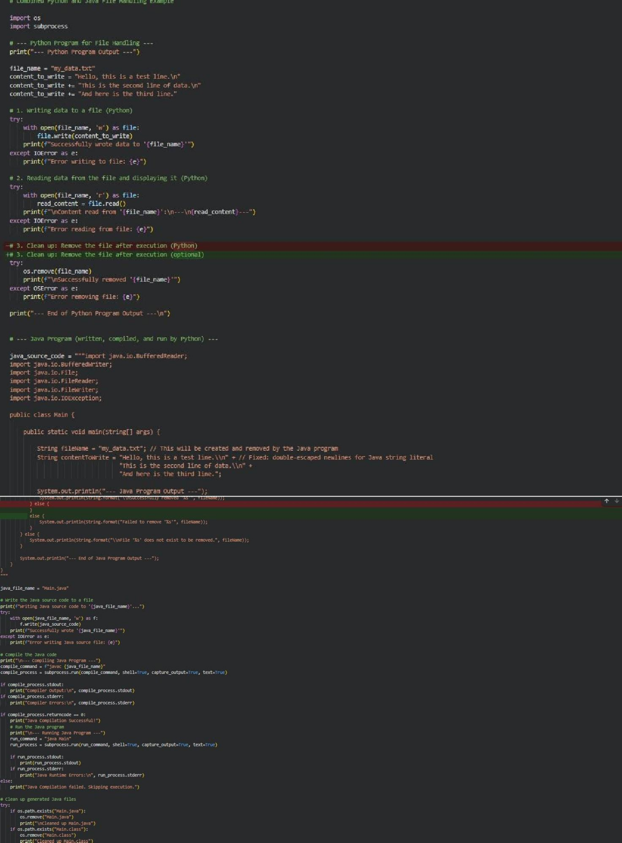
Output:

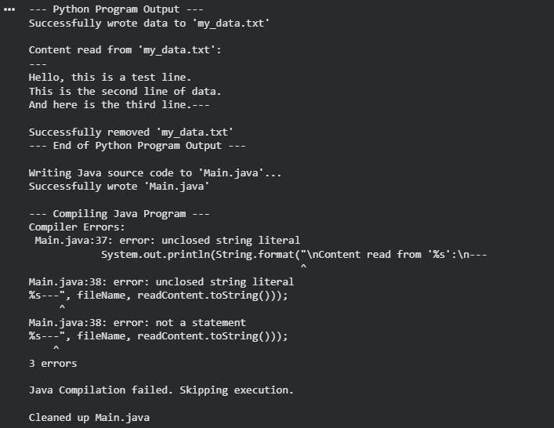

Explanation:

  - This Python program is used for file handling, which means it can write data into a file and read data from a file.
  - First, the program opens a file named sample.txt in write mode ("w") and writes
three lines of text into it.

  - After writing, it prints “Data written to file successfully.” to show that the file has been created and the data is stored.

  - Next, the program opens the same file in read mode ("r") and reads all the content using file.read().
  - Finally, it displays the file content on the console. The with open() statement is used so the file closes automatically after reading or writing.

Task 2 – C++ to Python Function Conversion Task:

Translate a C++ program that implements a sorting algorithm into Python using AI assistance. Instructions:
  - Provide AI with a C++ implementation of a sorting technique (e.g., Bubble Sort or Selection Sort).
  - Ask AI to generate an equivalent Python implementation.
  - Ensure logical correctness and validate results using multiple test cases.
  - Confirm that the Python version maintains the same sorting behavior.
Prompt:
Convert this C++ sorting program into Python. The Python program should do the same work as the C++ program and follow the same sorting logic. Keep the code simple and easy to
understand. Make sure the Python version gives the same sorted output as the C++ version. Also explain the Python code in simple language and test it with different input values to check correctness. Give the final answer with C++ code, Python code, explanation, sample input, sample output, and test cases.

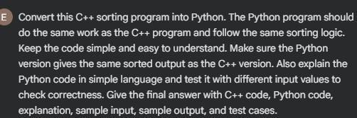
Code:

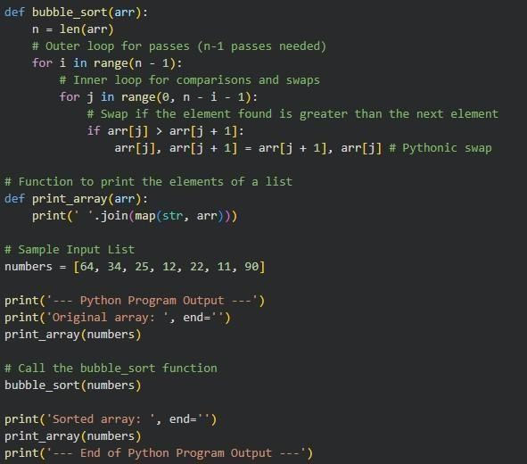
Output:
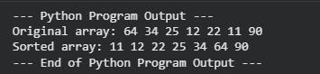

Task:
Convert a SQL query involving GROUP BY and aggregate functions into an equivalent Pandas Data Frame operation.
Instructions:
- Provide AI with a SQL query that calculates aggregate values (e.g., total sales per department).
- Prompt AI to generate equivalent Pandas code using groupby() and aggregation functions.
- Test the generated code using a sample dataset.
- Verify that both SQL and Pandas outputs match.

Prompt:

Convert this SQL query into equivalent Pandas code. The Pandas program should do the same work as the SQL query and produce the same result. Use groupby() and aggregation functions like sum(), count(), mean(), or any other needed function. Keep the code simple and easy to understand. Also explain the Pandas code in simple language and test it with a sample dataset to make sure the output matches the SQL query. Give the final answer with SQL query, Pandas code, sample dataset, explanation, sample output, and test case.
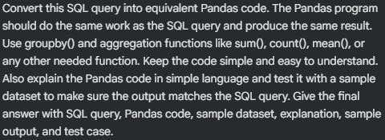
Code:
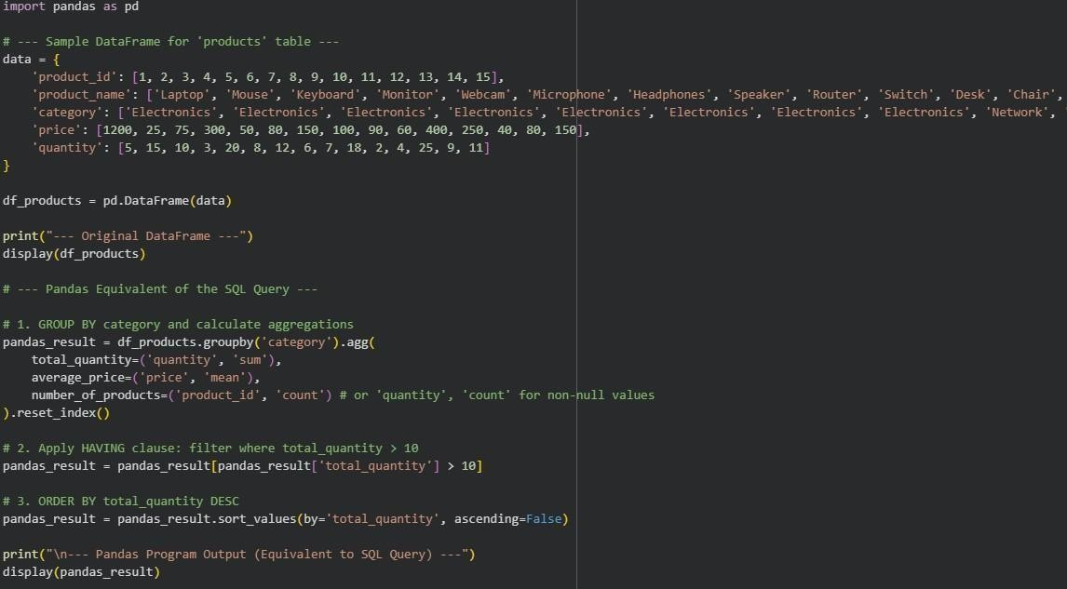
Output:

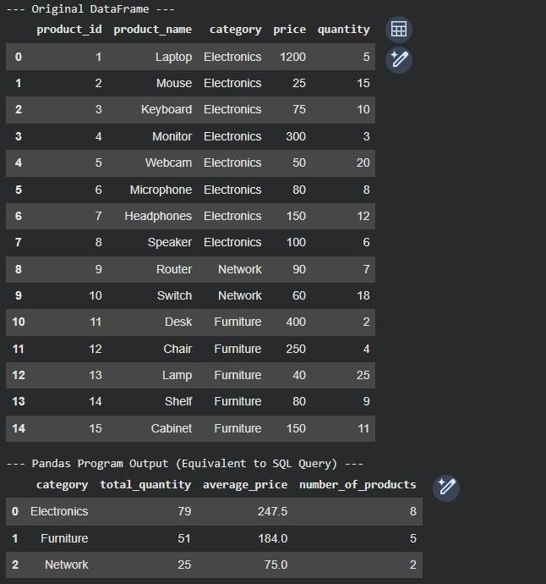
Explanation:

- SQL is used to work with data in tables.
- GROUP BY is used to group similar values together.
- Aggregate functions are used to calculate values like total, average, count, etc.
- In Pandas, the same thing is done using groupby() and aggregation functions.
- The final result in Pandas should match the SQL query output.
Task 4 – Real-Time Application: Multi-Language Snippet Converter Scenario: Students will select a practical real-world application requiring the same logic in two different programming languages. Example:
- Converting a REST API implementation from Python (Flask) to Java (Spring Boot).
- Translating a data processing script from Python to C++ for performance optimization. Instructions:
- Provide AI with source code in one programming language.
- Prompt AI to convert the code into another chosen language. • Execute and test both versions to ensure identical functionality.
- Document differences observed in syntax, libraries, and execution behavior.

Prompt:
Convert this program from one programming language into another programming language. The new program should do the same work and follow the same logic as the original code.
Keep the converted code simple, correct, and easy to understand. Make sure both programs
give the same output and behavior when tested. Also explain the code in simple language and compare both versions based on syntax, libraries used, and execution behavior. Give the final answer with source code, converted code, explanation, sample input, sample output, test
cases, and observations.

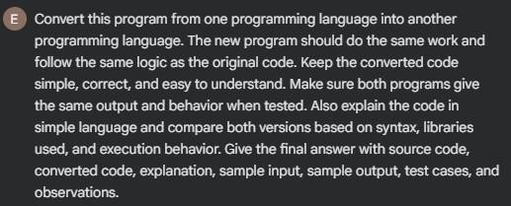
Code:

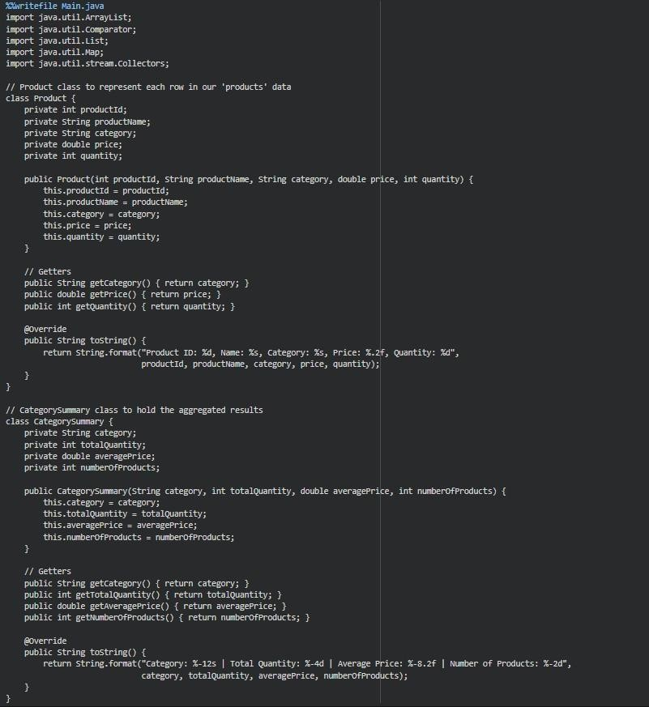

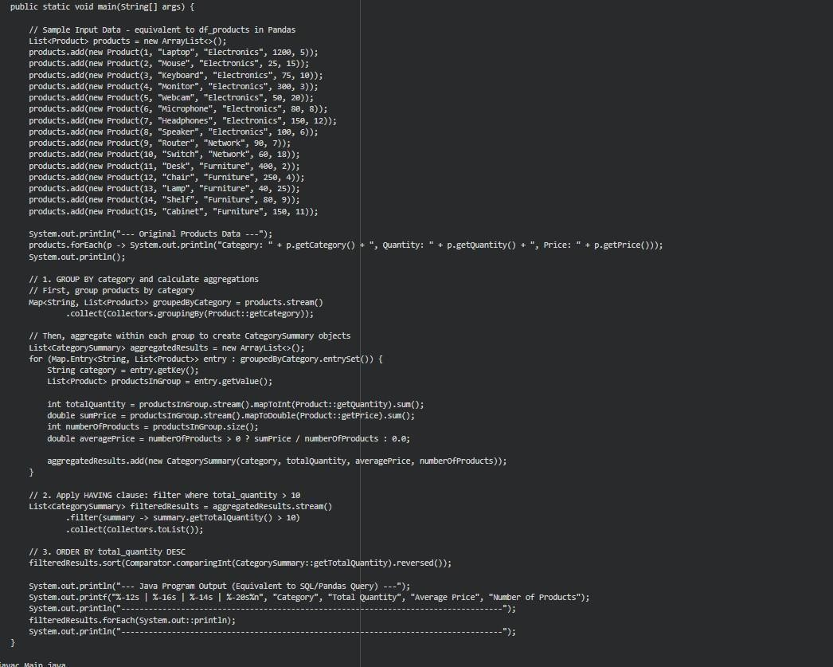

Output:
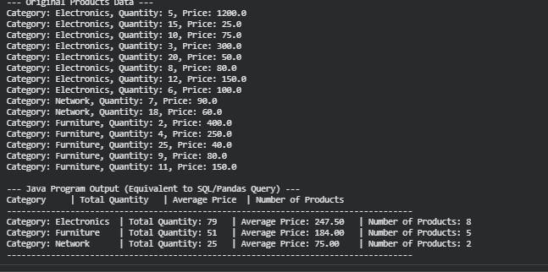
Explanation:

- The source code is written in one programming language.
- The same logic is converted into another programming language.
- Both versions should perform the same task.
- Both programs are tested with the same input.
- Differences in syntax, libraries, and execution are observed and documented.

Task -5: (Basic Function Translation (Python to C++) Translate a simple Python function that checks whether a number is even or odd into C++ using AI assistance.Instructions:
- Provide AI with a basic Python function that determines if a number is even or odd.
- Prompt AI to generate equivalent C++ code.
- Ensure correct syntax, input handling, and output formatting.
- Compile and run the C++ program to verify it produces the same result as the Python version.
- Test with at least three different input values.

Prompt:
Convert this Python program into C++. The C++ program should do the same work as the Python program and follow the same logic. The program should check whether a number is even or odd. Keep the C++ code simple, correct, and easy to understand. Make sure it handles input properly and gives the correct output in the same format. Also explain the C++ code in
simple language and test it with at least three different input values to verify that both programs give the same result. Give the final answer with Python code, C++ code,
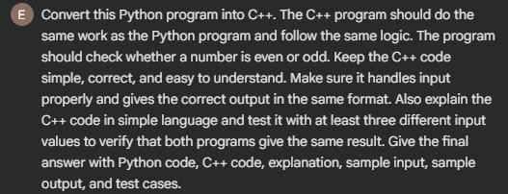
explanation, sample input, sample output, and test cases.

Code:

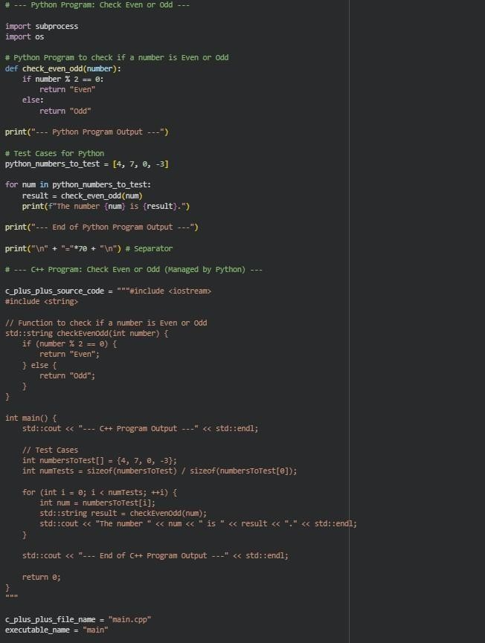

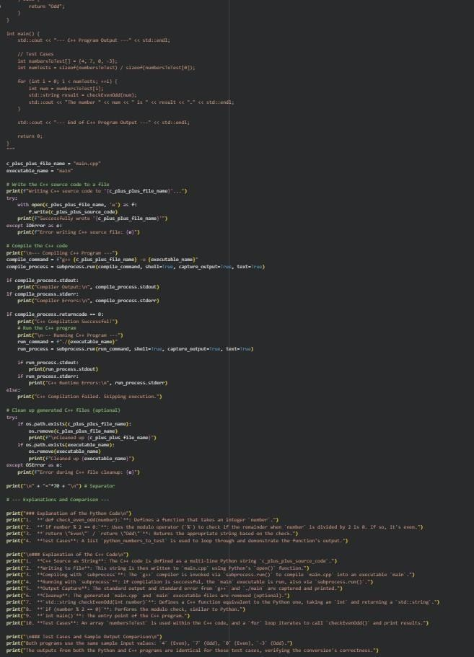
Output:

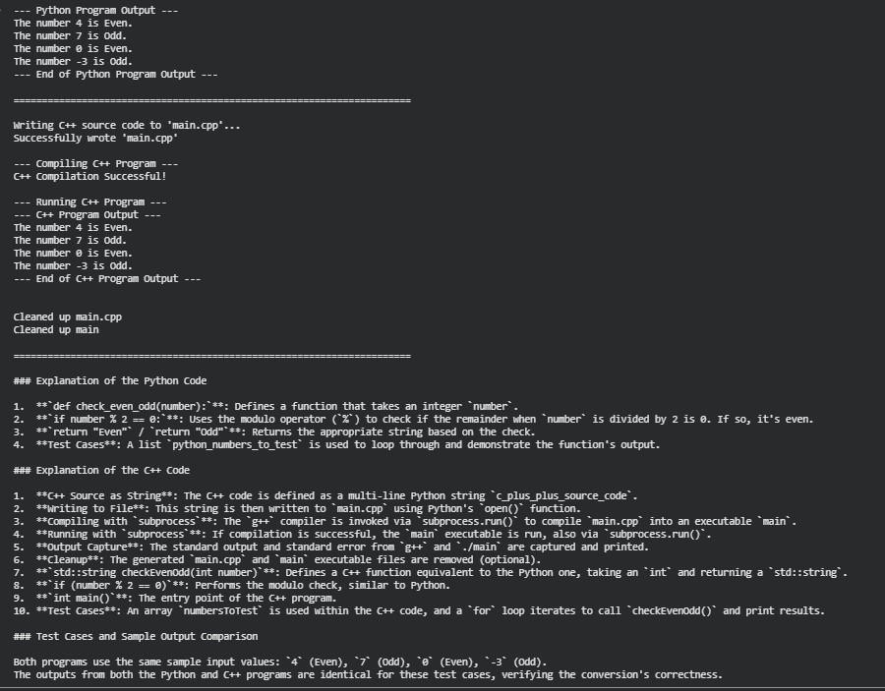

Explanation:
- The program takes a number as input.
- It checks whether the number is divisible by 2.
- If divisible, it prints Even.
- If not divisible, it prints Odd.
- The same logic is written in both Python and C++.

