AI ASSISTED CODING
LAB 7.1
NAME: MEGHA AKANKSHA
HT NO: 2303A52058
BATCH 39

Task 1
def greet():
print "Hello, AI Debugging Lab!"
greet()

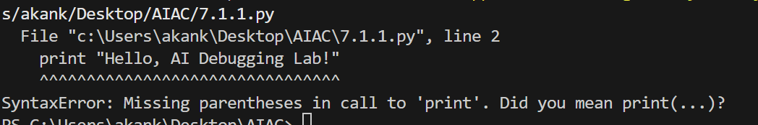

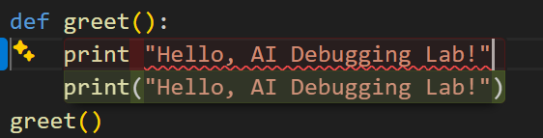
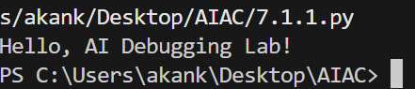

Task 2
def check_number(n):
if n = 10:
return "Ten"
else:
return "Not Ten"
print(check_number(10))
print(check_number(5))
print(check_number(3))

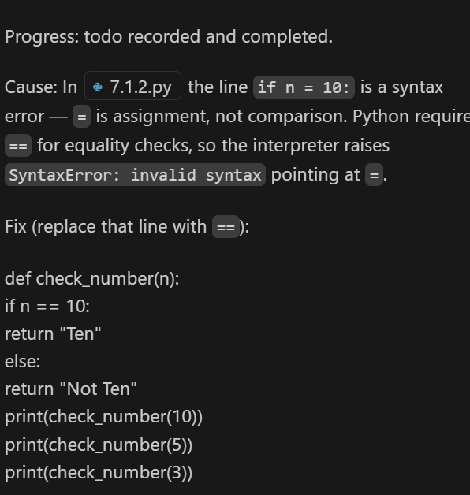

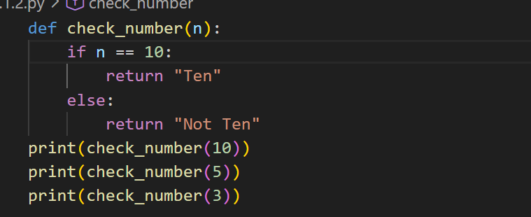

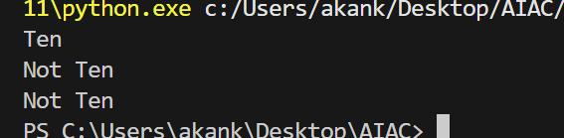

Task 3
def read_file(filename):
with open(filename, 'r') as f:
return f.read()

print(read_file("nonexistent.txt"))

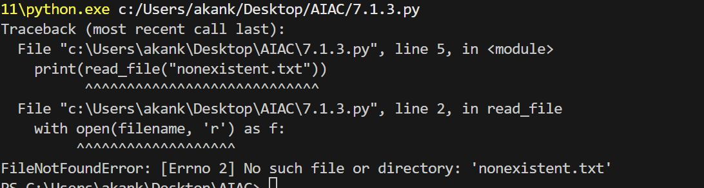

# Bug Fix: Program crashes if file is missing
# Solution: Implement try-except block with safe error handling

def read_file(filename):
"""
Safely read a file with proper error handling.

Args:
filename: Path to the file to read

Returns:
File contents if successful, or None if error occurs
"""
try:
with open(filename, 'r') as f:
return f.read()
except FileNotFoundError:
print(f"Error: File '{filename}' not found.")
print("Please check the file path and try again.")
return None
except PermissionError:
print(f"Error: Permission denied. Cannot read '{filename}'.")
return None
except Exception as e:
print(f"Unexpected error while reading '{filename}': {e}")
return None
# ============================================
# Test Scenario 1: File exists
# ============================================
print("=== Test 1: File Exists ===")
with open("sample.txt", "w") as f:
f.write("Hello, this file exists!")
content = read_file("sample.txt")
if content:
print(f"Successfully read: {content}\n")
# ============================================
# Test Scenario 2: File missing
# ============================================
print("=== Test 2: File Missing ===")
result = read_file("nonexistent.txt")
if result is None:
print("Gracefully handled missing file.\n")
# ============================================
# Test Scenario 3: Invalid path
# ============================================
print("=== Test 3: Invalid Path ===")
result = read_file("C:\\invalid\\path\\that\\does\\not\\exist.txt")
if result is None:
print("Gracefully handled invalid path.\n")
print("All tests completed!")

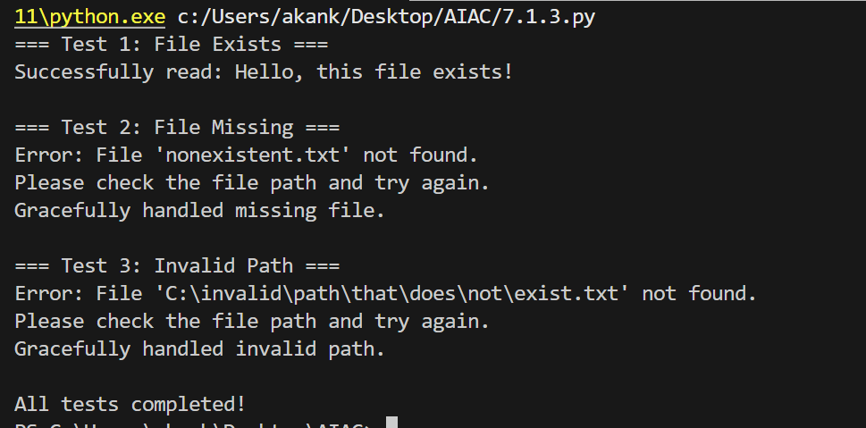
Task 4
class Car:
def start(self):
return "Car started"
my_car = Car()
print(my_car.drive())

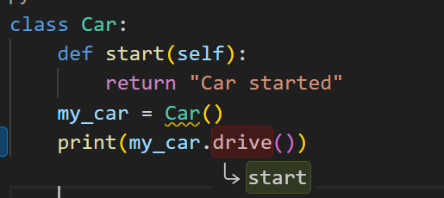

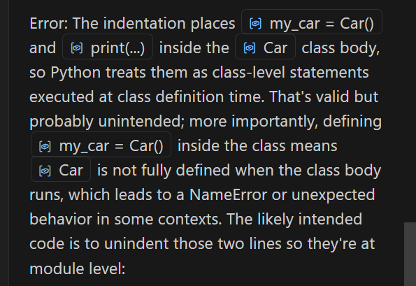

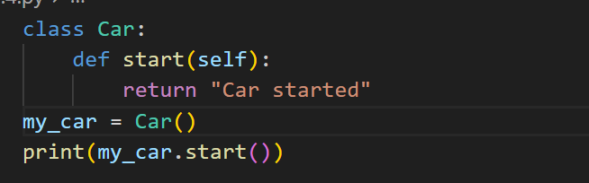

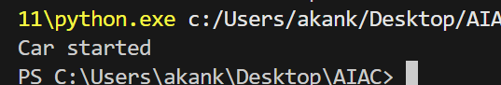

Task 5
def add_five(value):
return value + 5
print(add_five("10"))

