AI ASSISTED CODING
LAB 10.1
NAME: MEGHA AKANKSHA
HT NO: 2303A52058
BATCH 39

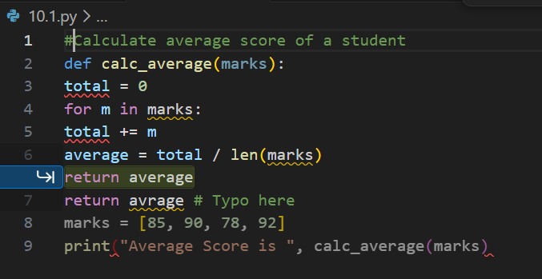

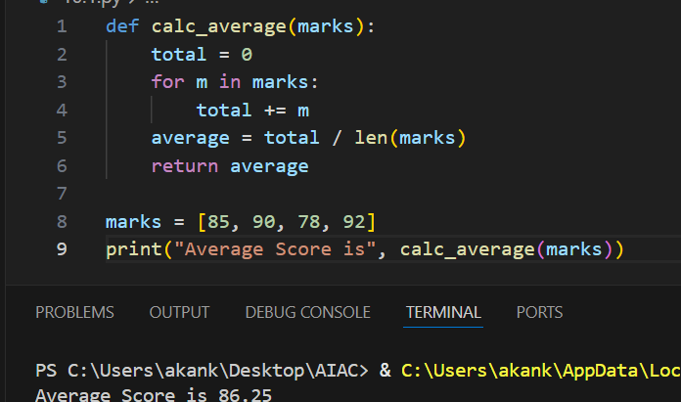
avrage typo → corrected to average
Missing closing parenthesis in print()
Ensured function returns correct variable
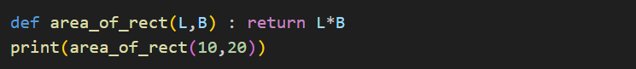
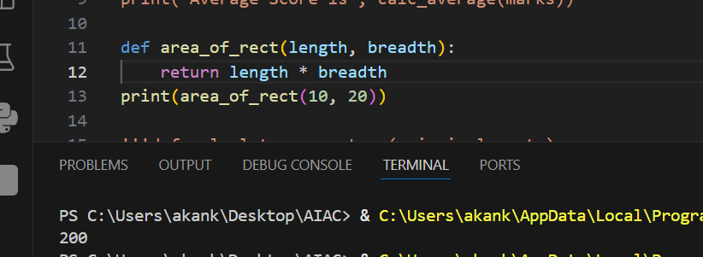
Replaced capital variables with lowercase descriptive names
Added spaces around operators
Split function and print into separate lines
Followed proper indentation and formatting
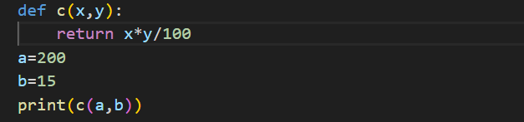
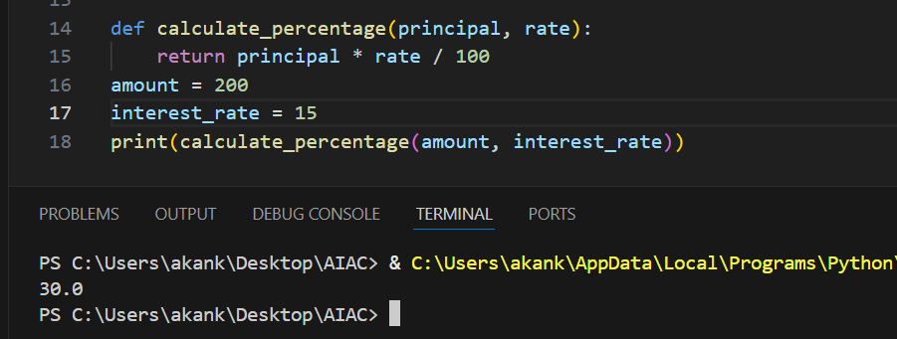
Function name made descriptive
Variables renamed meaningfully
Added spacing for readability
Improved structure without changing logic
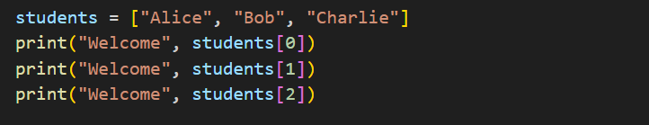
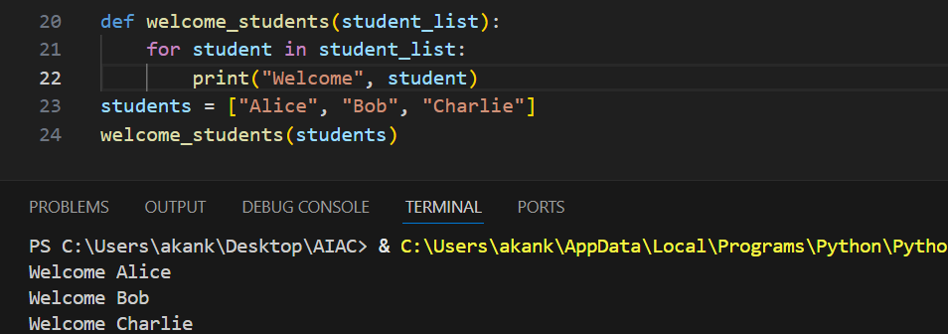
Removed repetitive print statements
Used loop instead
Created reusable function
Easier to maintain if list grows
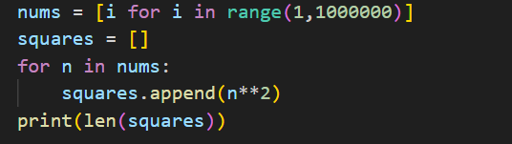
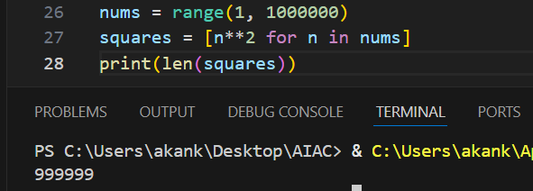
Avoided unnecessary list creation
Used list comprehension (faster execution)
Reduced memory usage
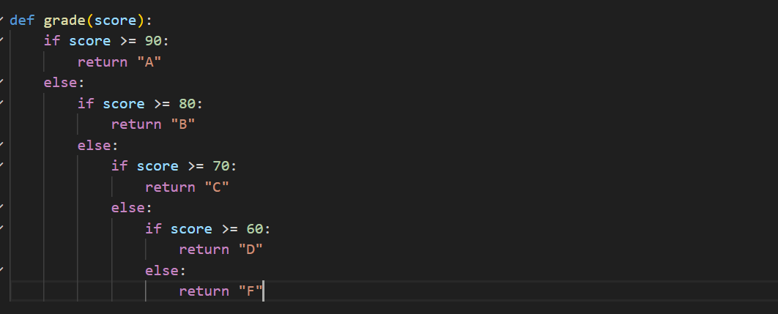
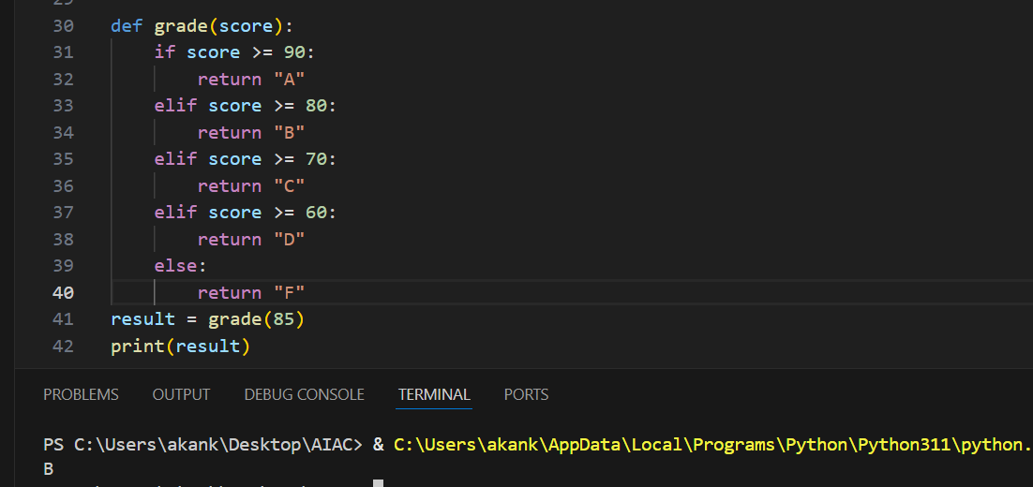
Removed deeply nested if–else statements
Replaced them with elif for cleaner logic
Reduced indentation levels
Improved readability and maintainability
Logic remains exactly the same

