AI ASSISTED CODING
LAB 15.2
NAME: MEGHA AKANKSHA
HT NO: 2303A52058
BATCH 39

Task1
http://127.0.0.1:8000/

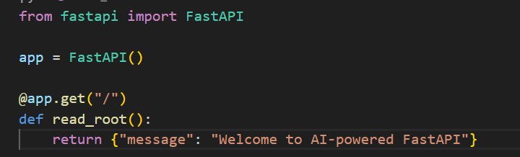

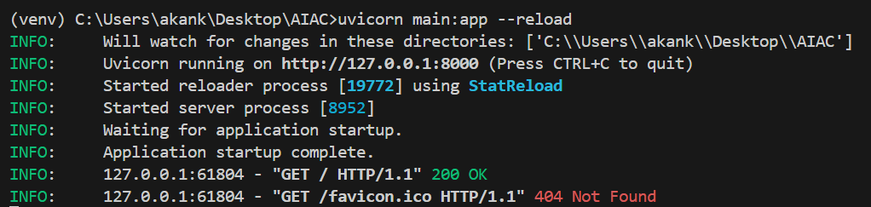

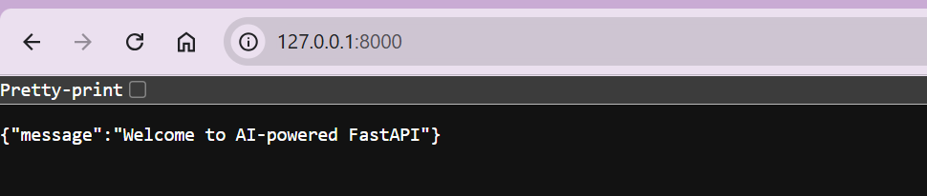

Task2
Prompt
Add API endpoints in FastAPI:

Requirements:
- Create a list to store items
- GET /items → return all items
- POST /items → add a new item (dictionary)
- Return message when item is added
- Keep code simple
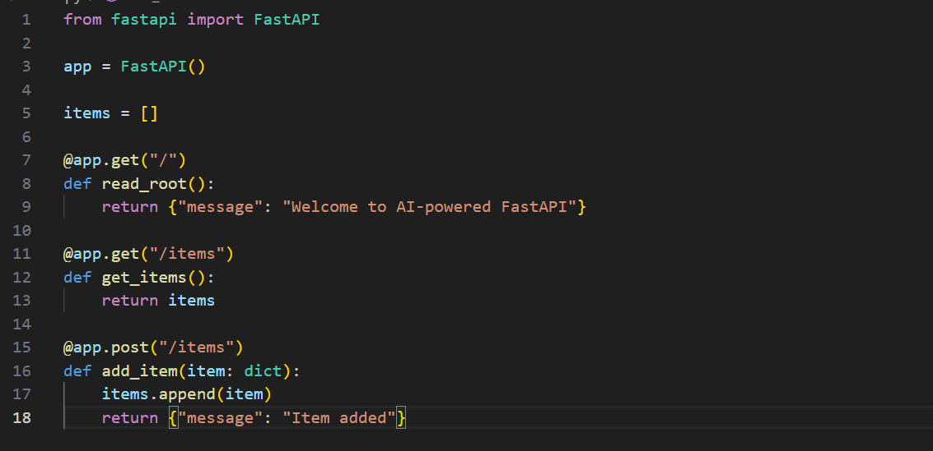
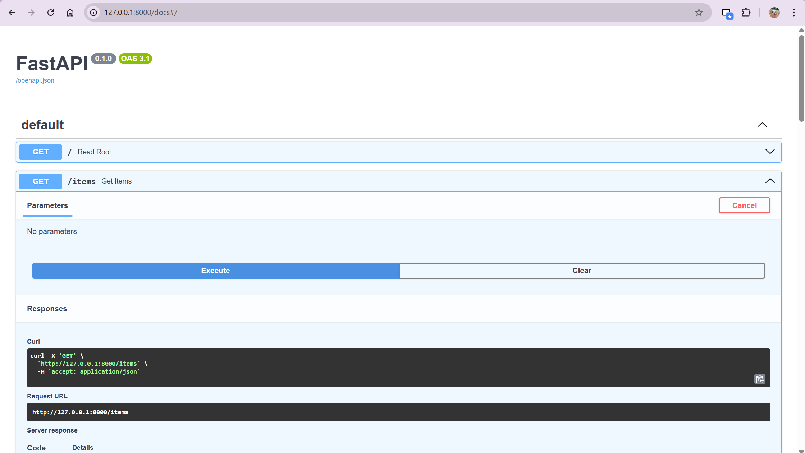
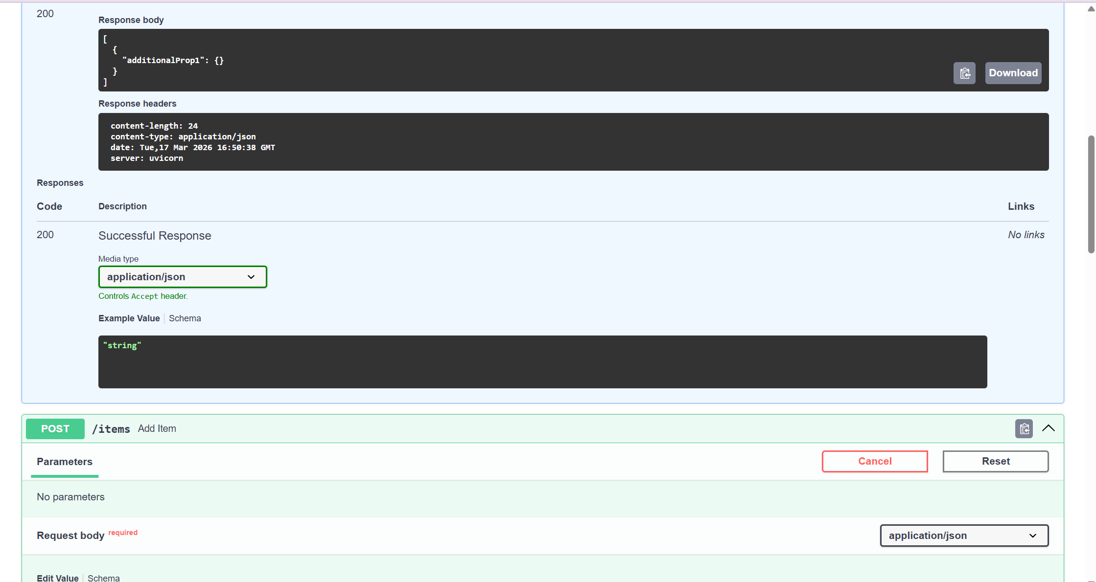
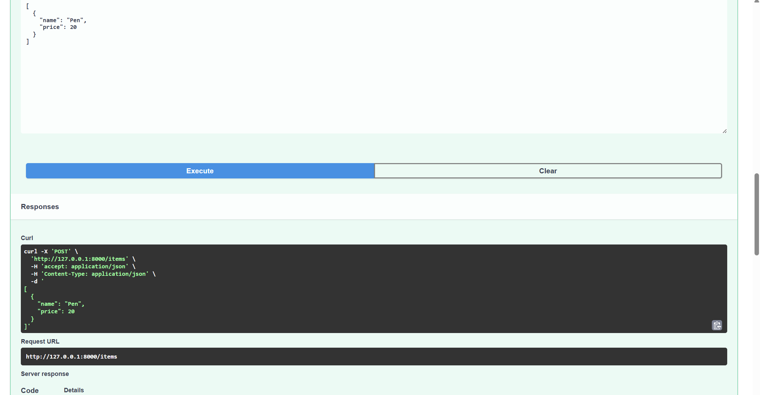
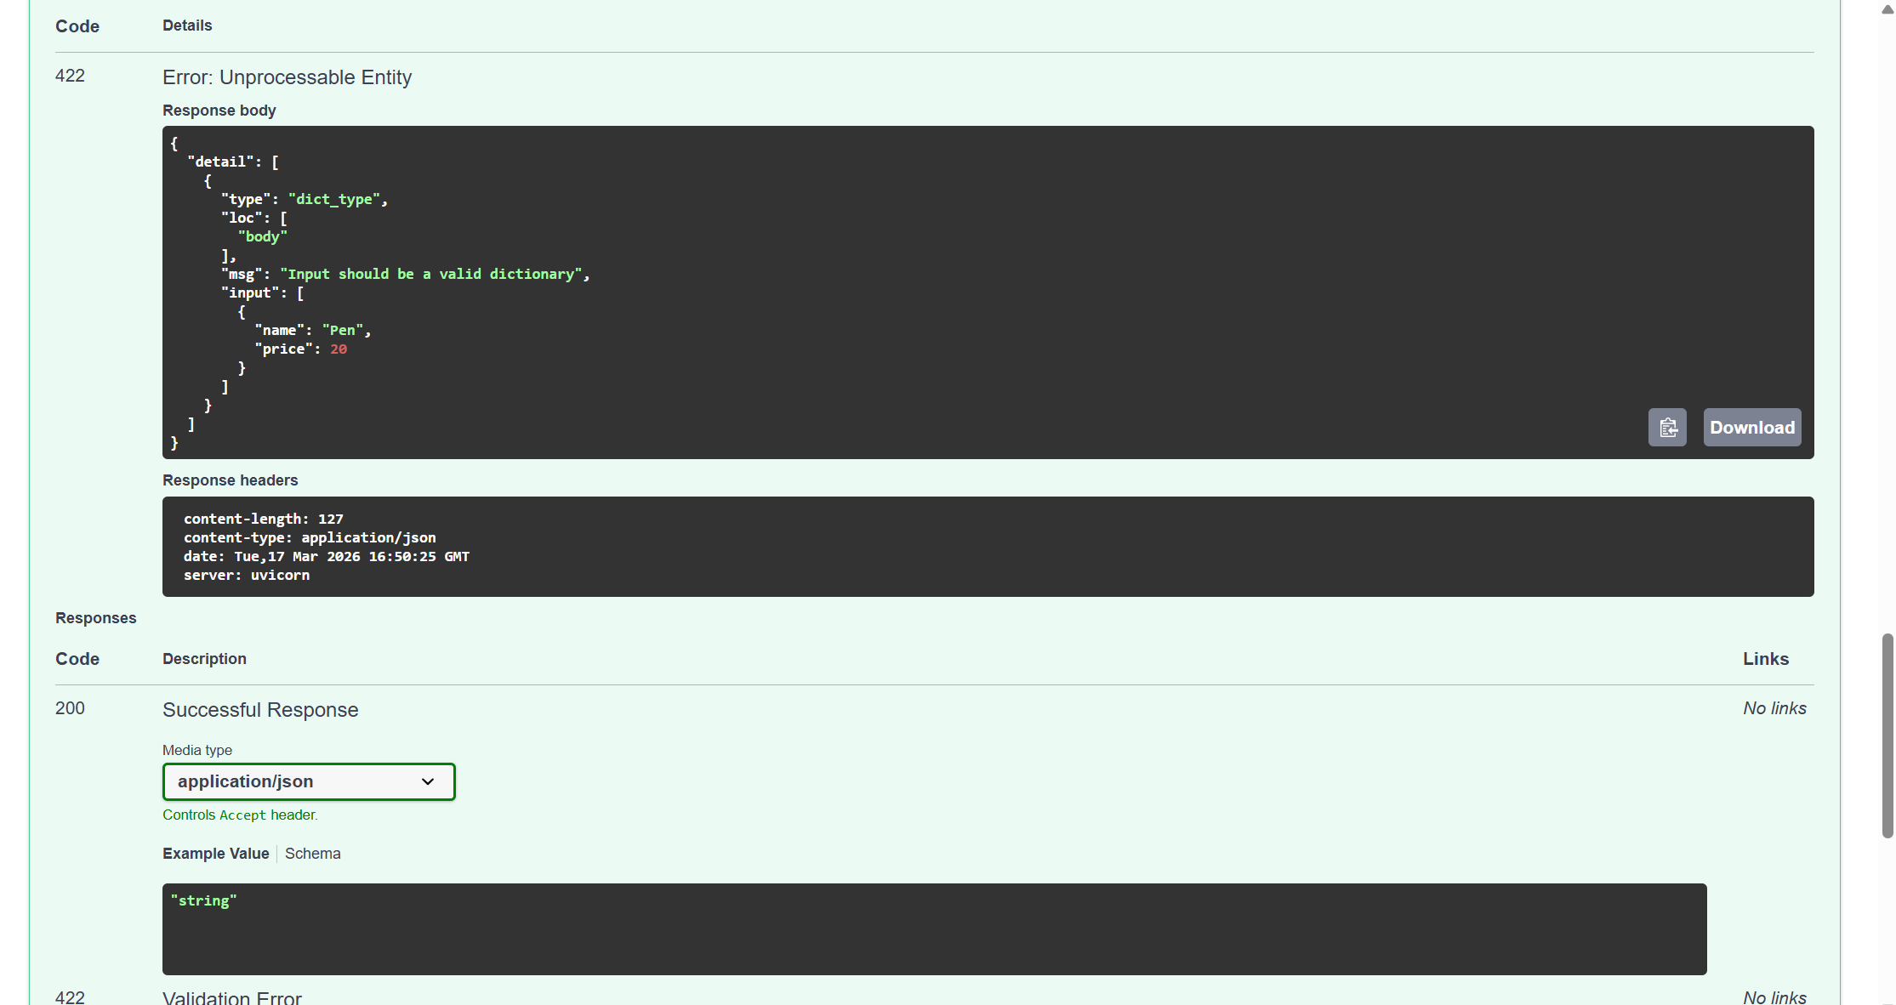
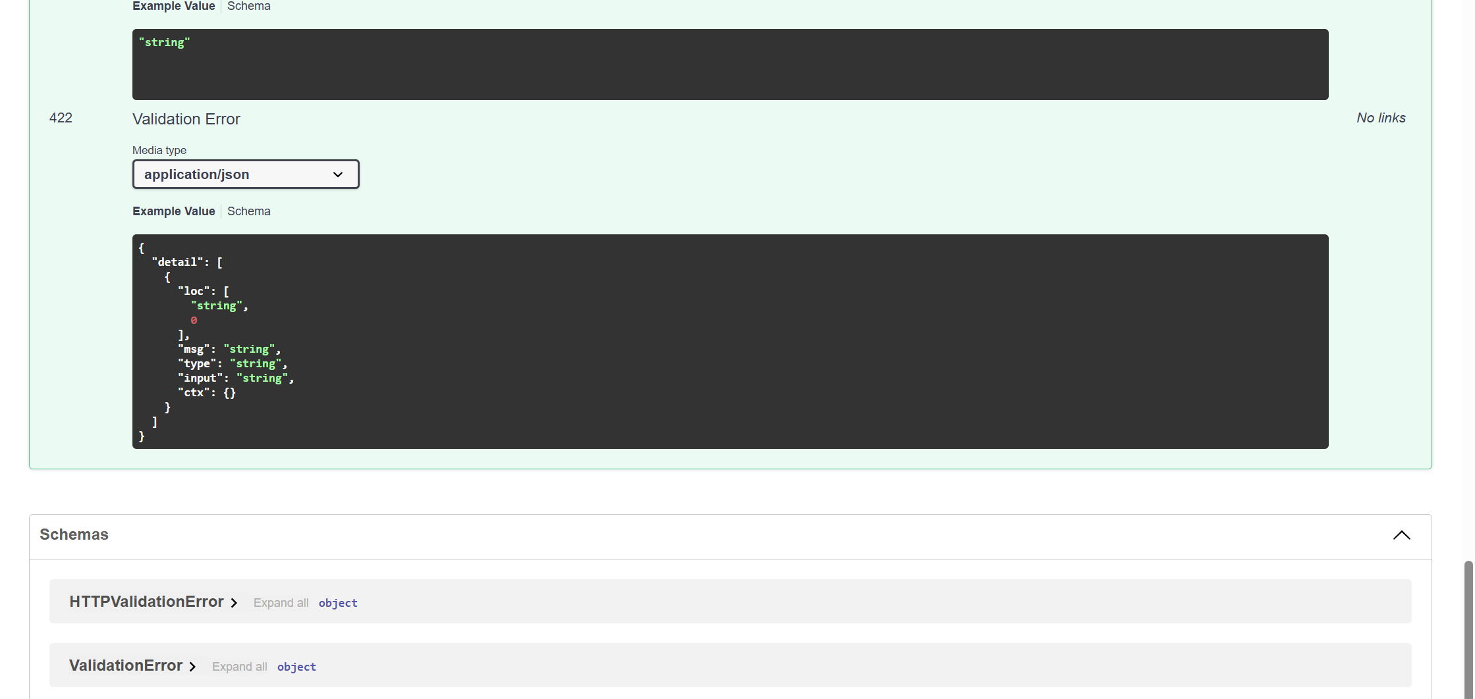

Task 3
Add a PUT endpoint in FastAPI to update an item by index.

Requirements:
- Endpoint: /items/{index}
- Check if index exists
- If not, return error message
- If exists, update item in list
- Return updated item
- Keep code simple

