AI ASSISTED CODING
LAB 8.1
NAME: MEGHA AKANKSHA .G
HT NO: 2303A52058
BATCH 39

Question 1 test is strong password with unit testing

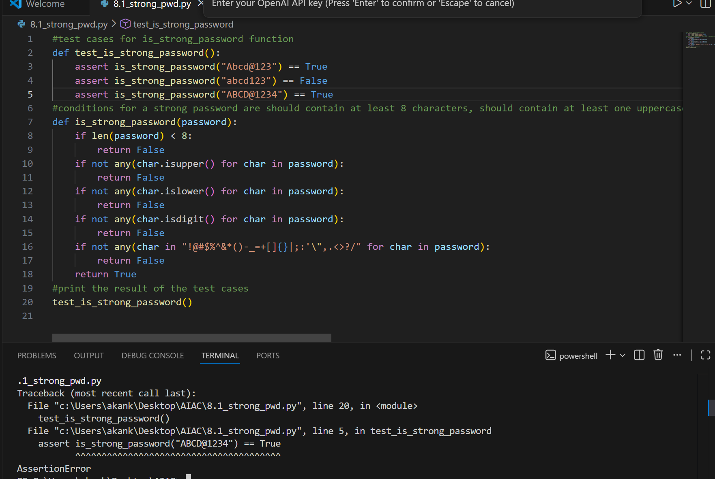
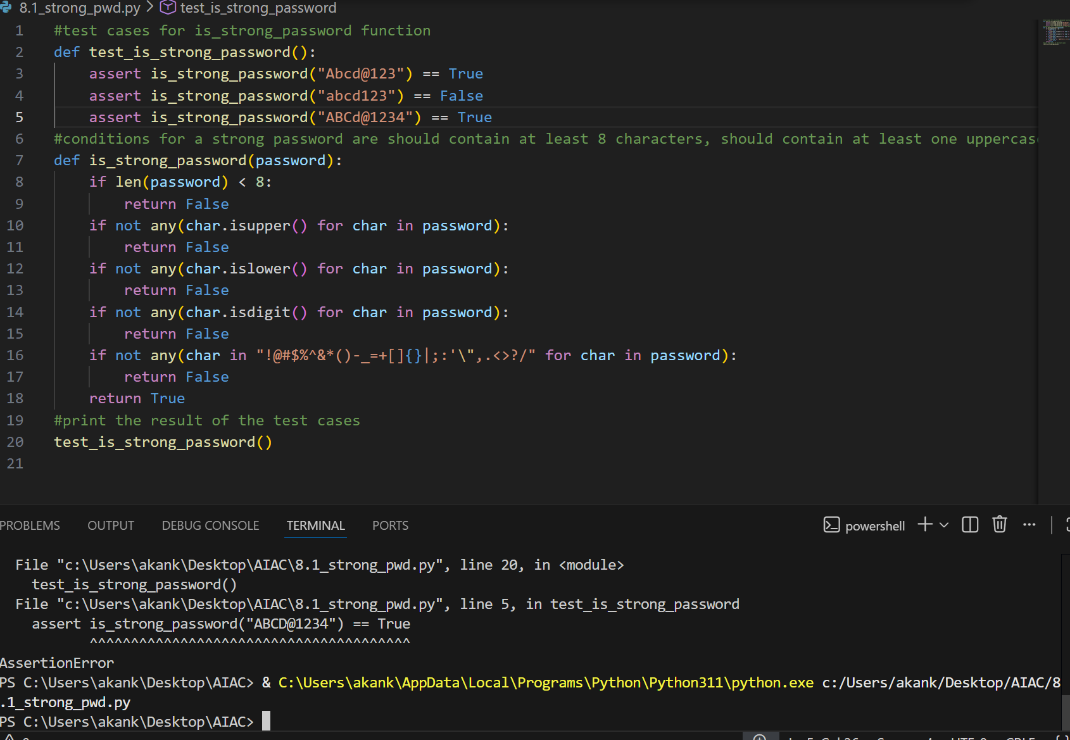
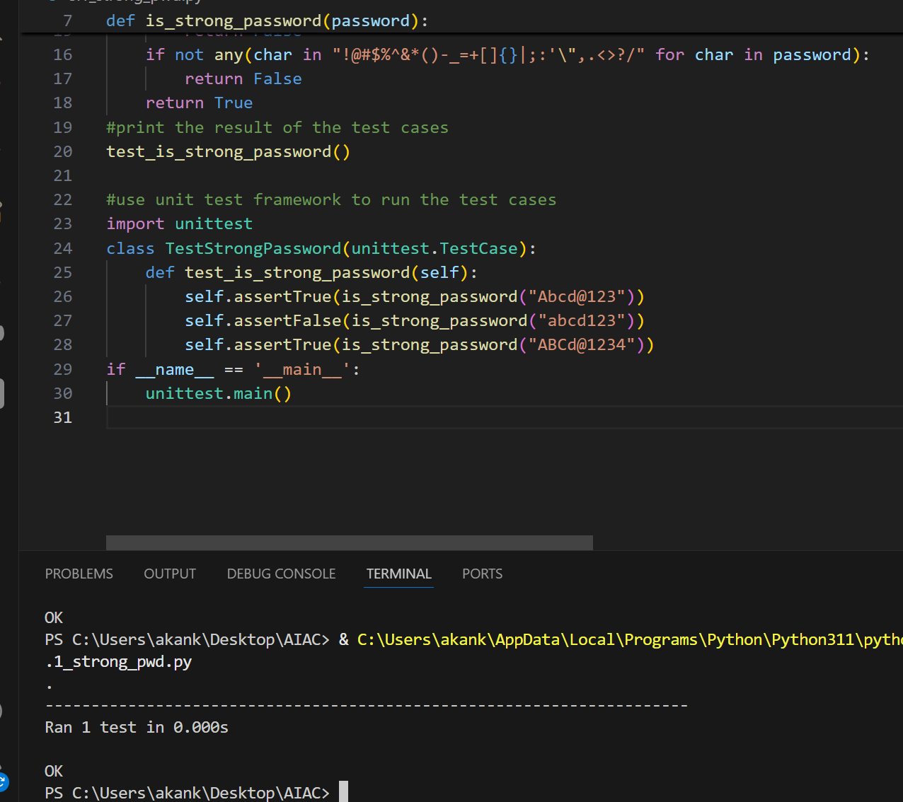

Question 2 test classification into positive, negative or zero
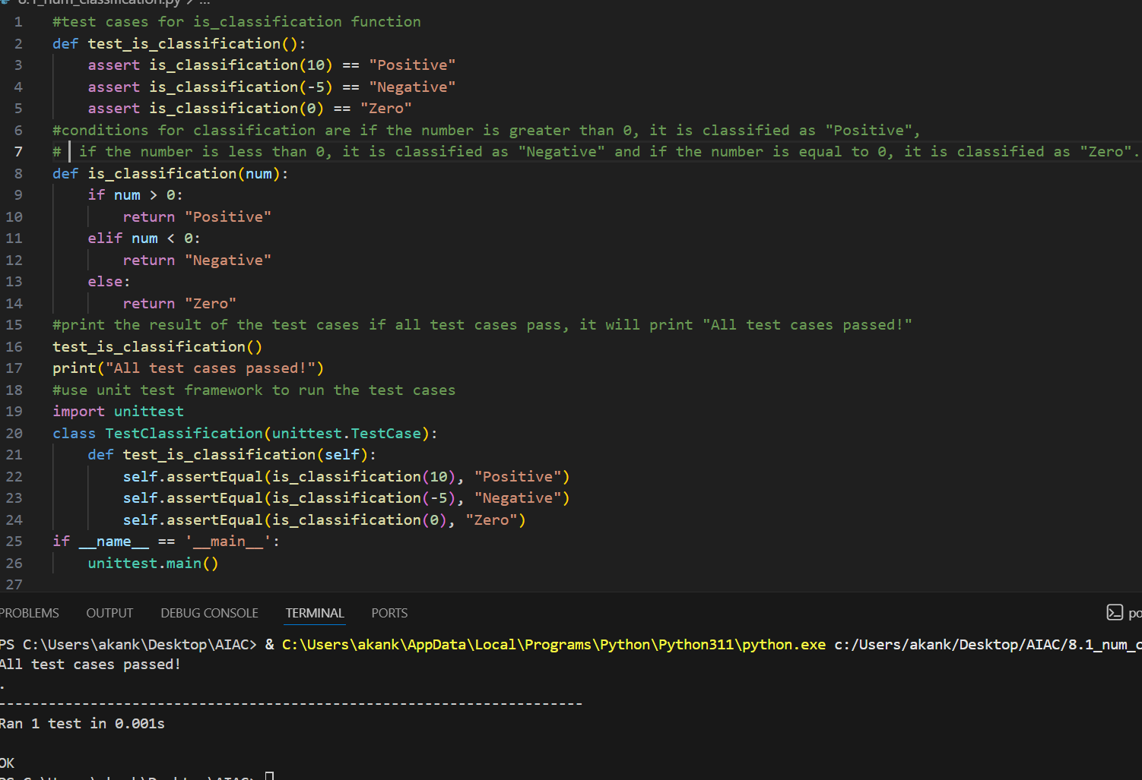

Question 3 test is anagram

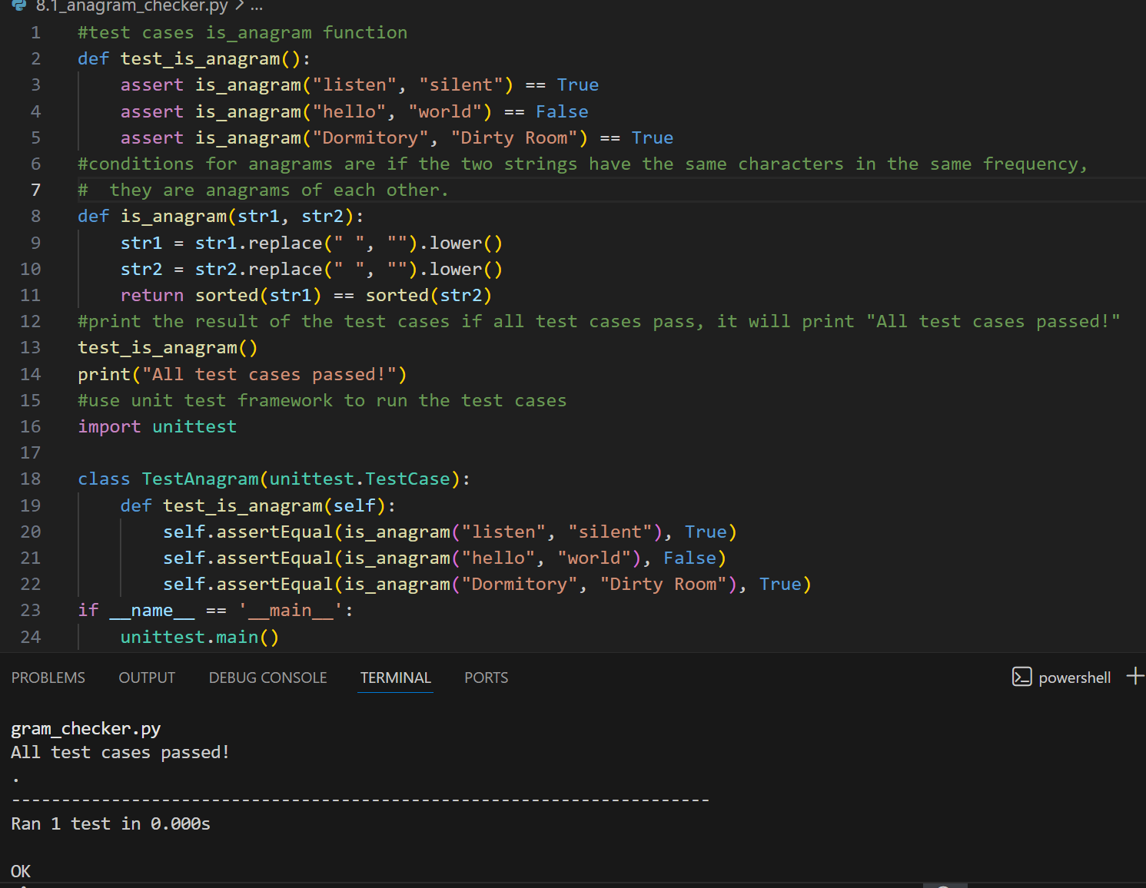

Question 4 test inventory class with stock management
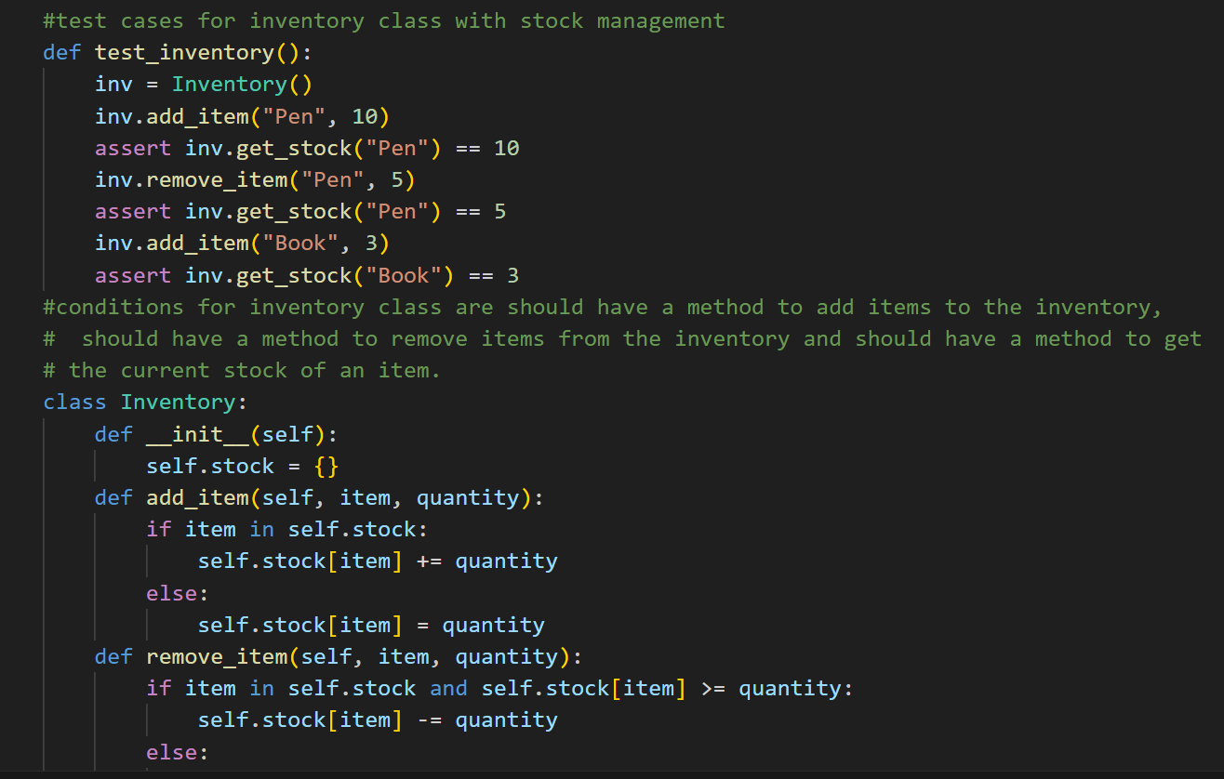
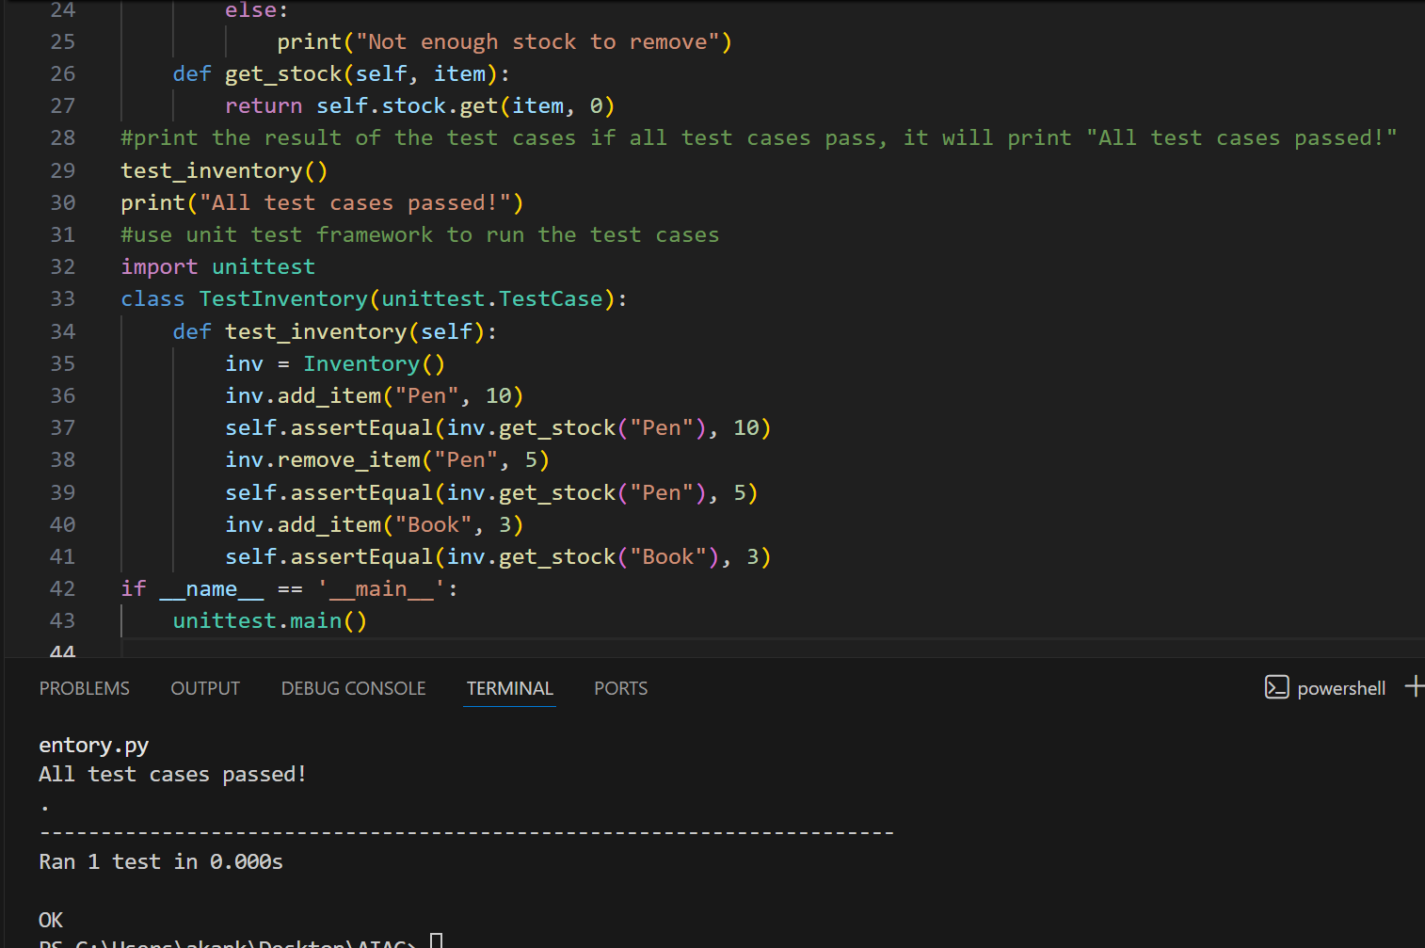

Question 5 test validate date and format date
