AI ASSISTED CODING
LAB 12.2
NAME: MEGHA AKANKSHA
HT NO: 2303A52058
BATCH 39

Task Description -1 (Data Structures – Stack Implementation with
AI Assistance)
➢ Task: Use AI assistance to generate a Python program that
implements a Stack data structure.
Instructions:
Prompt AI to create a Stack class with the following methods:
➢ push(element)
➢ pop()
➢ peek()
➢ is_empty()
➢ Ensure proper error handling for stack underflow.
➢ Ask AI to include clear docstrings for each method.
Expected Output:
➢ A functional Python program implementing a Stack using a
class.
➢ Properly documented methods with docstrings.
#create a stack class using data structures to implement push, pop, peek, and isEmpty methods
#include docstrings for each method
class Stack:
"""A stack data structure that follows the Last In First Out (LIFO) principle."""
def __init__(self):
"""Initialize an empty stack."""
self.stack = []
def push(self, item):
"""Add an item to the top of the stack.
Args:
item: The item to be added to the stack.
"""
self.stack.append(item)
def pop(self):
"""Remove and return the item at the top of the stack.
Returns:
The item at the top of the stack.
Raises:
IndexError: If the stack is empty.
"""
if self.is_empty():
raise IndexError("Stack is empty")
return self.stack.pop()
def peek(self):
"""Return the item at the top of the stack without removing it.
Returns:
The item at the top of the stack.
Raises:
IndexError: If the stack is empty.
"""
if self.is_empty():
raise IndexError("Stack is empty")
return self.stack[-1]
def is_empty(self):
"""Check if the stack is empty.
Returns:
True if the stack is empty, False otherwise.
"""
return len(self.stack) == 0
# Example usage:
if __name__ == "__main__":
stack = Stack()
stack.push(1)
stack.push(2)
stack.push(3)
print(stack.peek()) # Output: 3
print(stack.pop()) # Output: 3
print(stack.is_empty()) # Output: False
print(stack.pop()) # Output: 2
print(stack.pop()) # Output: 1
print(stack.is_empty()) # Output: True

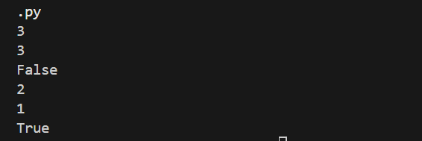

Task Description -2 (Algorithms – Linear vs Binary Search
Analysis)
➢ Task: Use AI to implement and compare Linear Search and
Binary Search algorithms in Python.
Instructions:
➢ Prompt AI to generate:
➢ linear_search(arr, target)
➢ binary_search(arr, target)
➢ Include docstrings explaining:
➢ Working principle
➢ Test both algorithms using different input sizes.
Expected Output:
• Python implementations of both search algorithms.
• AI-generated comments and complexity analysis.
• Test results showing correctness and comparison.
#implement a python program to compare linear search and binary search algorithms in terms of time complexity and efficiency.
#include ai generated comments and test results showing correctness and comparison of the two algorithms
#both search techniques should show different time complexities and efficiency based on the size of the input data.
import time
def linear_search(arr, target):
"""Perform a linear search for the target in the given array.
Args:
arr: A list of elements to search through.
target: The element to search for.
Returns:
The index of the target if found, otherwise -1.
"""
for i in range(len(arr)):
if arr[i] == target:
return i
return -1
def binary_search(arr, target):
"""Perform a binary search for the target in the given sorted array.
Args:
arr: A sorted list of elements to search through.
target: The element to search for.
Returns:
The index of the target if found, otherwise -1.
"""
left, right = 0, len(arr) - 1
while left <= right:
mid = left + (right - left) // 2
if arr[mid] == target:
return mid
elif arr[mid] < target:
left = mid + 1
else:
right = mid - 1
return -1
# Test results showing correctness and comparison of the two algorithms
if __name__ == "__main__":
# Test data
arr = list(range(1, 10000001)) # A sorted array of 1,00,00,000 elements
target = 9999

# Test linear search
start_time = time.time()
linear_result = linear_search(arr, target)
linear_time = time.time() - start_time
print(f"Linear Search: Found at index {linear_result}, Time taken: {linear_time:.6f} seconds")

# Test binary search
start_time = time.time()
binary_result = binary_search(arr, target)
binary_time = time.time() - start_time
print(f"Binary Search: Found at index {binary_result}, Time taken: {binary_time:.6f} seconds")

# Comparison of results
print("\nComparison:")
print(f"Linear Search Time Complexity: O(n), Time taken: {linear_time:.6f} seconds")
print(f"Binary Search Time Complexity: O(log n), Time taken: {binary_time:.6f} seconds")

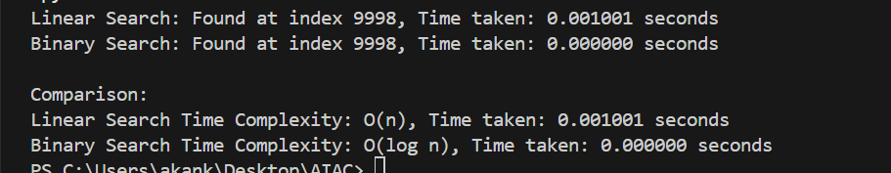

Task Description -3 (Test Driven Development – Simple Calculator
Function)
➢ Task:
Apply Test Driven Development (TDD) using AI assistance to
develop a calculator function.
Instructions:
➢ Prompt AI to first generate unit test cases for addition and
subtraction.
➢ Run the tests and observe failures.
➢ Ask AI to implement the calculator functions to pass all tests.
➢ Re-run the tests to confirm success.
Expected Output:
➢ Separate test file and implementation file.
➢ Test cases executed before implementation.
➢ Final implementation passing all test cases.

#Generate unit test cases using Python unittest framework for a calculator function.
#The calculator should support:
#1. Addition
#2. Subtraction
#Do NOT implement the calculator.
#Only generate test cases in a separate file named test_calculator.py.
#Assume functions add(a, b) and subtract(a, b) exist in calculator.py.
import unittest
from calculator import add, subtract
class TestCalculator(unittest.TestCase):
def test_add(self):
"""Test the add function with various inputs."""
self.assertEqual(add(1, 2), 3)
self.assertEqual(add(-1, 1), 0)
self.assertEqual(add(0, 0), 0)
self.assertEqual(add(-5, -5), -10)
self.assertEqual(add(1.5, 2.5), 4.0)
def test_subtract(self):
"""Test the subtract function with various inputs."""
self.assertEqual(subtract(5, 3), 2)
self.assertEqual(subtract(0, 1), -1)
self.assertEqual(subtract(-1, -1), 0)
self.assertEqual(subtract(-5, -10), 5)
self.assertEqual(subtract(2.5, 1.5), 1.0)
if __name__ == '__main__':
unittest.main()

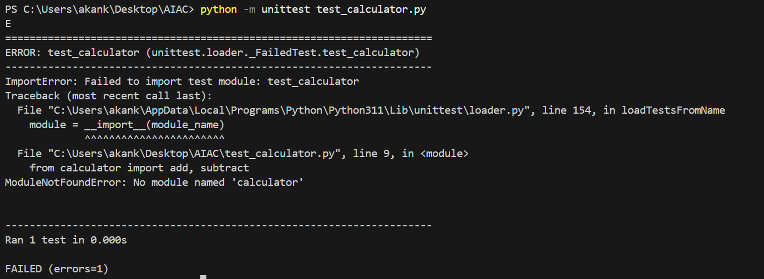
#Implement calculator.py file with two functions:
#1. add(a, b)
#2. subtract(a, b)
#Make sure all previously written unit tests pass.
#Follow PEP 8 guidelines.
def add(a, b):
"""Return the sum of a and b.
Args:
a: The first number to be added.
b: The second number to be added.
Returns:
The sum of a and b.
"""
return a + b
def subtract(a, b):
"""Return the difference of a and b.
Args:
a: The number from which b will be subtracted.
b: The number to be subtracted from a.
Returns:
The difference of a and b.
"""
return a - b

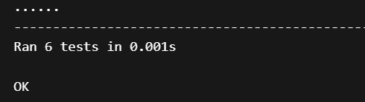

Task Description -4 (Data Structures – Queue Implementation with
AI Assistance)
➢ Task:
Use AI assistance to generate a Python program that implements
a Queue data structure.
Instructions:
➢ Prompt AI to create a Queue class with the following methods:
• enqueue(element)
• dequeue()
• front()
• is_empty()
➢ Handle queue overflow and underflow conditions.
➢ Include appropriate docstrings for all methods.
Expected Output:
➢ A fully functional Queue implementation in Python.
➢ Proper error handling and documentation.
#create a queue class using data structures to implement enqueue, dequeue, peek, and isEmpty methods
#include docstrings for each method
class Queue:
"""A queue data structure that follows the First In First Out (FIFO) principle."""
def __init__(self):
"""Initialize an empty queue."""
self.queue = []
def enqueue(self, item):
"""Add an item to the end of the queue.
Args:
item: The item to be added to the queue.
"""
self.queue.append(item)
def dequeue(self):
"""Remove and return the item at the front of the queue.
Returns:
The item at the front of the queue.
Raises:
IndexError: If the queue is empty.
"""
if self.is_empty():
raise IndexError("Queue is empty")
return self.queue.pop(0)
def peek(self):
"""Return the item at the front of the queue without removing it.
Returns:
The item at the front of the queue.
Raises:
IndexError: If the queue is empty.
"""
if self.is_empty():
raise IndexError("Queue is empty")
return self.queue[0]
def is_empty(self):
"""Check if the queue is empty.
Returns:
True if the queue is empty, False otherwise.
"""
return len(self.queue) == 0
# Example usage:
if __name__ == "__main__":
queue = Queue()
queue.enqueue(1)
queue.enqueue(2)
queue.enqueue(3)
print(queue.peek()) # Output: 1
print(queue.dequeue()) # Output: 1
print(queue.is_empty()) # Output: False
print(queue.dequeue()) # Output: 2
print(queue.dequeue()) # Output: 3
print(queue.is_empty()) # Output: True

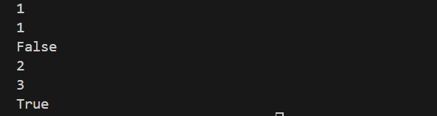

Task Description -5 (Algorithms – Bubble Sort vs Selection Sort)
➢ Task:
Use AI to implement Bubble Sort and Selection Sort algorithms
and compare their behavior.
Instructions:
➢ Prompt AI to generate:
• bubble_sort(arr)
• selection_sort(arr)
➢ Include comments explaining each step.
➢ Add docstrings mentioning time and space complexity.
Expected Output:
• Correct Python implementations of both sorting algorithms.
• Complexity analysis in docstrings.

#implement a python program to compare bubble sort and selection sort algorithms in terms of time complexity and efficiency.
#include ai generated comments and test results showing correctness and comparison of the two algorithms
#generate doc strings for each sorting algorithm explaining their time complexity and efficiency.
def bubble_sort(arr):
"""Sort an array using the bubble sort algorithm.
Time Complexity: O(n^2) in the worst and average cases, O(n) in the best case (when the array is already sorted).
Space Complexity: O(1) (in-place sorting).
Args:
arr: A list of elements to be sorted.
Returns:
A sorted list of elements.
"""
n = len(arr)
for i in range(n):
for j in range(0, n-i-1):
if arr[j] > arr[j+1]:
arr[j], arr[j+1] = arr[j+1], arr[j]
return arr
def selection_sort(arr):
"""Sort an array using the selection sort algorithm.
Time Complexity: O(n^2) in all cases (best, average, and worst).
Space Complexity: O(1) (in-place sorting).
Args:
arr: A list of elements to be sorted.
Returns:
A sorted list of elements.
"""
n = len(arr)
for i in range(n):
min_idx = i
for j in range(i+1, n):
if arr[j] < arr[min_idx]:
min_idx = j
arr[i], arr[min_idx] = arr[min_idx], arr[i]
return arr
# Test results showing correctness and comparison of the two algorithms
if __name__ == "__main__":
arr1 = [64, 34, 25, 12, 22, 11, 90]
arr2 = arr1.copy()

print("Original array:", arr1)

sorted_arr1 = bubble_sort(arr1)
print("Sorted array using Bubble Sort:", sorted_arr1)

sorted_arr2 = selection_sort(arr2)
print("Sorted array using Selection Sort:", sorted_arr2)

