AI ASSISTED CODING
LAB 16.1
NAME: MEGHA AKANKSHA
HT NO: 2303A52058
BATCH 39

Task 1 – Student Information System Schema Task:
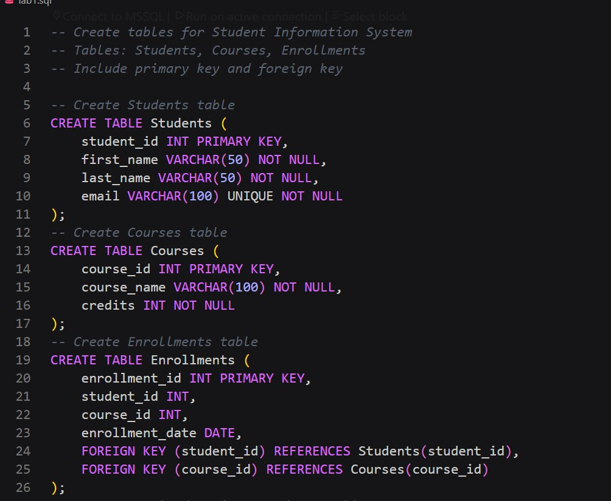
Design a database schema for a Student Information System and generate queries using AI.

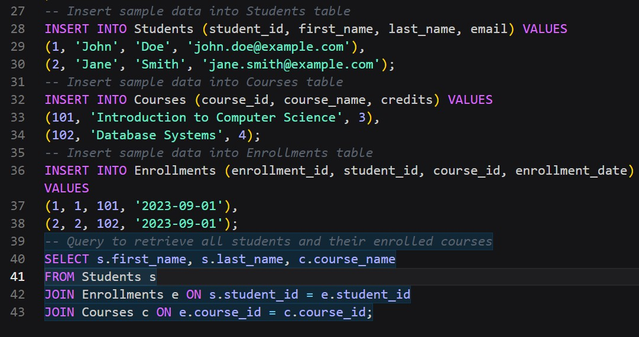

Output:
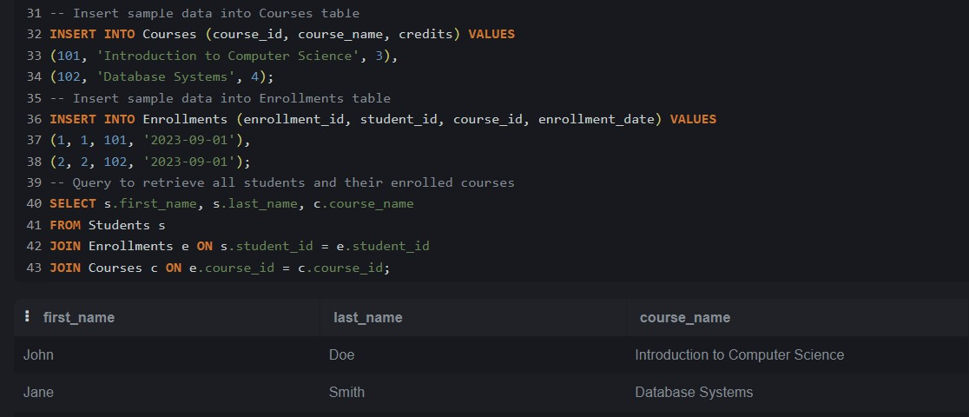

Explanation:
This database uses three tables: Students, Courses, and Enrollments to manage relationships between students and courses. The Enrollments table acts as a bridge using foreign keys, ensuring referential integrity. Insert operations add new student records, while JOIN queries retrieve courses for a student. Aggregation using COUNT helps determine the number of students per course. This design follows normalization principles and avoids data redundancy.

Task 2 – Hospital Management Database Task:
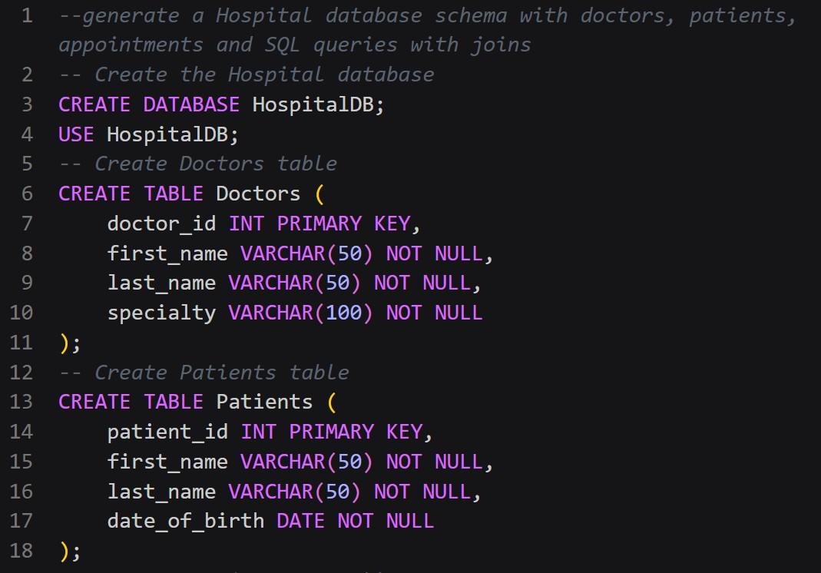
Create schema and queries for a Hospital Management System.

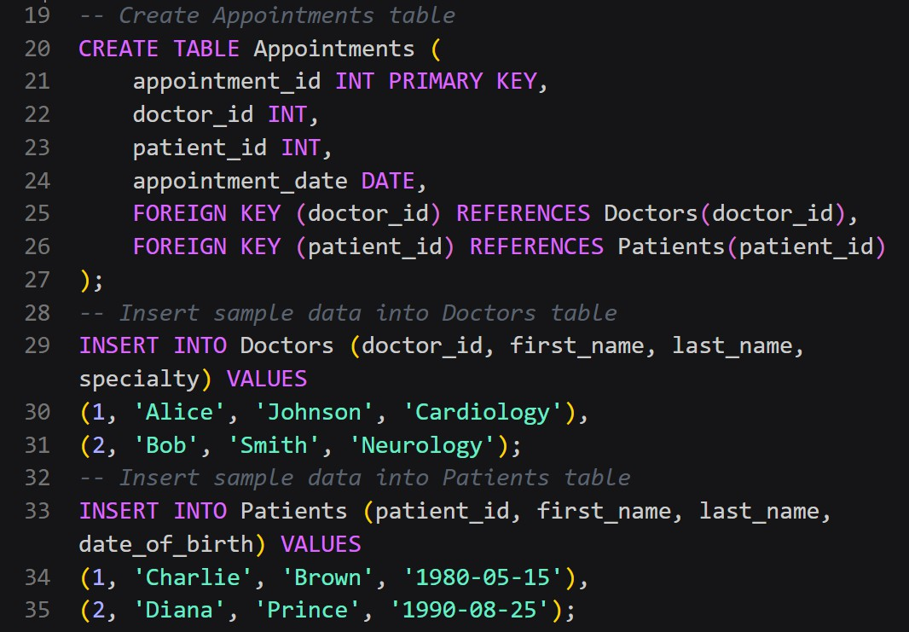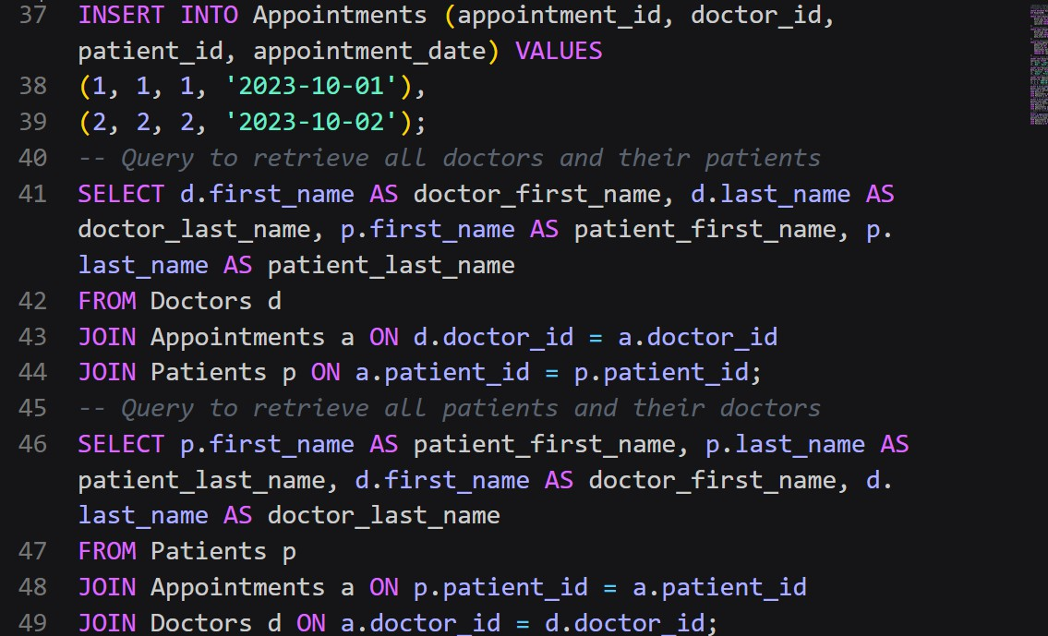

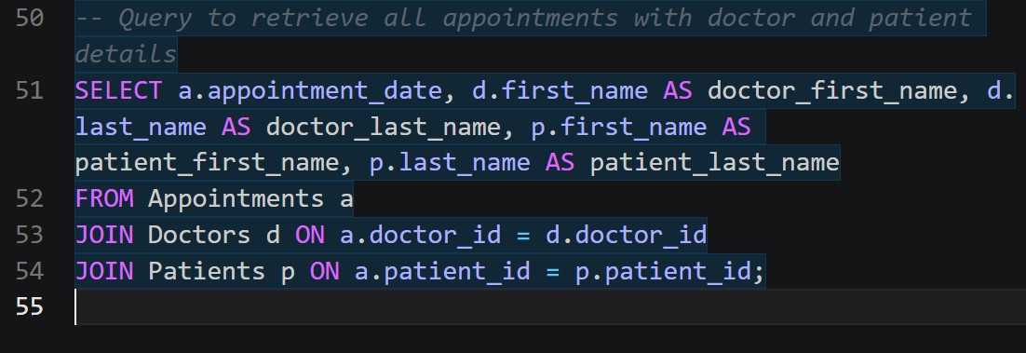

Output:
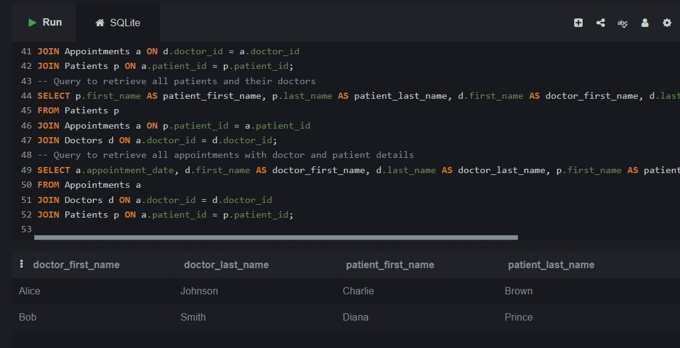
Explanation:
The hospital database consists of Doctors, Patients, and Appointments tables. Relationships are maintained using foreign keys to link doctors and patients through appointments. Queries allow retrieval of doctor schedules and patient history efficiently. Aggregation functions count the number of patients handled by each doctor. This structured schema ensures data consistency, reduces duplication, and supports efficient query execution using joins.

Task 3 – Library Database Task:
Design schema for a Library Management System.

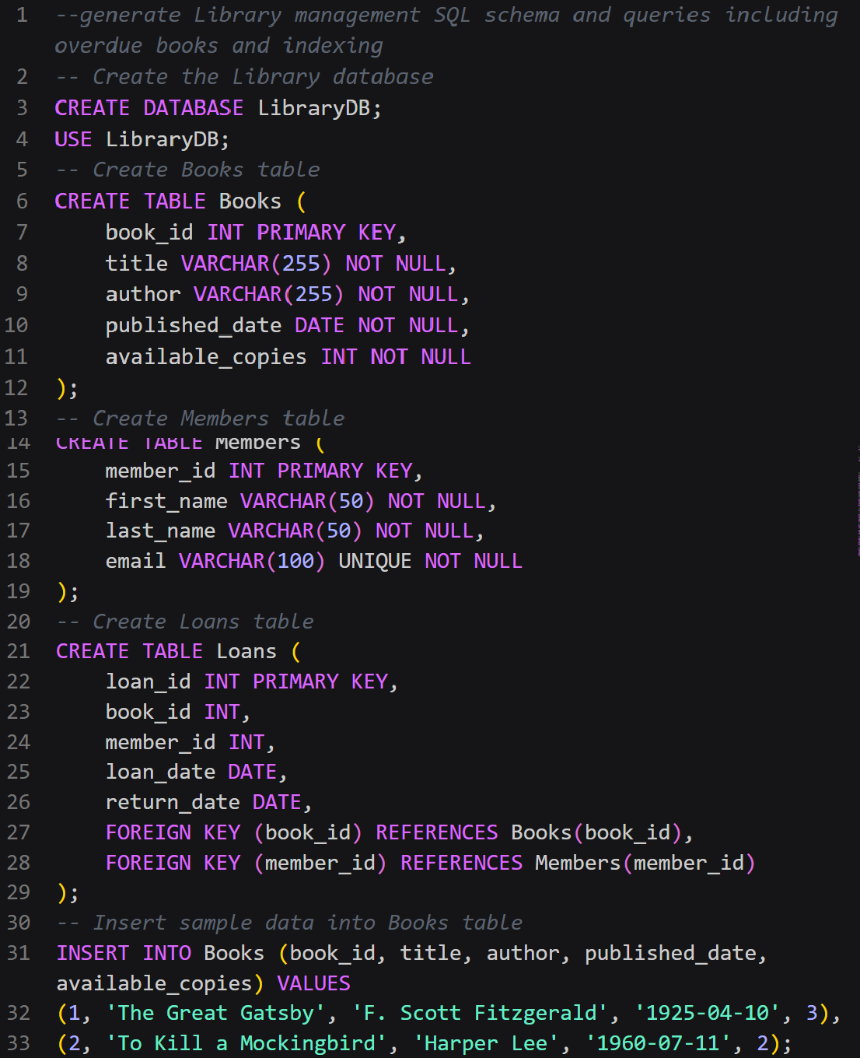

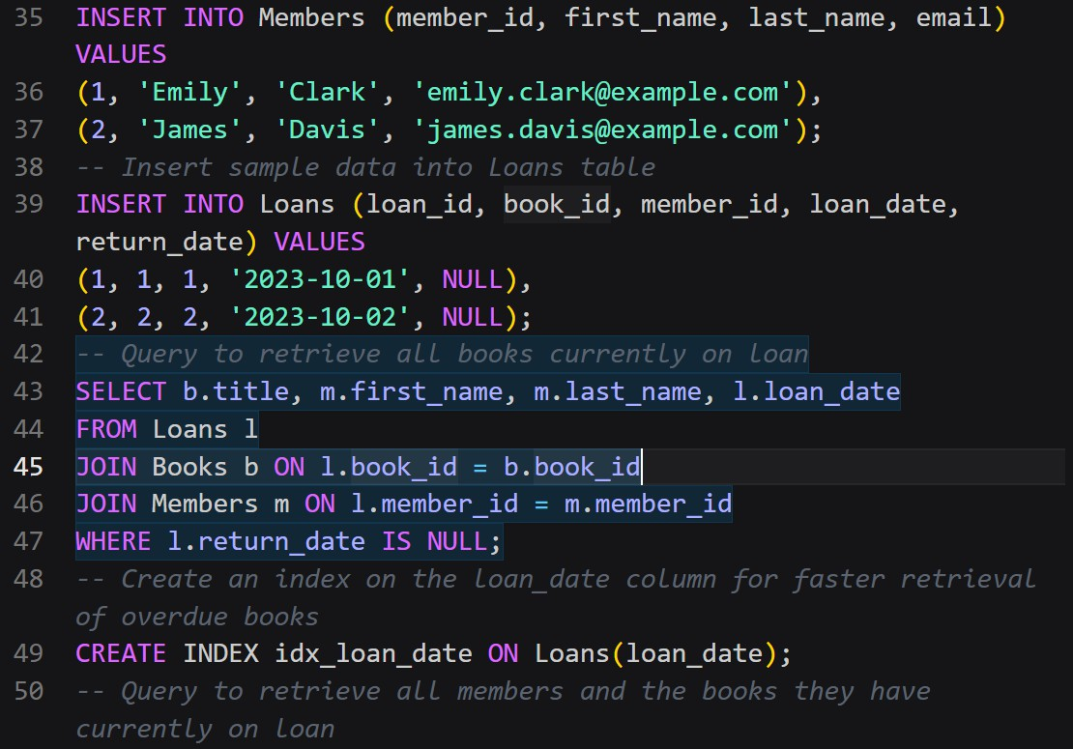

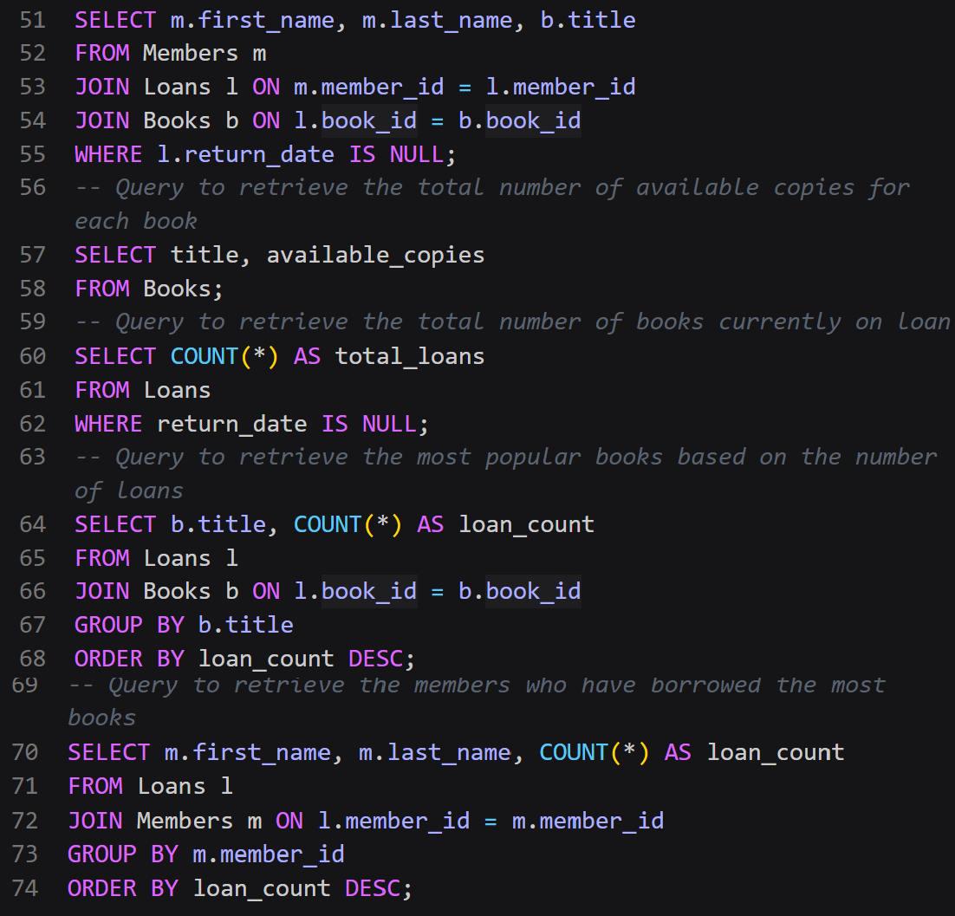

Output:
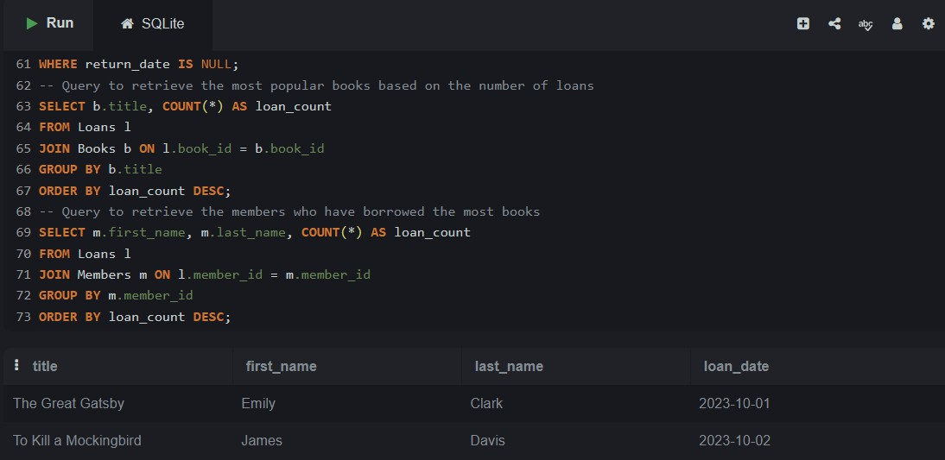
Explanation:
The library system uses Books, Members, and Loans tables to manage book borrowing activities. The Loans table connects books and members, maintaining issue and return details. Queries identify issued books, overdue records, and borrowing counts. Indexing improves query
performance for frequent searches. This design supports efficient tracking of library operations while maintaining normalized structure and minimizing redundancy.

Task 4 – Real-Time Application: Online Shopping Database Scenario:
Design a database for an E-commerce platform.

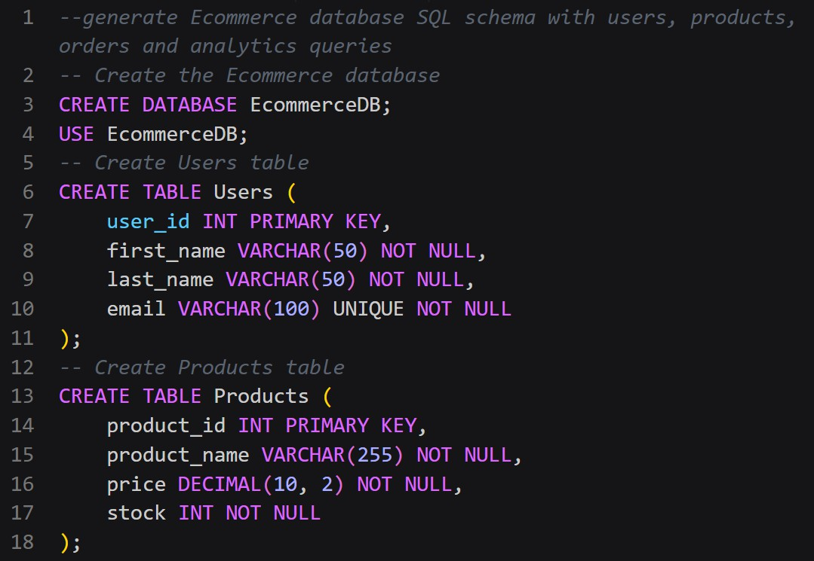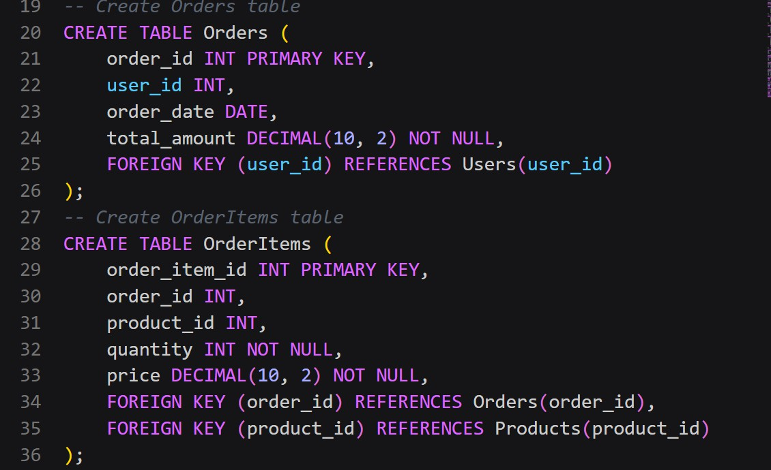

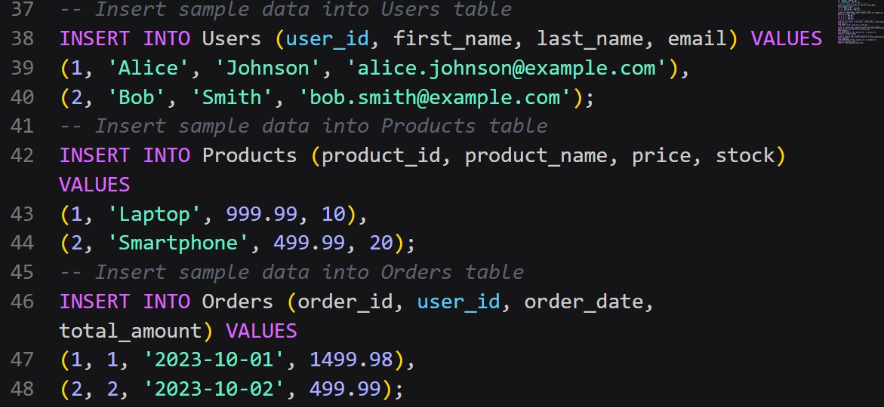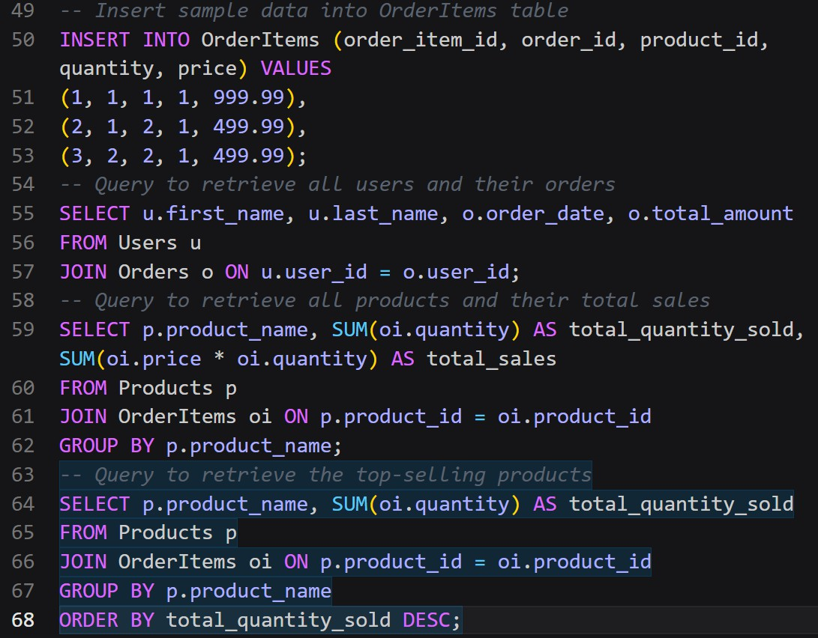

Output:

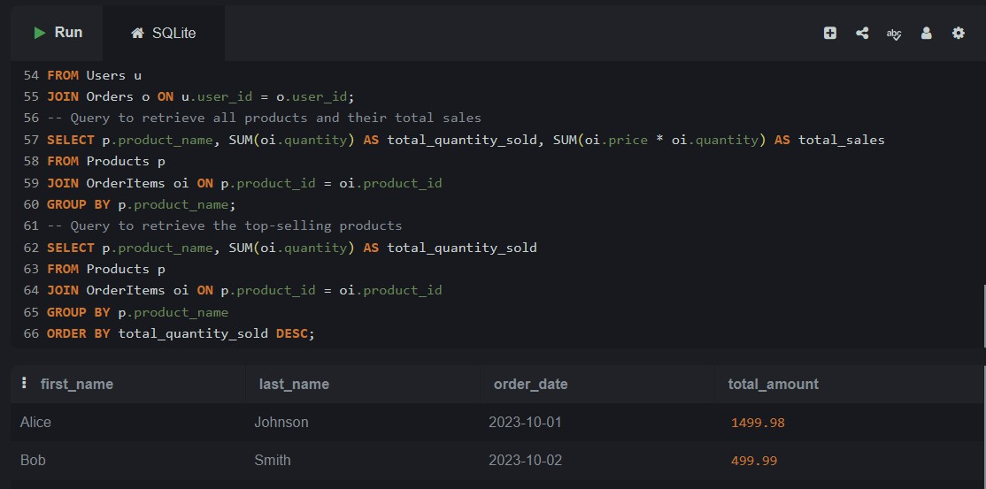
Explanation:
The e-commerce database includes Users, Products, Orders, and OrderDetails tables.
OrderDetails acts as a linking table to handle multiple products per order. Queries retrieve user orders, identify top-selling products, and calculate revenue using aggregation. The schema follows normalization by separating product and order data, preventing duplication. This structure supports scalable and efficient transaction processing.

Task 5 – University Examination Database

Design a database schema for a University Examination System and generate SQL queries using AI.

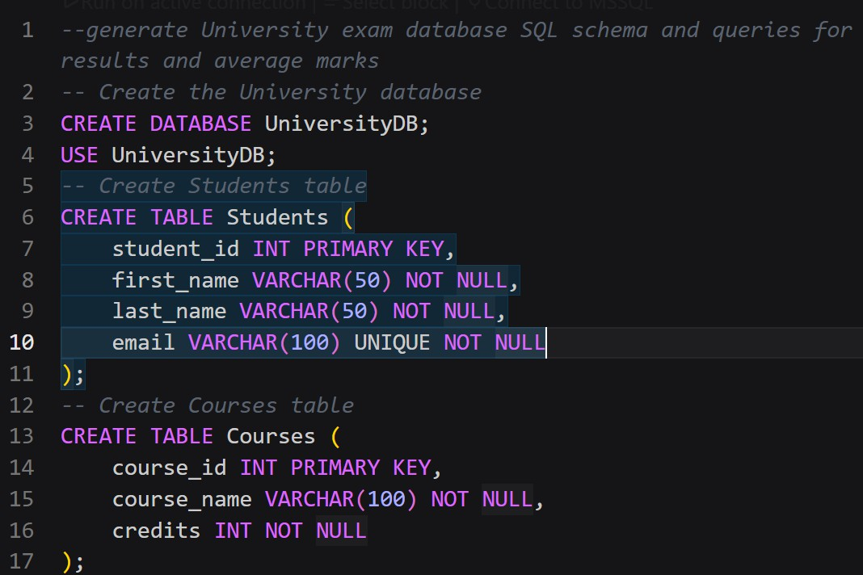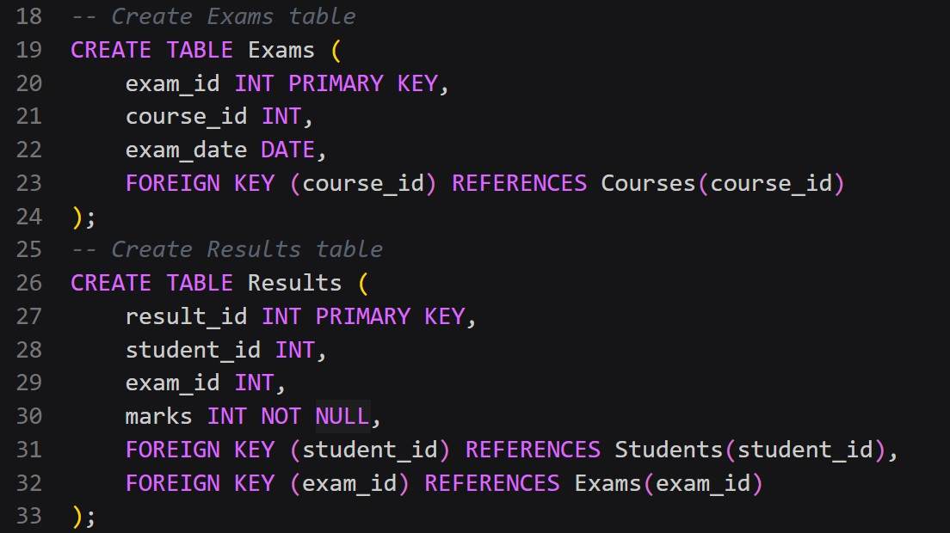

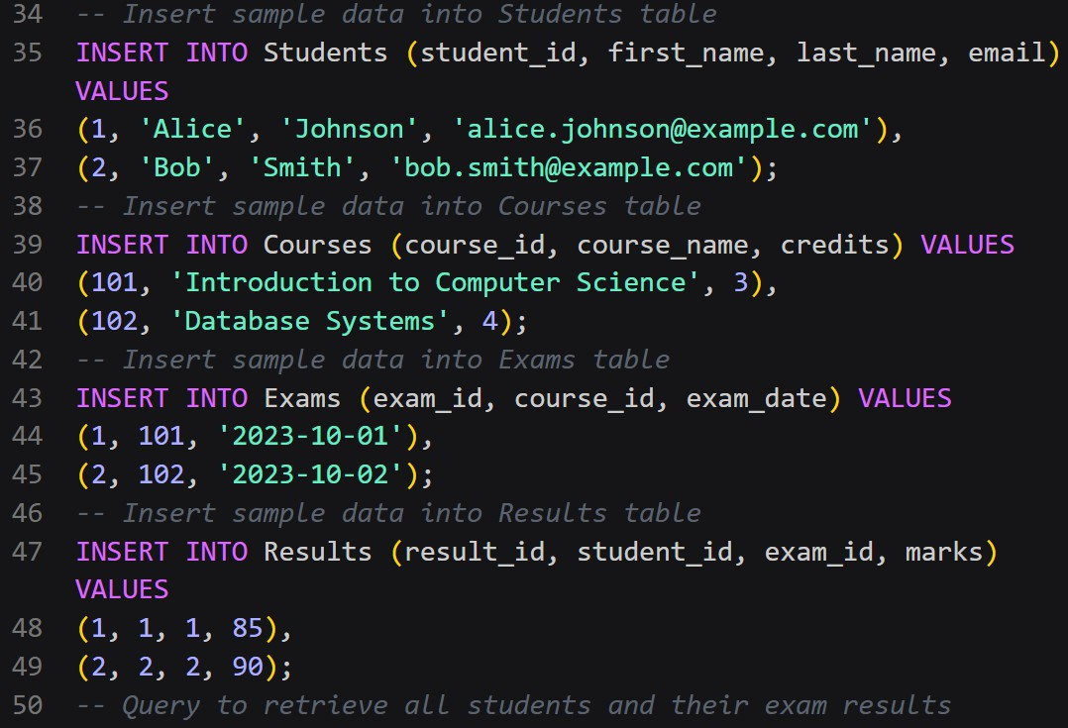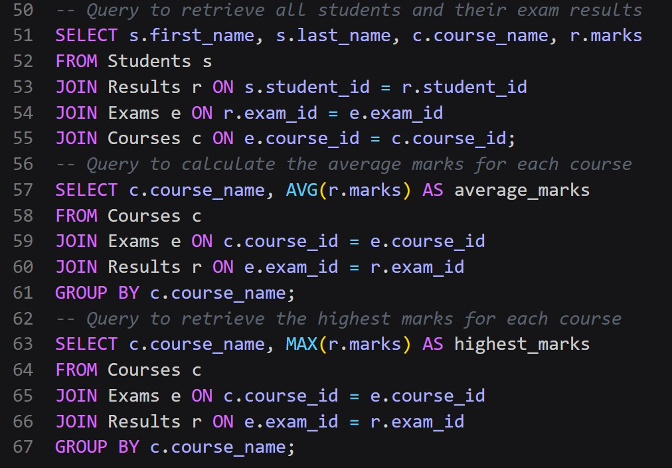

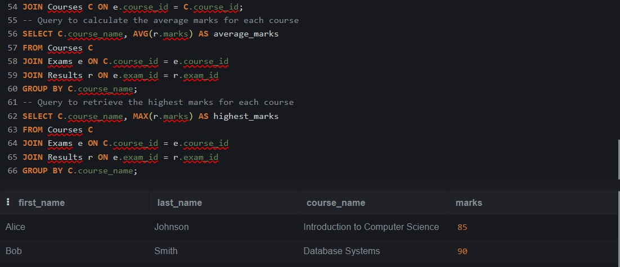
Output:
Explanation:
The examination system uses Students, Subjects, Exams, and Results tables to manage academic records. Results link students with exams and store marks. JOIN queries retrieve subject-wise
performance, while aggregation functions calculate average marks per subject. The schema ensures referential integrity using foreign keys and supports efficient academic analysis. This normalized design avoids redundancy and maintains data accuracy.

