AI ASSISTED CODING
LAB 6.1
NAME: MEGHA AKANKSHA
HT NO: 2303A52058
BATCH 39

Question 1
Prompt
generate a python code to print all even numbers from 1 to n using loops

code
n = int(input("Enter a number: "))
for i in range(1, n+1):
if i % 2 == 0:
print(i, end=" ")

output
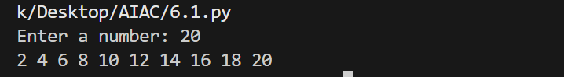

Analysis
This program prints all even numbers between 1 and n.
The value of n is taken as input from the user. A for loop is used to iterate from 1 to n. Inside the loop, a conditional statement checks whether the current number is divisible by 2 using the modulus operator (i % 2 == 0). If the condition is true, the number is printed.
The program demonstrates the use of loop control and conditional statements to filter even numbers from a given range.

Question 2
Prompt
Generate Python code to count how many numbers in a list are even and odd. the numbers in the list must be user input

code
numbers = list(map(int, input("Enter numbers separated by spaces: ").split()))
even_count = 0
odd_count = 0
for num in numbers:
if num % 2 == 0:
even_count += 1
else:
odd_count += 1
print("Even numbers count:", even_count)
print("Odd numbers count:", odd_count)

Output
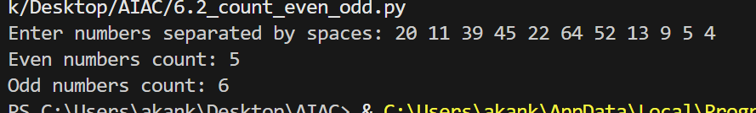

Analysis
This program counts how many numbers in a list are even and how many are odd.
The user enters multiple numbers separated by spaces, which are converted into a list using map() and split(). Two counters, even_count and odd_count, are initialized to zero. A for loop iterates through each number in the list. If a number is divisible by 2, the even counter is increased; otherwise, the odd counter is increased.
Finally, the program prints the total count of even and odd numbers. This program demonstrates list handling, loops, and conditional logic.

Question 3
Prompt
Generate a Python class User that validates age and email using conditional statements.

code
class User:
def __init__(self, name, age, email):
self.name = name
self.age = age
self.email = email

def is_valid_age(self):
# Age should be an integer between 1 and 119 (inclusive of 1, exclusive of 120)
if not isinstance(self.age, int):
return False
return 0 < self.age < 120
def is_valid_email(self):
# Basic validation using conditionals (no regex):
# - exactly one '@'
# - local part (before @) is non-empty
# - domain part (after @) contains at least one '.'
# - no empty labels and TLD length >= 2
email = self.email
if not email or " " in email:
return False
if email.count("@") != 1:
return False
local, domain = email.split("@")
if not local:
return False
if "." not in domain:
return False
parts = domain.split(".")
if any(not part for part in parts):
return False
if len(parts[-1]) < 2:
return False
return True
def validate_user(self):
age_valid = self.is_valid_age()
email_valid = self.is_valid_email()
return age_valid, email_valid
def _get_nonempty(prompt):
while True:
val = input(prompt).strip()
if val:
return val
print("Input cannot be empty.")
def _get_age_input(prompt):
while True:
s = input(prompt).strip()
try:
age = int(s)
if age <= 0 or age >= 120:
print("Age must be between 1 and 119.")
continue
return age
except ValueError:
print("Please enter a valid integer for age.")
def _get_email_input(prompt):
while True:
s = input(prompt).strip()
if not s:
print("Email cannot be empty.")
continue
# Use the class validation logic to check the email format
if not User("", 1, s).is_valid_email():
print("Invalid email. Example: user@example.com")
continue
return s
if __name__ == "__main__":
try:
name = _get_nonempty("Enter name: ")
age = _get_age_input("Enter age: ")
email = _get_email_input("Enter email: ")
user = User(name, age, email)
age_valid, email_valid = user.validate_user()
print("\n--- User Validation ---")
print(f"Name: {user.name}")
print(f"Age: {user.age} -> {'Valid' if age_valid else 'Invalid'}")
print(f"Email: {user.email} -> {'Valid' if email_valid else 'Invalid'}")
if age_valid and email_valid:
print("User is valid.")
else:
if not age_valid:
print("Reason: Age out of acceptable range (1-119).")
if not email_valid:
print("Reason: Email must be like user@example.com and contain no spaces.")
except (EOFError, KeyboardInterrupt):
print("\nInput cancelled. Exiting.")

output
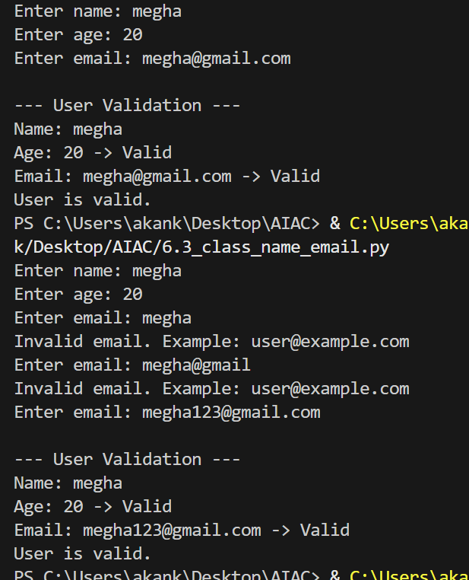

Analysis
This program defines a User class to validate age and email using conditional statements.
The constructor initializes name, age, and email. The is_valid_age() method checks whether the age is an integer between 1 and 119. The is_valid_email() method checks basic email format rules such as the presence of one @, a valid domain, and no empty parts.
The program also includes helper functions to take valid user input for name, age, and email. After input is taken, the program validates both age and email and prints whether they are valid or not.
This program demonstrates object-oriented programming, input validation, and conditional checking.
Question 4
prompt
# generate a Python class Student with attributes (name, roll number, marks)
# and methods to calculate total and average marks and print them. everything is user input

code
class Student:
def __init__(self, name, roll_number, marks):
self.name = name
self.roll_number = roll_number
self.marks = marks
def calculate_total(self):
return sum(self.marks)
def calculate_average(self):
total = self.calculate_total()
return total / len(self.marks) if self.marks else 0
def print_details(self):
print(f"Name: {self.name}")
print(f"Roll Number: {self.roll_number}")
print("Marks: ", end="")
print(", ".join(str(m) for m in self.marks))
print(f"Total Marks: {self.calculate_total()}")
print(f"Average Marks: {self.calculate_average():.2f}")
def _get_positive_int(prompt):
while True:
try:
val = input(prompt).strip()
if not val:
print("Please enter a value.")
continue
n = int(val)
if n <= 0:
print("Enter a positive integer.")
continue
return n
except ValueError:
print("Invalid number. Try again.")
def _get_marks(count):
marks = []
for i in range(1, count + 1):
while True:
try:
s = input(f"Enter marks for subject {i}: ").strip()
if not s:
print("Please enter a value.")
continue
m = float(s)
if m < 0:
print("Marks cannot be negative.")
continue
marks.append(m)
break
except ValueError:
print("Invalid marks. Enter a numeric value.")
return marks
if __name__ == "__main__":
try:
name = input("Enter student name: ").strip()
while not name:
name = input("Name cannot be empty. Enter student name: ").strip()
roll = input("Enter roll number: ").strip()
while not roll:
roll = input("Roll number cannot be empty. Enter roll number: ").strip()
num_subjects = _get_positive_int("Enter number of subjects: ")
marks = _get_marks(num_subjects)
student = Student(name, roll, marks)
print("\n--- Student Details ---")
student.print_details()
except (EOFError, KeyboardInterrupt):
print("\nInput cancelled. Exiting.")

output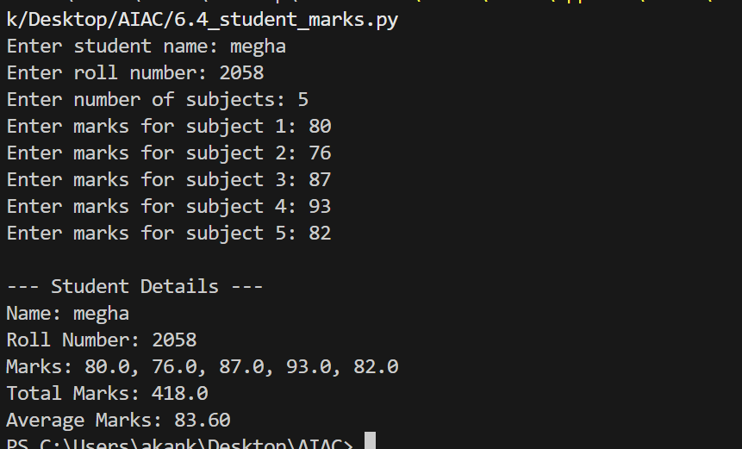

Analysis
This program defines a Student class with attributes name, roll number, and marks.
The class contains methods to calculate total marks using sum() and average marks by dividing total marks by the number of subjects. The print_details() method displays all student information including total and average.
The user enters student details and marks for each subject. Input validation ensures that only valid numbers are accepted.
This program demonstrates the use of classes, lists, loops, and basic arithmetic operations for processing student data.

Question 5
prompt
# Generate a Python program for a simple bank account system using class, loops, and conditional statements.
# All inputs are taken from the user and outputs are printed to the console.

code
class BankAccount:
def __init__(self, account_holder, balance=0.0):
self.account_holder = account_holder
self.balance = float(balance)
def deposit(self, amount):
if amount > 0:
self.balance += amount
print(f"Deposited: ${amount:.2f}")
return True
else:
print("Deposit amount must be positive.")
return False
def withdraw(self, amount):
if amount <= 0:
print("Withdrawal amount must be positive.")
return False
if amount > self.balance:
print("Insufficient funds.")
return False
self.balance -= amount
print(f"Withdrew: ${amount:.2f}")
return True
def display_balance(self):
print(f"Account Holder: {self.account_holder}")
print(f"Current Balance: ${self.balance:.2f}")
# Helper input functions
def _get_nonempty(prompt):
while True:
val = input(prompt).strip()
if val:
return val
print("Input cannot be empty.")
def _get_positive_float(prompt, allow_zero=False):
while True:
s = input(prompt).strip()
if not s and allow_zero:
return 0.0
try:
val = float(s)
if allow_zero:
if val < 0:
print("Please enter a non-negative number.")
continue
return val
if val <= 0:
print("Please enter a positive number.")
continue
return val
except ValueError:
print("Invalid number. Please enter a numeric value.")
def _get_int(prompt):
while True:
s = input(prompt).strip()
try:
return int(s)
except ValueError:
print("Please enter a valid integer.")
def _select_account(accounts):
if not accounts:
print("No accounts available. Create an account first.")
return None
acc_no = _get_int("Enter account number: ")
if acc_no not in accounts:
print("Account not found.")
return None
return acc_no
def main():
accounts = {}
next_acc_no = 1001
menu = (
"\n--- Simple Bank System ---\n"
"1. Create account\n"
"2. Deposit\n"
"3. Withdraw\n"
"4. Display balance\n"
"5. List accounts\n"
"6. Exit\n"
)
while True:
print(menu)
choice = input("Choose an option (1-6): ").strip()
if choice == "1":
name = _get_nonempty("Enter account holder name: ")
initial = _get_positive_float("Enter initial deposit (0 allowed): ", allow_zero=True)
acc = BankAccount(name, initial)
accounts[next_acc_no] = acc
print(f"Account created successfully. Account number: {next_acc_no}")
next_acc_no += 1
elif choice == "2":
acc_no = _select_account(accounts)
if acc_no is None:
continue
amount = _get_positive_float("Enter deposit amount: ")
accounts[acc_no].deposit(amount)
elif choice == "3":
acc_no = _select_account(accounts)
if acc_no is None:
continue
amount = _get_positive_float("Enter withdrawal amount: ")
accounts[acc_no].withdraw(amount)
elif choice == "4":
acc_no = _select_account(accounts)
if acc_no is None:
continue
accounts[acc_no].display_balance()
elif choice == "5":
if not accounts:
print("No accounts to display.")
else:
print("\nExisting accounts:")
for no, acc in accounts.items():
print(f" - {no}: {acc.account_holder} (Balance: ${acc.balance:.2f})")
elif choice == "6":
print("Exiting. Goodbye!")
break
else:
print("Invalid option. Please enter a number between 1 and 6.")
if __name__ == "__main__":
try:
main()
except (EOFError, KeyboardInterrupt):
print("\nInput cancelled. Exiting.")

output
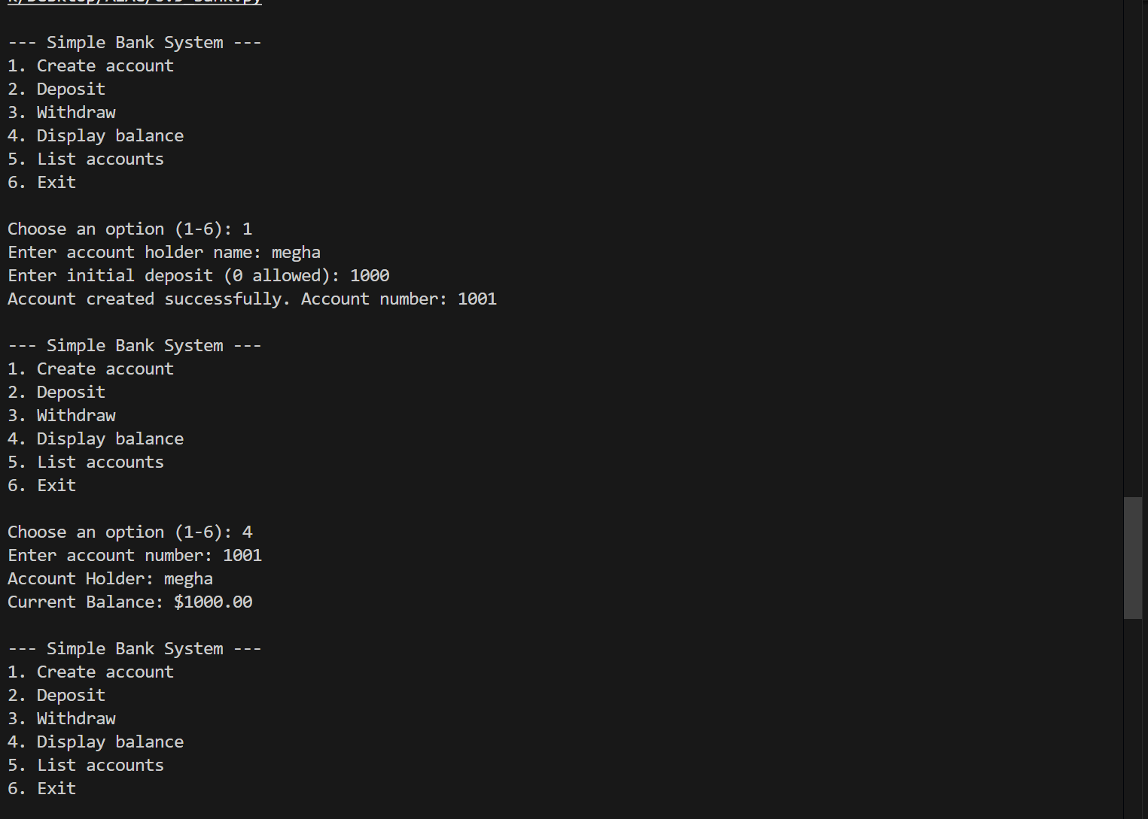

Analysis
This program implements a simple bank account system using a BankAccount class.
The class includes methods for deposit, withdrawal, and balance display. Conditional statements ensure that deposit and withdrawal amounts are valid and that sufficient balance is available before withdrawal.
A menu-driven loop allows the user to create accounts, deposit money, withdraw money, and view account details. All account information is stored in a dictionary using account numbers as keys.
This program demonstrates object-oriented programming, loops, conditional logic, and real-world simulation of a banking system.

Additional question

# Console-based supermarket sales processor
# Collects daily product sales and produces summaries:
# - Day-wise sales (product, quantity, subtotal)
# - Product-wise totals across the month
# - Grand total quantity and grand sales

from collections import defaultdict
def _get_positive_int(prompt, allow_zero=False):
while True:
s = input(prompt).strip()
try:
val = int(s)
if allow_zero:
if val < 0:
print("Please enter a non-negative integer.")
continue
return val
if val <= 0:
print("Please enter a positive integer.")
continue
return val
except ValueError:
print("Invalid input; enter an integer.")
def _get_nonempty(prompt):
while True:
s = input(prompt).strip()
if s:
return s
print("Input cannot be empty.")
def _get_nonneg_float(prompt):
while True:
s = input(prompt).strip()
try:
val = float(s)
if val < 0:
print("Please enter a non-negative number.")
continue
return val
except ValueError:
print("Invalid input; enter a number.")
def main():
print("--- Supermarket Sales Processor ---")
while True:
month = input("\nEnter month name (or press Enter to skip): ").strip()
if month:
print(f"Processing month: {month}")
days = _get_positive_int("Enter number of days in the month: ")
# Data structures (reset each month)
day_sales = [] # each element: list of entries (product, qty, price)
product_totals = defaultdict(lambda: {"quantity": 0, "sales": 0.0})
grand_total_qty = 0
grand_total_sales = 0.0
for day in range(1, days + 1):
print(f"\nDay {day}:")
num_products = _get_positive_int(" Enter number of products sold today: ", allow_zero=True)
entries = []
# To handle same product entered multiple times in a day, aggregate per day
day_product_agg = defaultdict(lambda: {"quantity": 0, "sales": 0.0})
for p in range(1, num_products + 1):
name = _get_nonempty(f" Product {p} name: ")
qty = _get_positive_int(f" Quantity sold for '{name}': ", allow_zero=True)
price = _get_nonneg_float(f" Unit price for '{name}': ")
subtotal = qty * price
entries.append((name, qty, price, subtotal))
# aggregate for the day
day_product_agg[name]["quantity"] += qty
day_product_agg[name]["sales"] += subtotal
# aggregate for the month
product_totals[name]["quantity"] += qty
product_totals[name]["sales"] += subtotal
grand_total_qty += qty
grand_total_sales += subtotal
# Convert day_product_agg to a sorted list for display
day_entries = [(name, info["quantity"], info["sales"]) for name, info in day_product_agg.items()]
day_sales.append({"day": day, "entries": day_entries})
# Display summaries
print("\n=== Month Summary ===")
if month:
print(f"Month: {month}")
# Day-wise summary
print("\n-- Day-wise Sales --")
for d in day_sales:
day_no = d["day"]
entries = d["entries"]
if not entries:
print(f"Day {day_no}: No sales recorded.")
continue
day_qty = sum(q for _, q, _ in entries)
day_sales_total = sum(s for _, _, s in entries)
print(f"Day {day_no}:")
for name, qty, sales in sorted(entries):
print(f" {name}: Qty={qty}, Sales=${sales:.2f}")
print(f" Day total quantity: {day_qty}")
print(f" Day total sales: ${day_sales_total:.2f}\n")
# Product-wise totals across the month
print("-- Product-wise Totals --")
if not product_totals:
print("No products sold this month.")
else:
print(f"{'Product':<20} {'Total Qty':>10} {'Total Sales':>15}")
print("-" * 47)
for name in sorted(product_totals):
info = product_totals[name]
print(f"{name:<20} {info['quantity']:>10} ${info['sales']:>14.2f}")
# Grand totals
print("\n-- Grand Totals --")
print(f"Grand total quantity sold: {grand_total_qty}")
print(f"Grand total sales for the month: ${grand_total_sales:.2f}")
# Ask user if they want to process another month
while True:
resp = input("\nProcess another month? (y/n): ").strip().lower()
if resp in ("y", "yes"):
break # outer while loop repeats
if resp in ("n", "no"):
print("Exiting. Goodbye!")
return
print("Please enter 'y' or 'n'.")

if __name__ == "__main__":
try:
main()
except (EOFError, KeyboardInterrupt):
print("\nInput cancelled. Exiting.")

