AI ASSISTED CODING
LAB 13.2
NAME: MEGHA AKANKSHA
HT NO: 2303A52058
BATCH 39

Ques1
Task Description -1 (Refactoring – Eliminating Repetitive Logic)
• Task: Use AI-assisted coding techniques to restructure a Python
program that performs repeated calculations, transforming it into
a reusable and maintainable design.
Instructions:
• Ask AI to locate repeated computations within the program.
• Encapsulate repeated logic into reusable functions.
• Verify that program output remains unchanged after refactoring.
• Add proper docstrings to all defined functions.
Sample Code:
length = 8
width = 4
print("Area:", length * width)
print("Perimeter:", 2 * (length + width))
length = 12
width = 6
print("Area:", length * width)
print("Perimeter:", 2 * (length + width))
Expected Output:
A refactored Python script that uses a single reusable function to
compute area and perimeter without repeating code.

#write a python code without repeating code for area and perimeter of rectangle
#take multiple user inputs for length and width and calculate area and perimeter for each
#ask for no of test cases and then take inputs for length and width in a loop
def calculate_area_perimeter(length, width):
area = length * width
perimeter = 2 * (length + width)
return area, perimeter
test_cases = int(input("Enter the number of test cases: "))
for _ in range(test_cases):
length = float(input("Enter the length of the rectangle: "))
width = float(input("Enter the width of the rectangle: "))
area, perimeter = calculate_area_perimeter(length, width)
print(f"Area: {area}")
print(f"Perimeter: {perimeter}\n")

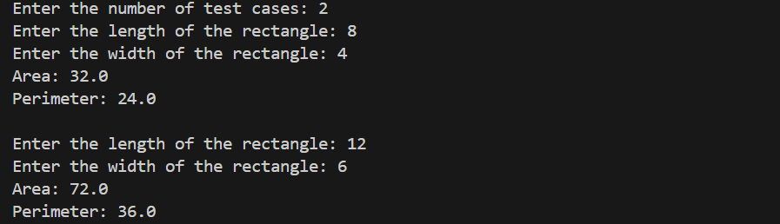

Refactoring removes repetitive calculations by using a reusable function to compute the area and perimeter of a rectangle efficiently.

Ques2
Task Description -2 (Refactoring – Modularizing Inline
Calculations)
• Task: Use AI to refactor a Python script by extracting repeated
inline calculations into reusable and well-documented functions.
Instructions:
• Identify repeated calculation patterns in the code.
• Convert them into reusable functions.
• Ensure readability and proper documentation.
Sample Code:
amount = 1000
discount = amount * 0.10
final_amount = amount - discount
print("Final Amount:", final_amount)
amount = 2000
discount = amount * 0.10
final_amount = amount - discount
print("Final Amount:", final_amount)
Expected Output:
A modular Python program that uses a reusable function to compute
final amounts for different inputs.

#write a python program reusing the code to find final amount after discount
def calculate_final_amount(original_price, discount_percentage):
discount_amount = (discount_percentage / 100) * original_price
final_amount = original_price - discount_amount
return final_amount
# Example usage
original_price = float(input("Enter the original price: "))
discount_percentage = float(input("Enter the discount percentage: "))
final_amount = calculate_final_amount(original_price, discount_percentage)
print(f"Final amount after discount: {final_amount}")

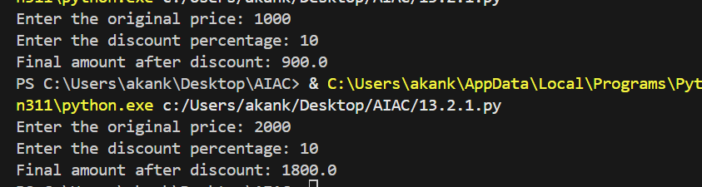

The program improves modularity by converting repeated discount calculations into a reusable function for better readability and maintainability.

Ques3
Task Description -3 (Refactoring – Improving Loop and
Conditional Performance)
• Task: Apply AI-based suggestions to enhance the performance of
Python code that relies on nested loops and repeated conditional
checks.
Instructions:
• Use AI to recommend more efficient data structures or logic
simplifications.
• Replace inefficient constructs while preserving program behavior.
• Compare execution efficiency before and after refactoring.
Sample Code:
students = ["Anil", "Bhavya", "Charan", "Divya"]
check_list = ["Charan", "Esha", "Bhavya"]
for name in check_list:
exists = False
for student in students:
if name == student:
exists = True
if exists:
print(name, "found")
else:
print(name, "not found")
Expected Output:
An optimized Python program that performs faster lookups using
efficient logic, along with execution performance comparison.

#Refactor the following Python program to improve its performance.
#The current implementation uses nested loops and repeated conditional checks to determine whether names in a checklist exist in a list of students.
#Tasks:
#1. Identify inefficiencies in the code.
#2. Suggest better data structures or logic to improve lookup performance.
#3. Refactor the code while preserving the original functionality.
#4. Compare the execution efficiency before and after optimization.
#5. Briefly explain why the optimized version performs better.
#Original Code:
#students = ["Anil", "Bhavya", "Charan", "Divya"]
#check_list = ["Charan", "Esha", "Bhavya"]
#for name in check_list:
#exists = False
#for student in students:
#if name == student:
#exists = True
#if exists:
# print(name, "found")
#else:
# print(name, "not found")

# Optimized Code
students = ["Anil", "Bhavya", "Charan", "Divya"]
check_list = ["Charan", "Esha", "Bhavya"]
# Convert the list of students to a set for O(1) average time complexity lookups
student_set = set(students)
for name in check_list:
if name in student_set:
print(name, "found")
else:
print(name, "not found")
# Explanation of Performance Improvement:
# The original code uses nested loops, resulting in O(n*m) time complexity, where n
# is the number of names in the check_list and m is the number of students. In contrast, the optimized code converts the list of students into a set, which allows for O(1) average time complexity for lookups. This significantly reduces the overall time complexity to O(n) for checking all names in the check_list, making it much more efficient, especially as the size of the students list grows.

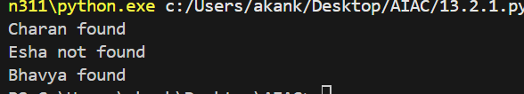

Performance is optimized by replacing nested loops with a set data structure, enabling faster lookup operations.

Ques4
Task Description -4 (Refactoring – Replacing Hardcoded Values
with Constants)
• Task: Utilize AI assistance to improve maintainability by
replacing hardcoded numerical values with named constants.
Instructions:
• Detect hardcoded numeric values used directly in expressions.
• Define descriptive constants at the beginning of the program.
• Update calculations to use these constants without changing
results.
Sample Code:
print("Simple Interest:", (1000 * 2 * 5) / 100)
print("Simple Interest:", (2000 * 2 * 5) / 100)
Expected Output:
A revised Python program using constants such as RATE and TIME for
clearer and maintainable calculations..

#write a python program reusing the code to find simple interest for given values
def calculate_simple_interest(principal, rate, time):
simple_interest = (principal * rate * time) / 100
return simple_interest
# Example usage
principal = float(input("Enter the principal amount: "))
rate = float(input("Enter the rate of interest: "))
time = float(input("Enter the time in years: "))
simple_interest = calculate_simple_interest(principal, rate, time)
print(f"Simple Interest: {simple_interest}")

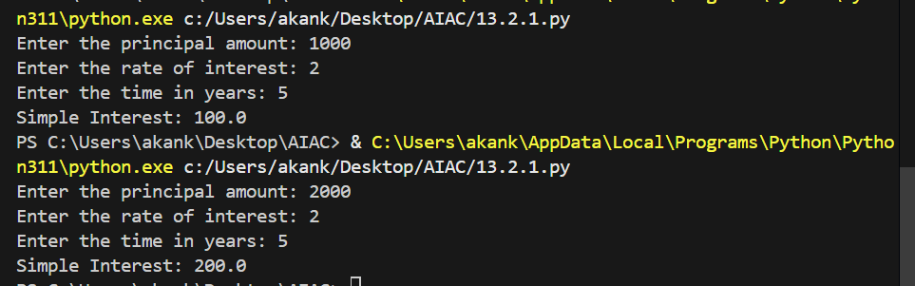

Hardcoded numeric values are replaced with variables/functions to improve code clarity and flexibility in simple interest calculations.

Ques5
Task Description -5 (Re factoring – Enhancing Variable Naming
and Code Clarity)
• Task: Apply AI tools to improve code readability by renaming
unclear variables and adding meaningful comments..
Instructions:
• Replace non-descriptive variable names with meaningful
identifiers.
• Add inline comments where the logic may be unclear.
• Ensure program output remains the same.
Sample Code:
x = 50
y = 30
z = x + y
print(z)
Expected Output:
A Python program with clear variable names and explanatory comments
that improve readability without altering functionality.

#write a python program improving code readability by using meaningful names to find sum of two numbers
#add the necessary comments to explain the code
def calculate_sum(num1, num2):
"""
This function takes two numbers as input and returns their sum.

Parameters:
num1 (float): The first number.
num2 (float): The second number.

Returns:
float: The sum of num1 and num2.
"""
return num1 + num2
# Example usage
number1 = float(input("Enter the first number: "))
number2 = float(input("Enter the second number: "))
result = calculate_sum(number1, number2)
print(f"The sum of {number1} and {number2} is: {result}")

Code readability is enhanced by using meaningful variable names and adding comments without changing the program output

