AI ASSISTED CODING
LAB 3.1
NAME: MEGHA AKANKSHA
HT NO: 2303A52058
BATCH 39

Question 1: Zero-Shot Prompting (Palindrome Number Program)

Prompt 1:
Generate a Python function which checks that a given number is palindrome or not.

Prompt2:
Include user input number and also give output whether the number is palindrome or not.

Code:
def is_palindrome(number):
"""
Check if a given number is a palindrome.
A palindrome is a number that remains the same when its digits are reversed.
For example: 121, 1331, 12321 are palindromes.
"""
# Convert the number to string to check for palindrome
str_num = str(abs(number)) # Use absolute value to handle negative numbers
return str_num == str_num[::-1] # Compare string with its reverse

if __name__ == "__main__":
# Get user input
user_input = input("Enter a number: ")
try:
number = int(user_input) # Convert input to integer
if is_palindrome(number):
print(f"{number} is a palindrome.")
else:
print(f"{number} is not a palindrome.")
except ValueError:
print("Please enter a valid integer.")

Output:
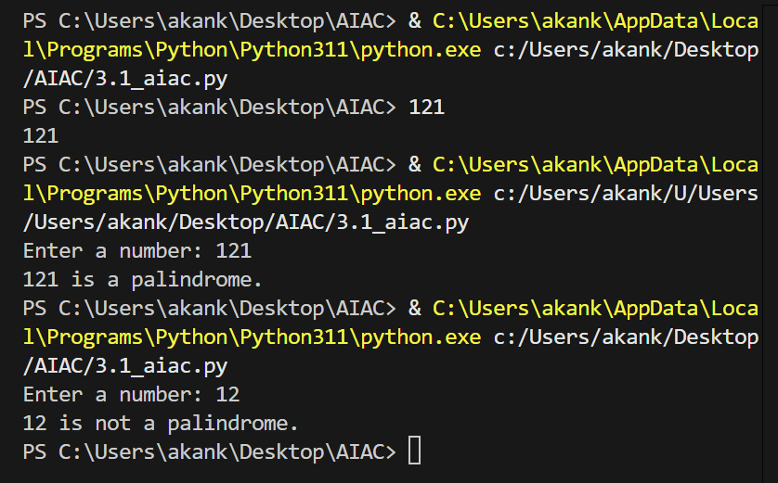

Analysis:
This is a zero-shot prompting approach i.e no examples are provided in the prompt.
The AI generated the code correctly and identifies the palindrome number by reversing the digits using string manupulation.

Question 2: One-Shot Prompting (Factorial Calculation)

Prompt:
Take a number as user input and find its factorial. for example input is 5 then the output should be 120

Code:
def calculate_factorial(number):
"""
Calculate the factorial of a given number.
Factorial of n is the product of all positive integers less than or equal to n.
For example: 5! = 5 * 4 * 3 * 2 * 1 = 120
"""
if number < 0:
return "Factorial is not defined for negative numbers."
elif number == 0 or number == 1:
return 1
else:
factorial = 1
for i in range(2, number + 1):
factorial *= i
return factorial

# Main program
if __name__ == "__main__":
# Get user input
user_input = input("Enter a number: ")
try:
number = int(user_input) # Convert input to integer
result = calculate_factorial(number)
print(f"The factorial of {number} is {result}.")
except ValueError:
print("Please enter a valid integer.")

Output:
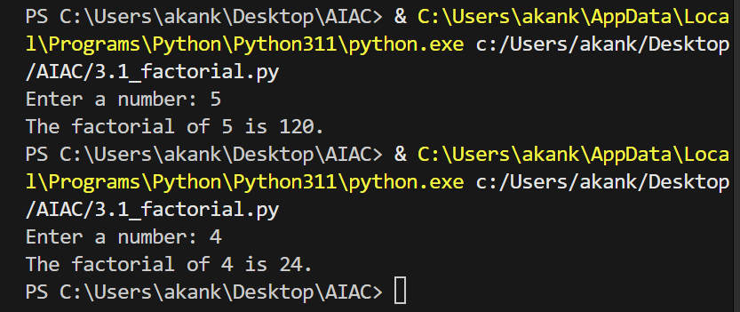

Analysis:
This is a one-shot prompting technique because a single input-output example (5 → 120) was provided in the prompt.
Compared to zero-shot prompting, the generated code is more structured and clear.
Question 3: Few-Shot Prompting (Armstrong Number Check)

Prompt:
write a python program to find whether the number is a armstrong number or not .. here are few examples to find whether the number is armstrong or not...
Input: 153 → Output: Armstrong Number
Input: 370 → Output: Armstrong Number
Input: 123 → Output: Not an Armstrong Number
Code:
def is_armstrong(number):
"""
Check if a given number is an Armstrong number (narcissistic number).
An Armstrong number is a number that is equal to the sum of its own digits
each raised to the power of the number of digits.
Examples:
- 153: 1^3 + 5^3 + 3^3 = 1 + 125 + 27 = 153 (Armstrong Number)
- 370: 3^3 + 7^3 + 0^3 = 27 + 343 + 0 = 370 (Armstrong Number)
- 123: 1^3 + 2^3 + 3^3 = 1 + 8 + 27 = 36 ≠ 123 (Not an Armstrong Number)
"""
# Convert number to string to get number of digits
str_num = str(abs(number))
num_digits = len(str_num)
# Calculate sum of digits raised to the power of number of digits
sum_of_powers = sum(int(digit) ** num_digits for digit in str_num)
# Check if the sum equals the original number
return sum_of_powers == abs(number)
# Main program
if __name__ == "__main__":
# Get user input
user_input = input("Enter a number: ")
try:
number = int(user_input) # Convert input to integer
if is_armstrong(number):
else:
print(f"{number} → Not an Armstrong Number")
except ValueError:
print("Please enter a valid integer.")
Output:
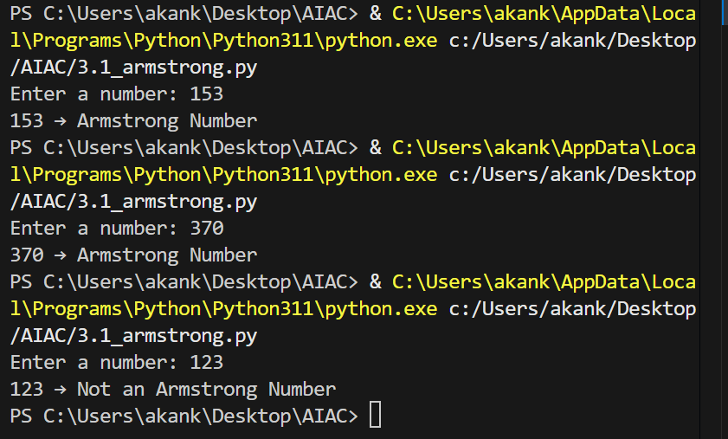
Analysis:
Few shot prompting guided the AI accurately with the help of multiple examples.
This provides the accurate output.

Question 4: Context-Managed Prompting (Optimized Number
Classification)
Prompt:
give me an optimised python code to classify the number as composite prime or neither . the input should be the user input
Code:
import math
def classify_number(number):
"""
Classify a number as Prime, Composite, or Neither.
Prime: A number > 1 with exactly 2 divisors (1 and itself)
Composite: A number > 1 with more than 2 divisors
Neither: Numbers 0 and 1
Args:
number: An integer to classify
Returns:
A string indicating the classification
"""
# Handle special cases
if number <= 1:
return "Neither"
# Check if number is 2 (only even prime)
if number == 2:
return "Prime"
# Even numbers greater than 2 are composite
if number % 2 == 0:
return "Composite"
# For odd numbers, check divisibility up to sqrt(number)
# Optimization: Only check odd divisors up to square root
for i in range(3, int(math.sqrt(number)) + 1, 2):
if number % i == 0:
return "Composite"
return "Prime"
# Main program
if __name__ == "__main__":
# Get user input
user_input = input("Enter a number: ")
try:
number = int(user_input) # Convert input to integer
result = classify_number(number)
print(f"{number} → {result}")
except ValueError:
print("Please enter a valid integer.")
Output:
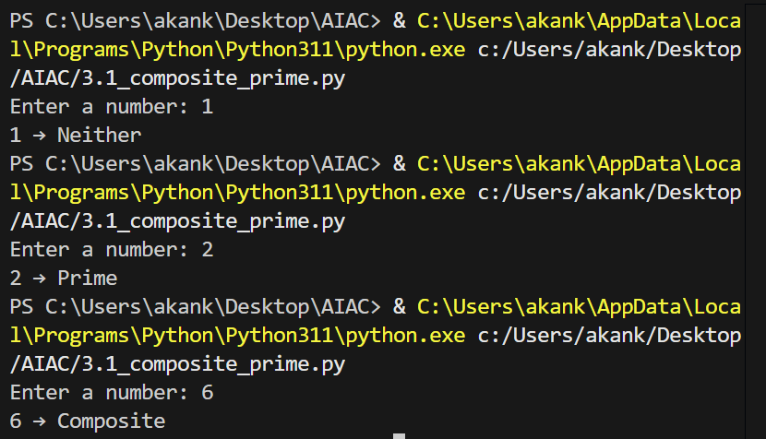

Analysis:
Context-managed prompting produces the best quality code because clear instructions and constraints guide the AI to write optimized, validated, and structured solutions.

Question 5: Zero-Shot Prompting (Perfect Number Check)
Prompt:
write a python function to print whether the number is a perfect number or not.. input must be user input
Code:
def is_perfect_number(number):
"""
Check if a given number is a Perfect Number.
A Perfect Number is a positive integer that is equal to the sum of its
positive divisors (excluding the number itself).
Examples:
- 6: Divisors are 1, 2, 3. Sum = 1 + 2 + 3 = 6 (Perfect Number)
- 28: Divisors are 1, 2, 4, 7, 14. Sum = 1 + 2 + 4 + 7 + 14 = 28 (Perfect Number)
- 10: Divisors are 1, 2, 5. Sum = 1 + 2 + 5 = 8 ≠ 10 (Not a Perfect Number)
"""
# Perfect numbers must be positive and greater than 0
if number <= 0:
return False
# Calculate sum of divisors (excluding the number itself)
sum_of_divisors = 0
# Check all numbers from 1 to number/2
for i in range(1, number // 2 + 1):
if number % i == 0:
sum_of_divisors += i
# Check if sum of divisors equals the number
return sum_of_divisors == number
# Main program
if __name__ == "__main__":
# Get user input
user_input = input("Enter a number: ")
try:
number = int(user_input) # Convert input to integer
if is_perfect_number(number):
print(f"{number} → Perfect Number")
else:
print(f"{number} → Not a Perfect Number")
except ValueError:
print("Please enter a valid integer.")
Output:
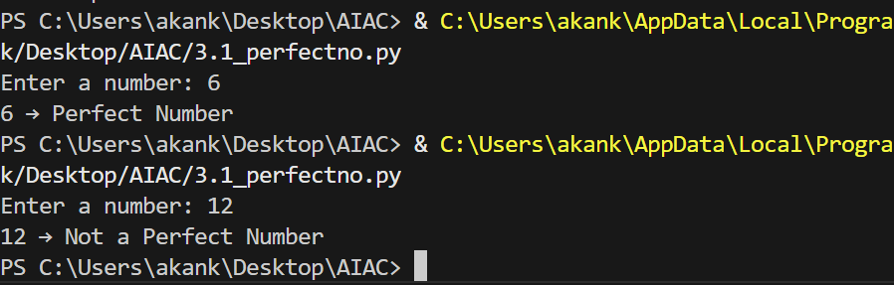

Analysis:
This is a zero-shot prompting approach i.e no examples are provided in the prompt.
The AI generated the code correctly and identifies the perfect number.

Question 6: Few-Shot Prompting (Even or Odd Classification with Validation)

Prompt:
Take number as user input and print whether the number is even or odd.. here are few examples... Input: 8 → Output: Even
Input: 15 → Output: Odd
Input: 0 → Output: Even
Code:
def is_even_or_odd(number):
"""
Check if a given number is Even or Odd.
Even: A number divisible by 2 (remainder = 0)
Odd: A number not divisible by 2 (remainder = 1)
Args:
number: An integer to check
Returns:
A string indicating "Even" or "Odd"
"""
if number % 2 == 0:
return "Even"
else:
return "Odd"
# Main program
if __name__ == "__main__":
# Get user input
user_input = input("Enter a number: ")
try:
number = int(user_input) # Convert input to integer
result = is_even_or_odd(number)
print(f"{number} → {result}")
except ValueError:
print("Please enter a valid integer.")
Output:
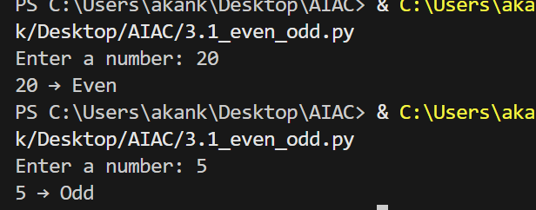

Analysis:
Few-shot prompting helped the AI generate a more complete and reliable program.

