MetroPark
Metropolitan City Parking Management System

A Course Project Report
Submitted in the partial fulfillment of the completion of the course

23CS401EL502 – Artificial Intelligence Application Development

In III Year II Semester B.Tech-CSE (AIML)

Submitted by
Megha Akanksha Gopishetty
2303A52058

Under the supervision of the faculty
Sallauddin Md
Assistant Professor
School of Computer Science & Artificial Intelligence

Academic Year 2025–2026

SRU
Department of Computer Science & Artificial Intelligence
SR University, Warangal, Telangana, India

Introduction

Background and Motivation
Urban parking is one of the most persistent pain points in modern cities. In dense metropolitan areas like Hyderabad, millions of commuters lose considerable time each day searching for available parking across commercial zones, tech parks, shopping malls, and residential areas. The absence of a centralised, real-time system forces drivers to rely on guesswork, leading to increased congestion, fuel waste, and driver frustration.

MetroPark addresses this challenge by offering a comprehensive, full-stack parking management portal tailored for Hyderabad's five major urban zones — Hitech City, Banjara Hills, Secunderabad, Gachibowli, and Madhapur. Built on Python Flask with a Vanilla JavaScript front-end, it enables both users and administrators to interact with live parking data through an intuitive web interface.

About the Project
MetroPark is a full-stack web application that simulates a real-world metropolitan parking management ecosystem. The system offers two distinct portals — an Admin Portal and a User Portal — each catering to specific functional needs. The backend is powered by Python Flask, while parking data is persisted in a lightweight JSON flat-file database, making the system easy to set up and run without any external database infrastructure.

The project covers 16 sub-area parking locations distributed across 5 zones of Hyderabad, with slot-level booking and release functionality, GPS-based nearest parking search, and a fully featured admin dashboard with live statistics and CSV export capability.

Objectives
- To develop a web-based parking management portal with real-time slot booking and release functionality.
- To implement a dual-portal system supporting both administrative management and end-user access.
- To incorporate GPS-based nearest parking search using the Haversine distance formula.
- To support fuzzy destination matching for user-friendly search across named Hyderabad landmarks.
- To enable admins to manage slot capacity dynamically and download booking reports as CSV files.

Scope of the Project
The project is scoped for standalone local deployment and covers 16 parking sub-areas across 5 zones of Hyderabad, with a total of approximately 150 parking slots. The system supports concurrent user bookings, admin oversight, and historical record tracking. External database integration, payment gateways, and real-time IoT sensor feeds are outside the current scope but identified as potential extensions.

Problem Statement
Urban parking management in Indian metropolitan cities remains largely undigitised. Manual or informal parking systems create several critical problems:

- Drivers waste significant time searching for available parking slots in busy commercial and IT zones.
- There is no real-time visibility into slot availability across different parking areas and sub-areas.
- Administrators have no centralised mechanism to monitor occupancy, manage capacity, or access booking history.
- GPS-based parking search is absent in most systems, leaving users without directional guidance to the nearest available lot.
- Report generation for audit and management purposes is cumbersome without an automated export mechanism.

MetroPark directly addresses each of these issues. By providing a live slot grid, GPS-based proximity search, fuzzy landmark lookup, and admin-level CSV export, the system transforms manual parking management into a streamlined digital workflow.

Methodology / Procedure

Development Approach
MetroPark was developed following a structured full-stack development approach, with clear separation between the backend API layer, data persistence layer, and frontend UI layer. The application uses Python Flask as the web server and routing framework, JSON as a flat-file database, and Vanilla JavaScript for dynamic client-side interactivity without any additional framework dependencies.

Step-by-Step Procedure
Step 1: Data Modelling and Initialisation
The parking data is modelled as a nested JSON structure. Each parking area contains its zone, GPS coordinates, address, total slot count, and an individual slot map. Each slot records its occupancy status and the associated booking object if occupied. The init_data() function seeds this structure with 16 sub-area locations and demo bookings to simulate a live environment upon first run.

Step 2: Flask Backend and API Design
All business logic is handled through a set of RESTful API endpoints in app.py. The routes are divided into three groups: Common routes (landing page, logout), Admin routes (login, stats, all bookings, CSV export, slot management), and User routes (browse areas, view slots, book, release, GPS search, destination search). Session-based authentication protects admin endpoints.

Step 3: GPS and Destination Search
Users can search for the nearest parking either by sharing their live GPS coordinates or by typing a landmark name. GPS-based search uses the Haversine formula to compute great-circle distances between the user's location and every parking sub-area. Destination-based search uses a fuzzy matching algorithm against a dictionary of 40+ known Hyderabad landmarks, resolving the text query to GPS coordinates and then applying Haversine distance sorting.

Step 4: Slot Booking and Release
Users browse an interactive slot grid where each cell is colour-coded green (free) or red (occupied). Selecting a free slot opens a booking form requesting name, vehicle number, and optional phone number. On confirmation, the slot is marked occupied and the booking is stored in parking_data.json. Release is verified by matching the user-provided vehicle number against the stored booking before freeing the slot.

Step 5: Admin Dashboard and CSV Export
The admin dashboard provides a live occupancy summary for all parking areas, a full active-booking table with force-release capability, and dynamic slot management (add or remove slots per area). All active and historical bookings can be downloaded as a structured CSV file containing booking IDs, zone, area, slot, driver details, booking time, vacated time, and status.

System Architecture & Tech Stack

Project Structure
The project follows a minimal and clean directory layout:
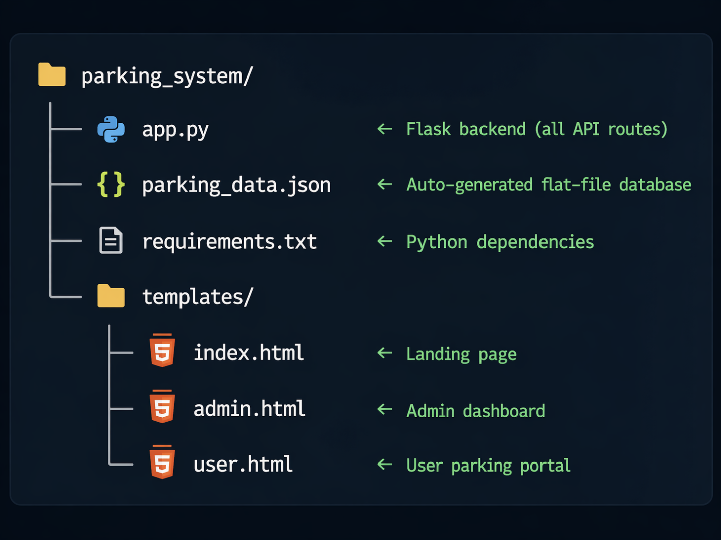

Tech Stack
Layer | Technology | Purpose
Backend | Python 3 + Flask | Web server, routing, session management, API endpoints
Frontend | HTML5 + CSS3 + Vanilla JS | User interface, dynamic slot grids, AJAX calls
Database | JSON flat-file | Parking area data, bookings, admin credentials
Geolocation | Haversine Formula | GPS-based nearest parking distance calculation
Search | Fuzzy Matching Algorithm | Text-to-landmark destination resolution
Export | Python csv module | CSV report generation and download

Parking Zones and Sub-Areas
MetroPark covers 5 major zones of Hyderabad with 16 sub-area parking locations:

Zone | Sub-Area | Slots
Hitech City | Cyber Towers | 10
Hitech City | HITEC Hub | 8
Hitech City | Mindspace IT Park | 10
Banjara Hills | Road No. 12 | 12
Banjara Hills | Peddamma Temple | 8
Banjara Hills | GVK One Mall | 10
Secunderabad | Paradise Circle | 10
Secunderabad | Clock Tower | 8
Secunderabad | SD Road | 10
Secunderabad | Trimulgherry | 8
Gachibowli | DLF Cyber City | 10
Gachibowli | University of Hyderabad | 8
Gachibowli | Aparna Sarovar | 8
Madhapur | Film Nagar | 10
Madhapur | Jubilee Hills Check Post | 8
Madhapur | Inorbit Mall | 10

Key API Endpoints
Method | Endpoint | Description
GET | / | Landing page — Admin / User entry
POST | /admin/login | Admin authentication
GET | /api/admin/stats | Live occupancy stats for all areas
GET | /api/admin/all_bookings | List all active bookings
GET | /api/admin/download_csv | Download CSV booking report
POST | /api/admin/release | Force-release a slot (admin)
POST | /api/admin/add_slots | Add new slots to an area
POST | /api/admin/remove_slot | Remove an empty slot from an area
GET | /api/areas | Get all areas with availability counts
GET | /api/slots/<area> | Get slot grid for a specific area
POST | /api/nearest | Find nearest parking by GPS coords
POST | /api/search_destination | Find parking near a named landmark
POST | /api/book | Book a specific slot
POST | /api/release | Release a slot (user, vehicle verification)

Result and Analysis
The following section presents the actual output generated when MetroPark is executed and accessed via a browser at http://localhost:5000.

a. Landing Page
On opening the application, users are greeted with the MetroPark landing page (index.html). The page presents two entry cards — one for Admin and one for User — with a clean, card-based layout and a city-themed header.
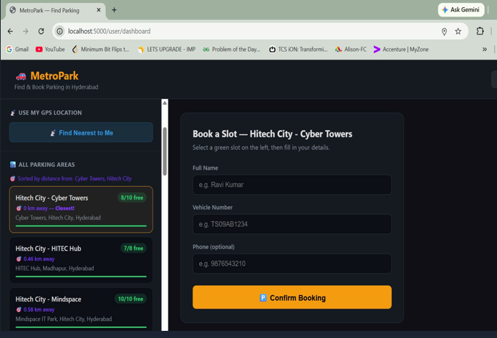

b. User Portal — Slot Grid View
Once a user selects a parking area, the interactive slot grid is displayed. Green cells represent available slots and red cells represent occupied ones. Clicking a green cell opens the booking form where the user enters their name and vehicle number. The total available and occupied counts are shown at the top of the grid.

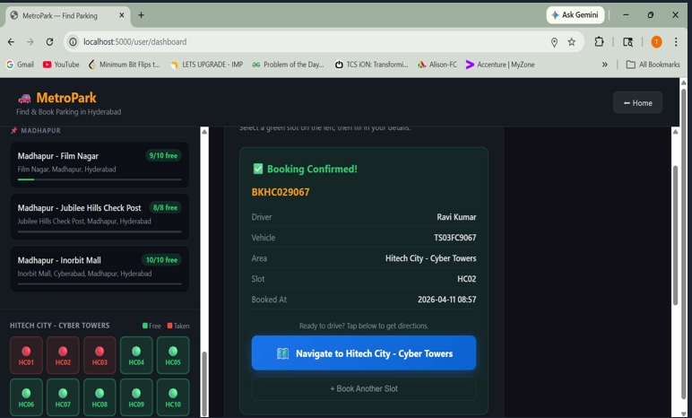
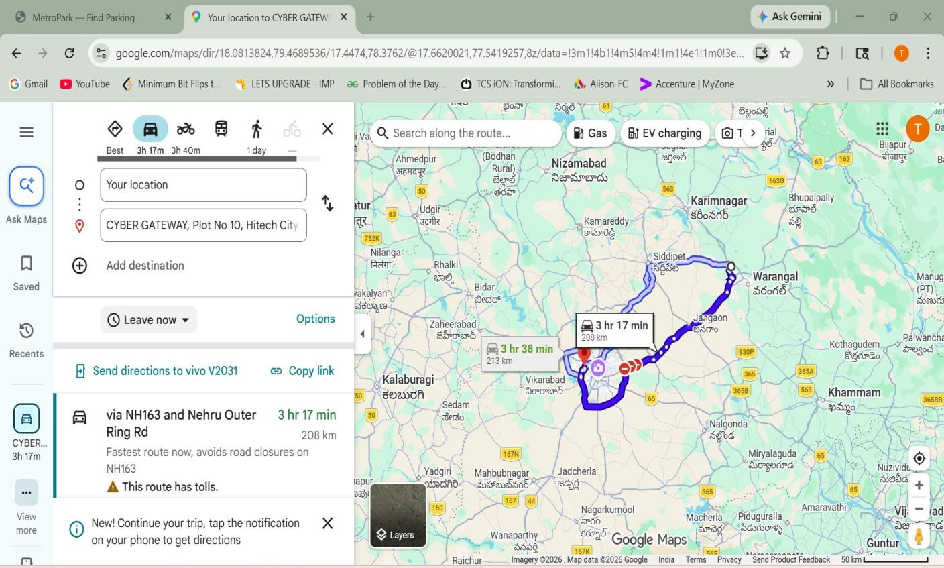

c. Admin Dashboard
The Admin Dashboard provides a live occupancy table listing every parking sub-area with its total, occupied, and available slot counts. Below the stats table, all active bookings are listed with options to force-release any slot. The dashboard also includes buttons to add or remove slots per area and to download the full booking report as a CSV file.

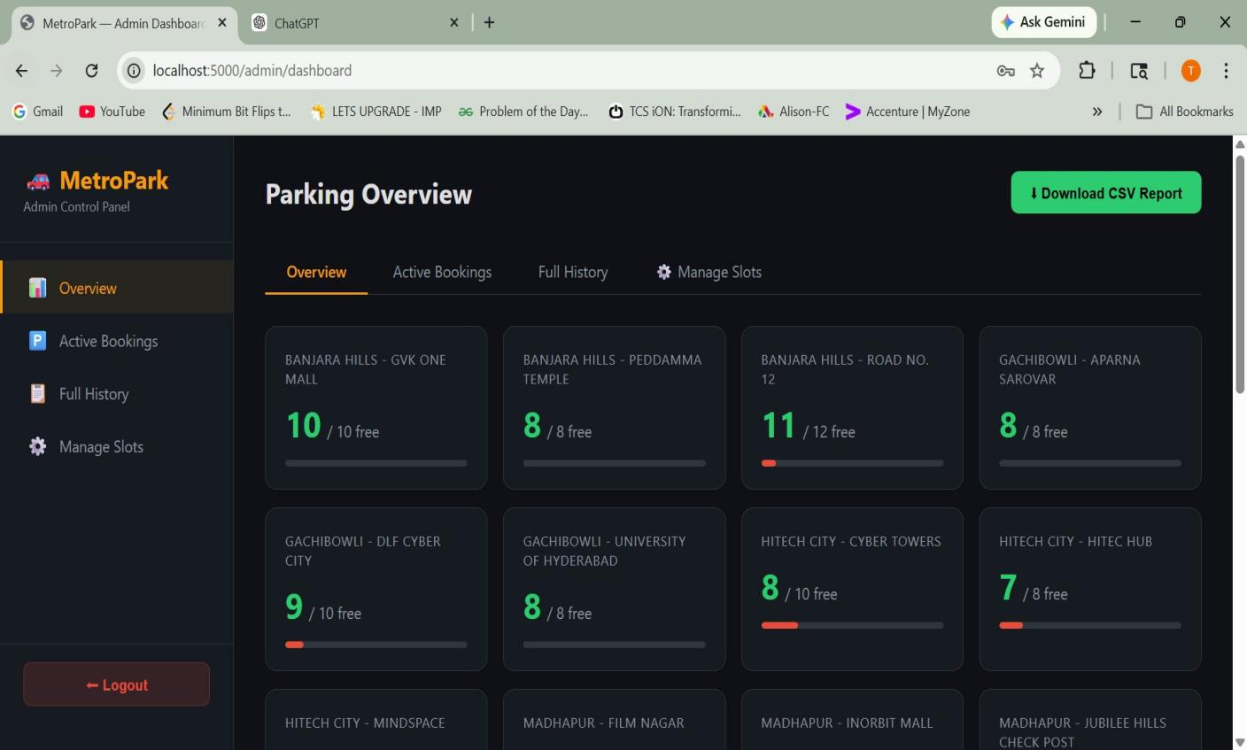

Conclusion
MetroPark successfully addresses the challenges associated with urban parking management by providing a centralized, digital solution for real-time parking monitoring and booking. The system eliminates the need for manual searching by offering users instant visibility into available parking slots across multiple locations.

By integrating GPS-based search and fuzzy destination matching, the application enhances user convenience and accessibility. The dual-portal design ensures that both users and administrators can interact with the system efficiently, with clearly defined functionalities for each role.

The use of a lightweight JSON database makes the system easy to deploy and maintain, while the Flask-based backend ensures scalability for future enhancements. The project demonstrates how modern web technologies can be effectively used to solve real-world urban problems.

Overall, MetroPark provides a practical and efficient solution for managing parking in metropolitan areas and lays a strong foundation for further development into a real-world application.

Future Enhancements
While MetroPark provides a functional and efficient parking management solution, several enhancements can be implemented to extend its capabilities further.

One major improvement would be the integration of a secure online payment system, allowing users to reserve and pay for parking slots in advance using digital payment methods such as UPI, credit/debit cards, or mobile wallets.

The system can also be extended into a mobile application for Android and iOS platforms, providing users with better accessibility and real-time notifications. Integration with mapping services such as Google Maps would enable navigation assistance to guide users directly to their selected parking location.

Incorporating IoT-based sensors in parking areas can provide real-time slot occupancy updates, eliminating the need for manual input and increasing system accuracy. Additionally, machine learning algorithms can be introduced to predict parking availability based on historical data and usage patterns.

Other enhancements may include multi-city support, cloud database integration for scalability, user account systems, and advanced analytics dashboards for administrators.

