**A Project Report on**

**FOR**

**ONLINE-SHOPPING**

**IN PARTIAL FULFILLMENT OF**

**MASTER OF COMPUTER APPLICATION**

**BY**

**BIRADAR MEGHA PRABHATRAO**

**MCA-FY SEM-1**

**2020-2021**

**Under The Guidance Of**

**Prof. Balchandra Doddi**



**Sinhgad Technical Education Society’s**

**SINHGAD INSTITUTE OF MANAGEMENT,**

**Vadgaon Bk, Pune**

**(Affiliated to Savitribai Phule Pune University, Approved by AICTE**

**& Accredited by National Board of Accreditation, New Delhi)**

|  |  |
| --- | --- |
| **Chapter** | **Page number** |
| **CHAPTER 1 : INTRODUCTION** | |
| 1.1 Existing System | **1-5** |
| 1.2 Need for System |  |
| 1.3 Operating Environment Hardware and Software |  |
| **CHAPTER 2 : PROPOSED SYSTEM 6-9** | |
| 2.1 Proposed System (Introduction of system) |  |
| 2.2 Module specifications (Scope) |  |
| 2.3 Objectives of System |  |
| **CHAPTER 3 : ANALYSIS & DESIGN 10-28** | |
| 3.1 Use Case Diagrams |  |
| 3.2 Activity Diagram |  |
| 3.3 Class Diagram |  |
| 3.4 Table specifications (Database design) |  |
| 3.5 Data dictionary |  |
| **CHAPTER 4 : USER MANUAL 2956** | |
| 4.1 User Interface Screens (Input) |  |
| 4.2 Output Screens with data |  |
| 4.3 Data Reports |  |
| 4.4 Sample program code |  |
| 4.5 Limitations and Bibliography |  |

1. **INTRODUCTION**
   1. **Problem Definition:**

E-commerce provides an easy way to sell products to a large customer base. However, there is a lot of competition among multiple e-commerce sites. When users land on an e-commerce site, they expect to find what they are looking for quickly and easily. Also, users are not sure about the brands or the actual products they want to purchase. They have a very broad idea about what they want to buy. Many customers nowadays search for their products on Google rather than visiting specific e-commerce sites. They believe that Google will take them to the e-commerce sites that have their product.

The purpose of any e-commerce website is to help customers narrow down their broad ideas and enable them to finalize the products they want to purchase. For example, suppose a customer is interested in purchasing a mobile. His or her search for a mobile should list mobile brands, operating systems on mobiles, screen size of mobiles, and all other features as facets. As the customer selects more and more features or options from the facets provided, the search narrows down to a small list of mobiles that suit his or her choice. If the list is small enough and the customer likes one of the mobiles listed, he or she will make the purchase..

This application is developed by using Java Enterprise, HTML, JavaScript, CSS as front end and Workbench as back end.

## Project Description:

An E-Commerce portal which will allow formal and informal merchants in developing countries

to advertise and sell their goods on the internet. This would permit rural communities to make their

wares available to the rest of the world via the World Wide Web.

The objective of this project is to create an e-commerce web portal with a content management

system which would allow product information to be updated securely using a mobile device. The web

portal will have an online interface in the form of an e-commerce website that will allow users to buy

goods from the merchants.

Description:

Any member can register and view available products.

Only registered member can purchase multiple products regardless of quantity.

ContactUs page is available to contact Admin for queries.

There are three roles available: Visitor, User and Admin.

• Visitor can view available products.

• User can view and purchase products.

• An Admin has some extra privilege including all privilege of visitor and user.

Admin can add products, edit product information and add/remove product. Admin can add user, edit user information and can remove user. Admin can ship order to user based on order placed by sending confirmation mail.

Using the code:

1. Attach the database in your "SQL Server Management Studio Express".

2. Run the application on Microsoft Visual Studio as web site.

3. Locate the database.

## SYSTEM STUDY

* 1. **Existing System:**

Existing system refers to the system that is being followed till now.

## Existing System of Online Shopping System

The present scenario for shopping is to visit the shops and market manually and then from the available product list one needs to choose the item he or she wants and then pay for the same item mainly in cash mode is done, as not every society is well educated and aware to use net banking or card modes or wallets etc.

This system is not much user-friendly as one needs to go to the market physically and then select items only from the available list. So mostly it is difficult to get the product as per our desire. Description About the products is less available and are mostly verbal only. For this type of shopping, one needs to have an ample amount of free time.

Also, not really good markets exist everywhere, so many times good markets become out of reach for certain people. In the proposed system customers need not go to the shops for purchasing the products. He/she can order the product he/she wishes to buy through the use of this system. The shop owner can be the admin of the system.

The shop owner can appoint officials particularly to handle this, who will help the owner in managing the customers and product orders. The system also endorses a home delivery system for delivering the purchased products.

## Proposed System:

The aim of proposed system is to develop a system of improved facilities. The proposed system can overcome all the limitations of the existing system. The system provides proper security and reduces the manual work. The existing system has several disadvantages and many more difficulties to work well. The proposed system tries to eliminate or reduce these difficulties up to some extent. The proposed system will help the user to reduce the workload and mental conflict. The proposed system helps the user to work user friendly and he can easily do his jobs without time lagging.

* The system is very simple in design and to implement.
* The system requires very low system resources and the system will work in almost all configurations. It has got following features :-
  + Ensure data accuracy.
  + Minimize manual data entry.
  + Minimum time needed for the various processing.
  + Greater efficiency.
  + Better Service.
  + This would help the corporation prepare and organize its schedules more efficiently on the basis of traffic demand.
  + It would provide data on concessions given to various sections.

## Use Case Diagram:

Use case diagrams are used to gather the requirements of a system including internal and external influences. These requirements are mostly design requirements. Hence, when a system is analyzed to gather its functionalities, use cases are prepared and actors are identified.

## Purpose of Use Case Diagrams

The purpose of use case diagram is to capture the dynamic aspect of a system. However, this definition is too generic to describe the purpose, as other four diagrams (activity, sequence, collaboration, and State chart) also have the same purpose.

* Used to gather the requirements of a system.
* Used to get an outside view of a system.
* Identify the external and internal factors influencing the system.
* Show the interaction among the requirements are actors.

## Notations:

**Actor:**

An actor represents a role that an outsider takes on when interacting with the business system. For instance, an actor can be a customer, a business partner, a supplier, or another business system.

Every actor has a name:

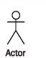

Instead of a stick figure, other symbols can be used as well, if they fit the characteristics of the actor and lead to practical, easy-to-read diagrams.

## Association:

An association is the relationship between an actor and a business use case. It indicates that an actor can use a certain functionality of the business system ; the business use case:



## Include Relationship:

The include relationship is a relationship between two business use cases that signifies that the business use case on the side to which the arrow points is included in the use case on the other side of the arrow. This means that for one functionality that the business system provides, another functionality of the business system is accessed.

In this way, functionalities that are accessed repeatedly can be depicted as individual business use cases, which can be used in multiple ways:



## Subject:

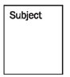A subject describes a business system that has one or more business use cases attached to it. A subject is represented by a rectangle that surrounds attached business use cases and is tagged with a name:

## Extend:

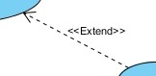

An extend relationship specifies how the behavior of the extension use case can be inserted into the behavior defined for the base use case.

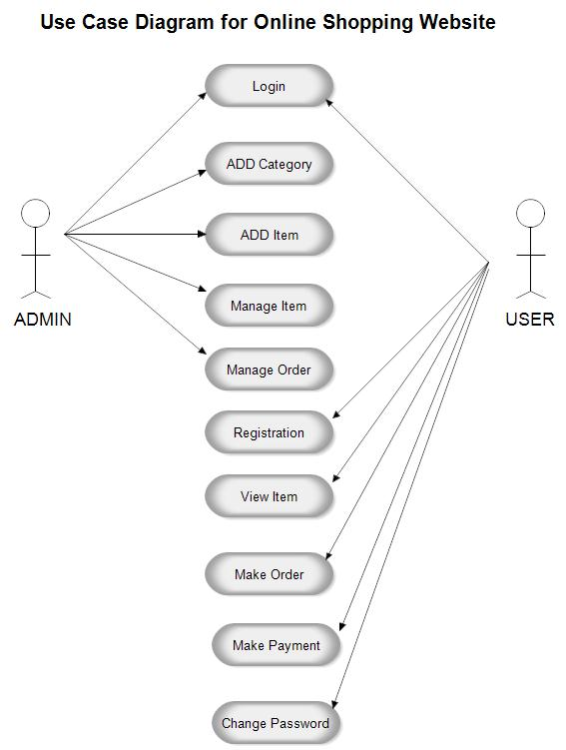

## Activity diagram:

Activity diagram is another important diagram in UML to describe the dynamic aspects of the system. Activity diagram is basically a flowchart to represent the flow from one activity to another activity. The control flow is

drawn from one operation to another. This flow can be sequential, branched, or concurrent. Activity diagrams deal with all type of flow control by using different elements such as fork, join, etc.

The purpose of an activity diagram can be described as −

* Draw the activity flow of a system.
* Describe the sequence from one activity to another.
* Describe the parallel, branched and concurrent flow of the system.

## Basic Activity Diagram Notations and Symbols Initial State or Start Point:

A small filled circle followed by an arrow represents the initial action state or the start point for any activity diagram.



## Activity or Action State:

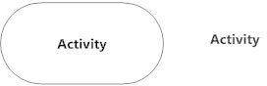An action state represents the non-interruptible action of objects. You can draw an action state in SmartDraw using a rectangle with rounded corners.

## Action Flow:

Action flows, also called edges and paths, illustrate the transitions from one action state to another. They are usually drawn with an arrowed line.



## Object Flow:

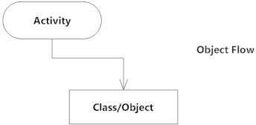Object flow refers to the creation and modification of objects by activities. An object flow arrow from an action to an object means that the action creates or influences the object. An object flow arrow from an object to an action indicates that the action state uses the object.

## Decisions and Branching:

A diamond represents a decision with alternate paths. When an activity requires a decision prior to moving on to the next activity, add a diamond between the two activities. The outgoing alternates should be labeled with a condition or guard expression. You can also label one of the paths "else."

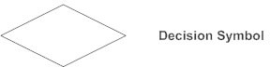

## Synchronization:

A fork node is used to split a single incoming flow into multiple concurrent flows. It is represented as a straight, slightly thicker line in an activity diagram.

A join node joins multiple concurrent flows back into a single outgoing flow.

A fork and join mode used together are often referred to as synchronization.

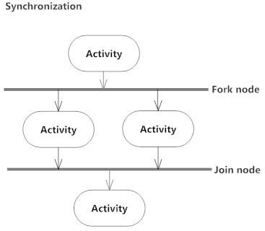

## Final State or End Point:

An arrow pointing to a filled circle nested inside another circle represents the final action state.

**ANALYSIS & DESIGN**

**Flowchart of System::**

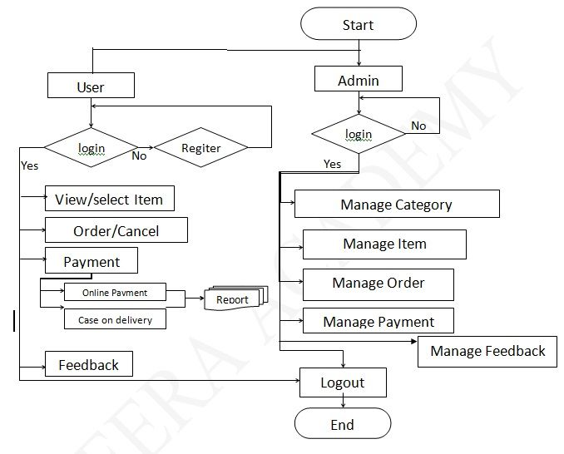

**Activity Digram :**

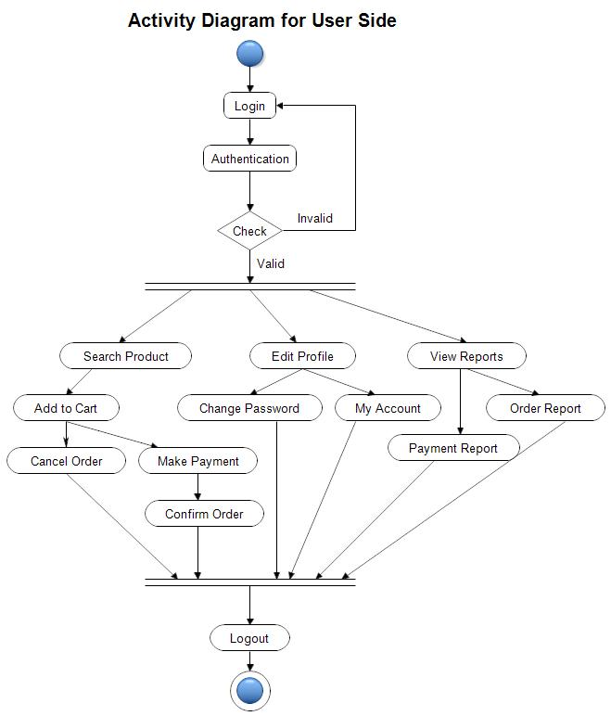

**Class Diagram:**

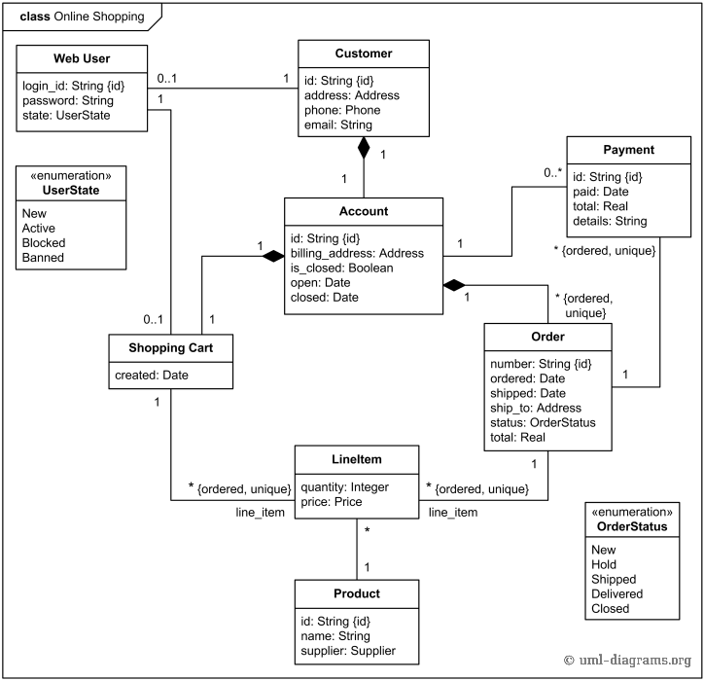

## Er- Diagram of Online Shopping System

Now we will discuss the whole ER-diagram to make better understanding.

**Here we have different Entities such as Online Shop, Customer, Product, Payment, Cart, Brand let looks one by one which is as follow:**

### Online Shop

This is the entity representing the whole online shopping system which further contains several other entities describing the entire application.

### Customer

This represents the set of customers, which are the clients who will be using this application.

**The customers are for whom the system is being designed. Its attribute set includes:**

#### Name:

This is the name of the customer, searching or purchasing the products. When signing up to the website the name of the customer is stored, this is done for the future referencing and maintaining the user’s data record (history). It is the composite attribute that contains two more attributes that are First Name and Last-named. That contains the user’s first name and last name.

#### Cust-id:

This is the identification number assigned by the admin to the users so as to identify them uniquely in the future. This identification number is helpful in fetching data of the individual user from a big set. This is mainly to manage the huge database system where the entire data is being stored.

#### Address:

This is the user’s address where the user lives so that to use it at the time of delivery or any further requirements. This is also a composite attribute that is divided into address1 and address2. These address1 contains house no. and lane no., whereas the address2 field is applicable for containing city and state address.

#### Email-id:

It involves the email address of the user, which can be used for sending advertisements or offers, to the user in the future, once the user becomes a part of the family and has signed up to the website. The user should enter a valid email address and not a fraudulent one, as the email id is verified at the time of sign-up only.

#### Contact-no:

This is the user’s mobile no., or any landline number, through which the user can be asked for confirmation at the time of placing an order, or it can also be used at times when the user has any query or feedback.

### Product

This is the entity representing the items that customers choose to buy. It can be added to the cart once the user likes it and then can be easily confirmed for order.

**This has the attribute set as:**

#### Name:

This is the name of the product by which it is identified and decided that in which category the user will be searching it and where the user can find this.

#### Prod-id:

This is the unique product identifier assigned to the items in the store so as to uniquely identify them, in condition if two products have the same name are available in the store. At that time the seller will update the record of the product based on this identity number, in the database.

#### Price:

It is one of the most important attributes since most of the time people change their shopping list contents depending upon their needs and economic situation. So, for them to know the actual MRP is most important in making decisions for what to buy and what not to.

### Brand

This is for the items that belong to some brands, and are kept in the store. People’s choice varies with their taste and standard of living. Most people these days prefer buying branded items.

#### Name:

The name of the brand often invites a crowd to buy their products no matter what the content is. So, the brand name is as important to maintain as the product.

#### Brand-id:

It is also the identification number given to the products for uniquely identifying them.

### Cart

A small place for the user to reserve their choice for checking and finalizing till they end their shopping. This is provided for a small period of time, that is till the user is in an active session. The cart in this system is kept to be the same as the wish list.

#### Quantity:

The number of individual items along with the total number of items the user has finalized for purchasing is maintained under this. So that it is to the knowledge of customers that what all have they bought. And also, the store needs to maintain a record of how many items they have sold and how much is required to bring more in the lot.

#### Cart-id:

A unique identifying number to indicate individual carts and manage their database along with the user’s data.

#### Total:

This attribute manages the total price sum of the purchase or transaction user has made in one attempt.

### Payment

It defines the payment to be done by the customer for purchasing the products from the web store at a worthwhile price. Also, various security encryption mechanisms have been used, so the customer details of accounts and other credentials are safe and secure.

#### Mode:

The user is provided with lots of options that he/she can opt for making the payment depending upon their ease. There are many choices available for net banking, use of wallets like pay and I-cash cards, also credit card and debit card options are available too.

#### Pay-id:

It is for the benefit of the user as well as the website owners since the pay-id is helpful in maintaining the payment record in the database, as well as it is also provided to the customer after the successful completion of payment. As later customers can claim anytime that they have already done the payments and the owners cannot deny.

So, it is useful to prevent any kind of fraud from both sides.

#### Amount:

It is the record of the total sum amount the user needs to pay, and after the payment, it is used to update the server-side database to keep the record of the net profit or loss on daily basis.

## SYSTEM CONFIGURATION

* 1. **Hardware Configuration:**

|  |  |
| --- | --- |
| HARDWARE COMPONENTS | REQUIREMENTS |
| Processor | 2.8GHz Processor and Above |
| RAM | 2 GB |
| Memory | 500 GB |

* 1. **Software Configuration:**

|  |  |
| --- | --- |
| Front-End | HTML, JAVASCRIPT, CSS  (Eclipse IDE for Enterprise Java Developers or Bracket text editor) |
| Back-End | Mysql |
| Operating System | Windows 10 |
| Local host : | XAMPP/WAMP/LAMP/MAMP |

1. **DETAILS OF THE SOFTWARE**
   1. **Overview of Front-End:**

**Java Enterprise Edition:**

The Java EE stands for Java Enterprise Edition, which was earlier known as J2EE and is currently known as Jakarta EE. It is a set of specifications wrapping around Java SE (Standard Edition). The Java EE provides a platform for developers with enterprise features such as distributed computing and web services. Java EE applications are usually run on reference run times such as micro servers or application servers. Examples of some contexts where Java EE is used are e-commerce, accounting, banking information systems. Java EE has several specifications which are useful in making web pages, reading and writing from in a transactional way, managing distributed queues. The Java EE contains several APIs which have the functionalities of base Java SE APIs such as Enterprise JavaBeans, connectors, Servlets, Java Server Pages and several web service technologies.

## JavaScript:

JavaScript is a dynamic computer programming language. It is lightweight and most commonly used as a part of web pages, whose implementations allow client-side script to interact with the user and make dynamic pages.

It is an interpreted programming language with object-oriented capabilities.

JavaScript can be implemented using JavaScript statements that are placed within the **<script>... </script>** HTML tags in a web page.

## Advantages of JavaScript:

The merits of using JavaScript are −

* + - **Less server interaction** − You can validate user input before sending the page off to the server. This saves server traffic, which means less load on your server.
    - **Immediate feedback to the visitors** − They don't have to wait for a page reload to see if they have forgotten to enter something.
    - **Increased interactivity** − You can create interfaces that react when the user hovers over them with a mouse or activates them via the keyboard.
    - **Richer interfaces** − You can use JavaScript to include such items as drag- and-drop components and sliders to give a Rich Interface to your site visitors.

## Limitations of JavaScript:

We cannot treat JavaScript as a full-fledged programming language. It lacks the following important features −

* + - * Client-side JavaScript does not allow the reading or writing of files. This has been kept for security reason.
      * JavaScript cannot be used for networking applications because there is no such support available.
      * JavaScript doesn't have any multi-threading or multiprocessor capabilities.

## HTML:

**Hypertext Markup Language** (**HTML**) is the standard [markup language](https://en.wikipedia.org/wiki/Markup_language) for documents designed to be displayed in a [web browser](https://en.wikipedia.org/wiki/Web_browser). It can be assisted by technologies such as [Cascading Style Sheets](https://en.wikipedia.org/wiki/Cascading_Style_Sheets) (CSS) and [scripting](https://en.wikipedia.org/wiki/Scripting_language) languages such as [JavaScript](https://en.wikipedia.org/wiki/JavaScript).

[Web browsers](https://en.wikipedia.org/wiki/Web_browser) receive HTML documents from a [web server](https://en.wikipedia.org/wiki/Web_server) or from local storage and [render](https://en.wikipedia.org/wiki/Browser_engine) the documents into multimedia web pages. HTML describes the structure of a [web page](https://en.wikipedia.org/wiki/Web_page) [semantically](https://en.wikipedia.org/wiki/Semantic_Web) and originally included cues for the appearance of the document.

[HTML elements](https://en.wikipedia.org/wiki/HTML_element) are the building blocks of HTML pages. With HTML constructs, [images](https://en.wikipedia.org/wiki/HTML_element) and other objects such as [interactive forms](https://en.wikipedia.org/wiki/Fieldset) may be embedded into the rendered page. HTML provides a means to create [structured documents](https://en.wikipedia.org/wiki/Structured_document) by denoting structural [semantics](https://en.wikipedia.org/wiki/Semantics) for text such as headings, paragraphs, lists, [links](https://en.wikipedia.org/wiki/Hyperlink), quotes and other items. HTML elements are delineated by *tags*, written using [angle brackets](https://en.wikipedia.org/wiki/Bracket). Tags such as

<**img** />

and

<**input** />

surround

<**p**>

directly introduce content into the page. Other tags such as and provide information about document text and may

include other tags as sub-elements. Browsers do not display the HTML tags,

but use them to interpret the content of the page.

## CSS (Cascading Style Sheets):

Cascading Style Sheets, fondly referred to as CSS, is a simple design language intended to simplify the process of making web pages presentable.

CSS handles the look and feel part of a web page. Using CSS, you can control the color of the text, the style of fonts, the spacing between paragraphs, how columns are sized and laid out, what background images or colors are used, layout designs, variations in display for different devices and screen sizes as well as a variety of other effects.

## Advantages of CSS:

* + - * **CSS saves time** − You can write CSS once and then reuse same sheet in multiple HTML pages. You can define a style for each HTML element and apply it to as many Web pages as you want.
      * **Pages load faster** − If you are using CSS, you do not need to write HTML tag attributes every time. Just write one CSS rule of a tag and apply it to all the occurrences of that tag. So, less code means faster download times.
      * **Easy maintenance** − To make a global change, simply change the style, and all elements in all the web pages will be updated automatically.
      * **Superior styles to HTML** − CSS has a much wider array of attributes than HTML, so you can give a far better look to your HTML page in comparison to HTML attributes.
      * **Multiple Device Compatibility** − Style sheets allow content to be optimized for more than one type of device. By using the same HTML document, different versions of a website can be presented for handheld devices such as PDAs and cell phones or for printing.
      * **Global web standards** − Now HTML attributes are being deprecated and it is being recommended to use CSS. So, it’s a good idea to start using CSS in all the HTML pages to make them compatible to future browsers.

## Overview of Back-end:

**MySQL Database:** MySQL is a database system used on the web. MySQL is a database system that runs on a server. MySQL is ideal for both small and large applications. MySQL is very fast, reliable, and easy to use. MySQL uses standard SQL. MySQL compiles on a number of platforms. MySQL is free to download and use. MySQL is developed, distributed, and supported by Oracle Corporation

. It also supports-

* testing SQL queries and viewing query plans.
* step-by-step debugging of stored routines.
* generating test data.
* transferring data between database systems (DataPump).
* import and export of data.
* database schema compare and change script creation.
* database [schema migration](https://en.wikipedia.org/wiki/Schema_migration), also from one database system to another.
* open ODBC or ADO data sources and MS Access databases.
* manage security items like users, groups and roles.
* create custom reports based on database queries.
* print database schema, source code, lists of objects or query result sets.

## SYSTEM DESIGN

**5.1 Architectural Design:**

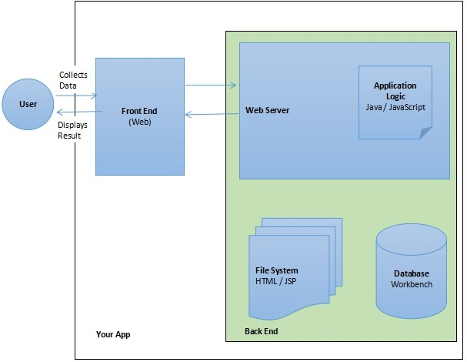

* 1. **Input Design:**

The design of input also includes specifying the means by which end-users and system operators direct the system in which action to take. Input design consists of developing specification procedures for data preparation. These steps are necessary to put transaction into such usable form for processing and entry, the activity of putting the data into the computer processing. The objectives guiding the design of input focus on controlling the amount of input required, avoiding the delay, controlling the errors and

keeping the steps in simple. Input design is the process of converting user- oriented inputs to such computer based format. System analysts decide the input design as:

* + - What data to input?
    - What medium to use?
    - How the data should arrange or coded?

## Output Design:

The output is the most important and direct source of the information to user. It is used to view the result of each operator we make. Efficient, intelligible output design should improve system‘s relationships with the user and help in decision making. System outputs are of three types, which are a report, a document and a message. When designing output, the systems analyst must accomplish:

* + - Determine what information to present.
    - Decide whether to display or print the information
    - Arrange the presentation of information in an acceptable format.
    - Decide how to distribute the output to intended receipts.

## Database Design

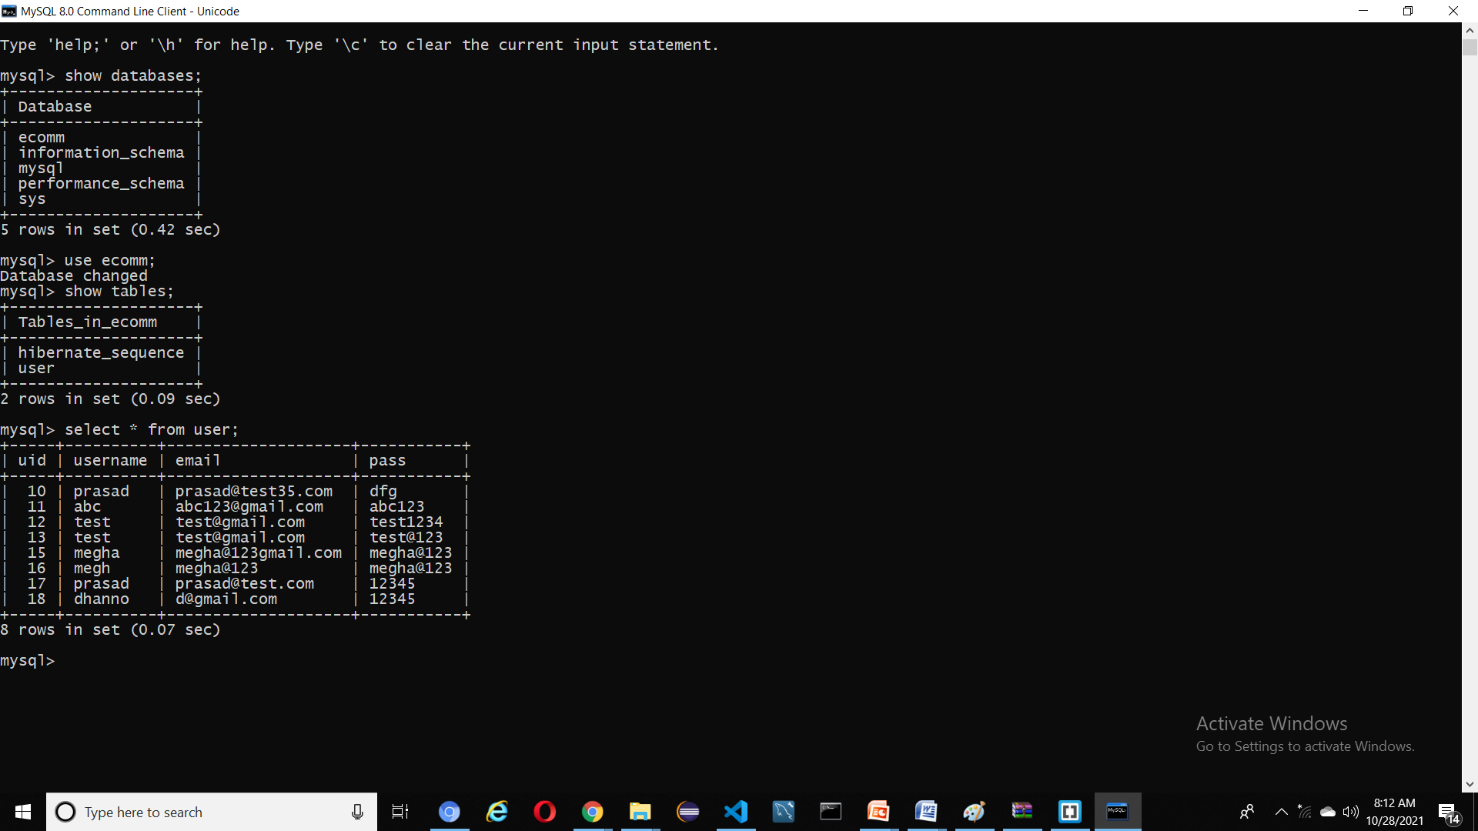

**Sample program code**

<!DOCTYPE html>

<html lang="en">

<head>

    <meta charset="UTF-8">

    <meta name="viewport" content="width=device-width,initial-scale=1.0">

    <title>RedStore ! Ecommerce Website Design </title>

    <link rel="stylesheet" href="style.css">

    <link href="https://fonts.googleapis.com/css2?family=Poppins:wght@200;300;400;500;600;700&display=swap" rel="stylesheet">

    </head>

   <link rel="stylesheet" href="https://stackpath.bootstrapcdn.com/font-awesome/4.7.0/css/font-awesome.min.css">

<body>

    <div class="header">

    <div class="container">

         <div class="navbar">

    <div class="logo">

        <a href="index.html">

           <img src="images/logo.png" width="125px"></a>

        </div>

        <nav>

        <ul id="MenuItems">

            <li> <a href="index.html">Home</a> </li>

            <li> <a href="products.html">Product</a> </li>

            <li> <a href="">About</a> </li>

            <li> <a href="">Contact</a> </li>

            <li> <a href="account.html">Account</a> </li>

            </ul>

        </nav>

             <a href="cart.html">

             <img src="images/cart.png" width="30px" height="30px" ></a>

             <img src="images/menu.png" class="menu-icon"

                  onclick="menutoggle()">

    </div>

        <div class="row">

  <div class="col-2">

            <h2> Give Your Workout <br> A New Style!</h2>

           <br>

            <p>Success isn't always about greatness. It's about consistency. Consistent hard work leads to success.Greatness

                will come.   </p>

      <a href="" class="btn"> Explore Now &#8594;</a>

            </div>

            <div class="col-2">

            <img src="images/image1.png">

                 </div>

    </div>

    </div>

   </div>

   <!____featured categorie_____________>

    <div class="categories">

        <div class="small-container">

            <div class="row">

            <div class="col-3"><img src="images/category-1.jpg"> </div>

            <div class="col-3"><img src="images/category-2.jpg"></div>

            <div class="col-3"> <img src="images/category-1.jpg"></div>

        </div>

    </div>

   </div>

        <!____featured products_____________>

    <div class="small-container">

    <h2 class="title">Featured Products</h2>

        <div class="row">

        <div class="col-4">

            <a href="product-details.html">

            <img src="images/product-1.jpg"></a>

            <a href="product-details.html"><h4> Red Printed T-Shirt</h4></a>

            <div class="rating">

                <i class="fa fa-star" ></i>

                <i class="fa fa-star" ></i>

                <i class="fa fa-star" ></i>

                <i class="fa fa-star-half-o" aria-hidden="true"></i>

                <i class="fa fa-star-o" aria-hidden="true"></i>

            </div>

            <p> $60.00</p>

            </div>

              <div class="col-4">

            <img src="images/product-2.jpg">

            <h4> HRX sports shoes</h4>

            <div class="rating">

                <i class="fa fa-star" ></i>

                <i class="fa fa-star" ></i>

                <i class="fa fa-star" ></i>

                <i class="fa fa-star" ></i>

                    <i class="fa fa-star-o" aria-hidden="true"></i>

            </div>

            <p> $60.00</p>

            </div>

              <div class="col-4">

            <img src="images/product-3.jpg">

            <h4> HRX Gray Trackpants</h4>

            <div class="rating">

                <i class="fa fa-star" ></i>

                <i class="fa fa-star" ></i>

                <i class="fa fa-star" ></i>

                <i class="fa fa-star-half-o" aria-hidden="true"></i>

                <i class="fa fa-star-o" aria-hidden="true"></i>

            </div>

            <p> $44.00</p>

            </div>

              <div class="col-4">

            <img src="images/product-4.jpg">

            <h4> Blue Printed T-Shirt</h4>

            <div class="rating">

                <i class="fa fa-star" ></i>

                <i class="fa fa-star" ></i>

                <i class="fa fa-star" ></i>

                <i class="fa fa-star-half-o" aria-hidden="true"></i>

                <i class="fa fa-star-half-o" aria-hidden="true"></i>

                </div>

            <p> $50.00</p>

            </div>

             </div>

         <h2 class="title">Latest Products</h2>

             <div class="row">

        <div class="col-4">

            <img src="images/product-5.jpg">

            <h4>Puma Gray Sport shoes</h4>

            <div class="rating">

                <i class="fa fa-star" ></i>

                <i class="fa fa-star" ></i>

                <i class="fa fa-star" ></i>

                <i class="fa fa-star-half-o" aria-hidden="true"></i>

                <i class="fa fa-star-o" aria-hidden="true"></i>

            </div>

            <p> $60.00</p>

            </div>

              <div class="col-4">

            <img src="images/product-6.jpg">

            <h4> Black Printed T-Shirt</h4>

            <div class="rating">

                <i class="fa fa-star" ></i>

                <i class="fa fa-star" ></i>

                <i class="fa fa-star" ></i>

                <i class="fa fa-star" ></i>

                    <i class="fa fa-star-o" aria-hidden="true"></i>

            </div>

            <p> $60.00</p>

            </div>

              <div class="col-4">

            <img src="images/product-7.jpg">

            <h4> hrx set of 3 sockes</h4>

            <div class="rating">

                <i class="fa fa-star" ></i>

                <i class="fa fa-star" ></i>

                <i class="fa fa-star" ></i>

                <i class="fa fa-star-half-o" aria-hidden="true"></i>

                <i class="fa fa-star-o" aria-hidden="true"></i>

            </div>

            <p> $44.00</p>

            </div>

              <div class="col-4">

            <img src="images/product-8.jpg">

            <h4> black Watch</h4>

            <div class="rating">

                <i class="fa fa-star" ></i>

                <i class="fa fa-star" ></i>

                <i class="fa fa-star" ></i>

                <i class="fa fa-star-half-o" aria-hidden="true"></i>

                <i class="fa fa-star-half-o" aria-hidden="true"></i>

                </div>

            <p> $50.00</p>

            </div>

             </div>

             <div class="row">

        <div class="col-4">

            <img src="images/product-9.jpg">

            <h4> black Sports Watch</h4>

            <div class="rating">

                <i class="fa fa-star" ></i>

                <i class="fa fa-star" ></i>

                <i class="fa fa-star" ></i>

                <i class="fa fa-star-half-o" aria-hidden="true"></i>

                <i class="fa fa-star-o" aria-hidden="true"></i>

            </div>

            <p> $60.00</p>

            </div>

              <div class="col-4">

            <img src="images/product-10.jpg">

            <h4> black HRX Shoes</h4>

            <div class="rating">

                <i class="fa fa-star" ></i>

                <i class="fa fa-star" ></i>

                <i class="fa fa-star" ></i>

                <i class="fa fa-star" ></i>

                    <i class="fa fa-star-o" aria-hidden="true"></i>

            </div>

            <p> $60.00</p>

            </div>

              <div class="col-4">

            <img src="images/product-11.jpg">

            <h4>  Gray Nike Shoes</h4>

            <div class="rating">

                <i class="fa fa-star" ></i>

                <i class="fa fa-star" ></i>

                <i class="fa fa-star" ></i>

                <i class="fa fa-star-half-o" aria-hidden="true"></i>

                <i class="fa fa-star-o" aria-hidden="true"></i>

            </div>

            <p> $44.00</p>

            </div>

              <div class="col-4">

            <img src="images/product-12.jpg">

            <h4>  black HRX Trackpants</h4>

            <div class="rating">

                <i class="fa fa-star" ></i>

                <i class="fa fa-star" ></i>

                <i class="fa fa-star" ></i>

                <i class="fa fa-star-half-o" aria-hidden="true"></i>

                <i class="fa fa-8star-half-o" aria-hidden="true"></i>

                </div>

            <p> $50.00</p>

            </div>

             </div>

    </div>

    <!_____________________offer_______________________>

    <div class="offer">

        <div class="small-container">

        <div class="row">

            <div class="col-2">

            <img src="images/exclusive.png" class="offer-img">

            </div>

            <div class="col-2">

                <p> Exclusively Available On RedStore</p><br>

                <h2><big> Smart band 4</big></h2>

                <small> The Mi Smart band 4 feature a 39.9% larger (than Mi band 3) AMOLED Color full touch display with adjustable brightness, so everthing is clear as can be .</small>

                <a href="" class="btn">Buy Now   &#8594;</a>

            </div>

            </div>

             </div>

    </div>

    <!---------testimonial------>

    <div class="testimonial">

    <div class="small-container">

        <div class="row">

        <div class="col-3">

            <i class="fa fa-quote-left"></i>

            <p> Lorem Ipsum is simply dummy text of the printing and typesetting industry.Lorem Ipsum has been the industrys standard dummy text ever </p>

            <div class="rating">

                <i class="fa fa-star" ></i>

                <i class="fa fa-star" ></i>

                <i class="fa fa-star" ></i>

                <i class="fa fa-star-half-o"></i>

                <i class="fa fa-star-o"></i>

                </div>

            <img src="images/user-1.png">

            <h3>Mahi Biradar</h3>

            </div>

            <div class="col-3">

            <i class="fa fa-quote-left"></i>

            <p> Lorem Ipsum is simply dummy text of the printing and typesetting industry.Lorem Ipsum has been the industrys standard dummy text ever </p>

            <div class="rating">

                <i class="fa fa-star" ></i>

                <i class="fa fa-star" ></i>

                <i class="fa fa-star" ></i>

                <i class="fa fa-star-half-o"></i>

                <i class="fa fa-star-o"></i>

                </div>

            <img src="images/user-2.png">

            <h3>raj shinde</h3>

            </div>

            <div class="col-3">

            <i class="fa fa-quote-left"></i>

            <p> Lorem Ipsum is simply dummy text of the printing and typesetting industry.Lorem Ipsum has been the industrys standard dummy text ever </p>

            <div class="rating">

                <i class="fa fa-star" ></i>

                <i class="fa fa-star" ></i>

                <i class="fa fa-star" ></i>

                <i class="fa fa-star-half-o"></i>

                <i class="fa fa-star-o"></i>

                </div>

            <img src="images/user-3.png">

            <h3>rani sharma</h3>

            </div>

        </div>

     </div>

    </div>

    <!___________________________brands______________________>

    <div class="brands">

    <div class="small-container">

        <div class="row">

        <div class="col-5">

            <img src="images/logo-godrej.png">

            </div>

            <div class="col-5">

            <img src="images/logo-oppo.png">

            </div>

            <div class="col-5">

            <img src="images/logo-coca-cola.png">

            </div>

            <div class="col-5">

            <img src="images/logo-paypal.png">

            </div>

            <div class="col-5">

            <img src="images/logo-philips.png">

            </div>

        </div>

        </div>

    </div>

    <!____________________footer_____________________>

    <div class="footer">

    <div class="container">

        <div class="row">

        <div class="footer-col-1">

            <h3> Download Our App</h3>

            <p>Download App For Android and ios mobile phone .</p>

            <div class="app-logo">

                <img src="images/play-store.png">

                <img src="images/app-store.png">

            </div>

            </div>

            <div class="footer-col-2">

            <img src="images/logo-white.png">

            <p>Our Purpose Is ToSustainably Make the pleasure and benifits of sports Accessible to the Many .</p>

            </div>

            <div class="footer-col-3">

            <h3> Usefull Links </h3>

                <ul>

                    <li>Coupons </li>

                    <li>Blog Post </li>

                    <li>return policy </li>

                    <li>job affiliate </li>

                </ul>

            </div>

            <div class="footer-col-4">

            <h3> Follow Us </h3>

                <ul>

                    <li>Facebook </li>

                    <li>Twitter </li>

                    <li>instagram </li>

                    <li>Youtube </li>

                </ul>

            </div>

             </div>

        <hr>

        <p class="copyright"> copyright 2021-</p>

             </div>

    </div>

    <!__________________________js for toggle menu---------------------->

    <script>

    var MenuItems=document.getElementById("MenuItems")

        MenuItems.style.maxHeight ="0px";

        function menutoggle()

        {

            if(MenuItems.style.maxHeight == "0px")

            {

              MenuItems.style.maxHeight="200px";

            }

            else

                {

                    MenuItems.style.maxHeight="0px";

                }

        }

    </script>

</body>

</html>

## TESTING

**Software Testing-Levels:**

**Black-Box Testing:**

The technique of testing without having any knowledge of the interior workings of the application is called black-box testing. The tester is oblivious to the system architecture and does not have access to the source code. Typically, while performing a black-box test, a tester will interact with the system's user interface by providing inputs and examining outputs without knowing how and where the inputs are worked upon.

## White-Box Testing:

White-box testing is the detailed investigation of internal logic and structure of the code. White-box testing is also called glass testing or open- box testing. In order to perform white-box testing on an application, a tester needs to know the internal workings of the code. The tester needs to have a look inside the source code and find out which unit/chunk of the code is behaving inappropriately.

## Unit Testing:

This type of testing is performed by developers before the setup is handed over to the testing team to formally execute the test cases. Unit testing is performed by the respective developers on the individual units of source code assigned areas. The developers use test data that is different from the

test data of the quality assurance team. The goal of unit testing is to isolate each part of the program and show that individual parts are correct in terms of requirements and functionality.

## Integration Testing:

Integration testing is defined as the testing of combined parts of an application to determine if they function correctly. Integration testing can be done in two ways: Bottom-up integration testing and Top-down integration testing. In a comprehensive software development environment, bottom-up testing is usually done first, followed by top-down testing. The process concludes with multiple tests of the complete application, preferably in scenarios designed to mimic actual situations.

## System Testing:

System testing tests the system as a whole. Once all the components are integrated, the application as a whole is tested rigorously to see that it meets the specified Quality Standards. This type of testing is performed by a specialized testing team.

# SCREENSHOTS

**Home page:**

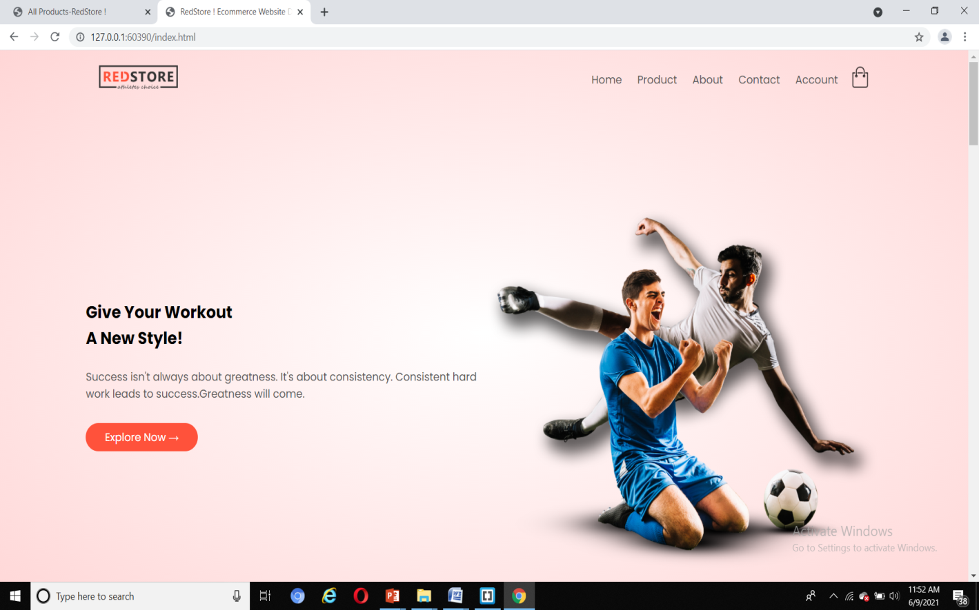

**Mobile View :**

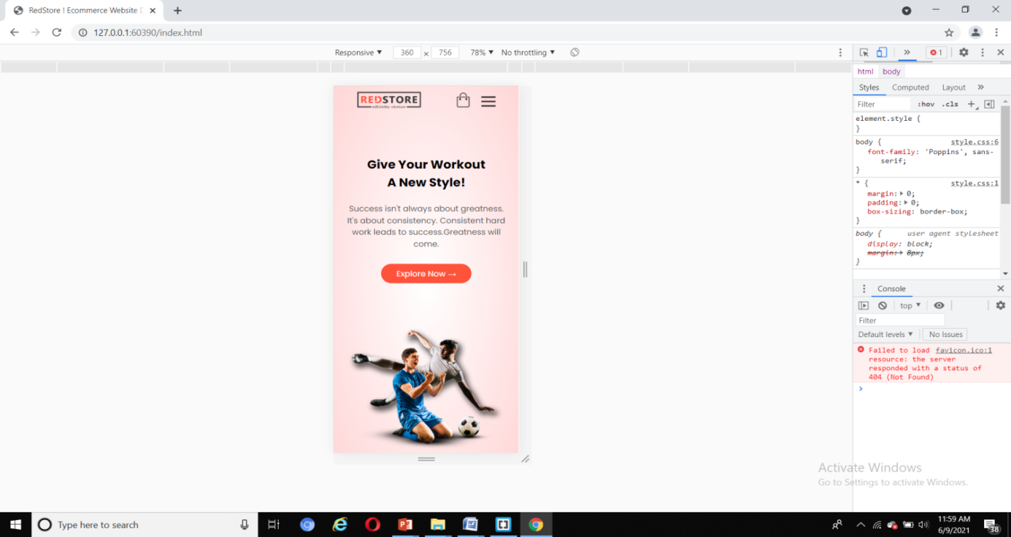

**Create account:**

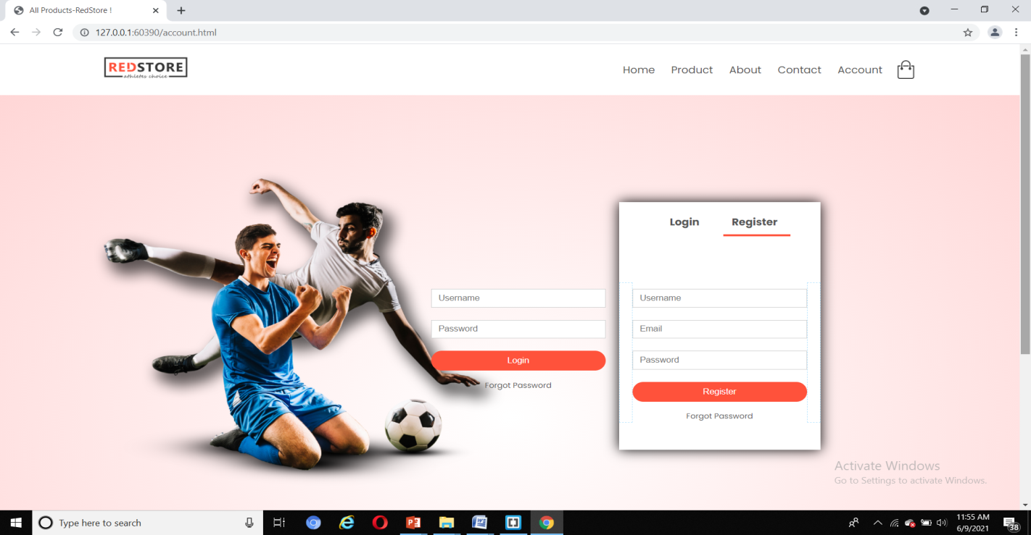

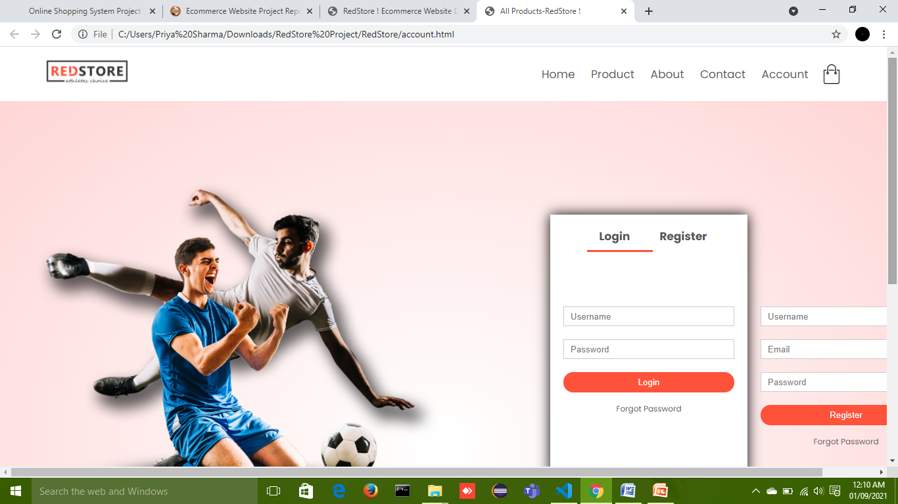

**Product Details :**

P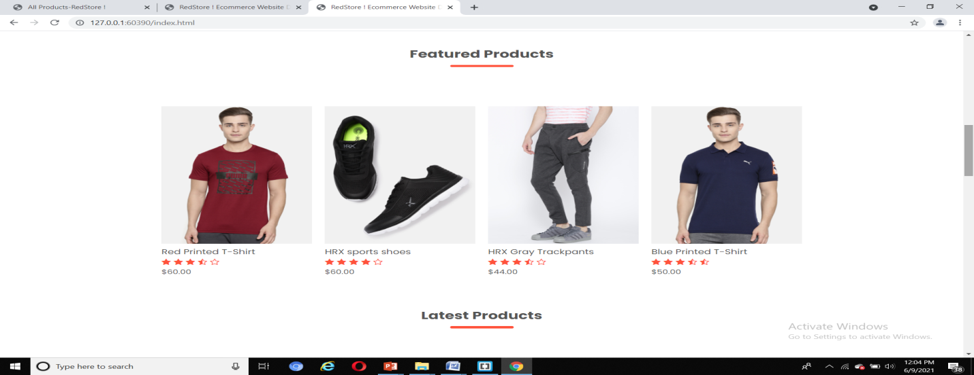

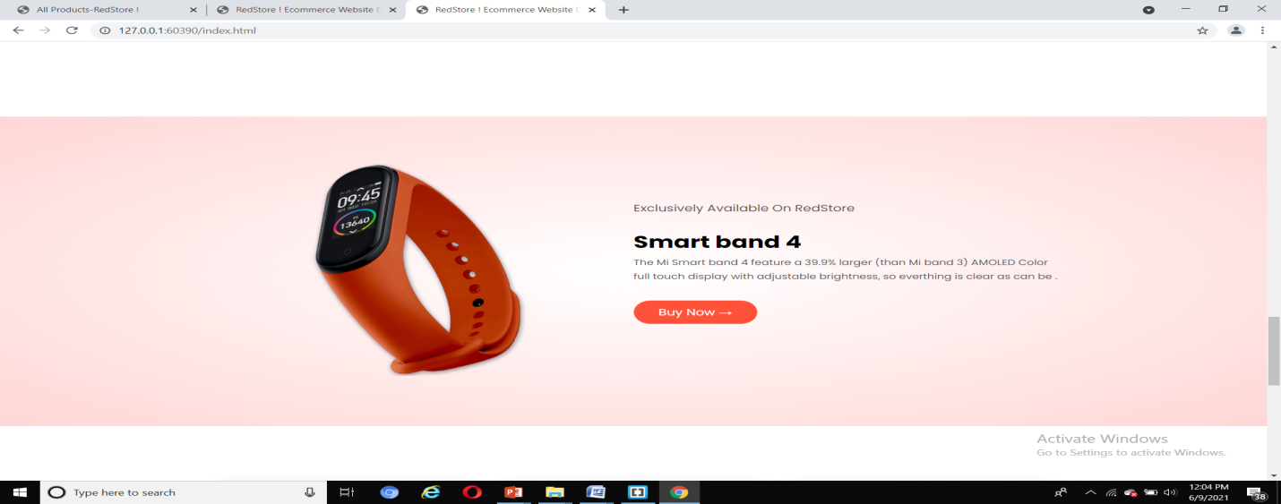

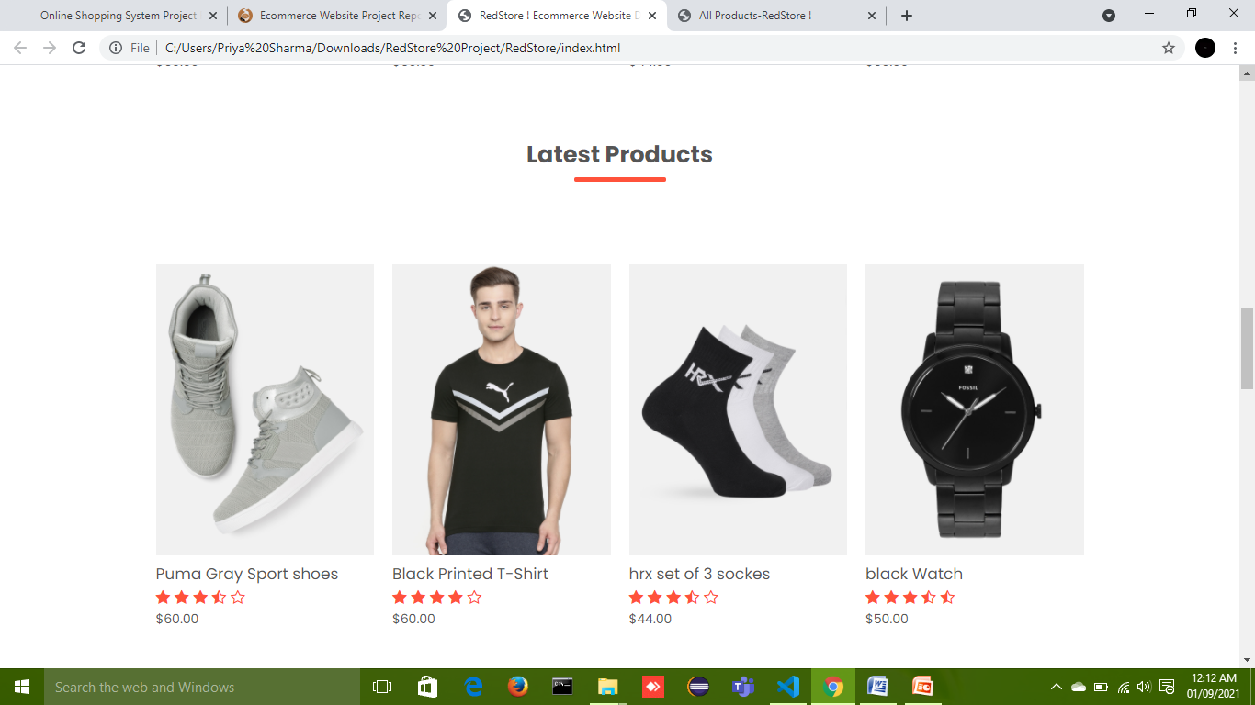

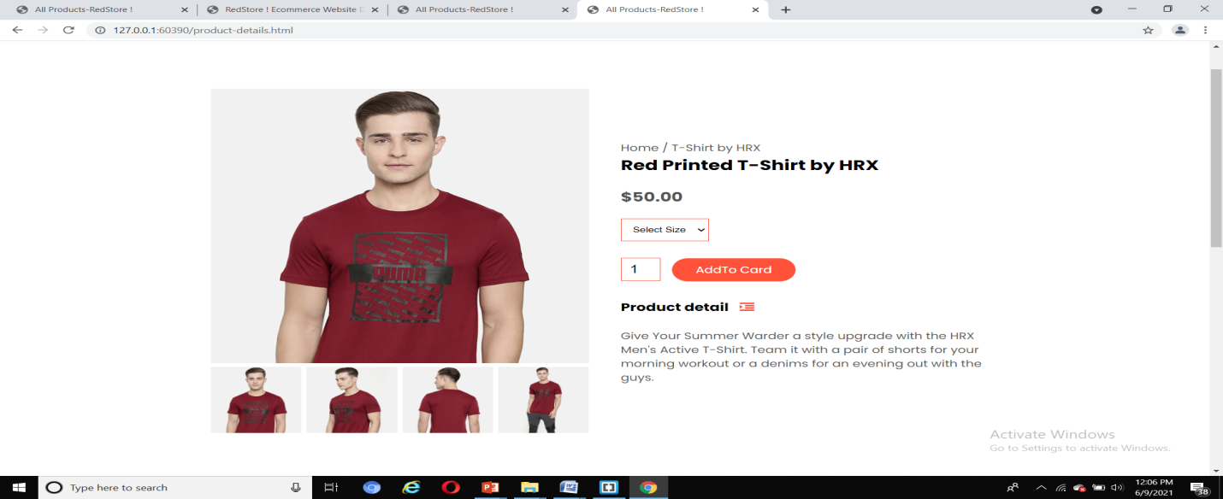

**Cart page :**

C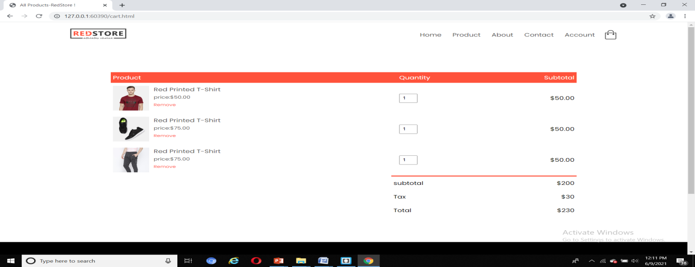

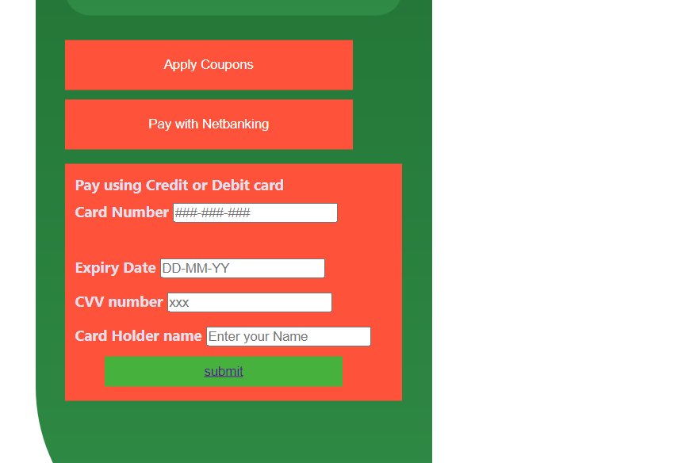

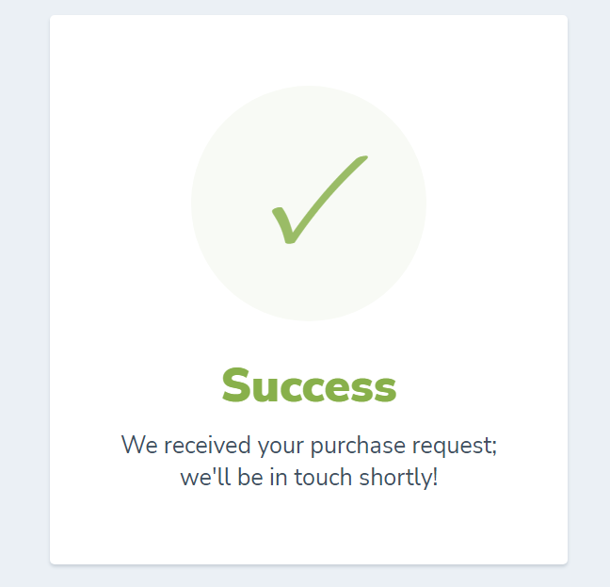

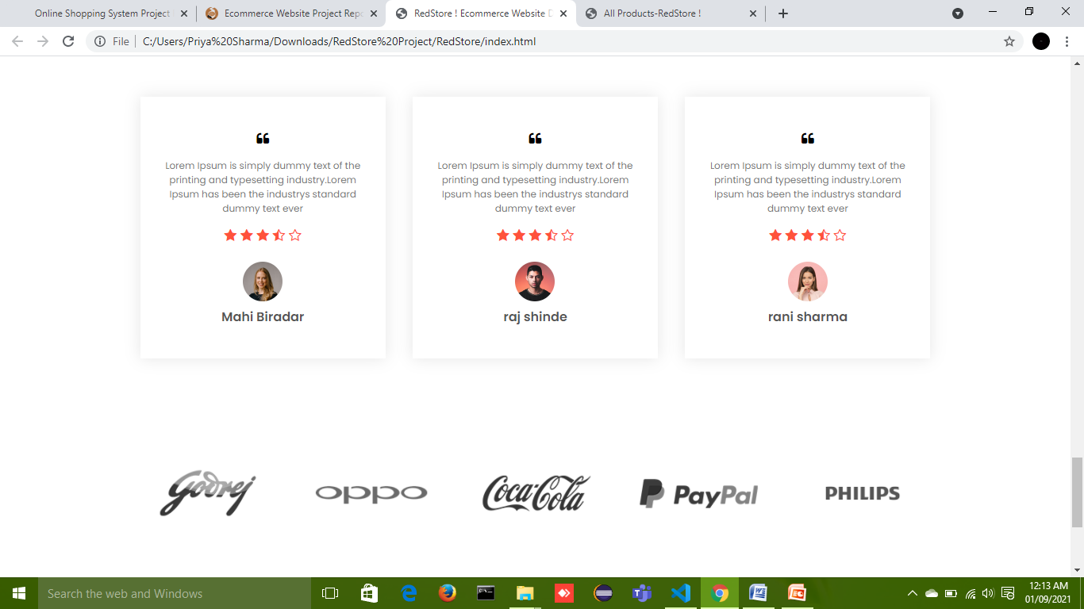

## CONCLUSION

Conclusion This project is only a humble venture to satisfy the needs in a shop. Several user friendly coding have also adopted. This package shall prove to be a powerful package in satisfying all the requirements of the organization. The objective of software planning is to provide a frame work that enables the manger to make reasonable estimates made within a limited time frame at the beginning of the software project and should be updated regularly as the project progresses. This website provides a computerized version of shop manipulate system which will benefit the users as well as the visitor of the shop. It makes entire process online where users can search product, and buy various product. It also has a facility for common user by login into the system where user can login and can see status of ordered item as well request for items or give some suggestions. It provide the facility of admin’s login where admins can add various item, review users activity and also give occasional discount and also add info about different events for the customer.

## BIBLIOGRAPHY

**BOOKS/REFERENCES:**

* Gary B. Shelly, Harry J. Rosenblatt, “*System Analysis and Design*”, 2009.
* Pankaj Jalote, “So*ftware Engineering*: a precise approach”, 2006.
* IEEE Std 1016 Recommended Practice for Software Design Descriptions.
* Software Engineering: A Practitioner’s Approach by Roger S. Pressman

## WEBSITES:

* **HTML tutorial: https://www.w3schools.com/php/**
* **CSS Design tutorial :** <https://www.w3schools.com/css/>
* **JAVASCRIPT:** https://[www.w3schools.com/js/](http://www.w3schools.com/js/)