SANDBOX · PROFILE STUDIO — TUTORIAL 3
The process stack
After the material stack and opening are built, the process stack transforms the profile step by step — the same idea as real fab steps (deposit, fill, etch, polish).
How it works
Steps run in order, top to bottom (①, then ②, ③ …). Each step acts on the result of the one above it. A Repeat block runs its steps ×N — handy for multilayers / superlattices.
The step types
• Deposit · conformal — coats every surface — walls, bottom, and top — with a uniform layer that follows the profile. Use it for liners and spacers.
• Deposit · planar — adds a flat layer on top only (no sidewall coverage).
• Fill — fills the opening/voids with a material (gap-fill), then continues above the surface.
• Etch · isotropic — removes material equally in all directions — rounds corners and undercuts.
• Etch · anisotropic — removes material vertically (directional). Anisotropy 1 = fully vertical, 0 = isotropic, in between = a rounded undercut. Pick a material to etch only that one, or “(any)”.
• Planarize — cuts everything flat at a height — like chemical-mechanical polish (CMP).
Worked example — liner + fill + polish
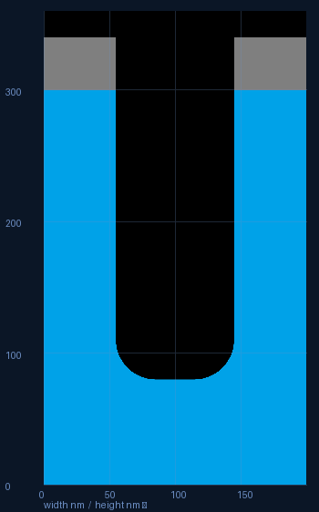  ① bare trench (stack + opening) | 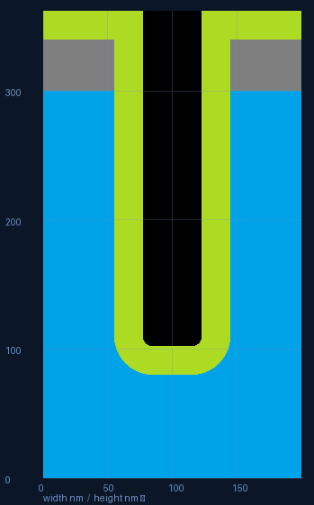  ② + Deposit·conformal (nitride liner) | 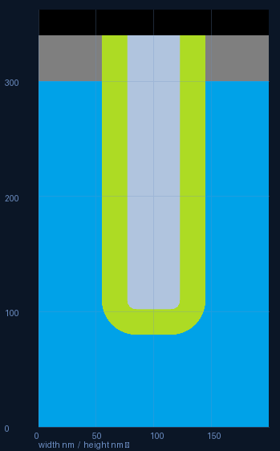  ③ + Fill (tungsten) + Planarize

Tips
• The material dropdown on Deposit/Fill/Etch lists only materials already in your stack (Etch adds “(any)”).
• Etch with a material selected removes only that material; “(any)” removes whatever it reaches.
• Build a superlattice with a Repeat block: e.g. deposit A, deposit B, repeated ×10.

