SANDBOX · PROFILE STUDIO — TUTORIAL 1
Building a U-shaped mask profile
Reproduce a flared mask with a rounded (U) opening bottom, using the material stack and per-layer shape treatments.
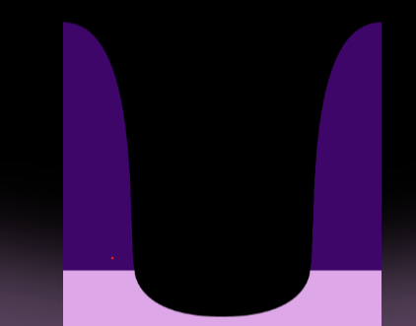  Target (your image) | 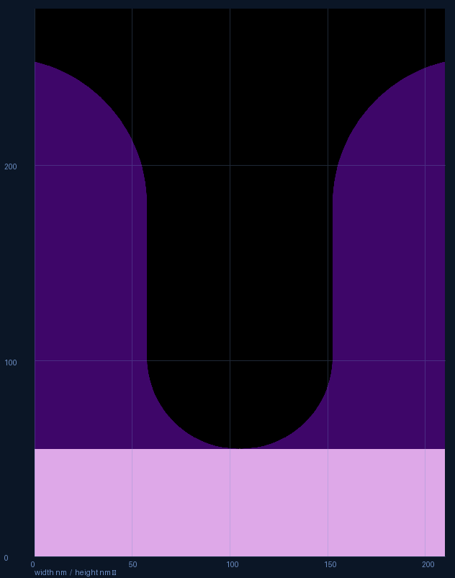  Result in Profile Studio
Steps
1. Material stack (row 1 = top). Add indigo 200 nm, then lavender 55 nm.
2. Base feature. Pitch 210, Space 95, Opening depth 200, Top vacuum 25.
3. Opening bottom round: 47 nm (about half of Space) — this makes the U-shaped bottom.
4. Shape the mask. On the indigo layer press shape and add Round radius 75 for the flared top.
5. Press Render, then Save .bmp to export the image.
Notes
Round / Taper / Opening-bottom-round each shape a different part: round softens the top corner, taper slopes the whole wall, and the opening-bottom-round curves the base.
Taper (optional here) slopes the whole wall; its angle is the sidewall angle from the horizontal base — 90° = vertical, smaller = more sloped.
Treatments combine and are order-independent — you get the same mask whichever you add first.

Tips
• The shape button is enabled only for layers the opening actually reaches.
• Toolbar Save stores the whole project; Save .bmp exports the picture.
• Add your own colors with the “+ New material” button.

