SANDBOX · PROFILE STUDIO — TUTORIAL 2
Using a CSV
Define an arbitrary, curved profile from a width/height trace instead of the rectangular Space opening. A CSV can describe a whole etched profile, not just a simple opening.
The CSV format  Two columns, one row per point:  width = the full opening width (CD) at that height — a size, always ≥ 0.  height = the vertical position (nm); it may be negative (a position).  The profile is drawn symmetric about the centerline (±width/2).  width height  0 0  22 6  36 16  48 40  56 80  62 130  64 180  62 220  58 248  60 262  example_profile.csv (a realistic etched trench) | 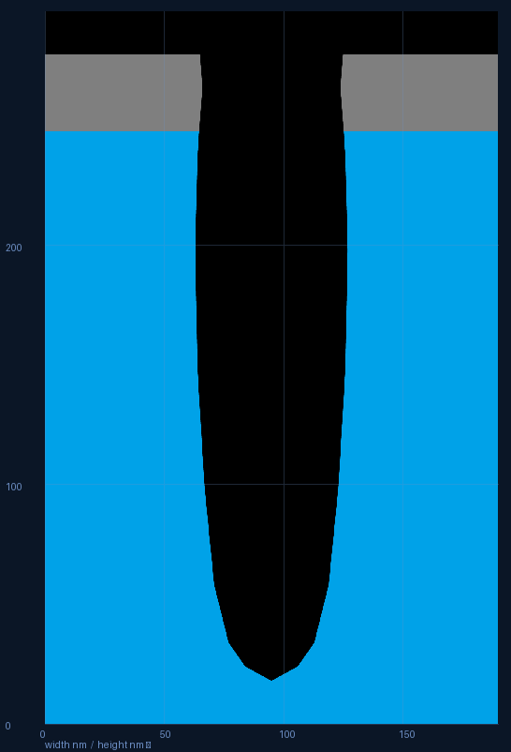  The trace loaded as the profile
Steps
1. Prepare a CSV with columns width,height (see example). Save it anywhere.
2. In Base feature, click “Load CSV…” and choose your file.
3. Placement. By default the trace is top-aligned (its top sits at the stack top, cutting downward). To pin it elsewhere, set “CSV height=0 at (nm)” — the row where height = 0 lands that many nm from the stack bottom; negative heights sit below that line.
4. While a CSV is active, Space and Opening depth are ignored; Top vacuum still applies.
5. If the curved walls look jagged, raise Smoothing (Off / 2× / 4× / 8×). Then Render and Save .bmp.

Tips
• If the material stack is empty, a silicon base is added automatically so the profile is visible.
• Negative width is rejected; ragged rows or blanks are rejected with a clear message.
• Points don’t need to be pre-sorted — they’re ordered by height internally.

