**Assignment Task-3**

**1) How does alexa work finding websites carmelsolutions.net?**

Amazon Echo might look like a cylindrical Bluetooth speaker, and it is in part. The device has built-in omnidirectional speakers that play music and other audio. But it does so much more than that. Like smartphones with voice-recognition capabilities, Echo is yet another step toward the voice-controlled computers of science fiction we've been seeing in television and movies for decades.

You can ask the gadget to play music, tell you the weather forecast, add to your to-do list, read you your schedule or the news, and much more. If you have compatible smart-home devices, you can tell Echo to dim the lights or turn appliances on or off. By design, you interact with the device hands-free so that you don't have to stop everything and fumble with your phone or get to a computer (although you do need to access an app or website to configure some of its settings). Want to listen to some Beethoven while you fix your hair, set some mood lighting and heat up the smart oven in the other room? The Echo's for you.

Echo connects to the Internet via your home WiFi network. It's always on and listening for the magic word to wake it up. Once it hears that, the device gathers the voice commands that follow and sends them to a natural voice recognition service in the cloud called Alexa Voice Service, which interprets them and sends back the appropriate response. The device has an array of microphones that can pick up your voice from across the room, even over music and other environmental noise.

Amazon is adding more services to the Echo all the time and has made the Alexa cloud service available for use by third-party developers, opening it up to lots of future possibilities.

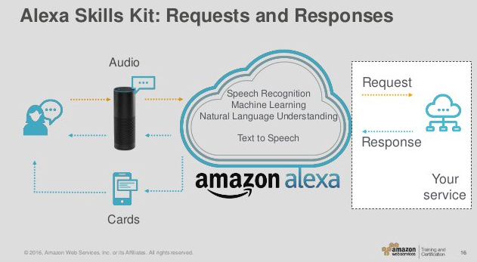

Echo speaker (or Amazon Echo) is a speaker device used by a user to speak to Amazon personal and intelligent assistant Alexa to pass instructions for a task. These devices are available in many models and activate by a very specific wake word. These devices are manufactured with pre-configured wake word/s.

The wake word activates an echo device to listen to user’s instructions. These could be usually pronounced as Alexa, Echo or Computer.

This is a keyword which requires to prompt particular Alexa skills. All custom skills must require an invocation name to get start the interaction. A developer can change invocation name during the development of skill but once skill gets certified and published then invocation name can’t be changed further. Use of invocation name abides by Alexa policies available under “Policy testing for Alexa skills”. For example, invocation name must not violate against intellectual property rights of a person or an organization as entity etc. Invocation name could be well associated with a question, command or action. Below is an example of invocation name in a sentence.

“Hey, Alexa can you browse the website CarmelSolutions.net”

“Alexa” is wake word in this instruction.

“Website” is the invocation name here.

As a policy. invocation name could only be of one word if it must relate to a brand or intellectual property. The good invocation name should be a compound of two or more words but there are more conditions around it, depending upon a language skill like German.

An utterance is what user wants Alexa to execute. In the above example, “CarmelSolution.net” is utterance. Utterances are nothing but the phrases what users use while giving instruction to Alexa. The response from Alexa is decided and based upon the identified utterance requested by the user.

NLP refers to Natural Language Processing in the technology world and a subset of Artificial Intelligence. It is responsible for interactions between humans and computerized devices. This drives a complex task of analyzing and processing natural language, used by humans, to be understood by computers. This enables computers to understand, analyze, process and respond back to humans in accordance with natural language. This makes the way possible for a man and machine communication in the form of text or speech and of course many more.

NLU stands for Natural Language Understanding, is a subset of NLP and could be termed as the first step in interpreting human natural language. This does also come under the umbrella of Artificial Intelligence. Understanding human natural language (many languages in this world) by a computational algorithm is a daunting task. A language could be native to a person and what makes it even more difficult is the formation of a sentence. This is because of the fact that the same sentence can be formed by many combinations and permutations of words, which complete a sentence in any order. Either it’s a speech or text formation. Here, computational power comes into play to decode meaningful words of a sentence and then pass it to further processing logic (NLP) so as to respond back to the user with most appropriate response against the request made by the user. This requires scaling of servers, which is done by the most possible way of cloud computing and Amazon carries that capability. NLU plays another major role by deeply understanding the context of a sentence and identifies that what is a verb, noun or tense used in a sentence. This process is known as “Part of Speech Tagging” (POS).

Deep learning is a subset of machine learning. Deep learning is a training process which caters to the acoustic model. This is accomplished by close observation on how audio and transcripts are paired. Deep learning can be well compared with, how the human brain works. As the human brain has neurons, which helps the brain to take the decision. Similarly, deep learning works with the web of artificial neural networks. The data to be processed is of huge amount and unstructured, so Deep Learning being a subset of Machine Learning, helps machines to process data in a non-linear way. Deep Learning is a continuous process, which is getting evolved day by day and many companies invested into research of this area.