**Assignment Task-1**

**1)What are the various industry domains that exist?**

Enterprise Software is a collection of computer programs that have common business applications, tools for modeling how the entire organization works, and development tools for building applications unique to the organization.

It is used to satisfy particular needs of an organization. The organizations may be businesses, schools, government organizations etc. Services provided by enterprise software are typically business-oriented tools, such as online shopping, and [online payment](https://en.wikipedia.org/wiki/Online_payment) processing, interactive product catalogue, automated billing systems, security, [Business Process Management](https://en.wikipedia.org/wiki/Business_process_management), [enterprise content management](https://en.wikipedia.org/wiki/Enterprise_content_management), [IT Service Management](https://en.wikipedia.org/wiki/IT_Service_Management), [customer relationship management](https://en.wikipedia.org/wiki/Customer_relationship_management), [enterprise resource planning](https://en.wikipedia.org/wiki/Enterprise_resource_planning), [business intelligence](https://en.wikipedia.org/wiki/Business_intelligence), [project management](https://en.wikipedia.org/wiki/Project_management), [collaboration](https://en.wikipedia.org/wiki/Collaboration), [human resource management](https://en.wikipedia.org/wiki/Human_resource_management), manufacturing, [occupational health and safety](https://en.wikipedia.org/wiki/Occupational_safety_and_health), [enterprise application integration](https://en.wikipedia.org/wiki/Enterprise_application_integration), and [enterprise forms automation](https://en.wikipedia.org/wiki/Enterprise_forms_automation).

Various Industries where there is Scope of IT Industry

1. Manufacturing
2. Banking and Investments
3. Transportation
4. Pharmacutical
5. Sales and Marketing
6. Education
7. Health Care

**2)Discuss and find the scope of the IT industry in the industry domains mentioned in question 1.**

1. Manufacturing

A manufacturing business is devoted to the production of tangible objects that are high in quality and competitive in cost, meet customers' expectations for performance, and are delivered in a timely manner.

An enormous amount of information is generated and used during the design, manufacture, and use of a product to satisfy customer needs and to meet environmental requirements. Thus it is reasonable to suppose that the use of information technology can enable substantial improvements in the operation, organization, and effectiveness of information-intensive manufacturing processes and activities, largely by facilitating their integration. Equipment and stations within factories, entire manufacturing enterprises, and networks of suppliers, partners, and customers located throughout the world can be more effectively connected and integrated through the use of information technology.

1. Banking and Investment

Information Technology enables sophisticated product development, better market infrastructure, implementation of reliable techniques for control of risks and helps the financial intermediaries to reach geographically distant and diversified markets. Internet has significantly influenced delivery channels of the banks. Internet has emerged as an important medium for delivery of banking products and services.

The customers can view the accounts; get account statements, transfer funds and purchase drafts by just punching on few keys. The smart card’s i.e., cards with micro processor chip have added new dimension to the scenario. An introduction of ‘Cyber Cash’ the exchange of cash takes place entirely through ‘Cyber-books’. Collection of Electricity bills and telephone bills has become easy. The upgradeability and flexibility of internet technology after unprecedented opportunities for the banks to reach out to its customers.

1. Transportation

Self-driving automobiles are already here. They’re still undergoing the earliest stages of development and testing, but they’re already present on our nation’s roadways. Many consumers already own smart vehicles.

GPS units are much more versatile. Not only do they fulfill the basic functionality of planning a trip, but they can make adjustments for extreme weather, traffic conditions or even your preferred route. Similarly there are many scope in Transportaion industry.

1. Pharmaceutical

In the pharmaceutical industry, intelligent technology usage scenarios can be divided into two main categories: Drug R&D and Drug Market. In the field of Drug R&D, AI is used primarily in drug discovery tasks such as lead compounds discovery, target screening, etc. AI’s role is more diverse in the Drug Market, which includes medical robots, pharmaceutical logistics, pharmacy automation, drug compliance and so forth.

1. Sales and Advertising

Websites have become business necessities when it comes to marketing products. The medium allows for plenty of room to share product details, reviews, photos and videos that engage potential customers. Announcements often go out through online services and media stories, while blog posts and word of mouth can drive traffic to a website. Businesses not only can announce products, but also can sell them directly to customers all over the world. That reach stretches far beyond what a local newspaper ad can achieve.

1. Education

Information technology makes it easy to access academic information at any time. Both students and teachers use Information technology to acquire and exchange educational material. ... Also teachers can assign tasks to students via electronic email or campus educational forums.

1. Health Care

Health information technology (HIT) is information technology applied to health and health care. It supports health information management across computerized systems and the secure exchange of health information between consumers, providers, payers, and quality monitors. ... reduce health care costs.

**3)What are the different products available in Microsoft?**

The different products available in Microsoft are

|  |  |  |  |
| --- | --- | --- | --- |
| **Windows**  Windows 10  Windows 8.1  Windows RT 8.1  Internet Explorer  **Office**  Office for home  Office 365 for business  Outlook  OneDrive  Word  Excel  PowerPoint  OneNote  Microsoft Teams  Access  Publisher  Office for iPhone and iPad  Office for Android  Outlook 2016 for Mac | **Business**  Microsoft Azure  Microsoft Intune  Microsoft Dynamics AX  Microsoft Dynamics CRM  Microsoft Dynamics GP  Other Microsoft Dynamics Business Solutions  Microsoft Partner Center Support  Power BI  Devices & more  Surface  Xbox  Microsoft mouse, keyboards, LifeChat, LifeCam & more  Mobile devices | **Developer & IT**  Windows SDK and app development  Visual Studio  Microsoft .NET Framework  Hardware development  Microsoft Exchange Server  Microsoft SQL Server  Microsoft SharePoint Server  System Center | **Apps**  Microsoft Edge  Microsoft Edge for iOS and Android  Skype  Microsoft account  Microsoft Store |

**4)Who else is offering the boutique solutions?**

Boutique software development company is firm that provides clients with software products and services tailored to their specific business needs. It is not a very large company that, however, has experience and expertise enough to implement projects of varying levels of complexity.

Boutique software development companies are industry-focused and strive to build strong, full of trust relations with their clients. They are flexible and support full transparency. Clients of boutique software development companies generally know all project team members personally.

I work for a boutique software development company SumatoSoft, which has a proven track record of building top-notch custom software solutions for its multiple clients.

The firm specializes in Ruby on Rails development and building high-end IoT solutions for a number of business domains.

**5)What could be the process in procuring the commodity?**

**Procurement** is the process of finding and agreeing to terms, and acquiring goods, services, or works from an external source. It is used to ensure the buyer receives goods, services, or works at the best possible price when aspects such as quality, quantity, time, and location are compared.

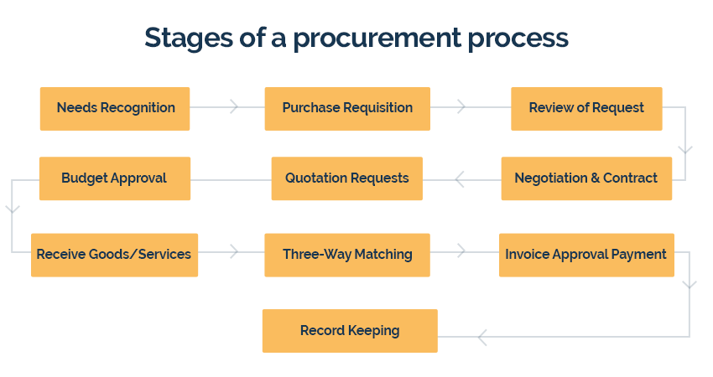

**Needs Recognition**

The preliminary step in a procurement process is recognizing the need for a product. Be it a brand new order or a recurring purchase, needs are analyzed and the availability is double-checked before creating a request for purchase.

**Purchase Requisition**

Typically, a procurement process starts with a [purchase requisition](https://kissflow.com/procurement-process/purchase-requisition/). The requester sends a request for procurement (paper form, electronic, or phone) to the purchasing department.

**Review of Request**

The purchase request is then reviewed by the procurement/finance team. Approved requests become POs, while rejected requests are sent back to the requester with the reason for rejection. All these can be handled with a simple [purchase order app](https://kissflow.com/procurement-process/purchase-order-app/)

**Budget Approval**

In enterprises, once the procurement team raises a PO, it is forwarded to the accounting department to receive budget approval.

**Quotation Requests**

Once the budget is approved, the procurement team forwards several requests for quotation (RFQ) to vendors with the intention to receive and compare bids to shortlist the perfect vendor.

**Negotiation & Contract**

Once a vendor is selected, the contract negotiation and signing are completed, and the purchase order is then forwarded to the vendor. A legally binding contract activates right after a vendor accepts a PO and acknowledges it.

**Receive Goods/Services**

The vendor delivers the promised goods/services within the stipulated timeline. After receiving them, the purchaser examines the order and notifies the vendor of any issues with the received items.

**Three-Way Matching**

At this step, three documents purchase orders, packaging slips (that arrive with the order), and vendor invoices are lined up and reconciled to pinpoint discrepancies and ensure that the transaction is accurate. Discrepancies should be addressed once they are discovered.

**Invoice Approval Payment**

Once three-way matching is complete, the invoice is approved and forwarded to payment processing depending on organizational norms.

**Record Keeping**

After the payment process, buyers make a record of it for bookkeeping and auditing. All appropriate documents right from purchase requests to approved invoices are stored in a centralized location.

**Procurement Process in Hospitality Industry**

The hospitality industry includes lodging, food and drink service, event planning, theme parks, transportation, cruise line, traveling and additional fields within the tourism industry.

**Purchasing Goods and Services**

The purchasing of goods and services for hotels, resorts, spas, cruise lines, and establishments of this nature. Often even industry professionals confuse procurement with purchasing. The purchasing process has to do with ordering the goods once vendors have been put in place by the procurement department.

**Making the Difference**

In procurement, responsibilities such as discovering sources for materials, contract negotiation, payment terms, and end of life management when appropriate are fundamental to the job.

**Sourcing**

Sourcing has to do with identifying suitable vendors for the various products and services necessary to your business. Once chosen, requests for quotes and proposals must be issued, manufacturing plants must be inspected, issues of quality must be discussed, and focus must be placed on longevity and replacement policies.

**Measuring up to Expectation**

As a chosen source for so many establishments in the hospitality industry, our role is to measure up to expectation so that guests are never disappointed by quality or the lack of availability of a specific product. In our case this means that every one of our luxury bathrobes, towels, and other spa accessories are manufactured with the utmost in quality control. It also means that our deliveries are accomplished in a timely fashion so that you are never left waiting for an order to arrive.

**Contract Negotiation**

Contract Negotiation is the focus of long-term contracts, which are part and parcel of creating good relationships with your vendors, as well as assuring reliability.

**Finding the Best Solutions**

The procurement department of your establishment acts as the between your hotel or spa and your vendors. Finding the best solutions for your needs is inherent in the job, where assuring the availability of products and services becomes the basis for keeping the business running at the highest and most efficient level.

**Costs**

The costs of running the procurement division of your facility are generally reported to your financial controller, which in turn is a part of the finance department. Elements such as salaries, benefits, bonuses, costs of supplies used, your electronic purchasing system, and more are another aspect of inventory and receiving that is important to be aware of when procuring the necessities.

**6)Create an imaginary company. As the head of the Procurement department of that company, write down the things that you do.**

Here I have taken the example of Hotel Management Company. And Different Fields in Hospitality Industry that needs to be maintained**.**

* Amenities
* Bed, Bath and Table Linens
* Commercial Laundry
* Fitness Equipment and Supplies
* Engineering and Facilities Maintenance Supplies
* Extended Stay
* Food and Beverage
* Kitchen Equipment
* Guest Room Amenities
* Housekeeping and Cleaning Products
* Linens and Bedding
* Office Supplies and Equipment
* Paper Products
* Signs and Print Solutions
* Small Appliances
* Trash Receptacles and Liners
* Uniforms

Other Aspects that add value to the hospitality business

* Well-designed app
* simple and easy-to-use app for booking
* speed and reliability in finding hotels, bars, theatres
* personalized room features
* Holiday packages & discounts
* Discount membership program
* community and entertainment services
* Amenities