**Enterprise Software**

Enterprise Software is a collection of computer programs that have common business applications, tools for modeling how the entire organization works, and development tools for building applications unique to the organization.

It is used to satisfy particular needs of an organization. The organizations may be businesses, schools, government organizations etc. Services provided by enterprise software are typically business-oriented tools, such as online shopping, and [online payment](https://en.wikipedia.org/wiki/Online_payment) processing, interactive product catalogue, automated billing systems, security, [Business Process Management](https://en.wikipedia.org/wiki/Business_process_management), [enterprise content management](https://en.wikipedia.org/wiki/Enterprise_content_management), [IT Service Management](https://en.wikipedia.org/wiki/IT_Service_Management), [customer relationship management](https://en.wikipedia.org/wiki/Customer_relationship_management), [enterprise resource planning](https://en.wikipedia.org/wiki/Enterprise_resource_planning), [business intelligence](https://en.wikipedia.org/wiki/Business_intelligence), [project management](https://en.wikipedia.org/wiki/Project_management), [collaboration](https://en.wikipedia.org/wiki/Collaboration), [human resource management](https://en.wikipedia.org/wiki/Human_resource_management), manufacturing, [occupational health and safety](https://en.wikipedia.org/wiki/Occupational_safety_and_health), [enterprise application integration](https://en.wikipedia.org/wiki/Enterprise_application_integration), and [enterprise forms automation](https://en.wikipedia.org/wiki/Enterprise_forms_automation).

**Various Industries where there is Scope of IT Industry**

1. Manufacturing
2. Real Estate
3. Banking and Investment
4. Telecommunication
5. Transportation
6. Pharmaceutical
7. Sales and Advertising
8. Education
9. Health Care
10. Hospitality

**Procurement**

**Procurement** is the process of finding and agreeing to terms, and acquiring goods, services, or works from an external source. It is used to ensure the buyer receives goods, services, or works at the best possible price when aspects such as quality, quantity, time, and location are compared.

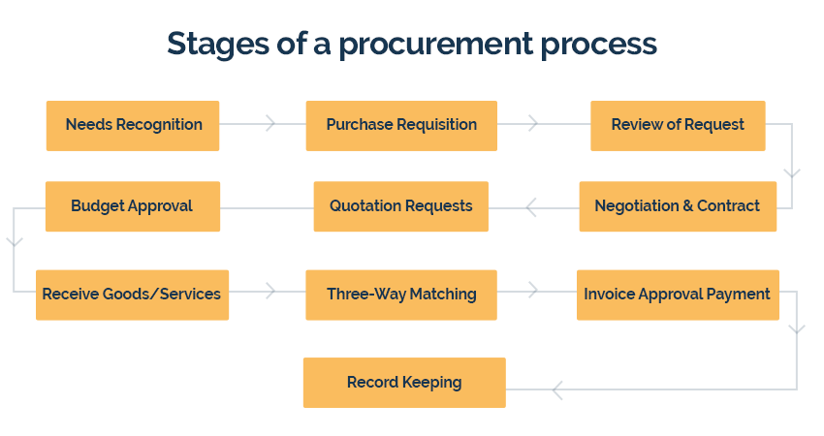

**Needs Recognition**

The preliminary step in a procurement process is recognizing the need for a product. Be it a brand new order or a recurring purchase, needs are analyzed and the availability is double-checked before creating a request for purchase.

**Purchase Requisition**

Typically, a procurement process starts with a [purchase requisition](https://kissflow.com/procurement-process/purchase-requisition/). The requester sends a request for procurement (paper form, electronic, or phone) to the purchasing department.

**Review of Request**

The purchase request is then reviewed by the procurement/finance team. Approved requests become POs, while rejected requests are sent back to the requester with the reason for rejection. All these can be handled with a simple [purchase order app](https://kissflow.com/procurement-process/purchase-order-app/)

**Budget Approval**

In enterprises, once the procurement team raises a PO, it is forwarded to the accounting department to receive budget approval.

**Quotation Requests**

Once the budget is approved, the procurement team forwards several requests for quotation (RFQ) to vendors with the intention to receive and compare bids to shortlist the perfect vendor.

**Negotiation & Contract**

Once a vendor is selected, the contract negotiation and signing are completed, and the purchase order is then forwarded to the vendor. A legally binding contract activates right after a vendor accepts a PO and acknowledges it.

**Receive Goods/Services**

The vendor delivers the promised goods/services within the stipulated timeline. After receiving them, the purchaser examines the order and notifies the vendor of any issues with the received items.

**Three-Way Matching**

At this step, three documents purchase orders, packaging slips (that arrive with the order), and vendor invoices are lined up and reconciled to pinpoint discrepancies and ensure that the transaction is accurate. Discrepancies should be addressed once they are discovered.

**Invoice Approval Payment**

Once three-way matching is complete, the invoice is approved and forwarded to payment processing depending on organizational norms.

**Record Keeping**

After the payment process, buyers make a record of it for bookkeeping and auditing. All appropriate documents right from purchase requests to approved invoices are stored in a centralized location.

**Procurement Process in Hospitality Industry**

The hospitality industry includes lodging, food and drink service, event planning, theme parks, transportation, cruise line, traveling and additional fields within the tourism industry.

**Purchasing Goods and Services**

The purchasing of goods and services for hotels, resorts, spas, cruise lines, and establishments of this nature. Often even industry professionals confuse procurement with purchasing. The purchasing process has to do with ordering the goods once vendors have been put in place by the procurement department.

**Making the Difference**

In procurement, responsibilities such as discovering sources for materials, contract negotiation, payment terms, and end of life management when appropriate are fundamental to the job.

**Sourcing**

Sourcing has to do with identifying suitable vendors for the various products and services necessary to your business. Once chosen, requests for quotes and proposals must be issued, manufacturing plants must be inspected, issues of quality must be discussed, and focus must be placed on longevity and replacement policies.

**Measuring up to Expectation**

As a chosen source for so many establishments in the hospitality industry, our role is to measure up to expectation so that guests are never disappointed by quality or the lack of availability of a specific product. In our case this means that every one of our luxury bathrobes, towels, and other spa accessories are manufactured with the utmost in quality control. It also means that our deliveries are accomplished in a timely fashion so that you are never left waiting for an order to arrive.

**Contract Negotiation**

Contract Negotiation is the focus of long-term contracts, which are part and parcel of creating good relationships with your vendors, as well as assuring reliability.

**Finding the Best Solutions**

The procurement department of your establishment acts as the between your hotel or spa and your vendors. Finding the best solutions for your needs is inherent in the job, where assuring the availability of products and services becomes the basis for keeping the business running at the highest and most efficient level.

**Costs**

The costs of running the procurement division of your facility are generally reported to your financial controller, which in turn is a part of the finance department. Elements such as salaries, benefits, bonuses, costs of supplies used, your electronic purchasing system, and more are another aspect of inventory and receiving that is important to be aware of when procuring the necessities.

**Different Fields in Hospitality Industry that needs to be maintained.**

* Amenities
* Bed, Bath and Table Linens
* Commercial Laundry
* Fitness Equipment and Supplies
* Engineering and Facilities Maintenance Supplies
* Extended Stay
* Food and Beverage
* Kitchen Equipment
* Guest Room Amenities
* Housekeeping and Cleaning Products
* Linens and Bedding
* Office Supplies and Equipment
* Paper Products
* Signs and Print Solutions
* Small Appliances
* Trash Receptacles and Liners
* Uniforms

**Other Aspects that add value to the hospitality business**

* Well-designed app
* simple and easy-to-use app for booking
* speed and reliability in finding hotels, bars, theatres
* personalized room features
* Holiday packages & discounts
* Discount membership program
* community and entertainment services
* Amenities