CHAPTER 1
INTRODUCTION
1.1 Background
Maternal health is an important part of healthcare, as the health of a mother during pregnancy directly affects both the mother and the developing fetus. Pregnancy involves many physical and physiological changes, and certain conditions such as high blood pressure, abnormal blood sugar levels, anaemia, increased heart rate, and other complications can increase the risk during pregnancy. Early identification of these conditions can help in providing timely medical attention and reducing the possibility of serious complications. Traditionally, pregnancy risk assessment is performed through regular medical examinations, laboratory tests, medical history, and monitoring of different health parameters. Although these methods are important, analysing multiple health parameters manually can be time-consuming.
With the development of Artificial Intelligence (AI) and Machine Learning (ML), healthcare data can be analysed more efficiently to identify patterns and predict possible health risks. The proposed AI Predictive System for Maternal Health and Pregnancy Risk is designed to analyze important maternal and fetal health parameters and provide a preliminary prediction of pregnancy risk. The system can classify pregnancy risk into Low, Medium, or High and can also provide fetal health status as Normal, Suspect, or Critical based on the available fetal health information.
1.2 Motivation
Pregnancy requires continuous monitoring because health conditions can change during +different stages of pregnancy. Some complications may not be easily noticed at an early stage, making regular monitoring and timely medical consultation important. The need to analyze several health parameters together create an opportunity for using AI and machine learning techniques. The main motivation of this project is to develop a smart and user-friendly system that can provide early awareness of possible pregnancy risks. By analyzing health-related information using machine learning models, the system can identify patterns and provide a risk prediction based on the available data.
Another motivation is to make the prediction process simple for users. Instead of requiring users to understand complex medical or machine learning outputs, the system presents the
result in clear categories such as Low, Medium, or High risk. The system can also provide basic recommendations related to healthy diet, safe activities, monitoring, and the need for medical consultation.
1.3 Objectives of the Project
- To develop an AI-based system for the preliminary prediction of pregnancy-related health risks.
- To analyze important maternal health parameters such as age, blood pressure, blood sugar, heart rate, BMI, haemoglobin, and other relevant factors.
- To use machine learning algorithms such as Logistic Regression, Decision Tree, and Random Forest for predicting pregnancy risk.
- To classify pregnancy risk into Low, Medium, and High categories.
- To assess fetal health using relevant fetal parameters and classify the condition as Normal, Suspect, or Critical, where applicable.
- To provide a simple and user-friendly interface using React JS and CSS for entering health information and viewing prediction results.
- To develop a backend using Python and FastAPI for data processing, prediction, and communication between the frontend and machine learning models.
- To implement JWT authentication to provide secure access to the application.
- To provide basic health recommendations based on the predicted risk category.
- To encourage timely consultation with healthcare professionals when the system indicates a potentially higher level of risk.
1.4 Scope of the Project
- Maternal Health Assessment: The system analyses selected maternal parameters such as age, blood pressure, blood sugar, heart rate, BMI, haemoglobin, and other relevant health information.
- Pregnancy Risk Prediction: The system predicts the pregnancy risk level as Low, Medium, or High based on the provided health information.
- Fetal Health Assessment: Where suitable fetal health data is available, the system can provide an indication of fetal health as Normal, Suspect, or Critical.
- Machine Learning: Machine learning algorithms are used to identify patterns in healthcare data and generate predictions.
- Web Application: React JS and CSS are used to provide an interactive and user-friendly interface.
- Backend Processing: Python and FastAPI are used to handle data processing, API requests, and communication with the machine learning models.
- Authentication: JWT authentication is used to provide secure access to the application and protect user information.
- Health Recommendations: The system can provide general recommendations related to diet, safe physical activities, health monitoring, and medical follow-up based on the predicted risk.
1.5 Significance of the Study
The proposed system is significant because it demonstrates how Artificial Intelligence and Machine Learning can be used to support maternal healthcare and pregnancy monitoring. Early identification of possible risks can increase awareness and encourage users to seek professional medical attention when required. For pregnant women, the system can provide a simple way to understand their predicted risk level based on the information they provide. This can encourage better awareness of important health parameters and the importance of regular medical monitoring.
The project is also significant from a technical and academic perspective because it integrates artificial intelligence, machine learning, web development, backend APIs, and authentication into a single healthcare application. The combination of Python, FastAPI, React JS, CSS, JWT authentication, and ML models demonstrate the development of a complete full-stack intelligent system.
Overall, the study highlights the potential of AI-based predictive systems in healthcare. Although the system cannot replace professional medical diagnosis, it can serve as an early-warning and awareness tool that supports better monitoring and encourages timely medical consultation.
CHAPTER 2
LITERATURE REVIEW
2.1 Introduction
Maternal and fetal healthcare is an important area of medical care that requires regular monitoring, accurate assessment, and timely identification of potential complications during pregnancy. Pregnancy involves several physiological and hormonal changes in the mother's body, and these changes may affect both maternal health and fetal development. Factors such as maternal age, blood pressure, blood glucose level, heart rate, body temperature, and previous medical conditions may be relevant to pregnancy-related health assessment. Similarly, fetal health monitoring involves the analysis of fetal heart rate and other measurements obtained through clinical monitoring techniques.
Traditional pregnancy assessment relies on medical history, physical examinations, laboratory investigations, antenatal check-ups, and the interpretation of clinical measurements by qualified healthcare professionals. These practices remain essential for safe pregnancy management. However, the increasing availability of digital healthcare data has created opportunities to use computational techniques to assist in analyzing health information and identifying patterns that may be difficult to recognize through simple manual analysis.
Artificial Intelligence (AI) and Machine Learning (ML) have gained importance in healthcare because they can learn patterns from previously collected data and use those patterns to classify new observations. In maternal healthcare, machine learning algorithms have been investigated for pregnancy-risk classification, while fetal-health research has explored the use of cardiotocography (CTG) measurements to classify fetal conditions. Research has examined methods such as Logistic Regression, Decision Trees, Random Forest, Support Vector Machines, and neural networks for these tasks.
2.2 Overview of Maternal and Fetal Health Prediction
2.2.1 Artificial Intelligence in Healthcare
Artificial Intelligence refers to computational techniques that perform tasks requiring capabilities such as pattern recognition, classification, and decision support. Machine Learning
is a branch of AI in which a model learns relationships from data rather than relying exclusively on manually specified rules.
In healthcare applications, machine learning can be used to analyze patient measurements, identify patterns associated with different health categories, and estimate the category associated with a new observation. The quality of these predictions depends on the data used, the selected algorithm, the preprocessing method, and the way the model is evaluated.
A typical machine learning-based healthcare prediction process includes collecting relevant data, checking its quality, preparing the input features, training a model using labelled examples, evaluating the model on data not used for training, and integrating the trained model into an application
2.2.2 Maternal Pregnancy-Risk Prediction
Maternal pregnancy-risk prediction focuses on estimating a risk category from relevant information about the mother. Depending on the dataset and the intended prediction task, the input features may include age, systolic and diastolic blood pressure, blood glucose, body temperature, heart rate, or other recorded clinical measurements.
The model learns patterns between these input variables and the risk labels available in the training dataset. A classification model may produce categories such as Low Risk, Medium Risk, and High Risk when these are the target labels used by the dataset.
Different machine learning algorithms can be considered for this task. Logistic Regression provides a relatively simple classification approach, Decision Trees represent decisions through branching rules, and Random Forest combines predictions from multiple decision trees. The appropriate model must be selected by comparing its measured performance on suitable evaluation data rather than assuming that one algorithm is always the best.
2.2.3 Machine Learning Algorithms Used in Healthcare Prediction
The following algorithms are relevant to the development and evaluation of classification systems.
Logistic Regression: Logistic Regression is a supervised learning algorithm commonly used for classification. It estimates the probability of an observation belonging to a class based on a combination of input features. It can provide a useful baseline for comparing more complex algorithms.
Decision Tree: A Decision Tree classifies observations through a series of feature-based decisions. Its branching structure can make the model easier to explain than some other methods, although a tree that is too complex may overfit the training data.
Random Forest: Random Forest combines the predictions of multiple decision trees. This ensemble approach can improve generalization compared with an individual tree, depending on the dataset and model configuration.
Neural Networks: Neural networks learn relationships through interconnected computational units. They can model complex patterns but may require careful tuning, sufficient training data, and appropriate evaluation.
Table 2.1 — Overview of Machine Learning Algorithms
Algorithm | Main principle | Potential advantage | Important limitation
Logistic Regression | Estimates class probabilities using a statistical model | Relatively simple baseline | May not capture complex nonlinear relationships
Decision Tree | Uses a sequence of feature-based decisions | Easy to visualize and explain | May overfit the training data
Random Forest | Combines multiple decision trees | Can improve generalization | Less straightforward to interpret than one tree
Support Vector Machine | Separates classes using a decision boundary | Useful for structured classification tasks | Requires appropriate feature scaling and parameter selection
Neural Network | Learns patterns through interconnected computational units | Can model complex relationships | Requires careful training and validation

2.2.4 Datasets Used for Maternal Health Prediction
The performance of a machine learning model depends substantially on the dataset used for its development and evaluation. Healthcare datasets contain recorded observations and corresponding labels that allow a model to learn patterns associated with particular classes.
Two different dataset types are relevant to the project.
Maternal Health Risk Dataset: A commonly used maternal health risk dataset contains 1,014 records with six input variables: age, systolic blood pressure, diastolic blood pressure, blood sugar, body temperature, and heart rate. Its target variable contains Low Risk, Mid Risk, and High-Risk categories. This dataset has been used in published research on maternal health risk classification.
Table 2.2 — Overview of Relevant Healthcare Datasets
Feature | Maternal Health Risk Dataset
Main purpose | Maternal pregnancy-risk classification
Number of records | 1014
Input variables | 6
Example inputs | Age, blood pressure, blood sugar, temperature, heart rate
Target variable | Risk Level
Target categories | Low, Mid, High
Source | UCI-associated maternal health risk dataset

2.2.5 Importance of Data Preprocessing and Model Evaluation
Data preprocessing is an important stage in machine learning because raw data may contain missing values, inconsistent formats, outliers, or features represented on different scales. These issues may affect the model's ability to learn meaningful patterns. Depending on the dataset and algorithm, preprocessing may involve checking data types, handling missing values, identifying unusual observations, encoding categorical labels, and scaling numerical features.
The dataset should be divided into training and testing subsets using a suitable procedure. The training subset is used to fit the model, while the testing subset provides an estimate of performance on observations that were not used during training. Where appropriate, a separate validation process or cross-validation may be used for model selection and hyperparameter tuning.
Model evaluation should consider more than overall accuracy. Precision indicates how often predictions of a particular class are correct, while recall indicates how many actual instances of that class are identified. The F1-score combines precision and recall into a single measure. A confusion matrix helps identify which classes are being confused by the model.
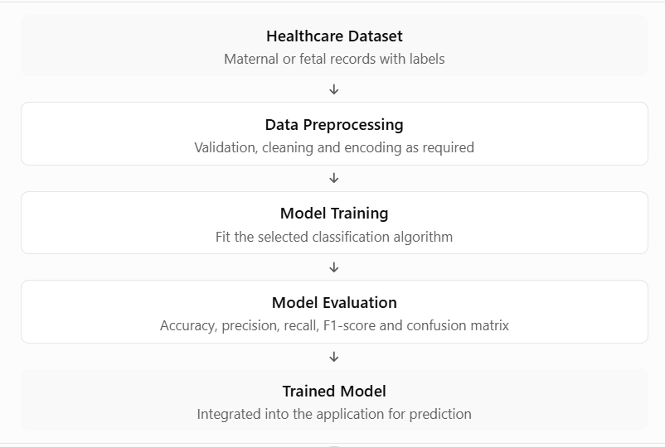
Figure 2.1: General Machine Learning Workflow for Healthcare Prediction
2.3 Literature Survey
The literature survey is important because it connects the project's design decisions with existing research. It also helps distinguish the task of developing a predictive model from the broader task of integrating a model into an accessible application.
2.3.1 Research on Maternal Health Risk Classification
Togunwa and colleagues (2023) presented a study titled Deep hybrid model for maternal health risk classification in pregnancy: synergy of ANN and random forest. The study investigated a hybrid approach combining an artificial neural network and Random Forest for maternal risk classification. It used the maternal health risk dataset containing 1,014 records and six predictive features. The authors reported test-set accuracy of 95% for their proposed hybrid model. The paper also identified generalization to other populations and evaluation in clinical settings as areas for further research.
The study demonstrates the potential of combining machine learning methods for maternal risk classification. However, its reported performance belongs to the authors' experimental setup and should not be assumed to represent the performance of a different model or dataset.
Pavagada and Vemuri (2025), in Prediction of Maternal Health Risk Factors Using Machine Learning Algorithms, investigated the prediction of low-, medium-, and high-risk categories using a dataset of 1,014 instances and six health metrics. The study evaluated several approaches, including ensemble methods, k-nearest neighbours, and neural networks. The authors reported that the Ensemble Bagged Trees method achieved 84.12% accuracy in their experiments.
The findings illustrate that different algorithms may produce different performance levels even when applied to a similar classification problem. They also support the importance of evaluating candidate models rather than selecting an algorithm solely on its popularity.
A further study, Prediction of high-risk pregnancy based on machine learning algorithms, published in Scientific Reports in 2025, investigated machine learning for high-risk pregnancy prediction using maternal health risk data from 1,014 pregnant women. It explored the development of a predictive model intended to support maternal health management.
2.3.3 Research on Antenatal Care and Healthcare Decision Support
The World Health Organization's WHO Recommendations on Antenatal Care for a Positive Pregnancy Experience describes evidence-informed recommendations for routine antenatal care. The guidance covers maternal and fetal assessment, nutrition, preventive measures, and interventions intended to improve the quality of antenatal care.
This guidance provides an important context for technology-based pregnancy assessment. Predictive software should be designed to complement established antenatal care rather than replace routine examinations or professional judgement.
The reviewed research therefore provides two complementary perspectives: machine learning can be investigated for maternal and fetal classification, while a practical application must also consider how information is entered, processed, presented, and protected.
Table 2.3 — Literature Survey of Related Research
Study | Area and method | Main contribution | Limitation or relevance to this project
Togunwa et al. (2023) | Maternal risk classification using an ANN–Random Forest hybrid | Reported 95% test accuracy on the maternal risk dataset | The result is specific to the study's experiment; further generalization and clinical evaluation are needed
Pavagada and Vemuri (2025) | Maternal risk prediction using several ML algorithms | Reported 84.12% accuracy for Ensemble Bagged Trees | Performance depends on the dataset and evaluation setup
Pi et al. (2025) | High-risk pregnancy prediction using machine learning | Investigated predictive modelling for maternal risk management | Results should be interpreted within the study's data and validation setting
Enhancing Fetal Health Classification: A Study on Fetal Cardiotocograms (2025) | Fetal classification using ML and DL methods on CTG records | Investigated multiple approaches to fetal-state classification | Dataset-based classification does not by itself establish clinical deployment readiness
World Health Organization (2016) | Evidence-informed antenatal care recommendations | Provides clinical context for maternal and fetal assessment | It is a healthcare guideline, not a machine learning prediction study

2.4 Existing System
Existing approaches to maternal and fetal health assessment can be broadly divided into traditional clinical assessment, dataset-based machine learning models, and digital healthcare applications.
2.4.1 Traditional Clinical Assessment
Traditional pregnancy assessment involves antenatal consultations, medical history, physical examinations, laboratory investigations, and monitoring of relevant maternal and fetal parameters. Healthcare professionals interpret the collected information and determine whether additional investigations, monitoring, or treatment may be required.
However, the interpretation of multiple measurements over time requires careful clinical assessment, and access to regular antenatal services may vary between settings. Digital tools may help organize health information and perform preliminary computational analysis, but they cannot independently replace the examination and judgement of a qualified healthcare professional.
2.4.2 Machine Learning-Based Prediction Systems
Machine learning-based prediction systems use previously collected and labelled health data to train classification models. In maternal healthcare, these systems may analyze measurements such as age, blood pressure, blood glucose, body temperature, and heart rate to estimate a maternal risk category.
These systems can compare multiple algorithms and quantify their performance using metrics such as accuracy, precision, recall, and F1-score. However, the model's predictions depend on the dataset, preprocessing, selected features, and evaluation method. A model trained on one dataset may not perform equally well on a different population or under different clinical conditions.
2.4.3 Limitations of Existing Approaches
The literature review identifies several limitations that are relevant when designing a complete pregnancy-risk prediction application.
- Separate prediction tasks: Maternal risk classification and fetal health classification use different input features and target labels. A system that addresses only one task does not automatically provide the other assessment.
- Dependence on dataset quality: Inaccurate values, missing information, class imbalance, and limited representation of patient populations may affect prediction quality.
- Limited user-facing integration: A research model may be evaluated in a notebook or experimental environment without being integrated into an application that supports data entry and understandable results.
- Interpretation of results: Technical model outputs may not be easily understood by users without a clear explanation of the predicted category and the limitations of the prediction.
- Security and privacy considerations: Applications that handle health information must consider authentication, controlled access, and appropriate protection of sensitive data.
2.5 Proposed System
The proposed system, titled Predictive System for Fetal Health and Pregnancy Risk, is a web-based application that integrates machine learning prediction with a user interface and authentication mechanism. Its purpose is to demonstrate how data-driven classification can be incorporated into a structured application for preliminary maternal and fetal health-risk awareness.
The proposed system combines relevant elements of healthcare data processing, machine learning, backend API development, and frontend interaction. The design aims to provide an accessible interface through which users can enter the required information and view the resulting prediction.
2.5.1 Maternal Health-Risk Assessment
The maternal assessment component accepts the maternal health parameters required by the selected trained model. Depending on the dataset used, these may include age, systolic and diastolic blood pressure, blood glucose, body temperature, and heart rate.
The submitted values are passed to the backend, where the input is validated and prepared for the maternal prediction model. The model then generates a classification based on the patterns learned during training. If the model uses the Low, Medium, and High categories, the application presents the corresponding predicted category.
The output represents the model's classification and should not be interpreted as a definitive assessment of the pregnancy. The actual features and labels must match the maternal dataset used in the implementation.
2.5.2 Web-Based Application and Authentication
The frontend is developed using React.js and CSS to provide the user interface. It enables users to interact with the application through forms and result displays.
The backend is developed using Python and FastAPI. It receives requests from the frontend, validates the supplied data, communicates with the relevant prediction model, and returns the result to the interface.
JWT authentication is used to support controlled access to protected application features. The authentication mechanism and API access controls must be implemented appropriately to protect user information.
2.5.3 Expected Benefits of the Proposed System
The proposed system has several potential benefits as an academic software project.
- Integrated access: It brings the implemented prediction features together within a single web application.
- Structured input: It accepts defined parameters through forms rather than requiring users to interact directly with model code.
- Consistent processing: The backend can apply the preprocessing and prediction workflow required by the trained models.
- Understandable output: Predictions can be displayed as categories rather than raw numerical model outputs.
- Controlled access: Authentication can restrict access to protected features.
- Extensibility: The modular design can support future improvements to the models, interface, and other application components.
These benefits describe the intended software capabilities. Their effectiveness must be established through implementation testing and evaluation.
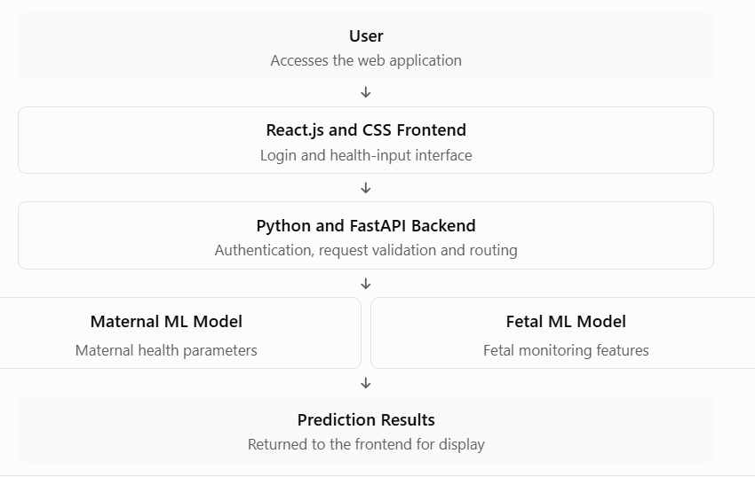
Figure 2.2 — Conceptual Workflow of the Proposed System
2.6 Comparison Between Existing and Proposed Systems
The existing approaches discussed in this chapter provide important foundations for pregnancy assessment and health prediction. Traditional clinical assessment relies on professional examination and interpretation, while research-oriented machine learning systems focus on learning patterns and evaluating predictive performance.
Table 2.4 — Comparison Between Existing and Proposed Systems
Feature | Traditional clinical assessment | Research-oriented ML model | Proposed system
Primary approach | Clinical examination and professional judgement | Data-driven prediction | Web-based application integrating ML
Maternal risk prediction | Based on clinical assessment | Available in maternal-risk models | Supported where the maternal model is implemented
Fetal health classification | Clinical fetal assessment and monitoring | Available in fetal classification models | Supported where the fetal model is implemented
User input interface | Clinical records and examination processes | May use datasets, scripts, or notebooks | Web forms developed using React.js and CSS
Prediction processing | Professional interpretation | Trained classification algorithm | Python backend and integrated ML model
Authentication | Depends on the healthcare setting | Depends on the research implementation | JWT authentication for protected features
Output presentation | Clinical interpretation and findings | Model output and evaluation results | Categorized prediction displayed in the interface
Integration | Part of clinical care workflows | May focus on a single model or task | Designed to combine application components
Evaluation | Clinical assessment and established procedures | Dataset-based model evaluation | Requires software testing and model evaluation
Limitations | Depends on clinical context and access to care | Depends on data and experimental design | Depends on model quality, implementation, and validation
2.7 Research Gap and Summary of Literature Review
    - Research Gap
The reviewed literature demonstrates that machine learning has been investigated for maternal health-risk classification and fetal-state prediction. Research has explored multiple algorithms and reported results using measures such as accuracy, precision, recall, and F1-score. However, research findings are specific to the datasets and experimental conditions under which they were obtained.
- Integration of prediction with a web interface: A trained model needs an application interface through which the required input can be submitted and the prediction displayed.
- Separation of maternal and fetal prediction tasks: The two assessments require appropriate input features and target labels rather than treating all health parameters as a single interchangeable dataset.
- Consistent input processing: Input validation and preprocessing should be aligned with the requirements of each trained model.
- Understandable results: The predicted category should be presented clearly, with suitable explanation of its limitations.
- Application-level access control: Protected features should use appropriate authentication and access control.
2.7.2 Summary of Literature Review
This chapter reviewed the use of Artificial Intelligence and Machine Learning in maternal pregnancy-risk prediction and fetal health classification. It described the general principles of healthcare classification, the role of common machine learning algorithms, the characteristics of relevant datasets, and the importance of preprocessing and model evaluation.
The literature survey discussed research on maternal risk classification and fetal-state prediction, showing that different algorithms have been explored for these tasks. It also emphasized that reported performance depends on the dataset, selected features, training procedure, and evaluation method.
The review of existing approaches identified important design considerations related to separate maternal and fetal prediction tasks, dataset quality, user interaction, authentication, result interpretation, and model validation. These considerations informed the proposed web-based system, which integrates a React.js frontend, a Python and FastAPI backend, JWT authentication, and the applicable trained machine learning models.
The chapter establishes the foundation for the next stage of the project. Chapter 3 describes the system analysis and design, including the architecture, modules, data flow, and prediction workflow.
CHAPTER 3
SYSTEM ANALYSIS AND DESIGN
3.1 Introduction
System analysis and design is an important phase in the development of the Predictive System for Fetal Health and Pregnancy Risk. It involves identifying the requirements of the system, understanding its major components, and designing the structure through which these components interact with one another.
The proposed system is a web-based healthcare application that uses Artificial Intelligence (AI) and Machine Learning (ML) techniques to perform preliminary maternal health-risk assessment and fetal health classification. The system accepts relevant health parameters from users, processes the information through a backend application, and uses trained machine-learning models to generate prediction results.
The system follows a modular architecture consisting of a user interface, authentication mechanism, backend API, data-processing component, machine-learning models, and result-presentation component. Each component performs a specific function, making the application easier to develop, test, maintain, and extend.
3.2 System Overview
The Predictive System for Fetal Health and Pregnancy Risk provides a platform for analyzing selected maternal and fetal health parameters. The system follows a client-server architecture in which the frontend collects user input and the backend processes the submitted information.
The process begins when a user registers or logs in to the application. After authentication, the user can access the available health-assessment features and enter the required information through the web interface.
For maternal health-risk prediction, the user may provide parameters such as age, systolic and diastolic blood pressure, blood sugar, body temperature, and heart rate, depending on the dataset used by the trained model. Additional parameters should be included only when they are supported by the selected model. For fetal health classification, the system processes the fetal health measurements required by the implemented model. These measurements depend on the fetal dataset and the features expected by the model.
Maternal risk results may be represented as Low, Medium, or High, while fetal health results may be represented as Normal, Suspect, or Critical, according to the classes supported by the respective model.
3.3 System Architecture
3.3.1 Presentation Layer
The presentation layer provides the interface through which users interact with the system. It is developed using React JS and CSS. The frontend includes the available pages and components for user registration, login, dashboard access, health-parameter entry, prediction results, and recommendations.
It collects user inputs and sends them to the backend through API requests. The interface is designed to present information clearly so that users can enter the required health parameters and understand the generated prediction without needing technical knowledge of machine learning.
3.3.2 Authentication Layer
The authentication layer manages access to protected application features. It supports user registration and login and uses JSON Web Token (JWT) authentication to verify requests from authenticated users. After successful login, an authentication token can be used when accessing protected backend endpoints.
The backend verifies the token before allowing access to the corresponding functionality. Authentication helps restrict unauthorized access. However, JWT alone does not provide complete data security; secure token handling, appropriate password protection, access control, and secure communication are also important.
3.3.3 Backend Processing Layer
The backend performs the following tasks:
- Receives prediction requests from the frontend.
- Validates the submitted information.
- Checks whether the required input features are present.
- Prepares the input in the format expected by the trained model.
- Calls the appropriate prediction function.
- Returns the prediction result to the frontend.
- Handles relevant authentication and API requests.
The backend separates application logic from the user interface. This makes it easier to maintain the application and update the prediction models independently of the frontend.
3.3.4 Machine-Learning Layer
The machine-learning layer performs the prediction task using trained models. It analyzes the supplied health parameters and classifies them according to patterns learned during model training. The project considers algorithms such as Logistic Regression, Decision Tree, and Random Forest. Their suitability depends on the dataset, preprocessing requirements, and evaluation results.
During prediction, the input data must be processed using the same preprocessing steps applied during model training. The model then returns a predicted class, which is passed back to the backend.
3.3.5 Result and Recommendation Layer
The result layer presents the model output in a format that is understandable to the user. For maternal health-risk assessment, the output may indicate Low, Medium, or High risk. For fetal health classification, the output may indicate Normal, Suspect, or Critical, depending on the model's actual class labels.
The application may provide general recommendations based on the displayed result. When a result indicates a possible high risk or concerning fetal-health classification, the interface should encourage prompt professional medical assessment rather than suggesting that the prediction is a confirmed diagnosis.
3.3.6 System Architecture Diagram
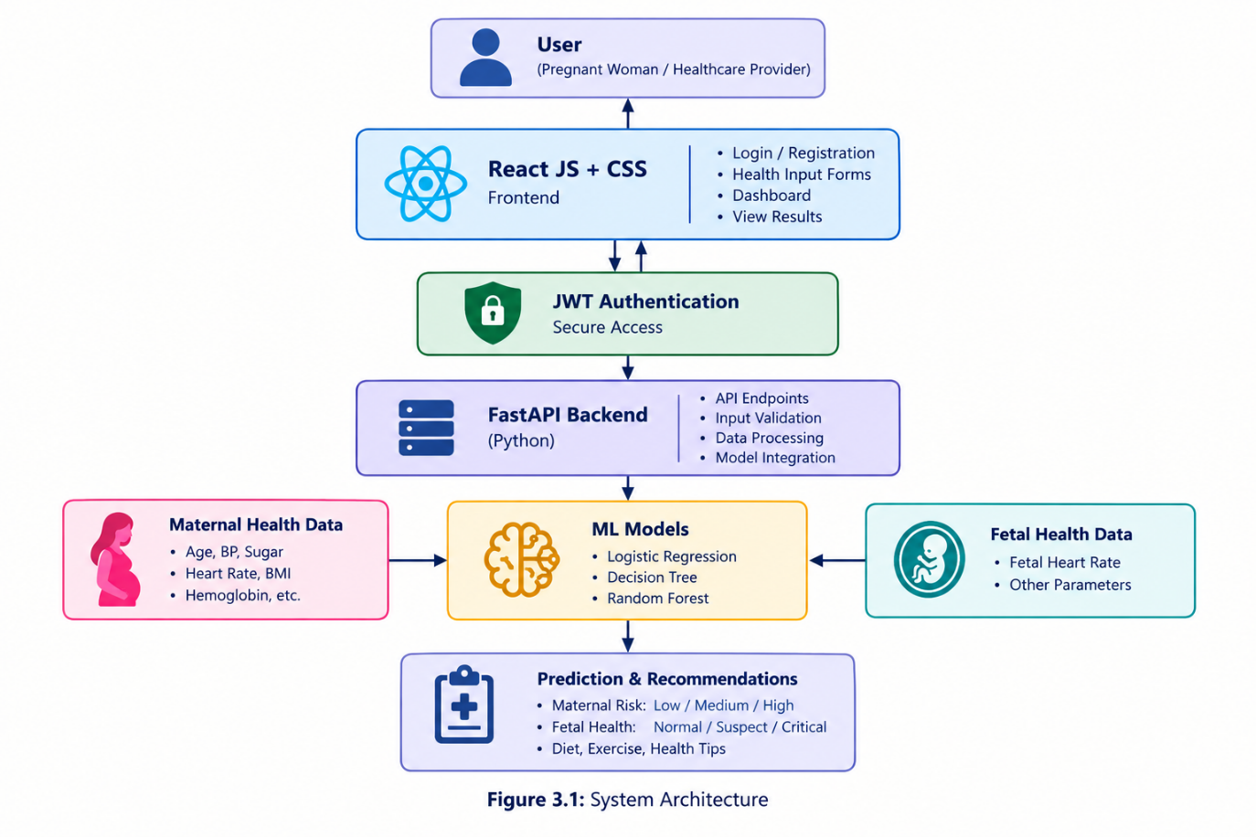
Figure 3.1: System Architecture of the Predictive System for Pregnancy Risk
3.4 Module Design
The proposed system is divided into functional modules. Each module has a specific responsibility and communicates with other modules through defined interfaces. This modular design supports easier development, testing, maintenance, and future improvement.
3.4.1 User Authentication Module
When a user submits login credentials, the backend verifies them. If the credentials are valid, the authentication process provides a token that can be used for authorized requests. Protected backend endpoints verify the token before allowing access.
This module helps prevent unauthorized access to restricted functionality. Sensitive health information should also be protected through suitable data-access controls and secure handling practices.
3.4.2 Maternal Health Assessment Module
Depending on the selected dataset and trained model, the input may include:
- Maternal age.
- Systolic blood pressure.
- Diastolic blood pressure.
- Blood sugar level.
- Body temperature.
- Heart rate.
Other parameters should be included only if they are part of the implemented model. The module checks that the required values have been entered in an acceptable format and sends the information to the backend.
The backend prepares the input for the maternal risk model and obtains the predicted risk category. The result is then returned to the frontend for display.
3.4.3 Machine-Learning Module
The machine-learning module is the core predictive component of the system. It uses trained classification models to analyze input features and generate predictions.
The project considers Logistic Regression, Decision Tree, and Random Forest as candidate algorithms. These models can be evaluated using appropriate training and testing data to determine their suitability for the relevant prediction task.
3.4.4 Backend API Module
The backend API module is implemented using Python and FastAPI. It receives requests from the frontend and coordinates the application’s processing activities.
Its main responsibilities include receiving user input, validating submitted data, communicating with the appropriate machine-learning model, and returning prediction results.
3.4.5 Result and Recommendation Module
The result and recommendation module presents prediction outputs and relevant general guidance.
The prediction category is displayed clearly so that users can understand the output without interpreting the underlying algorithm. General recommendations may include maintaining balanced nutrition, following activity appropriate to the pregnancy and individual circumstances, monitoring health parameters, and consulting a qualified healthcare professional.
3.4.6 Frontend Module
The frontend module is developed using React JS and CSS. It provides the pages and interactive components through which users access the application.
The frontend supports the available authentication pages, dashboard, maternal and fetal health input forms, prediction results, and recommendation displays. It sends requests to the backend and presents the returned responses to the user.
Table 3.1: Major Modules and Their Responsibilities
Module | Main Responsibility | Output
User Authentication | Registration, login, and access verification | Authorized access
Maternal Health Assessment | Collect and validate maternal health inputs | Maternal input data
Fetal Health Assessment | Collect and validate fetal health inputs | Fetal input data
Machine Learning | Process model-compatible inputs and generate predictions | Predicted class
Backend API | Coordinate validation, model calls, and responses | API response
Result and Recommendation | Display prediction and general guidance | Understandable result
Frontend | Provide the user interface and API interaction | User interaction and displayed information
3.5 System Requirements
System requirements define the functions the application must perform and the qualities it should maintain. They are divided into functional requirements and non-functional requirements.
3.5.1 Functional Requirements
Functional requirements describe the services and operations provided by the application.
- User registration and login: The system should allow users to access protected features through the implemented authentication process.
- Health-data entry: The system should provide forms for entering the maternal or fetal parameters required by the corresponding model.
- Input validation: The system should check for missing required values, invalid formats, and inappropriate input ranges before processing.
- Maternal risk prediction: The system should process supported maternal parameters and return the risk category generated by the trained model.
- Fetal health classification: The system should process the required fetal measurements and return the class generated by the fetal model.
- Result presentation: The system should display the returned prediction in a clear and understandable format.
3.5.2 Non-Functional Requirements
Non-functional requirements describe how the system should perform and the quality characteristics it should maintain.
- Usability: The interface should be understandable and easy to navigate. Input fields, buttons, and prediction results should be clearly labelled.
- Performance: The backend should process valid requests and return responses within a reasonable time under the expected usage conditions.
- Reliability: The system should handle valid inputs consistently and provide appropriate error responses when requests contain invalid or incomplete data.
- Security: Authentication, authorization, secure password handling, and suitable protection of health-related information should be considered during implementation.
- Maintainability: The separation of the frontend, backend, authentication, and machine-learning components should make it easier to modify individual components.
- Scalability: The architecture should allow additional models, features, or supported prediction tasks to be incorporated with appropriate changes.
Table 3.2: System Requirements
Requirement Type | Description
Functional | Registration, login, maternal assessment, pregnancy tracking, daily wellness check-ins, nutrition and activity guidance, dashboard, history, and supported report generation
Usability | Clear navigation, understandable forms, and readable results
Performance | Timely processing of supported requests and predictions
Security | Authentication, authorization, and careful handling of personal health information
Reliability | Appropriate validation and handling of invalid or incomplete inputs
Maintainability | Modular structure that supports updates to individual features
3.5.3 Hardware and Software Requirements
The system requires a computer capable of running the development environment, a supported web browser, and the software tools used to develop and execute the application.
The main technologies include React JS and CSS for the frontend, Python and FastAPI for backend processing, JWT for authentication, and machine-learning libraries for maternal risk prediction. The exact database and storage technologies should be documented according to the implementation used in the project.
3.6 Input and Output Design
Input and output design determines how users submit information and how the system presents the processed results.
3.6.1 Input Design
The major inputs include:
- Account information: Details required for registration and login.
- Maternal assessment data: Age, blood pressure, blood sugar, body temperature, and heart rate, as required by the implemented model.
- Pregnancy information: Last Menstrual Period (LMP) date.
- Daily wellness information: Mood, energy, sleep, water intake, cravings, pain or body comfort, digestion, and personal notes.
- Nutrition-related preferences: Food cravings, dietary preferences, and allergy information where supported.
- Activity-related information: Available preferences or wellness details used by the exercise recommendation feature.
3.6.2 Processing Design
After the user submits information, the application processes it according to the relevant module.
Maternal assessment data is validated and passed to the trained machine-learning model through the backend. The model generates the supported maternal risk category.
The LMP date is used to calculate estimated pregnancy information. Daily wellness entries are organized as dated records. Nutrition and exercise modules use the available information and implemented recommendation rules to present relevant guidance.
The dashboard collects selected information from the application's available records and presents it in a unified view. The history feature allows users to review previously saved entries.
3.6.3 Output Design
The main outputs include:
- Maternal health-risk category.
- Estimated pregnancy week, trimester, and due date.
- Daily wellness entry confirmation and saved records.
- Nutrition and digestion guidance.
- Activity and exercise suggestions.
- A maternal wellness dashboard.
- Previously saved assessment and wellness history.
The output interface should distinguish estimated information from confirmed clinical findings and communicate that the application's recommendations are supportive rather than diagnostic.
Table 3.3: Input and Output Design
Module | Input | Output
Maternal Health Assessment | Selected maternal health parameters | Estimated risk category
Pregnancy Tracking | LMP date | Estimated pregnancy week, trimester, and due date
Daily Wellness Check-in | Daily physical and emotional wellness details | Dated wellness record
Nutrition and Digestion | Available pregnancy details, cravings, preferences, and allergies | General food and nutrition suggestions
Activity and Exercise | Available pregnancy and wellness details | General movement and relaxation suggestions
Wellness Dashboard | Selected saved pregnancy and wellness records | Combined wellness overview
Maternal History | Previously saved entries | Reviewable historical records
Doctor-Visit Report | Available pregnancy and wellness information | Organized summary for consultation

3.7 Data Flow of the System
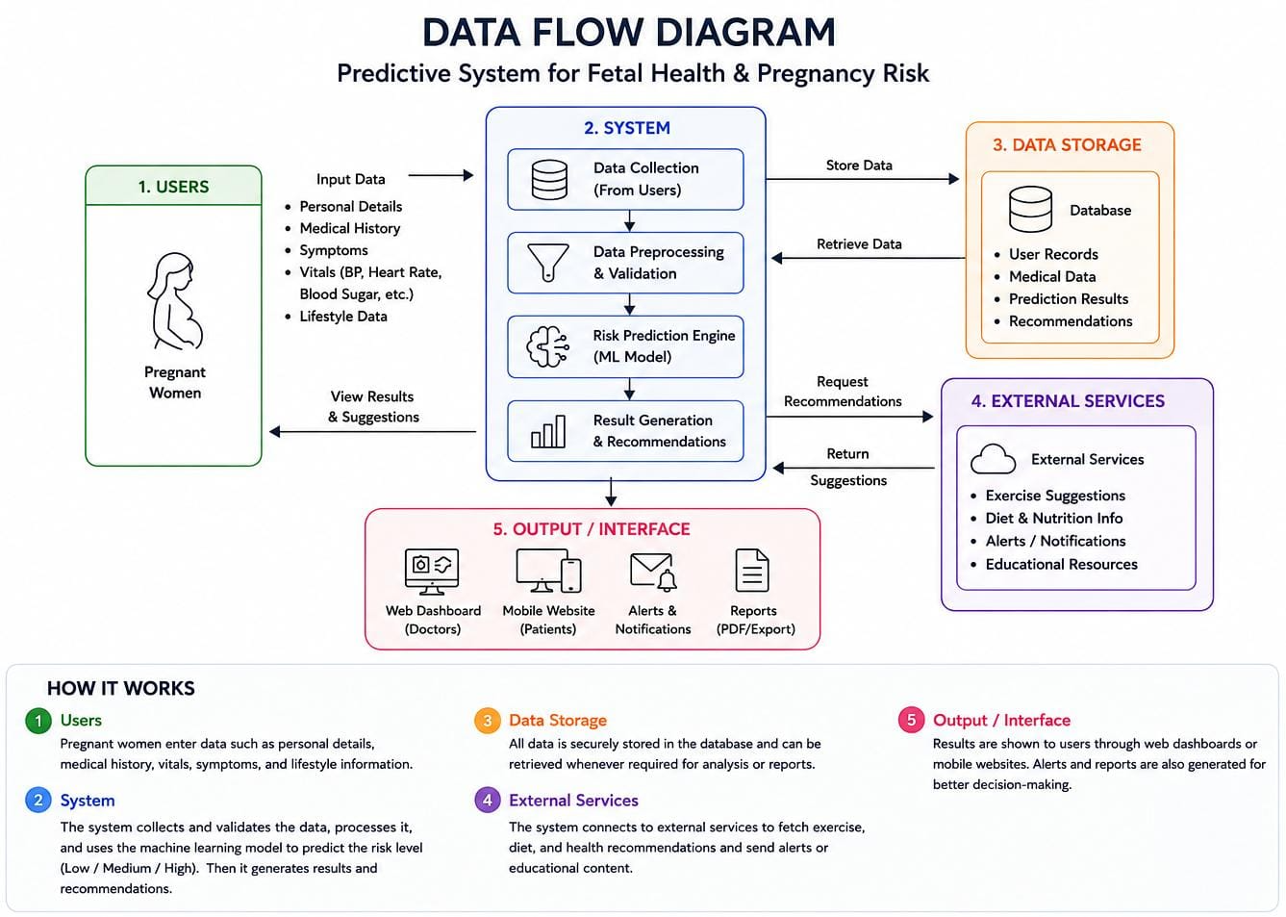
Figure 3.2: Data Flow of the Prediction Process
The data flow explains how information moves through the application from user input to prediction output. The process begins when the user accesses the application and completes the authentication process, if authentication is required for the selected feature. The user then selects the appropriate maternal or fetal health assessment and enters the required data.
The model generates the prediction, and the backend prepares the response. The frontend receives the response and displays the predicted category and any supported general recommendations. If the request contains invalid data or processing fails, the system should return an appropriate error message.
The data-flow diagram represents the logical process followed by the application. The maternal and fetal assessment paths use different models where their required inputs and output classes differ.
3.8 Advantages of the System Design
The proposed design provides the following advantages:
- Centralized platform: Pregnancy tracking, maternal assessment, wellness monitoring, nutrition, exercise, and history are accessible through one application.
- Modular structure: Each feature has a defined responsibility, making development and maintenance easier.
- Maternal risk awareness: The machine-learning model provides an estimated maternal risk category based on its supported input parameters.
- Continuous wellness recording: Daily check-ins help users maintain dated records of their reported physical and emotional well-being.
- Pregnancy-stage information: LMP-based tracking provides an estimate of pregnancy progress and trimester.
- Relevant wellness guidance: Nutrition and activity modules provide general suggestions using the information available to the application.
- Unified dashboard: Selected information from multiple modules is brought together for convenient review.
- History management: Previously saved assessments and wellness entries can be revisited, depending on the implemented storage and history features.
- User access control: Authentication supports controlled access to protected functionality.
- Scope for future improvement: The modular design can support future additions, such as enhanced visualization, improved recommendation logic, and more comprehensive record management.
3.9 Summary
This chapter presented the system analysis and design of the Predictive System for Fetal Health and Pregnancy Risk. It described the system overview, layered architecture, major functional modules, system requirements, input and output design, and data flow.
The proposed design combines a React JS and CSS frontend with a Python and FastAPI backend, JWT-based authentication, and machine-learning components for maternal and fetal health prediction. The modular architecture separates user interaction, authentication, backend processing, prediction, and result presentation.

CHAPTER 4
SYSTEM IMPLEMENTATION
4.1 Introduction
System implementation is an important phase in the development of the Maternal Health and Wellness System. It involves converting the system design into a functional web-based application by integrating the frontend, backend, machine-learning model, pregnancy tracking, wellness monitoring, nutrition guidance, exercise recommendations, dashboard, and history features.
The system is developed to support maternal health-risk assessment and pregnancy wellness management through a unified interface. Users can enter maternal health parameters, calculate their estimated pregnancy progress using the Last Menstrual Period (LMP), complete daily wellness check-ins, view nutrition and exercise suggestions, and review their recorded information through the dashboard and history features.
The implementation is organized into individual modules to make the application easier to maintain and update. Each module performs a specific task, while the dashboard brings selected information together for the user's convenience.
4.2 Tools and Technologies Used
The system uses different programming languages, frameworks, and libraries for frontend development, backend processing, authentication, data handling, and machine-learning integration. Each technology contributes to a specific part of the application.
Python Python is used for backend processing, machine-learning operations, and implementing application logic.
React JS React JS is used to develop the frontend, including forms, dashboards, pregnancy tracking, and wellness modules.
FastAPI FastAPI handles backend APIs, validates requests, processes assessments, and connects the frontend with backend services.
JWT Authentication JWT supports secure user authentication and access to protected application resources through token verification.
Machine Learning Machine learning predicts maternal health risk categories based on selected health parameters and trained data.
Pandas and NumPy Pandas and NumPy support data handling, numerical calculations, and preparation of data for machine-learning tasks.
Scikit-learn Scikit-learn provides tools for training, testing, and evaluating the maternal health-risk prediction model.
CSS CSS styles the application's layout, forms, buttons, cards, colours, and other frontend elements.
Development Environment Visual Studio Code is used to write, manage, test, and debug the project's frontend and backend code.

Table 4.1: Tools and Technologies Used
Technology | Purpose in the System
Python | Backend logic and machine-learning processing
React JS | Frontend interface and reusable components
FastAPI | Backend APIs and communication between components
JWT | Authentication and access control
Scikit-learn | Machine-learning model development and evaluation
Pandas and NumPy | Data preparation and numerical operations, where used
CSS | Styling and layout of the web interface
Visual Studio Code | Source-code development and debugging
4.3 Module Implementation
The system is implemented using a modular approach. Each module performs a specific function and communicates with other components where required.
4.3.1 User Authentication Module
The user authentication module manages registration and login. It allows users to access the application through the implemented authentication process. The backend verifies the submitted credentials. When authentication is successful, the system provides the required access mechanism for protected features.
4.3.2 Maternal Health-Risk Assessment Module
The assessment form collects the parameters required by the trained model. These may include age, systolic blood pressure, diastolic blood pressure, blood sugar, body temperature, and heart rate, according to the implemented input features.
After submission, the backend validates the data and converts it into the format expected by the model. The trained model processes the input and returns the predicted category, such as Low, Medium, or High, if those are the model's supported classes.
The result is displayed through the frontend so that the user can understand the model's estimate. The prediction is intended for preliminary awareness and should be interpreted alongside professional medical advice.
4.3.3 Pregnancy Tracking Module
The pregnancy tracking module uses the user's Last Menstrual Period (LMP) date to estimate pregnancy progress.
After the user enters the LMP date, the system calculates the approximate pregnancy duration and uses it to display information such as the current pregnancy week, trimester, estimated due date, and pregnancy progress, according to the implemented functionality.
The calculated information provides context for the user's pregnancy journey and supports the presentation of general wellness information.
4.3.4 Daily Wellness Check-in Module
The daily wellness check-in module enables users to record their physical and emotional well-being on a regular basis.
The available fields may include mood, energy level, feelings, pain or body comfort, sleep quality, sleep duration, water intake, food cravings, digestion, and personal notes. Other wellness fields are included only if they are present in the current application.
The user submits the check-in through the frontend, and the application processes the information according to the implemented data flow. The entry can then be made available for review through the history or dashboard features if saving is supported by the current implementation.
4.3.5 Nutrition and Food Recommendation Module
The nutrition module provides general food and nutrition suggestions using information available to the application. Depending on the implemented recommendation logic, the system may consider food cravings, dietary preferences, pregnancy stage, allergies, and reported digestion-related concerns.
The objective is to encourage informed food choices and general nutritional awareness during pregnancy. Recommendations are not intended to replace individualized advice from a qualified healthcare professional.
4.3.6 Activity and Exercise Recommendation Module
The activity and exercise module presents general movement and relaxation suggestions for pregnancy wellness. The module can use available pregnancy-stage and wellness information when selecting recommendations, where supported by the application logic. However, the user's preference alone does not establish that an exercise is medically suitable. Users with pregnancy complications, pain, or medical restrictions should follow the advice of their healthcare professional.
4.3.7 Maternal Wellness Dashboard Module
The maternal wellness dashboard combines selected information from the system's available modules into one view. The dashboard may present estimated pregnancy progress, recent daily check-ins, maternal assessment results, and selected nutrition or activity information. Its contents depend on the features connected to the current implementation.
4.3.8 History Management Module
The history module organizes previously saved records so users can review earlier information.
The module helps users revisit their entries and observe changes in the information they have recorded over time. It also helps keep pregnancy-related records organized for personal reference.
Access to history must follow the application's authorization rules so that one user cannot access another user's private records.
4.3.9 Doctor-Visit Report Module
Where included in the current implementation, the doctor-visit report module organizes selected pregnancy and wellness information into a summary for consultation.
The report may include maternal assessment results, pregnancy details, and available wellness records. Its exact contents depend on the information stored and the report-generation functionality implemented in the application.
4.4 Implementation Workflow and Use-Case
4.4.1 Implementation Workflow
The application follows a sequence of steps to process user information and present the relevant results.
- User access: The user registers or logs in to access the available features.
- Information entry: The user selects a feature and enters the required information, such as maternal health parameters, LMP date, or daily wellness details.
- Input validation: The frontend and backend perform the applicable checks to ensure that the submitted information is in an acceptable format.
- Backend processing: The FastAPI backend receives and processes requests for the relevant features.
- Maternal risk prediction: For a maternal assessment request, the backend passes the required input features to the trained machine-learning model and receives the predicted category.
- Pregnancy and wellness processing: The system calculates pregnancy information from the LMP date and processes wellness, nutrition, or activity requests according to the relevant implemented logic.
- Result presentation: The frontend displays the available results, estimated pregnancy information, or general recommendations.
- Dashboard and history: The dashboard combines selected available information, while the history module provides access to saved records where implemented.
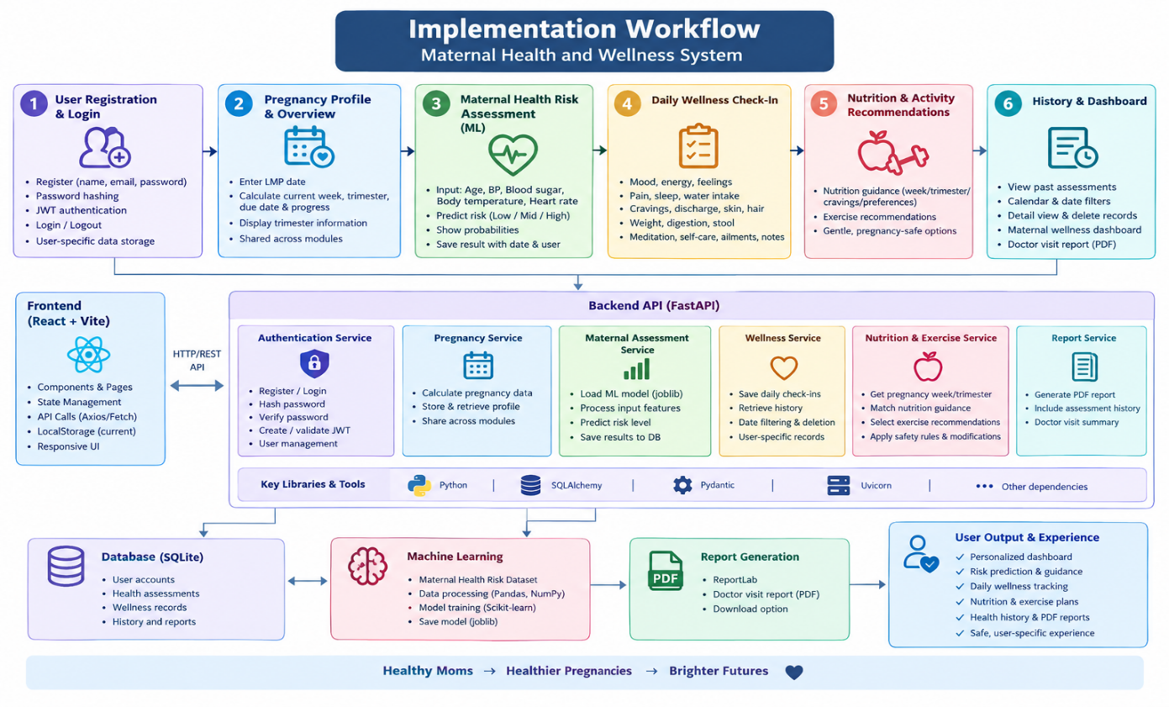
Figure 4.1: Implementation Workflow
4.4.2 Use-Case
- User Registration and Login: Allows users to create accounts, log in securely, and log out.
- Pregnancy Profile: Enables users to enter their Last Menstrual Period (LMP) and view pregnancy week, trimester, estimated due date, and progress.
- Maternal Health Assessment: Collects health parameters and uses the trained ML model to predict maternal risk levels.
- Daily Wellness Check-in: Records mood, energy, sleep, hydration, cravings, and other daily wellness details.
- Nutrition and Exercise Recommendations: Provides pregnancy-related nutrition guidance and suitable activity or exercise suggestions.
- History and Dashboard: Displays previous assessments, wellness records, activity logs, and an overview of pregnancy progress.
- Doctor Visit Report: Generates a PDF report summarizing relevant health and wellness information for doctor visits.
Actors involved
- Pregnant Woman (User): The primary actor who interacts with the system.
- Backend System (FastAPI and Database): Processes requests and stores user and health records.
- ML Model (Scikit-learn): Predicts maternal risk levels from assessment inputs.
- Report Generator (Report Lab): Creates downloadable PDF reports.
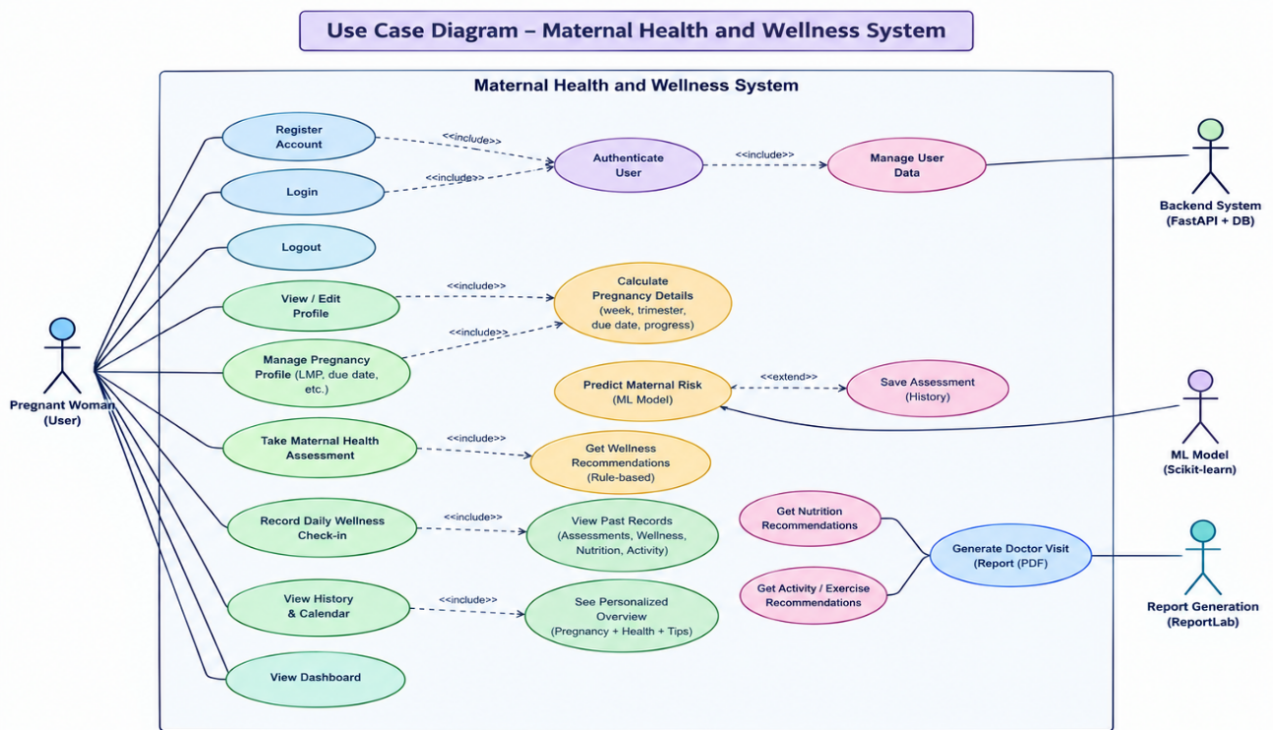
Figure 4.2: Use-case diagram
4.5 Data Handling and Integration
Data handling and integration are important for ensuring that information entered through the frontend is processed correctly and delivered to the appropriate module.
4.5.1 Input Validation
Input validation checks whether submitted information meets the requirements of the relevant feature. Required fields, numerical values, date formats, and other applicable constraints should be checked before processing.
For maternal health-risk prediction, the input must contain the features expected by the trained model. Missing values, invalid formats, or unsupported values should be handled appropriately instead of being passed directly to the model.
For pregnancy tracking, the LMP date must be in an acceptable format. For daily check-ins, the application should process the fields supported by its wellness form.
4.5.2 Frontend and Backend Integration
The React JS frontend communicates with FastAPI through the application's supported API endpoints. The frontend submits information, the backend processes the request, and the response is returned for display.
The main communication flow for maternal risk prediction is:
React JS Frontend → FastAPI Backend → Trained Maternal Risk Model → FastAPI Backend → React JS Frontend
Other requests, such as wellness check-ins, pregnancy tracking, and recommendations, follow their corresponding application logic rather than necessarily passing through the machine-learning model.
4.5.3 Record Management
The system needs an appropriate way to organize and retrieve records for the history and dashboard features.
Where persistent storage is implemented, records should be associated with the correct user and relevant date or assessment identifier. Retrieval should follow the application's authorization rules.
Table 4.2: Module Integration and Data Flow
Module | Data Received | Processing | Result
Maternal Health Assessment | Selected health parameters | Validation and trained model prediction | Maternal risk category
Pregnancy Tracking | LMP date | Pregnancy-date calculations | Estimated pregnancy information
Daily Wellness Check-in | Daily wellness details | Check-in processing | Wellness entry
Nutrition Recommendations | Available dietary and wellness information | Implemented recommendation logic | General nutrition guidance
Activity Recommendations | Available pregnancy and wellness information | Implemented recommendation logic | General activity suggestions
Dashboard | Selected available module information | Summary and presentation | Unified wellness overview
History | Previously saved records | Retrieval and organization | Reviewable records
4.6 Error Handling and Security Considerations
The system should handle invalid inputs, unsuccessful authentication, unavailable backend services, and processing errors in a controlled manner. Input errors should be communicated clearly so users can correct their entries. Backend errors should be handled without exposing internal implementation details. Authentication failures should prevent unauthorized access to protected features.
Because the application processes pregnancy-related information, access to user records should be restricted appropriately. Authentication alone does not guarantee complete data security; secure password storage, safe token handling, authorization checks, and suitable protection of stored information are also required. The application should present maternal risk predictions as estimates rather than confirmed diagnoses.
4.7 Summary
This chapter described the implementation of the Maternal Health and Wellness System, including the tools and technologies used, module implementation, workflow, data handling, integration, and security considerations.
The application uses React JS and CSS for the frontend and Python with FastAPI for backend processing. JWT authentication supports controlled access, while the trained machine-learning model provides maternal health-risk predictions using its supported input parameters.
Additional features support LMP-based pregnancy tracking, daily wellness check-ins, nutrition guidance, exercise suggestions, a combined wellness dashboard, and review of saved history where implemented. These modules provide a unified way to organize pregnancy-related information and support general maternal wellness awareness.
CHAPTER 5
TECHNOLOGIES USED
5.1 Introduction
The development of the Maternal Health Risk and Wellness Monitoring System involves the use of various software technologies, programming languages, and machine learning techniques. These technologies work together to provide a user-friendly web application for maternal health assessment, pregnancy tracking, and daily wellness monitoring.
The system uses React.js and CSS for the frontend, Python and FastAPI for backend processing, and JSON Web Token (JWT) authentication for managing secure access. Machine learning techniques can be used for preliminary maternal health risk classification, while the wellness modules provide pregnancy-related tracking, food and nutrition suggestions, exercise recommendations, and daily check-ins.
5.2 Python
Python is a high-level, interpreted programming language widely used in software development, data analysis, artificial intelligence, and machine learning. Its simple syntax and extensive library support make it suitable for developing healthcare applications.
Features of Python
- Simple and readable syntax.
- Supports object-oriented and procedural programming.
- Provides extensive libraries for data processing and machine learning.
- Integrates with web frameworks such as FastAPI.
- Supports rapid application development.
- Provides tools for processing structured health-related data.
Role of Python in Our Project
The major uses of Python in the project include:
- Processing maternal health assessment data.
- Performing data validation and transformation.
- Integrating machine learning models, where implemented.
- Supporting backend application logic.
- Connecting prediction functionality with the API layer.
5.3 React.js
React.js is a JavaScript library used to develop interactive user interfaces. It allows developers to build applications using reusable components, making the frontend easier to organize and maintain.
React.js is suitable for web applications that contain multiple pages, forms, dashboards, and dynamically updated information.
Features of React.js
- Component-based user interface development.
- Reusability of interface components.
- Efficient updating of displayed information.
- Support for interactive forms and dashboards.
- Simplified management of complex interfaces.
- Integration with backend APIs.
Role of React.js in Our Project
React.js supports the following functions:
- Creating login and registration interfaces.
- Collecting maternal health assessment information.
- Providing pregnancy tracking based on the last menstrual period (LMP).
- Displaying daily wellness check-in forms.
- Presenting food and nutrition suggestions.
- Displaying suitable exercise and activity recommendations.
- Showing dashboard information and available history records.
5.4 FastAPI
FastAPI is a Python web framework used to develop APIs and backend services. It enables the frontend application to communicate with the server-side logic and provides a structured way to process requests and return responses.
Features of FastAPI
- Supports REST API development.
- Provides request and response validation.
- Integrates with Python libraries.
- Generates interactive API documentation.
- Supports asynchronous request handling.
- Provides a structured approach to backend development.
Role of FastAPI in Our Project
FastAPI can be used to manage the following operations:
- Receiving maternal health assessment inputs.
- Processing assessment requests.
- Connecting the assessment process to the machine learning component.
- Managing authentication-related API requests.
- Supporting pregnancy and wellness data operations.
- Returning results and recommendation information to the frontend.
The basic communication flow is:
React.js → FastAPI → Python Processing / ML Model → FastAPI → React.js
5.5 JWT Authentication
JWT stands for JSON Web Token. It is a token-based mechanism used to represent authenticated user information and control access to protected application resources. JWT can be used in web applications where the frontend and backend operate as separate components.
Features of JWT Authentication
- Token-based authentication.
- Supports verification of authenticated requests.
- Can carry claims related to a user and token validity.
- Works with frontend and backend applications.
- Supports access control for protected API endpoints.
Role of JWT in Our Project
JWT authentication is intended to help protect user accounts and restrict access to features that require authentication.
In a typical JWT authentication flow, the user submits login credentials to the backend. The backend verifies the credentials and, if authentication is successful, issues a token. The frontend then includes the token in requests to protected endpoints, and the backend verifies it before allowing access.
The authentication flow can be represented as:
User Login → Credential Verification → JWT Generation → Authenticated Request → Access to Protected Resources
5.6 Machine Learning Models
Machine learning is a branch of artificial intelligence that enables computers to learn patterns from data and use those patterns to make predictions or classifications. The algorithms discussed in the project are Logistic Regression, Decision Tree, and Random Forest. The exact model used for the final prediction should correspond to the model actually trained and integrated into the application.
5.6.1 Logistic Regression
Logistic Regression is a supervised machine learning algorithm commonly used for classification tasks. It estimates the probability of an input belonging to a particular class.
Working principle:
- The model receives input features.
- It applies learned coefficients to the input values.
- It estimates the probability of the possible classes.
- A classification rule is used to determine the predicted class.
Role in the project:
Logistic Regression can be used as a baseline model for classifying maternal health assessment data into predefined risk categories, provided the training dataset and target labels support that classification.
5.6.2 Decision Tree
A Decision Tree is a supervised machine learning algorithm that makes predictions using a tree-like structure of decision rules. Each internal node represents a condition on an input feature, each branch represents an outcome of that condition, and each leaf represents a final prediction.
Working principle:
- The model receives the input health parameters.
- The parameters are evaluated against learned decision rules.
- The model follows the relevant branches.
- The leaf node provides the predicted class.
Role in the project:
A Decision Tree can classify maternal assessment data based on patterns learned during training. Its rule-based structure can also make the decision process easier to explain than some more complex models.
5.6.3 Random Forest
Random Forest is an ensemble learning algorithm that combines predictions from multiple decision trees. For classification tasks, the trees collectively determine the final class, commonly through majority voting.
Working principle:
- Multiple decision trees are trained using variations of the training data and feature selection.
- Each tree generates a prediction for the input.
- The individual predictions are combined.
- The combined result becomes the final classification.
Role in the project:
Random Forest can be considered for maternal health risk classification because it can learn nonlinear relationships and interactions among input features. Its performance must be evaluated using appropriate testing data before it is selected for the final system.
Importance of Model Evaluation
Machine learning predictions must be evaluated before being used in a healthcare-related application. Relevant evaluation measures may include accuracy, precision, recall, F1-score, and a confusion matrix.
The selected model should be based on the evaluation results and the requirements of the application. A predicted risk category is intended to support awareness and does not replace professional medical diagnosis or treatment.
5.7 CSS (Cascading Style Sheets)
CSS stands for Cascading Style Sheets. It is used to control the appearance, layout, spacing, and visual presentation of web pages. CSS works with the frontend components to create a consistent and user-friendly interface.
Features of CSS
- Controls colors, fonts, and text styles.
- Defines margins, padding, and spacing.
- Supports flexible page layouts.
- Styles forms, buttons, cards, and navigation elements.
- Helps create responsive interfaces for different screen sizes.
- Maintains visual consistency across application pages.
Role of CSS in Our Project
CSS supports the following design elements:
- Styling login and registration pages.
- Designing the maternal health assessment form.
- Organizing the pregnancy tracking interface.
- Styling daily wellness check-in sections.
- Displaying nutrition and exercise recommendations clearly.
- Designing dashboard cards and history sections.
- Maintaining consistent spacing, typography, and colors.
5.8 Summary of Technologies Used
The technologies used in the project have different responsibilities. Python and FastAPI support backend processing, React.js and CSS provide the user interface, JWT supports authentication, and machine learning algorithms can support preliminary risk classification.
Table 5.1: Summary of Technologies
Technology | Purpose in the Project
Python | Backend processing and machine learning integration
React.js | Development of interactive frontend pages
FastAPI | Backend API development and request handling
JWT | Authentication and access control for protected resources
Logistic Regression | Potential classification model for maternal assessment
Decision Tree | Rule-based classification using learned patterns
Random Forest | Ensemble-based classification
CSS | Styling, layout, and responsive interface design

The technologies work together to provide a structured web-based platform for maternal health assessment and wellness monitoring. Their integration supports the collection and presentation of maternal health information, pregnancy tracking, daily wellness check-ins, and relevant recommendations. The effectiveness and safety of the final system depend on correct implementation, validation, testing, and appropriate interpretation of the results.
CHAPTER 6
IMPLEMENTATION
6.1 Introduction
Implementation is an important phase of software development in which the system design is converted into a working application. It involves developing the individual modules, connecting the frontend and backend, processing user inputs, and displaying the required outputs.
The Maternal Health and Wellness System is implemented as a web-based application that brings maternal health assessment, pregnancy tracking, daily wellness monitoring, nutrition guidance, and physical activity recommendations together in one platform. The application is designed to help pregnant women record their health-related information, understand their estimated pregnancy progress, and review their wellness activities over time.
The frontend is developed using React.js and CSS, while Python and FastAPI are used for backend processing and API development. The maternal assessment component uses a machine learning model to generate a preliminary risk category. Other wellness components use the information entered by the user, pregnancy stage, and predefined recommendation logic to provide relevant guidance.
The main components implemented in the system are:
- Maternal health risk assessment.
- Maternal daily wellness check-in.
- Last Menstrual Period (LMP) tracking.
- Wellness history management.
- Maternal wellness dashboard.
- Nutrition and food recommendations.
- Exercise and physical activity recommendations.
These components work together to provide an organized platform for pregnancy-related health awareness and wellness management.
6.2 Implementation Overview
The system follows a modular implementation approach. Each component performs a specific task, while the frontend provides a common interface through which users can access the available features.
React.js manages the user interface and user interactions. When information needs to be processed by the backend, the frontend sends an API request to FastAPI. The backend validates the request, executes the required processing, and returns a response. The frontend then displays the result to the user.
Wellness information can also be maintained as dated records so that users can review their previous check-ins and observe changes in their reported wellness.
The overall implementation flow is:
User Input → React.js Interface → Validation and Processing → Backend or Recommendation Logic → Result Display → History and Dashboard
6.3 Implementation of Maternal Health Assessment
The maternal health assessment module evaluates selected maternal health parameters and provides a preliminary risk classification. It allows the user to enter relevant information through an assessment form.
The assessment inputs described in the project include:
- Age.
- Systolic blood pressure.
- Diastolic blood pressure.
- Blood sugar level.
- Body temperature.
- Heart rate.
After the user submits the form, the application validates the entered values and sends the information for processing. The backend prepares the input in the format required by the trained machine learning model. The model then generates a prediction, which is returned to the frontend.
The result is displayed as a maternal risk category, such as Low, Medium, or High, according to the model's supported output classes.
Implementation process
- Display the maternal assessment form.
- Collect the required health parameters.
- Check that all required values are entered in valid formats.
- Submit the data to the backend.
- Process the input using the trained model.
- Display the predicted risk category.
Code snippet
The following React example illustrates how the frontend can submit assessment data to a FastAPI endpoint.
import { useState } from "react";

function MaternalAssessment() {
const [result, setResult] = useState("");

async function assessMother(event) {
event.preventDefault();

const form = event.currentTarget;
const data = Object.fromEntries(
new FormData(form)
);

try {
const response = await fetch(
"http://localhost:8000/predict-maternal-risk",
{
method: "POST",
headers: {
"Content-Type": "application/json"
},
body: JSON.stringify(data)
}
);

if (!response.ok) {
throw new Error("Assessment failed");
}

const output = await response.json();
setResult(output.risk_level);
} catch (error) {
setResult("Unable to complete assessment");
}
}

return (
<form onSubmit={assessMother}>
<input name="age" type="number"
placeholder="Age" required />

<input name="systolic_bp" type="number"
placeholder="Systolic BP" required />

<input name="diastolic_bp" type="number"
placeholder="Diastolic BP" required />

<input name="blood_sugar" type="number"
placeholder="Blood sugar" required />

<input name="temperature" type="number"
step="0.1" placeholder="Temperature" required />

<input name="heart_rate" type="number"
placeholder="Heart rate" required />

<button type="submit">Assess Risk</button>
<p>Result: {result}</p>
</form>
);
}

export default MaternalAssessment;
6.4 Implementation of Maternal Daily Wellness Check-in
The daily wellness check-in module allows users to record their physical and emotional well-being on a particular day. Unlike the maternal health assessment, which focuses on selected health measurements, the wellness check-in captures everyday experiences and personal observations.
The information recorded may include:
- Mood and energy level.
- Sleep duration or quality.
- Water intake.
- Food cravings.
- Pain or body discomfort.
- Digestion.
- Skin and hair observations.
- Weight, meditation, self-care, or other relevant notes.
Implementation process
- Display the daily wellness form.
- Collect the user's responses.
- Add the date of the check-in.
- Validate the required information.
- Save the entry using the application's configured storage mechanism.
- Make the entry available for later review.
Code snippet
The following example illustrates the creation of a dated wellness entry and its storage in the browser.
function saveWellnessEntry(formData) {
const entry = {
...formData,
date: new Date().toISOString().slice(0, 10)
};

const previousEntries = JSON.parse(
localStorage.getItem("wellnessHistory") || "[]"
);

previousEntries.push(entry);

localStorage.setItem(
"wellnessHistory",
JSON.stringify(previousEntries)
);

return entry;
}

// Example usage
const todayEntry = saveWellnessEntry({
mood: "Good",
energy: "Moderate",
sleepHours: 8,
waterIntake: 2,
cravings: "Sweet",
digestion: "Normal",
notes: "Completed daily check-in"
});
6.5 Implementation of LMP-Based Pregnancy Tracking
The pregnancy tracking module helps users understand their estimated pregnancy progress. It uses the Last Menstrual Period (LMP) date entered by the user to calculate the approximate number of pregnancy weeks, the current trimester, and the estimated due date.
Pregnancy duration is commonly estimated as 280 days, or 40 weeks, from the first day of the last menstrual period. This calculation is an estimate and may differ from a clinician's assessment based on individual circumstances.
Implementation process
- Ask the user to enter the LMP date.
- Validate that the date is not in the future.
- Calculate the number of days elapsed since the LMP date.
- Convert the elapsed days into weeks and remaining days.
- Estimate the trimester and due date.
- Display the pregnancy information on the tracking page.
Code snippet
function calculatePregnancyProgress(lmpDate) {
const lmp = new Date(`${lmpDate}T00:00:00`);
const today = new Date();

today.setHours(0, 0, 0, 0);

if (
Number.isNaN(lmp.getTime()) ||
lmp > today
) {
return null;
}

const days = Math.floor(
(today - lmp) / (1000 * 60 * 60 * 24)
);

const weeks = Math.floor(days / 7);
const remainingDays = days % 7;

const trimester =
weeks < 13 ? "First Trimester" :
weeks < 28 ? "Second Trimester" :
"Third Trimester";

const dueDate = new Date(lmp);
dueDate.setDate(dueDate.getDate() + 280);

return {
weeks,
remainingDays,
trimester,
dueDate: dueDate.toLocaleDateString()
};
}

// Example
const progress = calculatePregnancyProgress("2026-06-01");
console.log(progress);
6.6 Implementation of Wellness History
The wellness history module allows users to review information recorded during earlier maternal assessments and daily check-ins. Instead of requiring the user to remember previous entries, the module organizes records by date for easier reference.
Depending on the features available in the application, the history may include:
- Previous maternal health assessments.
- Daily wellness check-ins.
- Pregnancy tracking information.
- Nutrition-related records.
- Exercise and activity records.
The module retrieves available records from the configured storage system and displays them in a chronological list or table. This helps users revisit their entries and understand changes in their reported wellness over time.
Implementation process
- Retrieve saved wellness records.
- Sort the records by date.
- Display the entries in chronological order.
- Allow the user to review individual records.
- Update the displayed history when a new entry is saved.
Code snippet
function getWellnessHistory() {
const entries = JSON.parse(
localStorage.getItem("wellnessHistory") || "[]"
);

return entries.sort((a, b) =>
b.date.localeCompare(a.date)
);
}

// Display history entries in React
function WellnessHistory() {
const entries = getWellnessHistory();

return (
<section>
<h2>Wellness History</h2>

{entries.map((entry, index) => (
<article key={`${entry.date}-${index}`}>
<h3>{entry.date}</h3>
<p>Mood: {entry.mood}</p>
<p>Energy: {entry.energy}</p>
<p>Cravings: {entry.cravings}</p>
<p>Notes: {entry.notes}</p>
</article>
))}
</section>
);
}
6.7 Implementation of Maternal Wellness Dashboard
The maternal wellness dashboard brings important information from different modules together on a single screen. It provides users with a convenient overview of their pregnancy progress and recorded wellness activities.
The dashboard can display:
- Current estimated pregnancy week and trimester.
- The most recent maternal assessment result.
- The latest wellness check-in.
- Mood, energy, sleep, and hydration information.
- Recent nutrition and activity records.
- Shortcuts to the other application modules.
The dashboard retrieves information from the available records and presents it using cards, summaries, and other visual elements. Its purpose is to improve accessibility and help users review their information without navigating through every individual module.
Implementation process
- Retrieve pregnancy tracking information.
- Retrieve the latest wellness entry.
- Retrieve the most recent assessment result, if available.
- Prepare summary values.
- Display the values using reusable React components.
- Update the dashboard when new information becomes available.
Code snippet
function WellnessDashboard({ pregnancy, entries, risk }) {
const latest = entries.length
? entries[entries.length - 1]
: null;

return (
<section className="dashboard">
<h2>Maternal Wellness Dashboard</h2>

<div className="dashboard-card">
<h3>Pregnancy Progress</h3>
<p>
{pregnancy
? `${pregnancy.weeks} weeks`
: "Enter your LMP date"}
</p>
</div>

<div className="dashboard-card">
<h3>Latest Assessment</h3>
<p>{risk || "No assessment available"}</p>
</div>

<div className="dashboard-card">
<h3>Latest Mood</h3>
<p>{latest?.mood || "No check-in yet"}</p>
</div>

<div className="dashboard-card">
<h3>Energy Level</h3>
<p>{latest?.energy || "Not recorded"}</p>
</div>
</section>
);
}

export default WellnessDashboard;
6.8 Implementation of Nutrition and Food Recommendations
The nutrition and food recommendation module provides general food guidance to support maternal wellness. Recommendations may consider the user's pregnancy stage, food preferences, cravings, digestion, and reported dietary restrictions.
The module aims to encourage balanced eating habits and make general nutritional information easier to access. For example, users who report a craving for sweet food may be shown suitable fruit or other balanced snack options. Users who report a preference for salty or crunchy foods may be offered appropriate alternatives, subject to their dietary needs.
The module may provide guidance related to:
- Fruits and vegetables.
- Whole grains and other fiber sources.
- Protein-containing foods.
- Calcium- and iron-containing foods.
- Hydration.
- Food preferences and reported allergies.
- General pregnancy-related nutrition information.
Implementation process
- Retrieve the available pregnancy and wellness information.
- Identify relevant preferences or reported concerns.
- Match the information to suitable predefined recommendations.
- Display the suggested food options.
- Provide general guidance and advise professional consultation where individual dietary needs require it.
Code snippet
function getFoodRecommendations(craving, digestion) {
const recommendations = {
sweet: [
"Fresh fruit",
"Plain yogurt with fruit, if suitable"
],
crunchy: [
"Washed and safely prepared vegetable sticks",
"Whole-grain crackers"
],
salty: [
"Lightly seasoned homemade poha",
"A balanced snack with moderate salt"
]
};

const options =
recommendations[craving?.toLowerCase()] || [
"Choose a balanced snack with varied nutrients"
];

if (digestion?.toLowerCase() === "loose stools") {
options.push(
"Drink fluids regularly and consider oral rehydration advice if needed"
);
}

return options;
}

// Example
console.log(
getFoodRecommendations("crunchy", "normal")
);
6.9 Implementation of Exercise and Physical Activity Recommendations
The exercise and activity module provides general suggestions for movement and relaxation during pregnancy. Recommendations may take into account the estimated trimester, the user's daily wellness information, and any relevant restrictions already known to the application.
Examples of activity categories include:
- Gentle walking.
- Suitable stretching and mobility exercises.
- Breathing and relaxation techniques.
- Pregnancy-appropriate yoga, where suitable.
- Pelvic floor exercises, when appropriate.
The module is designed to provide educational guidance rather than prescribe a medical exercise routine. Pregnancy complications, symptoms, and individual fitness levels can affect which activities are appropriate. Users should follow their healthcare professional's advice when personal medical circumstances require special precautions.
Implementation process
- Retrieve the available pregnancy-stage information.
- Review the user's recorded wellness information.
- Select suitable general activity suggestions from the recommendation rules.
- Display the activities and their basic descriptions.
- Allow the user to review the suggestions and choose an appropriate activity.
- Encourage the user to stop and seek medical guidance if concerning symptoms occur.
Code snippet
function getActivityRecommendations(trimester) {
const activities = {
"First Trimester": [
"Gentle walking, if suitable",
"Comfortable breathing exercises",
"Gentle mobility activities"
],
"Second Trimester": [
"Comfortable walking, if approved",
"Pregnancy-appropriate stretching",
"Relaxation and breathing exercises"
],
"Third Trimester": [
"Gentle movement, if comfortable",
"Supported relaxation positions",
"Breathing and relaxation exercises"
]
};

return activities[trimester] || [
"Consult a healthcare professional for suitable activities"
];
}

// Example
const activities =
getActivityRecommendations("Second Trimester");

console.log(activities);
6.10 Integration of the Implemented Components
The different components are integrated through the application's navigation, shared information, processing logic, and storage mechanisms. Each module contributes to the overall maternal wellness experience.
The maternal assessment component accepts selected health parameters and displays the returned risk category. The LMP tracking component calculates estimated pregnancy progress. The daily wellness module records day-to-day information, while the history module makes previous records available for review. The dashboard summarizes selected information, and the nutrition and activity modules provide general recommendations.
Table 6.1: Implementation of the Maternal Health and Wellness System
S. No. | Component | Implementation
1 | Maternal Assessment | Predicts maternal risk using health parameters.
2 | Pregnancy Tracking | Calculates pregnancy week, trimester, and due date.
3 | Daily Wellness | Records daily health and wellness information.
4 | Wellness History | Displays previous health and wellness records.
5 | Dashboard | Summarizes pregnancy progress and wellness information.
6 | Nutrition and Activity | Provides general nutrition and exercise recommendations.
7 | Doctor Visit Report | Generates PDF reports for doctor visits.
8 | Backend and Database | Processes requests and stores application data.
Proper integration ensures that the application presents information consistently and reduces the need for users to enter the same information repeatedly. Input validation, error handling, and appropriate access controls are important throughout the process.
6.11 Summary
The implemented components work together to provide pregnancy tracking, maternal risk assessment, daily wellness monitoring, personalized wellness guidance, historical record management, and PDF report generation. The React.js frontend manages user interactions, while the FastAPI backend handles server-side processing and communication with the machine learning model and configured database. The system provides supportive health information and does not replace professional medical advice.
CHAPTER 7
TESTING
7.1 Introduction
Testing is an essential phase of software development that verifies whether an application behaves according to its requirements. It helps identify errors, validate individual components, and ensure that the complete system operates correctly.
The Maternal Health and Wellness System is tested to verify the functionality of maternal health assessment, daily wellness check-ins, LMP-based pregnancy tracking, wellness history, the maternal dashboard, nutrition recommendations, and exercise recommendations.
The testing process focuses on checking the correctness of user inputs, the processing of health information, the display of results, and communication between the frontend and backend. It also examines whether saved records can be retrieved correctly and whether the application handles invalid or incomplete inputs appropriately.
Since the system deals with maternal health information, testing also considers the clarity of displayed results, appropriate handling of personal information, and the limitation that risk predictions and wellness recommendations are supportive tools rather than medical diagnoses.
7.2 Objectives of Testing
The main objectives of testing the proposed system are:
- To verify functional correctness: Ensure that the major modules perform their intended functions.
- To validate user inputs: Check that required fields are completed and values are entered in the expected format.
- To verify maternal assessment: Confirm that valid health parameters are processed and the model's returned risk category is displayed correctly.
- To verify pregnancy tracking: Check the calculation of estimated pregnancy weeks, trimester, and due date using the LMP date.
- To verify wellness record management: Ensure that daily entries are saved and can be retrieved for later review.
- To verify recommendation modules: Confirm that food and activity suggestions correspond to the implemented recommendation rules.
- To test module integration: Check that data is transferred correctly between the frontend, backend, and other relevant components.
- To evaluate usability and reliability: Ensure that the application is understandable, responsive, and capable of handling common errors.
7.3 Testing Strategy
The system follows a structured testing approach in which individual components are checked first, followed by testing of the connected application.
The main testing methods are described below.
7.3.1 Functional Testing
Functional testing verifies whether each feature performs according to its specified requirements. The maternal assessment form, daily wellness check-in, pregnancy tracker, dashboard, history, nutrition module, and exercise module are checked individually.
7.3.2 Input Validation Testing
Input validation testing checks whether the system handles missing, incorrectly formatted, or invalid information properly. For example, the maternal assessment form should not submit when required fields are empty. The LMP tracker should reject a date in the future.
7.3.3 Machine Learning Model Testing
The maternal assessment model is evaluated using suitable test data. The model's predictions are compared with the actual labels in the test dataset. Metrics such as accuracy, precision, recall, F1-score, and a confusion matrix may be used to assess its performance.
The model's evaluation results should be based on the actual test dataset and recorded experimental results rather than assumed values.
7.3.4 Frontend and Backend Testing
This testing verifies communication between the React.js frontend and the FastAPI backend. It checks whether requests contain the expected data, whether the backend processes the requests, and whether the frontend handles the returned response correctly.
7.3.5 Data Storage and Retrieval Testing
This testing checks whether wellness records and other supported information are saved and retrieved correctly. It verifies that saved records retain their dates and values and that the history module displays the appropriate entries.
The specific tests depend on the application's actual storage mechanism, such as browser storage or backend-managed database storage.
7.3.6 Integration Testing
Integration testing checks whether different components function correctly when connected. For example, a saved wellness entry should become available to the history module and, where supported, the dashboard.
Similarly, a maternal assessment request should pass through the relevant processing component and return the prediction to the frontend.
7.3.7 Usability and Error-Handling Testing
Usability testing checks whether users can navigate between modules, enter information, and understand the displayed results. Error-handling testing checks whether the application provides suitable feedback when required information is missing, an API request fails, or stored data cannot be retrieved.
7.4 Test Environment
The test environment consists of the software, development tools, and data required to run and evaluate the application.
Table 7.1: Test Environment
Component | Description
Frontend | React.js and CSS
Backend | Python and FastAPI
Programming language | JavaScript and Python
Machine learning | Trained maternal risk classification model, if integrated
Browser | Modern web browser
Development environment | Visual Studio Code or the environment used for development
Test data | Valid and invalid maternal inputs, LMP dates, and sample wellness entries
Storage | The storage mechanism implemented in the application
The application should be tested using the same configuration intended for demonstration. Required backend services, model files, environment variables, and storage connections must be configured before testing.
7.5 Functional Test Cases
Table 7.2: Functional Test Cases
Test ID | Module | Test Input or Action | Expected Result
TC01 | Maternal assessment | Enter all required valid health parameters | Input is processed and the model's returned risk category is displayed
TC02 | Maternal assessment | Leave a required field empty | The form prevents submission or displays a validation message
TC03 | Daily wellness | Enter mood, energy, sleep, hydration, and notes | The wellness entry is created with a date
TC04 | LMP tracking | Enter a valid past LMP date | Estimated weeks, trimester, and due date are calculated
TC05 | LMP tracking | Enter a future LMP date | The date is rejected or a suitable validation message appears
TC06 | Wellness history | Open the history page after saving an entry | The saved entry is displayed with its recorded information
TC07 | Dashboard | Open the dashboard when records are available | The dashboard displays the available pregnancy and wellness summaries
TC08 | Nutrition | Select a supported craving or preference | Relevant predefined food suggestions are displayed
TC09 | Exercise | Open activity recommendations for a supported trimester | The configured activity suggestions are displayed
TC10 | Error handling | Simulate a failed backend request | The application handles the error without crashing

7.6 Input Validation Testing
Input validation is particularly important because incorrect health parameters or dates can cause processing errors and misleading results.
The application should validate required fields, data types, and reasonable input constraints before processing the information. Backend validation should also be applied to API requests rather than relying only on frontend form controls.
Table 7.3: Input Validation Test Cases
Test ID | Test Condition | Expected Behaviour
IV01 | Age field is empty | Required-field validation is displayed
IV02 | Text is entered in a numerical health field | Invalid input is rejected
IV03 | A required maternal health parameter is missing | Assessment is not processed with incomplete data
IV04 | LMP date is later than the current date | Future date is rejected
IV05 | Wellness form contains optional blank notes | The entry can be accepted if notes are optional
IV06 | Backend receives incorrectly formatted data | The API returns an appropriate validation error
IV07 | An unsupported recommendation category is selected | The application provides a safe default or validation message

7.7 Machine Learning Model Testing
Machine learning model testing evaluates how well the maternal health assessment model classifies input data. The model should be tested on a separate test dataset that was not used to train it.
During testing, the model receives the required maternal health parameters and produces a predicted risk category. The predicted labels are compared with the corresponding actual labels to calculate evaluation metrics.
The main evaluation measures are:
- Accuracy: The proportion of all predictions that are correct.
- Precision: The proportion of predicted positive cases that are actually positive for a particular class.
- Recall: The proportion of actual positive cases correctly identified for a particular class.
- F1-score: The harmonic mean of precision and recall.
- Confusion matrix: A table showing correct and incorrect classifications across the classes.
For a multi-class risk prediction model, precision, recall, and F1-score should be reported using a clearly specified averaging method, such as macro or weighted averaging.
The following formula is used to calculate accuracy:
$$\text{Accuracy}=\frac{\text{Correct Predictions}}{\text{Total Predictions}}×100$$
The evaluation results should be inserted from the actual model evaluation output. No performance percentage should be reported unless it has been verified using the model's test results.
7.8 Frontend and Backend Integration Testing
The frontend and backend operate as separate components and must exchange data in the correct format. Integration testing verifies that the communication process works as expected.
For maternal assessment, the frontend sends the entered health parameters to the backend. The backend validates the input, processes the assessment, and returns the result. The frontend then displays the returned risk category.
For wellness functionality, the relevant storage or backend mechanism should accept the submitted record and make it available to the history or dashboard component as designed.
The following conditions should be checked:
- The frontend sends the required fields.
- The backend receives and validates the request.
- The relevant processing component returns the expected response.
- The frontend handles successful responses correctly.
- Errors and unsuccessful responses are handled appropriately.
- Saved information is available to the relevant modules.
7.9 Data Storage and Retrieval Testing
Data storage and retrieval testing checks whether the information entered by the user remains available according to the application's intended behaviour.
The daily wellness module should save the entry with the correct date and values. The history module should retrieve the saved entry and display it correctly. The dashboard should use the appropriate available records for its summaries.
The tests should also check how the application behaves when no records exist, when an entry contains optional fields, or when the storage mechanism returns an error.
If the application uses browser local storage, the testing should reflect that design. If records are stored through a backend or database, the tests should verify the corresponding API and database operations instead.
7.10 Integration Testing of Wellness Modules
The wellness modules should be tested together to ensure that information moves correctly across the application.
For example, after a user completes a daily wellness check-in, the saved entry should be visible in the history module. If the dashboard is designed to show the latest check-in, the same entry should be reflected there. The LMP tracker should provide pregnancy-stage information to the parts of the application that use it for displaying trimester-related guidance.
Similarly, the nutrition and exercise modules should display recommendations supported by their implemented rules. A missing wellness entry should not cause the dashboard to fail, and an unavailable assessment result should not be displayed as if it were a valid prediction.
7.11 Debugging and Error Handling
Debugging is the process of identifying and correcting errors discovered during development and testing. It helps improve the stability and reliability of the application.
Common issues that may require debugging include:
- Missing or invalid form values.
- Incorrect field names between frontend and backend.
- API connection failures.
- Errors while loading the trained machine learning model.
- Incorrect date calculations.
- Missing or incorrectly stored wellness records.
- Unexpected recommendation output.
- Errors while rendering dashboard information.
The debugging process involves reproducing the problem, examining the relevant code and error messages, correcting the cause, and repeating the related test case. Errors should be handled in a way that provides useful feedback without exposing sensitive information.
7.12 Final System Testing
Final system testing evaluates the complete application after the individual modules and their interactions have been checked.
A typical end-to-end test begins when the user opens the application and navigates to the maternal assessment module. The user enters valid health parameters and submits the assessment. The application displays the returned result, where the prediction component is implemented.
The user then enters an LMP date, reviews the estimated pregnancy progress, completes a daily wellness check-in, and opens the history page. The user can also navigate to the nutrition and exercise modules to review the configured recommendations.
The complete flow should be repeated with valid and invalid inputs to confirm that the application responds appropriately. The dashboard and history should reflect the records actually saved by the application.
The final system can be considered ready for demonstration when all required features have been tested, critical errors have been resolved, and the observed behaviour is consistent with the documented requirements.
7.13 Summary
This chapter described the testing approach for the Maternal Health and Wellness System. The testing process covers functional testing, input validation, machine learning model evaluation, frontend-backend communication, data storage and retrieval, integration testing, and error handling.
The proposed test cases provide a structured method for checking the maternal assessment, daily wellness check-in, LMP tracking, wellness history, dashboard, nutrition, and exercise modules. Testing these components individually and as an integrated application helps identify errors and improve reliability.
Since the application handles maternal health information, its inputs, predictions, and recommendations must be interpreted carefully. The system is intended to support health awareness and wellness tracking and does not replace professional medical diagnosis or treatment
CHAPTER 8
SAMPLE OUTPUT
8.1 User Registration
The user registration page allows a new user to create an account in the proposed Maternal Health and Wellness System. The user is required to enter basic account information such as name, email address, password, and password confirmation.
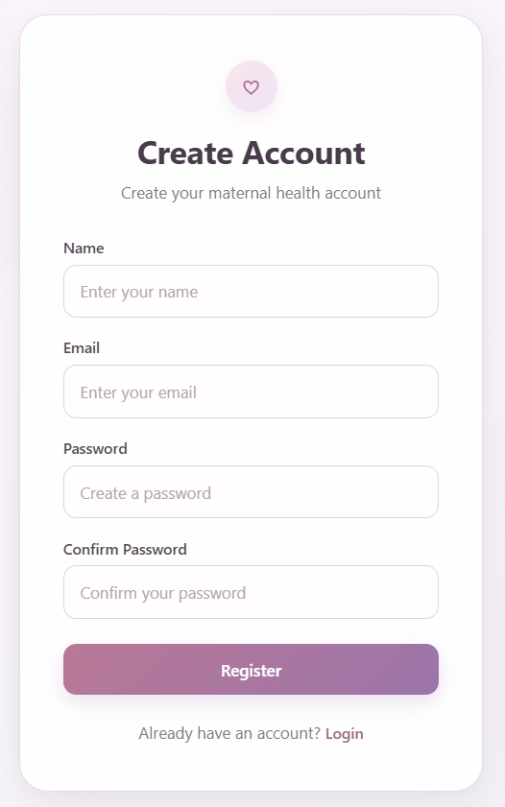
Fig 8.1: User Registration Page
8.2 User Login Output
The user login page allows registered users to securely access their account in the Maternal Health and Wellness System. The user enters the registered email address and password and selects the Login button.

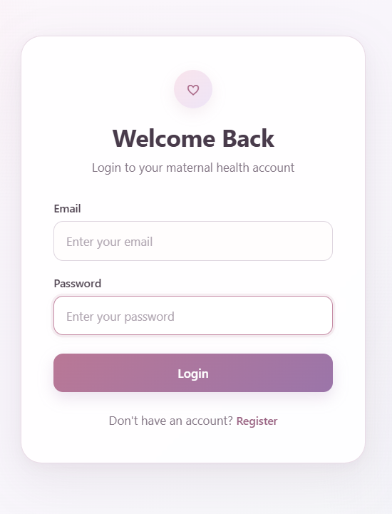
Fig 8.2: User Login Page
8.3 Pregnancy Tracking Output
The Pregnancy Tracking module helps the user monitor the progress of pregnancy based on the Last Menstrual Period (LMP) entered into the system. After providing the required date, the system calculates and displays important pregnancy information such as the estimated due date, current pregnancy week, trimester, pregnancy progress, and remaining weeks.
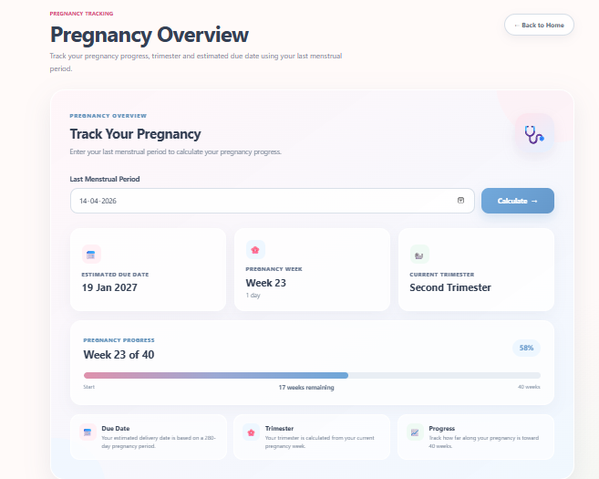
Fig 8.3: Pregnancy Tracking Output
8.4 Daily Wellness Check-in Output
The Daily Wellness Check-in module enables the user to record their daily physical and emotional wellness information. The system provides options for recording the user's mood, energy level, feelings, pain and body comfort, sleep quality, sleep duration, water intake, and food cravings. The user can select the appropriate options and submit the information to maintain a record of their daily wellness. This information can be used by the system to provide more personalized pregnancy wellness, nutrition, and activity recommendations.
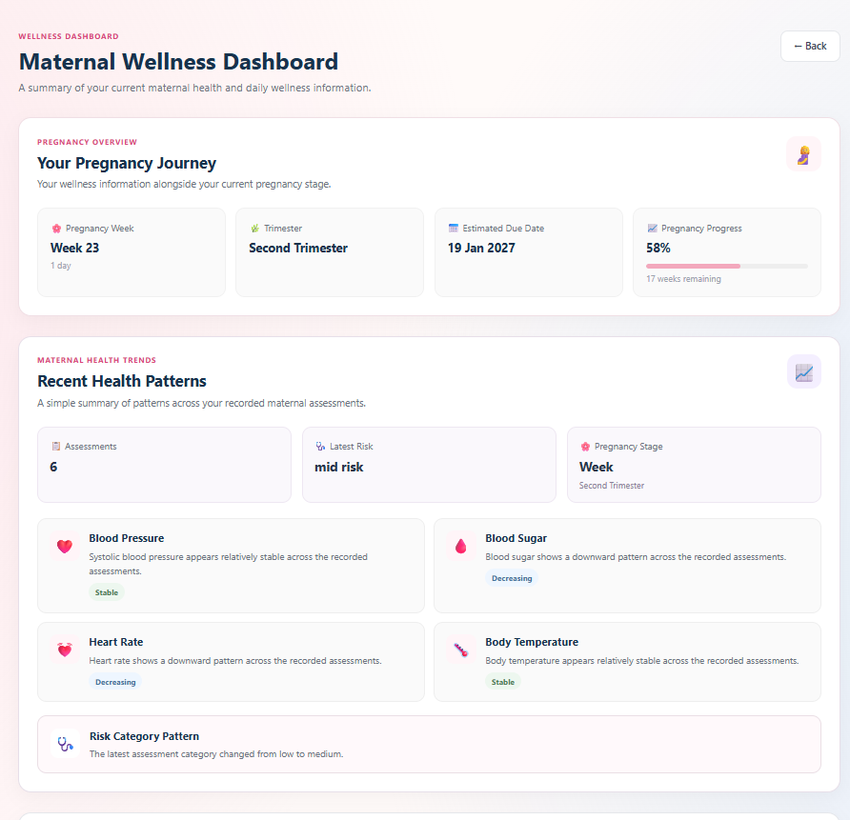
Fig 8.4: Daily Wellness Check-in Output
8.5 Nutrition and Digestion
Provides personalized pregnancy nutrition guidance based on pregnancy week, trimester, cravings, and dietary preferences. Suggests healthy foods, balanced meals, and essential nutrients for maternal wellness. Considers food allergies and dietary restrictions to offer safer, more suitable food recommendations.
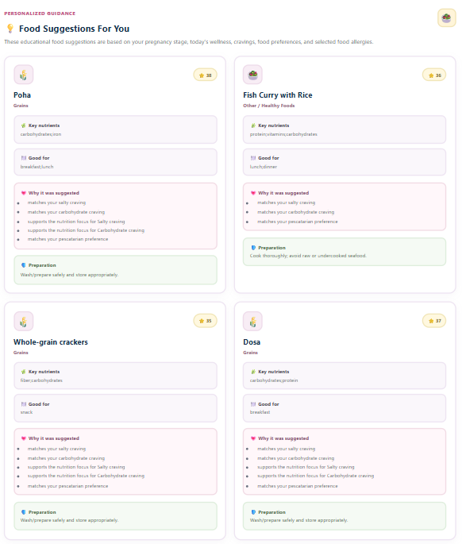
Fig 8.5: Nutrition and Digestion output
8.6 Activity and Exercise
Recommends pregnancy-appropriate exercises based on trimester and daily wellness information. Includes low-impact movement, prenatal yoga, stretching, pelvic floor exercises, and breathing techniques.
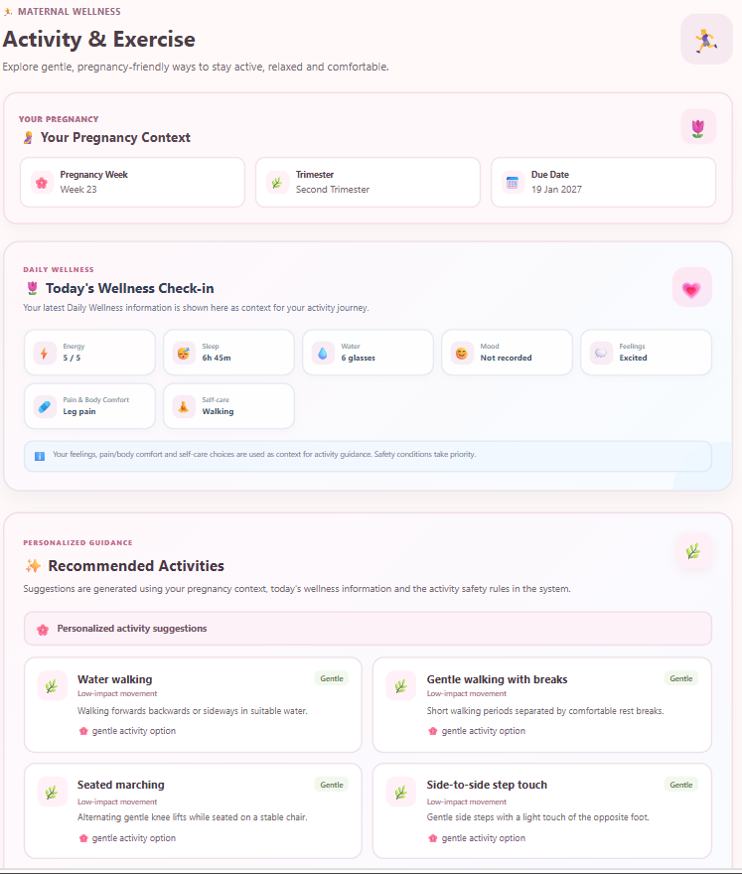
Fig 8.6: Activity and Exercise output
8.7 Maternal Assessment
Evaluates maternal health using inputs such as age, systolic and diastolic blood pressure, blood sugar, body temperature, and heart rate. Uses a machine learning model to predict the maternal risk level as low, medium, or high. Displays prediction results to help users understand their estimated health risk.
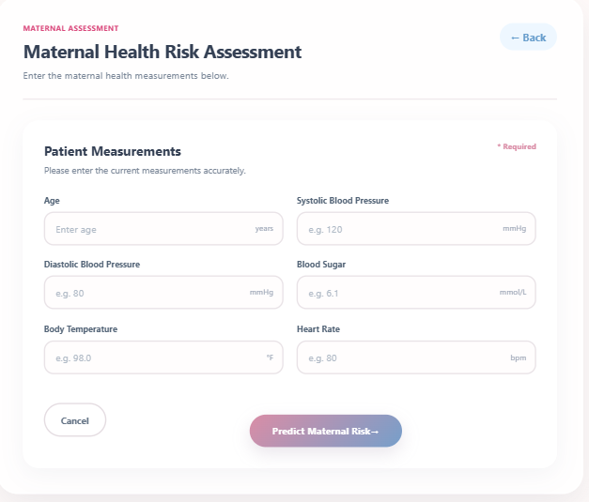
Fig 8.7: Maternal health assessment
8.8 Doctor Visit Report
The Doctor Visit Report module helps users maintain and review important pregnancy-related healthcare information. It provides an organized summary of the user's recorded health and pregnancy information.
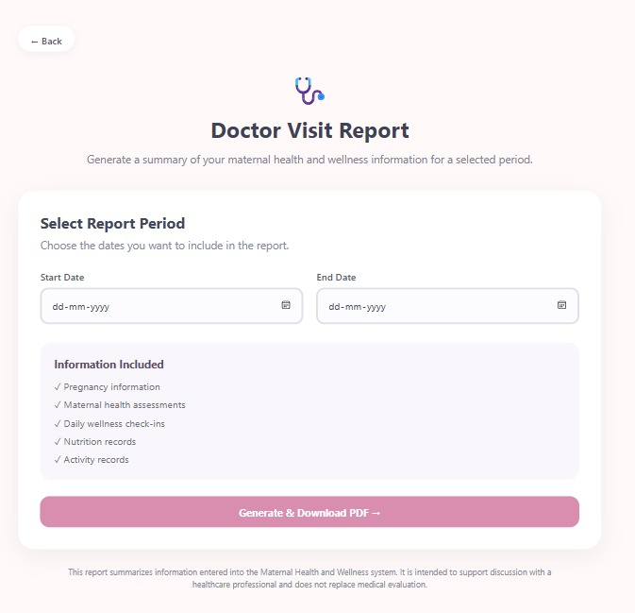
Fig 8.8: Doctor Visit Report
8.9 Maternal History
Stores previous maternal risk assessments and daily wellness records for future reference. Maintains a history of nutrition and physical activity entries. Allows users to review past records and track changes in their wellness over time.
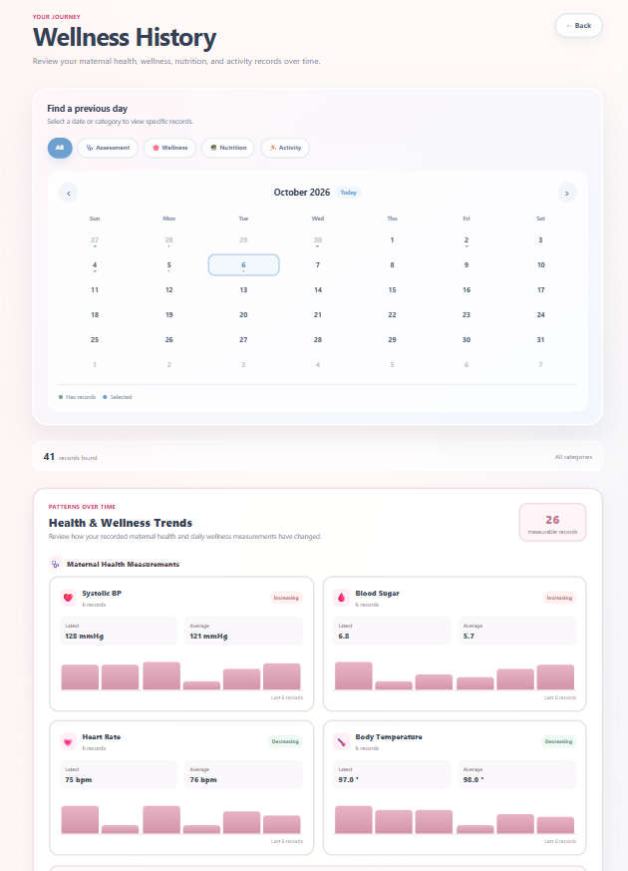
Fig 8.9: wellness history
CHAPTER 9
CONCLUSION AND FUTURE SCOPE
9.1 Conclusion
The Maternal Health Assessment and Wellness Monitoring System is designed to support pregnant women by providing a convenient platform for monitoring maternal health parameters and maintaining daily wellness records. The system combines maternal health assessment with pregnancy tracking and personalized wellness guidance to encourage awareness of health conditions throughout pregnancy.
The maternal health assessment module collects essential parameters such as age, systolic blood pressure, diastolic blood pressure, blood sugar level, body temperature, and heart rate. Based on the configured assessment or prediction model, the system can classify the maternal risk level as Low, Medium, or High. This information can help users understand their assessment results and recognize when further medical consultation may be necessary.
The system also includes pregnancy tracking based on the Last Menstrual Period (LMP) date to estimate the current pregnancy week and trimester. Daily wellness monitoring enables users to record information such as mood, energy level, sleep, water intake, cravings, pain, and digestion. Based on the information recorded, the system can provide suitable food suggestions and general physical activity recommendations.
The use of React.js for the frontend and Python with FastAPI for the backend provides a structured approach to developing the application. Machine learning techniques can support the maternal risk assessment component, while the user interface allows information to be entered and presented in an accessible format.
Overall, the project demonstrates how web technologies and data-driven assessment can be combined to support maternal health awareness and daily wellness monitoring. The system is intended to act as a supportive tool and not as a replacement for professional medical advice, diagnosis, or treatment. Any high-risk assessment or concerning symptoms should be discussed with a qualified healthcare professional.
9.2 Limitations
Although the system provides useful features for maternal health assessment and wellness monitoring, certain limitations remain:
- Input dependency: The quality of the assessment depends on the accuracy and completeness of the health information entered by the user.
- Prediction limitations: The reliability of the maternal risk classification depends on the quality, representativeness, and validation of the dataset and prediction model.
- General wellness recommendations: Food and activity suggestions may not account for every medical condition, dietary restriction, or individual pregnancy complication.
- Limited clinical integration: The system does not replace regular antenatal check-ups or direct consultation with healthcare professionals.
- Need for further validation: The assessment model and recommendations require appropriate testing and clinical evaluation before being relied upon in real-world healthcare settings.
9.3 Future Scope
The system can be enhanced in several ways to improve its usefulness, reliability, and accessibility.
9.3.1 Improved Maternal Risk Prediction
The prediction component can be enhanced using larger, more diverse, and clinically validated maternal health datasets. Different machine learning algorithms can be compared using evaluation metrics such as accuracy, precision, recall, F1-score, and confusion matrix. This would help assess the model's performance and identify areas requiring improvement.
9.3.2 Integration with Healthcare Professionals
In the future, the system could support secure sharing of maternal health summaries with authorized healthcare professionals. This could help users maintain organized records for antenatal consultations. Any such feature would require appropriate access controls and the user's informed consent.
9.3.3 Personalized Nutrition and Wellness Guidance
The recommendation module could be improved to provide more personalized food and activity suggestions based on pregnancy stage, recorded wellness patterns, dietary preferences, and user-provided restrictions. Recommendations should follow reliable medical guidance and include safeguards for users with specific health conditions.
9.3.4 Notifications and Reminders
The system could include optional reminders for regular wellness check-ins, hydration, prescribed supplements, antenatal appointments, and other schedules recommended by a healthcare professional. Users should be able to customize reminders according to their needs.
9.3.5 Advanced Pregnancy Progress Tracking
Pregnancy tracking could be extended to display weekly information about pregnancy progress, upcoming milestones, and general maternal wellness guidance. The estimated pregnancy week and due date should be clearly identified as estimates and confirmed by a healthcare professional when necessary.
9.3.6 Enhanced Data Security and Privacy
Future development could introduce stronger privacy controls, encrypted storage and communication, secure account management, role-based access, and appropriate data backup procedures. These improvements would help protect sensitive maternal health information.
9.3.7 Mobile-Friendly and Multilingual Support
The system could be optimized further for mobile browsers and made available in multiple languages, including Hindi and other regional languages. This could improve accessibility for users who have limited technical experience or prefer receiving health information in their local language.
9.3.8 Long-Term Wellness Analytics
Future versions could provide charts and summaries of recorded blood pressure, blood sugar, wellness check-ins, and other supported parameters over time. These summaries could help users observe changes in their records and discuss them with healthcare professionals.
REFERENCES
[1] S. A. Auxilia and M. Thirugnanam, “An AutoML-Based Stacked Ensemble Framework for Early Prediction of Maternal Health Risks,” Scientific Reports, 2026. Available: https://doi.org/10.1038/s41598-026-73295-z
[2] M. Mousavi Nogholi, A. Mozdgir, and Y. Javid, “High-Risk Pregnancy Prediction Using Taguchi-Optimized Machine Learning Methods and TOPSIS-Based Model Selection,” Scientific Reports, vol. 16, 2026. Available: https://doi.org/10.1038/s41598-026-55011-z
[3] “Enhancing Maternal Health Risk Prediction: Addressing Class Imbalance with Oversampling and Machine Learning,” Procedia Computer Science, vol. 283, pp. 5536–5546, 2026. Available: https://doi.org/10.1016/j.procs.2026.06.603
[4] World Health Organization, WHO Recommendations on Maternal Health: Guidelines Approved by the WHO Guidelines Review Committee, 2nd ed., 2025. Available: https://www.who.int/publications/b/59332
[5] “Machine Learning Models to Predict Risk of Maternal Morbidity and Mortality From Electronic Medical Record Data: Scoping Review,” 2025. Available: https://www.sciencedirect.com/org/science/article/pii/S143888712501091X
[6] A. O. Khadidos et al., “Ensemble Machine Learning Framework for Predicting Maternal Health Risk During Pregnancy,” Scientific Reports, vol. 14, article 21483, 2024. Available: https://doi.org/10.1038/s41598-024-71934-x
[7] S. S. Al Mashrafi, L. Tafakori, and M. Abdollahian, “Predicting Maternal Risk Level Using Machine Learning Models,” BMC Pregnancy and Childbirth, vol. 24, article 820, 2024. Available: https://doi.org/10.1186/s12884-024-07030-9
[8] “Comparative Analysis of Machine Learning Decision Tree-Based Models for Predicting Maternal Health Risks,” Procedia Computer Science, vol. 245, pp. 57–64, 2024. Available: https://doi.org/10.1016/j.procs.2024.10.229
[9] “Machine Learning-Enabled Maternal Risk Assessment for Women With Pre-Eclampsia (the PIERS-ML Model): A Modelling Study,” The Lancet Digital Health, vol. 6, no. 4, pp. e238–e250, 2024. Available: https://doi.org/10.1016/S2589-7500(23)00267-4
[10] “Machine Learning and Disease Prediction in Obstetrics,” Computational and Structural Biotechnology Journal, 2023. Available: https://doi.org/10.1016/j.crphys.2023.100099
[11] “New Advances in Prediction and Surveillance of Preeclampsia: Role of Machine Learning Approaches and Remote Monitoring,” Archives of Gynecology and Obstetrics, vol. 308, pp. 1663–1677, 2023. Available: https://doi.org/10.1007/s00404-022-06864-y
[12] M. N. Islam, S. N. Mustafina, T. Mahmud, and N. I. Khan, “Machine Learning to Predict Pregnancy Outcomes: A Systematic Review, Synthesizing Framework and Future Research Agenda,” BMC Pregnancy and Childbirth, vol. 22, article 348, 2022. Available: https://doi.org/10.1186/s12884-022-04594-2
[13] A. Bertini, R. Salas, S. Chabert, L. Sobrevia, and F. Pardo, “Using Machine Learning to Predict Complications in Pregnancy: A Systematic Review,” Frontiers in Bioengineering and Biotechnology, vol. 9, article 780389, 2022. Available: https://doi.org/10.3389/fbioe.2021.780389
[14] World Health Organization, WHO Guidelines on Physical Activity and Sedentary Behaviour, 2020; online publication and recommendations relevant to pregnancy and postpartum activity. Available: https://www.ncbi.nlm.nih.gov/books/NBK566046/
[15] World Health Organization, WHO Guidelines on Physical Activity and Sedentary Behaviour, 2020. Available: https://www.who.int/publications/i/item/9789240015128
[16] UCI Machine Learning Repository, “Maternal Health Risk Dataset.” Dataset containing maternal health attributes such as age, systolic and diastolic blood pressure, blood sugar, body temperature, heart rate, and risk level. Available: https://archive.ics.uci.edu/dataset/863/maternal+health+risk
[17] World Health Organization, “WHO Recommendations on Antenatal Care for a Positive Pregnancy Experience,” 2016. Available: https://www.who.int/publications/i/item/9789241549912

