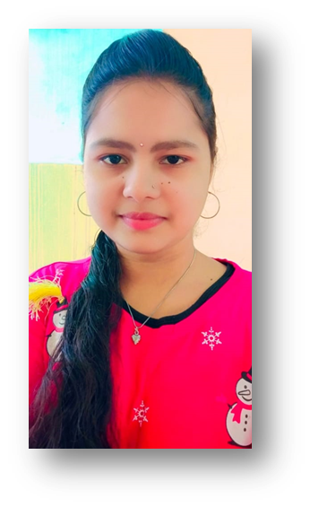 |  | KANTAYAPALEM MEGHANA
Profile  NAME: kantayapalem Meghana  ROLL NO: 23WH1A12C1  COLLEGE: BVRIT HYDERABAD college of engineering for Women  BTECH : 1ST YEAR  SEM : 2  Contact  Mobile no:  9505113160  EMAIL:  23wh1a12c1@bvrithyderabad.edu.in  - https://www.linkedin.com/in/megha-k-99794728a  Hobbies  - listening songs  - Watching movies  - Travelling long  - Exploring new things  - Learning something new  - Reading books  - Playing badminton  WEBSITES: Where I practiced coding  - https://snakify.org/profile/  - https://github.com/Sudha4884/PPS-2023-IT-B/tree/main/23WH1A12C1  - https://www.hackerrank.com/domains/c?filters%5Bstatus%5D%5B%5D=unsolved&badge_type=c  - https://www.hackerrank.com/domains/python?filters%5Bstatus%5D%5B%5D=unsolved&badge_type=python |  | EDUCATION  SIDDHARTHA HIGH SCHOOL  FROM : childhood to till 10th  Prizes: Academic prizes , outdoor games, indoor games etc ,.  TOPPER IN ACADEMICS  GPA: 10.0  NRI Junior College  FROM: inter 1st and 2nd years  Prizes: campus topper in 1st year  CAMPUS TOPPER with 987 marks  GPA: 98.7  bvrit hyderabad college of engineering for women  BTECH – present  CGPA: Sem1 – 9.35  VOLUNTEER – from NSS and Nature club  PRIZES - Best paper award( 1000 rupees cash prize),paper presentation memo  1st Sem – participated in ted x , toast masters, research on pure earth( paper presentation),  CERTIFICATES – voting awareness, Ted x , toast masters , pure earth foundation research, energy swaraj certificate, space week  working experience  studying in BVRIT HYDERABAD college of engineering for women from 9 months  SKILLS  - programing languages: c, python  - web technologies: html, css (basics)  - Technical skills  - Drawing pictures  PROJECT  Caesar Cipher Cryptography  During my SEM1 , I undertook a cryptography project utilizing the C. Through hands-on coding .I gained valuable insights into the principles of cryptography and honed my skills in secure coding practices. This experience enhanced my understanding of cybersecurity concepts and prepared me for tackling real-world encryption challenges.

