**CIA 1**

**Q1:**

**CODE:**

**package** com.selenium.day4_project;

**import** org.openqa.selenium.By;

**import** org.openqa.selenium.WebDriver;

**import** org.openqa.selenium.chrome.ChromeDriver;

**import** org.openqa.selenium.chrome.ChromeOptions;

**import** io.github.bonigarcia.wdm.WebDriverManager;

**public** **class** cia1_q1 {

**public** **static** **void** main( String[] args ) **throws** InterruptedException

{

ChromeOptions co = **new** ChromeOptions();

co.addArguments("--remote-allow-origins=*");

WebDriverManager.*chromedriver*().setup();

WebDriver driver = **new** ChromeDriver(co);

driver.get("https://www.amazon.in/Lenovo-IdeaPad-Gaming-39-62cm-82K201V2IN/dp/B0B7RXC1Y1/ref=sr_1_1_sspa?crid=1ADD4UB25DN4A&keywords=laptops&qid=1683195740&sprefix=laptop%2Caps%2C684&sr=8-1-spons&sp_csd=d2lkZ2V0TmFtZT1zcF9hdGY&th=1");

driver.manage().window().maximize();

String title = driver.getTitle();

String etitle = "Lenovo IdeaPad Gaming 3 AMD Ryzen 7 5800H 15.6\" (39.62cm) FHD IPS 120Hz Gaming Laptop (8GB/512GB SSD/Win 11/Office 2021/NVIDIA RTX 3050 4GB/Alexa/3 Month Game Pass/Shadow Black/2.2Kg), 82K201V2IN : Amazon.in: Computers & Accessories";

System.***out***.println(title);

**if**(title.equals(etitle)) {

System.***out***.println("Title is matching");

}

**else** {

System.***out***.println("Title Mismatch");

}

driver.findElement(By.*xpath*("//*[@id=\"add-to-cart-button\"]")).click();

Thread.*sleep*(5000);

Boolean present = driver.findElement(By.*xpath*("//*[@id=\"attach-close_sideSheet-link\"]")).isDisplayed();

System.***out***.println("Is item added to cart:" + present);

driver.get("https://www.amazon.in/gp/cart/view.html/ref=dp_atch_dss_cart?");

Thread.*sleep*(5000);

driver.findElement(By.*xpath*("//*[@value=\"Delete\"]")).click();

Thread.*sleep*(2000);

String removeText = driver.findElement(By.*xpath*("//*[@id=\"sc-active-cart\"]/div/div[1]/div/h1")).getText();

String extext = "Your Amazon Cart is empty.";

**if**(removeText.equals(extext)) {

System.***out***.println("Product is removed");

}

driver.get("https://www.amazon.in/ASUS-15-6-inch-GeForce-Windows-FA506IHRZ-HN111W/dp/B0B5DZTNZQ?ref_=Oct_DLandingS_D_6c1a28b8_61");

driver.findElement(By.*xpath*("//*[@id=\"add-to-cart-button\"]")).click();

Thread.*sleep*(2000);

driver.get("https://www.amazon.in/gp/cart/view.html/ref=dp_atch_dss_cart?");

Thread.*sleep*(5000);

driver.findElement(By.*xpath*("//*[@id=\"a-autoid-0-announce\"]")).click();

driver.findElement(By.*xpath*("//*[@id=\"quantity_2\"]")).click();

Thread.*sleep*(3000);

driver.findElement(By.*xpath*("//*[@name=\"proceedToRetailCheckout\"] ")).click();

Thread.*sleep*(1000);

String sign = driver.getTitle();

System.***out***.println(sign);

String esign = "Amazon Sign In";

**if**(sign.equals(esign)) {

System.***out***.println("Success");

}

**else** {

System.***out***.println("Failure");

}

driver.findElement(By.*id*("ap_email")).sendKeys("phoojasubramanian@gmail.com");

driver.findElement(By.*id*("continue")).click();

driver.findElement(By.*id*("ap_password")).sendKeys("Phooja2003$");

driver.findElement(By.*id*("signInSubmit")).click();

String ur = driver.getCurrentUrl();

System.***out***.println("Url of the payment page :"+ ur);

}

}

**OUTPUT:**

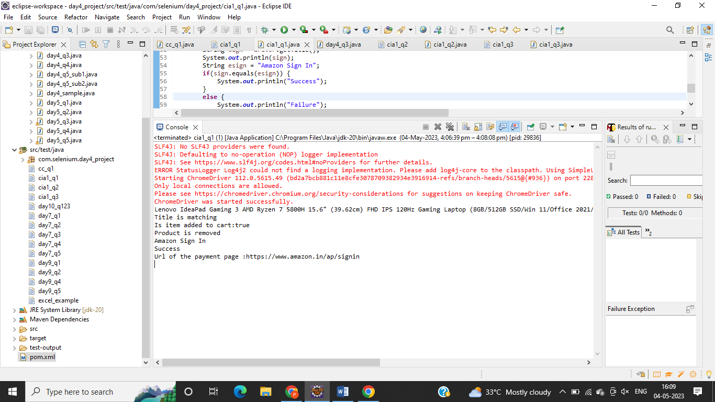

**Q2:**

**CODE:**

**package** com.selenium.day4_project;

**import** java.util.List;

**import** org.openqa.selenium.By;

**import** org.openqa.selenium.Keys;

**import** org.openqa.selenium.WebDriver;

**import** org.openqa.selenium.WebElement;

**import** org.openqa.selenium.chrome.ChromeDriver;

**import** org.openqa.selenium.chrome.ChromeOptions;

**import** org.testng.annotations.Test;

**import** io.github.bonigarcia.wdm.WebDriverManager;

**public** **class** cia1_q2 {

@Test

**public** **void** f() {

**int** productCount = 0;

WebDriverManager.*chromedriver*().setup();

ChromeOptions co = **new** ChromeOptions();

co.addArguments("--remote-allow-origins=*");

WebDriver driver=**new** ChromeDriver(co);

driver.get("https://www.amazon.in/");

driver.manage().window().maximize();

driver.findElement(By.*id*("twotabsearchtextbox")).sendKeys("laptops");

driver.findElement(By.*id*("twotabsearchtextbox")).sendKeys(Keys.***ENTER***);

List<WebElement> tiltleElements = driver.findElements(By.*xpath*("//h2[@class='a-size-mini a-spacing-none a-color-base s-line-clamp-2']"));

**for** (WebElement titleElement : tiltleElements) {

System.***out***.println(titleElement.getText());

productCount++;

**if**(productCount == 5) {

**break**;

}

}

System.***out***.println("===========================================================");

WebElement sort = driver.findElement(By.*xpath*("//*[@id=\"a-autoid-0-announce\"]"));

sort.click();

System.***out***.println("Applied Filter!");

WebElement lhfilter = driver.findElement(By.*xpath*("//*[@id=\"s-result-sort-select_1\"]"));

lhfilter.click();

System.***out***.println("Applied Filter based on Price");

sort.click();

WebElement reviewfilter = driver.findElement(By.*xpath*("//*[@id=\"s-result-sort-select_3\"]"));

reviewfilter.click();

System.***out***.println("Applied Filter based on Reviews");

}

}

**OUTPUT:**

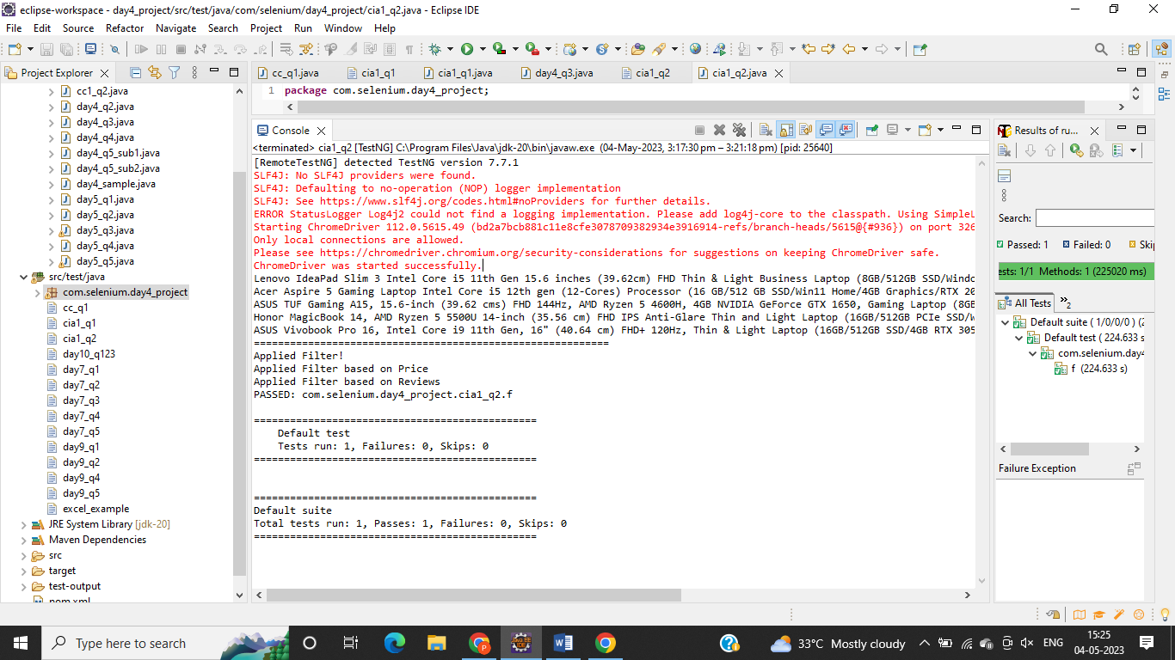

**Q3:**

**CODE:**

**package** com.selenium.day4_project;

**import** org.openqa.selenium.By;

**import** org.openqa.selenium.WebDriver;

**import** org.openqa.selenium.WebElement;

**import** org.openqa.selenium.chrome.ChromeDriver;

**import** org.openqa.selenium.chrome.ChromeOptions;

**import** io.github.bonigarcia.wdm.WebDriverManager;

**public** **class** cia1_q3{

**public** **static** **void** main(String[] args) {

ChromeOptions co=**new** ChromeOptions();

co.addArguments ("--remote-allow-origins=*");

WebDriverManager.*chromedriver*().setup ();

WebDriver driver=**new** ChromeDriver(co);

driver.get ("https://www.amazon.in/");

driver.manage().window().maximize() ;

String currentTitle=driver.getTitle();

System.***out***.println(currentTitle);

String expectedTitle="Online Shopping site in India: Shop Online for Mobiles, Books, Watches, Shoes and More - Amazon.in";

**if**(currentTitle.equals(expectedTitle)) {

System.***out***.println("Title Matched");

}

**else** {

System.***out***.println("Title not Matched");

}

driver.findElement(By.*xpath*("//*[@id=\"nav-link-accountList\"]")).click();

WebElement txtBoxl=driver.findElement(By.*xpath*("//*[@id=\"ap_email\"]"));

txtBoxl.sendKeys("phoojasubramanian@gmail.com");

driver.findElement(By.*xpath*("//*[@id=\"continue\"]")).click();

WebElement txtBox2=driver.findElement(By.*xpath*("//*[@id=\"ap_password\"]"));

txtBox2.sendKeys("Phooja2003$");

driver.findElement(By.*xpath*("//*[@id=\"signInSubmit\"]")).click();

driver.findElement(By.*xpath*("//*[@id=\"nav-link-accountList\"]")).click();

driver.findElement(By.*xpath*("//*[@id=\"a-page\"]/div[2]/div/div[2]/div[1]/a/div/div")).click();

driver.findElement(By.*xpath*("//*[@id=\"a-autoid-2-announce\"]")).click();

driver.findElement(By.*xpath*("//*[@id=\"ordersInPackage-container\"]/div/div/a[1]")).click();

}

}

**OUTPUT:**

