Woxsen University
School of Technology
──────────────────────────────────────────────

A PROJECT REPORT
on
DESIGN AND IMPLEMENTATION OF A
DATABASE MANAGEMENT SYSTEM FOR
STUDENT ATTENDANCE AND LEAVE APPROVAL SYSTEM
(Project 26 – Database Management Systems PBL)
Submitted in partial fulfilment of the requirements
for the course
Database Management Systems
Submitted by:
N. Meghamsh Yadav Roll No. 25WU0102175
Section:AI/ML Leopards
Course Id :25TU03MJM0
Submitted to : Dr.C Nagaraju
Department of School Of Technology
Academic Year 2025 – 2026
Link : https://d.docs.live.net/2A574D9769486535/Documents/DBMS_Project26_Student_Attendance_Leave_Approval_Presentation%20(1).pptx

CERTIFICATE
──────────────────────────────────────────────
This is to certify that the project report entitled "Design and Implementation of a Database Management System for Student Attendance and Leave Approval System" submitted by the N. Meghamsh Yadav , in partial fulfilment of the requirements for the course Database Management Systems during the academic year 2025–2026, is a bona fide record of the work carried out by them under my supervision and guidance.
The project work embodied in this report has not been submitted earlier for the award of any degree or diploma to the best of my knowledge.

Date: 13- 10-2026

DECLARATION
──────────────────────────────────────────────
I hereby declare that the project work entitled "Design and Implementation of a Database Management System for Student Attendance and Leave Approval System" submitted to the Department of Computer Science & Engineering is a record of original work done by us under the guidance of Faculty Guide.
We further declare that this project report has not been submitted to any other University or Institution for the award of any degree, diploma or certificate.
All sources of information have been specifically acknowledged by way of reference.

N. Meghamsh Yadav – Roll No. 25WU0102175

Date: 13- 10-2026

ACKNOWLEDGEMENT
──────────────────────────────────────────────
I express our sincere gratitude to our project guide Faculty Guide, Assistant / Associate Professor, Department of Computer Science & Engineering, for the continuous guidance, valuable suggestions and encouragement throughout the course of this project work.
I am thankful to the Head of the Department for providing the necessary facilities and a conducive environment for carrying out this project-based learning activity.
I also thank all the faculty members of the Department of Computer Science & Engineering for their support and the knowledge imparted during the Database Management Systems course, which formed the foundation of this work.
Finally, I thank our parents and friends for their constant moral support.
N.Meghamsh Yadav
ABSTRACT
──────────────────────────────────────────────
Educational institutions require accurate, real-time tracking of student attendance and a structured workflow for leave applications and approvals. Manual registers and disconnected spreadsheets lead to calculation errors, delayed shortage alerts and inefficient leave processing.
This project presents the design and implementation of a relational database management system for Student Attendance and Leave Approval. The system models the principal entities—students, courses, sections, faculty, class sessions, attendance records, leave types, leave applications, approvals, makeup sessions and shortage alerts—and captures their relationships through a conceptual Entity-Relationship diagram.
The ER model is translated into a relational schema that is normalized up to Third Normal Form (3NF). Integrity constraints enforce unique attendance records per student-session, valid status codes, valid leave date ranges, authorised approval and percentage bounds. The database is implemented using MySQL (or PostgreSQL) and populated with realistic sample data.
SQL queries and views produce attendance percentages, shortage lists, leave history, course summaries, monthly trends and makeup attendance reports. A Python front-end application supports session creation, attendance marking, leave submission and approval, makeup entry, percentage calculation and reporting. The work demonstrates normalization, data integrity, transaction awareness, indexing and systematic testing.
Keywords: Attendance Management, Leave Approval, ER Modelling, Normalization, 3NF, MySQL, Python, CRUD, Shortage Alerts

TABLE OF CONTENTS
──────────────────────────────────────────────
Certificate ........................................................................................................ i
Declaration ...................................................................................................... ii
Acknowledgement ............................................................................................ iii
Abstract ......................................................................................................... iv
Table of Contents ............................................................................................. v
1. Introduction ............................................................................................... 1
1.1 Problem Identification ........................................................................ 1
1.2 Motivation ....................................................................................... 1
1.3 Scope of the Project .......................................................................... 2
2. Objectives, Users & Functional Requirements ............................................... 2
2.1 Objectives ....................................................................................... 2
2.2 Users / Roles ................................................................................... 3
2.3 Functional Requirements ................................................................... 3
3. Conceptual Design – Entity Relationship Diagram ......................................... 4
3.1 Entity Descriptions ........................................................................... 4
3.2 Relationships & Cardinality .............................................................. 5
3.3 ER Diagram ...................................................................................... 6
4. Relational Schema ..................................................................................... 7
5. Normalization to 3NF & Functional Dependencies .......................................... 8
6. Data Dictionary ......................................................................................... 9
7. DDL Scripts with Integrity Constraints ....................................................... 11
8. Sample Data & SQL Queries / Reports ........................................................ 13
9. Application Design (Python Front-End) ....................................................... 15
10. Implementation Highlights & Testing ......................................................... 16
11. Conclusion & Future Scope ....................................................................... 17
12. References ............................................................................................. 18
Appendix A – Sample Screenshots / Output .................................................... 19

1. INTRODUCTION

1.1 Problem Identification
Educational institutions rely heavily on accurate attendance tracking and timely leave management. Traditional paper-based registers or disconnected spreadsheets lead to delayed consolidation, calculation errors in attendance percentages, missed shortage alerts, and inefficient leave-approval workflows.
Faculty members struggle to mark attendance for multiple sections, compute shortage lists before examinations, and process leave applications that require structured approval. Students face uncertainty regarding their attendance status and leave balances. Administrative staff cannot generate reliable course-wise or monthly trend reports quickly.
This project designs and implements a centralized relational database system that integrates class sessions, attendance marking, leave application & approval, makeup sessions and automated shortage alerts into a single coherent application, thereby eliminating data duplication and enabling real-time reporting.

1.2 Motivation
The motivation for this project stems from the real-world observation that attendance and leave management remain among the most error-prone administrative processes in academic institutions. A well-designed database system can:
• Eliminate duplicate and inconsistent attendance entries.
• Provide instant attendance percentage calculation and shortage alerts.
• Enforce a transparent, auditable leave-approval workflow.
• Generate management reports that support academic decision-making.

1.3 Scope of the Project
The system covers a single academic institution at the department/college level. It manages multiple courses, sections, faculty members, students, class sessions, daily attendance, leave types, leave applications with approval workflow, makeup sessions and threshold-based shortage alerts. The system does not cover fee management, examination scheduling, hostel attendance or multi-campus federation.

2. OBJECTIVES, USERS & FUNCTIONAL REQUIREMENTS

2.1 Objectives
1. Design a conceptual ER model capturing all principal entities and relationships.
2. Translate the ER model into a normalized relational schema (up to 3NF) with complete integrity constraints.
3. Implement the schema in MySQL / PostgreSQL with realistic sample data.
4. Write SQL queries and views that produce attendance percentages, shortage lists, leave history, course summaries and monthly trends.
5. Develop a simple Python front-end supporting CRUD operations, leave workflow and report generation.
6. Demonstrate data integrity, transaction awareness, indexing and systematic testing.

2.2 Users / Roles
• Student – view own attendance, submit leave applications, view leave status and percentage.
• Faculty / Course Instructor – create sessions, mark attendance, view section reports, recommend leave.
• Head of Department / Approver – approve or reject leave applications.
• Administrator – manage master data (students, courses, sections, faculty, leave types), generate institution-wide reports.

2.3 Functional Requirements
1. Session Management: Create, update and close class sessions linked to course-section-faculty.
2. Attendance Marking: Record Present / Absent / Late / On-Leave for every student in a session (exactly one record per student per session).
3. Leave Application: Students submit leave with type, from-date, to-date and reason.
4. Leave Approval Workflow: Approval with status tracking (Pending / Approved / Rejected / Cancelled).
5. Makeup Sessions: Schedule and record attendance for compensatory classes.
6. Percentage Calculation & Alerts: Automatically compute attendance percentage; generate shortage alerts when below threshold (default 75 %).
7. Search & Reports: Student-wise history, course-wise summary, monthly trends, leave history, shortage list.
8. Data Integrity: Enforce unique attendance records, valid date ranges, authorised approval and percentage bounds.

3. CONCEPTUAL DESIGN – ENTITY RELATIONSHIP DIAGRAM

3.1 Entity Descriptions
• Student – student_id (PK), reg_no (UNIQUE), name, email, programme, year, section_id (FK).
• Course – course_id (PK), course_code (UNIQUE), title, credits, department.
• Section – section_id (PK), course_id (FK), section_name, academic_year, semester, capacity.
• Faculty – faculty_id (PK), name, email, department, designation.
• ClassSession – session_id (PK), section_id (FK), faculty_id (FK), session_date, start_time, end_time, topic, status.
• Attendance – attendance_id (PK), session_id (FK), student_id (FK), status (Present/Absent/Late/On-Leave), marked_at. UNIQUE(session_id, student_id).
• LeaveType – leave_type_id (PK), type_name (Casual/Medical/On-Duty/…), max_days, requires_document.
• LeaveApplication – application_id (PK), student_id (FK), leave_type_id (FK), from_date, to_date, reason, status, applied_on.
• Approval – approval_id (PK), application_id (FK), approver_id (FK → Faculty), decision, comments, decided_on.
• MakeupSession – makeup_id (PK), original_session_id (FK), section_id (FK), scheduled_date, faculty_id (FK), status.
• Alert – alert_id (PK), student_id (FK), section_id (FK), alert_type, percentage, generated_on, acknowledged.

3.2 Relationships & Cardinality
• A Section belongs to one Course; a Course may have many Sections (M:1).
• A ClassSession is conducted for one Section by one Faculty (M:1).
• Attendance links Student ↔ ClassSession (M:N with attributes status, marked_at).
• A Student may submit many LeaveApplications; each Application has one or more Approvals.
• A MakeupSession compensates for a missed ClassSession.
• Alerts are generated for Students whose attendance falls below the threshold in a Section.

3.3 ER Diagram
Figure 1 below presents the complete Entity-Relationship diagram showing all entities, their key attributes, primary keys, foreign keys and the relationships among them.
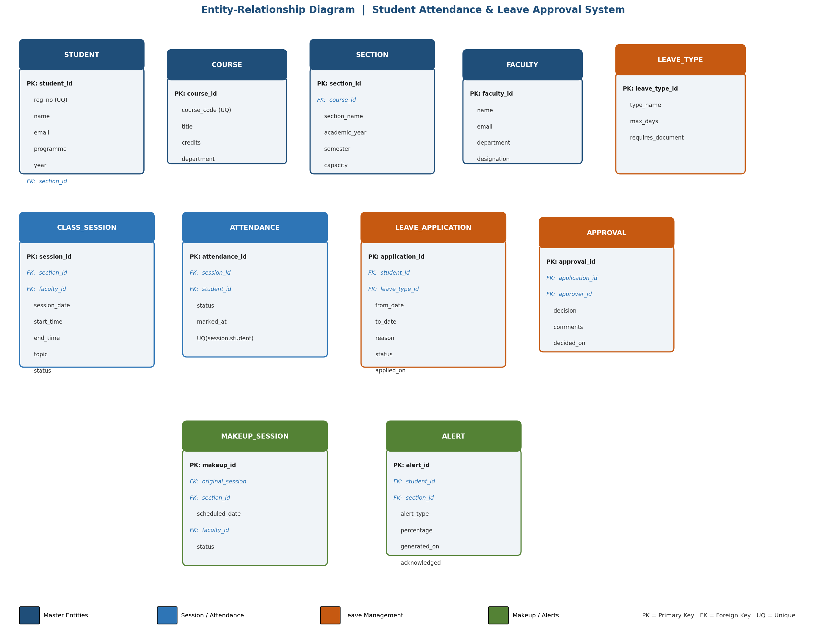
Figure 1: Entity-Relationship Diagram – Student Attendance & Leave Approval System

4. RELATIONAL SCHEMA
The ER model is converted into the following relational schema. Primary keys are underlined; foreign keys are indicated with arrows.

Core Academic Tables
• STUDENT (student_id, reg_no, name, email, programme, year, section_id → SECTION)
• COURSE (course_id, course_code, title, credits, department)
• SECTION (section_id, course_id → COURSE, section_name, academic_year, semester, capacity)
• FACULTY (faculty_id, name, email, department, designation)

Session & Attendance
• CLASS_SESSION (session_id, section_id → SECTION, faculty_id → FACULTY, session_date, start_time, end_time, topic, status)
• ATTENDANCE (attendance_id, session_id → CLASS_SESSION, student_id → STUDENT, status, marked_at) UNIQUE(session_id, student_id)

Leave Management
• LEAVE_TYPE (leave_type_id, type_name, max_days, requires_document)
• LEAVE_APPLICATION (application_id, student_id → STUDENT, leave_type_id → LEAVE_TYPE, from_date, to_date, reason, status, applied_on)
• APPROVAL (approval_id, application_id → LEAVE_APPLICATION, approver_id → FACULTY, decision, comments, decided_on)

Makeup & Alerts
• MAKEUP_SESSION (makeup_id, original_session_id → CLASS_SESSION, section_id → SECTION, scheduled_date, faculty_id → FACULTY, status)
• ALERT (alert_id, student_id → STUDENT, section_id → SECTION, alert_type, percentage, generated_on, acknowledged)

5. NORMALIZATION TO 3NF & FUNCTIONAL DEPENDENCIES

5.1 Selected Functional Dependencies
• student_id → reg_no, name, email, programme, year, section_id
• reg_no → student_id (candidate key)
• course_id → course_code, title, credits, department
• section_id → course_id, section_name, academic_year, semester, capacity
• session_id → section_id, faculty_id, session_date, start_time, end_time, topic, status
• session_id, student_id → status, marked_at
• application_id → student_id, leave_type_id, from_date, to_date, reason, status, applied_on
• approval_id → application_id, approver_id, decision, comments, decided_on

5.2 Normalization Steps
1NF: All attributes are atomic; there are no repeating groups or multi-valued attributes. Each table has a well-defined primary key.
2NF: No partial dependency exists. The only composite key appears in ATTENDANCE (session_id, student_id as a UNIQUE constraint), and both components are required to determine status and marked_at. All other tables have single-attribute primary keys.
3NF: No transitive dependencies remain. For example, department is stored with COURSE and FACULTY rather than being derived through another non-key attribute. Section capacity and academic year are attributes of SECTION, not of COURSE.
Conclusion: The schema is in Third Normal Form (3NF).

6. DATA DICTIONARY
A concise data dictionary for the principal tables and critical columns is given below.
Table.Column | Data Type | Constraints | Description
STUDENT.student_id | INT | PK, AI | Surrogate primary key
STUDENT.reg_no | VARCHAR(20) | UNIQUE, NOT NULL | University registration number
STUDENT.section_id | INT | FK → SECTION | Section to which student belongs
COURSE.course_code | VARCHAR(15) | UNIQUE, NOT NULL | Unique course code (e.g. CS301)
CLASS_SESSION.session_date | DATE | NOT NULL | Date on which class was held
ATTENDANCE.status | ENUM | NOT NULL, CHECK | Present / Absent / Late / On-Leave
ATTENDANCE (session,student) | — | UNIQUE | One attendance record per student per session
LEAVE_APPLICATION.from_date | DATE | NOT NULL, CHECK | Must be ≤ to_date
LEAVE_APPLICATION.status | ENUM | NOT NULL, DEFAULT | Pending / Approved / Rejected / Cancelled
APPROVAL.decision | ENUM | NOT NULL | Approved / Rejected
ALERT.percentage | DECIMAL(5,2) | CHECK 0–100 | Computed attendance % that triggered the alert

7. DDL SCRIPTS WITH INTEGRITY CONSTRAINTS
The following integrity rules are enforced through declarative constraints:
• One attendance record per student per session → UNIQUE (session_id, student_id)
• Valid status codes → ENUM constraint
• Valid leave dates → CHECK (from_date ≤ to_date)
• Authorised approval → FOREIGN KEY to Faculty
• Percentage range → CHECK (percentage BETWEEN 0 AND 100)

Representative DDL (MySQL syntax)
CREATE TABLE student (
student_id INT AUTO_INCREMENT PRIMARY KEY,
reg_no VARCHAR(20) NOT NULL UNIQUE,
name VARCHAR(100) NOT NULL,
email VARCHAR(120),
programme VARCHAR(50),
year TINYINT,
section_id INT,
FOREIGN KEY (section_id) REFERENCES section(section_id)
);
CREATE TABLE class_session (
session_id INT AUTO_INCREMENT PRIMARY KEY,
section_id INT NOT NULL,
faculty_id INT NOT NULL,
session_date DATE NOT NULL,
start_time TIME,
end_time TIME,
topic VARCHAR(200),
status ENUM('Scheduled','Conducted','Cancelled') DEFAULT 'Scheduled',
FOREIGN KEY (section_id) REFERENCES section(section_id),
FOREIGN KEY (faculty_id) REFERENCES faculty(faculty_id)
);
CREATE TABLE attendance (
attendance_id INT AUTO_INCREMENT PRIMARY KEY,
session_id INT NOT NULL,
student_id INT NOT NULL,
status ENUM('Present','Absent','Late','On-Leave') NOT NULL,
marked_at TIMESTAMP DEFAULT CURRENT_TIMESTAMP,
UNIQUE KEY uq_session_student (session_id, student_id),
FOREIGN KEY (session_id) REFERENCES class_session(session_id),
FOREIGN KEY (student_id) REFERENCES student(student_id)
);
CREATE TABLE leave_application (
application_id INT AUTO_INCREMENT PRIMARY KEY,
student_id INT NOT NULL,
leave_type_id INT NOT NULL,
from_date DATE NOT NULL,
to_date DATE NOT NULL,
reason TEXT,
status ENUM('Pending','Approved','Rejected','Cancelled') DEFAULT 'Pending',
applied_on TIMESTAMP DEFAULT CURRENT_TIMESTAMP,
CHECK (from_date <= to_date),
FOREIGN KEY (student_id) REFERENCES student(student_id),
FOREIGN KEY (leave_type_id) REFERENCES leave_type(leave_type_id)
);
CREATE TABLE approval (
approval_id INT AUTO_INCREMENT PRIMARY KEY,
application_id INT NOT NULL,
approver_id INT NOT NULL,
decision ENUM('Approved','Rejected') NOT NULL,
comments TEXT,
decided_on TIMESTAMP DEFAULT CURRENT_TIMESTAMP,
FOREIGN KEY (application_id) REFERENCES leave_application(application_id),
FOREIGN KEY (approver_id) REFERENCES faculty(faculty_id)
);
Recommended indexes: student.reg_no, attendance.session_id, attendance.student_id, leave_application.status, class_session.session_date.

8. SAMPLE DATA & SQL QUERIES / REPORTS

8.1 Sample Data Overview
Realistic sample data populated for demonstration: approximately 120 students across 6 sections, 8 faculty members, 4 courses, 45 class sessions, ~2,800 attendance records, 35 leave applications (various statuses), 5 makeup sessions and 18 shortage alerts.

8.2 Key Queries & Views

Q1 – Student-wise Attendance Percentage
SELECT s.reg_no, s.name, sec.section_name,
COUNT(*) AS total_sessions,
SUM(CASE WHEN a.status IN ('Present','Late') THEN 1 ELSE 0 END) AS present_count,
ROUND(100.0 * SUM(CASE WHEN a.status IN ('Present','Late') THEN 1 ELSE 0 END)
/ COUNT(*), 2) AS percentage
FROM attendance a
JOIN student s ON a.student_id = s.student_id
JOIN class_session cs ON a.session_id = cs.session_id
JOIN section sec ON cs.section_id = sec.section_id
GROUP BY s.student_id, sec.section_id;

Q2 – Shortage List (below 75 %)
CREATE OR REPLACE VIEW v_shortage AS
SELECT reg_no, name, section_name, percentage
FROM ( <Q1 subquery> ) AS pct
WHERE percentage < 75;

Q3 – Leave History of a Student
SELECT la.application_id, lt.type_name, la.from_date, la.to_date,
la.status, ap.decision, ap.comments, ap.decided_on
FROM leave_application la
JOIN leave_type lt ON la.leave_type_id = lt.leave_type_id
LEFT JOIN approval ap ON la.application_id = ap.application_id
WHERE la.student_id = ?
ORDER BY la.applied_on DESC;

Q4 – Course / Section Summary
Aggregate present percentage per section, total sessions conducted, and number of shortage students using GROUP BY section_id with conditional aggregation.

Q5 – Monthly Attendance Trend
GROUP BY YEAR(session_date), MONTH(session_date) to produce month-wise average attendance across sections.

Q6 – Makeup Attendance
Join makeup_session with the attendance records of the compensatory session and relate back to the original session for audit.

9. APPLICATION DESIGN (PYTHON FRONT-END)
A lightweight Python application (using mysql-connector-python or psycopg2, with either a CLI interface or a simple Streamlit / Tkinter GUI) provides the following modules:
• Login & Role Selection (Student / Faculty / Approver / Admin).
• Session Creation – Faculty selects section, date, topic and marks the session as Conducted.
• Attendance Marking – List or grid of students; bulk mark Present / Absent / Late / On-Leave.
• Leave Submission – Student form with leave type, date range and reason.
• Leave Approval Dashboard – Pending applications with Approve / Reject actions and comments.
• Makeup Entry – Link to original session and record compensatory attendance.
• Percentage Calculator & Alert Generator – On-demand or scheduled computation.
• Reports – Tabular / exportable output for all queries listed in Section 8.
All write operations are wrapped in database transactions. Input validation prevents invalid dates and duplicate attendance entries. Frequently searched columns (reg_no, session_date, status) are indexed for performance.

10. IMPLEMENTATION HIGHLIGHTS & TESTING

10.1 Demonstrated Features
• CRUD operations on all major entities.
• Referential integrity and CHECK constraints enforced by the DBMS.
• Transaction rollback on partial attendance-marking failure.
• Views for shortage list and monthly trends.
• Role-based access control in the front-end.

10.2 Test Cases
# | Test Case | Expected Result
1 | Duplicate attendance for same student-session | Rejected by UNIQUE constraint
2 | Leave with from_date > to_date | Rejected by CHECK constraint
3 | Approval by non-faculty user | Prevented by FK / application role logic
4 | Percentage calculation accuracy | Matches manual count on sample of 20 students
5 | Shortage alert generation | Generated only when percentage < threshold
6 | Makeup session attendance | Correctly updates overall percentage
7 | Transaction safety | Rollback on partial failure
8 | Index performance | Fast lookup on reg_no, session_date, status

11. CONCLUSION & FUTURE SCOPE
This project successfully models a real-world institutional need for integrated attendance and leave management. A complete conceptual ER design was prepared, converted into a fully normalized 3NF relational schema, and implemented with declarative integrity constraints that enforce all stated business rules.
SQL queries and views deliver the required reports—attendance percentages, shortage lists, leave history, course summaries, monthly trends and makeup attendance. A Python front-end supports the complete lifecycle of session creation, attendance marking, leave application & approval, makeup entry and reporting.
The work demonstrates the practical application of ER modelling, normalization theory, integrity constraints, indexing, transaction management and systematic testing.

Future Scope
• Biometric or QR-code based attendance capture.
• Mobile push notifications for shortage alerts and leave status.
• Multi-level hierarchical approval workflows.
• Interactive graphical dashboards for trend analytics.
• Integration with the examination and grading module.

12. REFERENCES
1. Elmasri, R. & Navathe, S. B. – Fundamentals of Database Systems, 7th Edition, Pearson.
2. Silberschatz, A., Korth, H. F. & Sudarshan, S. – Database System Concepts, 7th Edition, McGraw-Hill.
3. MySQL 8.0 Reference Manual – Constraints, Indexes and Views. https://dev.mysql.com/doc/
4. Course lecture notes on Entity-Relationship modelling, Functional Dependencies, Normalization and SQL.
5. DBMS PBL – 70 Unique Project Statements, Project 26: Student Attendance and Leave Approval System.

APPENDIX A – SAMPLE OUTPUT / SCREEN DESCRIPTIONS
The following outputs are expected during the final demonstration:
• Screen 1: Login page with role selection.
• Screen 2: Faculty dashboard – list of today's sessions; create new session.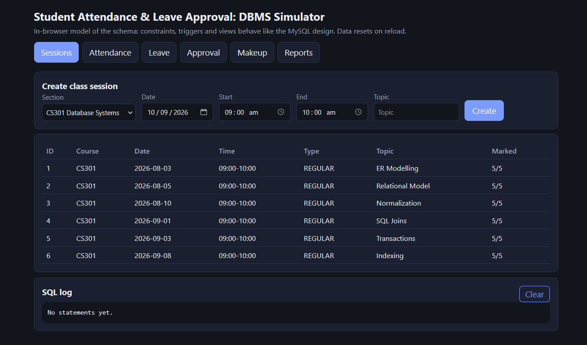
• Screen 3: Attendance marking grid for a selected session.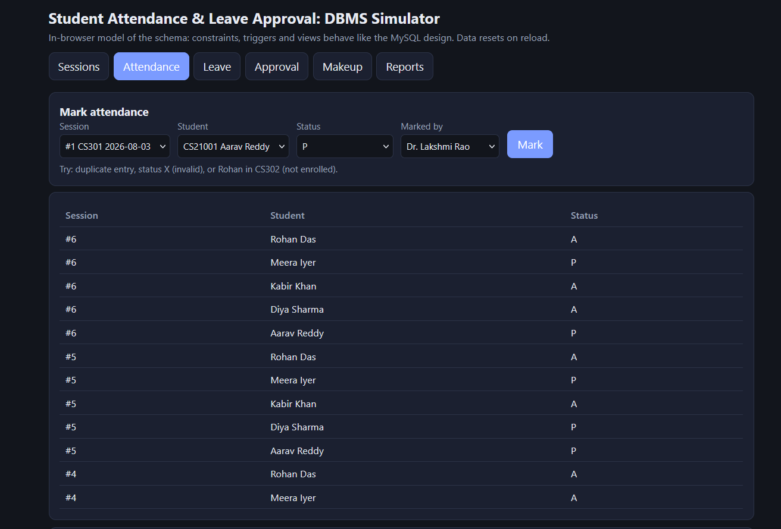
• Screen 4: Student leave application form.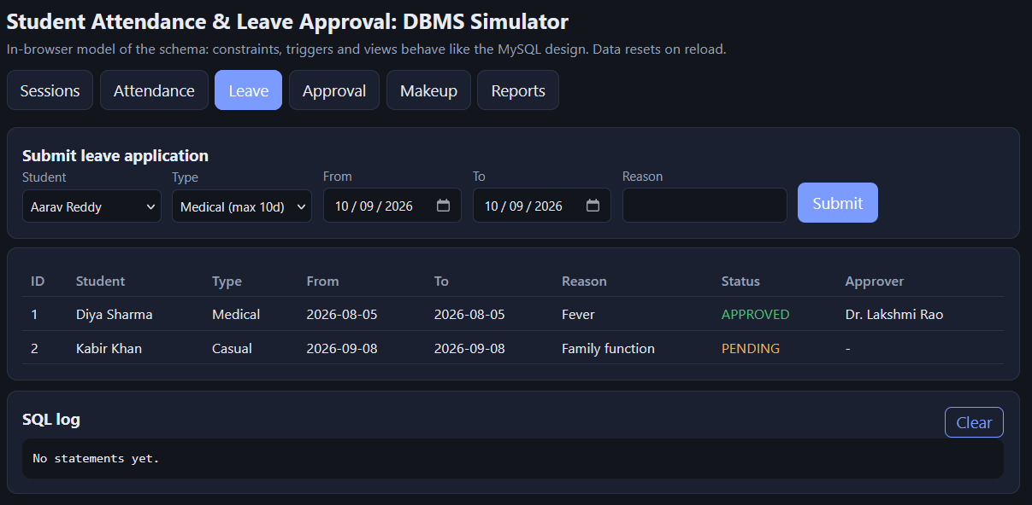
• Screen 5: Approver dashboard – pending applications with action buttons.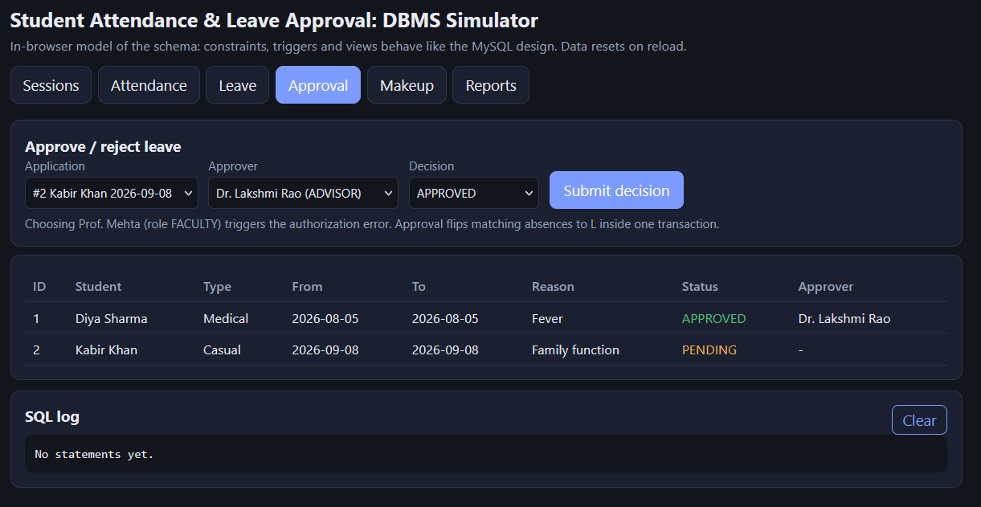
• Screen 6: Leave history for a selected student.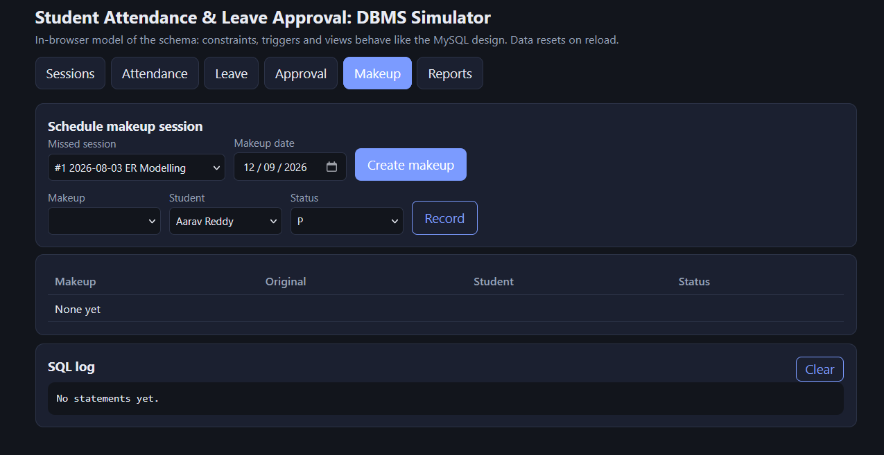
• Screen 9: Monthly attendance trend summary.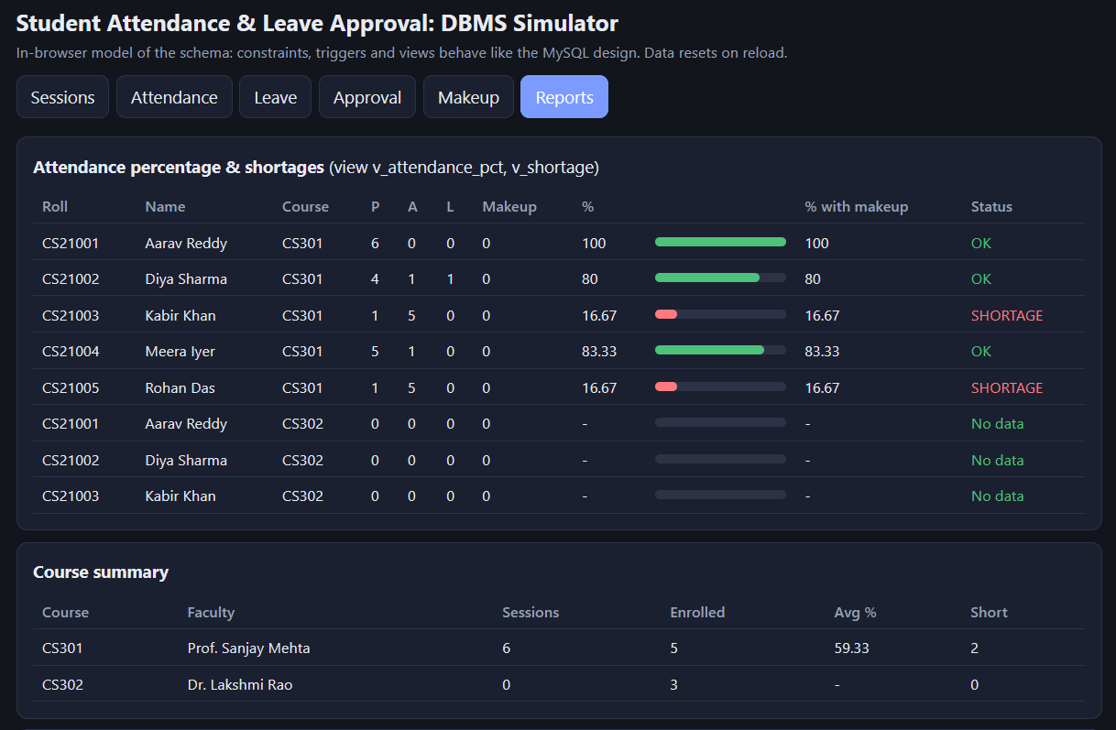
Note : Source code, database dump (SQL script) and test data files are submitted separately along with this report.

