# Outputs

1. **Input op operations without scanner class**

Code: public class scanops {

public static void main(String[] args) {

String operation = "subtract";

int value1 = 50;

double value2 = 25.5;

System.out.println("Operation: " + operation);

System.out.println("Value 1: " + value1);

System.out.println("Value 2: " + value2);

// Example operation based on hardcoded values

if (operation.equals("subtract")) {

System.out.println("Result of subtraction: " + (value1 - value2));

}

}

}

Output:

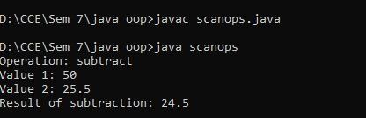

1. **All operations arithmetic logical**

Code: public class arithmaticops {

public static void main(String[] args) {

// Arithmetic Operations

int a = 10;

int b = 3;

System.out.println("Arithmetic Operations:");

System.out.println("a + b = " + (a + b)); // Addition

System.out.println("a - b = " + (a - b)); // Subtraction

System.out.println("a * b = " + (a * b)); // Multiplication

System.out.println("a / b = " + (a / b)); // Division (integer division)

System.out.println("a % b = " + (a % b)); // Modulus

// Logical Operations

boolean x = true;

boolean y = false;

System.out.println("\nLogical Operations:");

System.out.println("x && y = " + (x && y)); // Logical AND

System.out.println("x || y = " + (x || y)); // Logical OR

System.out.println("!x = " + (!x)); // Logical NOT

}

}

Output:

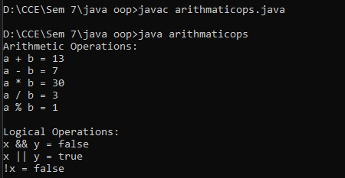

1. **Data types**

Code: public class datatypes {

public static void main(String[] args) {

// Integer types

byte myByte = 127; // -128 to 127

short myShort = 32767; // -32,768 to 32,767

int myInt = 2_000_000_000; // Commonly used integer type

long myLong = 9_000_000_000_000_000_000L; // Suffix 'L' for long literal

System.out.println("Integer Types:");

System.out.println("byte: " + myByte);

System.out.println("short: " + myShort);

System.out.println("int: " + myInt);

System.out.println("long: " + myLong);

// Floating-point types

float myFloat = 3.14159f; // Suffix 'f' for float literal

double myDouble = 3.1415926535; // Default for decimal numbers

System.out.println("\nFloating-Point Types:");

System.out.println("float: " + myFloat);

System.out.println("double: " + myDouble);

// Character type

char myChar = 'A';

System.out.println("\nCharacter Type:");

System.out.println("char: " + myChar);

// Boolean type

boolean myBoolean = true;

System.out.println("\nBoolean Type:");

System.out.println("boolean: " + myBoolean);

}

}

Output:

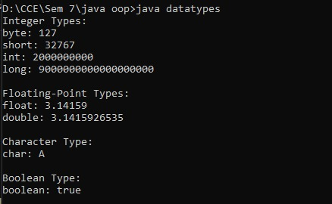

1. **Access Modifier**

Code: // Public class, accessible from anywhere

public class accessmodifier {

// Public member: Accessible from anywhere

public int publicVar = 10;

// Private member: Accessible only within this class

private String privateVar = "Private Data";

// Protected member: Accessible within the package and by subclasses

protected double protectedVar = 99.99;

// Default (package-private) member: Accessible only within the same package

int defaultVar = 50;

// Final variable: Its value cannot be changed once initialized

public final String MY_NAME = "Meghan";

public void displayVariables() {

System.out.println("--- AccessModifiersSet1 ---");

System.out.println("Public Variable: " + publicVar);

System.out.println("Private Variable: " + privateVar);

System.out.println("Protected Variable: " + protectedVar);

System.out.println("Default Variable: " + defaultVar);

System.out.println("Final Constant: " + MY_NAME);

}

public static void main(String[] args) {

accessmodifier obj = new accessmodifier();

obj.displayVariables();

}

}

Output:

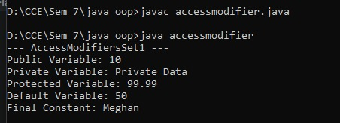

1. **Control Statements**

Code:

public class controlstatement {

public static void main(String[] args) {

int score = 75;

String day = "Tuesday";

int counter = 0;

System.out.println("--- If-Else Statements ---");

if (score >= 90) {

System.out.println("Grade: A");

} else if (score >= 80) {

System.out.println("Grade: B");

} else if (score >= 70) {

System.out.println("Grade: C");

} else {

System.out.println("Grade: D or F");

}

System.out.println("\n--- For Loop ---");

for (int i = 0; i < 5; i++) {

System.out.println("For loop iteration: " + i);

}

System.out.println("\n--- While Loop ---");

while (counter < 3) {

System.out.println("While loop iteration: " + counter);

counter++;

}

System.out.println("\n--- Do-While Loop ---");

int doWhileCounter = 0;

do {

System.out.println("Do-While loop iteration: " + doWhileCounter);

doWhileCounter++;

} while (doWhileCounter < 2);

System.out.println("\n--- Switch Statement ---");

switch (day) {

case "Monday":

System.out.println("It's Monday, start of the week.");

break;

case "Tuesday":

System.out.println("It's Tuesday, a working day.");

break;

case "Wednesday":

System.out.println("It's Wednesday, hump day!");

break;

default:

System.out.println("It's another day.");

}

}

}

Output:

